Heart Disease 2 Analysis

The following is a SVM linear model for Heart Rate and Blood Pressure testing for heart disease.

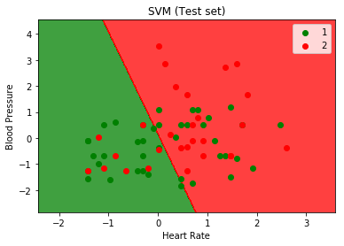

To explain further, heart disease in this dataset is a Boolean. So having heart disease is a value of 2, indicated by the red color. Not having it is green, value of 1. The dots are the predicted values given our training model and information from the dataset. The two large color sections are the division between where heart rate and blood pressure measures would result in heart disease. The axis are on an interpretive scale from their averages. For example, being at the negatives for both blood pressure and heart rate indicates measures lower than average, hence being in the “no heart disease” section.

The model and type of analysis were first based off the dependent variable. Since it is a Boolean, we need to use a classification model. Then, I picked the variables I wanted to test, in this case the two shown. Using a grid search and k 10 fold cross validation allowed for testing of different options to pick the best model.

That being said, despite following the best models, the accuracy is still at best 64%. This can be seen by the variation in colors, with green dots being in the red section and red dots in the green section. The conclusion here is that blood pressure and heart rate does not conclusively determine having heart disease, but having high levels in each is likely to have this condition. Further testing can be done with other variables in the same manner, switching them out and seeing the accuracy measures that result.