Potential API’s to use

**General Mapping Tools**

Leaflet - <https://leafletjs.com/plugins.html>

* Javascript library for mobile interactive maps
* Layering
* Custom map markers
* Density maps (heat maps)

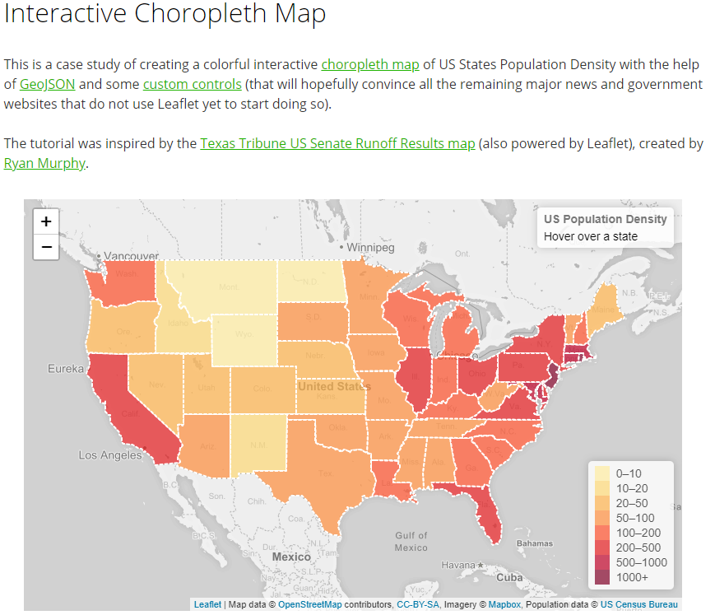

* Ability to add custom shapes or point markers

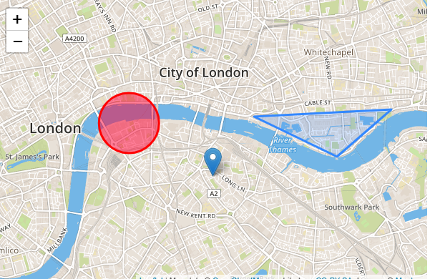

Google Maps API (heatmap linked) - <https://developers.google.com/maps/documentation/javascript/examples/layer-heatmap>

* Heat map functionality
* Markers with custom descriptions
* Custom shapes can be made
* Has pretty much any basic map features we would need

OpenLayers - <http://openlayers.org/en/latest/examples/heatmap-earthquakes.html>

Mapbox (Python) - <https://www.mapbox.com/api-documentation/?language=Python#reading-this-documentation>

**Crime Data**

FBI CDE - <https://crime-data-explorer.fr.cloud.gov/api>

IBM Crime Data - <https://developer.ibm.com/clouddataservices/2016/11/03/open-crime-data/>

SpotCrime (Unofficial) - <https://github.com/skyline-ai/spotcrime>

**Visualization**

Ggplot (high familiarity with this tool already)

Matplot

Plotly (interactive graphs)

Geoplotlib (plotting geographic data)

Seaborn