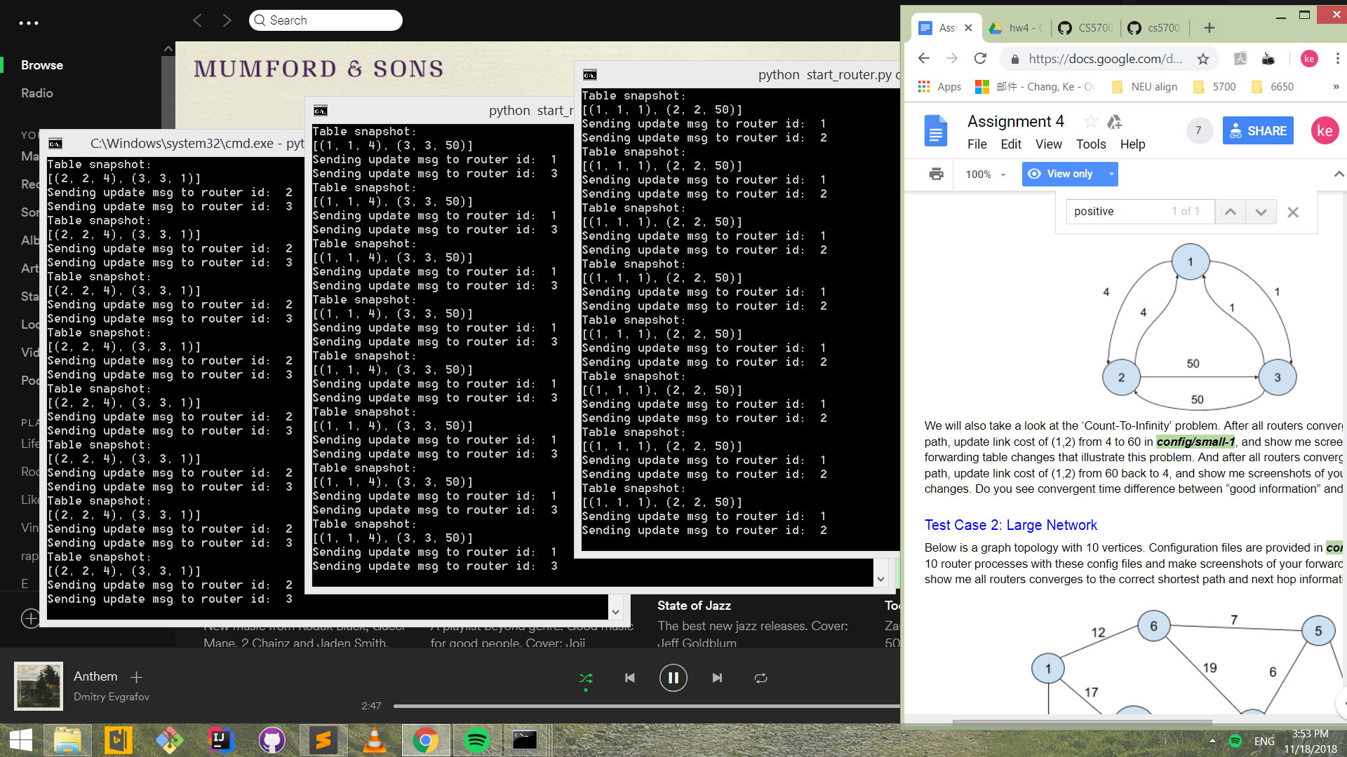

Routes 1, 2, 3 getting shortest paths

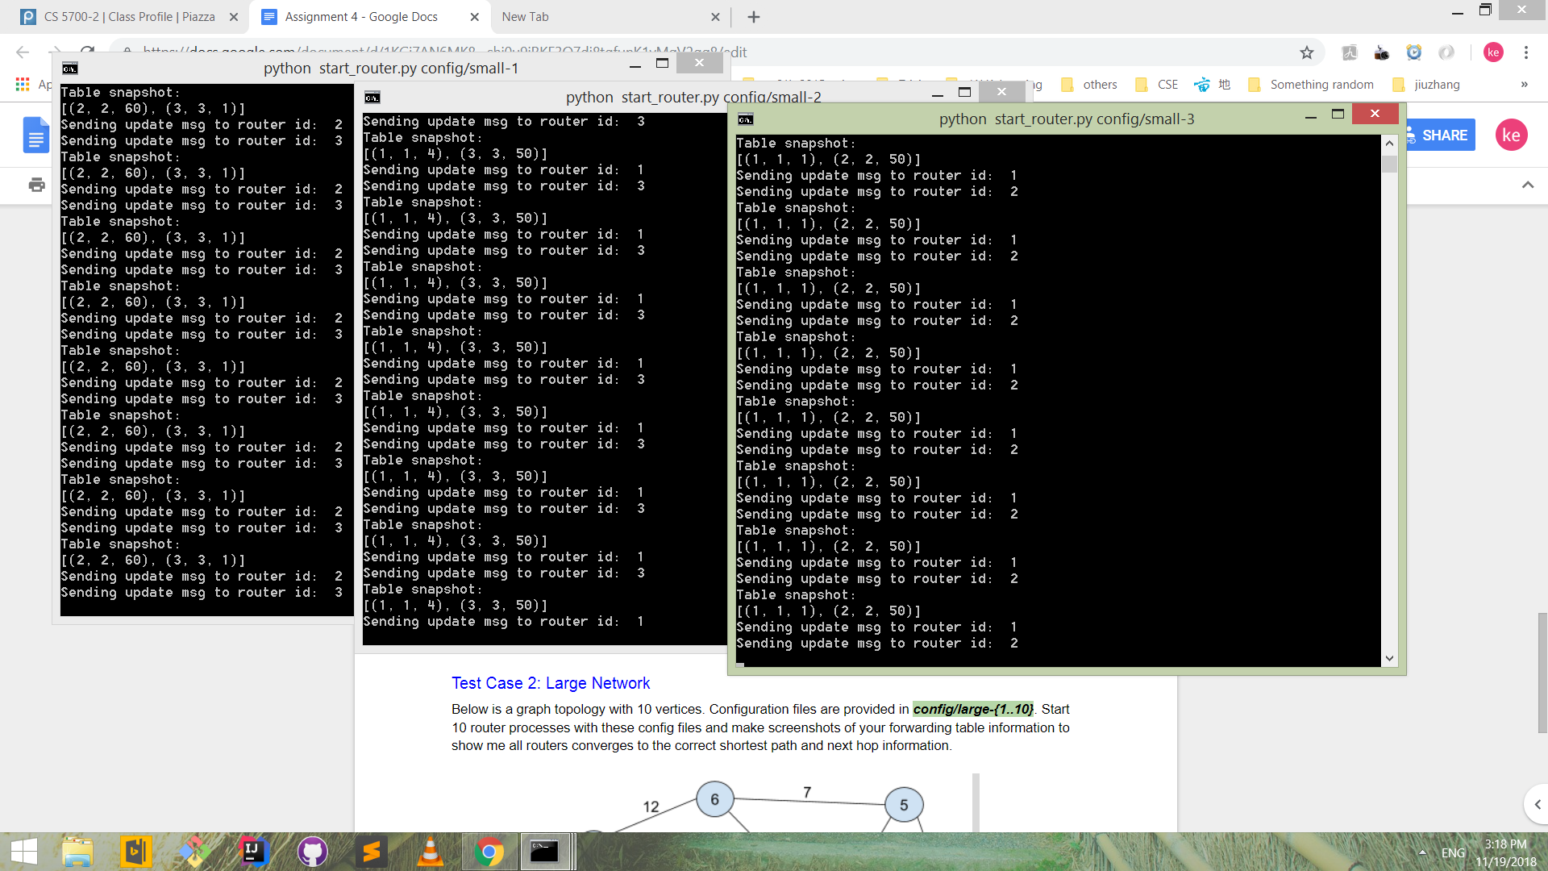

Routers 1, 2, 3 after change (1, 2) from 4 to 60

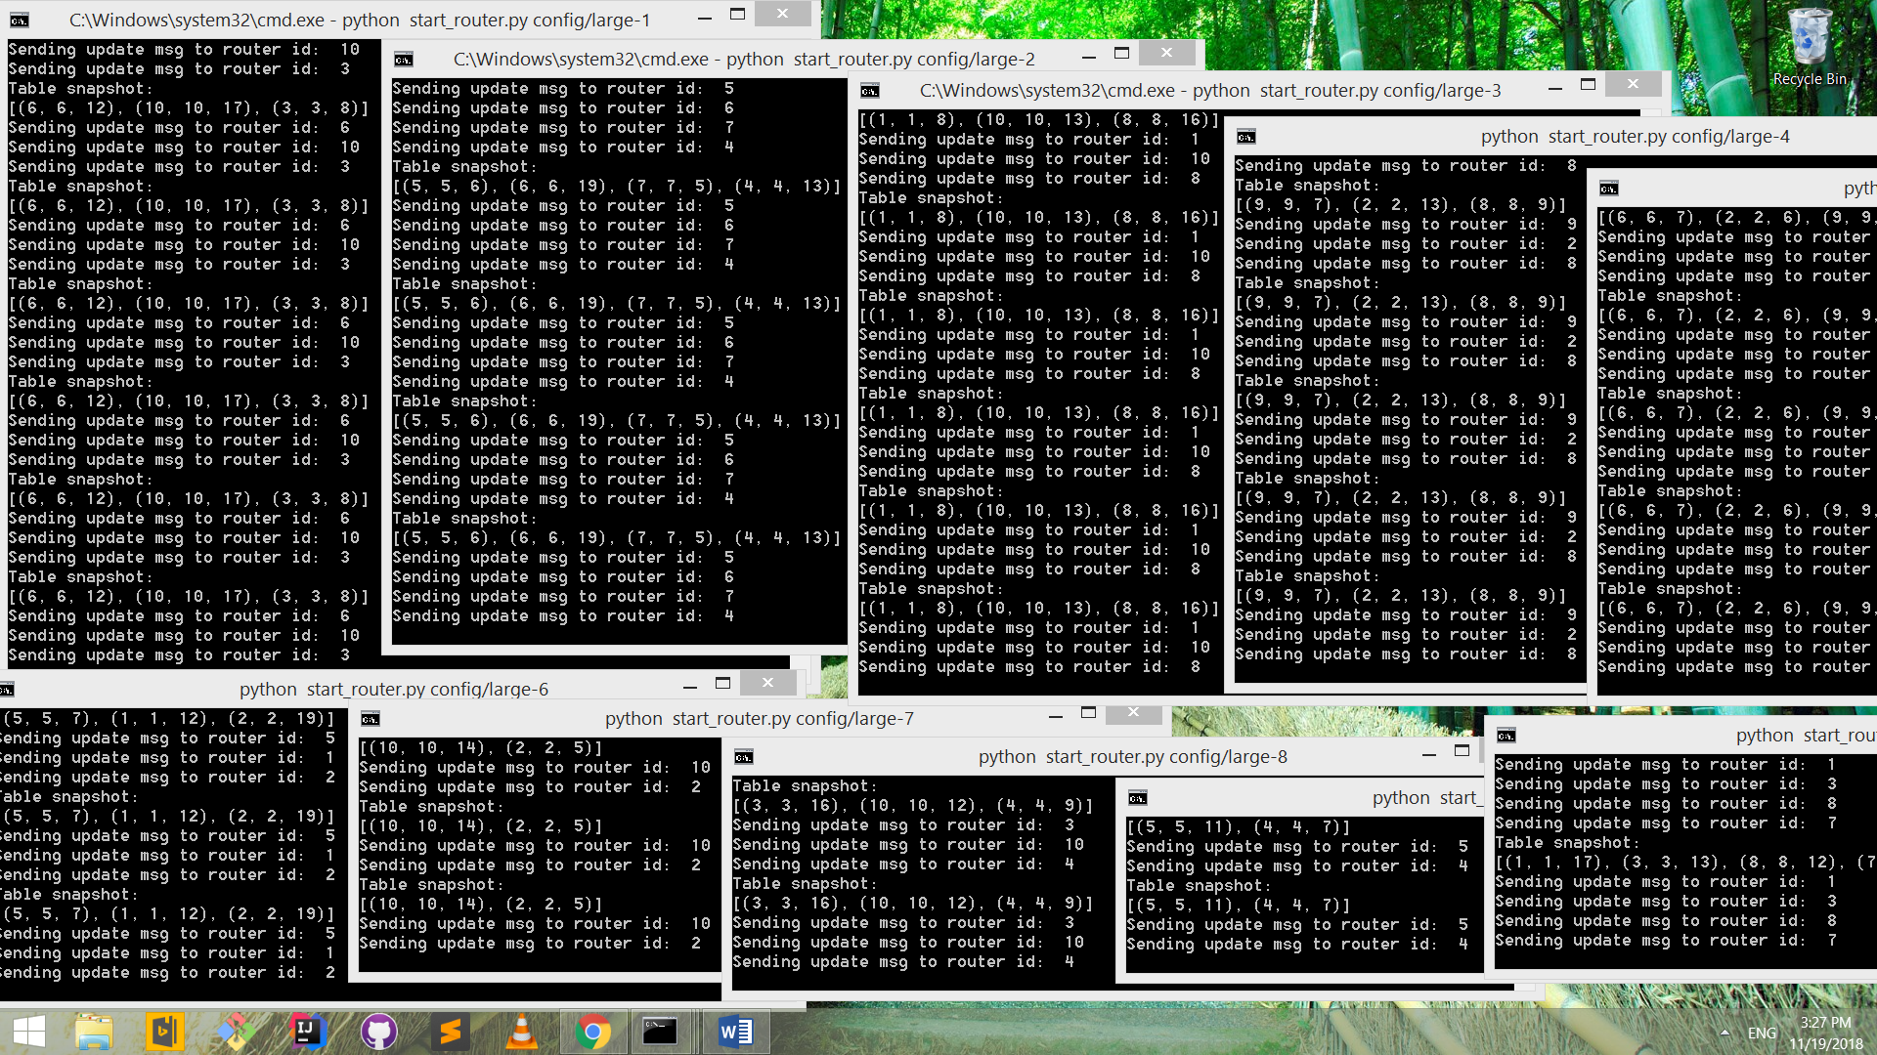

Routers large 1- 10 snapshot of forwarding tables