AI Stock Trading – statics and algorithms

“They give away too much power”. “For first time, average Joe has data that were only available to the rich cats”.

This document discusses studies of Pandas codes and algorithms of stock trading history. There is a background section, followed by explanation of the code setup.

Author: Chang Liu

Time: November 2024

Executive summary:

There are lots of trading historical data for stocks, foreign exchange, and bit coin. What can they tell about future trades?

* Can we identity turning points of stock?
* Can we start a day knowing the chance of buying, selling, or do nothing about a stock?
* Are there sure fire indicators buried in stock data about future movements?
* Can trading options be better predicted using ensemble statics, business supply chain logic, and societal trends?

I used LSTM, ARIMA and decision tree modeling to model stock history. The goal is not to predict the stock price from historical data, as it is both laden with inaccuracy and not productive in real business. However, my study presented here is meant to contain two stages. Stage 1: to understand the state of the art of stock marketing modeling, in terms of both prevailing practices and tools. Stage 2: to investigate new techniques such as ensemble analysis, ensemble indicators and new statistical dynamics to predict actions such as buy or sell.

As a point of reference, random walk stock decisions typically lead to only 6% overall loss. On the other hand, stock buying predictions based on LSTM/ARIMA today have at beat lead to 10% profit, or 8% annual gains. Compared to SP500 index and random walk baselines, such performances are not very impressive. Given that over 60 percent of trades today are done by algorithms, I am motivated to find the signals among noise. This work is the beginning of my exploration.

Contents

Part 1: Motivation of this study 3

Part 2: Comprehensive review of state of the art 4

What most people are doing wrong 4

Stock trade is a coin toss – statics and psychology 4

Data science algorithms 6

Commercial trading tools 6

Improvement of work 8

Glossary 9

Stock trading graph 9

Four kinds of trades 10

Trends, momentum and support 10

The science of trading 12

Trading block patterns 12

Trading psychology 13

Part 3: Algorithmic Trading Studies – professional certificate program 14

Source of data 14

Free data 14

Paid data 14

Future efforts 15

References 15

Figures 15

# Part 1: Motivation of this study

Stock market is a great generator of wealth. Everyday millions of trades of stocks happen. Some one loses, while someone else gains. Some buy stocks, and some sell stocks. Some buy and hold for a long time, waiting for the stock price to increase beyond the inflation. Some buy and sell multiple times of day, taking advantage of fluctuations. The smart money trade on proprietary information, and predict the stock movement. They have models and tools (such as high frequency trading). **But most important of all, they have data! And they have quants who can explain and model the data.**

**Stock trading can be a great equalizer, if everyone has knowledge of data. But most people just loses money.** Stock trading is largely a realm for the professionals. Over 65% of stock trade is done by machine algorithms today. Most people can go into the stock market and lose a lot of money.

What I am interested in include at least the following questions:

1. Can a program warn people against stock purchases based on expertise and algorithm? Basically a go-no-go indicator for everyone, based on past patterns.
2. Can a program identify opportune moments to buy a stock? Either on the time scale of minutes or days? Forecast momentum reversal before they happen, predict moves such as wait and enter long trade. If we believe that stock movement is enigma, is there a “first principle” that no one is aware of? Is the white noise of stock movement actually all explanaable?
3. Can one identify stock trade signals by integrating information from multiple sources and identify patterns that are hard to perceive? For example, information about supply chain companies and their reports can help predict movements of related companies. Is there relation between the indicators to other features of a stock such as dividend position, PE ratio, industry, etc.
4. Can one use external information to make stock movement prediction more accurate? Such as other stocks of same or related category of same day?

I realize suddenly that a lot of long term stock movement information is online for free, and powerful tools are available for free.

**I want to learn what is out there, test established theories, and hopefully find new insights.**

**Analyze. Refine. Learn. Predict. Direct. For ordinary people.**

# Part 2: Comprehensive review of state of the art

If you are an expert of stock market and trades, please skip this entire section.

Disclaimer: I do not believe there is a secret formula for trading stocks, but I want to understand better. I also don’t believe blindly videos and advertisements blindly.

## What most people are doing wrong

Most AI stock trading algorithms use regression to fit the curve. However, this is not very useful. If we take out the trends and cycles, the stock movement everyday is actually white noise, because the ACF has only the zeroth term. Some people try to apply chaos theory[1].

Stock trading is a way of battle and war. It is like chess. If you can not win, then you will lose. If you can not beat the SP500 index, then you are still not winning.

By viewing a lot of courses and youtube training, I realized:

* Money has no limit. It cannot be scaled. Therefore any attempts to “normalize” data is useless[2].
* The daily movement (removing trends and cycles) is largely white noise and perfectly stationary signal. Anyone who claims to fish out signals from white noise must realize the challenges.
* Don’t try to predict stock prices. There is no point. It is like predicting the tremor in one’s voice when they say something. It is like try to predict the meaning of human sounds by fitting the sound vibration.
* A prediction can be completely perfect and yet completely wrong.
* There is no baseline such as naïve forecast.
* A lot of things on the internet are wrong and just financial TV. [[3] [4]]

One cannot predict the price. If you can predict the price trend, then others can also predict. Very quickly there is nothing to gain.

**Overall, if one can make a good algorithmic trading algorithm, they will not share it.**

## Science of coin toss and risk taking – statics and psychology

Stock trading is fascinating. On paper, it is a legal way for you to take money from someone. Most day traders lose money all the time, just like someone in a Las Vegas casino. However, professionals have both experience and unfair information. They also use high frequency trading to capture money from noise – this is something ordinary investors can never do.

Even if someone has a lot of experience, it is still hard to become an Alpha [5] – beating baseline performances of index funds and the broader market. [https://youtu.be/5K8-liOIWFU?si=vkGh0PptI2FboAK_ [6]]

Trading is statistical [[7]][[8]]. If we trade the daily performance as a head or tail flip, then the distribution will win and loss will be Gaussian. The chance to win and lose everyday hovers around 50%.

Trading is psychological [[9]]. The psychology of greed and fear, and of gain vs. risk.

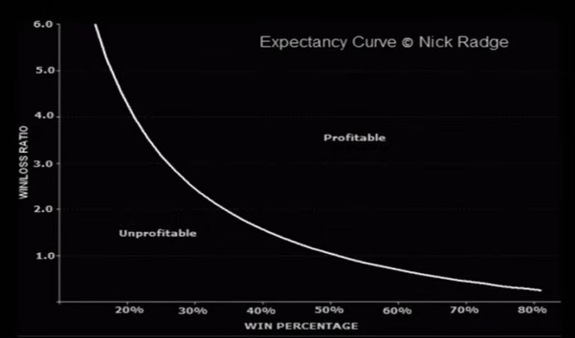

Plot of risk vs. win rate. The vertical axis is win/loss ratio, and the horizontal axis is win percentage.

Trading is mathematical. The theory of chaos and pendulum have a place, since the buying and selling stocks of driven by minds. This is not just noise, but there are human psychology, greed, and fear at play. It is a highly complex system. Very few mathematical governing equations are present. [[10]]

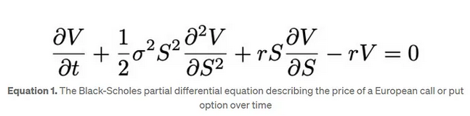

## Data science algorithms

There are several tools that people have used, including Time series prediction, using ARIMA[11], SARIMA, LSTM[12][13][14] RNN, and even LLM [15].

However, I do not see a lot of data science work in predicting trading block patterns. Perhaps the best quants in the best wall street firms do this – but this is largely top trade secret.

One past work actually try to decipher trading block trends. [Ref [16]]

#### Trading window and other trades

The New York stock exchange is open between 9:30 am to 4 pm eastern time. However, there is also pre-trade window and after-hours trading. In the after-hours, there are often times “smart money” buying and selling , although the overall liquidity is lower due to lack of public participation.

The trading algorithm may also apply to trading of currency (FOREX), gold, and commodities.

Reference [ [17] ]

## Commercial trading tools

There are some resources online of established platforms, including:

1. Robinhood
2. [TradingView](https://www.tradingview.com/): A supercharged super-charting platform for analysis.
3. [Ninja Traders](http://ninjatrader.com), A website for algorithm trading tools.
4. Barclays trading strategy [[18]]

Yahoo finance seems to provide a lot of free insight for free.

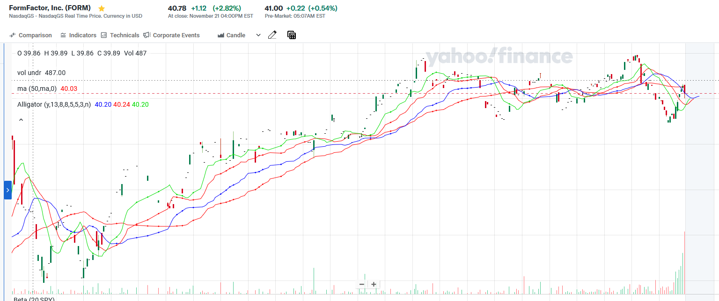

There are many indicators one can apply.

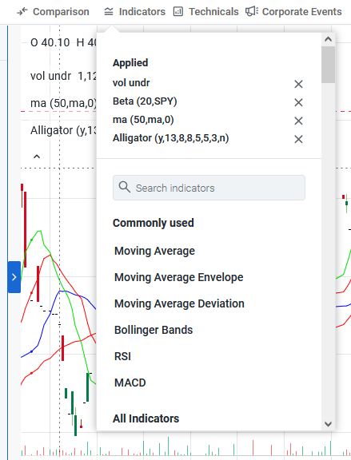

This includes go-no-go indicators. In retrospect, the go and no-go signatures seem to corresponds to longer rallies. If I had the hind sight, I can use this information to buy and sell with ease. However, it is questionable if this indicator is applied before hand.

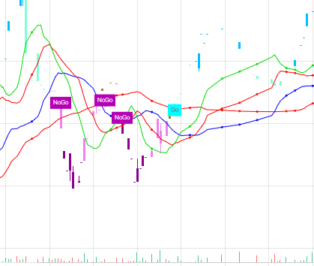

These systems allow people to have power tools, such as indicators and trade alerts. However, there is a fee and I am not sure they are accurate.

## Improvement of work

1. Linear regression fitting of some features to some outcome
2. Identification of chart patterns for trade (candlestick patterns), power and limitations
3. Instead of predicting the price, predict the trend in next 24 hours
4. Validate the validity of patterns with extensive back testing.

Questions to answer:

1. How to produce better trading results than index or long trading?
2. What type of flag signature is most accurate?
3. Can off hour trading info be used to guide. Can we predict daily gap ups and gap downs?
4. Can we predict a breakout a hour or a day prior?

External sources of information

1. Options info
2. Overall momentum and time in a trade day
3. Signature candle stick patterns

Features:

* Identify support level
* Show options

## Glossary

### Stock trading graph

Stock trading history is captured in stock trading charts. In each time window, there are starting price and ending price. The candle stick patterns also record the highest and lowest price reached.

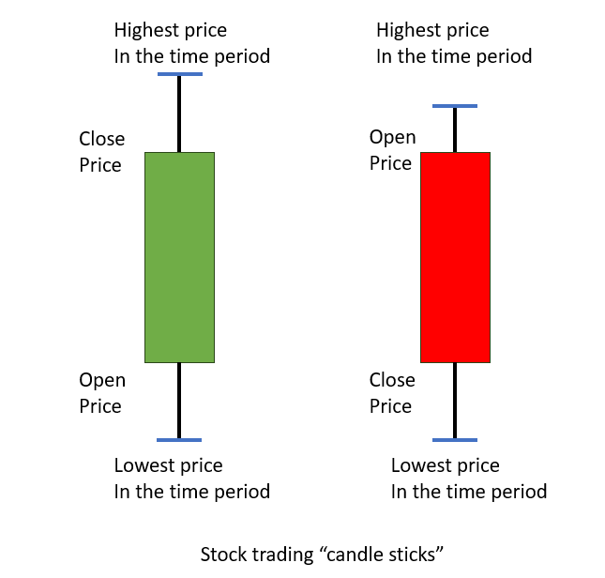

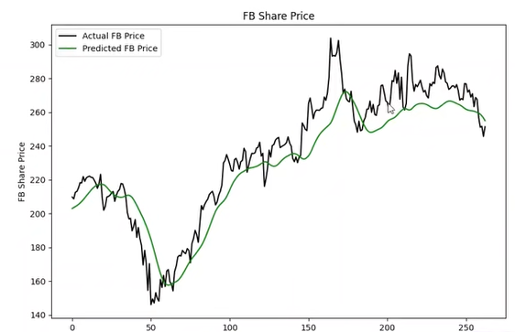

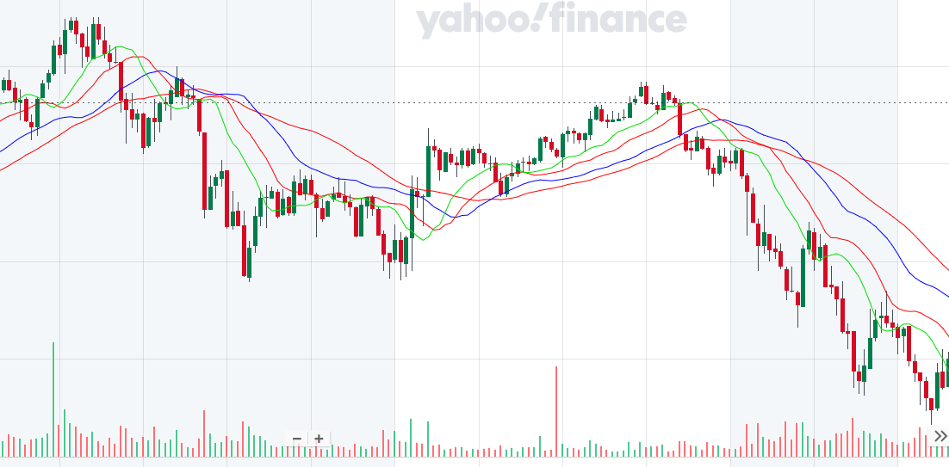

### Four kinds of trades

There are four kinds of trades: long, short, put, and call.

**Long position**: An investor buys an asset with the expectation of selling it at a higher price later. The investor believes the asset's value will increase.

**Short position**: An investor sells an asset they don't own, intending to buy it back later at a lower price. The investor believes the asset's value will decrease.

**Call option**: Gives the buyer the right to buy a stock at the strike price before the expiration date. The buyer profits if the stock price rises above the strike price.

**Put option:** Gives the buyer the right to sell a stock at the strike price before the expiration date. The buyer profits if the stock price falls below the strike price.

### Trends, momentum and support

References: [[19] [20]]

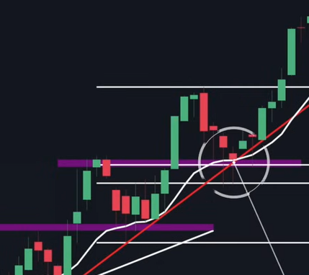

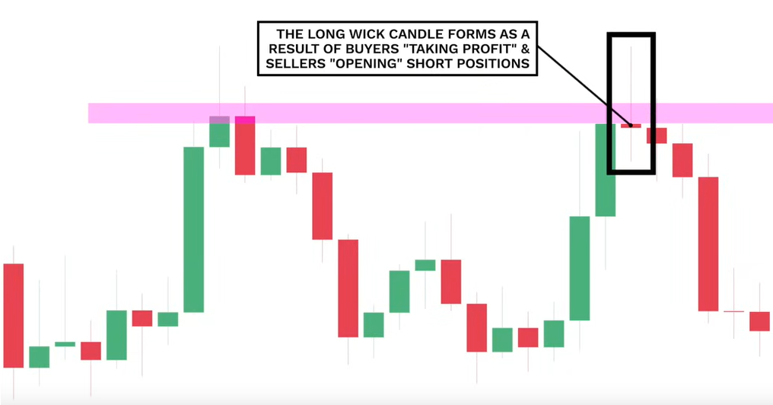

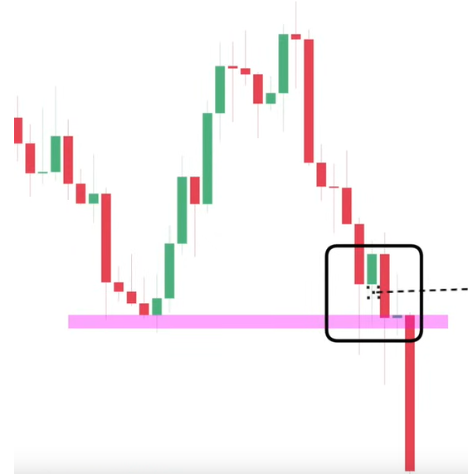

### The science of trading

Most trade in a day is setup at start and end. Many trades are driven by options. There are smart money and high frequency trading. Identifying such signatures would be useful. Many times the stock news is released after hours.

Fair value gap.

Chaos and long-term cycles.

Can we do FFT of stock?

### Trading block patterns

I do believe good traders have good information and good experience, and they are also better reading tea leaves. However, I know that I do not have that sense.

Stock trading movement is largely white noise, representing randomness of competing profit takers. However, there are some studies of trade block patterns that can be used to predict future moves.

There are hidden support, resistance and trend lines that are buried in the random motion of historical data. [21]

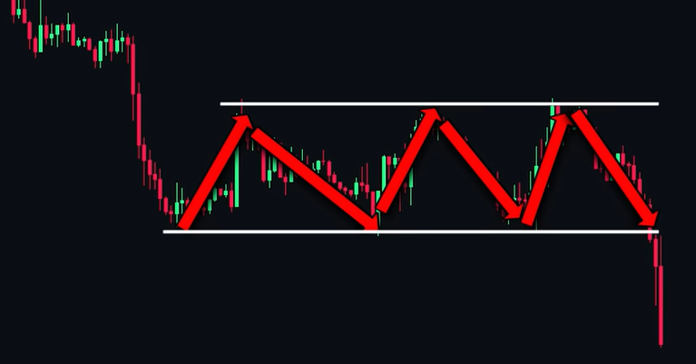

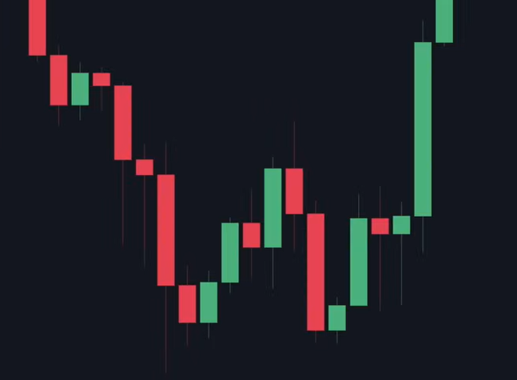

Head and shoulders

Double bottom (The ultimate beginner guide)

Tripple bottom, flag, falling wedge, Maribouzu confirmation

Engulfing candle, momentum candle, DOJI, hammer (The only ..)

#### State and regime

Continuation, reversal, consolidation

Statement and regimes:

Consolidation, manipulation, distribution,

### Trading psychology

Trading is an educated game. It is like gambling, where the buyers and sellers do battle.

Resistance and support, supply and demand, liquidity and momentum

# Part 3: Algorithmic Trading Studies – professional certificate program

## Source of data

### Free data

Yahoo financial historical data for every stock

Yahoo ticker symbol data

Others? News? Option number? Categories

PE ratio?

### Paid data

Can we buy from survey research firms?

#### Python trading codes and classes

Here are some good resources. [22][23]

# Future efforts

**Stock is not random, although it appears to be random. Stock is chaotic and difficult to predit.**

Build good resource for Github

Build a good course

Simulation and education tool

Stock navigator (red/green lights, path choice)

Trade hero

Alpha Stock game changer algorithm automated trading and winning

Using random walk selling pattern, one can get 94% return easily without using any prediction model. An ARIMA model that looks back a few days is said to have profit margin of 10%. However, any more over fit model would result in loss.

AI trade pattern recognition

# References

Trading view

Jim Simons “start with data”

Chaos theory for trading. Ref [[24]]

ARIMA profit optimization [[25]]

## Figures

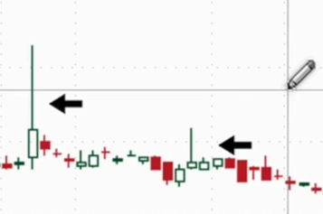

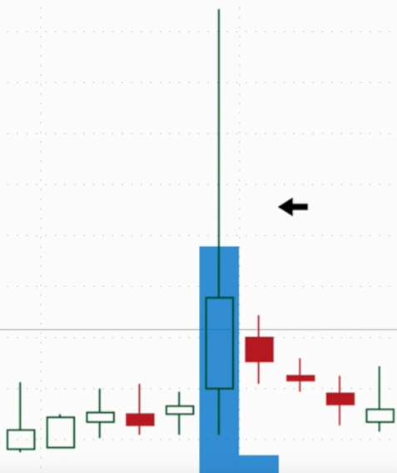

1. <https://youtu.be/GMhVuZa6VtY?si=YABWs6v67CRmDcLK>
2. <https://youtu.be/PuZY9q-aKLw?si=-IA4twD2H9I5VEDY> Predicting stock prices in Python
3. One mistake everyone makes <https://youtu.be/Vfx1L2jh2Ng?si=l9R4IEozZiej-PNp>
4. LSTM top mistake in price movement prediction <https://youtu.be/lhrCz6t7rmQ?si=FNTYd7hQFHb7-SOy>
5. How financial firms actually make money <https://youtu.be/5K8-liOIWFU?si=D3_fQjidvULmZMaX>
6. Algorithmic trading on youtube is fake <https://youtu.be/5K8-liOIWFU?si=vkGh0PptI2FboAK_>
7. The math of winning in trading, <https://youtu.be/FGLuyx0aM-I?si=samGAMyaN2dKgu78>
8. The physics of financial markets <https://youtu.be/NZU9wjOAnRQ?si=hoAN5v7_-mRYNEVL>
9. Trading psychology by Dr. David Paul, <https://youtu.be/MGglyvc8d58?si=8JTbQKntKijGWgBm>
10. The Black-Schole’s model <https://medium.com/@quant_views/insight-into-black-scholes-equation-c9475c74cf53>
11. Predicting stock prices and making money using the ARMA <https://youtu.be/Vyr5dthe-2s?si=osMaXRAlrT52b3l7>
12. LSTM based time series with Pytorch <https://youtu.be/hIQLy5zCgH4?si=DXlUmJDpTDxonF-C>
13. LSTM top mistakes in price movement predictions <https://youtu.be/lhrCz6t7rmQ?si=RNBP4MQ-YQFC4s7D>
14. Predicting stock prices with LSTMs: one mistake everyone makes <https://youtu.be/Vfx1L2jh2Ng?si=IJHRbWgtNN4gfBXX>
15. Neural networks trading models <https://youtu.be/m1rY2J8ZlsY?si=2dnmOTvAzjlqEJUt>
16. Algorithmic trading and price prediction using Neural Network models <https://youtu.be/m1rY2J8ZlsY?si=0NAW6DEivh8eFtv_>
17. <https://youtu.be/OzO8XEu5h5o?si=OD1NqLex8DNvS8NE> How to trade premarket and after hours
18. <https://youtu.be/8pYgz4YlQnE?si=DHR4EvqT27PfdIAa>
19. <https://youtu.be/UU4ZQF-X9jE?si=KjuYy-o3ifymotOA> Ultimate candlestick patterns
20. Every trading strategies explained in 12 minutes <https://youtu.be/ZX-Tp4zgJYc?si=det4ocRzYjCpJ7Ai>
21. <https://youtu.be/bZ3pffta3-A?si=tM4ToRkkFAW7tVE1> 14:30 The only candle stick patterns you need to know
22. <https://youtu.be/xfzGZB4HhEE?si=0FFhJtXTel3A00Ce> Algorithmic trading using python full course
23. <https://youtu.be/Jfo22-qB4UI?si=C7L8-K4yf6SdY32G> Analyzing stock price correlations in Python
24. How chaos theory affects the stock market <https://youtu.be/GMhVuZa6VtY?si=DBp2JG3B0Y9HwAPH>
25. <https://youtu.be/Vyr5dthe-2s?si=Tws23Af_Iv0aw02I>