.

Receptionist Application

# User Manual

Version 0.1

02/05/2021

Document Number: <document’s configuration item control number>

Contract Number:

## Introduction

Receptionist Application is a modern visit management tool which is used on the front desk of a company or an organization to facilitate receptionists to deal with daily routines of greeting visitors.

The App can be deployed on a mobile terminal(pad) or a PC placed in the front desk. This User Manual (UM) provides the information necessary for front desk receptionist to effectively use the Receptionist App.

## Overview

### Receptionist App supports following features:

* Visiting reason selection: The visiting reason is categorized to different types.
* Visited contact selection: The visited contact can be searched and visualized on the App.
* Visitor information recording. The visitor’s contact information is entered into system
* Terms and Condition assurance: The visitor can read security terms and conditions of the company and sign with signature.
* Pre-arranged visit:
* Check in and Check out management
* Speed visitor information recording with a used badge
* Visiting badge generation

### Architecture of system

Receptionist App is a web-based application, which includes front end (Mobile App or PC web page) and backend server. The frontend part can be deployed on a Pad as a mobile App or deployed on a PC with web page. The backend part includes a web server and database.

### User access mode

User can interact with this app by touching and scratching on a mobile terminal, the experience is same as using a normal mobile application.

## Getting Started

### Set-up Considerations

1. The Receptionist App designed to be installed on Pad, not designed for small screen. A better user experience can be achieved on a large screen
2. If use Web Brower is used to run Receptionist, Latest modern browsers are required. Chrome version (88) is verified.

### Accessing the System

1. If receptionist is installed on a Pad as a mobile App, user can access by open the App by double touch the application icon on the screen. The App is expected to run continuously, and it handles each visit flow in order. When one visit is finish, the app return to main page, ready to handle next visit.
2. User can access the App through browser too. By inputting the URL of App, the web page of App is loaded to handle new visit.

### Service flow

There are two types of users, receptionist and visitor. The receptionist is expected to operate the App and follow the flow step by step. The visitor is expected to input user information during the check in or check out flow.

In the following paragraphs, the check in /out flow is detailed.

#### Check in flow

1.When a visitor comes to the front desk of the office , the receptionist will greet him , and ask for his visiting purpose

2.Based on the visitor’s response, the receptionist chooses the corresponding visiting reason from the App screen. Now there are 4 different types of visit:

* Here for an appointment
* Document Deposit
* Delivery
* Preregistered visit

Here for an appointment and Preregistered visit flow

According to different visit types, the different check in flow will be taken. If user comes here for an appointment:

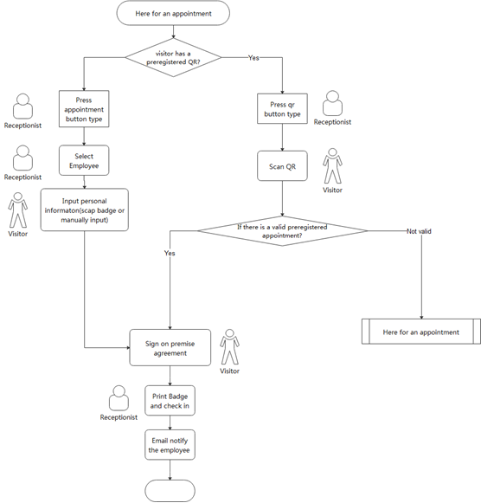

There are two scenarios:

* one is that there is a pre-arranged appointment, visitor has a invitation with him. The inviter has already registered the visitor information in reception system and the invitation was sent to visitor by email. There is QR code in the email. The visitor can show his QR code at the front desk, and the receptionist can scan the QR code with Pad or cameral on PC. If it’s valid invitation, after scan, the receptionist system will read the recorded visiting information from backend database. And on the screen, the visitor personal contact information, the inviter’s name, and prearranged visiting time are shown.

The receptionist can check the visit information, if the information is valid, he/she normally makes a call to the inviter to notify him his visitor is here and waiting for his greeting.

After finishing personal information input, the visitor is required to read and sign the security terms and conditions show on the screen

At the last step the App will generate a badge for him. On this badge, there is a QR code, which records the visit information, and will be used when the visitor checks out.

Then the check in flow for the visitor is finished, the check in information is recorded in the system. An email about the visit is sent to the visited contact to notify his visitor is coming. The visitor can be permitted to go into the office or wait at front desk for the inviter to greet him.

* The other scenario is that the visitor does not have an invitation. In this case, the receptionist needs to ask for the name of the visited contact. The receptionist can search the contact in the App by full name or part of the name of the contact. If the contact is found, the receptionist needs to make a call to the contact to notify him/her there is a visitor.

If getting the confirmation, the visitor is asked to input his personal contact information on the App. The required information includes name, company, email and phone number.

After finishing personal information input, the visitor is required to read and sign the security terms and conditions show on the screen

The last step the App will generate a badge for him. On this badge, there is a QR code, which records the visit information, and will be used when the visitor check out.

Then the check in flow for the visitor is finished, the check in information is recorded in the system. An email about the visit is sent to the visited contact to notify his visitor is coming. The visitor can be permitted to go into the office or wait at front desk for the inviter to greet him.

Delivery and deposit document flow

If the visitor is a courier, and he is here to deliver a package or a documents to someone in the company. There is no need to record the personal contact information of the courier or ask the courier to sign security terms or conditions for the courier may not be permitted to walk into office. Normally the courier put the package or document, ask the receptionist to sign for the stuff or call the receiver to the front desk to sign.

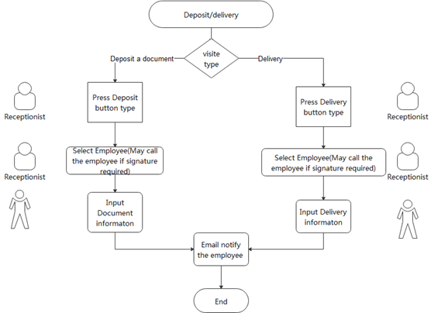

The flow for courier visit is as following:

1. Based on the visit type, the receptionist chooses “Deposit document” or “Delivery” button on APP.
2. The receptionist chooses the receiver of the deposit/delivery from employee list. If the reception requires employee to collect in person, the receptionist needs to call the employee.
3. Optionally, the visit can input information about deposit document or delivery. The information includes the delivery company, and the content type of the delivery.
4. APP will send email to notify the receiver there is a document or delivery waiting for his reception on the desk.

#### Check out flow

When visitor has finish his visit and prepare to leave the office, he can scan his QR code on his badge to check out.

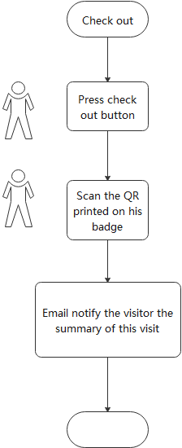

This flow can be handled either by receptionist or be visitor himself. After check out, the checkout time is recorded in the system.

The visitor can take his badge ,next time when he come back for a new appointment ,he can scan his badge to speed input his personal information.

For courier, there is no check out flow.

## Using the System

This chapter demonstrate detailed operation of Receptionist App in check in and check out flow at the front desk.

### Visiting reason selection

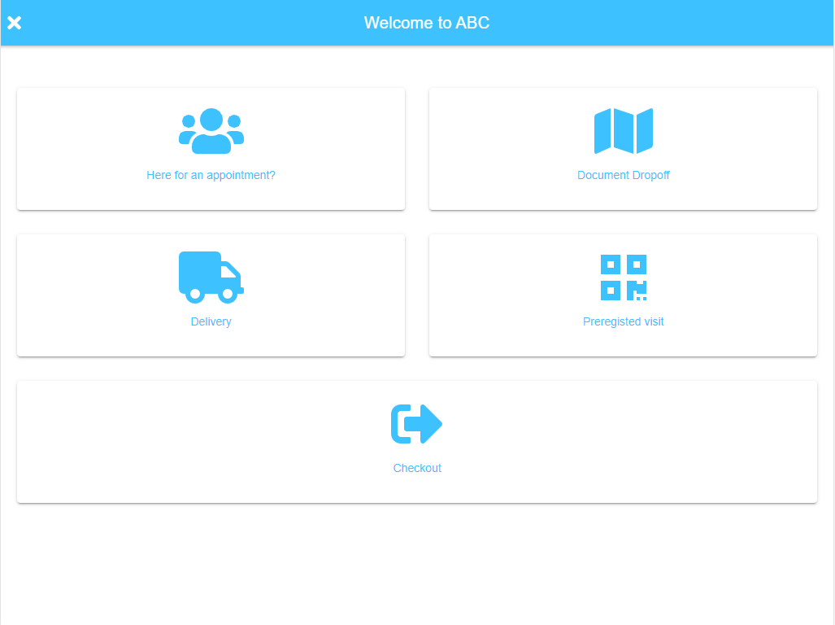

When a visitor comes to the front desk, the receptionist should ask the purpose of his visit. This is the first step to handle a visit. 4 types of visit reasons are listed here, and receptionist can choose one according to the purpose of the visit.

Table 2 - Record of Changes

|  |  |  |
| --- | --- | --- |
| **User Selection** | **Description** | **What’s next step** |
| Here for an appointment | The visitor has an appointment with someone in the company, and he is coming for it | Select contact |
| Document Deposit | The visitor is a carrier staff, he is here to deliver a document to someone in the company | Select contact |
| Delivery | The visitor is a carrier staff, he is here to deliver a package to someone in the company | Select contact |
| Preregistered visit | Someone in the company has pre-arranged a visit for the visitor. And visitor is here for this appointment | Scan QR code |
| Check out | The visitor has finished the visit and plan to check out from the company | Scan QR code |

#### After visit reason is chosen , depending on different reason, the application flow comes to next step.

### Visited contact selection

This step helps receptionist to get the visited person the visitor wants to see.

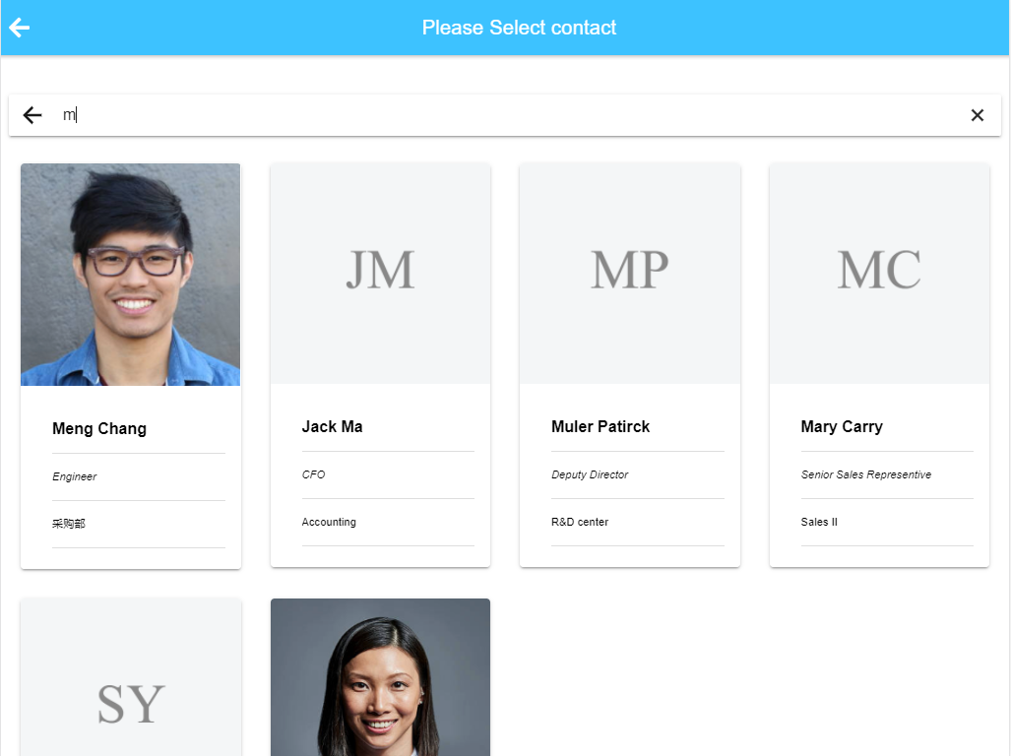

This page show cards of all staffs in the company, and each card show the photo, name, position and department information of the employee.

The receptionist can go through all members by scrolling down.

Receptionist is able to search employees by name. The whole name or part of name can be input into the search bar, and employees with matched name are present.

The receptionist chooses the person by touch on mobile pad or click on web page. After selection, a modal popup presents to ask receptionist to confirm the selection:

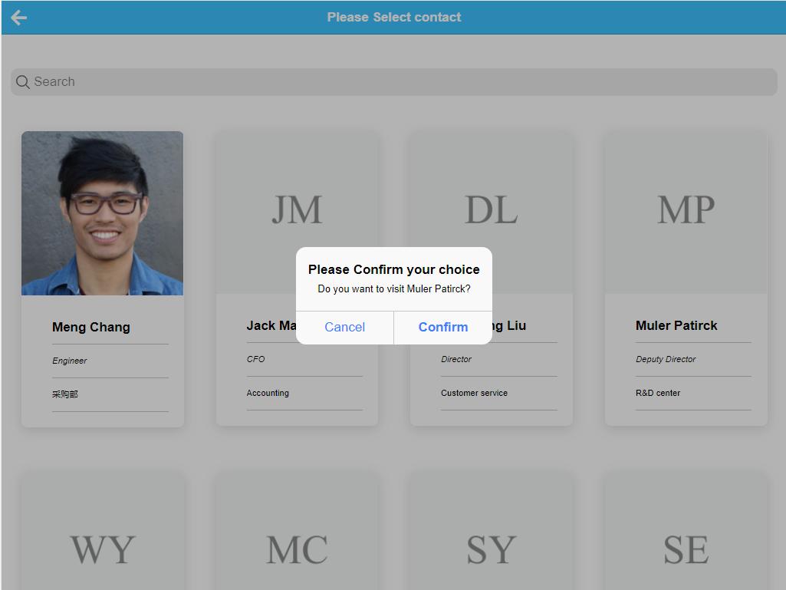

If the receptionist confirms the selection, then depending on the visiting reason, the flow goes to next step:

Table 2 - Record of Changes

|  |  |  |
| --- | --- | --- |
| **Visiting reason** | **Description** | **What’s next step** |
| Here for an appointment | The visitor has an appointment with someone in the company, and he is coming for it | Visitor information collection |
| Document Deposit | The visitor is a carrier staff, he is here to deliver a document to someone in the company | Register OK |
| Delivery | The visitor is a carrier staff, he is here to deliver a package to someone in the company | Register OK |

### Visitor information collection

This step will collect the contact information of the visitor. The name, company or organization name where the visitor is from, email address and phone number of the visitor are collected. Among these items, only user’s full name is mandatory. For the optional information, user can press ‘Next’ button to skip over.

Name collection:

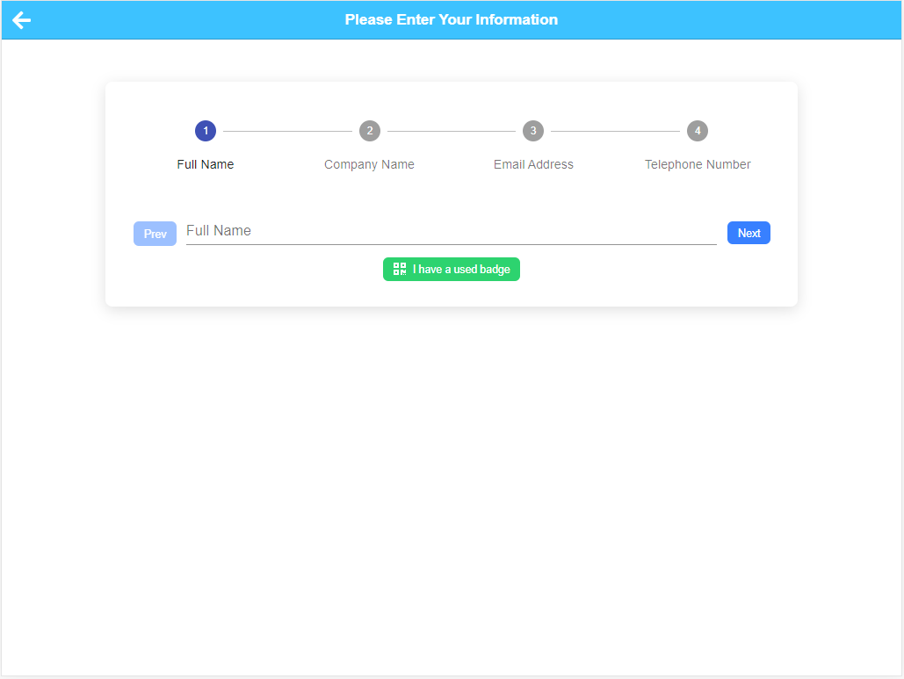

This step is mandatory, and user cannot skip over. If user press next, the input will trun to red color and warn this field is required :

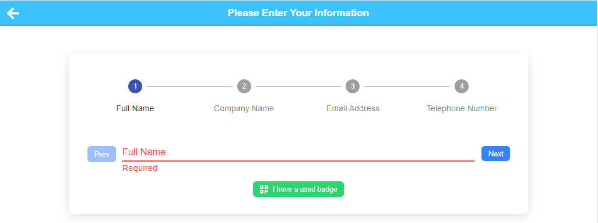

When visitor or receptionist has input full name of the visitor, press ‘Next’ button to input next information.

To enter company name:

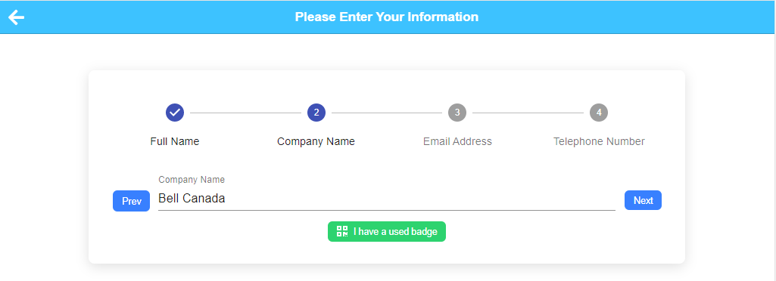

If user want to go back to previous input, he can press ‘Prev’ button to previous page to modify the input.

To enter email address:

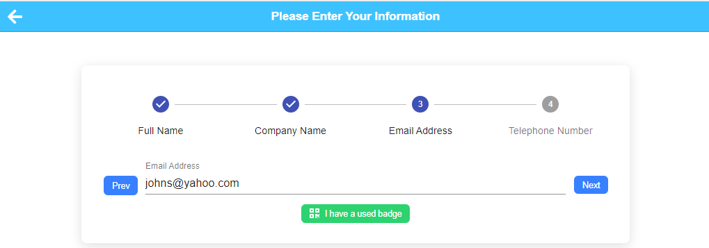

And telephone number of the visitor:

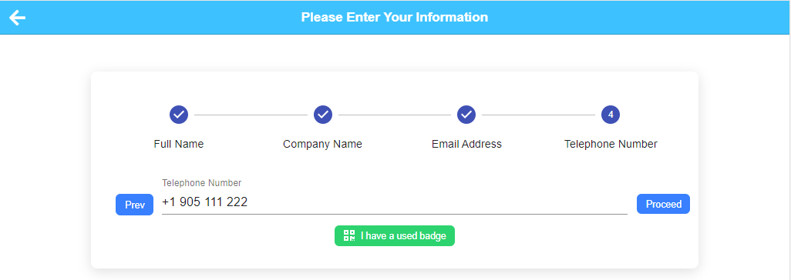

After all information has been inputted, user can press ‘Proceed’ button to next step.

‘I have a used badge’ is a feature to facilitate information input if visitor has a used badge of his previous visit, and on this badge a QR code is printed. In this situation, by pressing ‘‘I have a used badge’ button, the QR code will be scanned, and user information will be fetched from previous visit record.

### Sign the security terms and conditions

This step the visitor is required to read through security terms and conditions of the company for this visit. After finishing reading, the visitor is expected to sign his name to acknowledge his obedience to these terms.

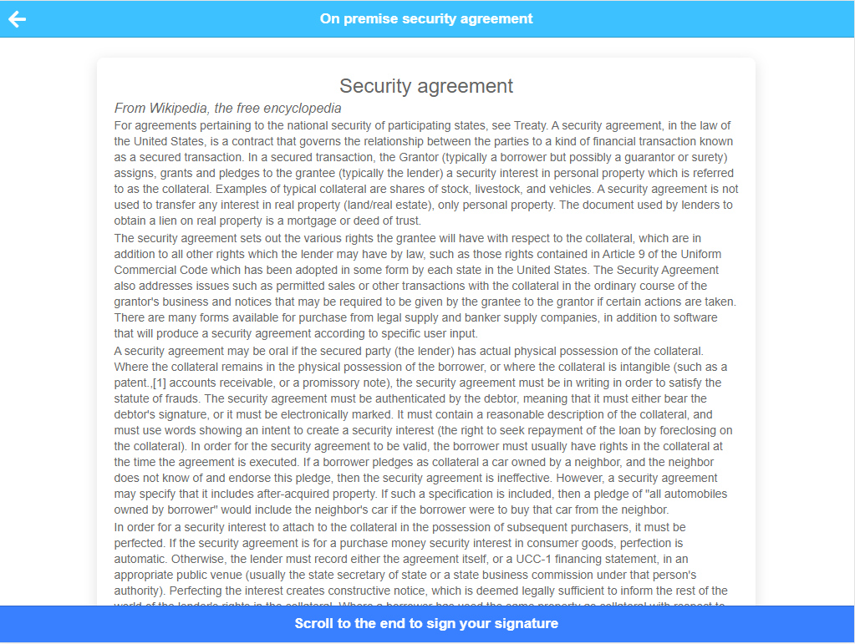

With reading the terms, the user scrolls to the end of the document to sign his name there.

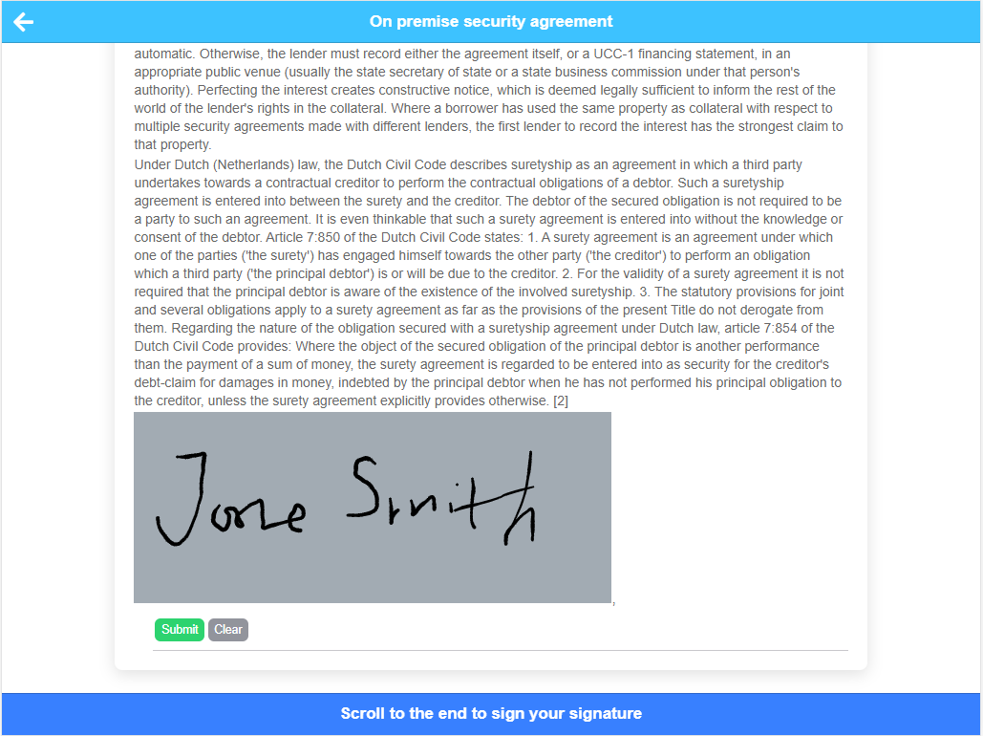

### Badge generation

When all information is collected and visitor sign the security terms and conditions, the check in flow is almost finished. A badge with a QR code on it is generated by App . This badge records the visit information like visitor name, visited employee name and check in time:

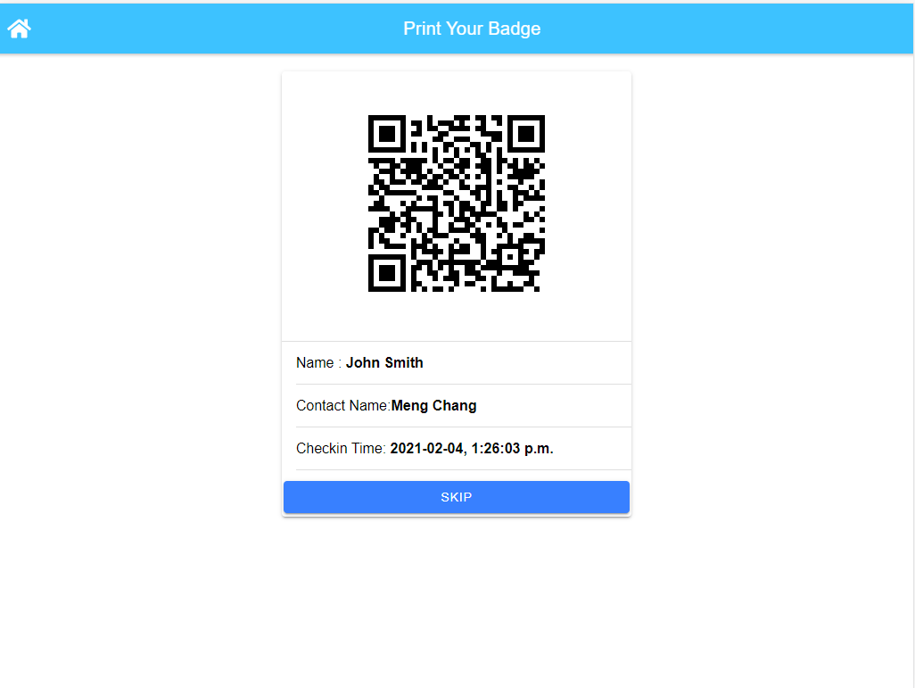

### Scan QR code

In Scan QR code page, user is expected to show a QR code either on his/her mobile phone or on a printed badge.

In this App, there are 3 scenarios use will step into Scan QR code page:

Table 2 - Record of Changes

|  |  |  |
| --- | --- | --- |
| Entry Point | Description | What’s next step |
| From visit reason selection page, user chooses preregistered visit | User has received an invitation email from contact in the company, and there is an QR code in this email, | If user has a valid QR code, then his personal information and contact information is automatically collected by system (from preregistered record). All this information is shown on the screen. After confirmation, the user is moving step to ‘Sign the security terms and conditions’ directly |
| From visit reason selection page, user chooses check out | After user has finished his visit and about to leave, he can scan his badge here to check out | After successful scan of user’s QR code, the visit information is displayed on the screen. Receptionist can confirm this information to check the user out. |
| User presses ‘I have a used badge’ from Visitor information collection step | If user has a used badge of last visit, he can scan this badge to collect his information from the visit record in the system. | User information is shown on the screen. After confirmation, user will move to ‘Sign the security terms and conditions’ directly |

### Delivery and deposit a document

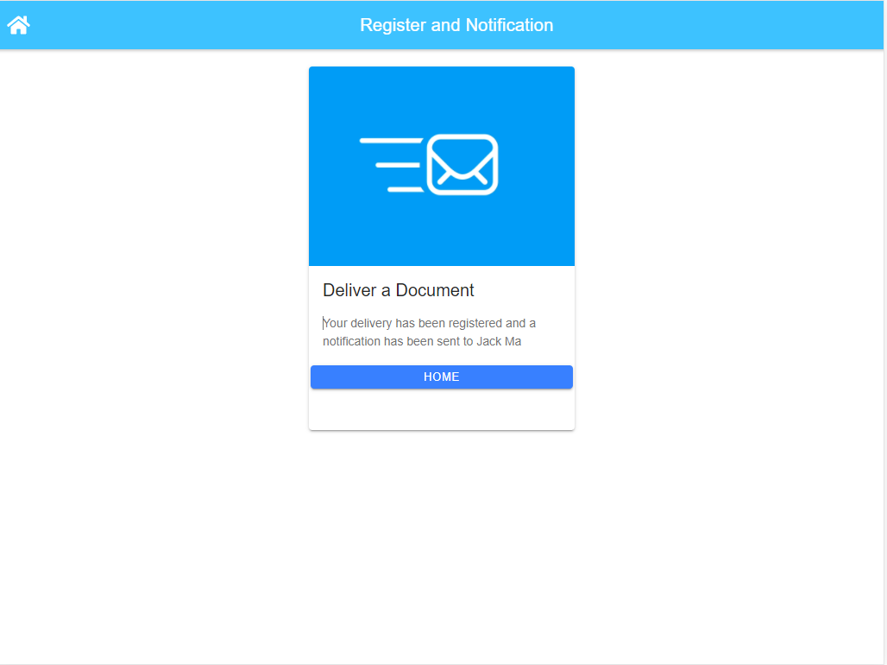

In delivery and deposit a document flow, normally the carrier staff leaves the package or document in the front desk, and receptionist needs to call the receiver to collect his articles.

And the carrier staff is not permitted to enter into office zone, so there is no need to collect contact information and signature of security terms and conditions.

After selecting contact, the flow will send a notification email to the receiver to tell him/her that he has an articles in the front desk to take. The receptionist presses ‘Home’ button or Home icon on the header, to go back to the first page to prepare greet next visitor.

Appendix A: Record of Changes

Table 2 - Record of Changes

| Version Number | Date | Author/Owner | Description of Change |
| --- | --- | --- | --- |
| 0.1 | 02/08/2021 | Meng Chang | Receptionist App User Manual |
|  |  |  |  |
|  |  |  |  |

Appendix B: Acronyms

ITable 3 - Acronyms

| Acronym | Literal Translation |
| --- | --- |
| <Acronym> | <Literal Translation> |
| <Acronym> | <Literal Translation> |
| <Acronym> | <Literal Translation> |

Appendix C: Glossary

Instructions: Provide clear and concise definitions for terms used in this document that may be unfamiliar to readers of the document. Terms are to be listed in alphabetical order.

Table 4 - Glossary

| Term | Acronym | Definition |
| --- | --- | --- |
| <Term> | <Acronym> | <Definition> |
| <Term> | <Acronym> | <Definition> |
| <Term> | <Acronym> | <Definition> |