**VE527 Computer-Aided Design of Integrated Circuits**

**Written Assignment Two Solution**

1. (12%) Quadratic Wirelength Calculation

Consider the following simple placement of 5 gates in a small 6x6 grid.

This is a 6x6 grid, with x and y from 0 to 5. There are five gates numbered 1 to 5, four nets labeled A, B, C and D.

The gates are placed as follows:
Gate 1: x=1, y=4
Gate 2: x=3, y=3
Gate 3: x=2, y=2
Gate 4: x=2, y=1
Gate 5: x=5, y=0

The connections are as follows:
Net A:  gates 1, 3, 4
Net B:  gates 2, 3
Net C:  gates 2, 5
Net D:  gates 3, 4, 5

Each gate is drawn as a circle with number (1–5). Assume the gate is located at the center of the grid cell, and its (X, Y) coordinates are taken from the column (X) and row (Y) coordinates in the figure. There are 4 nets, labeled A, B, C and D, connected as follows:

* Net A: gates 1, 3, 4
* Net B: gates 2, 3
* Net C: gates 2, 5
* Net D: gates 3, 4, 5

For this placement, what is its total quadratic wirelength?

**Solution**:

(3%) QWL(A) = 0.5(22+12) + 0.5(32+12) + 0.5(12+02) = 8

(2%) QWL(B) = 1(12+12) = 2

(2%) QWL(C) = 1(22+32) = 13

(3%) QWL(D) = 0.5(12+02) + 0.5(22+32) + 0.5(32+12) = 12

(2%) Total QWL = 8+2+13+12 = 35.

2. (24%) Quadratic Placement

Consider the following simple netlist of 4 gates and 3 pads, to be placed in a square that extends from X = 0 to 1, and Y = 0 to 1. Assume that these are the final 2-point nets to be used in a quadratic placement. All nets have weight 1.0, except the two nets highlighted in the diagram: the net from gates 3 to 4 and the net from gate 4 to the pad at (0.25, 1). Their weights are 10 and 20, respectively. To perform a quadratic placement, we solve two systems of linear equations and .

This figure shows a square where X=0 to 1 and Y=0 to 1. There are 4 gates and 3 pads.  The coordinates of the pads are (0, 0) and (0.25, 1) and (1, 1). All the nets are 2-point nets. The connections are as follows:

Gate 1 and Gate 2.
Gate 1 and Gate 3.
Gate 1 and Pad at (1, 1).
Gate 2 and Gate 3.
Gate 2 and Pad at (0, 0).
Gate 3 and Gate 4. The weight of this net is 10.
Gate 4 and Pad at (0.25, 1). The weight of this net is 20.

(a) (8%) Build the matrix $A$ using the recipe from the lecture.

(b) (8%) Build the vectors $b_{X}$ and $b_{Y}$ using the recipe from the lecture.

(c) (4%) Solve for the (X, Y) coordinates for gates 1, 2, 3, and 4. You can solve this any way you like (i.e., you can use your favorite solver).

(d) (4%) After the initial placement, now suppose we want to do recursive partitioning and we divide the chip in half **vertically**. We want to next formulate a new, smaller QP problem in the region left of the cutline. Which gates should be assigned to this left region? Which gates/pads should be propagated to the vertical cutline as pseudo-pads?

**Solution**:

(a) Connectivity matrix $C$ is

$$C=\left[\begin{matrix}\begin{matrix}0 & 1 \\ 1 & 0\end{matrix} & \begin{matrix}1 & 0 \\ 1 & 0\end{matrix} \\ \begin{matrix}1 & 1 \\ 0 & 0\end{matrix} & \begin{matrix}0 & 10 \\ 10 & 0\end{matrix}\end{matrix}\right]$$

Matrix $A$ is

$$A=\left[\begin{matrix}\begin{matrix}3 & -1 \\ -1 & 3\end{matrix} & \begin{matrix}-1 & 0 \\ -1 & 0\end{matrix} \\ \begin{matrix}-1 & -1 \\ 0 & 0\end{matrix} & \begin{matrix}12 & -10 \\ -10 & 30\end{matrix}\end{matrix}\right]$$

(b) Vector $b_{X}$ is

$$b_{X}=\left[\begin{matrix}\begin{matrix}1 \\ 0\end{matrix} \\ \begin{matrix}0 \\ 5\end{matrix}\end{matrix}\right]$$

Vector $b_{Y}$ is

$$b_{Y}=\left[\begin{matrix}\begin{matrix}1 \\ 0\end{matrix} \\ \begin{matrix}0 \\ 20\end{matrix}\end{matrix}\right]$$

(c) $\left(X,Y\right)=\left[\begin{matrix}\begin{matrix}0.5163 & 0.8424 \\ 0.2663 & 0.5924\end{matrix} \\ \begin{matrix}0.2826 & 0.9348 \\ 0.2609 & 0.9783\end{matrix}\end{matrix}\right]$

(d) Gates 2 and 4 should be assigned to the left region. Gates 1 and 3 should be propagated to the vertical cutline as pseudo-pads.

3. (6%) Maze Routing: Basics

Which of the following statements about maze routing are correct?

1. Maze routing can only handle a maximum of two routing layers.
2. Maze routing routes a set of nets simultaneously.
3. To efficiently find a minimum-cost item from the wavefront, we can use a data structure such as a min heap.
4. If we add to the cost function a predictor that is a lower bound on the actual extra pathcost to the target, then maze routing will still find the minimum cost path. This kind of search is called A* search.

**Solution**:

c and d.

4. (12%) Basic 2-point net routing in 1 layer

Consider the simple 6x6 routing grid shown below. We label a source S cell, a target T cell, and several obstacle cells in black. All white cells have unit cost. Use the simple unit-cost maze routing expansion method, and perform wavefront expansion by hand on the grid, to find a route from S to T. Mark the route you obtain. What is the pathcost of this route?

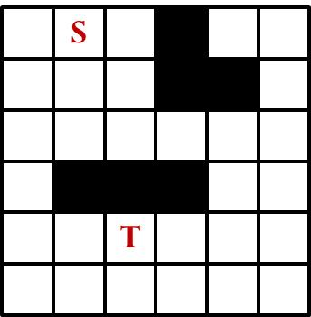

**Solution**:

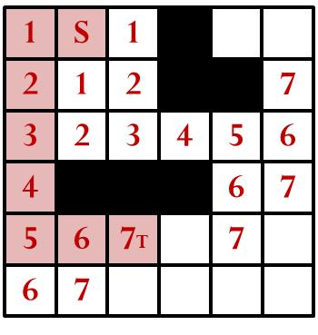

The pathcost of the route is 7.

5. (20%) Multi-point net routing in 1 layer

Consider the simple 6x6 routing grid shown below. We label one source cell S, two target cells T, and several obstacle cells in black. All white cells have unit cost. Use the simple unit-cost maze routing expansion method and the technique for completing multi-point nets, and perform wavefront expansion by hand on the grid, to find a route for this 3-point net. Mark the route you obtain. What is the total pathcost of this route?

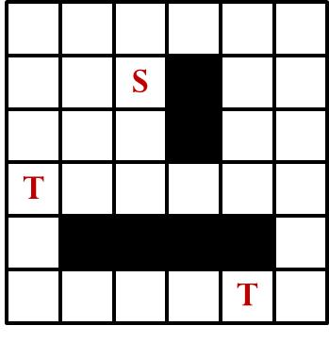

**Solution**:

Expand and reach the first target:

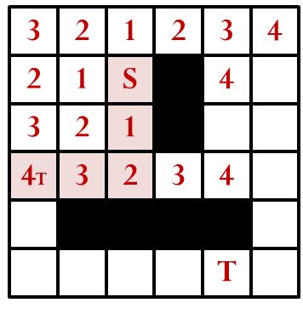

Treat all the cells on the path to the first target as source “S”. Expand and reach the second target

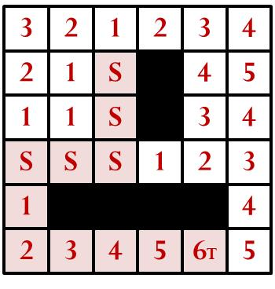

Pathcost of the route is 4+6=10.

6. (10%) Routing with non-unit costs in 1 layer

Consider the simple 6x6 routing grid shown below. We label one source S, one target T, and several non-unit-cost cells in pink with **integer** cost K. All white cells have unit cost. Assume your router uses the cheapest-cell-first maze routing expansion algorithm. Suppose that your router finally returns a path that **avoids** all non-unit-cost cells. In this case, K must be large enough so that the path through the unit-cost cells will be cheaper than the path through the non-unit-cost cells. Then, what is the minimum value of K?

The pictures shows a routing grid of size 6x6, where X, Y are from 0 to 5.
The following cells have costs K:

1 2, 2 2, 3 2, 4 2, 5 2,
1 3, 2 3, 3 3, 4 3, 5 3.

Source is at 5 5, target is at 5 0.

**Solution**:

Since 15 < 3+2K, we have K > 6. The minimum value of K is 7.

7. (16%) Cheapest-cell-first expansion

Consider the simple 6x6 routing grid shown below. We label one source S and one target T. The white cells have cost 1, the green cells have cost 2, and the pink cells have cost 3. Apply the cheapest-cell-first maze routing expansion algorithm to find a route from S to T. Mark the route you have found. What is its pathcost?

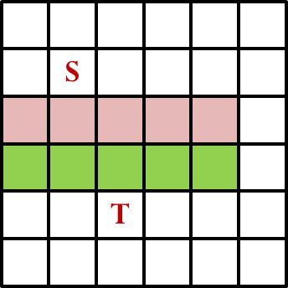

**Solution**:

Do the cheapest-cell-first expansion, we get the cost as follows

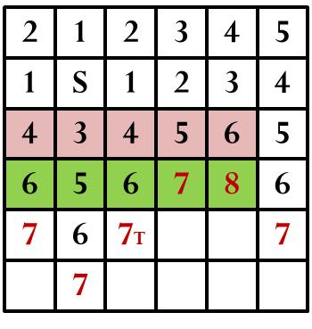

A route is shown below, with pathcost as 7.

