**VE527 Computer-Aided Design of Integrated Circuits**

**Written Assignment Three Solution**

1. (8%) Static Timing Analysis: Basics

Which of the following statements about static timing analysis are correct?

1. All nodes on the longest delay path from source to sink will have the same worst case slack value.
2. To find the worst paths in decreasing delay order, we can use an algorithm that is similar to maze routing by storing the partial paths in a heap, where the item with most positive slack is always on top.
3. To find the longest path, we can simply enumerate ALL the source-to-sink paths in the delay graph. This is efficient enough since the paths will not be too many.
4. A positive slack at a node means the node does not meet timing requirement, so it is always bad to see positive slack.
5. Negative slack is always bad and indicates a timing problem.
6. We may get a false longest path in static timing analysis because we ignore the logic of the circuit.

**Solution**:

a, e, f

2. (45%) Static Timing Analysis

Consider the small logic network shown below. There are 6 primary inputs (PIs) labeled A, B, C, D, E, F. There is 1 primary output (PO) Z. There are 11 logic gates. There are 10 internal wires that represent gate outputs/inputs, labeled: w1, w2, ..., w10. The gate delay for each inverter is 2. The gate delay for each NAND2 is 3. Ignore delay for the wires. This logic operates on a clock with a cycle time = 15.

The picture have 11 gates labeled 1 to 11, primary inputs A to F, and a primary output Z. The connections are as follows:

Gate 1 is a NOT gate with input connected to primary input C.
Gate 2 is a NOT gate with input connected to primary input D.
Gate 3 is a NAND gate with inputs connected to output of Gate 1 and 2. 
Gate 4 is a NAND gate with inputs connected to primary inputs A and B.
Gate 5 is a NOT gate with input connected to Gate 3 and primary input E.
Gate 6 is a NOT gate with input connected to primary input F.
Gate 7 is a NAND gate with inputs connected to Gate 3 and 4.
Gate 8 is a NAND gate with inputs connected to Gate 5 and 6. 
Gate 9 is a NAND gate with inputs connected to Gate 3 and 4.
Gate 10 is a NAND gate with inputs connected to Gate 7 and 8.
Gate 11 is a NAND gate with inputs connected to Gate 9 and 10. The output is primary output Z.

The output  wire of Gate i is labeled as wi, i ranges from 1 to 10. For example, the output wire of Gate 4 is w4.


Draw the Delay Graph for this logic network, including one source and one sink node, and appropriate edges representing all the delays. Then, calculate the arrival time (AT), the required arrival time (RAT), and the slack for each node in the graph. Is there a timing violation? Report a longest path in the graph.

**Solution**:



Delay graph (15%), AT (8%), RAT (8%), Slack (8%)

(2%) Yes, there is a timing violation.

(4%) A longest path: src-C-w1-w3-w5-w8-w10-w11-snk.

Worst path reporting:

Initial: (src, 0, -2)

Expand path src: (src-c, 0, -2) (src-d, 0, -2) (src-a, 0, 3) (src-b, 0, 3) (src-e, 0, 3) (src-f, 0, 4)

Expand path src-c: (src-c-w1, 2, -2) (src-d, 0, -2) (src-a, 0, 3) (src-b, 0, 3) (src-e, 0, 3) (src-f, 0, 4)

Expand path src-c-w1: …

3. (4%) Elmore Delay Analysis: Basics

Which of the following statements about Elmore delay analysis are correct?

1. According to Elmore delay, the delay between the root node and a leaf node in an RC tree equals to the root node resistance times the downstream capacitance.
2. Elmore delay is the most precise and accurate measure of the electrical delay through an RC network. Thus it is very popular.
3. The capacitance of a metal wire is proportional to its width and its length.
4. The resistance of a metal wire segment is proportional to its width and inversely proportional to its length.
5. In a multi-point net, the Elmore delay from the root to each leaf is the same.

**Solution:**

c).

4. (43%) Elmore Delay Calculation

Consider a chip-level long interconnect wire shown in the figure below. The wire is a 4-point net: gate *a* drives the net; gates *b*, *c*, and *d* are driven by the net. The wire decomposes into 6 separate metal segments, with 3 internal nodes labeled 1, 2, and 3 in the figure. The length of each wire is labeled next to each wire.



The table below further gives the detailed dimension of each wire segment (including the width).

|  |  |  |
| --- | --- | --- |
| Segment | Length L | Width W |
| a-1 | 1200 | 1 |
| 1-b | 800 | 0.5 |
| 1-2 | 1600 | 1 |
| 2-3 | 600 | 0.5 |
| 3-c | 600 | 0.5 |
| 3-d | 1000 | 0.5 |

We further assume the following electrical parameters:

* Resistance of driver gate *a*: 500
* Capacitance of the driven gates *b*, *c*, *d*: $1×{10}^{-7}$
* Resistance constant $r=\frac{ρ}{H}=0.5$
* Capacitance constant $c=\frac{ε}{d}=1×{10}^{-9}$

Don't worry about the units. Do the following:

(a) (25%) Draw the RC tree model for this wire, including the effect from driver and driven gates.

(b) (18%) Calculate the Elmore delay from the driver to each of the driven gates, i.e., the delay from *a* to *b*, the delay from *a* to *c*, and the delay from *a* to *d*.

**Solution**:

(a)

$$R_{a1}=600, R_{1b}=800, R_{12}=800, R_{23}=600, R_{3c}=600, R_{3d}=1000$$

$$C_{a1}=1200e-9, C_{1b}=400e-9, C_{12}=1600e-9, C_{23}=300e-9, C_{3c}=300e-9,$$

$$C_{3d}=500e-9$$

The RC tree is shown below

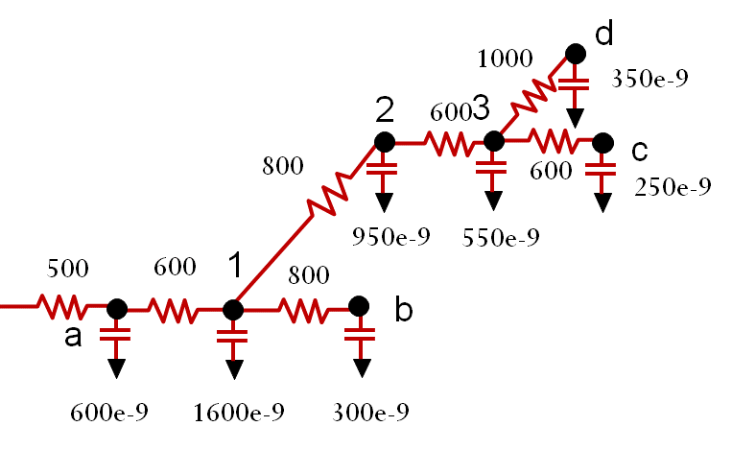

(b) $D_{ab}=\left[500×\left(600+1600+300+950+550+350+250\right)+600×\left(1600+300+950+550+350+250\right)+800×300\right]×{10}^{-9}=\left[500×4600+600×4000+800×300\right]×{10}^{-9}=4.94×{10}^{-3}$

$$D_{ac}=\left[500×\left(600+1600+300+950+550+350+250\right)+600×\left(1600+300+950+550+350+250\right)+800×\left(950+550+350+250\right)+600×\left(550+350+250\right)+600×250\right]×{10}^{-9}=7.22×{10}^{-3}$$

$$D_{ad}=\left[500×\left(600+1600+300+950+550+350+250\right)+600×\left(1600+300+950+550+350+250\right)+800×\left(950+550+350+250\right)+600×\left(550+350+250\right)+1000×350\right]×{10}^{-9}=7.42×{10}^{-3}$$