## 1: ez_setup---可要可不要

Download ez_setup.py from <https://pypi.python.org/pypi/setuptools>

python ez_setup.py #ez_setup install

## 2: pip install

Download get-pip.py from <https://raw.github.com/pypa/pip/master/contrib/get-pip.py>

Python get-pip.py #pip install

## 3: pyreadline install------ipython自动补全软件。

pip install pyreadline, 一定要先安装这个，然后再安装ipython，否则ipython无法执行。

## 4: ipython install

Download ipython from <http://archive.ipython.org/release/2.3.1/ipython-2.3.1.zip>

Python setupegg.py install #ipython install

Or just use command pip install ipython to install ipython

## 5: pywin32 install----for win32com to use excel

To download pywin32, please select the "View All Downloads" button, then select the installer executable for your system. Note that there is one download package for each supported version of Python - please check what version of Python you have installed and download the corresponding package.

<https://sourceforge.net/projects/pywin32/files/?source=navbar>

## 5: set 环境变量

设置ipython的环境变量，ipython的可执行文件在C:\Python27\Scripts中；如下图所示。

[[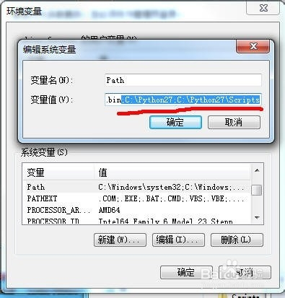](http://jingyan.baidu.com/album/8cdccae9698758315413cdfe.html?picindex=6)](http://jingyan.baidu.com/album/8cdccae9698758315413cdfe.html?picindex=6)