1: leave out not used variables.

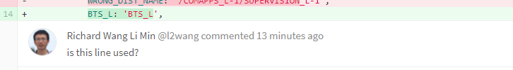

2: camel case in js and kebab case in html

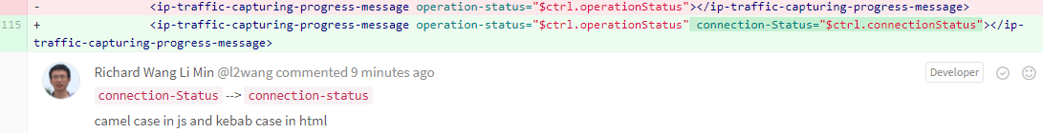

3: line is too long, wrap return to new line

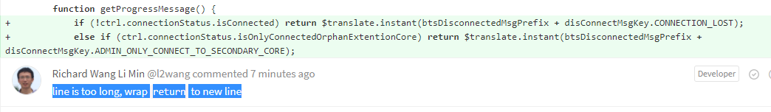

4: no any logic method in html