Visium V1 Spatial Transcriptomics Analysis Report

1. Project Overview
This report summarizes the analysis of 10x Genomics Visium V1 spatial transcriptomic data comparing control diet (CD_PBS), high-fat diet (HFD_PBS), and TZP-treated high-fat diet (HFD_TZP) rat intestine. The main objective was to determine how TZP modulates lipid metabolism and structural integrity in the intestine, particularly in epithelial cells and smooth muscle cells (SMCs).

2. Data Processing and Integration
Spatial expression data were processed from SpaceRanger outputs using Seurat v5 in R 4.5.1. Each dataset underwent SCTransform normalization (glmGamPoi method), followed by filtering for high-quality spots (nFeature_Spatial > 200, percent.mt < 20). Datasets were integrated using SCT-based anchors and reduced via PCA and UMAP, yielding nine clusters across 3967 total spots.

3. Cell Type Identification
Cell clusters were annotated using marker genes. Epithelial cells expressed Vil1, Alpi, Apoa1, and Apoa4, while smooth muscle cells (SMCs) showed high Acta2 expression. Non-specific clusters were grouped as 'Other'.
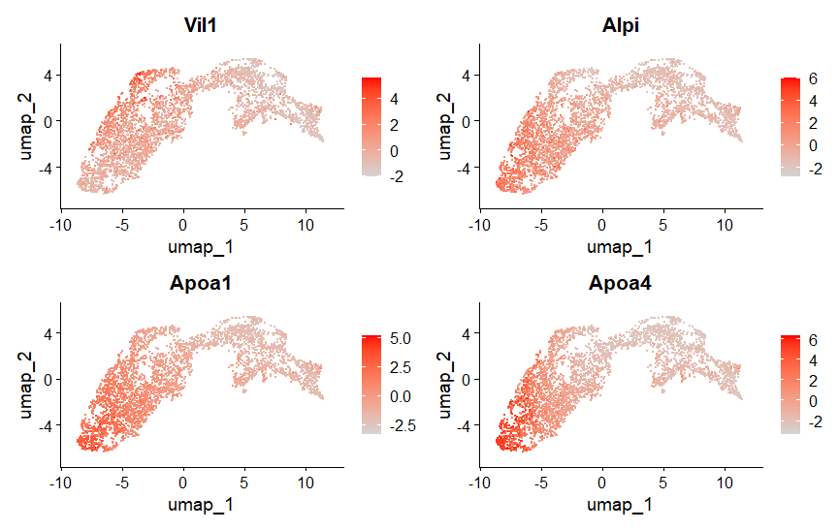
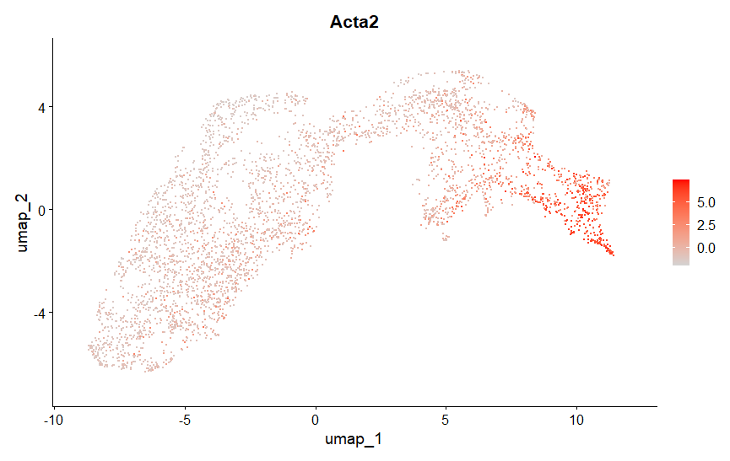

4. Differential Gene Expression Analysis
Using the Wilcoxon test, DEGs were identified between conditions. Epithelial cells showed 765 upregulated and 321 downregulated genes (HFD_PBS vs CD_PBS), and 344 upregulated with 947 downregulated (HFD_TZP vs HFD_PBS). For SMCs, 71 genes were upregulated and 26 downregulated (HFD_PBS vs CD_PBS), and 206 upregulated with 439 downregulated (HFD_TZP vs HFD_PBS). TZP therefore induced a broad gene expression reprogramming toward metabolic and structural recovery.

5. GO Enrichment Results
GO enrichment analysis (org.Rn.eg.db, clusterProfiler) identified distinct biological responses. Epithelial DEGs under TZP were enriched for ribosome biogenesis, RNA processing, and mRNA splicing—signifying enhanced biosynthesis and recovery. SMCs showed enrichment in extracellular matrix organization, angiogenesis, and adhesion pathways—indicating structural and vascular repair.
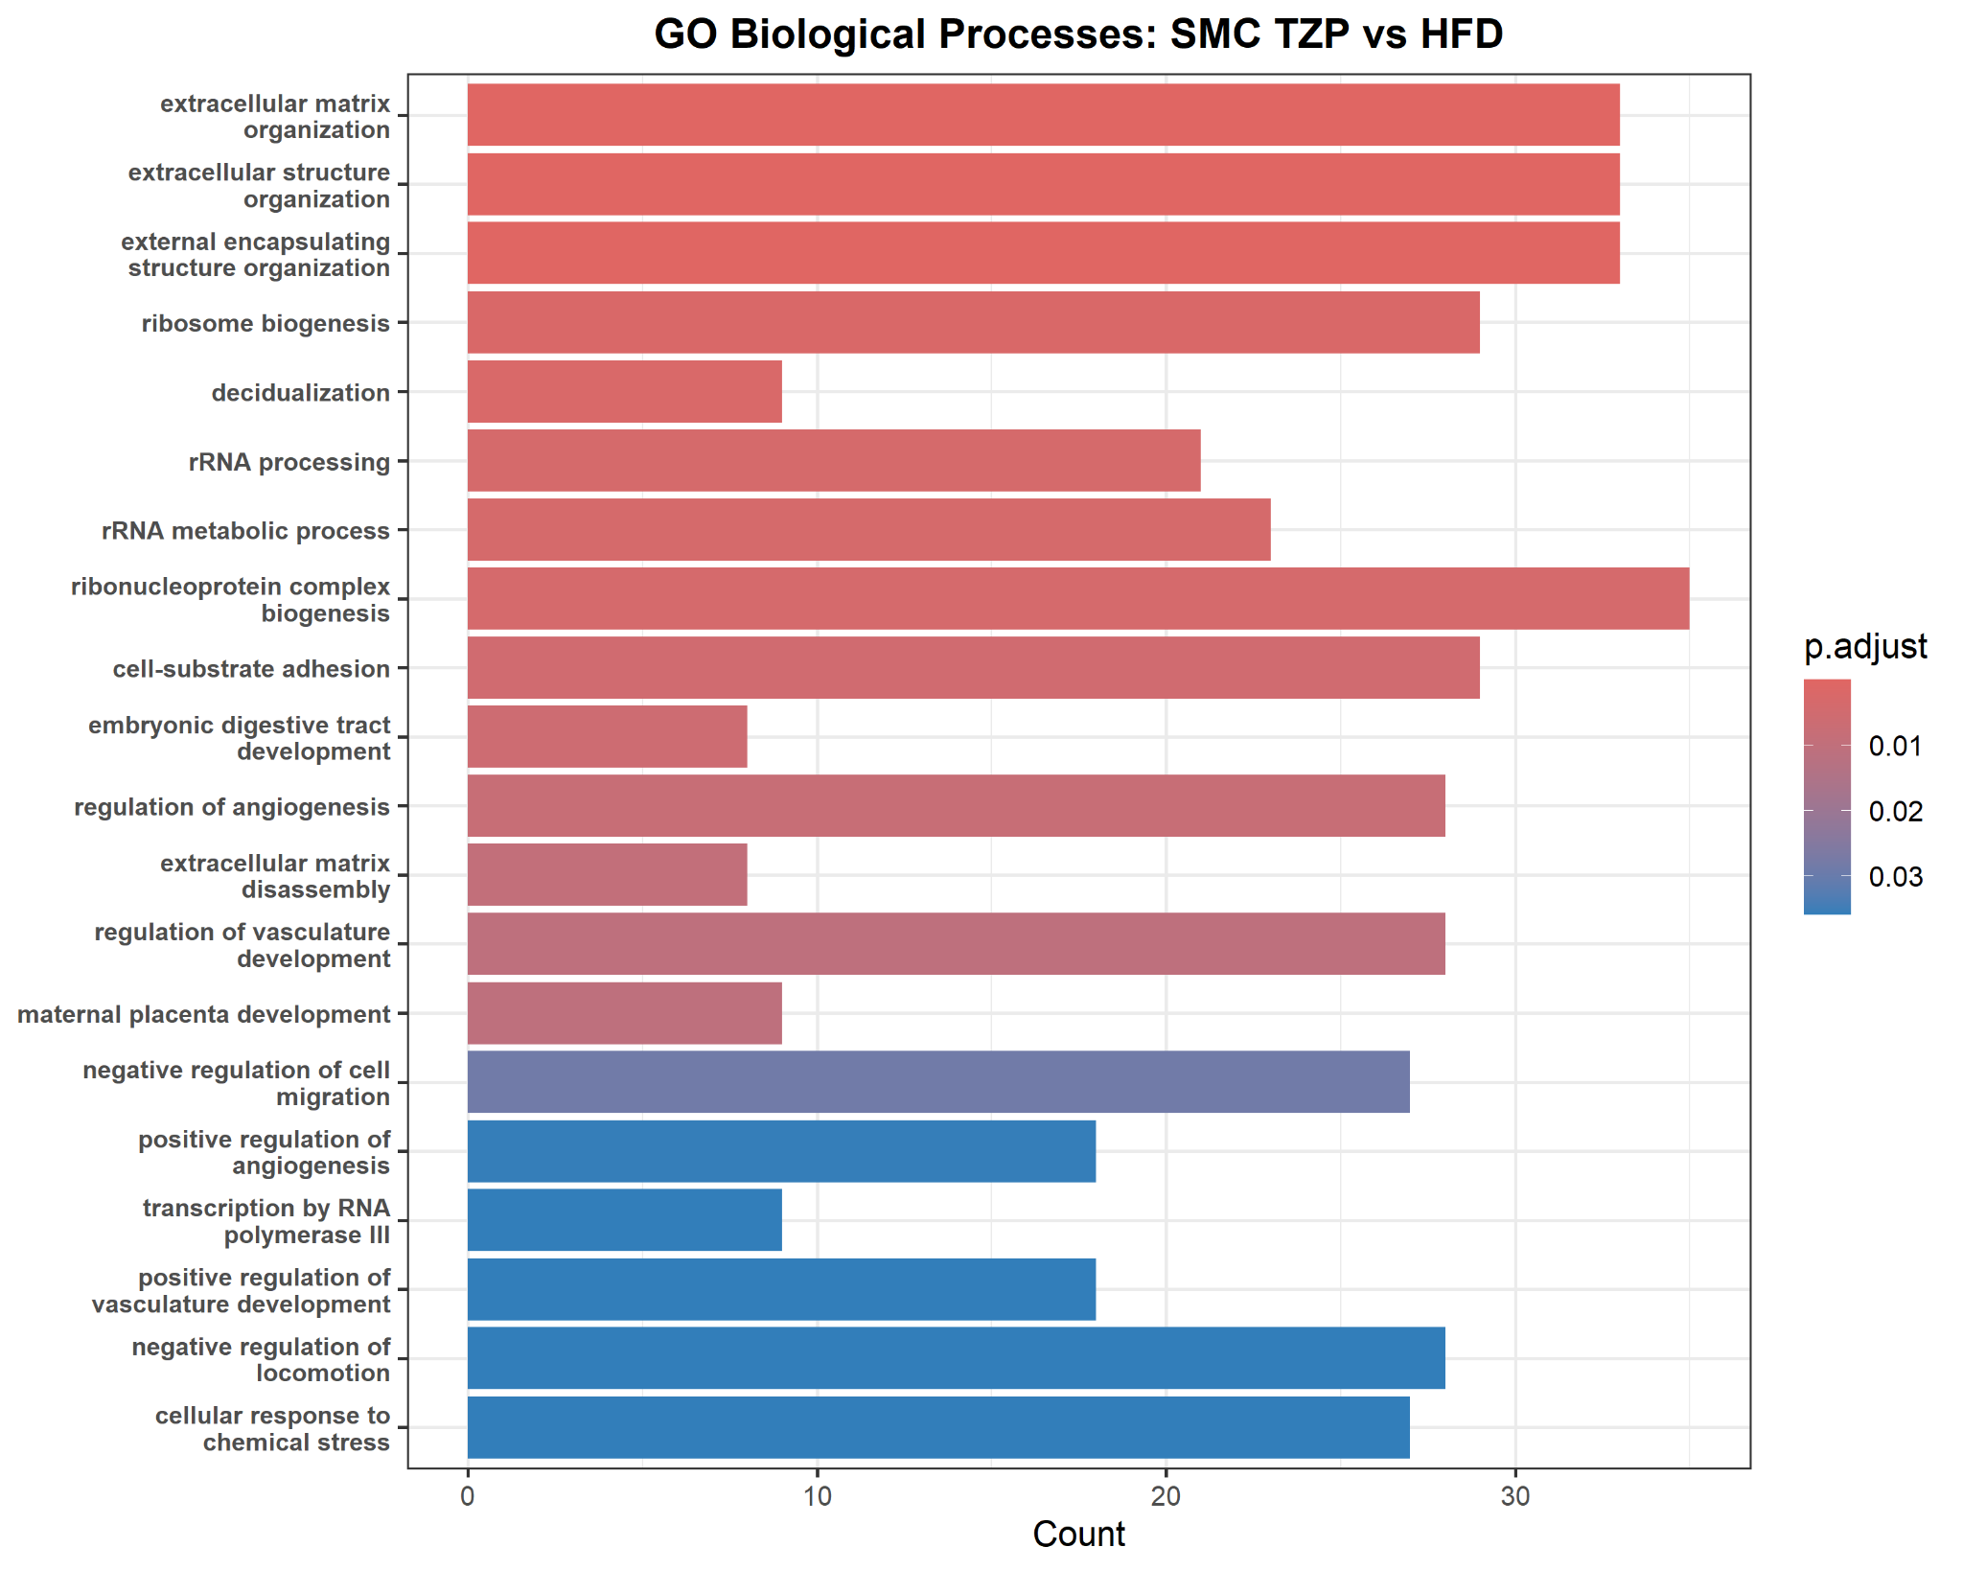
Figure 1. GO Biological Processes enriched in SMCs (TZP vs HFD).

6. Comparative GO Summary
A combined GO analysis demonstrated that TZP exerts complementary effects: epithelial cells activated translational and metabolic pathways, while SMCs promoted extracellular and structural remodeling. These distinct responses underline TZP’s dual action—metabolic recovery and structural stabilization.
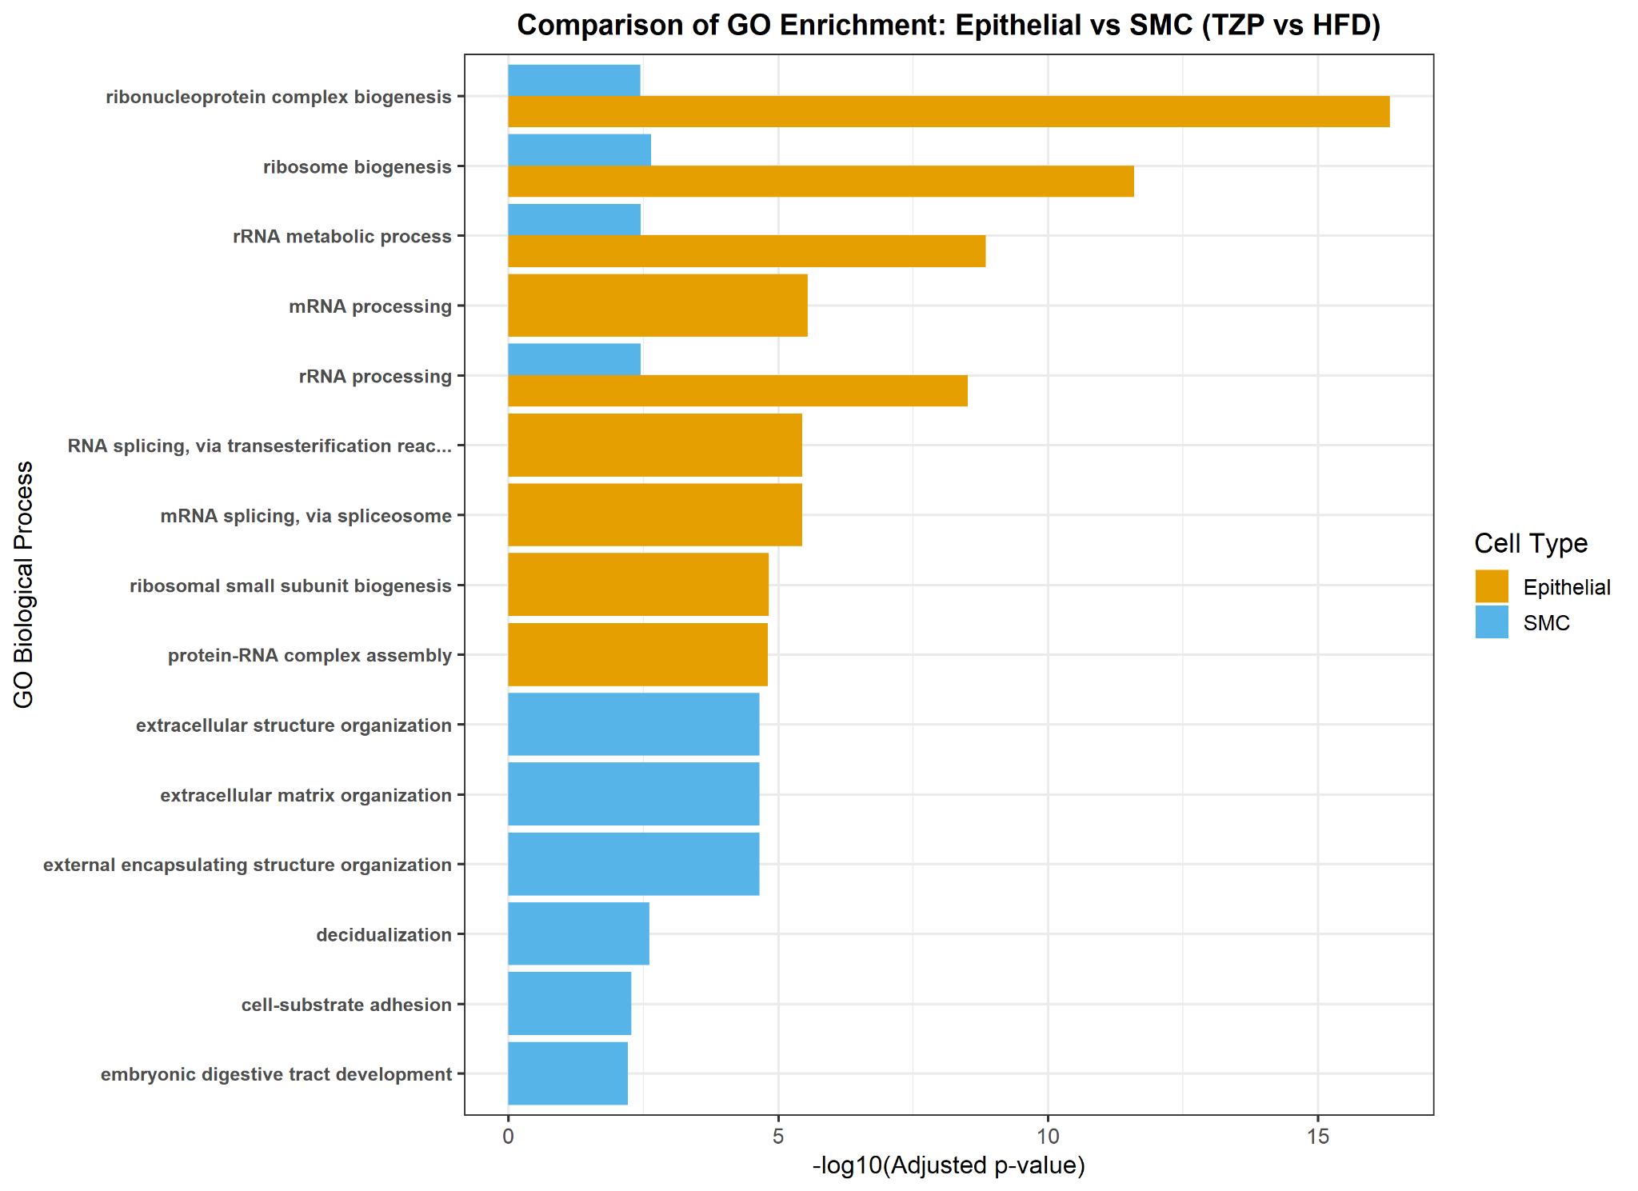

7. Key Differentially Expressed Genes
- Epithelial (TZP vs HFD): Gnpat, Wdr43, B3gnt4, LOC100911055, Sdr39u1, Mthfd2, Clns1a, Scg2, Rcn3, Cdh11.
- SMC (TZP vs HFD): Adamts1, Hdgfl3, Foxf2, Ldhb, Itga5, F3, Pf4, Otud1, P2ry10, Zeb2.

8. Conclusion
TZP treatment partially reverses HFD-induced transcriptional impairments. It boosts ribosomal biogenesis and mRNA processing in epithelial cells, reflecting enhanced protein synthesis and metabolic recovery. In SMCs, TZP promotes extracellular matrix remodeling and vascular organization, supporting tissue integrity and function. These findings collectively indicate that TZP improves both metabolic and structural homeostasis in intestinal tissues.

