CMS Analytics Studio
User Guide

Instagram, Facebook, YouTube and LinkedIn analytics, cross-platform publishing and Instagram auto-replies in one place.
Web address: https://cms.changtechs.com
How to read this guide
Every screenshot has red numbered labels. The table under each screenshot explains what each number is and what to do with it. "Figure 7, label 6" means label number 6 in Figure 7.
A product of changtechs.com · Version 1.0 · November 2026

Contents

1. Signing in
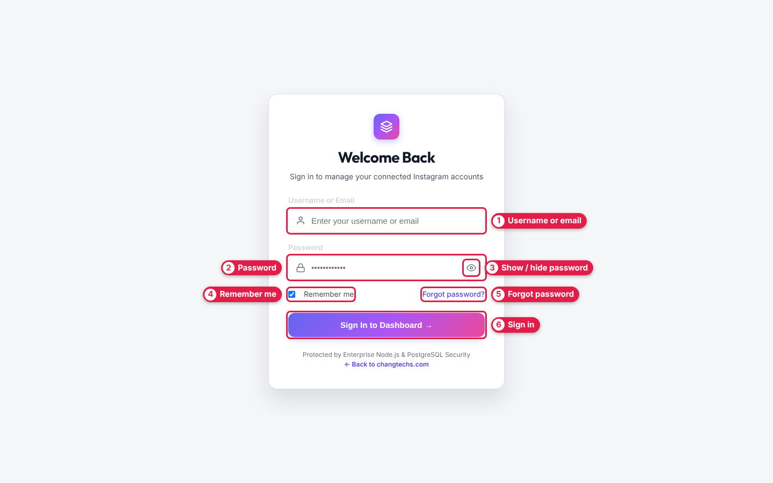
Figure 1 — Sign in page
# | Label | What to do
1 | Username or email | Type your username (e.g. chang) or your email address.
2 | Password | Type your password.
3 | Show / hide password | Click the eye to check what you typed.
4 | Remember me | Keep it ticked to stay signed in on this browser.
5 | Forgot password | Passwords are reset by your administrator — contact them.
6 | Sign in | Click to open the dashboard. You land on Overview (Figure 4).

2. Finding your way around

Top menu bar
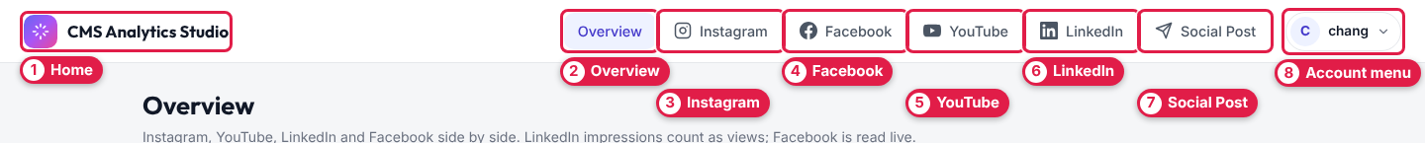
Figure 2 — Top menu bar (visible on every page)
# | Label | Opens
1 | Home | Goes back to Overview.
2 | Overview | All accounts side by side — section 3.
3 | Instagram | Instagram analytics — section 5.
4 | Facebook | Facebook Page analytics — section 6.
5 | YouTube | YouTube channel analytics — section 7.
6 | LinkedIn | LinkedIn company page analytics — section 8.
7 | Social Post | Write and publish a post — section 9.
8 | Account menu | Opens the menu in Figure 3.

On a phone, tap the ☰ icon to open this menu.

Account menu
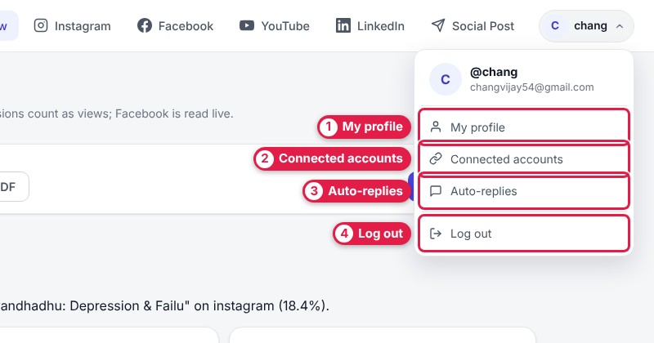
Figure 3 — Account menu (click your name, Figure 2, label 8)
# | Label | Opens
1 | My profile | Your details — section 12.
2 | Connected accounts | Add or fix social accounts — section 11.
3 | Auto-replies | Instagram keyword replies — section 10.
4 | Log out | Signs you out of this browser.

3. Overview — all platforms at once

Controls and totals
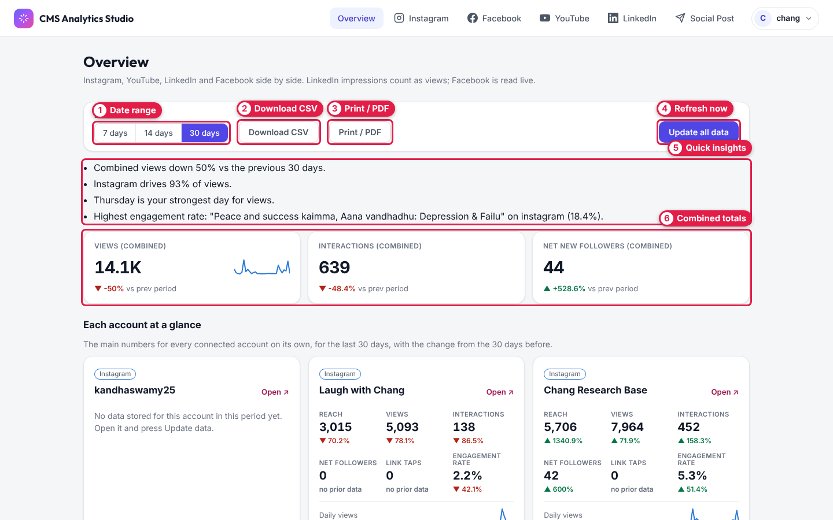
Figure 4 — Overview page, top
# | Label | What it does
1 | Date range | Choose 7, 14 or 30 days. Every number is compared with the same number of days just before.
2 | Download CSV | Downloads the numbers as a spreadsheet (opens in Excel / Google Sheets).
3 | Print / PDF | Print the page, or choose "Save as PDF" in the print window.
4 | Refresh now (Update all data) | Fetches the latest numbers from every platform immediately.
5 | Quick insights | Plain sentences such as "Instagram drives 93% of views".
6 | Combined totals | Views, interactions and new followers across all platforms. ▲ green = up, ▼ red = down vs the previous period.

Each account at a glance
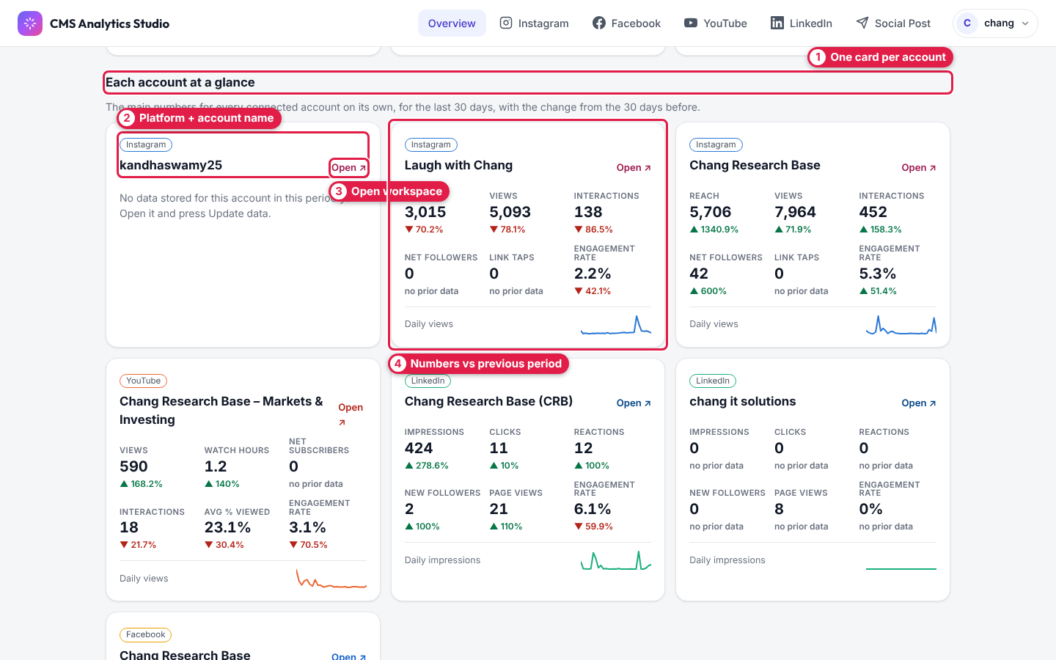
Figure 5 — One card per connected account
# | Label | What it means
1 | One card per account | Every connected Instagram, YouTube, LinkedIn and Facebook account gets a card.
2 | Platform + account name | Which platform and which account the card is for.
3 | Open workspace | Click Open ↗ to see that account in detail (Figure 7).
4 | Numbers vs previous period | Key numbers with % change. If the card says "No data stored…", open it and press Update data.

Charts and best content
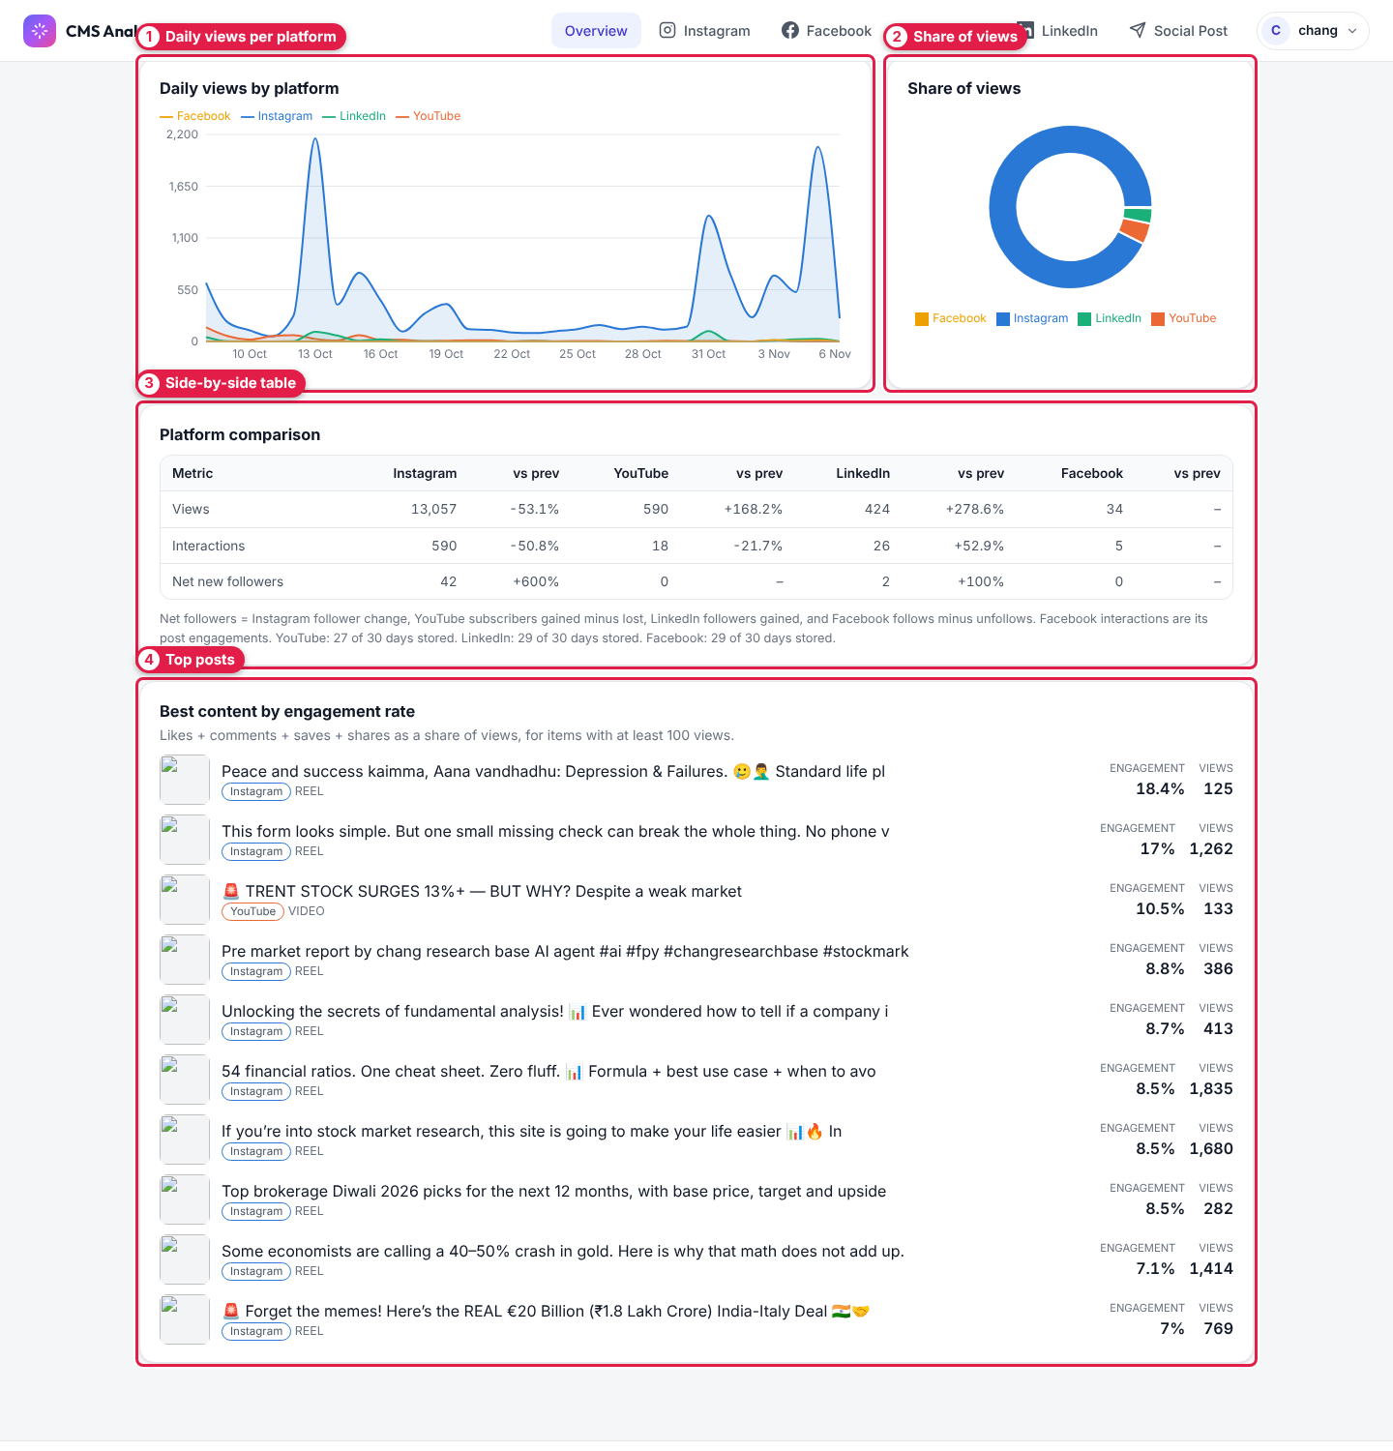
Figure 6 — Overview page, lower half
# | Label | What it shows
1 | Daily views per platform | Line chart of daily views, one colour per platform.
2 | Share of views | Which platform brings most of your views.
3 | Side-by-side table | Views, interactions and new followers per platform, with % change.
4 | Top posts | Your best posts/videos by engagement rate (only items with 100+ views).

LinkedIn impressions count as views here. Facebook numbers are read live.

4. Platform workspace basics
Instagram, Facebook, YouTube and LinkedIn pages all share the same layout.
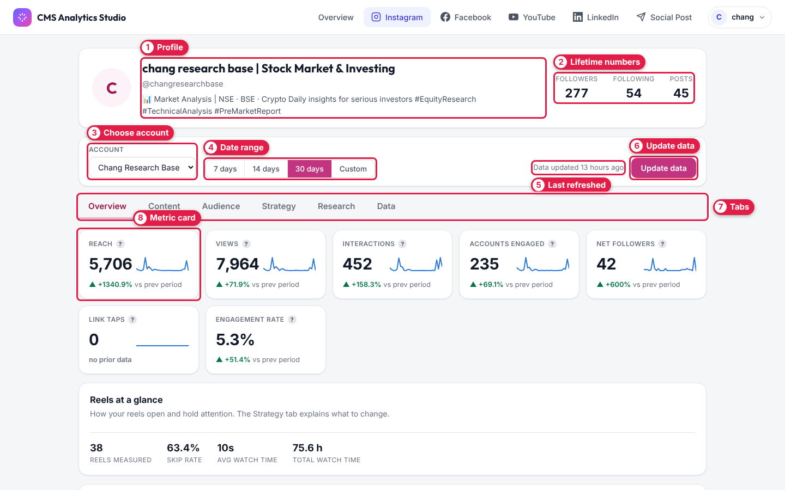
Figure 7 — Platform workspace (Instagram shown)
# | Label | What to do
1 | Profile | Account name, handle and bio.
2 | Lifetime numbers | Followers, following and posts right now.
3 | Choose account | If you have several accounts on this platform, pick one here.
4 | Date range | 7 / 14 / 30 days, or Custom for exact dates (custom ranges load live and can be slower).
5 | Last refreshed | When the numbers were last updated.
6 | Update data | Click to refresh now (takes a few seconds).
7 | Tabs | Overview, Content, Audience, Strategy, Research, Data (each explained below).
8 | Metric card | Big number = total for the period; ▲/▼ = change vs previous period; small line = daily trend. Hover the ? for an explanation. "no prior data" = nothing to compare yet.

The Overview tab also has Reels at a glance, Stories at a glance, What your data says (plain language takeaways) and More numbers.

5. Instagram

Content tab
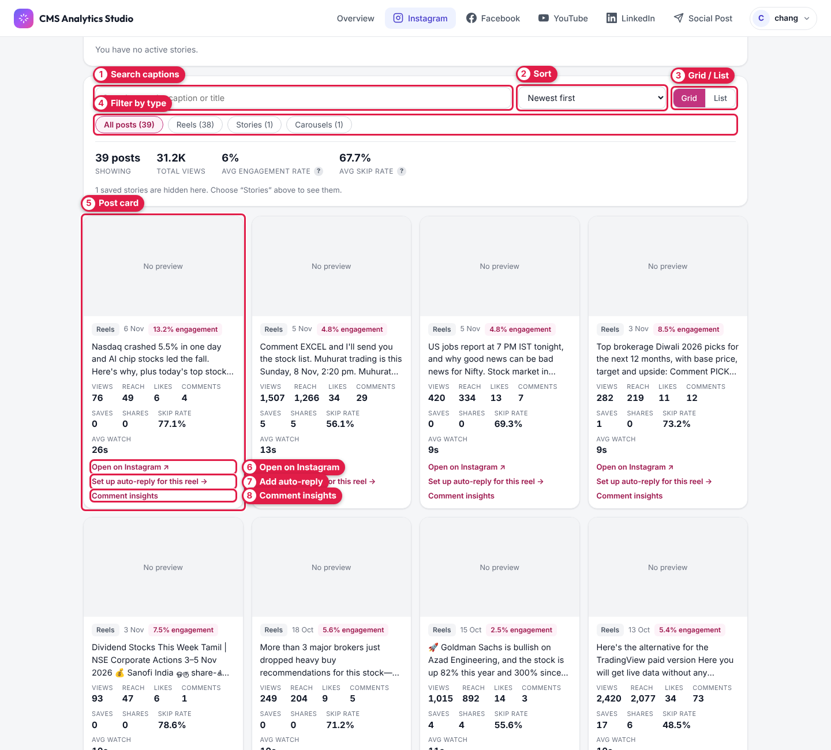
Figure 8 — Instagram → Content
# | Label | What to do
1 | Search captions | Find a post by words in its caption.
2 | Sort | Newest, most views, best engagement, most likes/comments/saves/shares, lowest skip rate, longest watch time.
3 | Grid / List | Switch between cards and a compact list.
4 | Filter by type | All posts, Reels, Stories, Carousels.
5 | Post card | Views, reach, likes, comments, saves, shares, skip rate and average watch time for one post.
6 | Open on Instagram | Opens the post in Instagram.
7 | Add auto-reply | Opens the auto-reply form already set to this post (Figure 24).
8 | Comment insights | Summary of the comments on this post.

Stories: Instagram keeps story numbers for only 24 hours. The app saves them every 6 hours (and whenever you press Update data) so you keep their history.

Audience tab
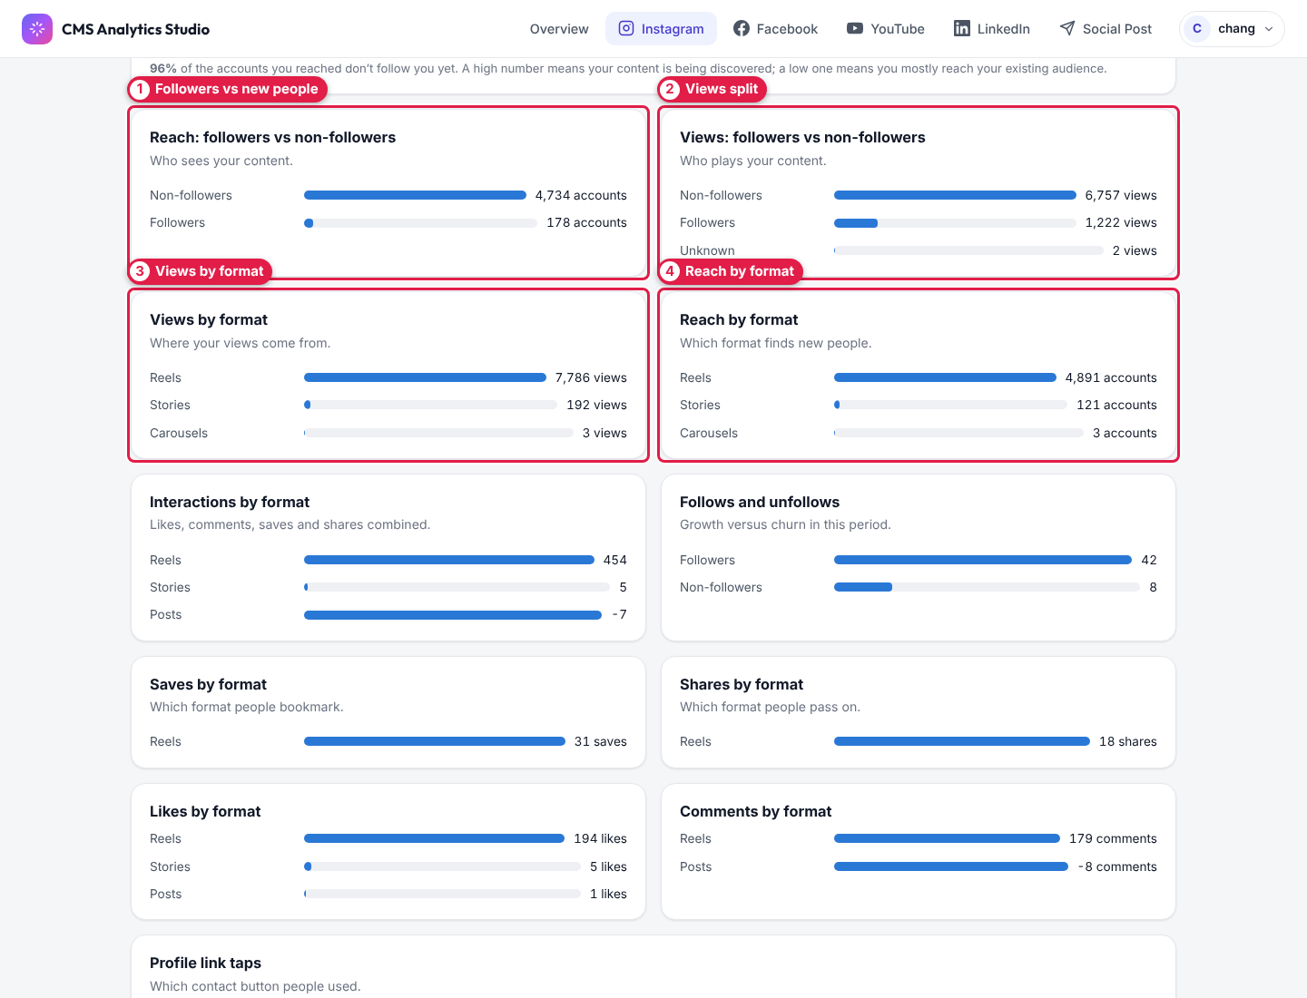
Figure 9 — Instagram → Audience
# | Label | What it tells you
1 | Followers vs new people | How many accounts reached were followers vs people who don't follow you. High share of people who don't follow you = you're being discovered.
2 | Views split | Same split for views.
3 | Views by format | Views from reels, posts and stories.
4 | Reach by format | Which format finds new people.

Further down this tab: follows vs unfollows, saves/shares/likes/comments by format, Best time to post heat map, and follower age, gender, countries and cities.
Instagram only provides demographics and "best time to post" for accounts with 100+ followers.

Strategy tab
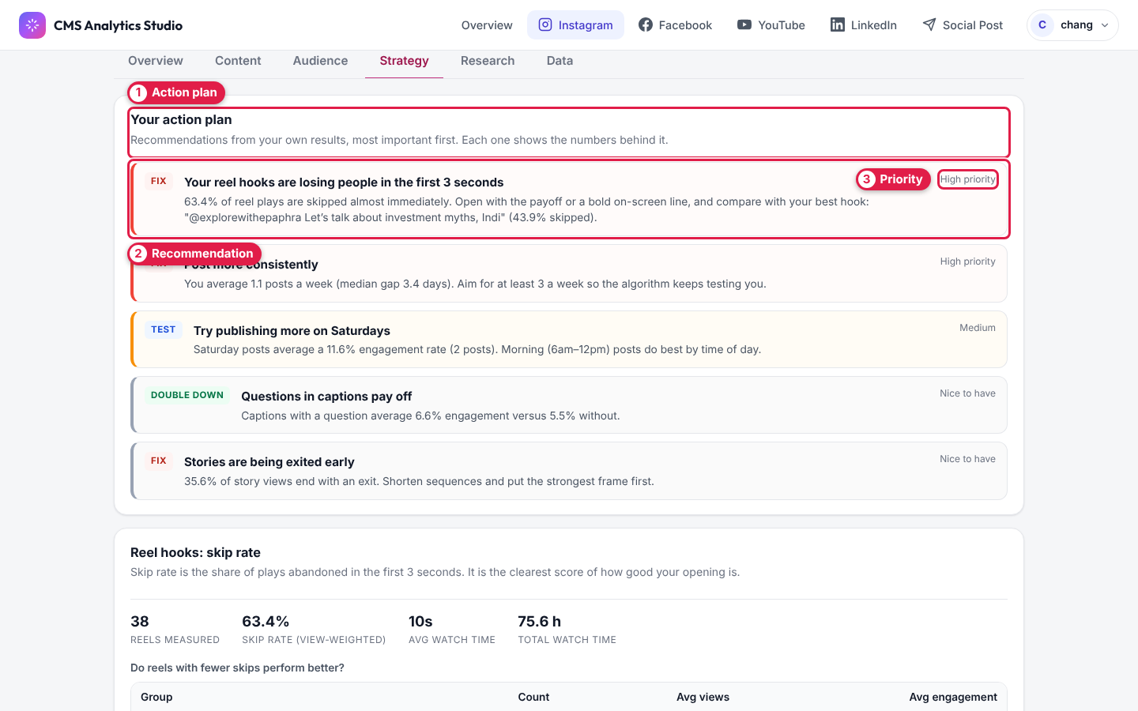
Figure 10 — Instagram → Strategy (action plan)
# | Label | What it means
1 | Action plan | Recommendations made from your own results, most important first.
2 | Recommendation | One tip, with the numbers behind it (e.g. "Post more consistently").
3 | Priority | High priority, Medium or Nice to have — start with High.

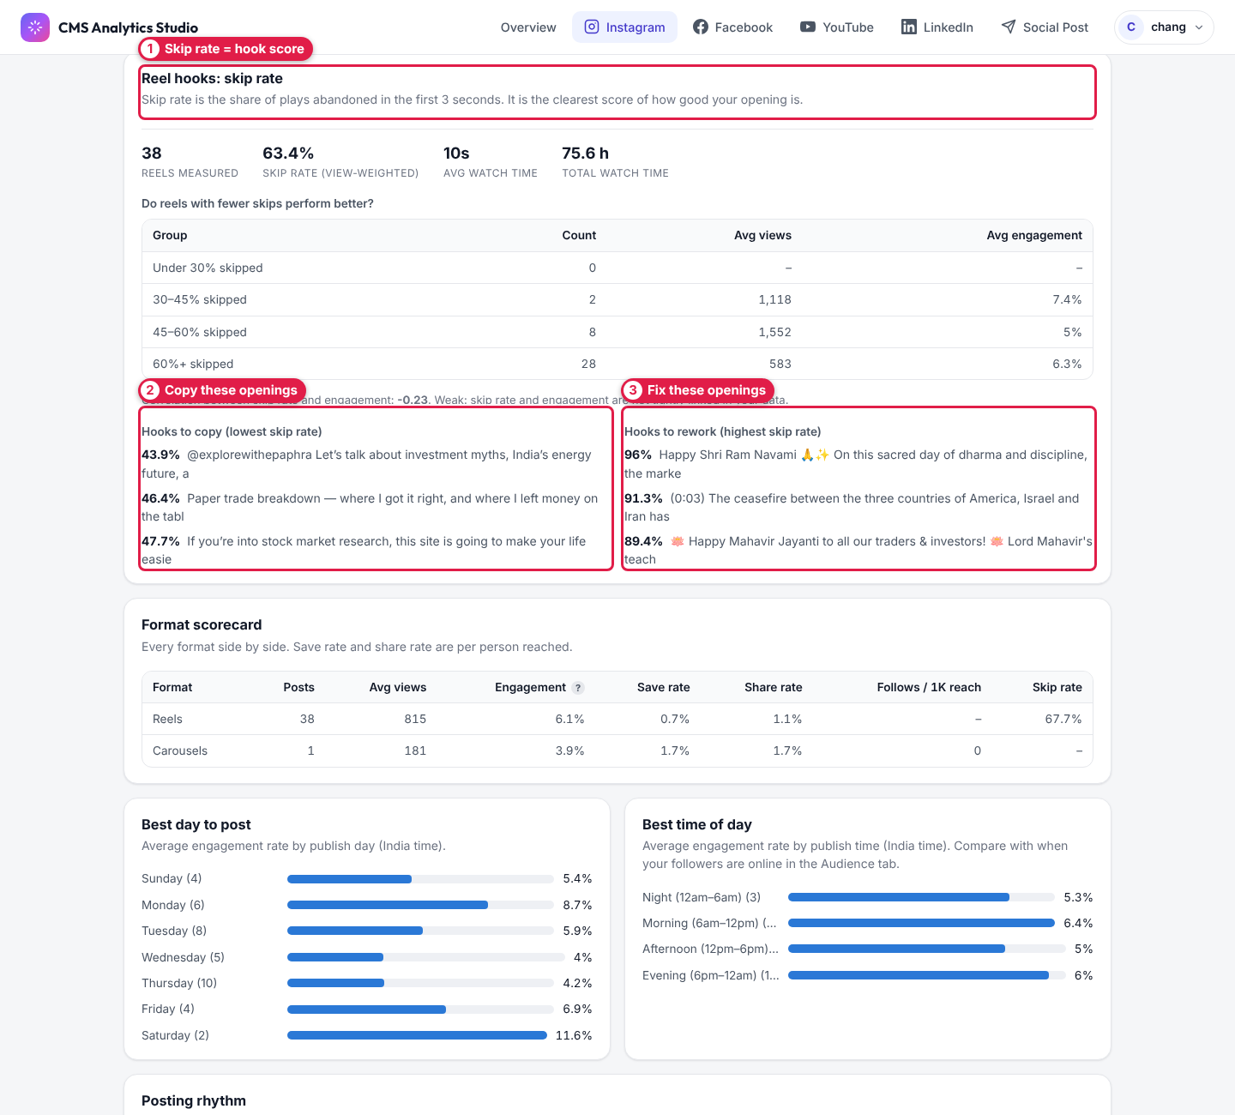
Figure 11 — Instagram → Strategy (reel hooks)
# | Label | What it means
1 | Skip rate = hook score | % of plays that stop in the first 3 seconds. Lower is better.
2 | Copy these openings | Your reels with the lowest skip rate — reuse their style.
3 | Fix these openings | Your reels with the highest skip rate — rework the first 3 seconds.

Below this: the Format scorecard comparing reels, carousels and images.

Research tab
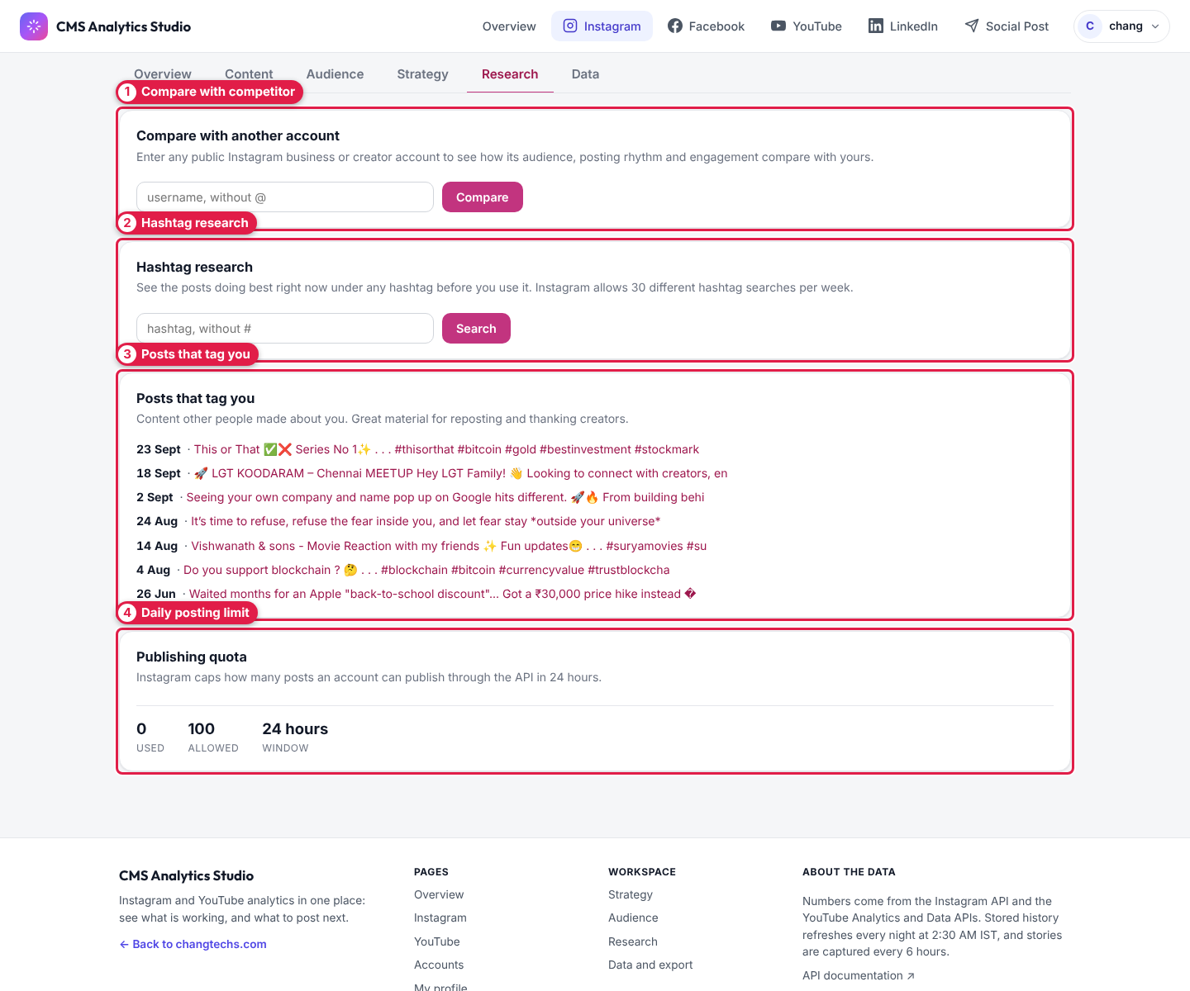
Figure 12 — Instagram → Research
# | Label | What to do
1 | Compare with competitor | Type any public Business/Creator username and click Compare.
2 | Hashtag research | Type a hashtag and click Search to see its top posts. Limit: 30 different hashtags per week.
3 | Posts that tag you | Content others made about you — good for reposting.
4 | Daily posting limit | Posts published through the app in the last 24 hours, out of Instagram's limit (100).

Data tab
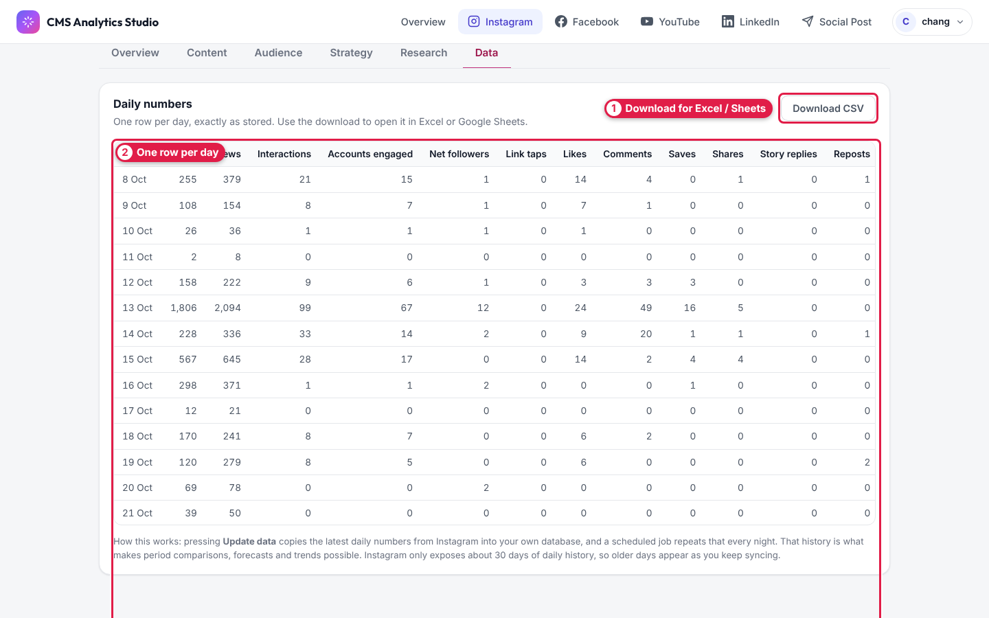
Figure 13 — Instagram → Data
# | Label | What to do
1 | Download for Excel / Sheets | Click Download CSV.
2 | One row per day | Daily reach, views, interactions, followers, likes, comments, saves, shares and more.

6. Facebook
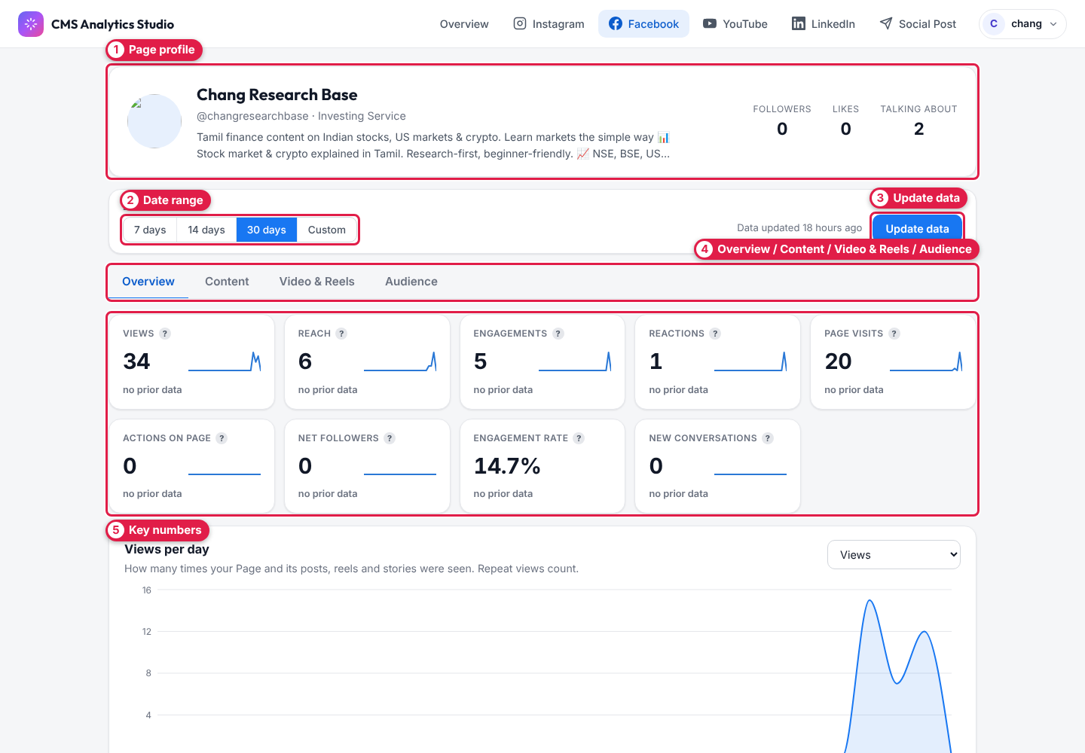
Figure 14 — Facebook → Overview
# | Label | What to do
1 | Page profile | Page name, category, bio, followers and likes.
2 | Date range | 7 / 14 / 30 days or Custom.
3 | Update data | Refresh now.
4 | Tabs | Overview, Content (every post with its numbers, best type/day/time to post), Video & Reels (views, minutes watched, table for each reel), Audience.
5 | Key numbers | Views, reach, engagements, reactions, page visits, actions, net followers, engagement rate, new conversations.

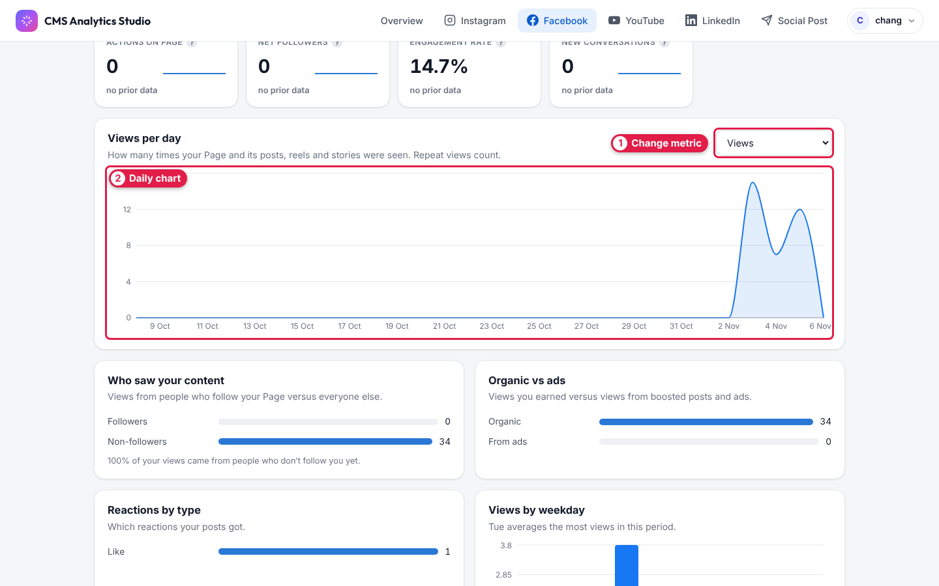
Figure 15 — Facebook daily chart
# | Label | What to do
1 | Change metric | Pick which number the chart shows (views, reach, follows, video views…).
2 | Daily chart | One point per day. Below it: followers vs people who don't follow you, organic vs ads, reactions by type, views by weekday.

7. YouTube
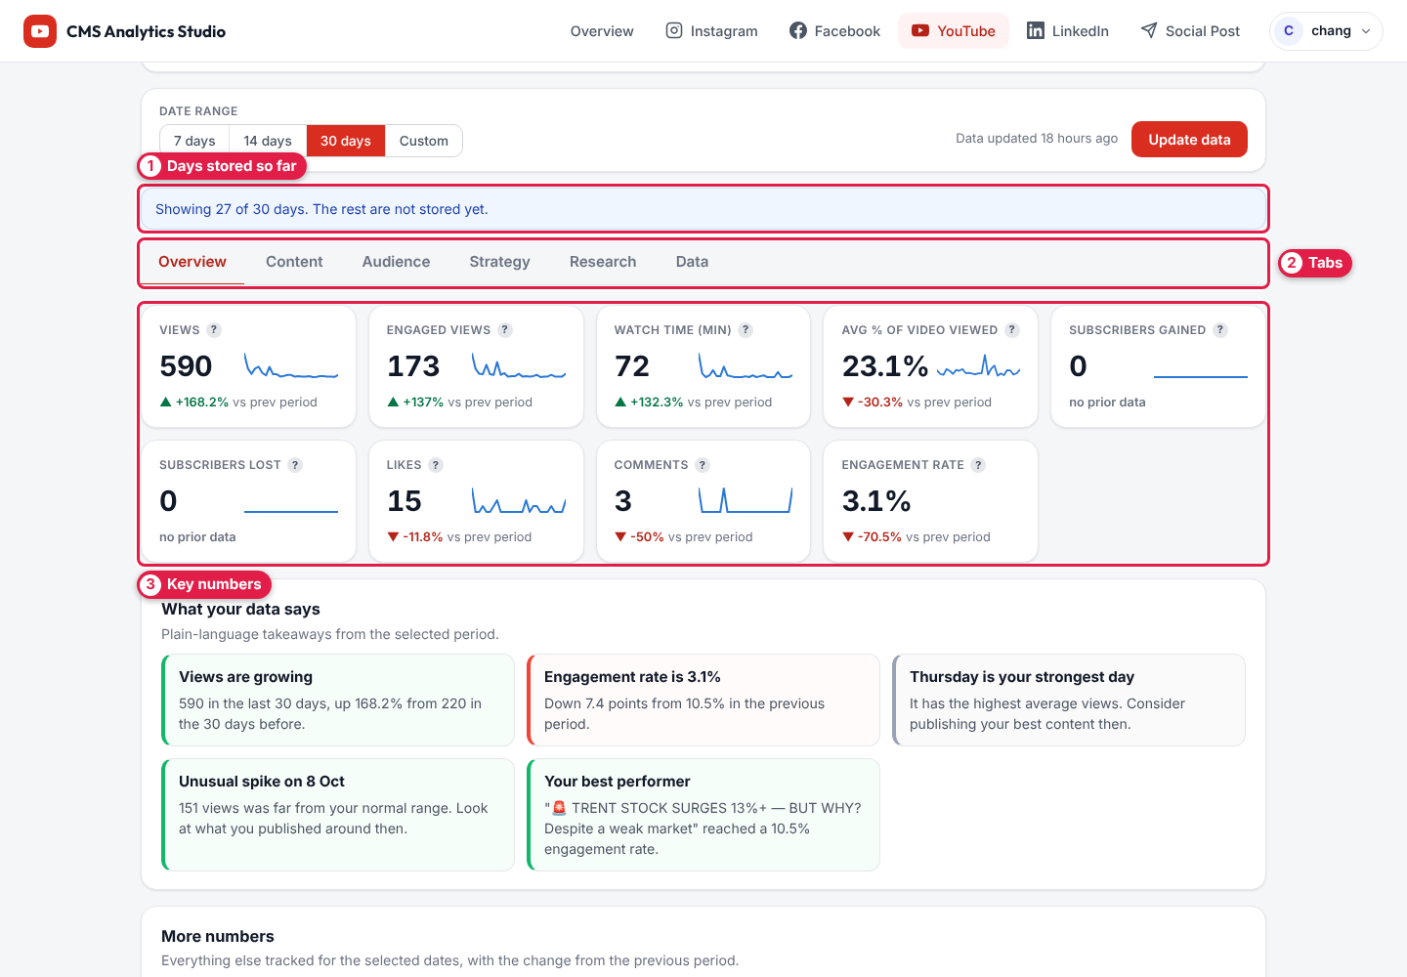
Figure 16 — YouTube → Overview
# | Label | What it means
1 | Days stored so far | e.g. "Showing 27 of 30 days" — a few days aren't saved yet. Press Update data or wait for the nightly update.
2 | Tabs | Overview, Content, Audience, Strategy, Research, Data.
3 | Key numbers | Views, engaged views, watch time, avg % viewed, subscribers gained/lost, likes, comments, engagement rate.

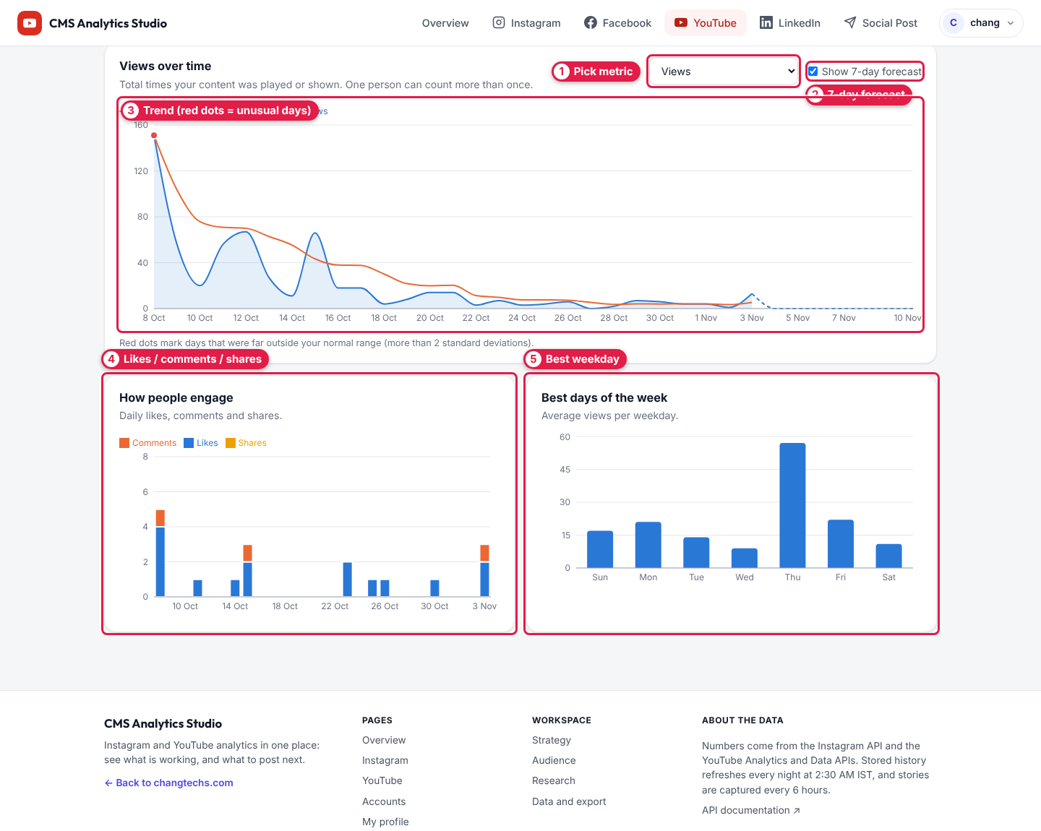
Figure 17 — YouTube charts
# | Label | What to do
1 | Pick metric | Choose what the chart shows.
2 | 7-day forecast | Tick to see a projection for the next 7 days.
3 | Trend (red dots = unusual days) | Red dots mark days far outside your normal range — check what you posted then.
4 | Likes / comments / shares | Daily engagement.
5 | Best weekday | Average views per weekday — publish your best videos on the tallest bar.

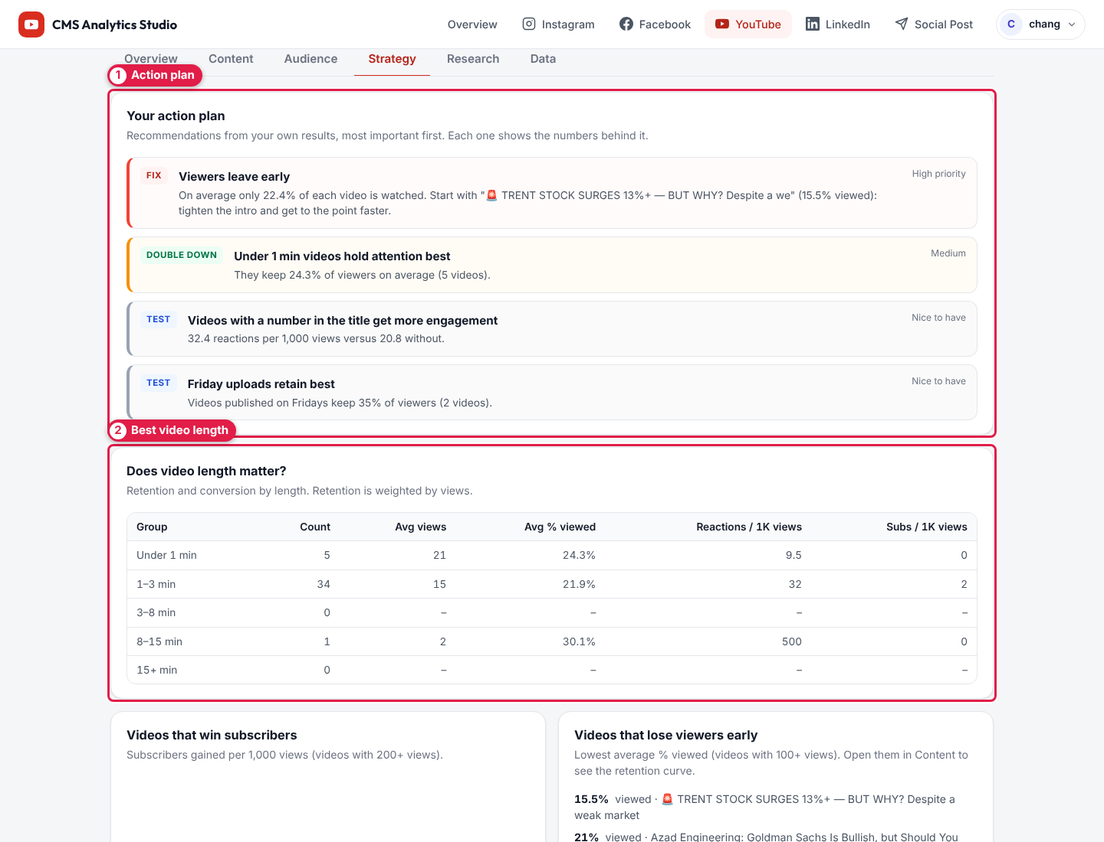
Figure 18 — YouTube → Strategy
# | Label | What it means
1 | Action plan | Tips such as "Viewers leave early", with priority.
2 | Best video length | Retention and subscribers by video length. Further down: videos that win subscribers, videos that lose viewers early, and title patterns.

The Content tab lists every video (search, sort, open on YouTube, comment insights). The Data tab has the daily table and Download CSV.

8. LinkedIn
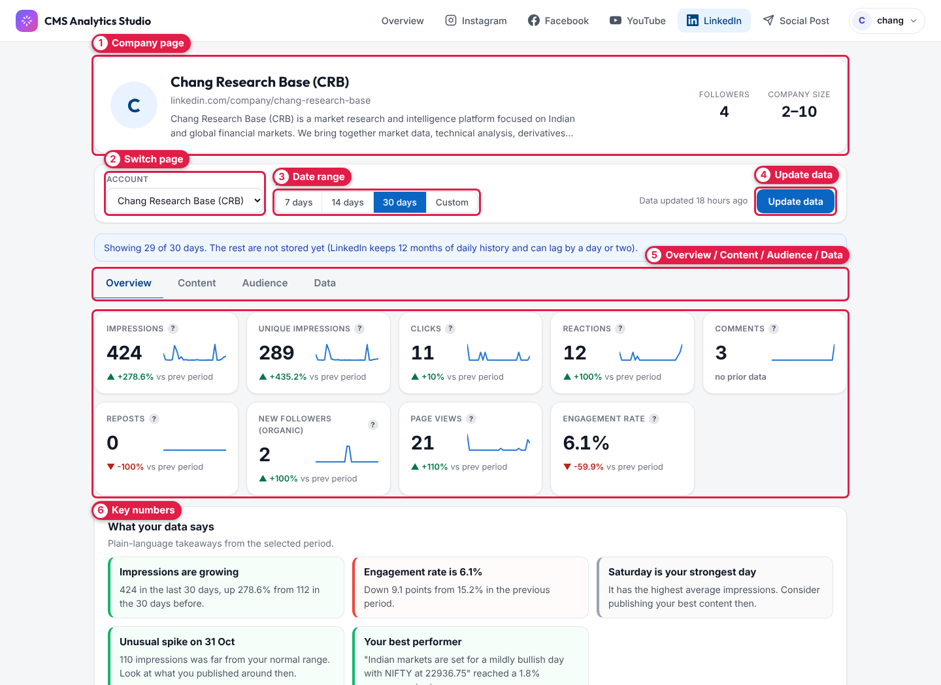
Figure 19 — LinkedIn → Overview
# | Label | What to do
1 | Company page | Page name, link, description, followers, company size.
2 | Switch page | Choose which company page to view.
3 | Date range | 7 / 14 / 30 days or Custom.
4 | Update data | Refresh now.
5 | Tabs | Overview, Content (each post's impressions, clicks, CTR, reactions), Audience, Data (CSV).
6 | Key numbers | Impressions, unique impressions, clicks, reactions, comments, reposts, new followers, page views, engagement rate.

LinkedIn keeps 12 months of daily history and can lag by a day or two.

9. Social Post — publish everywhere
Write once, publish (or schedule) to Instagram, Facebook, LinkedIn and YouTube. Steps: Platform → Account → Content → Auto reply → Review. Your work is saved as a draft automatically.

Step 1 — Choose platforms
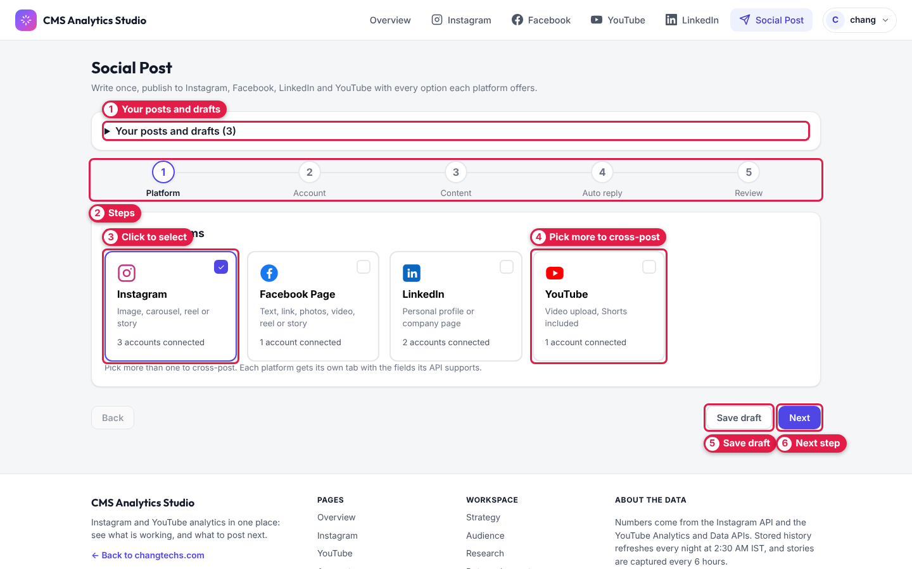
Figure 20 — Social Post, step 1
# | Label | What to do
1 | Your posts and drafts | Click to reopen a draft, see scheduled/finished posts, or delete a draft.
2 | Steps | Shows where you are in the 5 steps.
3 | Click to select | Click a platform card (tick appears).
4 | Pick more to cross-post | Select several platforms to post the same content everywhere.
5 | Save draft | Save and come back later.
6 | Next step | Go to step 2.

Post types per platform
Platform | Post types
Instagram | Image, Carousel (2–10 items), Reel, Story
Facebook Page | Text, Link, Photo, Multi-photo, Video, Reel (3–90 s), Story
LinkedIn | Text only, Image, Multi-image (2–20), Video, Document (PDF), Article, Poll (2–4 options)
YouTube | Video (vertical, 3 minutes or less = Short)

Step 2 — Choose accounts
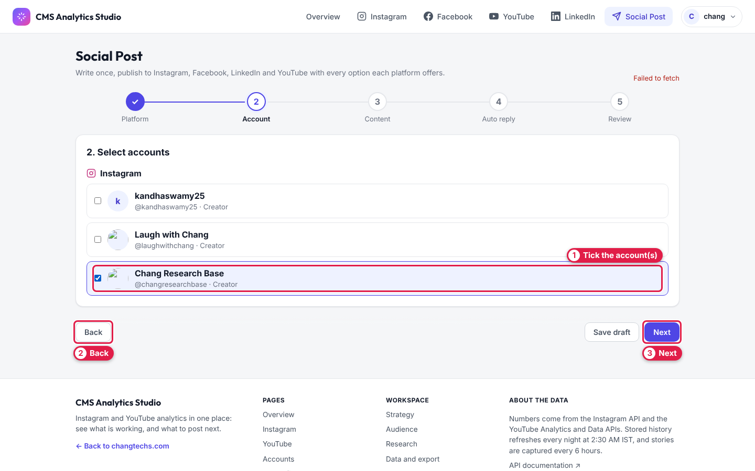
Figure 21 — Social Post, step 2
# | Label | What to do
1 | Tick the account(s) | Pick which account(s) to post from.
2 | Back | Return to step 1.
3 | Next | Go to step 3.

Step 3 — Write the post
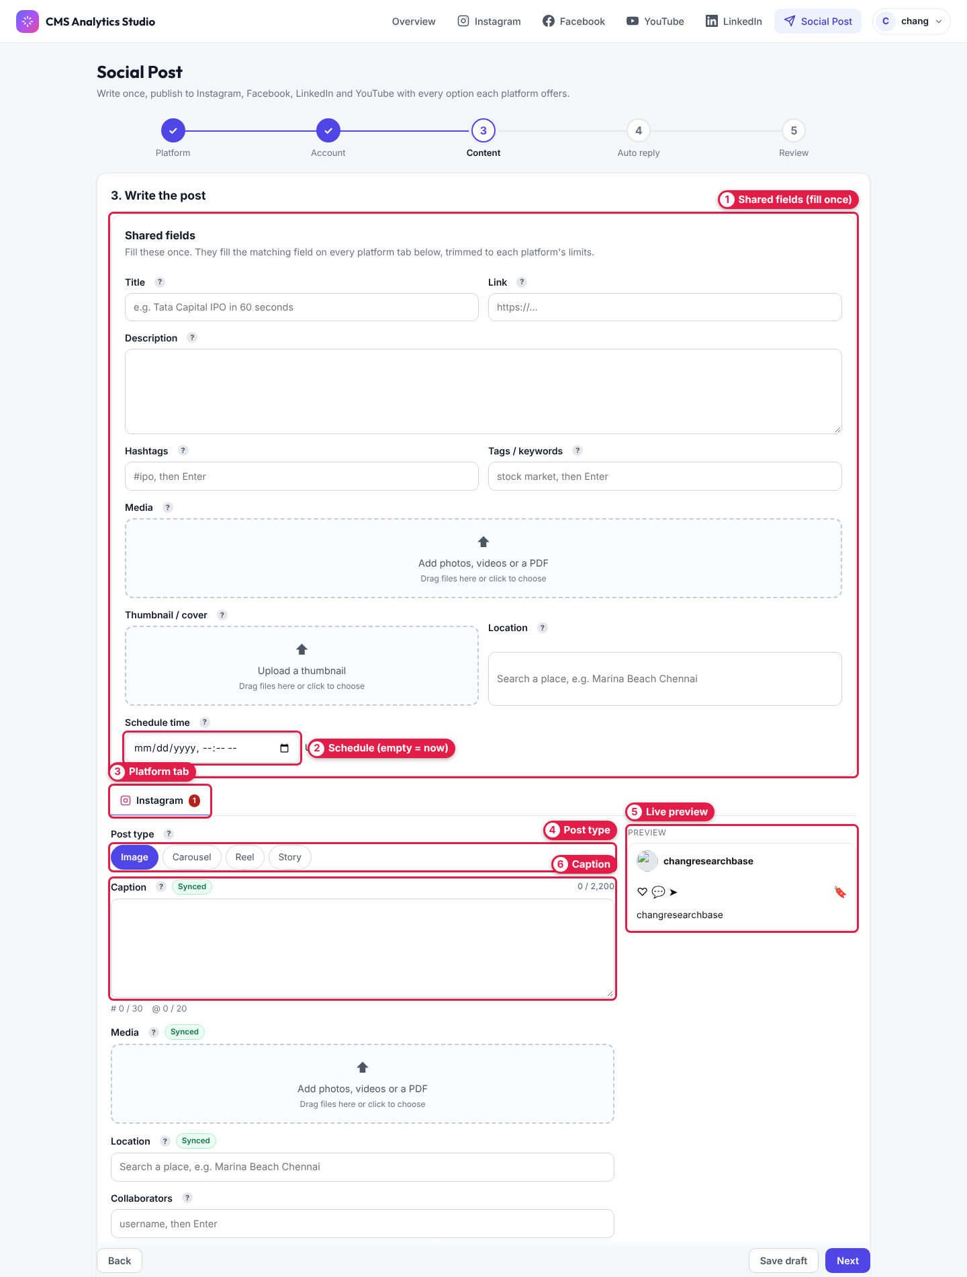
Figure 22 — Social Post, step 3
# | Label | What to do
1 | Shared fields (fill once) | Title, link, description, hashtags, tags, media, thumbnail, location. They copy to every platform tab, trimmed to each platform's limits.
2 | Schedule (empty = now) | Leave empty to publish immediately, or pick a future date/time. Facebook schedules must be 10 minutes to 30 days ahead.
3 | Platform tab | One tab per platform for its own options. A red number = something to fix (the message appears in red at the bottom of the tab).
4 | Post type | e.g. Image, Carousel, Reel, Story.
5 | Live preview | Roughly how the post will look.
6 | Caption | Text for this platform. Synced = it follows the shared field. Counters show limits (e.g. 0 / 2,200, # 0 / 30).

Then click Next.

Step 4 — Auto reply (Instagram only, optional)
Turn it on to answer comments on this new post automatically:
- Public reply under the comment — up to 10 variants; one is chosen at random. {username} becomes @their_name.
- Private reply by DM — message, link, up to 3 link buttons, quick replies. {{link}} places the link.
- Ask them to follow before sending the link (optional) — they get an "I followed ✅" button; the link is sent after the app checks they follow.

Step 5 — Review and publish
Check the summary, then click Publish now (or Schedule for …). You'll see live progress per platform (Upload → Create → Processing → Publish). If one platform fails, click Retry for just that platform.

10. Auto-replies (Instagram)
Open from Account menu → Auto-replies (Figure 3, label 3). When someone comments or DMs a keyword (e.g. "link"), the app sends them your message and URL automatically.

Rules list
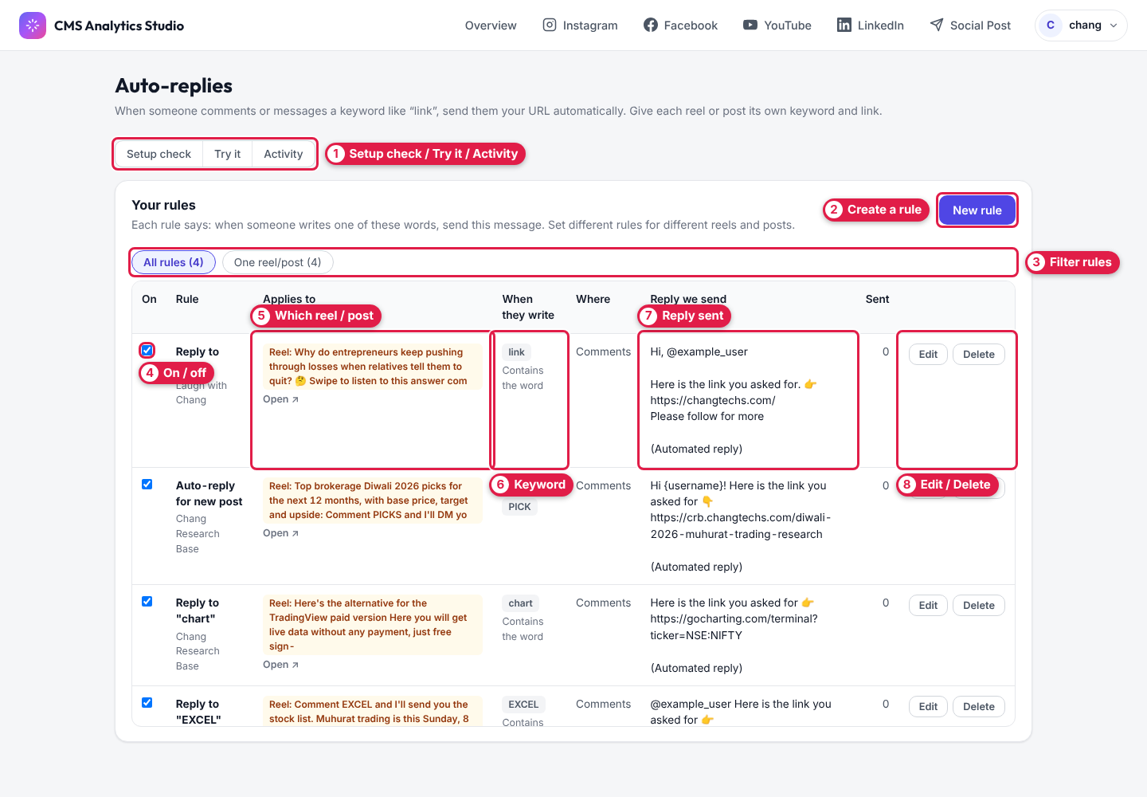
Figure 23 — Auto-replies page
# | Label | What to do
1 | Setup check / Try it / Activity | Opens the tools in Figures 26–27.
2 | Create a rule | Click New rule (Figure 24).
3 | Filter rules | All rules, or only rules for one reel/post.
4 | On / off | Untick to pause a rule without deleting it.
5 | Which reel / post | The content the rule applies to. Open ↗ shows it on Instagram.
6 | Keyword | The trigger word and how it's matched.
7 | Reply sent | The message people receive. The Sent column counts replies sent.
8 | Edit / Delete | Change or remove the rule.

Create a rule
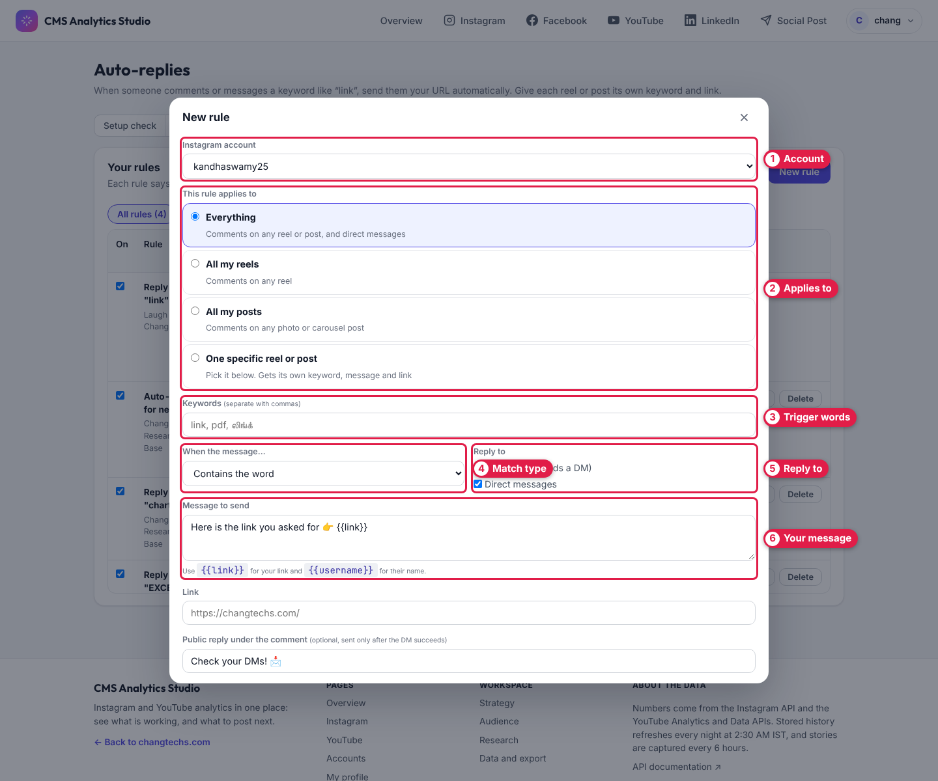
Figure 24 — New rule (top half)
# | Label | What to do
1 | Account | Choose the Instagram account.
2 | Applies to | Everything (comments + DMs), All my reels, All my posts, or One specific reel or post (pick from thumbnails).
3 | Trigger words | Keywords separated by commas, e.g. link, pdf, லிங்க்.
4 | Match type | Contains the word, Starts with, or Is exactly.
5 | Reply to | Comments (sends a DM) and/or Direct messages.
6 | Your message | Use {{link}} for the link and {{username}} for their name.

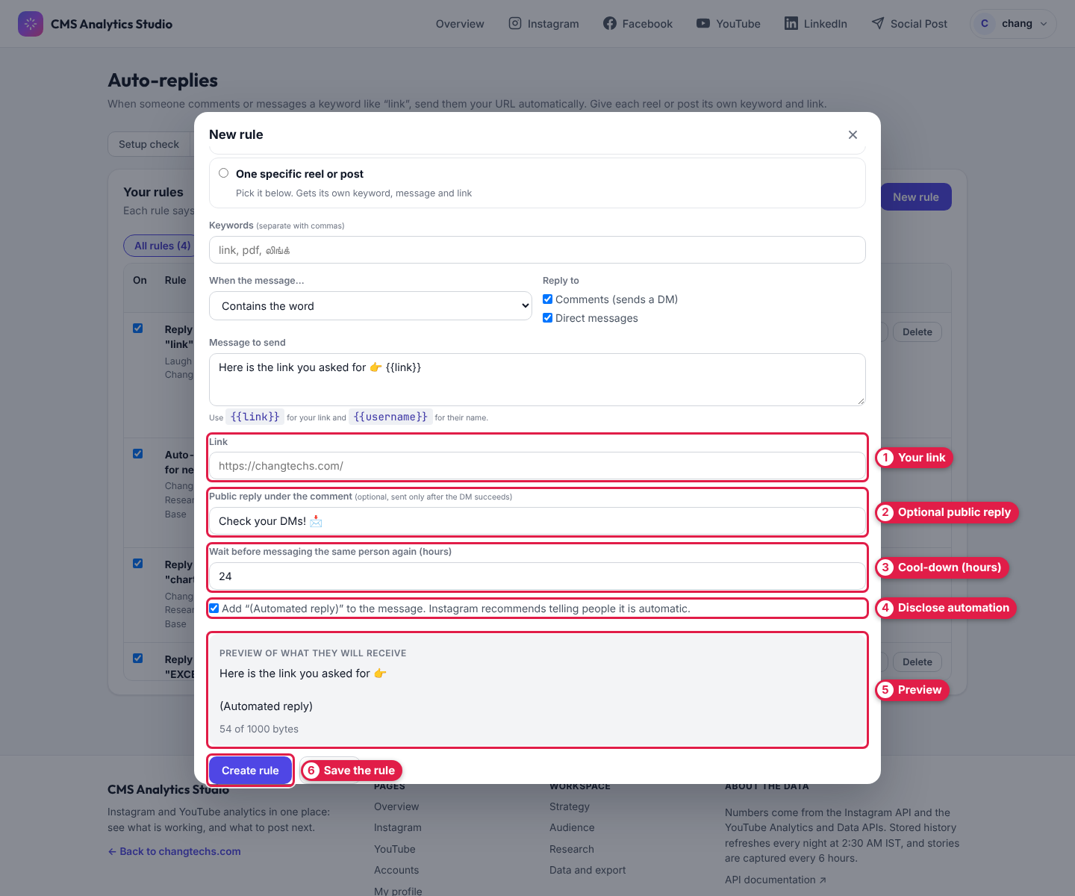
Figure 25 — New rule (bottom half — scroll down in the form)
# | Label | What to do
1 | Your link | The URL to send (must start with https://).
2 | Optional public reply | A short public reply under the comment, posted only after the DM succeeds.
3 | Cool-down (hours) | Don't message the same person again within this many hours.
4 | Disclose automation | Adds "(Automated reply)" — recommended by Instagram.
5 | Preview | Exactly what they will receive.
6 | Save the rule | Click Create rule.

Which rule wins? The most specific: one reel/post rule → all reels/posts rule → Everything rule. Reel/post rules only answer comments (a DM can't be linked to a post).
Shortcut: Instagram → Content → Set up auto-reply for this reel (Figure 8, label 7) opens this form already pointed at that post.

Setup check
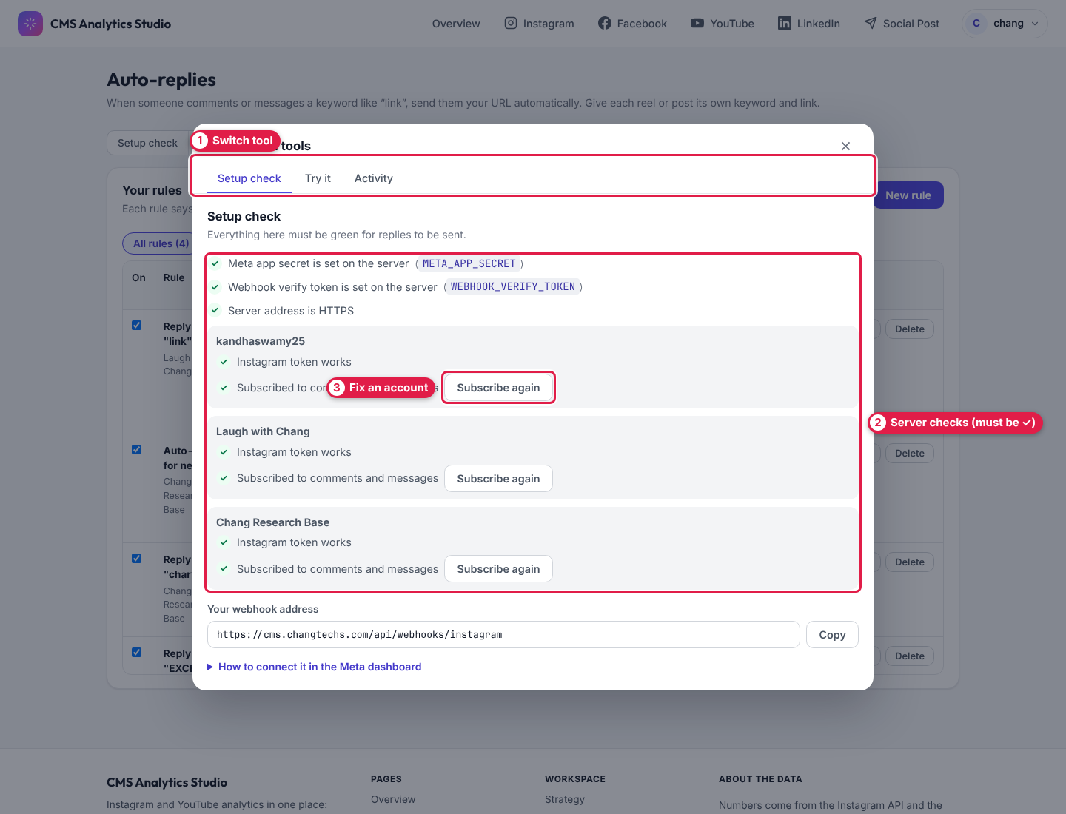
Figure 26 — Automation tools → Setup check
# | Label | What to do
1 | Switch tool | Move between Setup check, Try it and Activity.
2 | Server checks (must be ✓) | Everything must be green ✓ for replies to be sent.
3 | Fix an account | If an account shows ✕, click Subscribe again.

Try it (safe test)
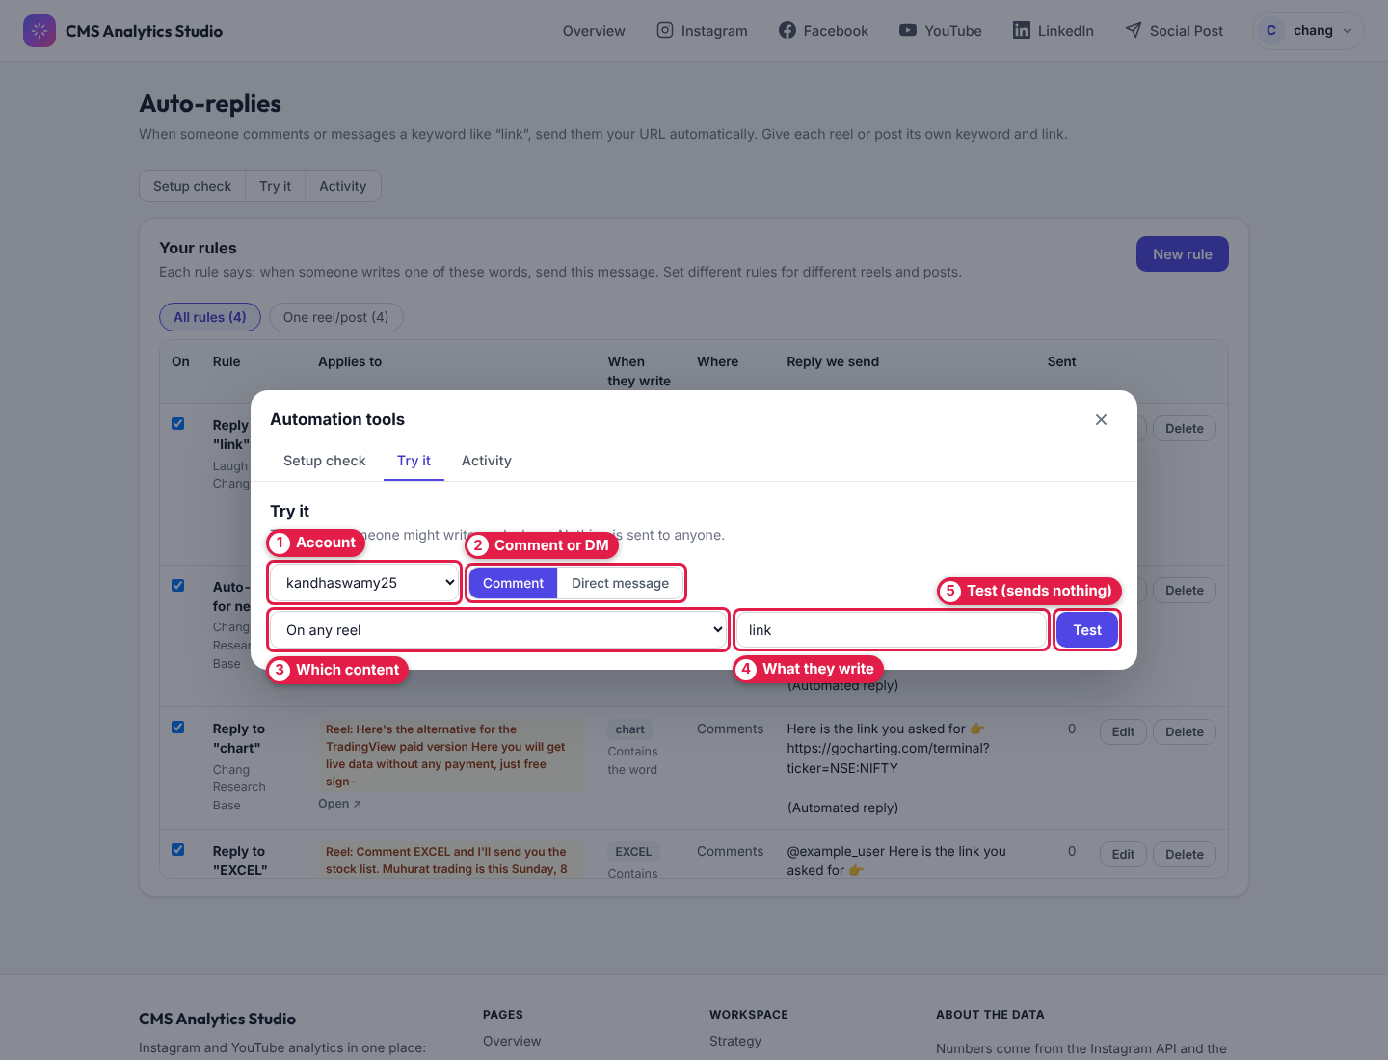
Figure 27 — Automation tools → Try it
# | Label | What to do
1 | Account | Pick the account to test.
2 | Comment or DM | Simulate a comment or a direct message.
3 | Which content | Any reel, any post, or a specific one.
4 | What they write | Type a sample message, e.g. link please.
5 | Test (sends nothing) | Shows which rule would answer and what would be sent. Nothing is sent to anyone.

Activity (third tool) lists the latest messages handled, with Instagram's error code if something failed. Click Refresh to reload.
Instagram's limits: one private reply (DM) per comment, within 7 days of the comment; DMs can be answered within 24 hours.

11. Connected accounts
Open from Account menu → Connected accounts (Figure 3, label 2). Connect each platform once; connections renew themselves.
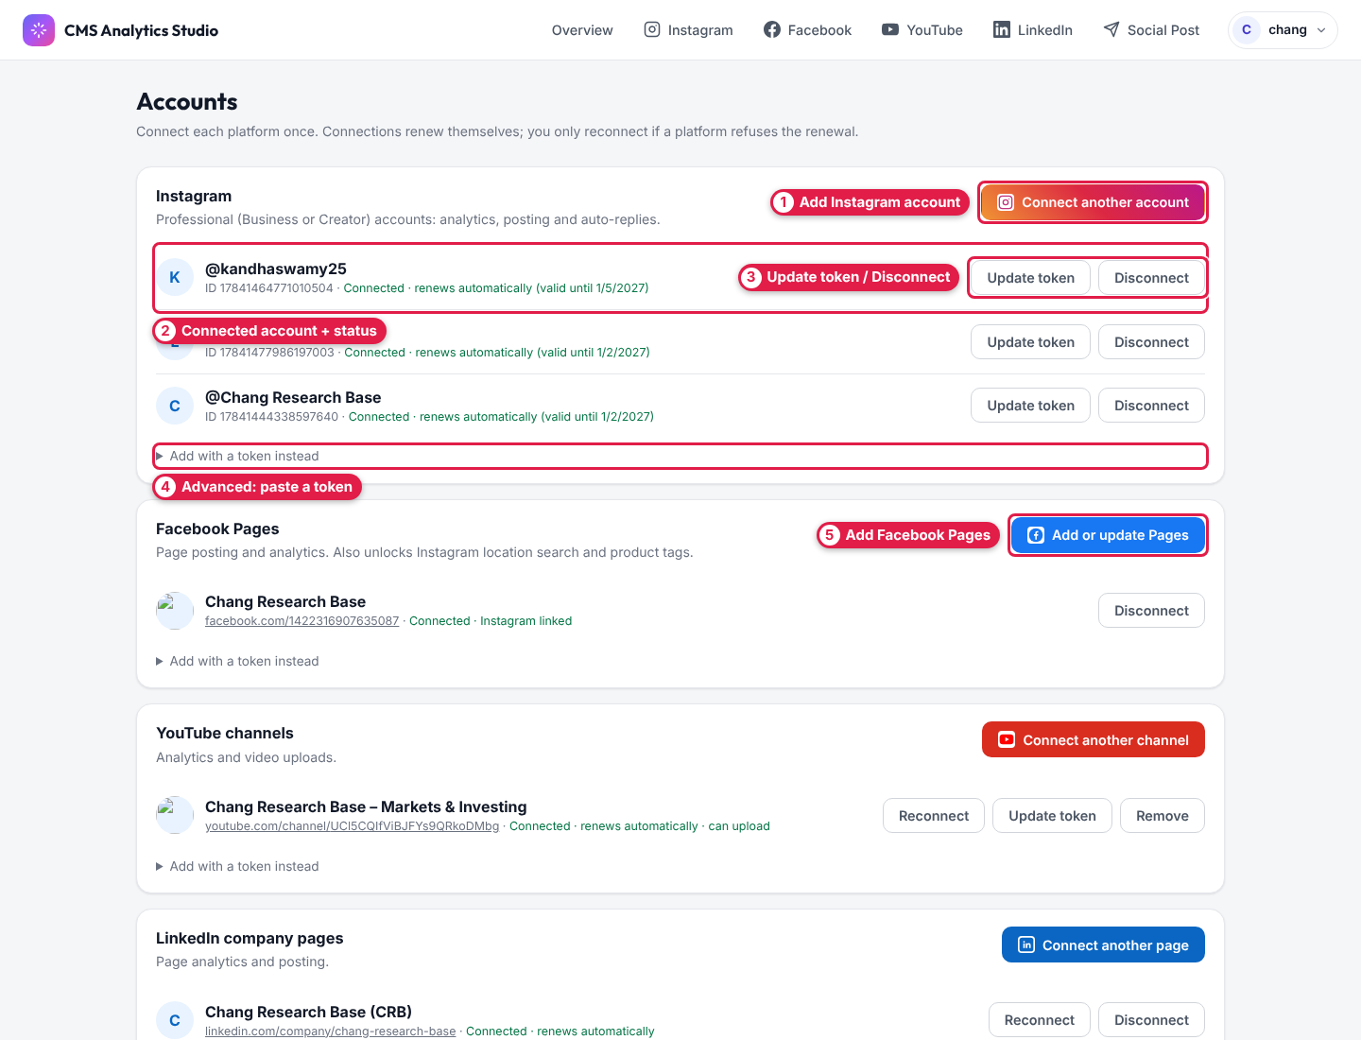
Figure 28 — Accounts page (Instagram and Facebook)
# | Label | What to do
1 | Add Instagram account | Sign in with a Professional (Business or Creator) Instagram account.
2 | Connected account + status | Shows Connected · renews automatically (valid until …).
3 | Update token / Disconnect | Refresh a broken connection, or remove the account.
4 | Advanced: paste a token | Add an account by pasting an access token (advanced users).
5 | Add Facebook Pages | Sign in with a Facebook account that manages the Page and tick the Pages. Also enables Instagram location search and product tags.

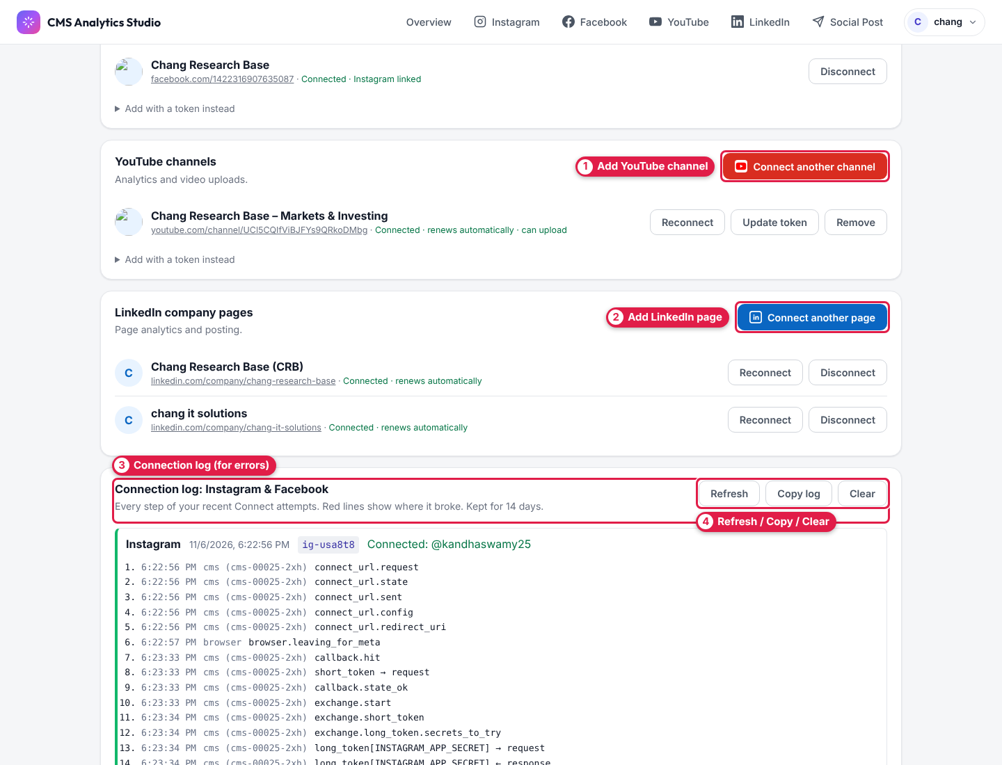
Figure 29 — Accounts page (YouTube, LinkedIn, connection log)
# | Label | What to do
1 | Add YouTube channel | Sign in with the Google account that owns the channel.
2 | Add LinkedIn page | Sign in with a LinkedIn admin of the company page — all pages you manage are added.
3 | Connection log (for errors) | Every step of recent Instagram/Facebook connect attempts (kept 14 days). Red lines show where it failed.
4 | Refresh / Copy / Clear | Copy log to send it to support when a connection fails.

12. My profile and logging out
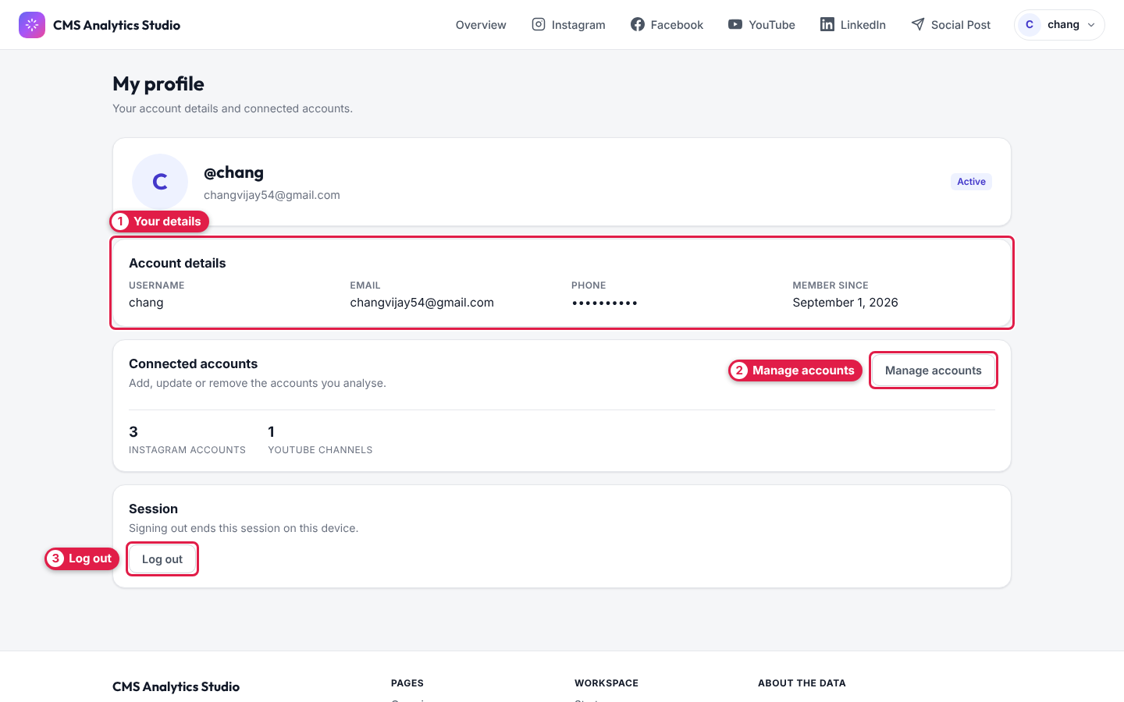
Figure 30 — My profile
# | Label | What it does
1 | Your details | Username, email, phone, member since.
2 | Manage accounts | Shortcut to Connected accounts (Figure 28).
3 | Log out | Ends your session on this device.

13. How the data is updated
When | What happens
Every night, 2:30 AM IST | Latest daily numbers are saved for every connected account.
Every 6 hours | Instagram stories are captured (Instagram deletes story numbers after 24 h).
Every minute | Scheduled posts are checked and sent at their time.
When you click Update data / Update all data | Numbers refresh immediately.

Preset ranges (7/14/30 days) use saved history; Custom ranges are fetched live. All times are in India Standard Time (IST).

14. Glossary
Term | Meaning
Reach | Number of different accounts that saw your content.
Views / Impressions | Times content was shown or played (one person can count more than once).
Interactions / Engagements | Likes + comments + saves + shares (plus reactions/clicks where counted).
Engagement rate | Interactions as a share of views (or reach).
Net followers | New follows minus unfollows.
Skip rate | % of reel plays stopped in the first 3 seconds. Lower = better hook.
Avg % viewed | How much of each video people watched on average.
Watch time | Total minutes/hours watched.
Link taps | Taps on profile link/contact buttons.
Red dot (unusual day) | A day far outside your normal range (more than 2 standard deviations).
vs prev period | Compared with the same number of days just before.

15. Troubleshooting and FAQ
"No data stored yet for this period" — press Update data (Figure 7, label 6). After that it refreshes every night.
Audience/demographics are empty — Instagram only shares these for accounts with 100+ followers.
An account stopped updating — Connected accounts → Update token or Reconnect (Figure 28, label 3).
Auto-replies aren't being sent
- Setup check must be all green ✓ — click Subscribe again if not (Figure 26, label 3).
- Rule must be On (Figure 23, label 4). Test it in Try it (Figure 27).
- Look at Activity for Instagram's error code.
- Limits: one DM per comment within 7 days; DMs answered within 24 hours.
A post failed on one platform — on the progress screen click Retry for that platform, or reopen it from Your posts and drafts (Figure 20, label 1).
Red number on a platform tab / "Image needs an image" — each post type needs the right media (e.g. Reel = one video, Carousel = 2–10 items). Fix the red message and the number disappears.
Times look wrong — all times are in India Standard Time (IST).
Forgot password — contact your administrator.

