**[Include a title for your proposal]**

**Table of contents   
[no need for a ToC in your proposal]**

1. **Introduction**

* may include background

1. **Problem Statement / Motivation / Market Gap Analysis**

* can be research on what others have done in the market
* hopefully can introduce innovations, differentiations, or improvements

1. **Proposed idea / solution / contribution**

* can include scope (to narrow down what will be delivered by the next milestone, as part 2 of the assignment, but your mobile application needs to be a working one)

1. **Initial design of solution**

* overall system design of solution (can be a simple diagram to show how everything fits together with some explanation without getting into too much details)

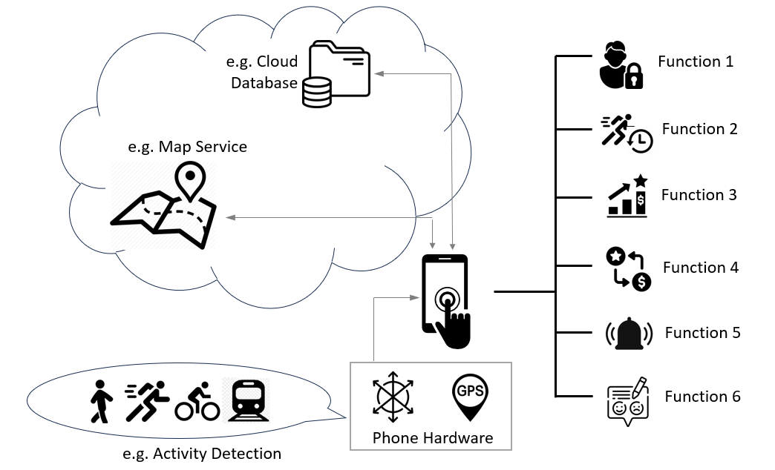

An example of a simple system block diagram.

* mock-up UI design of mobile application (can be screenshots of emulator or wireframes designed using graphics tool, focusing on a theme for your mobile application, whether your application employs a certain way to help user navigate around etc and try to impress considering that this is a proposal)

**[Keep the proposal under 10 pages]**