Key Domain: Business Productivity (Team Task Management App)

A. Project Title
WorkHub

B. Background
Today, many companies in Singapore have trouble managing their team's work and tasks. Teams often have problems like unclear task assignments, hard to track project progress, and poor communication. This causes missed deadlines and lost productivity. Many teams now work from home or in different places. They need one app to help them work together better. So, WorkHub is a mobile app that helps teams manage their tasks and projects in one place, and it makes it easy for teams to stay organized and work together, no matter where they are.

C. Objectives
The WorkHub app helps team leaders create and manage projects easily on their phones. It lets users create tasks, give them to team members, and see how they are doing. The app shows how much work each project has done and how busy each team member is. It helps teams work together better by putting all task information in one place. WorkHub helps Singapore companies finish their projects on time and work better. The app has a nice design that is easy to use.
D. Key Functional Features
Mandatory Features (8):
• Login/Logout/Registration
Users can create a new account with email and password
Users can log in with their email and password
Password must be confirmed when signing up
Users can log out from the app
• View and Edit Profile
Users can edit their name, email, phone number, and job title
Users can change their profile information
Updates are saved persistently using Shared Preferences so data remains after the app closes
• View About Us
Show what the app does
Show company name and information
Show & provide clickable links/buttons to call the company directly and launch the email app to send feedback
Show developer information
• Project Dashboard (Home Page)
Show all projects in a list
Show project name, description, and number of tasks
Show how much of the project is done with a progress bar
Button to create a new project
• Project Management
Create new projects with name and description
View project details
Search for projects by name
Filter projects by status
• Task Management
Create tasks with title and description
Assign tasks to team members
Set task priority (Low, Medium, High)
Set task deadline date
Change task status (To-Do, In Progress, Done)
View all tasks in a project
Edit and delete tasks
• Team Member Management
View all team members in a project
Show how many tasks each team member has
Show how busy each team member is (percentage)
Add new team members to projects
• Navigation and User Interface
Bottom tabs to switch between pages: Home, Projects, Tasks, Team, Profile
Easy to navigate between different screens
Clean and professional design
Works well on different phone screen sizes

Bonus Features (4):
• Project Details Page
Display full project information
Show all tasks in the project
Show team members assigned to the project
Display project progress percentage
Edit and delete project options
• Task Details Page
Show complete task information
Display assigned person
Show priority level and deadline
Display task status
Allow editing and deleting from this page
• Edit Profile Page
Allow users to edit their profile information
Edit name, email, phone number, job title
Save and cancel buttons
Validate input before saving
• Filter Tasks Page
Filter tasks by Priority (Low, Medium, High)
Filter tasks by Status (To-Do, In Progress, Done)
Filter tasks by Assigned Person
Apply and reset filter buttons
Show filtered results

Challenging Bonus Feature (1):
• Data Persistence - Profile Data Storage
Save profile information (name, phone number, job title) to Shared Preferences
Profile data persists even after app closes
When user edits profile and saves, data is stored locally
When user opens app again, their profile data is loaded from storage
Demonstrates understanding of local data storage in Flutter
Uses Shared Preferences package for data persistence

Use Case Diagram
The following diagram shows all the actions and features that users can perform in the WorkHub application: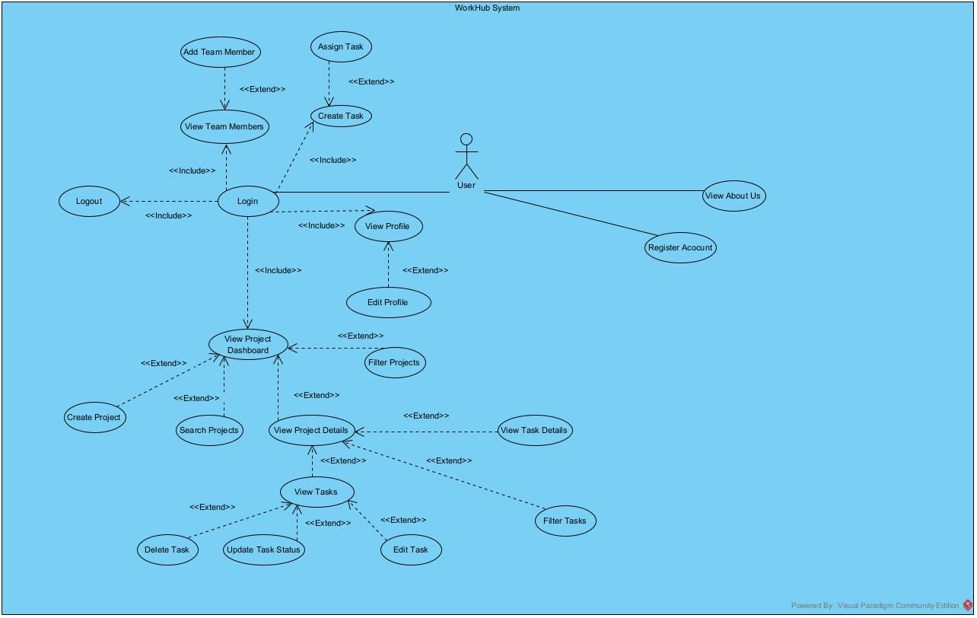

UI Design and Navigation Flow
The following diagram shows the user interface design of each screen and how users navigate between them:
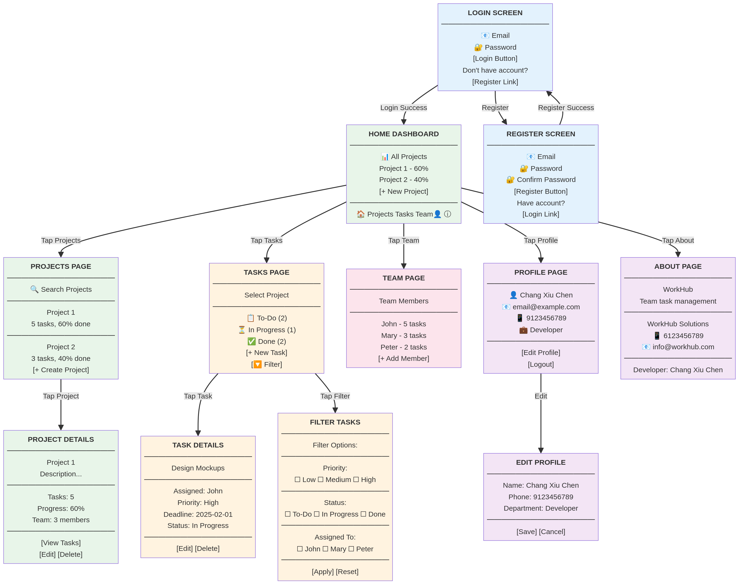

E. References
Material Design Guidelines - https://material.io/design
Android Design Principles - https://developer.android.com/design
Task Management Best Practices - https://www.projectmanager.com/blog/task-management
Mobile App UI/UX Design Patterns - https://www.interaction-design.org/literature/topics/mobile-design
Flutter Shared Preferences - https://pub.dev/packages/shared_preferences

