LAB211 Project Report
Student and Short Course Management System
Student Name: Lê Gia Phúc Chánh
Student Code: SE210518
Class: SE2012

1. Introduction
This report presents the development of the Student and Short Course Management System. The application is implemented in Java using Object-Oriented Programming (OOP) principles and Computational Thinking (CT). The system allows managing students and courses, performing CRUD operations, sorting, searching, validating input, and saving/loading data from text files.

2. Requirement Analysis
The project is based on the assignment J1.L.P0039 with the following requirements:
- Manage student information stored in brands.txt
- Manage car information stored in Students.txt
- Provide 12 main functions:
1. List all students
2. Add a new student
3. Search for a student by ID
4. Update a student by ID
5. List all students by major
6. Add a new course
7. List all courses by student (grouped)
8. Calculate total study duration by student ID
9. Remove a student by ID
10. Sort students by GPA
11. Save data to files
12. Quit program

3. Applying Computational Thinking

3.1. Decomposition
The system is divided into three main modules:
- StudentManagement: list, add, update, delete, search, filter students, sort by GPA.
- CourseManagement: list by student, add, calculate total duration
- StudentDAO, CourseDAO: read/write courses and students data from text files.

3.2. Pattern Recognition
Common patterns include:
- Each entity (Student, Course) has a unique ID.
- Both Student and Course share core CRUD operations (add, getAll, save, load)
- Both can be persisted to text files.

3.3. Abstraction
Essential attributes are identified:
- Student: id, name, major, gpa.
- Course: courseId, studentId, name, duration, startedDate.
Unnecessary details are omitted to focus on core attributes and behaviors.

3.4. Algorithm Design
Student Management (7)
3.4.1 List All Students
Step 1: Call StudentDAO.getAll() → List<Student>
Step 2: If list empty → Display "No students"
Step 3: Else print header + iterate list, print each student.toString()
Step 4: End
3.4.2 Add New Student
Step 1: Input studentID
Step 2: Validate format STU#### (regex ^STU\d{4}$)
Step 3: Input name → validate ≥2 words
Step 4: Input major → validate not empty
Step 5: Input GPA → validate 0.0 ≤ GPA ≤ 4.0
Step 6: Check duplicate: StudentDAO.findById(studentID) == null?
Step 7: If valid → create Student object
Step 8: StudentDAO.add(student)
Step 9: StudentDAO.save() → file
Step 10: Display "Added successfully"
3.4.3 Search Student by ID
Step 1: Input studentID
Step 2: Validate not empty
Step 3: Call StudentDAO.findById(studentID)
Step 4: If found → display student info (toString)
Step 5: Else → display "Student not found"
Step 6: End
3.4.4 Update Student by ID
Step 1: Input studentID
Step 2: StudentDAO.findById(studentID) → student
Step 3: If not found → display "Not found", End
Step 4: Backup old values (name, major, GPA)
Step 5: Input new name → validate format
Step 6: Input new major → validate not empty
Step 7: Input new GPA → validate 0.0–4.0
Step 8: If any validation fails → rollback to backup, display error, End
Step 9: student.setName(), setMajor(), setGpa()
Step 10: StudentDAO.save() → file
Step 11: Display "Updated successfully"
3.4.5 Filter Students by Major
Step 1: Input major
Step 2: Validate not empty
Step 3: Call StudentDAO.findStudentByMajor(major) → List<Student>
Step 4: If empty → display "No students in this major"
Step 5: Else print header + iterate list
Step 6: End
3.4.6 Remove Student by ID
Step 1: Input studentID
Step 2: Validate not empty
Step 3: StudentDAO.findById(studentID) → student
Step 4: If not found → display "Student not existed", End
Step 5: StudentDAO.removeStudent(studentID)
Step 6: StudentDAO.save() → file
Step 7: Display "Removed successfully"
3.4.7 Sort Students by GPA Ascending
Step 1: Call StudentDAO.sortAscendingGpa() → List<Student> sorted by GPA ↑
Step 2: If empty → display "No students"
Step 3: Else print header + iterate list (lowest GPA first)
Step 4: End
Course Management (3)
3.4.8 List All Courses Grouped by Student
Step 1: Call CourseDAO.GroupAllCourseByStudent() → List<Course> sorted by studentId
Step 2: If empty → display "No courses"
Step 3: Else iterate courses:
If studentId != prevStudentId:
→ fetch Student via StudentManagement.findById()
→ print student header (id, name, major)
→ print course line (courseId, duration, startDate)
Step 4: End
3.4.9 Add New Course
Step 1: Input courseID
Step 2: Input studentID
Step 3: StudentManagement.findById(studentID) → student
Step 4: If student not found → display "Student not existed", End
Step 5: Input courseName
Step 6: Input duration → validate > 0 weeks
Step 7: Input startDate (dd/MM/yyyy) → parse LocalDate, validate future date
Step 8: CourseDAO.isDuplicate(courseID, studentID)?
Step 9: If duplicate → display "Student already registered this course", End
Step 10: Create Course object
Step 11: CourseDAO.add(course)
Step 12: CourseDAO.save() → file
Step 13: Display "Course added successfully"

3.4.10 Calculate Total Duration by Student ID
Step 1: Input studentID
Step 2: StudentManagement.findById(studentID) → student
Step 3: If not found → display "ID not existed", End
Step 4: CourseDAO.findAllCourseByStudentId(studentID) → List<Course>
Step 5: If empty → display "No courses for this student"
Step 6: Else:
total = sum of duration for all courses
Print student info
Print "Total duration: X weeks"
Step 7: End
Main Menu (2)
3.4.11 Save All Data to Files
Step 1: Call CourseDAO.save() → courseOk
Step 2: Call StudentDAO.save() → studentOk
Step 3: If courseOk AND studentOk → Display "Save all successfully"
Step 4: Else → Display "Save all failed"
Step 5: End
3.4.12 Quit Program
Step 1: Input choice (Y/N): "Do you want to save changes before exiting?"
Step 2: Loop until valid:
If Y/N:
If Y → saveAll(courseDAO, studentDAO), print "Good bye", System.exit(0)
If N → return to main menu
Else → display "Input not valid", repeat Step 1
Step 3: End

4. System Design (UML)
The system applies OOP principles with the following classes:
- Entities: Student, Course
- BusinessObject: StudentManagement, CourseManagement, Program (entry point)
- DataObject: BasedDAO, StudentDAO, CourseDAO
- Utilties: Constants, DataInput, DataValidation, Menu
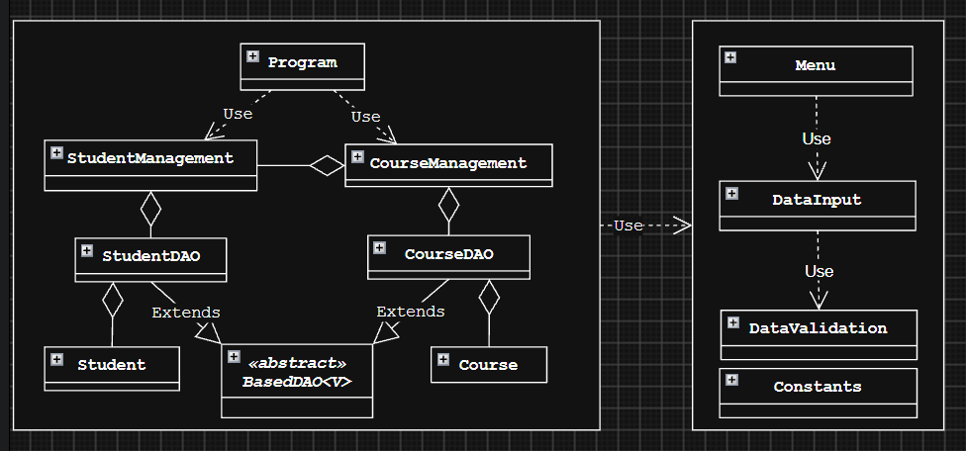
Figure 1: High-Level UML Class Diagram
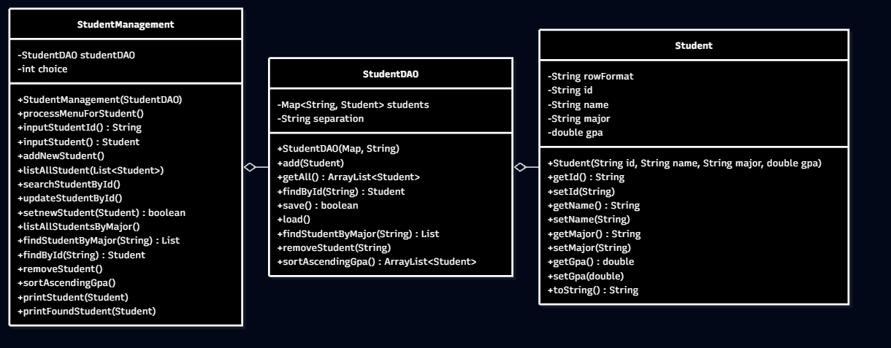
Figure 2: Detailed UML for Student Object Group — Student, StudentDAO and StudentManagement

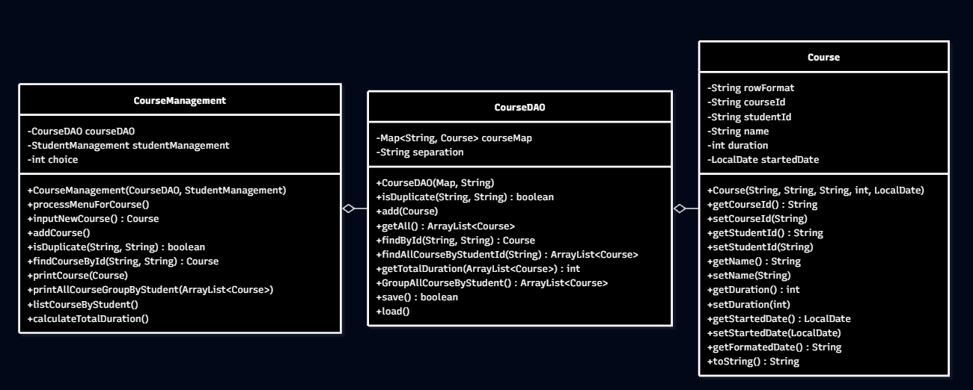
Figure 3: Detailed UML for Course Object Group — Course, CourseDAO and CourseManagement
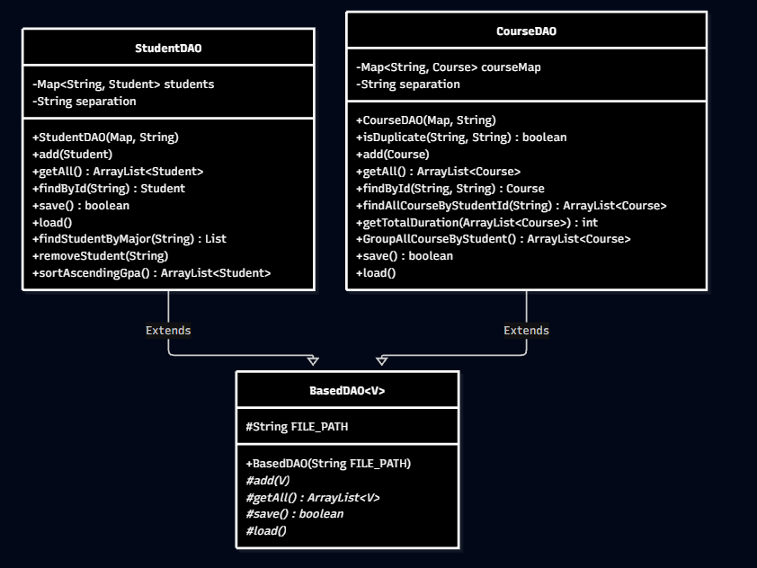
Figure 4: Detailed UML for the Data Persistence Layer, inheriting from BasedDAO<V> to StudentDAO and CourseDAO

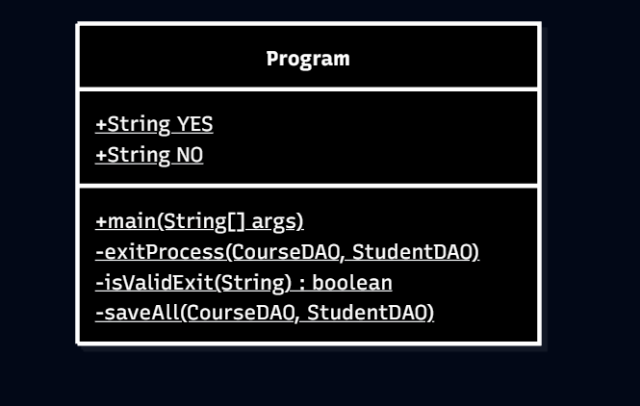
Figure 5: Detailed UML for Main Entry Class Program
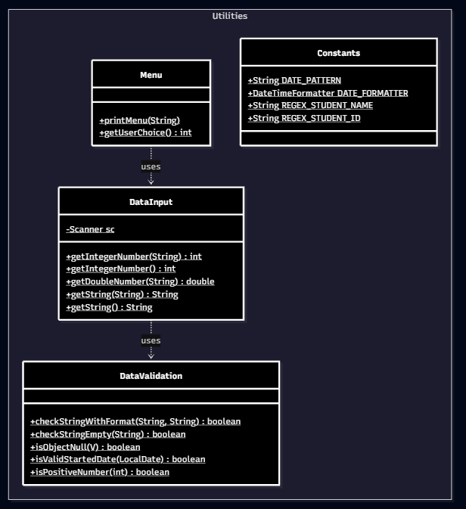
Figure 6: Detailed UML for Utilities Package with Internal Dependencies

5. Implementation & Testing
The application is implemented in Java console application. Main test cases include:
- Add a valid student.
- Search for a non-existent student ID.
- Add a course with invalid duration / past start date (should fail).
- List students by major.
- Calculate total duration by student ID.
- Save and reload data from files.

6. Experimental Results
Screenshots demonstrate successful execution of the program: main menu, add brand, add car, update brand, list cars by color, and save data.
[Screenshot placeholder: Main menu and operations]
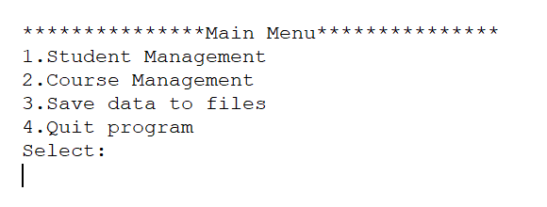
Figure 7: Main menu
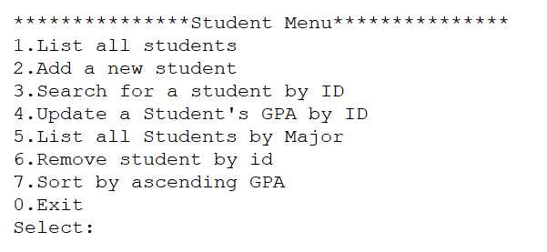
Figure 8: Student Management menu
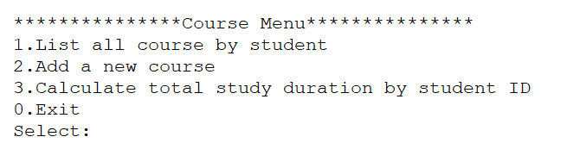
Figure 9: Course Management menu
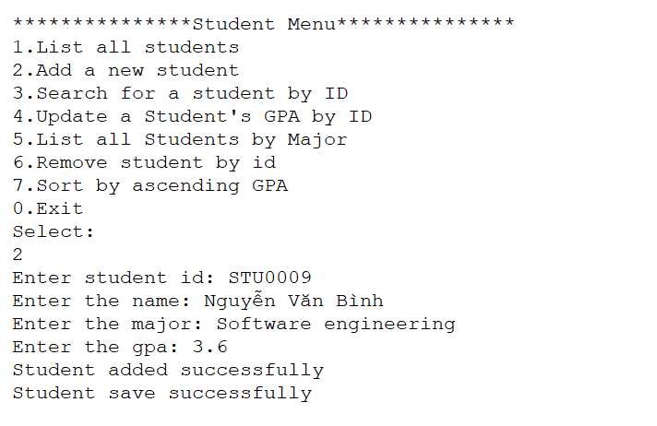
Figure 10: Add a valid student.
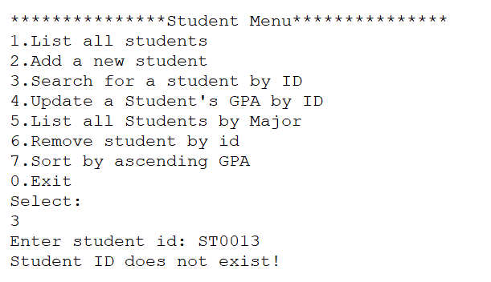
Figure 11: Search for a non-existent student ID.

7. Appendix
Source files: Brand.java, Car.java, BrandManager.java, CarManager.java, FileHandler.java, Main.java,…
Sample data files: brands.txt, cars.txt

