Test Project
  - Mobile Applications Development

Module A Functionality

Submitted by:

Introduction
You are training in mobile application development. Your school is tasked with developing an assignment scoring app to provide smooth teacher scoring and feedback to players.
Your product manager provides a tablet version of the wireframe. Your job as a mobile application developer is to develop corresponding apps based on specific wireframes for specific development needs.

Description of project and tasks
Developers do not need to consider the aesthetics of the program interface or the location of elements. The work may be inconsistent with the wireframes provided, but developers should consider usability appropriately.
 | Part | Name | Competition Time | Marking Devices
✓ | ModuleA | Functionality (Tablet) | 2.5h | Emulator: Pixel C API33

Application wireframe

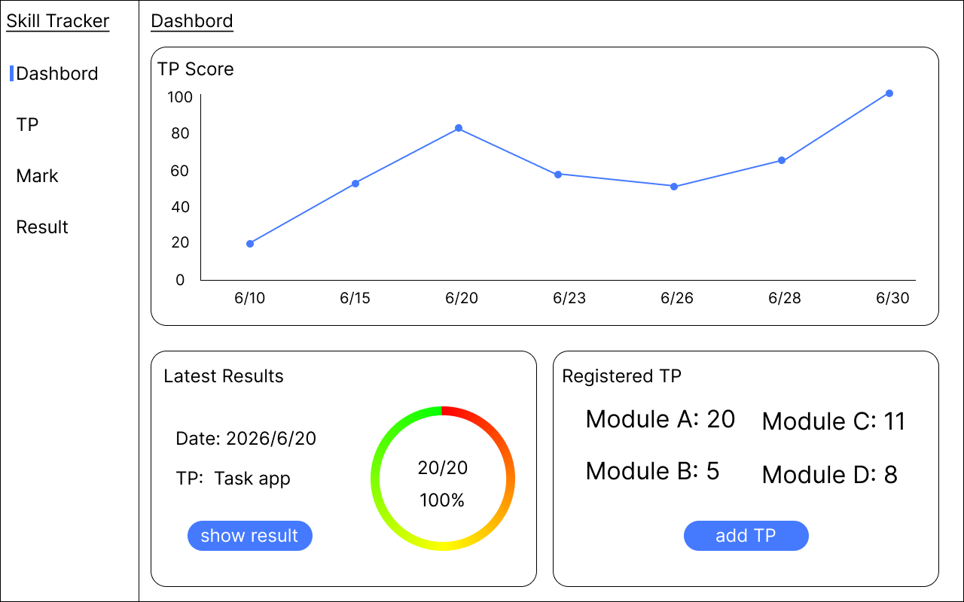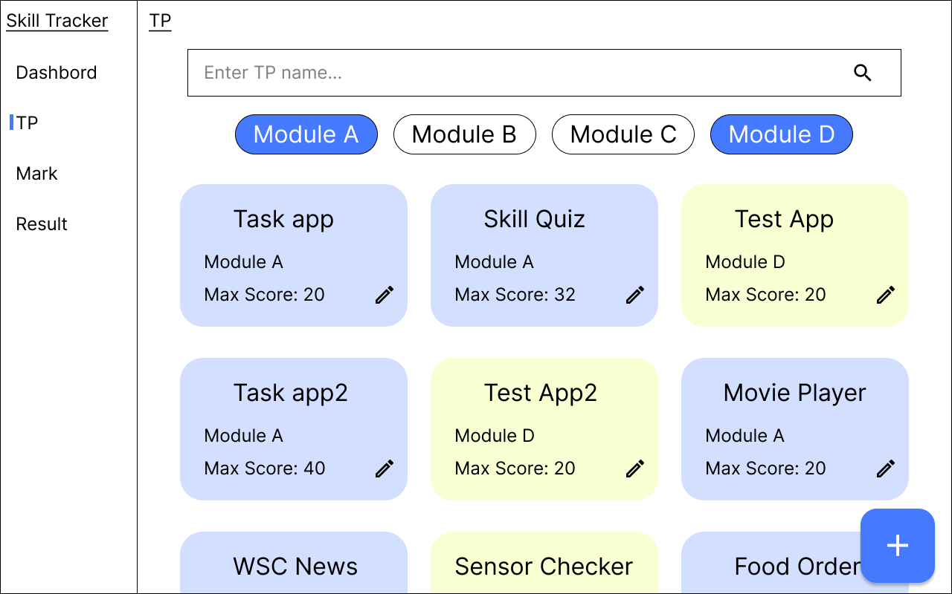
TP Page
Dashbord Page

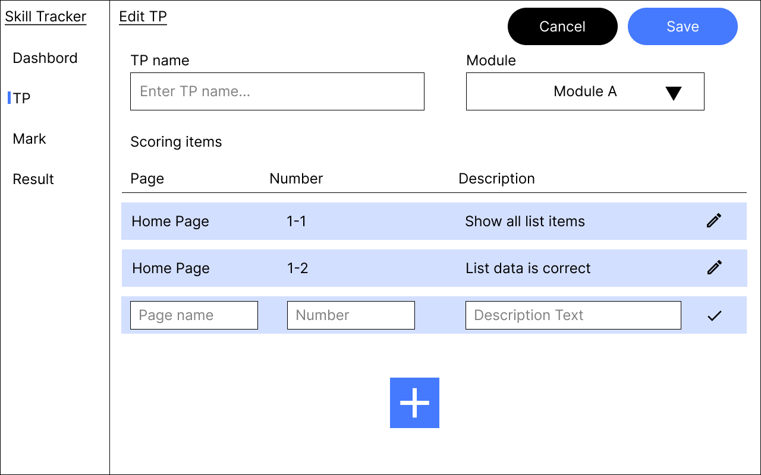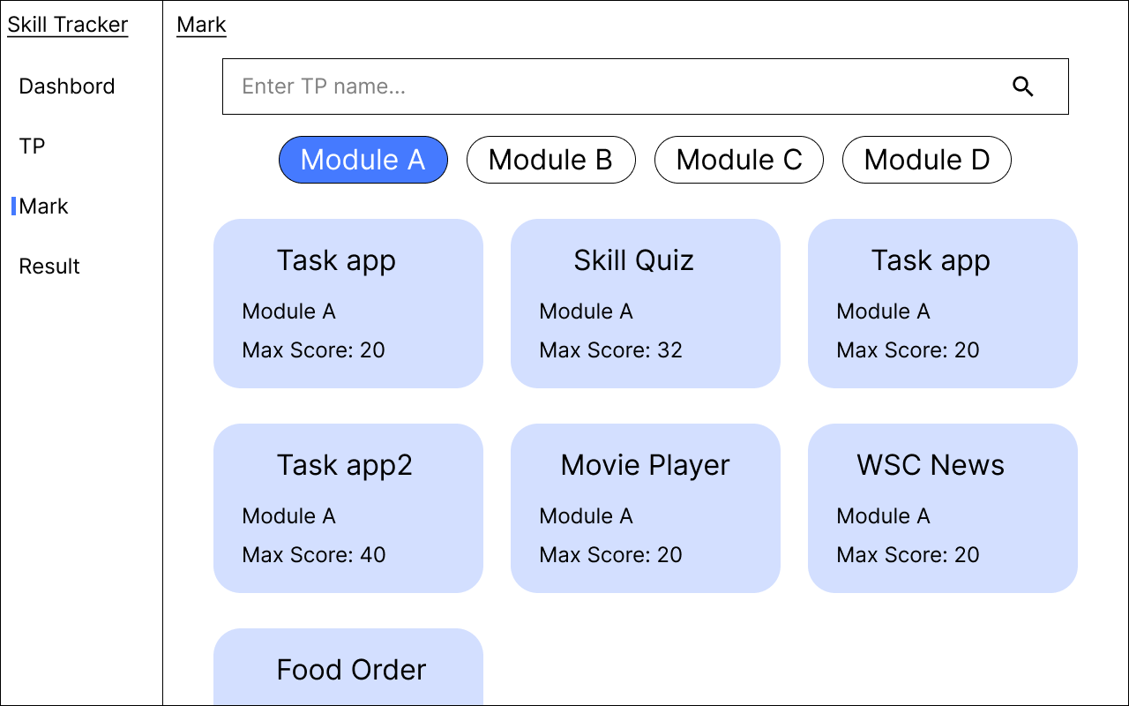
Mark List Page
Edit TP Page
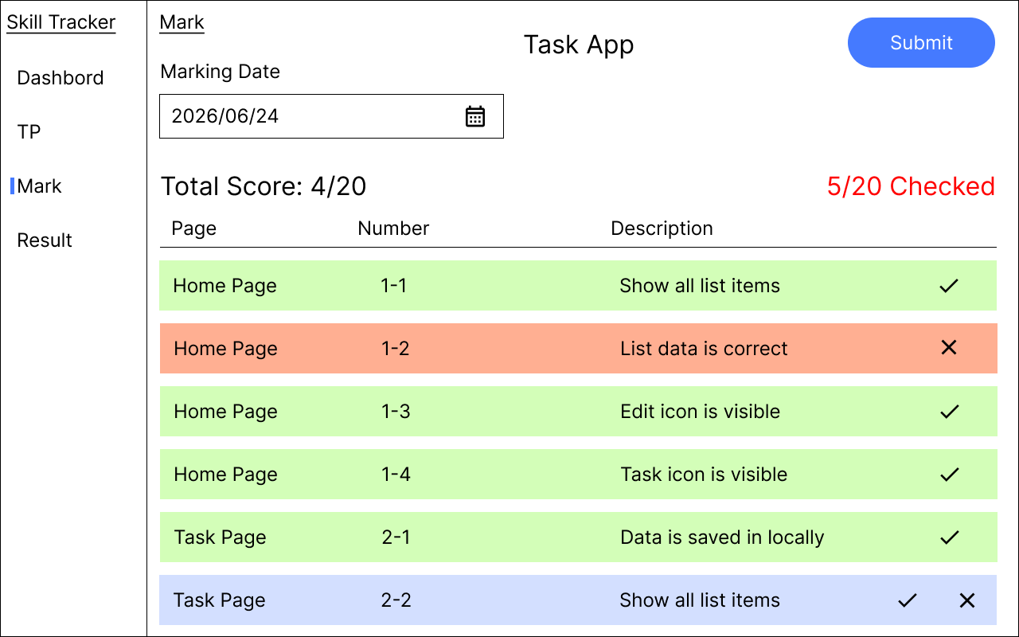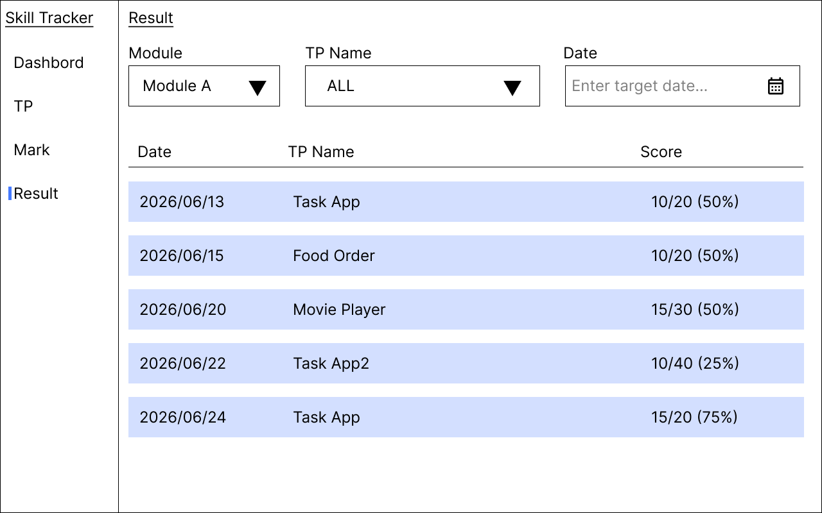
Result Page
Marking Page
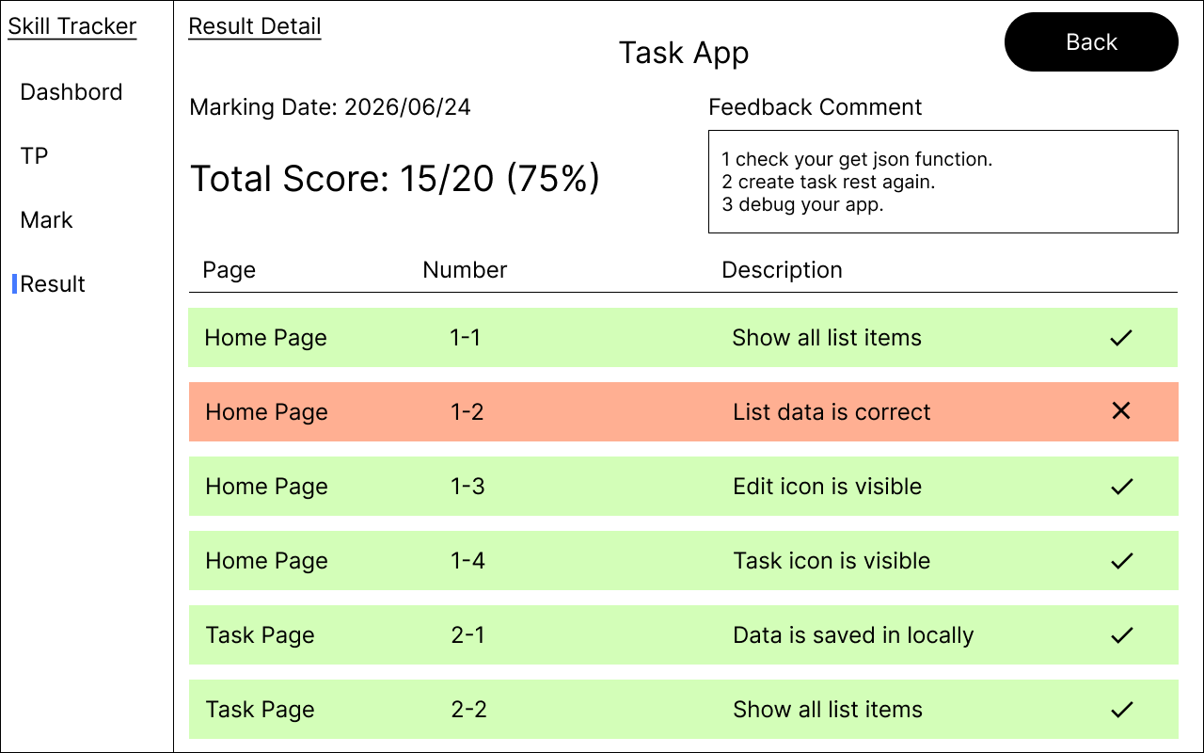
Result Detail Page

General Demands
- Terminate functionality of this application on request;
- All text enclosed in quotation marks must be the same as contained in the element;
- The application must display an application icon in the system launcher;
- All pages must display navigation rails;
- Click a navigation rail item to navigate to the corresponding page;
- “Dashboard”→Dashboard Page
- “TP”→TP Page
- “Mark”→Mark List Page
- “Result”→Result Page
- The selected navigation rail item is highlighted;

Page Demands

Dashboard Page
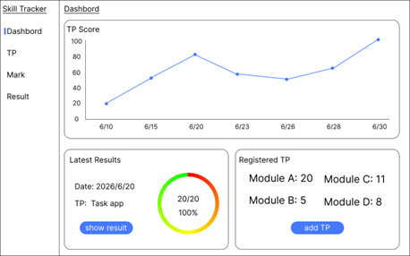

Elements include:
- Underlined title “Dashboard ”;
- Line chart area;
- TP Score text;
- 0~100 Vertical axis;
- Marking date horizontal axis;
- Score plot and line;
- Latest result area
- “Latest Results” text;
- Marking Date text;
- Tp name text;
- Gradient Circuler indicator, number of correct items, and accuracy rate text;
- "show result" button.
- Registered TP area
- "Registered TP" text;
- Text of the number of registered modules;
- "add TP" button

Functional requirements:
- All displayed data refers to data saved locally in device;
- Line chart shows all score data for the current month;
- Latest result area shows the latest score;
- Gradient Circuler indicator is graded from red to yellow to green according to the score obtained;
- Press the “show result” button to navigate to the corresponding Result Detail Page;
- The registered TP area shows the number of TP data registered for each module;
- Press the “add TP” button to navigate to the TP Page;

TP Page
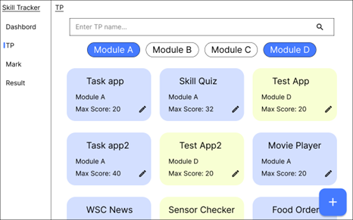

Elements include:
- Underlined title “TP ”;
- TP name Search Box;
- Module filter button;
- Registered TP list; Included in each item;
- TP name;
- Module;
- Maximum number of points;
- Edit icon button;
- FAB for adding data;

Functional requirements:
- The displayed data refers to data saved locally in device;
- TP list is displayed as a 3-column Grid List;
- The background color of the list item is changed by Modlue (the color is optional);
- When a value is entered in the search box, data that contains the characters entered in the TP name is filtered;
- When a module filter button is pressed, the TP of the corresponding module are displayed or hidden. (Multiple selections are possible);
- The selected module filter button is highlighted;
- All module filter buttons are selected by default;
- Press the Edit icon button of each list item to navigate to the corresponding Edit TP Page;
- When FAB for adding data is pressed, navigate to Edit TP Page;

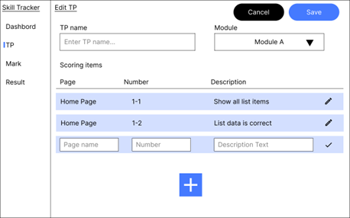
Edit TP Page

Elements include:
- Underlined title "Edit TP";
- "Cancel" button;
- "Save" button;
- TP name input box;
- Module selection drop-down;
- "Scoring items" text;
- List header; "Page”, "Number", "Description";
- List of scoring items; Included in each item;
- Page name;
- Item No;
- Scoring content;
- Edit icon button or check icon button;
- Add item button;

Functional requirements:
- When editing a registered TP is selected on the TP page, the TP name, Module, and scoring item list reflect the registered data;
- In the Module selection drop-down list, four items can be selected: “Module A ”,“ Module B,” “Module C,” and“ Module D”;
- When the Add Item button is pressed, the item is added to the scoring item list;
- The input box and check icon button for each item are displayed for the added item;
- When the check icon button is pressed, the item is registered and changes to the Edit icon button;
- When the item that is already registered is clicked, it changes to the Edit mode again;
- Pressing the “Cancel” button will discard all changes and navigate to the TP Page;
- When the “Save” button is pressed, the entered data is saved locally in device and navigate to the TP Page;

Mark List Page
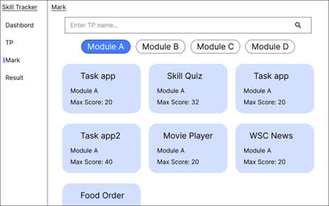

Elements include:
- Underlined title "Mark";
- TP name Search Box;
- Module filter button;
- Registered TP list; Included in each item;
- TP name;
- Module;
- Maximum number of points;

Functional requirements:
- The displayed data refers to the data saved locally in device;
- TP list is displayed as a three-column Grid List;
- The background color of list items is changed by Modlue (any color);
- When a value is entered in the search box, data containing the characters entered in the TP name is filtered;
- When a module filter button is pressed, the TP of the corresponding module are displayed or hidden. (Multiple selections are possible);
- The selected module filter button is highlighted;
- All module filter buttons are selected by default;
- Press each list item to navigate to the corresponding Marking Page;

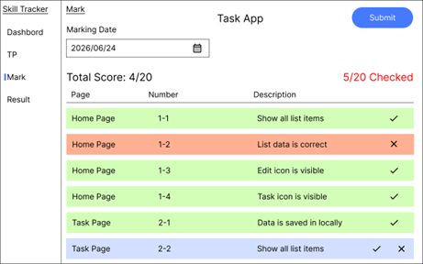
Marking Page

Elements include:
- Underlined title "Mark";
- TP name text;
- "Submit" button;
- Grading date input box with calendar icon;
- Number of scoring items text;
- Number of scorings completed text;
- List header; “Page”, “Number”, “Description”;
- List of scoring items; Included in each item;
- Page name;
- Item No;
- Scoring content;
- Check or × icon button

Functional requirements:
- Data displayed matches the task selected in Mark Page;
- Pressing the calendar icon launches the Date Picker Dialog where you can enter a date;
- Dates can also be entered directly into the input box;
- Dates are recognized correctly in any of the following formats;
- yyyy/MM/dd b) yyyy-MM-dd c) yyyyMMdd;
- The number of scoring items text shows the current number of scoring items and updates automatically based on the grading status;
- The number of scorings completed text shows the current number of scorings completed items and changes the text color according to the scoring status;
- Scoring not completed → Red b) All items scored → Yellow green
- The scoring item list shows all registered scoring items;
- By default, both the check icon and × icon are shown in the list, and the background color is blue;
- When the check icon is pressed, the item is registered as a correct answer, and the background color is green;
- When the × icon is pressed, the item is registered as an incorrect answer, and the background color is red;
- When you click an item that has already been scored, that item returns to its previous state;
- When the “Submit” button is pressed, the following operation is performed depending on the situation;
- No date has been entered or the scoring has not been completed → An error message is displayed;
- The date has been entered and all scoring items have been checked → A confirmation dialog box is displayed;
- The dialog box contains the following contents;
- Close icon button. When pressed, the dialog box closes;
- The text of the total score;
- The text of the scoring date;
- Feedback comment input box;
- “Submit” button;
- If you press the Submit button after entering a Feedback Comment, the scoring result will be saved locally in device and navigate to the Result Page;
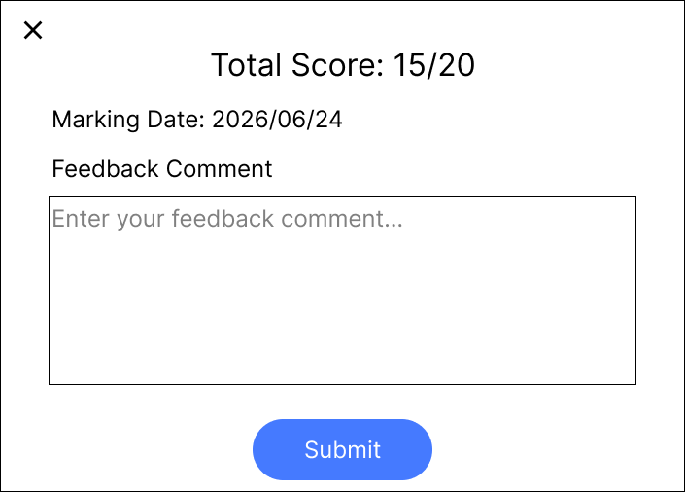
- If you have not entered a Feedback Comment, an error message will appear prompting you to enter one;

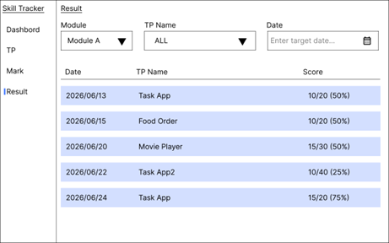
Result Page

Elements include:
- Underlined title "Result";
- Module selection drop-down;
- TP name drop-down;
- Date input box with calendar icon;
- List header; “Date”, “TP Name”, “Score”;
- Result list; Included in each item;
- Date;
- TP name;
- Points;

Functional requirements:
- The displayed data refers to the data saved locally in device;
- In the Module selection drop-down list, four items can be selected: “Module A “,” Module B”,” Module C”, and ”Module D”;
- “Moudle A” is selected as the Module by default;
- In the TP name drop-down list, the “All“ option and TP name candidates applicable to the selected Module can be selected;
- When the calendar icon is pressed, the Date Picker Dialg is launched and the date can be entered;
- The date can also be entered directly into the input box;
- The date is recognized correctly in any of the following formats;
- yyyy/MM/dd b) yyyy-MM-dd c) yyyyMMdd;
- Data is correctly filtered according to the selected filter conditions;
- Press a list item to navigate to the corresponding Result Detail Page;

Result Detail Page
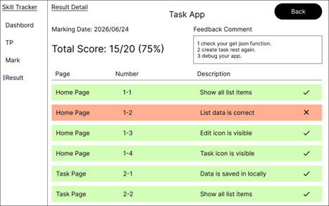

7.1 Elements include:
- Underlined title "Result Detail";
- TP name text
- "Back" button;
- Scoring date text;
- Total score;
- Feedback comment display area;
- List header; “Page”,” Number”; “Description”;
- List of scoring items; Included in each item;
- Page name;
- Item No;
- Scoring content;
- Check or × icon;

Functional requirements:
- Data displayed matches the task selected in Result Page;
- The TP name, scoring date, score, feedback comment, and result of each scoring item are displayed correctly;
- The background color and icon of the scoring item list change according to conditions;
- The corresponding item is correct → green background color and check icon;
- The corresponding item is incorrect → red background color and × icon;
- Feedback comments can be shared to another messaging app by dragging and dropping in split-screen mode;
- Click the “Back” button to return to the Result Page;

Instructions to the Competitor
- Create a project with the correct package name (Android)/organization identifier (iOS);
Naming convention: edu.ws2026.ma.pm
- Project should be saved in folder xx_Module_A_PM;
- The generated apk (Android)/app (iOS) files should be renamed to XX_Module_A_PM.apk (Android)/XX_Module_A_PM.app (iOS) and saved to the root of the XX_Module_A_PM folder;
- The entire XX_Module_A_PM folder should be pushed to the provided remote Git repository;
- Only works pushed to the remote Git server within the specified time will be marked;

Note:XX is the country code

