Test Project
  - Mobile Applications Development

Module B (PM) Functionality(Smartphone)

Submitted by: Ankur Sharma (Expert IN)

Introduction
ScholarMatch Foundation plans to launch an offline learning-network application ahead of the JP2026 Online Friendly Competition, connecting students, professionals and WorldSkills aspirants across participating countries so they can discover peer scholars, review their profiles and send connection requests without any internet connectivity.
Today, the Product Manager has provided you with the product wireframe for the Scholar Details screen. As a Mobile Applications Developer, your task is to develop the ScholarMatch smartphone application according to the specific development needs described in this document.

Description of project and tasks
You do not need to consider the program interface's aesthetics and the elements' position. The work can be inconsistent with the given wireframe, but you need to consider the ease of use.
Competition time: 2.5 hours
Marking Emulator:
- iOS: iOS 26 for Apple iPhone 17 (Simulator)
- Android: Android 16 (API 36) for Pixel 9 (Emulator)

Provided Material (media-files)
The following JSON data files are provided in the material. All application data must be read from these files. The structure of the files must not be modified.
File | Content
countries.json | List of countries (id, name, code) for the country filter.
skills.json | List of skills (id, name) for the skill filter and skill lookups.
scholars.json | 20 scholar records: identity, university, primary skill, skill match, availability, online status, profile image, field, location, badges, bio, learning goals, technical skills and competition history.
profile.json | The logged-in user's own profile (name, country, university, primary skill, avatar).
saved_scholars.json | Initial bookmark state (userId, scholarId pairs).
connection_requests.json | Initial connection-request state (id, toScholarId, status, purpose, message).

General Demands
- Finish the function of this application according to the demands;
- The application should remain in portrait orientation;
- The application needs to display the application name "ScholarMatch" in the operating system;
- The application needs to display an application icon in the operating system. You should use scholarmatch_icon.png in the material as the icon;
- Create two application shortcuts* that can navigate to the Saved Scholars page and the Profile page of the application on the icon of the launcher screen;
- The application must run entirely offline. All data must be read from the provided JSON files and local images in the material; no network calls, APIs, backend or AI tools are permitted.
*The shortcuts are the menu items when long-clicking the application icon.

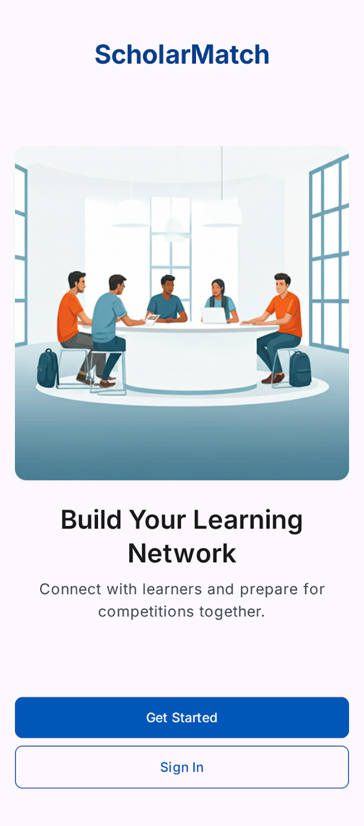
Splash Page
Elements include:
- Background/logo image;
- "ScholarMatch" text;
- Tagline text.
Functional requirements:
- On launch, display the splash screen with a fade-in animation (refer to the media file “FadeInAnimation”);
- After 2 seconds, navigate automatically:
  - On first launch, to the Onboarding page;
  - On subsequent launches, to the Login page.

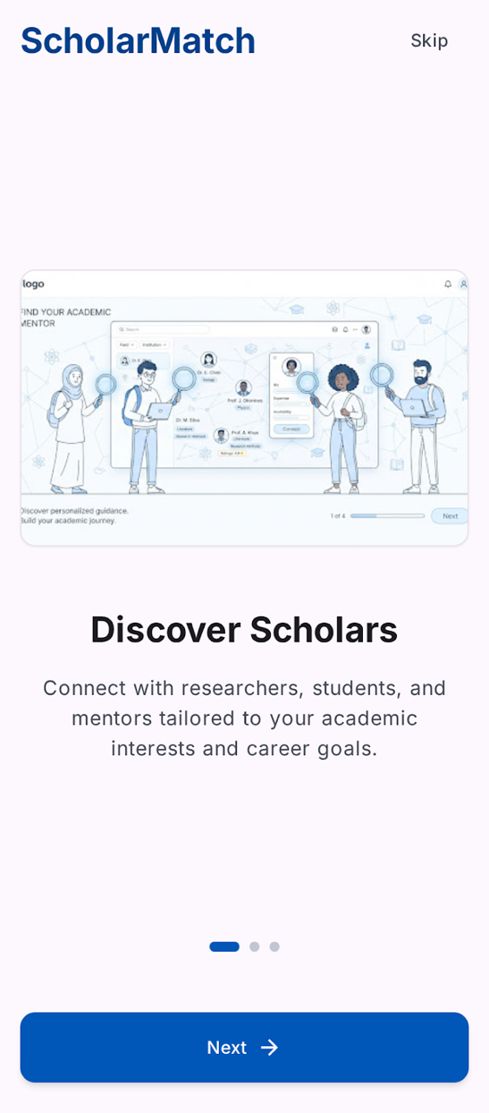
Onboarding Page
Elements include:
- Illustration for each page;
- Page text:
  - Page 1 – "Discover Scholars";
  - Page 2 – "Join Communities";
  - Page 3 – "Grow Together".
- Dots indicator;
- "Next" button;
- "Skip" button;
- "Get Started" button (page 3 only).
Functional requirements:
- Swiping, or clicking "Next", advances to the following page and updates the dots indicator;
- Clicking "Skip" navigates directly to the Login page from any onboarding page;
- Clicking "Get Started" on page 3 navigates to the Login page;
- Onboarding is shown only on first launch.

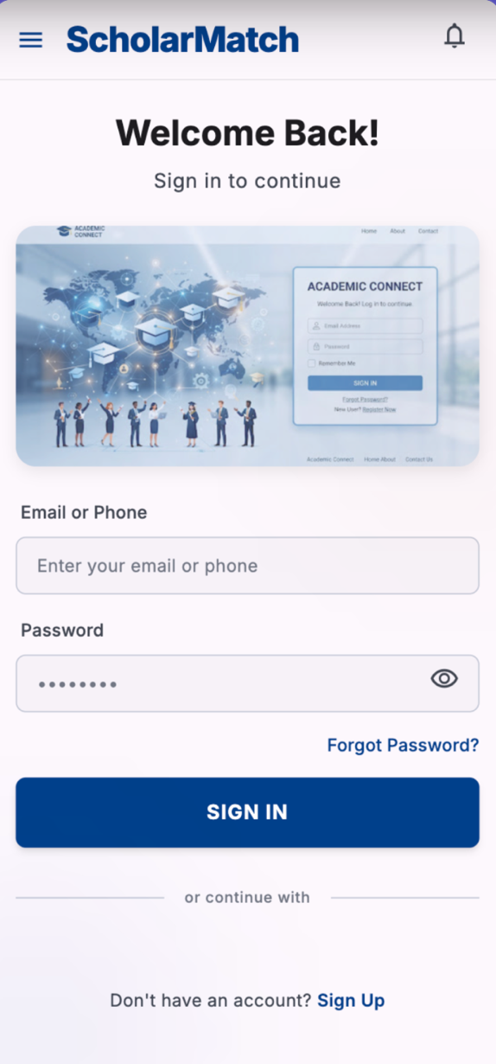
Login Page
Elements include:
- Email input box, hint text "Email";
- Password input box, hint text "Password";
- "Remember Me" checkbox;
- "Forgot Password" text link;
- "Sign In" button.
Functional requirements:
- Click the "Sign In" button:
  - If the email is not a valid email format, a prompt box will pop up with the message "Invalid email";
  - If the password is fewer than 6 characters, or does not contain at least one letter and one number, a prompt box will pop up with the message "Invalid password";
  - If both fields are valid, load the current user from profile.json and navigate to the Discover page.
- The "Forgot Password" link is present but does not need to be functional.

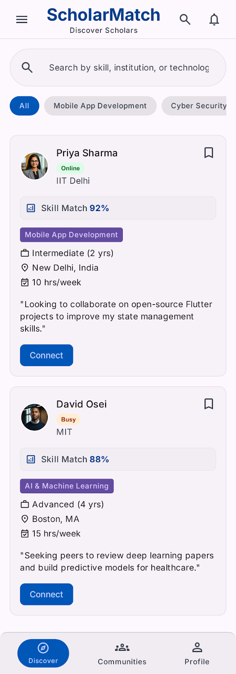
Discover Page (Home)
Elements include:
- Search input box, hint text "Search scholars";
- Country filter control;
- Skill filter control;
- Scrollable list of Scholar Cards, each containing:
  - Profile photo;
  - Name;
  - University;
  - Primary skill;
  - Skill Match percentage;
  - Online/availability status;
  - Bookmark icon;
  - "Connect" button.
Functional requirements:
- The scholar list is populated from scholars.json; the primary skill name of each card is resolved through skills.json;
- Typing in the search box filters the list in real time by name, country, university or skill;
- The country filter is populated from countries.json; selecting a country narrows the list to that country;
- The skill filter is populated from skills.json; selecting a skill narrows the list to that skill;
- Country filter and skill filter can be applied together;
- Clicking the bookmark icon on a card toggles its saved state without opening the scholar's details;
- Clicking anywhere else on a card navigates to the Scholar Details page for that scholar;
- When the filtered list is empty, display the text "No Search Results".

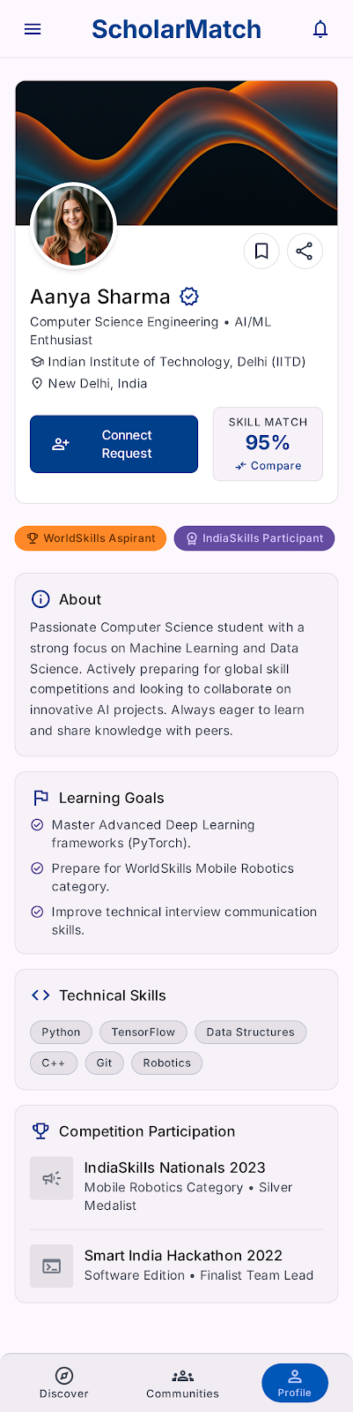
Scholar Details Page
Elements include:
- Cover/banner image;
- Circular avatar overlapping the bottom edge of the banner;
- Bookmark icon and Share icon (top right, over the banner);
- Name text with a verified badge icon;
- Field/branch text;
- University text with an institution icon;
- Location text with a pin icon;
- "Connect Request" button;
- "Skill Match XX%" card with a "Compare" link;
- Badge row (e.g. "WorldSkills Aspirant", "IndiaSkills Participant");
- "About" card containing a biography paragraph;
- "Learning Goals" card containing a checklist of items;
- "Technical Skills" card containing skill chips;
- "Competition Participation" card containing a list of past competitions, each with a title, category and result/role.
Functional requirements:
- All content on this page is read from the matching record in scholars.json (field, location, badges, bio, learningGoals, technicalSkills, competitionHistory);
- Clicking the bookmark icon toggles the saved state and stays synchronised with the Discover page;
- Clicking the Share icon copies the scholar's name to the clipboard and shows a snackbar "Profile copied";
- Clicking "Connect Request" opens the Connect bottom sheet (see next page);
- If a scholar record has an empty competitionHistory, the "Competition Participation" card is not displayed;
- Clicking the back control returns to the Discover page.

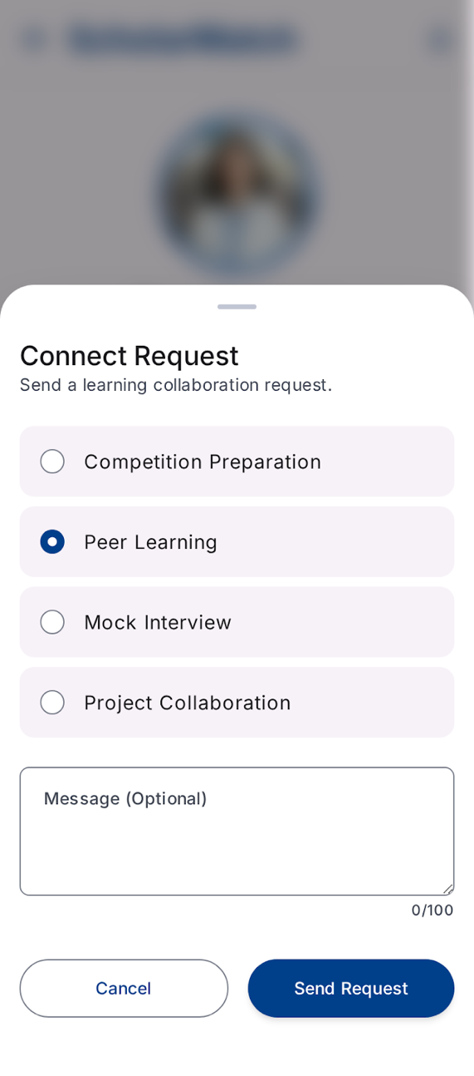
Connect (Bottom Sheet)
Elements include:
- Title text "Connect with Scholar";
- Purpose selector:
  - Competition Preparation;
  - Peer Learning;
  - Project Collaboration;
  - Mock Interview.
- Optional message input box, 100-character limit with a live counter;
- "Cancel" button;
- "Send Request" button.
Functional requirements:
- The "Send Request" button remains disabled until a purpose is selected;
- The message input box does not accept more than 100 characters;
- Clicking "Send Request":
  - Save the request (scholar id, purpose, message, status) to local storage, following the record structure of connection_requests.json;
  - Show a snackbar "Request Sent";
  - Close the bottom sheet;
  - Update the "Connect Request" button on the Scholar Details page to a disabled "Pending" state.
- Requests already present in connection_requests.json are shown in the "Pending" state when the application starts;
- Clicking "Cancel" closes the bottom sheet without saving anything.

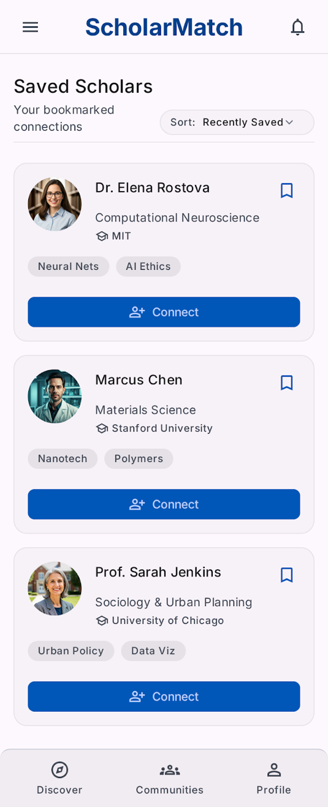
Saved Scholars Page
Elements include:
- List of bookmarked Scholar Cards (same component as the Discover page);
- Empty-state illustration and text "No Saved Scholars".
Functional requirements:
- The initial bookmark state is loaded from saved_scholars.json; afterwards the state is maintained in local storage;
- Display only scholars whose bookmark state is true;
- If no scholar is bookmarked, display the empty-state illustration and text;
- Clicking a card navigates to the Scholar Details page for that scholar.

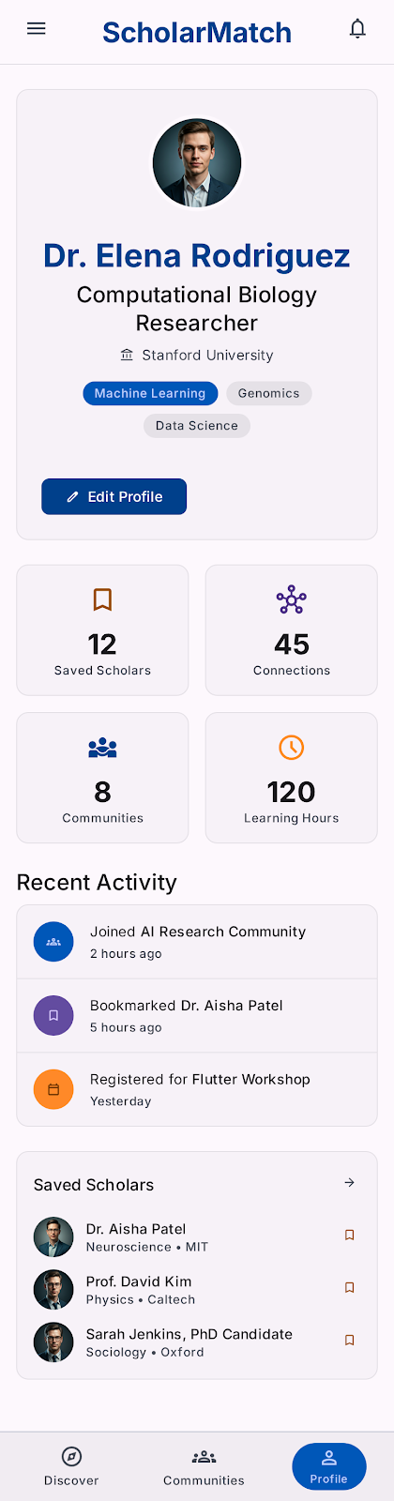
Profile Page
Elements include:
- Avatar;
- Name;
- Country;
- University;
- Statistics row:
  - Saved Scholars count;
  - Connections count;
  - Learning Hours.
- "Sign Out" button.
Functional requirements:
- Avatar, name, country and university are read from profile.json;
- Saved Scholars count and Connections count are computed from the current local storage state;
- Clicking "Sign Out" clears the session and navigates to the Login page.

Instructions to the Competitor
- Create a project with the correct package name (Android)/organization identifier (iOS);
- Naming convention: edu.jp2026.mb.pm
- Project should be saved in folder XX_Module_B_PM;
- The generated apk (Android)/app (iOS) files should be renamed to XX_Module_B_PM.apk (Android)/XX_Module_B_PM.app (iOS) and saved to the root of the XX_Module_B_PM folder;
- The entire XX_Module_B_PM folder should be pushed to the provided remote Git repository;
- Only works pushed to the remote Git server within the specified time will be marked;

Note: XX is the country code

