ModuleC MO

HP Riddle
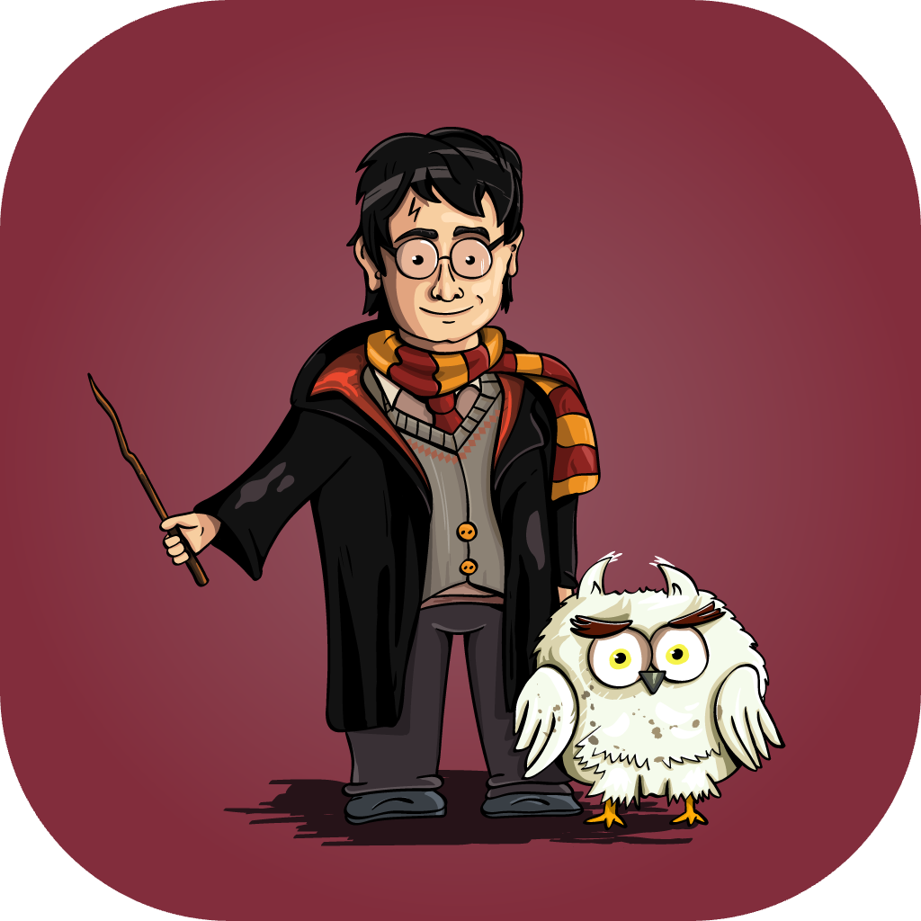

Introduction

HP Riddle is an interactive trivia app for Harry Potter fans of all ages. Choose the favorite book from the series, and the game will generate a tailored set of questions based on that specific installment.

The designer has provided you with product prototypes. As a mobile application developer, your task is to develop the corresponding app in strict accordance with the requirements of the prototype and the videos.

Emulator
Android 16(API 36) for AVD Pixel 2 or
iOS 26 for iPhone 14

Module Time
2.5 hours
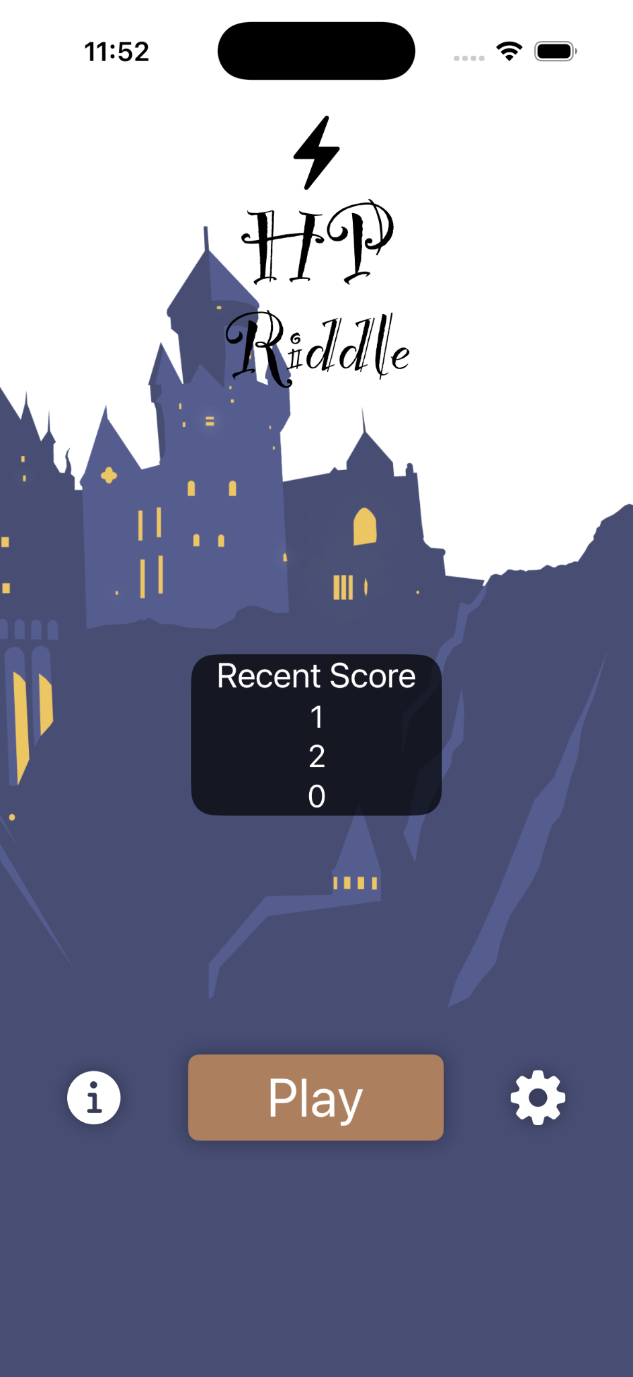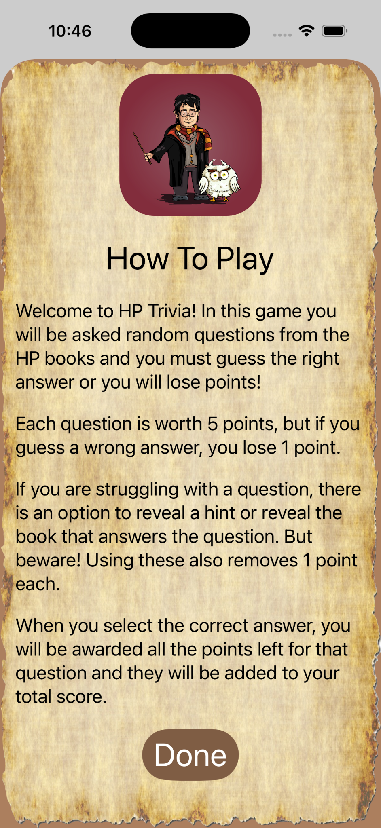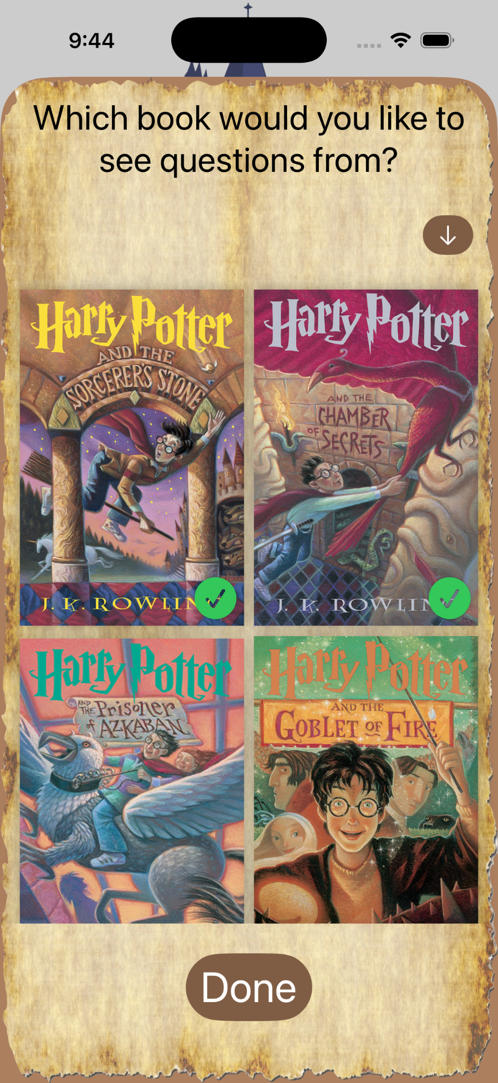

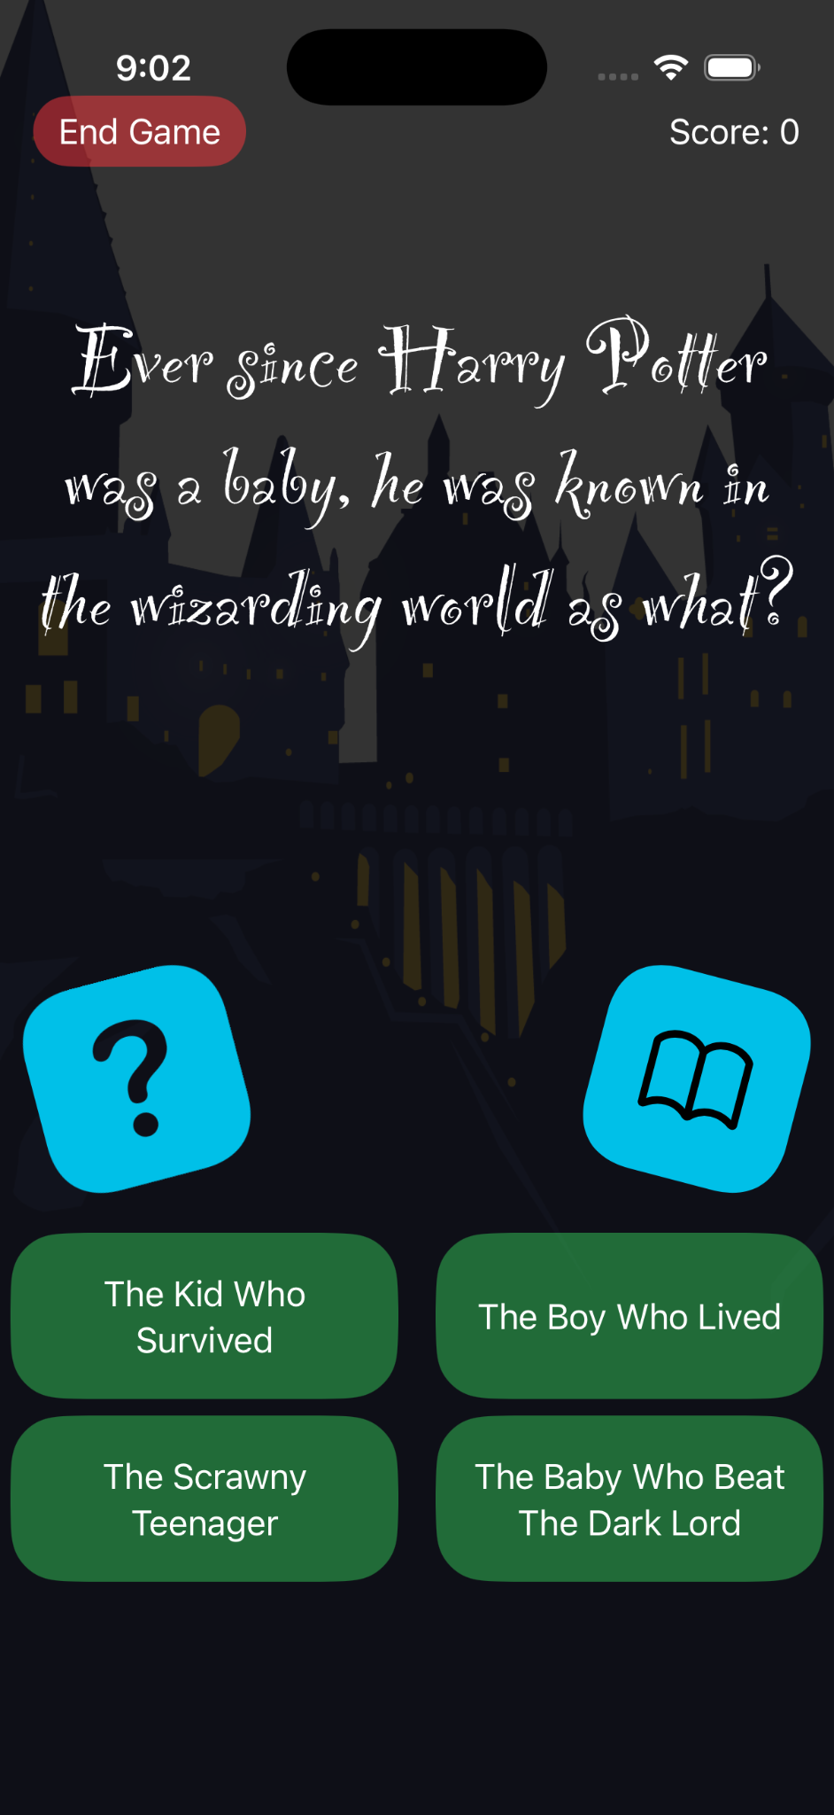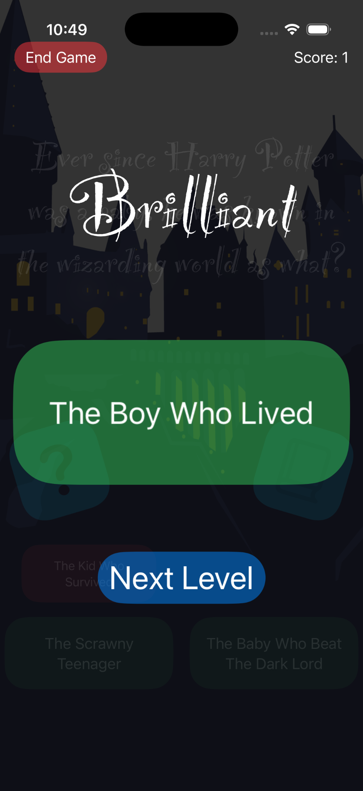

General Demands

- All animation effects should be developed to match those shown in the videos;
- The appearance must strictly follow the details of the prototype. Functions not mentioned in the description do not need to be implemented;
- Use the provided font consistently throughout the application;
- The application display the application icon using the file "appicon.png";
- The application name shown in the operating system must be "HP Riddle".

Pages Demands

Home page
Elements include:  - Title "HP Riddle;  - "Recent Score" area with fixed score "1", "2" and "0";  - "How To Play" icon (info_circle.png);  - "Play" button;  - "Select Book" icon (settings.png);  - Background image (hogwarts.png). | 

Functional requirements:
- When entering the page, play the background music (magic-in-the-air.mp3);
- Play the title "HP Riddle" enter animation appear with a 3-seconds delay (1.1-gameplay_enter.mov);
- Play the "Play" button enter animation with a 3-seconds delay (1.1-gameplay_enter.mov);
- Play the "How To Play" icon enter animation (1.1-gameplay_enter.mov);
- Play the "Select Book" icon enter animation (1.1-gameplay_enter.mov);
- Play the "Recent Score" area enter animation (1.1-gameplay_enter.mov);
- The animation plays in the following order (1.1-gameplay_enter.mov):
  - Title "HP Riddle" enter animation and "Play" button animation;
  - "How To Play" icon enter animation and "Select Book" icon enter animation;
  - "Recent Score" area enter animation.
- The background image has a looping moving animation (1.2-gameplay_background_moving.mov);
- The "Play" button has a looping scales up and down animation (1.3-gameplay_button.mp4);
- Clicking the "How To Play" icon go to "How to play page";
- Clicking the "Select Book" icon go to "Select book page".

How to play page
Elements include:  - Background Image(parchment.png) and background color (brown);  - Image "appiconwithradius.png";  - Title "How To Play";  - 5 lines of text are loaded from a JSON file (how-to-play.json);  - "Done" button. | 

Functional requirements:
- This page appears as a sheet or an alert dialog;
- Clicking the "Done" Button back to the "Home page".

Select book page

Elements include:  - Background Image(parchment.png) and background color (brown);  - Title "Which book would you like to see questions from?";  - Toggle books order button;  - Display all 7 book images, loaded from a JSON file (books.json);  - Each book has a selectable checkbox;  - "Done" Button. | 

Functional requirements:
- This page appears as a sheet or an alert dialog;
- When first entering this page, The checkboxes for Book 1 (id:1) and Book 2 (id:2) are selected by default;
- Each time the "Toggle books order button" is clicked, the books are re-sorted in ascending or descending order based on their IDs;
- Play the animation when the books are re-sorted (3.1-select_book_resort.mov);
- Clicking each active book toggles its checkbox state;
- Book 7 (id:7) is inactive. Inactive books are displayed with a transparency effect;
- Clicking an inactive book displays an alert dialog with the message "Please purchase this book first.";
- If no book is selected, the text "You must select at least 1 book." appears, the "Done" button becomes disabled, and user cannot leave this page;
- The checkbox states of all books are saved, and when returning to this page, the previous checkbox states are preserved;
- Clicking the "Done" Button back to "Home page".

Game play page

Elements include:  - "End Game" button;  - "Score: X" text;  - Random question from a JSON file (riddle.json);  - Question mark button (question.png) and reveal button (book.png);  - 4 answer buttons and the corresponding answer text for the question;  - Background image with opacity (hogwarts.png). | 

Functional requirements:
- 4 answer buttons and their text from a JSON file (riddle.json) and randomize their order;
- All questions are fetched only from the book(s) selected on the "Select book page";
- When entering the page, the question text play an enter animation (4.1-gameplay_enter.mov);
- Play 4 answer buttons enter animation (4.1-gameplay_enter.mov);
- Play question mark button and reveal button enter animations (4.1-gameplay_enter.mov);
- The animation plays in the following order (4.1-gameplay_enter.mov):
  - question text enter animation;
  - 4 answer buttons enter animation;
  - question mark button and reveal button enter animations.
- Question mark button and Reveal button with looping shaking animation (4.2-gameplay_shaking.mp4);
- Clicking the question mark button has the following effects:
  - Play the sound (page-flip.mp3);
  - Play the animation (4.3-gameplay_questionmark.mov);
  - Hide the question mark button and display the question's corresponding hint text.
- Clicking the reveal button has the following effects:
  - Play the sound (page-flip.mp3);
  - Play the animation (4.4-gameplay_book.mov);
  - Hide the reveal button and display the question's corresponding book image.
- Clicking any incorrect answer button has the following effects:
  - Play the sound (negative-beeps.mp3);
  - Play the animation (4.5-gameplay_wrong_answer.mov);
  - The incorrect answer button changes to a red background and scales down.
- Clicking the correct answer button has the following effects:
  - Play the sound (magic-wand.mp3);
  - Play the animation (4.6-gameplay_wrong_answer.mov);
  - Go to "Next level page";
- Clicking "End Button" back to the "Home page".

Next level page
Elements include:  - "End Game" button;  - "Score: X" text;  - "Brilliant" text;  - The text of the answer to the question;  - "Next Level" button;  - Background image with opacity (hogwarts.png). | 

Functional requirements:
- When entering the page, the text "Brilliant" and text "1" play a enter animation (5.1-next_level_enter.mov);
- Play the text "1" moves to the location of "Score X" animation (5.1-next_level_enter.mov);
- Upon completion of the animation where the text '1' moves to the location of "Score: X", the text "Score: X" is updated to "Score: X+1";
- Play the button "Next Level" enter animation (5.1-next_level_enter.mov);
- The animation plays in the following order (5.1-next_level_enter.mov):
  - Text "Brilliant" and Text "1" enter animation;
  - Text "1" move to the location of "Score X" animation;
  - Button "Next Level" enter animation;
- The "Next Level" button looping scales up and down animation (5.2-next_level_button);
- Clicking "Next Level" back to the "Game play page" and shows a question that has not been used before;
- Clicking "End Button" back to the "Home page".

Instructions to the Competitor

1. You need to compress the dedicated files and related resource files into XX_Module_C.zip, export
the mobile application as XX_Module_C.apk (for Android) or XX_Module_C.ipa/XX_Module_C.app
(for iOS) executable files, and finally place them into the XX_Module_C folder.
2. The entire XX_Module_C folder should be pushed to the provided remote Git repository.

Note: XX refers to your country code.

