Test Project
Mobile Applications Development
Module C (Tablet)
Duration: 2.5 hours

Mission Background
During the upcoming WorldSkills 2026 competition, the Chief Expert needs a tablet app to manage and display the countdown for TP reading, expert communication, and module competition time. The app must work as a reliable workshop timer, be readable from a distance, prevent the tablet from sleeping during active timing, and show clear visual feedback when a countdown ends.
The product owner has requested a tablet-first countdown timer named Skill08 Timer. Your task is to build this timer app according to the provided requirements. The app theme must remain a competition countdown / alarm tool.

Task Description
Develop a tablet application that allows the Chief Expert to prepare a Day Plan, add countdowns from preset timers, start, pause, and reset the selected countdown, enter a full-screen display mode, and show a polished time-expired effect.
Component | Marking Devices
Module C | Emulator：  iPad Simulator (11” or above) / Android tablet emulator (8” or above)

Screen | Purpose
Main Console | Shows the Day Plan, circular countdown, session details, and timer controls.
Add Countdown Sheet | Lets the user choose a preset countdown using a coverflow-style picker.
Manage Presets Sheet | Lets the user create, edit, and remove preset timer definitions.
Full-Screen Countdown | Hides panels and enlarges the active countdown for display use.
Time Expired Overlay | Shows the end animation and reset action when the countdown reaches zero.

Reference Screenshots
The following screenshots were captured from the provided iOS project running on the tablet Pro 11-inch Simulator.

Figure 1. Main Console
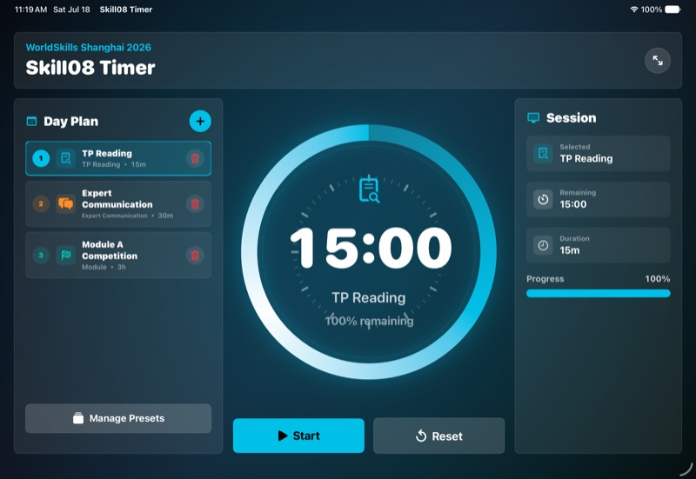
Main Console screenshot

Figure 2. Add Countdown Coverflow
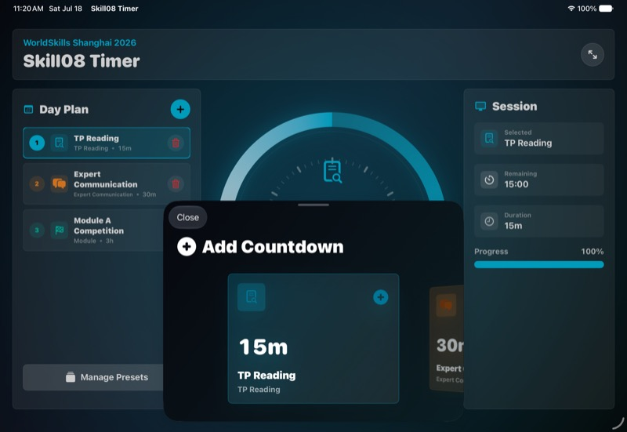
Add Countdown coverflow screenshot

Figure 3. Manage Presets Coverflow
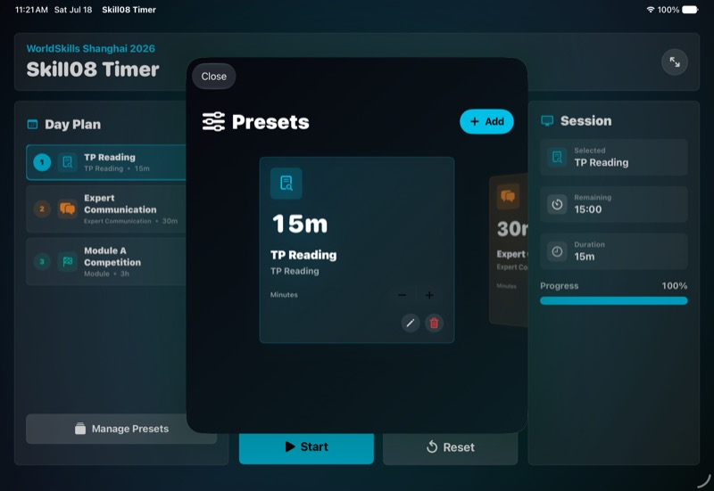
Manage Presets coverflow screenshot

Figure 4. Full-Screen Countdown
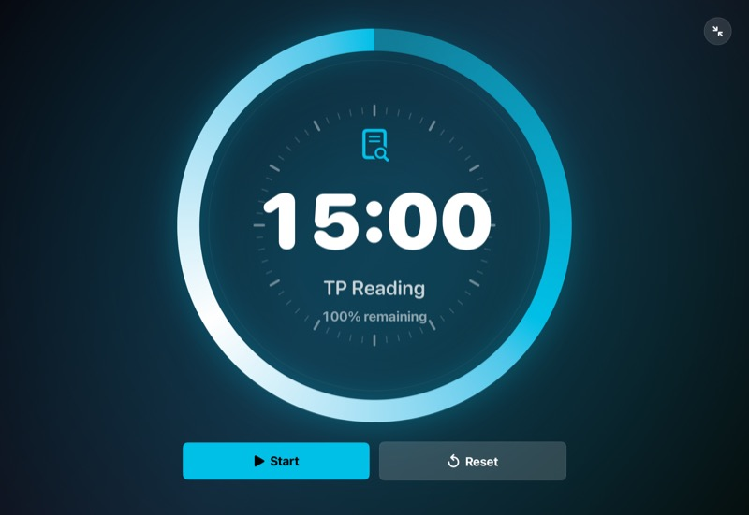
Full-screen countdown screenshot

Figure 5. Running Countdown Animation
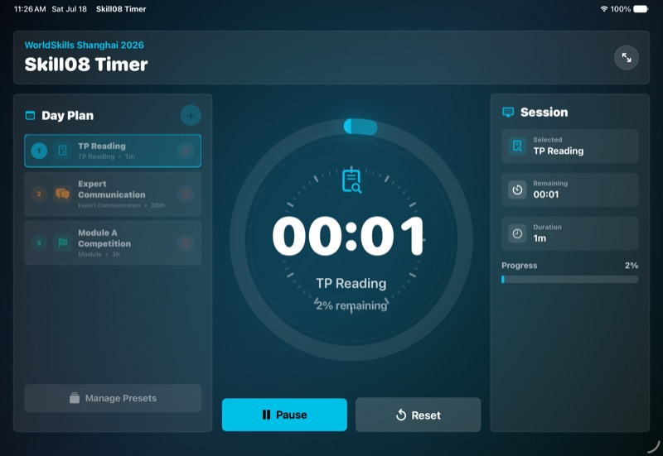
Running countdown animation screenshot

Figure 6. Time Expired End Animation
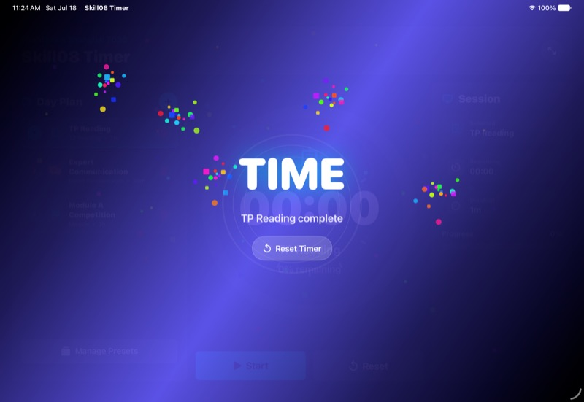
Time expired end animation screenshot

Provided Materials
All supplied files are located in the materials/ folder.
File | Purpose
preset-timers.json | Default preset names, categories, and durations.
app-icon.png | Provided app icon file. Candidates must use this file as the tablet app icon.

Timer Categories
The app must support exactly four preset categories. Each category must have a distinct accent colour and may use an emoji as its visual icon.
Category | Accent Colour | Emoji / Icon Example | Example Use
TP Reading | Cyan | 📄 Document | TP reading and preparation countdowns.
Expert Communication | Orange | 💬 Speech Bubble | Expert briefing, clarification, and communication time.
Module | Mint / Green | 🏁 Flag | Module A, B, C, or D competition countdowns.
Misc | Pink | 🧩 Puzzle | Breaks, setup time, buffer time, or other workshop countdowns.

General Requirements
- All text enclosed in double quotes in this test project must be displayed exactly, including spelling and capitalization.
- The app must be designed for tablet landscape use and must not feel like a phone app enlarged onto a tablet.
- The interface must be clear enough for live workshop operation, with large touch targets and readable timer information.
- The app must run smoothly without visible lag during countdown, panel animation, coverflow browsing, or the end animation.
- The app must not require network access for its core timer, preset, or day plan functionality.
- The default preset library and default Day Plan must include TP Reading with a duration of 15 minutes.
- The four preset categories must remain visually distinguishable by colour and icon throughout the app.
- Every countdown must support Start, Pause, and Reset controls.
- The submitted app must use the provided materials/app-icon.png file as its app icon.
- Timer editing, Day Plan editing, preset editing, and preset selection must be locked while a countdown is running.
- The visual representation of the produced app must look similar with the provided screens. Variations in colours and icons are accepted.
- Any changes in day plan or preset (including insert/edit/delete ) must be persisted and could be retrieved after restarting the app.

Page Requirements

1. Main Console Page
Element Requirements:
- Top panel:
  - "WorldSkills Shanghai 2026" label.
  - "Skill08 Timer" title.
  - Full-screen toggle button.
- Day Plan panel on the left side. (Details refer to 2. Day Plan Panel)
- Main Panel:
  - Countdown view in the centre.
  - Start / Pause button.
  - Reset button.
- Session details panel on the right side.
  - “Session” title with item.
  - A cell showing the name of selected category.
  - A cell showing the remining time.
  - A cell showing the duration of the time.
  - A progress bar showing the progress of the countdown with percentage value.

Functional Requirements:
- The default active countdown is “TP Reading” with a duration of 15 minutes.
- The Session panel must show the selected countdown name, remaining time, total duration, and progress percentage.
- Clicking Start begins the countdown and disables the tablet idle timer.
- A set of animation must be shown while counting down (Details refer to 5. Count Down Animation and Time Behaviour)
- Clicking Pause pauses the countdown, keeps the remaining time, and re-enables normal idle timer behaviour.
- Clicking Reset restores the selected countdown to its full duration.

2. Day Plan Panel
Element Requirements:
- “Day Plan” title.
- Add countdown icon button at the top-right of the Day Plan panel.
- Countdown rows showing
  - order number,
  - icon,
  - preset name,
  - category,
  - duration, and
  - remove button.
- “Manage Presets” button at the bottom of the panel.

Functional Requirements:
- The Day Plan must list multiple countdowns in a clear order.
- Clicking the top-right add button opens the Add Countdown Sheet.
- The panel must not include a second large “Add Countdown” button at the bottom.
- Clicking a Day Plan row makes that countdown the active timer.
- Clicking the remove button removes that countdown from the Day Plan before the timer starts.
- Removing a selected Day Plan item must safely select another countdown or leave no Day Plan selection without crashing.
- If there is only one counter item left, that item could not be deleted. (At least one item in the list)
- Clicking “Manage Presets” opens the preset management sheet.

3. Add Countdown Sheet and Preset Coverflow
Element Requirements:
- “Add Countdown” title with icon.
- Preset cards for TP Reading, Expert Communication, Module, and Misc categories.
- A list of preset. Each card must show (rendered in the corresponding category colour)
  - preset name,
  - category,
  - duration, and
  - emoji icon.
- A close button.
Functional Requirements:
- Presets must be browsed using a coverflow-style horizontal card carousel, not a plain vertical list.
- The focused preset card must appear larger and visually closer than the side cards.
- Side cards must remain partially visible and use scale, opacity, or 3D rotation to create the coverflow effect. (5-coverflow.mp4)
- Swiping or dragging through presets must animate smoothly and snap the nearest card into the focused position. (5-coverflow.mp4)
- Choosing a focused preset adds a new countdown to the Day Plan and makes it active.

4. Manage Presets Sheet
Element Requirements:
- “Presets” title with icon.
- Add preset button with icon.
- Preset editing form (show after clicking the add button).
  - Input name of the preset
  - Category choices: TP Reading, Expert Communication, Module, and Misc, each with its assigned colour and emoji icon.
  - Duration input or stepper.
  - Save / cancel button.
- A list of presets. Each card must show (rendered in the corresponding category colour)
  - preset name,
  - category,
  - duration
  - emoji icon, and
  - edit and delete controls.

Functional Requirements:
- The user can add new presets.
- The user can edit preset name, category, and duration.
- The user can delete presets when more than one preset remains.
- Present the list of presets in cloverflow style with animation and snaping (5-coverflow.mp4).
- Changes to a preset must update any Day Plan rows that reference that preset. If there is only one preset left, that preset could not be deleted.
- If there is only one item in the day plan list, the preset of that particular item could not be deleted. (e.g. There is only one “TP Reading” left at the Day Plan panel. The TP Reading preset could not be delete.)
- Preset management must not accidentally start, pause, or reset the active countdown.

5. Countdown Animation and Timer Behaviour
Element Requirements:
- Large numeric countdown using HH:MM:SS or MM:SS.
- Circular progress ring.
- Remaining percentage text.
- Selected countdown name.
- Category emoji icon and colour accent.
- Tick marks (visually differentiates hour markers (total: 12) and minute markers (total: 48)).

Functional Requirements:
- The circular progress ring must animate continuously from full to empty as time decreases.
The related textual displays must update the number with respect to the remaining time. (2-countdown-animation.mp4)
- Also, the “Session Panel”’s progress bar also show the decreasing processing with animation. (2-countdown-animation.mp4)
- Pause must freeze the ring and numeric countdown at the same remaining time.
- Resume must continue from the paused remaining time.
- Reset must return the ring and numeric countdown to 100 percent remaining.
- Selecting a different Day Plan countdown must update the timer display before countdown starts.

6. Full-Screen Show / Hide Panel Animation
Element Requirements:
- Exit full-screen button.

Functional Requirements:
- Press the full-screen button at the top-left corner will trigger the full-screen mode.
- Entering full-screen mode must move the top panel upward, the left panel to the left, and the right panel to the right. (4-fullscreen-animation.mp4)
- The centre countdown must expand smoothly into the available space.
- Exiting full-screen mode must reverse the animation: top panel returns from the top, left panel returns from the left, and right panel returns from the right.
- Full-screen mode must hide the tablet status bar and restore it when exiting full-screen mode.

7. Time Expired End Animation
Element Requirements:
- Full-screen time-expired overlay.
- Selected countdown name.
- Clear "Time" or equivalent end state.
- Reset action.

Functional Requirements:
- When the countdown reaches zero, the app must show a fancy looped end animation. (3-timesup.mp4)
- The end animation must include at least two visual layers, such as confetti, particle burst, glow, pulse, scale, blur, or colour wash.
- The animation must clearly cover the main timer area.
- The end state must stop the idle timer lock and allow the tablet to return to normal sleep behaviour.
- The reset action must dismiss the overlay and restore the selected countdown.

Submission Guidelines
- Build the completed work as a runnable tablet executable in either .app or .apk format.
- Create an XX_ModC_Tablet folder and save all work inside it, where XX is the workstation code.
- The XX_ModC_Tablet folder must project folder and any installable build artifact available in the competition environment.
- Compress the project folder and rename it into XX_ModC_Tablet.zip and then push it to the given Git repository.

