
Test Project
Module D Development and Testing
Day 4 PM
Mobile Applications Development

Contents
Contents 2
Introduction 3
Description of project and tasks 3
General Demands 3
Develop by Test Case 5
Automated Test 8
Instructions to the Competitor 10
Automated Test Guide 11

Introduction
FIFA World Cup Fan Services is rolling out a suite of companion applications to help travelling supporters navigate host cities, follow their favourite teams, and attend matches with ease.
This module focuses on GoalPass, a fan companion app that lets supporters browse the match schedule, explore stadium seat availability in real time, reserve match tickets, and manage their bookings across the tournament.
In this module, you need to develop the basic App functional logic and write automated test scripts to run the App.

Description of project and tasks
You should push the full project and an installable apk (Android) or app (iOS) package to Git Server.

Marking Emulator:
- iOS: iPhone 15
- Android: Pixel 8

The wireframes are for reference only. You do not need to replicate the exact appearance, colors, decorative icons/images, or elements' positions/styles.

General Demands
- All data you need are in media-files/goalpass.json.
- Your application functions should be developed according to all test cases (Form 1.1/1.2/1.3) and the automated function test case (Form 2.1).
- User preferences (Favourite team alerts, Fan Zone Pass default, Remember Payment Method) must be persisted so they survive app restarts.

Alert Dialogs:

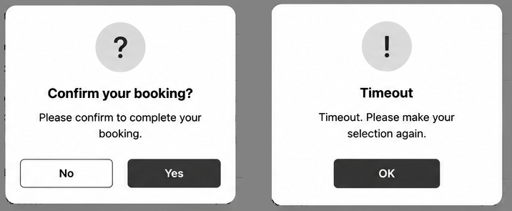

Screens:
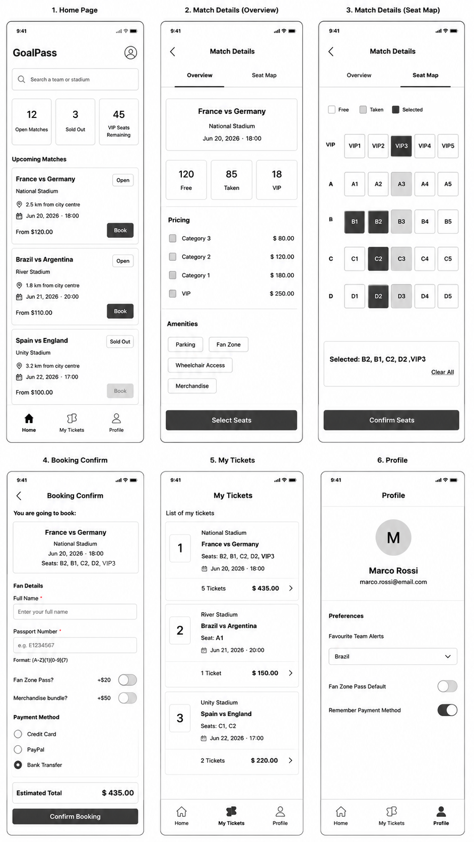

Develop by Test Case
Develop the application by understanding the test cases.

FORM 1.1: APPLICATION UI TEST CASE
No. | Area | Demands
1 | Home page | 1. The title bar displays the app name "GoalPass" and a profile icon in the top right corner;  2. The homepage contains a search bar, an availability summary row, and a scrollable list of upcoming matches;  3. The search bar displays the hint text "Search a team or stadium" – supports partial match (non case-sensitive);  4. Keyboard IME action shall be Search.  5. The availability summary row shows counts for: Open Matches, Sold Out, and VIP Seats Remaining;  6. Each match list item includes: Match name; Stadium name and distance ("X.X km from city centre"); Kickoff date and time; Ticket price from ("From $X.XX"); Status badge ("Open" / "Sold Out"); Book button;  7. Tapping the Book button of a match list item navigates to the corresponding Match Details page (only data with match_id 2026001 and 2026008 need to be implemented);  8. A bottom navigation bar is present with tabs: Home, My Tickets, Profile;  9. Tapping the profile icon in the top right corner navigates to the Profile page.
2 | Match Details (top bar and tabs) | 1. The title bar contains a back button and the text "Match Details";  2. Tapping the back button navigates to the previous page (Home);  3. Two tabs are present to navigate between sub-pages: Overview and Seat Map.
2.1 | Match Details page (Overview) | 1. The availability summary row shows three counters: Free, Taken, VIP;  2. The Pricing area includes:  (a) Title - "Pricing";  (b) A list of ticket categories (Category 3, Category 2, Category 1, VIP);  (c) Each pricing row displays the category label and the formatted price "$ X.XX".  3. The Amenities area includes filter chips (e.g. Parking, Fan Zone, Wheelchair Access, Merchandise) - active amenities are visually highlighted;  4. A "Select Seats" button navigates to the Seat Map tab.
2.2 | Match Details page (Seat Map) | 1. A grid of seats is displayed, with each seat cell showing its seat ID (e.g. "A1", "VIP3");  2. Each seat is visually distinguished by status using colour or icon: Free, Taken  3. A legend is displayed indicating the meaning of each seat status;  4. Tapping a Free or available VIP seat selects it; a summary card below the grid updates to show "Selected: [Seat ID, Seat ID, ...]" listing every currently selected seat;  5. Tapping an already-selected seat deselects it and removes it from the summary card (if it was the only selection, the summary card clears);  6. Taken seats cannot be selected;  7. Up to 6 seats may be selected in a single booking;  8. "Confirm Seats" button is displayed below the summary card; the button is disabled (or hidden) when no seat is selected;  9. Tapping "Confirm Seats" navigates to the Booking Confirm page, passing the selected match and the full list of selected seat IDs.
2.3 | Booking Confirm page | 1. The title bar includes a back button and the text "Booking Confirm";  2. A "You are going to book:" label and a summary card showing the match name, stadium, and selected seat IDs are displayed at the top;  3. The Fan Details area includes:  (a) "Full Name" input – must be at least 2 characters, not more than 40 characters;  (b) "Passport Number" input - must match the format "[A-Z]{1}[0-9]{7}";  (c) "Fan Zone Pass?" toggle (+$20);  (d) "Merchandise bundle?" toggle (+$50) – default Off;  (e) "Payment Method" radio group with sub-options "Credit Card", "PayPal", and "Bank Transfer" – default Bank Transfer;  (f) Automatically calculated estimated total price;  (g) "Confirm Booking" button.
3 | My Tickets page | 1. The title bar includes the text "My Tickets";  2. "List of my tickets" subtitle;  3. Ticket records list, ordered newest first;  4. Each list item includes:  (a) Numerical sequence (starting from 1);  (b) Stadium name  (c) Match name and seat IDs;  (d) Kickoff date and time (formatted as: Jun 20, 2026 · 18:00);  (e) Ticket quantity;  (f) Total price.
4 | Profile page | 1. The title bar includes the text "Profile";  2. A user avatar circle shows the first letter of the fan's name, alongside the fan's display name and email;  3. A Preferences section includes one selection and two toggle switches:  (a) Favourite Team Alerts;  (b) Fan Zone Pass Default;  (c) Remember Payment Method  4. All selection and toggle states must be persisted and restored correctly when the app is relaunched.

FORM 1.2: APPLICATION TEST CASE
No. | Area | Demands
1 | Fan details form - input area | Full Name
 |  | Passport Number
Note:
1. The estimated total is automatically recalculated whenever Fan Zone Pass, or Merchandise Bundle selection changes. Formula: Total = sum(price of each selected seat's category) + (Fan Zone Pass fee if applicable) + (Merchandise Bundle fee if applicable).
(a) Category 1: Row A
(b) Category 2: Row B, C
(c) Category 3: Row D
3. Tapping "Confirm Booking" triggers all validation.
4. (a) If an error is detected, a corresponding error prompt is displayed.
(b) If validation succeeds:
- And “Confirm Booking” button is clicked within 30 seconds since Booking Confirm page is loaded, “Confirm Purchase” dialog appears. Tapping "No" closes the dialog; tapping "Yes" saves the booking, closes the dialog, and navigates to the My Tickets page.
- And “Confirm Booking” button is clicked after 30 seconds since Booking Confirm page is loaded, “Timeout” dialog appears. Fan details and selected seats are cleared and navigates to Match Details (Seat Map).

FORM 1.3: SHARED PREFERENCES & APP METADATA TEST CASE
No. | Area | Demands
1 | App Name | The app launcher icon label must read exactly "GoalPass" on both Android and iOS devices.
2 | Preference Persistence | All three preference selection on the Profile page (Favourite Team Alerts, Fan Zone Pass Default, Remember Payment Method) must be saved immediately when toggled. When the app is force-closed and relaunched, each toggle must restore to its last-saved state.
3 | Default values | On first install (no saved preferences), the defaults must be:  • Favourite Team Alerts: Brazil  • Fan Zone Pass Default: OFF  • Remember Payment: ON (Bank Transfer selected by default)
4 | Session persistence | Completed bookings must be stored and must still appear in My Tickets after an app restart.

Automated Test
Finish the automated test script according to the Test Project description.
The test script files must be stored in the location specified in the Automated Test Guide.
All steps need to be held on for at least 5 seconds, and the "Step No: $Steps_No,$Description of the Action" should be logged in the "output" area, such as terminal, debug area or console.

FORM 2.1: APPLICATION FUNCTION TEST CASE
Program Name |  |  | GoalPass
Test Type |  |  | Function Test
Test Method |  |  | Black Box Test, Automated Test
Test Demand |  |  | The workflow of the application functions runs normally.
Test Execution Steps
Steps_No | Page | Description of the Action |  | Input Data | Expected Results
1 |  | Application startup |  |  | Application starts normally; app launcher label is "GoalPass"
2 | Home | Scroll to the bottom of the match list |  |  | The match list is successfully scrolled to the bottom
3 | Home | Enter a search term in the search bar and perform the search |  | Germany | Search results show the listing "France vs Germany"
4 | Home | Tap the listing item "France vs Germany" |  |  | Navigates to the Match Details page for "France vs Germany" and displays the Overview sub-page
5 | Match Details (Overview) |  |  |  | All prices are shown in 2 decimal places.
6 | Match Details (Overview) | Tap on “Select Seats” |  |  | Shows “Seat Map” tab
7 | Match Details (Seat Map) | Tap a Taken seat (e.g. "A3") |  |  | The tap has no effect: seat A3 remains Taken, the summary card stays empty, and the app does not crash or navigate away
8 | Match Details (Seat Map) | Scroll the seat grid to find seat "VIP3" and tap it |  |  | Seat VIP3 is selected; the summary card below the grid shows "Selected: VIP3"
9 | Match Details (Seat Map) | Tap seat "B2" (Free) |  |  | Seat B2 is also selected; the summary card shows "Selected: VIP3, B2"
10 | Match Details (Seat Map) | Tap seat "B1" (Free) |  |  | Seat B1 is also selected; the summary card shows "Selected: VIP3, B2, B1"
11 | Match Details (Seat Map) | Tap seat "C2" (Free) |  |  | Seat C2 is also selected; the summary card shows "Selected: VIP3, B2, B1, C2"
12 | Match Details (Seat Map) | Tap seat "A2" (Free) |  |  | Seat A2 is also selected; the summary card shows "Selected: VIP3, B2, B1, C2, A2"
13 | Match Details (Seat Map) | Tap seat "D2" (Free) |  |  | Seat D2 is also selected; the summary card shows "Selected: VIP3, B2, B1, C2, A2, D2"
14 | Match Details (Seat Map) | Tap seat "D3" (Free) |  |  | The tap has no effect: seat D3 remains Free, the summary card remains as "Selected: VIP3, B2, B1, C2, A2, D2", and the app does not crash or navigate away
15 | Match Details (Seat Map) | Tap seat "VIP3" again to deselect it |  |  | The summary card updates to show only "Selected: B2, B1, C2, A2, D2", confirming individual deselection does not clear the entire multi-seat selection
16 | Match Details (Seat Map) | Tap the "Confirm Seats" button |  |  | Navigates to the Booking Confirm page showing match "France vs Germany" and seats B2, B1, C2, A2, D2
17 | Booking Confirm |  |  |  | “Bank Transfer” is selected in Payment Method
18 | Booking Confirm |  |  |  | Total shows 435.00
19 | Booking Confirm | Enter Full Name |  | Marco Rossi | The Full Name field displays "Marco Rossi"
20 | Booking Confirm | Enter Passport Number |  | E123 | The Passport Number field displays "E123"
21 | Booking Confirm | Toggle "Fan Zone Pass?" ON |  |  | Fan Zone Pass toggle switches ON; estimated total increases by $20
22 | Booking Confirm | Toggle "Merchandise Bundle?" ON |  |  | Merchandise Bundle toggle switches ON; estimated total increases by $50
23 | Booking Confirm | Tap "Confirm Booking" (Passport number still invalid) |  |  | An error message pop-up window appears indicating an invalid passport number
24 | Booking Confirm | Correct the Passport Number |  | E1234567 | Passport Number is displayed in the correct format
25 | Booking Confirm | Remain on this page without confirming for another 20 seconds, then tap "Confirm Booking" |  |  | Timeout dialog appears: "Timeout. Please make your selection again" instead of the usual confirmation dialog
26 | Booking Confirm | Dismiss the dialog |  |  | Fan details and selected seats are cleared and the application navigates back to the Match Details (Seat Map) page.
27 | Booking Confirm | Enter:  Full Name,  Passport Number,  Toggle "Fan Zone Pass?  Toggle "Merchandise Bundle?",  Payment Method  Tap “Confirm Booking” |  | Marco Rossi  E1234567  ON  ON  PayPal | "Confirm your booking?" dialog appears;
28 | Booking Confirm | Tap "Yes" in the dialog to complete the booking |  |  | Navigates to My Tickets
29 | My Tickets | Send the app to the background, wait briefly, then bring it back to the foreground and navigate to My Tickets |  |  | My Tickets page still displays the same ticket with no data loss after the app lifecycle transition
30 | My Tickets | Navigate to the Profile page via the bottom navigation bar |  |  | Profile page is displayed
31 | Profile | Toggle "Fan Zone Pass Default" ON |  |  | Fan Zone Pass Default ON with no data loss after the app lifecycle transition
32 | Profile | Click on “Home” from navigation |  |  | Navigates to Home
33 | Home | Tap the listing item "Brazil vs Germany" |  |  | Navigates to the Match Details page for "Brazil vs Germany" and displays the Overview sub-page
34 | Match Details (Overview) | Tap on “Select Seats” |  |  | Shows “Seat Map” tab
35 | Match Details (Seat Map) | Tap seat "D1" (Free) |  |  | Seat D1 is selected; the summary card below the grid shows "Selected: D1"
36 | Match Details (Seat Map) | Tap the "Confirm Seats" button |  |  | Navigates to the Booking Confirm page showing match "Brazil vs Germany" and seats D1
37 | Booking Confirm |  |  |  | “PayPal” is selected in Payment Method
38 | Booking Confirm |  |  |  | "Fan Zone Pass? is toggled ON

Instructions to the Competitor

- Please create the project with correct package name (Android)/ Organization Identifier (iOS). The naming convention is com.japan.worldskills.dXX;
- You should save the project in the folder XX_Module_D;
- You should rename the generated apk (Android)/ app (iOS) file as XX_Module_D.apk (Android)/ XX_Module_D.app (iOS) and save it in the root of the XX_Module_D folder;
- The whole XX_Module_D folder should be pushed to the provided remote Git repository in time;
- Note: "XX" is your country code.

Automated Test Guide
Automated test dependencies configuration guide and scripts storage demands:
  - If you use native Android platform, you should use "UI Automator" to finish the automated test scripts. You must write your UI test scripts entrance method "startTesting" in ApplicationUITesting class in androidTest directory. You must make sure that UI test in Android Studio can be started by clicking the start run button of the method: "startTesting".
Before building your UI test with UI Automator, make sure to configure your test source code location and project dependencies. In the build.gradle file of your Android app module, you must set a dependency reference to the UI Automator library:

dependencies {
...
androidTestImplementation 'androidx.test.uiautomator:uiautomator:X.X.X'
}
  - If you use Flutter platforms, you should use ‘flutter_test’ and ‘integration_test’ packages to finish the automated test scripts. You must write your UI test scripts in integration_test/app_test.dart file. You must make sure that the UI test can be started by running the console command:
    - "flutter pub get --offline";
    - "flutter test --no-pub integration_test/app_test.dart".
Before building your UI test with flutter_test and integration_test packages, make sure to configure your project dependencies. In the pubspec.yaml file of your flutter module, you must set dependencies reference to the flutter_test and integration_test packages:
dev_dependencies: flutter_test:
sdk: flutter integration_test: sdk: flutter
  - If you use native iOS platforms, you should finish the automated test scripts. During the marking process, the Experts will mark your UI test with the Xcode. You must make sure that the UI test in Xcode can be started by clicking the start run button of the method: "testStart" in "[Project Name]UITests.swift" or "[Project Name]UITests.m".
When you create a project, select the Include Unit Tests and Include UI Tests checkboxes that appear under the Language pop-up menu on the first sheet. These options preconfigure your project with [Project Name]Tests and [Project Name]UITests targets. In the Test navigator, you can view and edit the code for these tests, and add additional tests. Then run the UI tests and unit tests on simulated and connected devices.

