Project: Chapy Card

**History of change**

|  |  |  |  |
| --- | --- | --- | --- |
| Updated date | Author | Comment | Version |
| 10/25/13 | Chanh Pham | compose | 0.1 |
| 11/5/13 | Chanh Pham | Update | 0.2 |
|  |  |  |  |
|  |  |  |  |

Table of Contents

I. Introduction 3

II. Overall function 3

1. Function 3

2. Page: 3

III. Specification 4

1. Homepage 4

3. Filter 4

4. Favorite card 4

5. Login, sign up 4

6. Save 4

7. New 5

8. Open 5

9. Template: 5

10. Export: 5

11. Share/public: 5

12. Card in preview 6

13. Controls 6

a) General tab: 6

b) Design tab: 7

c) Text tab: 7

d) Picture tab: 8

# Introduction

This is product of Chapygroup.com, it's a only free tool to create card visit for registered user. By adjusting necessary information and having desired design, user can download it as image or sharing via social network.

# Overall function

## Function

* List all public card
* User favorite card
* Log in
* Sign up
* Save
* New
* Open
* Template
* Export
* Share
* Card in preview – front side, back side
* Controls – used for design card on both front side and back side.

## Page:

* Home page
* Design page



# Specification

## Homepage



Homepage will show all public cards, each box is as a card showing front side fading to back side.

* If not login, show FB share, Like
* If login, show FB share, Like, Favorite (add/remove). If user is owner of that card, show toolbar (edit, delete, export)

## Filter

Filter all public cards by following criteria of user (can combine):

* City
* Occupation

## Favorite card

For login users, all public cards can be added to favorite list. Once the card is added, it will be showed in favorite page, user can remove favorite one from this.

## Login, sign up

Login and sign up page element will show. It's able to be authenticated by Facebook.

## Save

This action is required user authenticated.

Once save is performed, all current setting will be saved for continuing other works or for later working section.

## New

Once new is performed, there're 2 cases:

* If current setting is not saved yet, a popup will show to ask users if they wish to save current work or not. If yes, perform SAVE. If no, reset tool to default setting.
* If current setting already saved, reset tool to default setting.

## Open

This action is required user authenticated.

It'll list out all saved card of user:

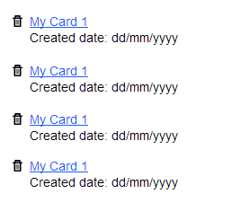

* Link card: it will direct user to design page of clicked card
* Delete card: delete permanently clicked card.
* Created date: text only, showing the created date of that card.

## Template:

User can pick predefined card for their card and edit info from this.

## Export:

* This action is required user authenticated.
* Show popup to ask user where to save in local drive.
* The card will be downloading as image (or zip) (both front side and back side)

## Share/public:

* Required user authenticated
* Use Facebook share
* The URL for sharing should be /chapycard/username/card-code
* Logo of Chapy card used as thumbnail of sharing.

Once a card is shared, it will be marked as public care show in homepage.

## Card in preview

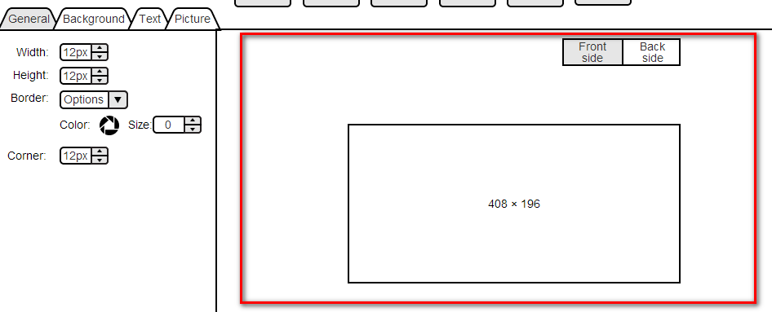

Any setting will be affected to card UI immediately. It's having both front side and backside

## Controls

All controls will be grouped together as below:

### General tab:

It will affect to both front side and back side of card

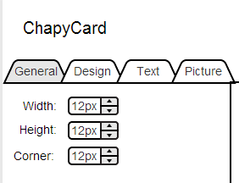

### Design tab:

Depend on which side is selected, it will affect to corresponding side of card.

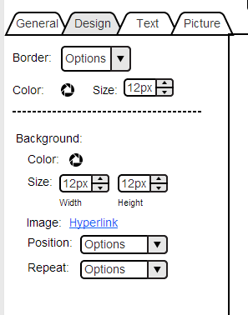

### Text tab:

Depend on which side is selected, the text will be added to that side. Once the text is added, when user chooses certain text in **card preview**, all setting of text will be retrieved for editing or removed.

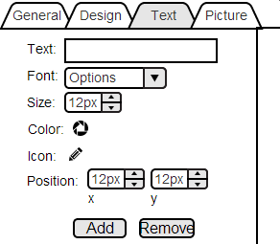

### Picture tab:

Depend on which side is selected, the image will be added to that side. Once the image is added, when use choose certain image in **card preview**, all setting of image will be retrieved for editing or removing.

