**PROJECT-NAME: FOOD52**

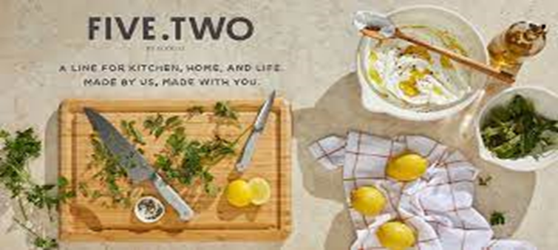

**\*OVERVIEW:** It’s an e-commerce website for food ,

from food & nightlife everything is available

under the same roof.

1. **HOME PAGE:**

# LOGO

# ICONS - (SOCIAL MEDIA)

# SEARCH BAR

# SLIDERS WITH ARROWS - (IMAGES)

# FEATURED - (IMAGES)

# TRENDING - (IMAGES)

# FOOTER – ( CONTACT US , ABOUT COMPANY , BREIF)

1. **REGISTRATION FORM:**

# NAME

# E-MAIL ADDRESS

# MOBILE NUMBER

**3. MAIN PAGE:**

# FILTERS - ( COST , CUSINIE , MEALS , RESTUARANTS ,

CITIES , SORT BY: )

# IMAGES OF THE CHOSEN WITH DETAILS LIKE -

( BRAND ,MEALS , PRICE , DISCOUNT %( IF

ANY ) )

# DESCRIPTION - BRAND , RESTUARANT NAME ,

PRICE , DISCOUNT% (IF ANY) ,

DELIVERY OPTIONS , DETAILS ,

RATINGS , CUSTOMER REVIEWS

WITH IMAGES (IF ANY )

# LOWER HALF OF THE PAGE - RELATED TO SOME OF

RESTUARANTS

1. **PAYMENT PAGE:**

# ADDRESS SELECTION

# PAYMENT METHOD - (PHONEPE , GOOGLE PAY , BHIMUPI ,

COD , CREDIT/DEBIT CARD , NET-

BANKING , EMI , PAYTM)