Step-by-step guide to implement firebase

1. Login Airost gmail account
2. Go to <https://console.firebase.google.com/project/airost-inventory-system-60861/overview>
3. Click “Build” on the left panel, then “Hosting” 🡪 “Get started”
4. Paste all the commands on VS code terminal (ctrl + ` to activate the terminal)
5. (skip this step is the terminal doesn’t ask for it after executing “firebase init”)

For firebase init, select the following 3 (if the terminal asks):

Spacebar to select/deselect, enter to proceed

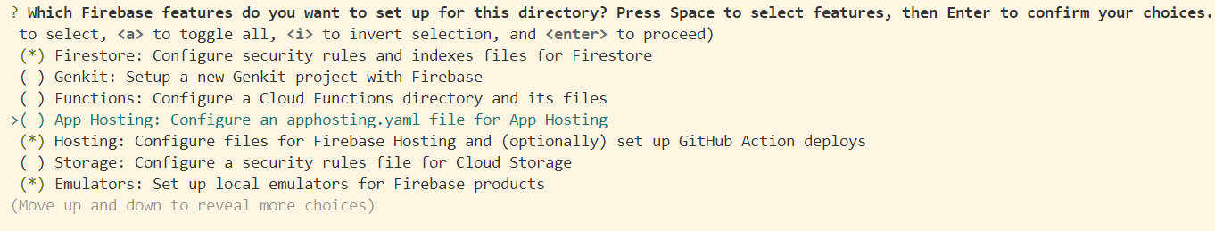

Then select “use the existing project”



