Computational Analysis to Discover the Potential Neutralizing Antibodies for Novel Coronavirus

Chan Joshua Juan Yin
School of Physical and Mathematical Sciences

Ng Yue Hao, Shaun
School of Chemmical and Biomolecular Engineering

Wang Chuhan
School of Computer Science and Engineering

URECA Supervisor Name
Assoc Prof Kwoh Chee Keong
Dr Shamima Rashid
School of Computer Science and Engineering

Abstract - The development of medication for novel coronavirus often requires screening of thousands of available strains of antibodies, which is prohibitively expensive and often not feasible due to a lack of available resources. Accordingly, Machine learning (ML) models can enable the rapid and inexpensive exploration of vast sequences with affordable resources. Existing literature has applied this process with various successes, however, few of the works were based on SARS-CoV2 antibody-antigen data. In this project, we developed a pipeline which utilized graph featurization and ML approaches to predict neutralizing properties for SARS-CoV2 antibodies. Firstly, we constructed a dataset comprising 310 pairs of antibody paratope and antigen epitope FASTA sequences, as well as their neutralizing properties. Second, building on the paper by Magar et al. 2021, we extracted graph features of antibody and antigen molecules, and improved the model by introducing Mean and Max Pooling for data augmentation, applied Repeated Stratified 5-Fold strategy for splitting the training and test dataset, expanded to 8 ML classifier models for model robustness. Our research discovered that Logistic Regression with Mean Pooling could achieve the highest Accuracy score (74.17%) and F1 score (85.01%). We then conducted hyperparameter random searching to fine tune the selected model, achieving final Accuracy, F1 and ROC AUC score at 74.92%, 85.39% and 53.05%. Our research aimed to develop an ML approach pipeline which can generate predictions on the neutralizing property of any given SARS-CoV2 antibody-antigen pair. This research could provide insights to future ML prediction approaches to coronavirus antibody-antigen binding properties.
Keywords – coronavirus, SARS-CoV2, antibody, antigen, machine learning, classifier graph featurization, FASTA, Decision Tree, Random Forest, Logistic Regression, Support Vector Machine, Multilayered Perceptron, XGBoost, LightGBM, TabNet, Mean Pooling, Max Pooling, repeated stratified k-fold, accuracy, F1, ROC, ROC AUC

1 Introduction
The novel coronavirus (COVID-19, or SARS-CoV2) was first identified in December 2019 in Wuhan, China, and was subsequently declared as a global pandemic by the World Health Organisation in March 2020 [1]. As of the end of June 2022, over 540 million confirmed cases have been recorded, leading to over 6.3 million recorded deaths [2]. To this day, SARS-CoV2 has developed five Variants of Concern (VOCs), namely: Alpha, Beta, Gamma, Delta and Omicron [3].
SARS-CoV2 initiates cell invasion by using its spike (S) glycoprotein to bind with human ACE2 receptors. Antibodies neutralises the virus (or antigen) by competitive targeting of the S protein region of the antigen, thereby inhibiting its ability to bind with human ACE2 receptors. Of note is that the region of an antibody that binds to an antigen is referred to as paratope, whereas the region of an antigen that binds to an antibody is referred to as epitope [4-5]. IC₅₀ value is widely used in existing literature to measure the inhibitory effectiveness of an antibody to a SARS-CoV2 antigen [6-7].
Traditional approaches to discovering potential antibodies is through identifying patterns from large number of antibody sequences [8]. However, this approach requires repetitive experimental processes to discover the inhibitory responses of antibodies to antigens, which is prohibitively expensive and often not feasible. Recent developments of computational and physics-based approaches were either utilizing the bound crystal structure of the antibody-antigen complex to build simulation models [9], or utilizing sequences of the antibody and antigen, combined with graph featurization and machine learning (ML) approaches to determine the neutralizing properties of the antibody-antigen pairs [10-11]. Of note is that when discussing sequence data of antibodies and antigens in literature, often it is referred to as the FASTA sequence. FASTA sequence is a text-based sequential data used for representing peptide sequences. Each FASTA sequence is represented in English alphabetical characters of no more than 80 characters in length [12].
It is noteworthy that in both of the aforementioned literature, research were based on training data of Ebola and HIV virus respectively. This presents a research gap, as the models developed were not tailored to SARS-CoV2 but based on other virus types, which is a Domain Shift problem [13] and we will further elaborate it in the later Section 2 of Literature Review. Given the sufficiency of SARS-CoV2 antibody-antigen data in the current literature, thanks to the recent research development of SARS-CoV2 antibody database [6-7, 14-15], our research therefore focused on generating a SARS-CoV2 antibody-antigen dataset, and applied ML models based on the sequential and graph featurization data of the antibody-antigen complex to perform predictions.
Our study was conducted in two steps. First, we constructed a dataset comprising 310 pairs of SARS-CoV2 antibody paratope and antigen epitope FASTA sequences, as well as their neutralizing properties. Second, we extracted graph features of antibody and antigen molecules, and improved the algorithms of the ML model developed in Magar et al. 2021’s paper [10-11]. The improved algorithms were applied to the SARS-CoV2 antibody-antigen data that we have constructed in the first step. Improvements of the ML model included introducing Mean and Max Pooling for data augmentation, applying Repeated Stratified K-fold strategy for splitting the training and test dataset, expanding to 8 ML classifier models for model robustness, and conducting hyperparameter random search to fine tune the selected model. Overall, our goal was to develop an ML approach pipeline which can generate predictions on the neutralizing property of any given SARS-CoV2 antibody-antigen pair. Our research could provide insights to future ML prediction approaches to coronavirus antibody-antigen binding properties.

2 LITERature review
In this section, we will first present an overview of biomolecular visualization tools, followed by presenting the SARS-CoV2 antibody-antigen datasets in existing literature, lastly we will illustrate current research trends of computational-approaches in antibody predictions.
2.1 biomolecular visualization tools
Biomolecular visualization tools are crucial for our research purposes. As illustrated in Section 3 Methodology, for graph featurization of the crystal structures of antibody-antigen complexes and identification of their binding region, we relied on both the PyMOL [16-17] library and the RDKit library [18-19] in Python.
PyMOL [16] is a molecular graphics visualisation Python library that has been widely used for 3-D visualization of proteins, nucleic acids and other biological macromolecules [17]. PyMOL is able to read and edit .cif file format, which is commonly used for representation of a molecular crystal structure.
RDKit library is an open source cheminformatics and machine-learning software based on C++ and Python [18-19]. RDKit allows visualisation of molecules in 2-D images. For each input molecule, RDKit also allows generation of an adjacency matrix and a feature matrix. Since adjacency matrix and feature matrix capture important graph features and information of each atom in a molecular structure. It is a powerful tool for graph featurization of molecular data.
2.2 SARS-COV2 antibody-antigen datasets
Since the initial outbreak of COVID-19, numerous research has been conducted to discover and analyse potential antibodies. Several databases have emerged with an attempt to consolidate all research work in the current literature and form a general database for potential antibodies for COVID-19. These include: Bioinformatics Protein Data Bank (RCBS PDB or PDB) [20-21], COVID-19 Antibody Therapeutics Tracker [6-7] and The Coronavirus Antibody Database [14-15].
Bioinformatics Protein Data Bank (RCBS PDB pr PDB) is a platform that organizes 3-D structural data of biological macromolecules including proteins and nucleic acids. The 3-D structures of the biological macromolecules data were determined by experimental methods including X-ray crystallography, nuclear magnetic resonance spectroscopy and electron microscopy. PDB contains more than 80,000 data including over 77,000 proteins, over 2,000 nucleic acids and over 3,000 proteins-DNA complexes [20-21]. Although not directly targeting SARS-CoV-2, some SARS-CoV-2 antibody-antigen complexes can be searched on PDB where their crystal structures are provided and exportable in .cif file format.
The COVID-19 Antibody Therapeutics tracker was developed collaboratively by the Chinese Antibody Society and The Antibody Society. Designed to track antibody-based therapeutics in preclinical and clinical development, the database comprises 217 data based on over 150 research and development programs. Data are categorized by their targets, approval status, formats, country of origin, derivation and discovery platforms. It is noteworthy that a majority of the antibody candidates are targeting the antigen S protein and are of full-length monoclonal [6-7]. Nevertheless, this dataset was last updated on August 1, 2022, and no further maintenance or updates were made thereafter. Hence, the disadvantage of relying on this dataset for our research purpose is obvious.
The Coronavirus Antibody Database (CoV-AbDab) was developed by the Oxford Protein Informatics Group. As of June 14, 2022, CoV-AbDab has compiled 7,964 data entries of SARS-CoV-2 binding antibodies, among which 328 antibody structures are provided with PDB 4-digit codes. CoV-AbDab provides data of SARS-CoV-2 binding antibodies in more details, documenting each antibody’s name, protein and epitope type, VHH sequence (binding fragment of heavy chain), CDR-H3 and CDR-L3 sequence, RMSD of Virus Alignment, whether the antibody is neutralising with the antigen, and the source of discovery of the antibody in research literature [14-15]. However, CoV-AbDab does not provide the FASTA sequence of the paratope and epitope of each antibody-antigen binding region, which is essential for our machine learning processes.
To identify the FASTA sequence of the paratope and epitope binding region, we relied on the research provided by Sikora et al. 2021 [22]. In the research paper, it provided 9 epitope candidates through construction of epitope mapping of SARS-CoV-2 S protein via computational methods. The 9 epitope sequences were extracted and presented in Appendix 2.
2.3 ComputATIONAl approaches in antibody prediction
Machine learning is a predictive algorithm that generates data predictions based on statistical inferences and inputs of large data [23]. In recent developments of computational-based approaches to biomolecular research, ML models have been employed to facilitate process of antibody predictions and discovery. These include: publication by Farimani et al. 2016 [9] and Magar et al. 2021 [10-11].
Farimani et al. developed a computational model that allowed predictions of potential Eloba antibody candidates based on molecular dynamics simulations. The mechanism was based on computing the interaction energies between the antibody and the glycoprotein residues [9].
Magar et al. 2021 [10-11] developed another entirely different computational approach which was based on graph featurization and ML algorithms on FASTA sequential data of each antibody-antigen pair to predict the neutralizing property of antibody candidates. Building from the Compile, Analyze and Tally NAb panels (CATNAP) database, the research generated a training dataset based on antibody-antigen FASTA sequences, which was named as Virusnet in the paper. The training dataset comprised 1933 data samples, among which 1887 (97.62%) were HIV data, 11 (0.57%) were Dengue, 11 were Influenza, and the rest were other types of viruses. Details of the distribution proportion of each virus type to the Virusnet dataset was documented in Appendix 3. IC₅₀ value was also recorded, which was used to measure the neutralizing property of each antibody-antigen pair.
After generating the Virusnet dataset which documented 1933 pairs of antibody-antigen FASTA sequences, the research team employed RDKit library to generate an adjacency matrix and a feature matrix for each molecule. This captured information of a molecule at each atom’s level and was a useful graph featurization technique.
Mean Pooling and element-wise sum of all antibody and antigen molecules were then performed, and was fed into 5 ML models, namely: Random Forest (RF), Logistic Regression (LR), Support Vector Machine (SVM), Multilayered Perceptron (MLP), and XGBoost (XGB). Data were then split into 5-folds where separate trainings were performed. As according to the paper, XGB attained the highest Accuracy score (90.57%) [10].
The selected XGB model were then fitted into the prediction dataset comprising 416 pairs of SARS-CoV2 antibody-antigen complexes. It was able to identify 18 antibody candidates during model predictions, hence demonstrating feasibility of applying graph featurization and ML techniques to perform predictions on a given antibody’ neutralizing properties against a given antigen.
The research work conducted by Magar et al. 2021 suffered from 4 weaknesses. First, although majority of the training data were based on HIV data (97.62%), the remaining proportion of the data were non-HIV antibodies and viruses. Given that the data were not properly shuffled when splitting into 5-folds for model training, the model performance did not stay consistent across 5-folds of trainings.
During our research stage, we have actually attempted to replicate the research processes documented in Magar et al. 2021’s publication based on the GitHub code provided [11]. A summary table of the results were presented in Table 1 below. As referring to Table 1, the 5 models (RF, LR, DVM, MLP, XGB) behaved inconsistently across 5-folds of training: most notable is that the training Accuracy dropped significantly in the 5th-fold as compared with other folds.
Explanation to this observation was because non-HIV data clustered in the test dataset in the 5th-fold, which is a class imbalance problem [24]. Hence, an improvement of ML algorithm should focus on splitting the training and test dataset in a random and more properly shuffled manner, so data classes can be evenly split across different folds.

 | Accuracy score (%)
ML model | Fold 1 | Fold 2 | Fold 3 | Fold 4 | Fold 5
RF | 91.47 | 93.28 | 93.54 | 97.41 | 70.47
LR | 53.49 | 81.40 | 93.54 | 95.85 | 81.61
SVM | 62.02 | 71.06 | 93.54 | 97.15 | 73.58
MLP | 38.50 | 78.04 | 93.54 | 96.11 | 81.87
XGB | 93.80 | 95.61 | 95.09 | 96.89 | 71.50
Table 1: Summary of Accuracy score performance across 5-folds training data. Note that results were based on our attempt to replicate the process in Magar et al. 2021’s provided source code.
Second, the training and validation data were based on HIV and other non-SARS-CoV2 antibodies and viruses, whereas the prediction data were based on SARS-CoV2 antibody-antigen pairs. This presents a Domain Shift problem [13]. Domain Shift is a terminology in ML literature, especially unsupervised learning literature, to describe the difference in feature distributions between the source domain (training dataset) and the target domain (prediction dataset). In the context of Magar et al. 2021’s paper, it referred to the difference in virus types between the training and prediction dataset. An effective way to solve would be to adapt Magar et al. 2021’s model into our newly constructed SARS-CoV2 FASTA sequence dataset, which we will illustrate in Section 3.1 Methodology of this report.
Third weakness was that the choice of Mean Pooling and element-wise sum of all antibody and antigen molecules appeared to be arbitrary. Fourth weakness was that the number of ML training models could be expanded. All of these issues would be addressed in Section 3.2 Methodology of this report.
All in all, Farimani et al. 2016 [9] and Magar et al. 2021 [10-11] research have demonstrated the feasibility of applying computational techniques, graph featurization and ML techniques to perform prediction on neutralizing properties of antibodies. Weaknesses of their research would be addressed in Section 3 Methodology.

3 methodology
Our study was conducted in two steps. First, we constructed a dataset comprising 310 pairs of SARS-CoV2 antibody paratope and antigen epitope FASTA sequences, as well as their neutralizing properties. Second, we applied computational approaches, including graph featurization and ML methods, to analyse the SARS-CoV2 antibody-antigen data that we have constructed in the first step.
3.1 construction of sars-cov2 antibody-antigen FASTA sequence dataset
To begin, CoV-AdDab was selected as our reference database due to its large data availability, extensive documentation of the characteristics of each antibody, availability of PDB 4-digit code for some antibody data, and credibility and reliability of data source due to constant updates and maintenance of the database.
Based on over 3,000 antibody-antigen pairs solicited from CoV-AdDab dataset, we selected 328 pairs where 4-digit PDB codes were provided for the antigen molecule. Afterwards, for each selected antibody-antigen complex, we manually downloaded its crystal structures from PDB in .cif file format, based on the provided antibody and antigen name. We also kept a record of the neutralizing property of each antibody-antigen pair (0 represents non-neutralizing, 1 represents neutralizing).
The antibody-antigen complex .cif files were then visualized in PyMOL. For each complex, we generated a copy of the antibody-antigen complex in the correct orientation from its original trimeric complex representation. We then isolated the antibody’s paratope region by filtering amino acid residues within 5Å of the antigen S protein.
At this stage, we were also aware that the SARS-CoV2 reference S protein was represented as “7VXF” in 4-digit PDB format, based on searching on the PDB database [25]. The associated .cif file of 7VXF protein structure was then loaded into PyMOL and alignment with the S protein was performed. The epitope region of the 7VXF reference S protein was identified by filtering amino acid residues within 5Å of the paratope.
At the last stage, the paratope and epitope FASTA sequences for each antibody-antigen pair was extracted. The epitope sequences were also cross-verified with the epitope candidates from Appendix 2 [22]. Together with the neutralizing property of each antibody-antigen pair (0 represents non-neutralizing, 1 represents neutralizing), we formed a database of 310 antibody-antigen pair data. A summary table was presented in Table 2 below.
Index | Ab | Class | Paratope | Epitope
1 | m396 | 0 | SYTWGGITILIANYQRDTVMGGSKWDSSDY | FSTFRGDEVRNNGQPTYGVGYQY
2 | c105 | 1 | GFTSSNYYSGSTYREWELYGGYKYYGN | RDERQTGNDYYLFRKSNYQAGSFNYQTYGGY
3-308
309 | RBD-chAb-15 | 1 | GHWTTWGGSTNGYYV | YASFSTFKRGDRAWNTYGVGYQPY
310 | BD-813 | 1 | VEFISANYYSGGSFRLPTYDSISYHDTTP | RDERQTGNDYYLFRKSNYQAGSTFNYQYGY
Table 2: Summary of our generated SARS-CoV2 antibody-antigen dataset. Note that class represents the neutralizing property of each antibody-antigen pair, with 0 representing non-neutralizing and 1 representing neutralizing
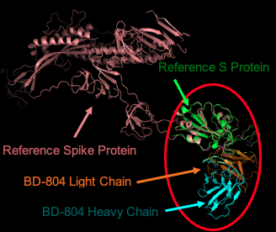
Figure 1: BD-804 Antibody-Antigen Complex visualized in PyMOL
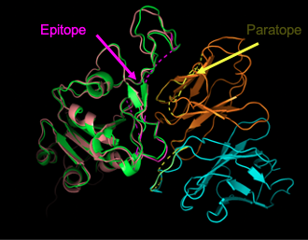
Figure 2: BD-804 Epitope-Paratope Region vizualised in PyMOL (zoomed-in from the red circle in Figure 1)
3.2 computational approaches and application of machine learning algorithms
After constructing the dataset of SARS-CoV2 antibody-antigen FASTA sequences, the next step was to apply computational methods to predict the neutralizing property of the sequences. We decided to follow the approach documented in Magar et al. 2021 [10-11] paper, because it contains the most comprehensive steps of how graph features from FASTA sequences can be extracted and how results can be fitted into various ML models for cross-comparison purposes. Below we will illustrate the steps of applying Magar et al. 2021 model on our newly constructed SARS-CoV2 antibody-antigen FASTA sequences dataset, along with addressing some weaknesses as identified in Section 2.3 of Literature Review.
To begin, we employed the RDKit Python library to generate an adjacency matrix and a feature matrix for each molecule. This allowed capturing the information of a molecule at each atom’s level and hence was a useful graph featurization technique.
Note that at this stage, we were working on each molecule separately. There were 310 antibody-antigen pairs in our constructed FASTA sequence dataset. However, 3 pairs of sequences could not be read by the RDKit library, so we dropped the 3 pairs and 307 pairs remained. In total, we were working on 614 number of antibody and antigen molecules.
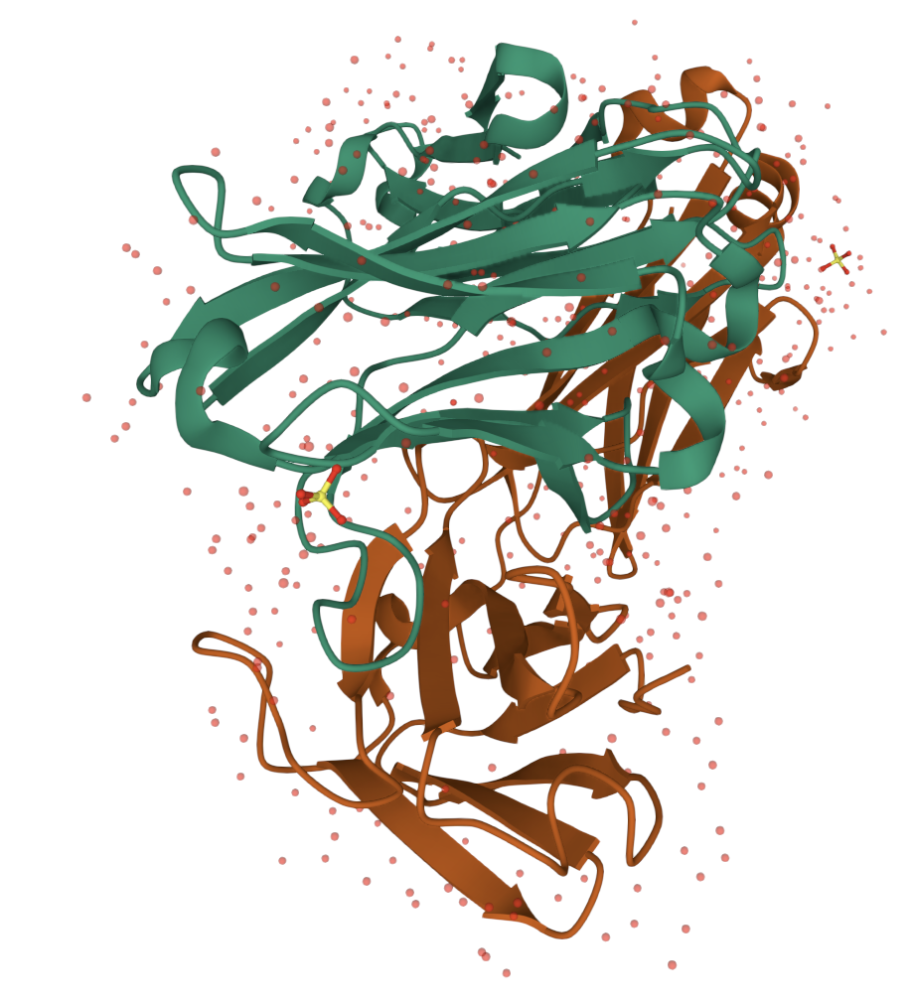
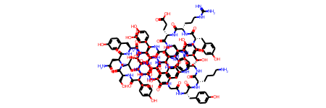

Figure 3: Illustration of graph featurization using RDKit library. Illustrated in the diagram is the 6XCA molecule, also named as C105 neutralizing antibody Fab fragment. This pair of paratope-epitope is neutralising. Left-hand-side is the PyMOL illustration of the extracted FASTA sequences of the paratope and epitope. Right-hand-side is the 2-D graphical illustration based on RDKit library.
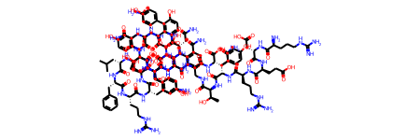
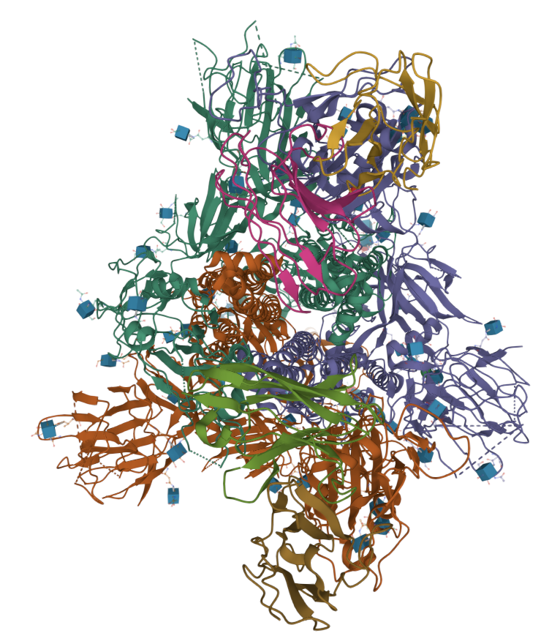

Figure 4: RDKit graph featurization of 6XCM molecule, which is a SARS-CoV-2 spike glycoprotein. This pair of paratope-epitope is neutralising.
In RDKit library, the adjacency matrix records the bonding between each atom of a given molecule. Its output is a [number of atoms X number of atoms] dimensional square array. The feature matrix records the Symbol (‘C’, ‘N’, ‘O’, ‘S’, ‘H’, ‘Unknown’), Degree (0-10), Implicit Valence (0-6), Formal Charge (0 or 1 binary), number of Radical Electrons (0 or 1 binary), Hybridization (SP, SP2, SP3, SP3D, SP3D2), Aromatic Property (0 or 1 binary) and number of Hydrogen atoms (0-4) of each atom in a molecular structure. Details of feature matrix representation generated from the RDKit library are presented in Appendix 4. RDKit feature matrix presents the features of each atom in a one-hot vector. Since there are a total number of 37 possible values for all features of an atom, the feature matrix is a [number of atoms X 37] dimensional array for any given molecule.
After generating the adjacency matrix and feature matrix for each molecule, the adjacency matrix would then matrix multiply with the feature matrix to form a [number of atoms X 37]) product matrix.
As according to Magar et al. 2021 [10-11] paper, the next step would be to perform Mean Pooling in each column, so the matrix after Mean Pooling would be a [1 X 37] vector. However, we decided that this Mean Pooling was arbitrary, and so we expanded the model to include Max Pooling. Later in Section 4.2 of Results, we would compare results from Mean Pooling and Max Pooling.
At this stage, we were working on each molecule separately. Referring to Magar et al. 2021 [10-11] model, for each antibody-antigen pair, the next step was to conduct an element-wise sum on the antibody [1 X 37] Mean Pooling vector and the antigen [1 X 37] Mean Pooling vector. This resulted in a [1 X 37] dimensional vector for each pair. We decided that element-wise sum was an arbitrary choice, and would lead to losing of antibody-specific or antigen-specific feature information. For this reason, we decided to replace element-wise sum with concatenation: concatenate the [1 X 37] dimensional antibody vector with the same dimensional antigen vector, leading to a resultant [1 X 74] dimensional vector for each pair. The method of vector concatenation was applied to both the Mean Pooling vector pairs and the Max Pooling vector pairs.
As there were 307 pairs of antibody-antigen sequences, we row-wise stacked all 307 number of [1 X 74] dimensional vectors to form a resultant [307 X 74] dimensional matrix. This matrix became the predictor variable for our ML models. Note that we applied the same method to both the Mean Pooling vectors and Max Pooling vectors, thus forming the respective Mean Pooling matrix and Max Pooling matrix, which were predictor variables for our ML models.
We also extracted the “class” column from our constructed antibody-antigen FASTA sequence dataset, removed the 3 rows that were unsuccessfully read by RDKit, and formed a [307 X 1] dimensional column vector, which became our outcome variable for ML models. Note that each entry of the outcome variable was 0 or 1 binary, representing non-neutralizing or neutralizing respectively.
The next step would be to split the data into train and test data. Considering the class imbalance problem [24] as mentioned in Section 2.3 of Literature Review, we applied Repeated Stratified 5-Fold strategy in splitting training and test data. Stratified means preserving the percentage of data samples for each class (0 or 1 class in our outcome variable) [26]. Repeat means repeating the stratified splitting strategy for a certain number of times with different randomization in each repetition [27]. In our strategy, we decided to repeat 10 times. Since each repetition had 5-folds train and test data, this strategy would lead to 50 iterations of training and testing for each ML model. We then observed the consistency of the performance of the Accuracy scores across 50 iterations, which would help detect potential class imbalance problem. Provided that the performance was consistent, we averaged the Accuracy scores which became the Accuracy of a particular ML model.
Magar et al. 2021 [10-11] paper employed 5 ML models: RF, LR, SVM, MLP and XGB. We decided to expand 3 additional ML models: Decision Tree (DT) [28], LightGBM (LGBM) [29] and TabNet (TN) [30]. The variety of this wide range of ML models allowed cross-model comparisons to be made and hence model selection processes became more robust. Below we would explain the 3 newly added models.
Decision Tree is a ML algorithm that splits a data population into branches based on Information Gain at different nodes. DT is non-parametric and hence efficient in large sample, yet is vulnerable to overfitting problem due to the model’s strong correlation with potential input variables [28].
LightGBM is a form of Gradient Boosting Decision Tree (GBDT) algorithm that seeks to improve computational efficiency by reducing data size during computation of Information Gain (IG), while retaining reasonable accuracy of prediction. LGBM is shown to be capable of speeding up computational training process by up to over 20 times while retaining satisfactory accuracy [29].
TabNet is another classifier algorithm that uses sequential attention to select features at each decision step, thus improves interpretability of the training model and enhances computational efficiency [30].
When measuring the ML model performance, apart from Accuracy score, we also recorded the F1 score and ROC AUC score of each model. F1 score is the harmonic mean of Precision and Recall. It is given by the following formula:
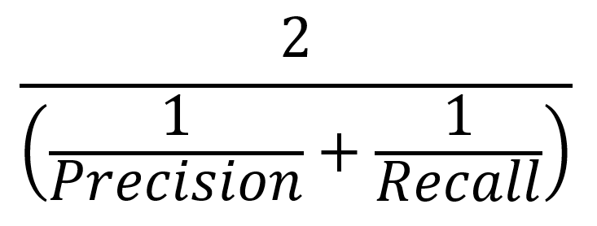 (1)
where Precision refers to the ratio of True Positive to total predicted positive, and Recall refers to the ratio of True Positive to total observed positive [31].
ROC AUC score refers to the "Area under the ROC Curve". The ROC curve is plotted by varying classification threshold values and recording the respective Sensitivity (Recall) against one minus Specificity (True Negative Rate) [32]. The higher the ROC AUC score, the more probable it is to find an optimal classification threshold which achieves highest Sensitivity and Specificity, thus the more robust the ML model indicates.
However, it must be mentioned that ROC AUC score offers less meaning to our analysis when applied on RF, DT, MLP, XGB, LGBM and TN machine learning models. This is because the predictions generated from these 6 models are strict binary classifications (strictly 0 or 1 value), hence the classification threshold does not make a difference to the prediction when the threshold takes any value strictly between the 0 and 1 range. ROC AUC score offers meaning to our analysis only when applied to LR or SVM model, because the predictions are float values between 0.0 and 1.0, and hence the classification threshold makes a difference to the prediction outcome. In our analysis, we included ROC AUC score for completeness.
At the last step, we performed model selection, based on cross-model comparisons between the Accuracy, F1 and ROC AUC score achieved by each ML model. The selected model would then undergo hyperparameter random search [33], where its model hyperparameters could be fine-tuned and the optimal performance was obtained. We would present the results in Section 4.2 of Results.

4 results
In this section, we first present a summary of the characteristics of the SARS-CoV2 antibody-antigen dataset that we have constructed. Then we present and compare results of Accuracy score, F1 score and ROC AUC score across 8 ML models, and perform model selection. Thereafter, we present the results of hyperparameter random search of the selected model. This section will conclude by drawing evaluation on the selected model performance.
4.1 characteristics of SARS-COV2 ANTIBODY-ANTIGEN FASTA SEQUENCE DATASET
Our generated SARS-CoV2 antibody-antigen dataset comprised 310 data entries, of which 228 were neutralizing and 82 were non-neutralizing. 267 were antibodies and 43 were nanobodies. 290 data had the SARS-CoV2 epitope region being the receptor binding domain, while the epitope region of the remaining 20 data were the N-Terminal domain. All in all, our generated dataset was adequately diverse for our machine learning model purposes.
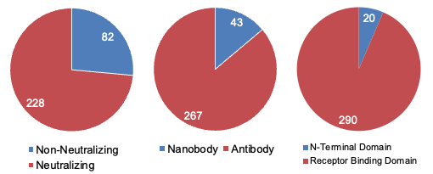
Figure 5: Characteristics of the our generated SARS-CoV2 antibody-antigen dataset
After analysis and cross-comparison of extracted epitopes from the new dataset with the 9 epitope candidates in Sikora et al. 2021 paper [22], we discovered 3 most common epitopes. 2 epitopes are located in the receptor binding domain while 1 is located in the N-terminal domain.
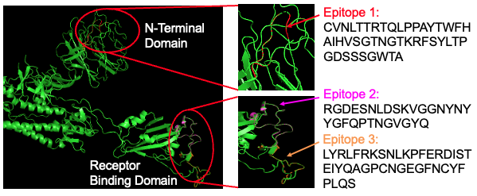

Figure 6: Three most common epitopes from the new generated SARS-CoV2 antibody-antigen dataset
4.2 comparison of accuracy, f1 and roc auc score across 8 ML models
First of all, an observation of the overall performance of Accuracy score, F1 score and ROC AUC score showed that results were consistent across 50 iterations for all 8 ML models. Details of results can be found in Appendix 1 where we provided readers with a link to our GitHub repository. The consistency of the results across 50 iterations was a strong evidence that the class imbalance problem was properly addressed through our Repeated Stratified 5-Fold strategy during splitting of train and test data. As results did not vary a lot, we averaged the results across 50 iterations, and showed the average scoring of 8 ML models as below.
As Figure 7 below showed, average Accuracy scores of 8 ML models ranged from 60% to 75%. The choice of Mean and Max Pooling matrix produced varying results on different ML models. For DT, fitting Max Pooling matrix as predictor variable led to significantly higher average Accuracy score than fitting Mean Pooling matrix; whereas for TN, the result was reverse with Mean Pooling matrix leading to significantly better performance than Max Pooling matrix. For the remaining 6 ML models, results remained consistent for both Mean and Max Pooling matrix as predictor variables. Overall, LR model with Mean Pooling matrix achieved the best average Accuracy score standing at 74.17%.
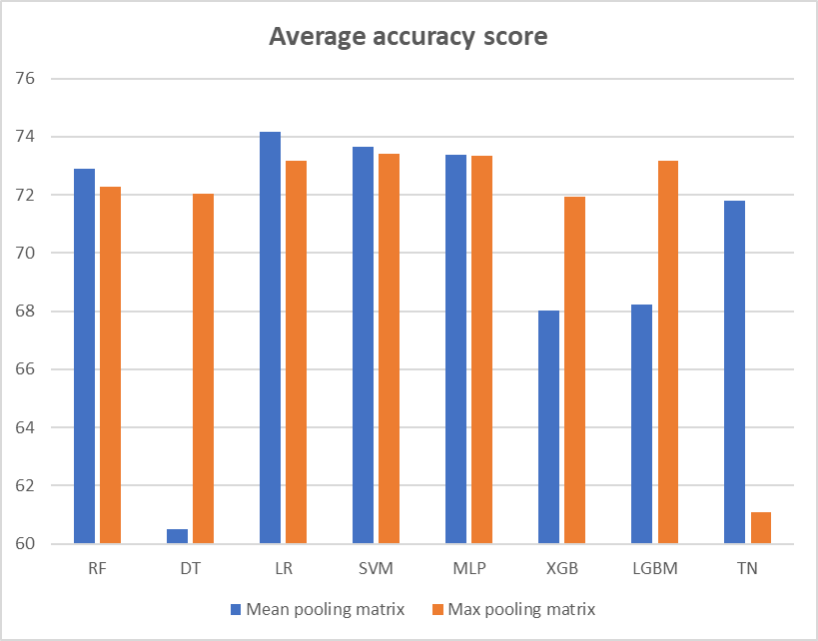
Figure 7: Comparison of average Accuracy score across 8 ML models. We applied Mean Pooling matrix and Max Pooling matrix as predictor variables for each ML model
The performance of average F1 scores, as showed in Figure 8 below, had the same pattern as the performance of average Accuracy scores. For DT, fitting Max Pooling matrix led to significantly higher average F1 score than fitting Mean Pooling matrix; and the reverse case was for TN. For the remaining 6 ML models, average F1 scores remained consistent for both Mean and Max Pooling matrix. Overall, LR model with Mean Pooling matrix achieved the best average F1 score standing at 85.01%.
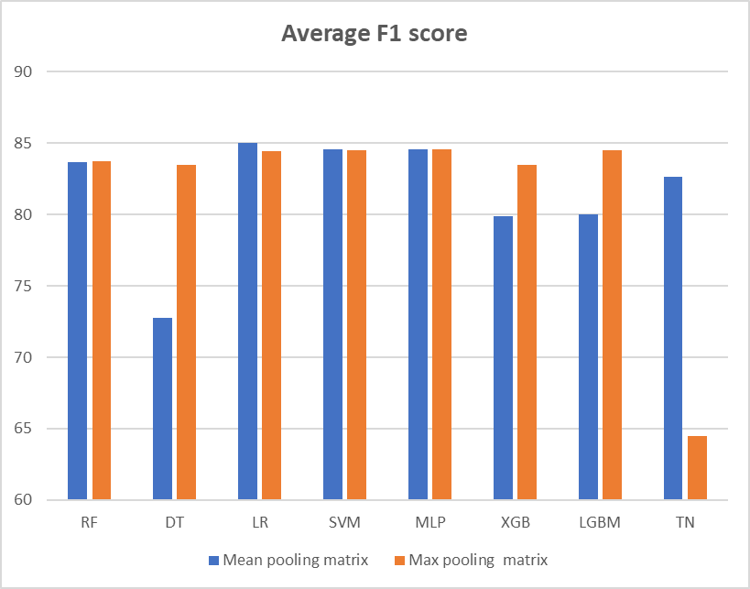
Figure 8: Comparison of average F1 score across 8 ML models. We applied Mean Pooling matrix and Max Pooling matrix as predictor variables for each ML model
As Figure 9 showed, Mean Pooling matrix led to higher average ROC AUC score than Max Pooling matrix in RF, LR, SVM, MLP, XGB and LGBM models. The reverse cases appeared for DT and TN models. RF attained the highest average ROC AUC score standing at 53.86%. As discussed previously, ROC AUC score offers less meaning to our analysis for all ML models except LR and SVM. Hence, we will not further elaborate the implications of this score in our remaining discussion.
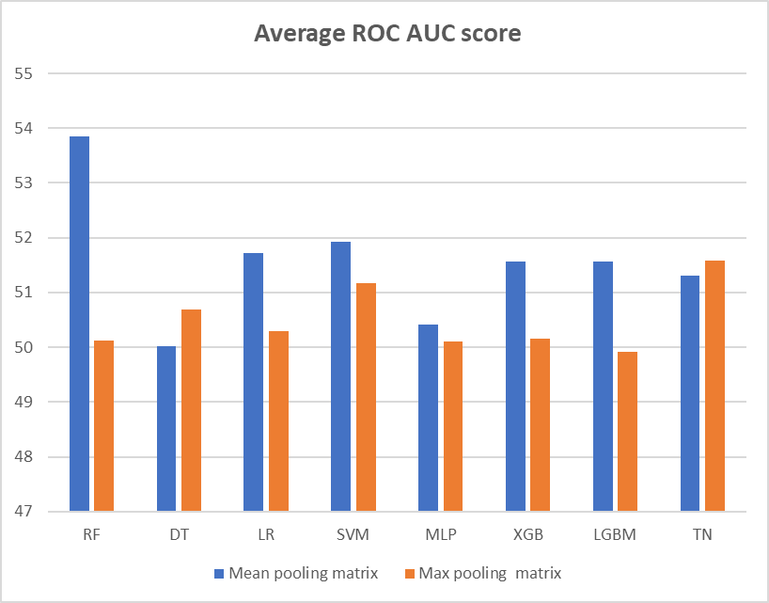
Figure 9: Comparison of average ROC AUC score across 8 ML models. We applied Mean Pooling matrix and Max Pooling matrix as predictor variables for each ML model
4.3 model selection
In Table 3 below, we displayed top 4 best performing ML models and their associated predictor variable matrix based on their average Accuracy score and average F1 score performance. Overall, LR with Mean Pooling matrix as predictor variable recorded the best average Accuracy score at 74.17% and the best average F1 score at 85.01%. Hence, LR was selected as the best performing model, and the Mean Pooling matrix was selected as the best predictor variable matrix for model training.
Model / predictor variable matrix | Average Accuracy score (%) | Average F1 score (%) | Average ROC AUC score (%)
LR / Mean Pooling | 74.17 | 85.01 | 51.72
SVM / Mean Pooling | 73.65 | 84.58 | 51.92
SVM / Max Pooling | 73.42 | 84.51 | 51.18
MLP / Mean Pooling | 73.39 | 84.60 | 50.42

Table 3: Comparison of best performing ML models based on average Accuracy and F1 score. Average ROC AUC score is included for completeness
In Figure 10 below, we displayed the ROC curves of the top 3 best performing models. Note that we deliberately eliminated MLP Mean Pooling in our display because ROC curve for MLP model was a flat line lying on the X axis due to the fact that classification threshold does not affect prediction outcomes for MLP model. An observation of the ROC curves suggested that the 3 curves were very closed to the Y=X diagonal line. Hence, our model failed to suggest an optimal classification threshold which would achieve highest Sensitivity and Specificity.
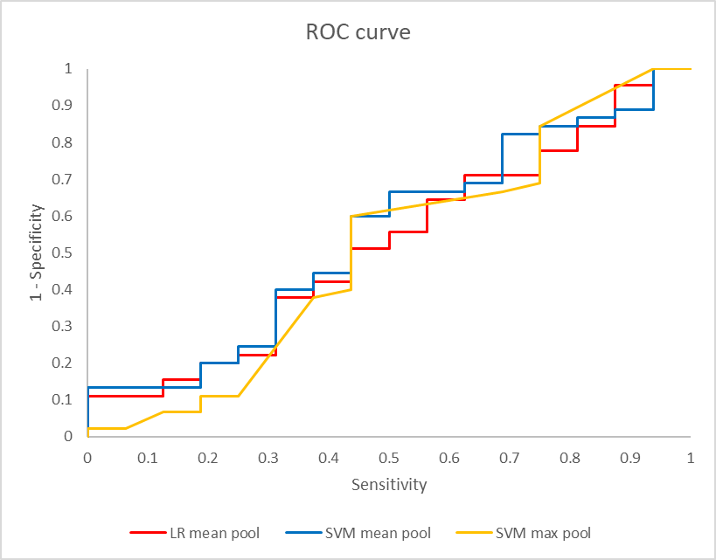
Figure 10: ROC curves of top 3 best performing ML models
4.4 hyperparameter random search
The final step was to perform hyperparameter random search on the selected best performing model, namely: Logistic Regression with Mean Pooling matrix as predictor variable. The final Accuracy score was recorded at 74.92%, F1 score at 85.39% and ROC AUC score at 53.05%. The results, as well as the optimal set of hyperparameters, were illustrated in Appendix 5 and 6 respectively.
4.5 evaluation of model performance
Although we found the best performing ML model with our approach, the results were significantly worse performing than the results obtained from Virusnet dataset in Magar et al. 2021 [10-11] paper, which was able to achieve highest Accuracy score 90.57% by XGB. Furthermore, our ROC curve of the best performing model was very closed to the Y=X diagonal line and failed to obtain an optimal classification threshold. This suggests that our model were not sufficiently robust. An improvement would be to adopt a completely new approach based on Long Short Term Memory (LSTM) and Graph Neural Network (GNN) deep learning models [34] to conduct computational predictions on our SARS-CoV-2 antibody-antigen FASTA sequences. This workstream was carried out by another research member, Wang Chuhan, and will not be further elaborated on this report.

5 Conclusion
In this research, we developed a complete pipeline of generating predictions on the neutralizing property of any given SARS-CoV2 antibody-antigen pair based on computational approaches. The pipeline involved first constructing a SARS-CoV2 antibody-antigen FASTA sequence dataset based on CoV-AdDab database. Second, graph features were extracted using RDKit library. Third, Mean Pooling, Max Pooling and vector concatenations were applied to generate a predictor variable matrix. Fourth, Repeated Stratified 5-Fold strategy was applied for splitting the training and test dataset. Fifth, data would be fitted into 8 ML classifier models for comparisons of their Accuracy, F1 and ROC AUC scores. Sixth, the best performing model would be selected. Seventh, hyperparameter random search was applied to the selected model, generating a final prediction to the neutralizing properties of antibody-antigen pairs. Our research could provide insights to future ML prediction approaches to coronavirus antibody-antigen binding properties. Future work could involve adapting the model to more COVID-19 variants, as well as developing LSTM or GNN based deep learning models to improve robustness of our predictions.

Acknowledgment
I would like to acknowledge the funding support from Nanyang Technological University – URECA Undergraduate Research Programme for this research project.
This project would not have been possible without the support given by my URECA supervisors and group members. First, I would like to thank my supervisor Assoc Prof Kwoh Chee Keong for his technical expertise and guidance throughout our research. Second, I would also like to thank Dr Shamima Rashid for her coaching and guidance throughout our project, her patience in answering our questions during group meetings, and her support when we were drafting the PyMOL code.
Next, I would like to thank my URECA group member. Ng Yue Hao Shaun, who made most contributions to the development of SARS-CoV2 antibody-antigen FASTA sequence dataset. Finally, I would also like to thank my another URECA group member, Wang Chuhan, who worked on the LSTM and GNN workstream of this project.

References
- D. Cucinotta and M. Vanelli, “WHO Declares COVID-19 a Pandemic”, Acta Biomed, Vol 19, No. 1, pp. 157-160, Mar 2020. https://doi.org/10.23750/abm.v91i1.9397
- World Health Organisation, “WHO Coronavirus (COVID-19) Dashboard”, 28 June 2022; https://covid19.who.int/
- B. Hewinset al., “Alpha, Beta, Delta, Omicron, and SARS-CoV-2 Breakthrough Cases: Defining Immunological Mechanisms for Vaccine Waning and Vaccine-Variant Mismatch”, Front. Virol., Vol. 2, Article 849936, 6th May 2022. https://www.frontiersin.org/articles/10.3389/fviro.2022.849936/full
- S. Pomplun, “Targeting the SARS-CoV-2-spike protein: From antibodies to miniproteins and peptides”, RSC Medicinal Chemistry, Vol. 12, pp. 197-202, 2021. https://doi.org/10.1039/D0MD00385A
- J. T. Ladner et al., “Epitope-resolved profiling of the SARS-CoV-2 antibody response identifies cross-reactivity with endemic human coronaviruses”, Cell Reports Medicine, Vol. 2, 2020. https://doi.org/10.1016/j.xcrm.2020.100189
- L. Yang, W. Liu, X. Yu, M. Wu, J. M. Reichert and Mitchell Ho, “COVID-19 Antibody Therapeutics Tracker: A Global Online Database of Antibody Therapeutics for the Prevention and Treatment of COVID-19”, Antibody Therapeutics, Vol. 3, No. 3, pp. 205–212, August 2020. https://doi.org/10.1093/abt/tbaa020. COVID-19
- L. Yang, W. Liu, X. Yu, M. Wu, J. M. Reichert and Mitchell Ho, “COVID-19 Antibody Therapeutics Tracker”, 1st August 2021; https://chineseantibody.org/opendata/dashboards/covid-19-mab-tracker
- C.R. Miller et al., “Initiating a watch list for Ebola virus antibody escape mutations”, PeerJ, Vol. 4, No. 1674, 16th February 2016. https://doi.org/10.7717/peerj.1674
- A. B. Farimani, N. R. Aluru, E. Tajkhorshid and E. Jakobsson, “Computational approach to designing antibody for Ebola virus”, Biophysical Journal, Vol. 110, No. 3, 2016. https://doi.org/10.1016/j.bpj.2015.11.2877
- R. Magar, P. Yadav and A. B. Farimani, “Potential neutralizing antibodies discovered for novel corona virus using machine learning”, Nature Scientific Reports, Vol. 11, No. 5261, 2021. https://doi.org/10.1038/s41598-021-84637-4
- R. Magar, P. Yadav and A. B. Farimani, “Potential neutralizing antibodies discovered for novel corona virus using machine learning”, 26th March 2021; https://github.com/BaratiLab/Potential-Neutralizing-antibodies-discovered-for-novel-corona-virus-using-machine-learning
- W. Shen, S. Ke, Y, Li, F. Hu, “SeqKit: A Cross-Platform and Ultrafast Toolkit for FASTA/Q File Manipulation”, PLoS ONE, Vol. 11, No. 10, e. 0163962, 5th October 2016. https://journals.plos.org/plosone/article?id=10.1371/journal.pone.0163962
- J. Jang, B. Na, D. Shin, M. Ji, K. Song, I.C. Moon, “Unknown-Aware Domain Adversarial Learning for Open-Set Domain Adaptation”, arXiv, submitted on 15th June 2022. https://arxiv.org/abs/2206.07551
- M. Raybould, A. Kovaltsuk, C. Marks and C. M. Deane, “CoV-AbDab: the coronavirus antibody database”, Bioinformatics, Vol. 37, No. 5, pp. 734–735, March 2021. https://doi.org/10.1093/bioinformatics/btaa739.
- M. Raybould, A. Kovaltsuk, C. Marks and C. M. Deane, “Coronavirus-Binding Antibody Sequences & Structures”, 14th June 2022; http://opig.stats.ox.ac.uk/webapps/covabdab/
- PyMOL contributors, “PyMOL by Schrodinger”, 2022; https://pymol.org/2/.
- S. Yuan, H.C.S. Chan, Z. Hu, “Using PyMOL as a platform for computational drug design”, Wiley Interdisciplinary Reviews: Computational Molecular Science, Vol. 7, No. 2, e. 1298, January 2017.
https://www.researchgate.net/publication/312107501_Using_PyMOL_as_a_platform_for_computational_drug_design
- G. Landrum, “The RDKit Documentation”, 1st March 2022; https://www.rdkit.org/docs/
- G. Landrum, “GitHub repository: The official sources for the RDKit library”, 3rd March 2022; https://github.com/rdkit/rdkit
- S. Parasuraman, “Protein data bank”, Journal of Pharmacology and Pharmacotherapeutics, Vol. 3, Issue 4, October – December 2012. https://www.ncbi.nlm.nih.gov/pmc/articles/PMC3543563/pdf/JPP-3-351.pdf
- S. Parasuraman, “RCBS PDB Protein Data Bank”, n.d.; https://www.rcsb.org/
- M. Sikora, S. von Bu ̈low, F. Blanc, M. Gecht R. Covinoa and G. Hummer, “Computational epitope map of SARS-CoV-2 spike protein”, PLoS Computational Biology, Vol. 17, No. 4, 2021. https://doi.org/10.1371/journal.pcbi.1008790
- I. H. Sarker, “Machine Learning: Algorithms, Real-World Applications and Research Directions”, SN Computer Science, Vo. 2, No. 160, 22nd March 2021. https://link.springer.com/article/10.1007/s42979-021-00592-x
- A. Ali, S. M. Shamsuddin, A. L. Ralescu, “Classification with class imbalance problem: a review”, International Journal of Advances in Soft Computing and its Applications, Vol. 5, No. 3, November 2013.
https://www.researchgate.net/publication/288228469_Classification_with_class_imbalance_problem_A_review
- C. Xu, Y. Cong, “7VXF”, 1st December 2021; https://www.rcsb.org/structure/7VXF
- Pedregosa et al., “sklearn.model_selection.StratifiedKFold”, n.d.; https://scikit-learn.org/stable/modules/generated/sklearn.model_selection.StratifiedKFold.html
- Pedregosa et al., “sklearn.model_selection.RepeatedStratifiedKFold”, n.d.; https://scikit-learn.org/stable/modules/generated/sklearn.model_selection.RepeatedStratifiedKFold.html
- Y. Y. Song and Y. Lu, “Decision tree methods: applications for classification and prediction”, Shanghai Archives of Psychiatry, Vol. 27, No. 2, pp. 130–135, 2015. https://www.ncbi.nlm.nih.gov/pmc/articles/PMC4466856/
- G. Ke et al., “LightGBM: A Highly Efficient Gradient Boosting Decision Tree”, NIPS'17: Proceedings of the 31st International Conference on Neural Information Processing Systems, pp. 3149-3157, December 2017. https://doi.org/10.5555/3294996.3295074
- S. Ö. Arik and T. Pfister, “TabNet: Attentive Interpretable Tabular Learning”, Google Cloud AI, December 2020. https://doi.org/10.48550/arXiv.1908.07442
- R. Joshi, “Accuracy, Precision, Recall & F1 Score: Interpretation of Performance Measures”, Exsilio Solutions, 9 September 2016; https://blog.exsilio.com/all/accuracy-precision-recall-f1-score-interpretation-of-performance-measures/
- Google Developers, “Classification: ROC Curve and AUC”, 6th February 2021; https://developers.google.com/machine-learning/crash-course/classification/roc-and-auc
- J. Brownlee, “Hyperparameter Optimization With Random Search and Grid Search”, 14th September 2020; https://machinelearningmastery.com/hyperparameter-optimization-with-random-search-and-grid-search/
- W. Jin, J. Wohlwend, R. Barzilay, T. Jaakkola, “Iterative Refinement Graph Neural Network for Antibody Sequence-Structure Co-design”, International Conference on Learning Representations 2022, 27th January 2022. https://arxiv.org/abs/2110.04624

APPENDIX
Appendix 1
Our GitHub repository can be found via the link: https://github.com/chanjuanyin/URECA_Yr_2_SARS_CoV2_antibody_prediction
Appendix 2
Epitope candidates on SARS-CoV2 S protein and their corresponding sequences
Epitope | Residues | Sequence
E1 | 15-28  63-79  247-260 | CVNLTTRTQLPPAY TWFHAIHVSGTNGTKRF  SYLTPGDSSSGWTA
E2 | 97  178-189  207-219 | K  DLEGKQGNFKNL  HTPINLVRDLPQG
E3 | 137-164 | NDPFLGVYYHKNNKSWMESEFRVYSSAN
E4 | 332-346 | ITNLCPFGEVFNATR
E5 | 403-406  438  440-451  495-506 | RGDE  S  NLDSKVGGNYNY  YGFQPTNGVGYQ
E6 | 452-476  479-482  484-494 | LYRLFRKSNLKPFERDISTEIYQAG  PCNG  EGFNCYFPLQS
E7 | 527-537 | PKKSTNLVKNK
E8 | 603-605  633-642  656-661  674-693 | NTS  WRVYSTGSNV  VNNSYE  YQTQTNSPRRARSVASQSII
E9 | 808-814 | DPSKPSK

Appendix 3
Distribution proportion of each virus type to the Virusnet dataset
Virus type | Count | % proportion
HIV | 1187 | 97.62%
Dengue | 11 | 0.57%
Influenza | 11 | 0.57%
Hepatitis | 4 | 0.21%
SARS | 4 | 0.21%
Ebola | 4 | 0.21%
RSV | 3 | 0.16%
WNV | 2 | 0.10%
Cytomegalovirus | 1 | 0.05%
Pseudorabies | 1 | 0.05%
Vaccinia | 1 | 0.05%
H1N1 | 1 | 0.05%
HS | 1 | 0.05%
Poxvirus | 1 | 0.05%
F&MD | 1 | 0.05%
Total | 1933 | 100%

Appendix 4
Feature matrix representation of any given molecule by RDKit library
Molecule feature | Function in RDKit library | Possible values (PV) | PV Count
Symbol | atom.GetSymbol() | {‘C’, ‘N’, ‘O’, ‘S’, ‘H’, ‘Unknown’} | 6
Degree | atom.GetDegree() | { 0, 1, 2, 3, 4, 5, 6, 7, 8, 9, 10} | 11
Implicit Valence | atom.GetImplicitValence() | {0, 1, 2, 3, 4, 5, 6} | 7
Formal charge | atom.GetFormalCharge() | {0, 1} binary | 1
Number of radical electrons | atom.GetNumRadicalElectrons() | {0, 1} binary | 1
Hybridization | atom.GetHybridization() | {SP, SP2, SP3, SP3D, SP3D2} | 5
Aromatic property | atom.GetIsAromatic() | {0, 1} binary | 1
Number of Hydrogen atoms | atom.GetTotalNumHs() | {0, 1, 2, 3, 4} | 5
Total |  |  | 37

Appendix 5
Optimal performance of LR model with Mean Pooling matrix after hyperparameter random search
Measurement | Score (%)
Accuracy | 74.92
F1 | 85.39
ROC AUC | 53.05

Appendix 6
Optimal performance of LR model with Mean Pooling matrix after hyperparameter random search
Hyperparameter | Optimal value
Solver | liblinear
Penalty | l2
C | 1.623776739188721

