

CCP6214 Algorithm Design and Analysis (2610) Assignment (40 marks)

Lecture section: TC6L
Tutorial section: T21L
Group number: G03 Group ID: T21L_G03
Group leader name: Chan Jia Yi

No | Student ID | Student name by alphabetical order and phone number, label group leader in parentheses | Task percentage in 100%
1 | 242UC244SR | Chan Jia Yi 012-253 9359 (Group Leader) | 25%
2 | 242UC244QN | Chew Jia Yi 013-282 3398 | 25%
3 | 242UC244FZ | Koay Yee Shuen 011-5680 0192 | 25%
4 | 242UC244GL | Ong Wan Ning 016-607 0825 | 25%
**Every student is responsible for 100% (task percentage) of this group assignment work.

Marksheet checklist (40%) // on new page Assignment programming, documentation and interview
- You are required to submit assignment to your respective tutor before the submission deadline.
- Also document all your assignment tasks with this marking table that contain cover page, table of contents, page numbering, inputs, outputs, screenshots, explanations, and others. Group member names in alphabetically order. Label group leader in parentheses.
  - Student Name A
  - Student Name B if this is the group leader (leader)
  - Student Name C
  - Student Name D

Questions | Criteria | Weight | Actual Mark
Q1 | Dataset generation (group) | 5 | ?
Q2 | Radix sort (group) | 5 | ?
Q3 | Heap sort (group) | 5 | ?
Q4 | Hash table search (group) | 5 | ?
Q5 | Conclusion (group) | 5 | ?
Q6 | Document clarity and completeness (group) | 5 | ?
Q7 | Experiments (individual) | 5 | [?] [?] [?] [?]
Q8 | Interview, demo and Q&A (individual) | 5 | [?] [?] [?] [?]
 | Total mark | 40 | [?] [?] [?] [?]

Additional comments:

You are required to fill in your task percentage and task descriptions.
Every student is responsible for 100% (task percentage) of this group assignment work.

Student 1

Student ID | 242UC244SR
Student name | Chan Jia Yi
Task percentage | 25%
Task descriptions | Hash Table Search

Student 2

Student ID | 242UC244QN
Student name | Chew Jia Yi
Task percentage | 25%
Task descriptions | Radix Sort

Student 3

Student ID | 242UC244FZ
Student name | Koay Yee Shuen
Task percentage | 25%
Task descriptions | Dataset Generation

Student 4

Student ID | 242UC244GL
Student name | Ong Wan Ning
Task percentage | 25%
Task descriptions | Heap Sort

Each feature will be evaluated based on documentation, fulfilment of requirements, correctness, compilation without warnings and errors, error free during runtime, error handlings, quality of comments, user friendliness, good coding format and style.

Table of contents with page numbers and links // on new page
Table of Contents
Question Section 7
Q1 [5] Dataset generation 7
Q2 [5] Radix Sort 12
Q3 [5] Heap Sort 16
Q4 [5] Hash Table Search 20
Q5 [5] Conclusion 32
Q7 [5] Experiments 34
Q8 [5] Hardware Specifications 60
References 62

Insert the comment below at the beginning of your source code files // on new page
// *********************************************************
// Program: YOUR_FILENAME.cpp
// Course: CCP6214 Algorithm Design and Analysis
// Lecture Class: TC4L
// Tutorial Class: T13L
// Trimester: 2610
// Member_1: ID | NAME | EMAIL | PHONE
// Member_2: ID | NAME | EMAIL | PHONE
// Member_3: ID | NAME | EMAIL | PHONE
// Member_4: ID | NAME | EMAIL | PHONE
// *********************************************************
// Task Distribution
// Member_1:
// Member_2:
// Member_3:
// Member_4:
// *********************************************************

Question Section // on new page

Q1 [5] Dataset generation
Question tasks
Implement functions to generate the dataset with 10 different input sizes as the input to the algorithm. The generated datasets must contain unique, random, and positive 10-digit integers ranging from 1,000,000,000 to 9,999,999,999. Each row must consist of two record fields separated by a comma: the 10-digit integer and a 5-letter string of lowercase alphabet letters. The elements in the datasets should be in random order before sorting.
Furthermore, the group leader's student ID must be used as the seed number for the random number generator so that different groups have different inputs.

Screenshots, inputs, outputs, figures, explanations, tables, charts
Seed Number Calculation
The standard 64-bit Mersenne Twister (mt19937_64) is used because standard 32-bit integers cannot hold the 10-digit limits. The engine is seeded using the calculated group leader ID. The uniform integer distribution bounds strictly enforce the assignment's 10-digit positive integer constraint (from 1-billion to 9.99-billion). The group leader is Chan Jia Yi (ID: 242UC244SR). Based on the assignment's letter-to-digit mapping (A=1, B=2... Z=6):
U maps to 1
C maps to 3
S maps to 9
R maps to 8
Thus, the 64-bit seed generated is 2421324498ULL.

Generated Input Sizes
The dataset generator targets the following 10 input sizes n to ensure sufficient runtime variance for the sorting algorithms:
n = 1,000 | 5,000 | 10,000 | 50,000 | 100,000 | 500,000 | 1,000,000 | 5,000,000 | 10,000,000 | 50,000,000.
For each iteration, two distinct CSV output files are structured inside dedicated directories:
- Main Dataset File: dataset/dataset_n.csv containing $n$ random rows.
- Search Query File: dataset_search/dataset_search_from_n.csv containing n / 5 structural query pairs used to isolate Best, Average, and Worst-case execution times.
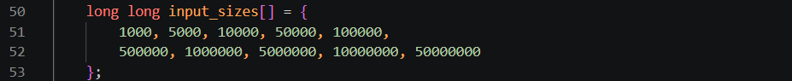
Outputs
The program outputs a single unsorted CSV file for each input size, containing n rows of randomized, unique data.
Filename Format: dataset_n.csv
Data Format: Each row contains a 10-digit integer and a 5-letter string, separated by a comma. Code Output:
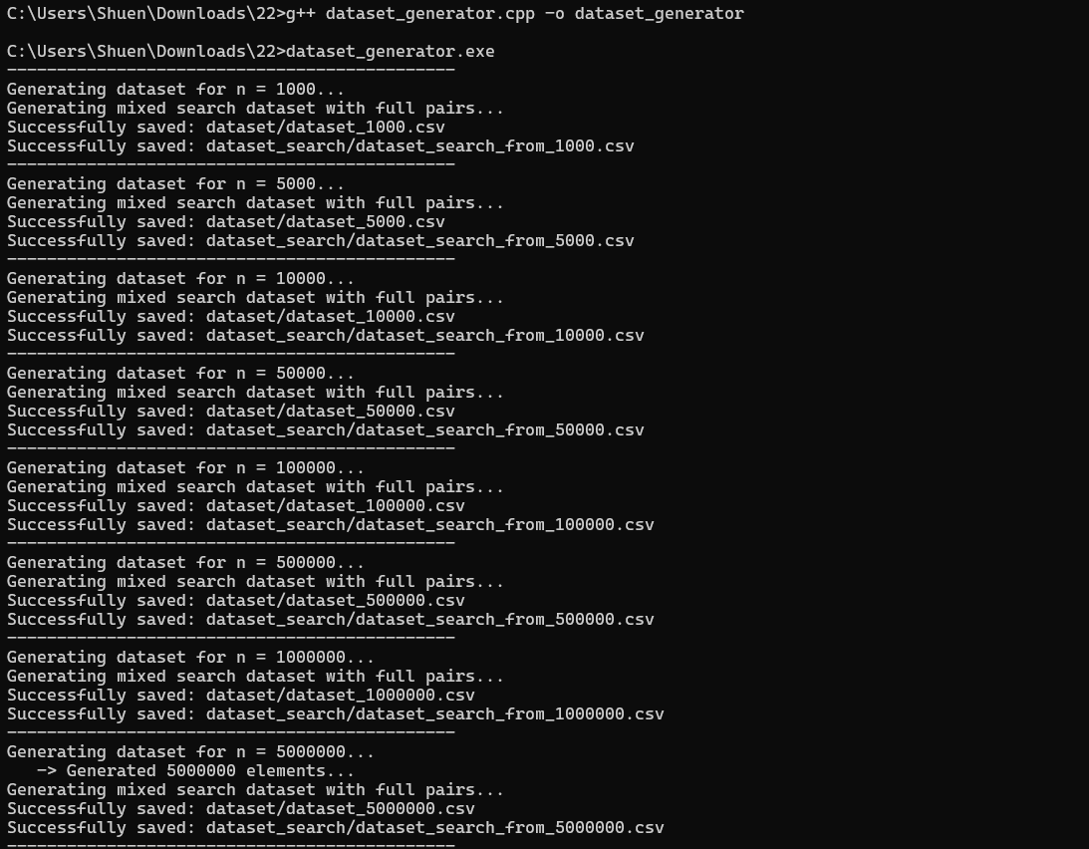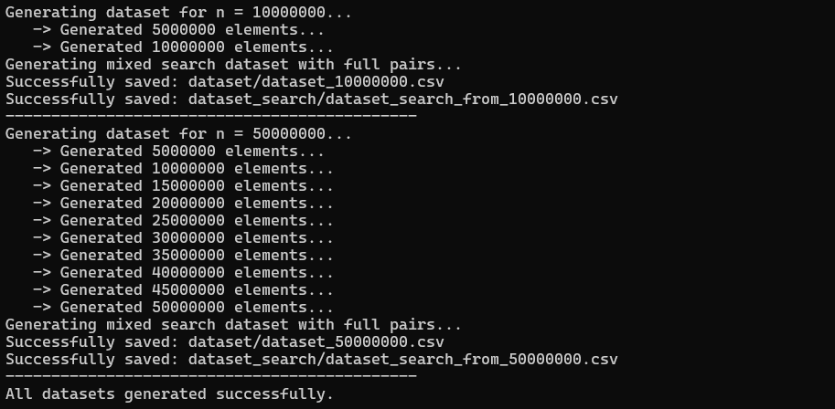
Sample of dataset file in CSV format:
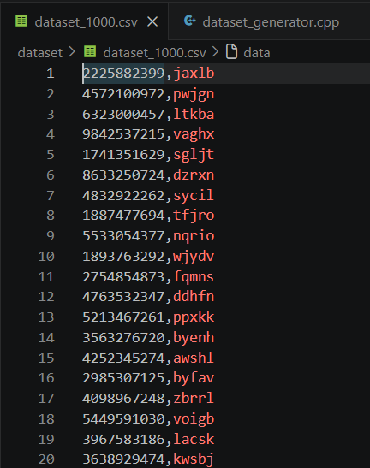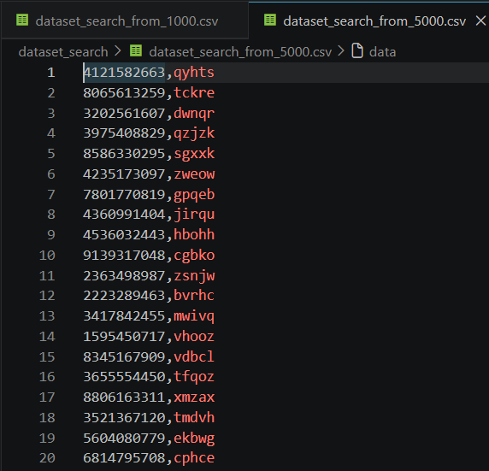
Code parts, explanations
Random String Generation
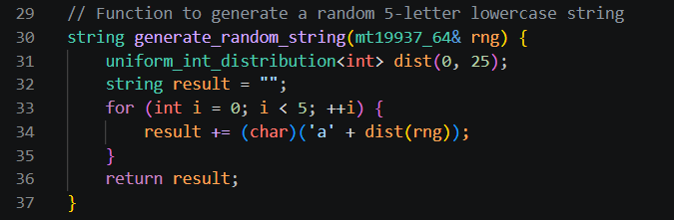
Explanation: This function generates the required 5-letter lowercase string. It takes the Mersenne Twister engine by reference so the random state advances correctly. It uses a uniform distribution from 0 to 25, mapping these integer values to the ASCII characters 'a' through 'z'.

Unique Dataset Generated
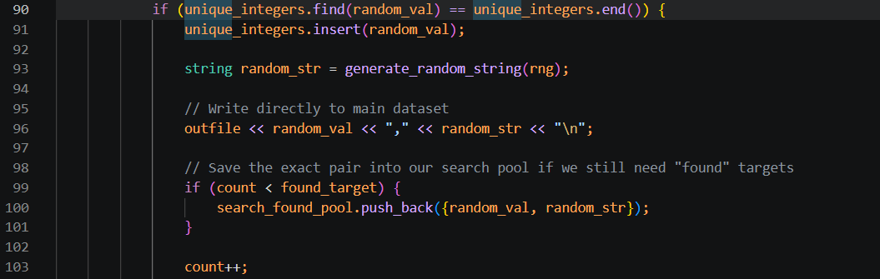
Explanation: An unordered_set is utilized to track every generated integer in O(1) average time. If an integer is already present in the set, the collision is skipped, and a new one is generated. This ensures that all n records have strictly unique 10-digit integers. Once verified, the valid integer and its corresponding random string are written directly to the CSV file.

Search Dataset Generation (Dual File Feature): To accommodate the separate search benchmarks, the generator dynamically outputs a companion search file (dataset_search_from_n.csv) for every main data file.
- The search space consists of exactly n/5 rows. (20% of n size from main data file)
- First Half (Found Case): Represents successful lookups (50% of the search file). It captures exact, valid records stored directly inside a memory pool during the main loop phase, ensuring matching key,string integrity.
- Second Half (Worst/Not Found Case): Represents unsuccessful lookups (50% of the search file). It generates brand new 10-digit integers validated against the main hash set to guarantee absolute absence from the original dataset.
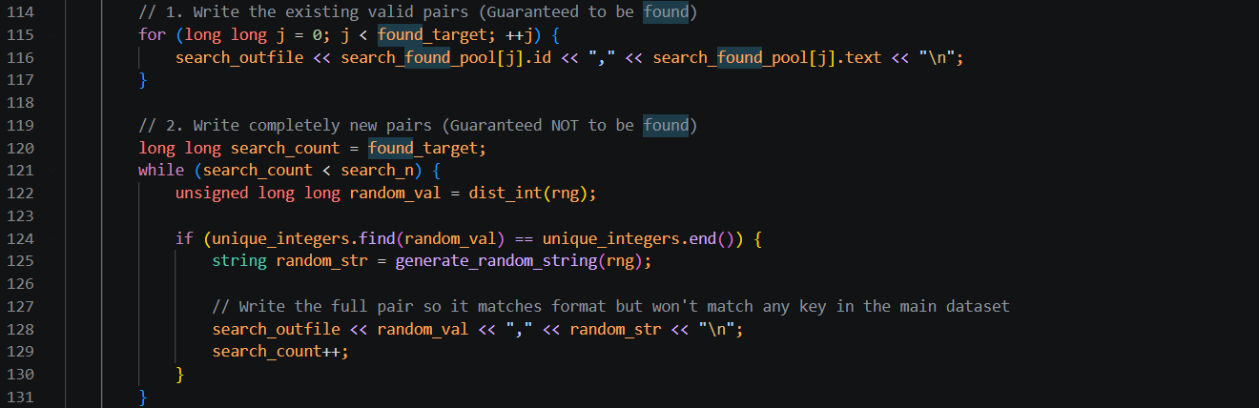

Q2 [5] Radix Sort
Question tasks
Perform a comparative analysis on Radix Sort (process from the rightmost character). Implement the algorithm in standard C++ without using built-in sorting libraries or data structures. Perform running time analysis capturing at least 10 different input sizes, excluding I/O time.
- Concept Explanation
Radix Sort is a non-comparative sorting algorithm that groups elements by their individual digits. This implementation uses the Least Significant Digit (LSD) method, processing the 10-digit integers from right (ones place, d = 10) to left (billions place, d = 1). For each of the 10 passes, it uses Counting Sort as a subroutine to group the numbers based on the current digit.

- Why Process from the Rightmost Digit?
The LSD approach relies on Counting Sort being a stable sort. This means if two numbers have the same digit in the current pass, their relative order from the previous pass is preserved. By sorting from right to left, each pass organizes the next place value without scrambling the work done by previous passes. If we started from the left, later passes would ruin the initial sorting.

- Time Complexity Analysis
Each Counting Sort pass processes n elements with a base b = 10:
- Counting and Building Output: O(n + b)
- Total Passes: d = 10 passes
- Total Time: T(n) = O(d × (n + b))
Because d and b are small constants for 10-digit, base-10 integers, they are dropped.
- Final Time Complexity: O(n) for best, average, and worst cases.
Unlike comparison sorts, Radix Sort always processes every digit of every element, making it consistently linear and theoretically faster than Heap Sort’s O(n log n).

- Space Complexity Analysis
Output array: O(n) to temporarily store the sorted elements during each pass.
Count array: O(b) = O(10) = O(1) for the digit frequencies (0-9).
Total Space Complexity: O(n)
Unlike Heap Sort, which sorts in-place (O(1) auxiliary space), Radix Sort requires extra memory equivalent to the input array size.

Screenshots, inputs, outputs, figures, explanations, tables, charts
Figure 1: Compiling and executing radix_sort_step.cpp on dataset_1000.csv (rows 1–7)
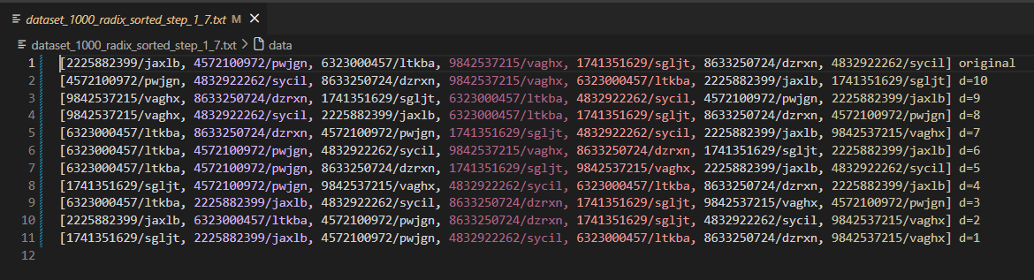
Figure 2: Step-by-step output of Radix Sort showing the array state after each of the 10 digit passes, from d=10 (ones digit) to d=1 (billions digit)
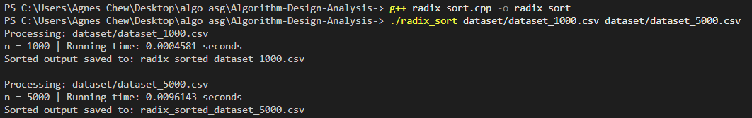
Figure 3:Compiling radix_sort.cpp with -O2 optimization and executing on dataset_1000.csv and dataset_5000.csv
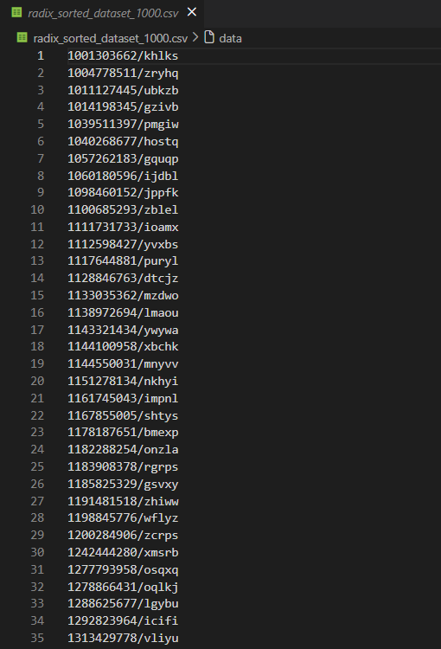
Figure 4: First 35 rows of radix_sorted_dataset_1000.csv, confirming integers are sorted in ascending order
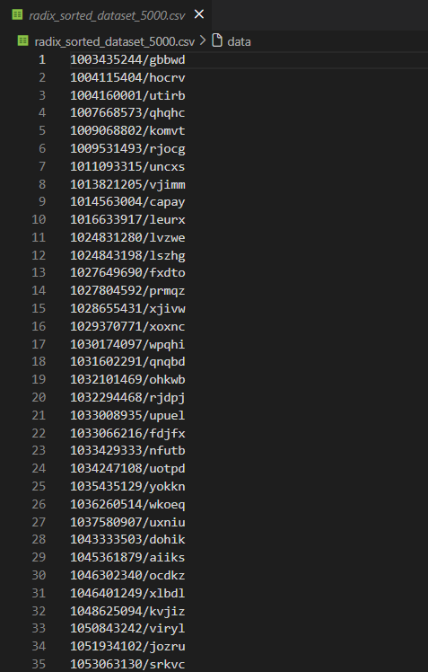
Figure 5: First 35 rows of radix_sorted_dataset_5000.csv, confirming integers are sorted in ascending order

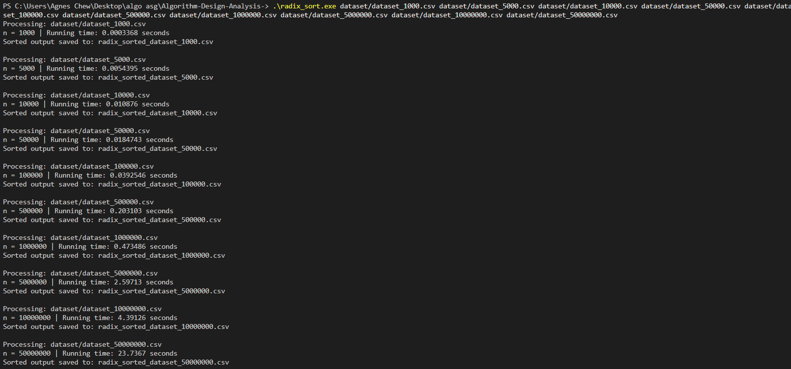
Figure 6: Running time of Radix Sort across all 11 input sizes (n = 1,000 to 50,000,000), measured with file I/O excluded
Code parts, explanations
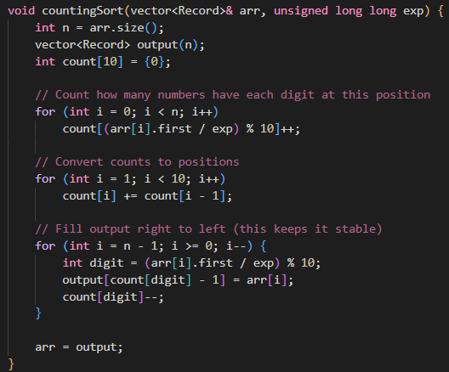
Figure 7: countingSort function
Extracting Digits: The current digit is isolated using (arr[i].first / exp) % 10. The exp variable starts at 1 (ones place) and multiplies by 10 after each pass.

Maintaining Stability: The output array is filled by looping from right to left (last element to first). This ensures elements with the same current digit keep their relative order from the previous pass.

Like the dataset array, the vector is passed by reference (vector<Record>& arr) into both functions. This avoids C++ creating a full copy of potentially 50 million records on every one of the 10 passes, which would otherwise cause severe memory and performance overhead.

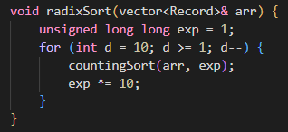
Figure 8: radixSort function
Execution: The main loop runs exactly 10 times for the 10-digit integers. As required by the assignment the timing mechanism only measure the sorting process and strictly exclude file I/O time.

Q3 [5] Heap Sort
Question tasks
Perform a comparative analysis on Heap Sort (Using maxheap). Implement the algorithm in standard C++ without using built-in sorting libraries. Perform running time analysis capturing at least 10 different input sizes, excluding I/O time.
Screenshots, inputs, outputs, figures, explanations, tables, charts
dataset_1000_heap_sorted_step_1_7.txt
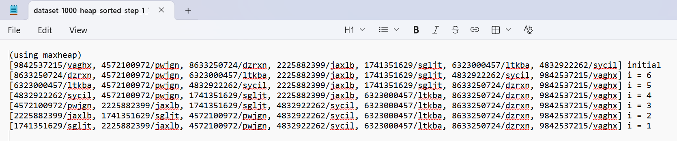
Sample of heap sort dataset file in CSV format - First 15 rows of heap_sort_dataset_1000.csv
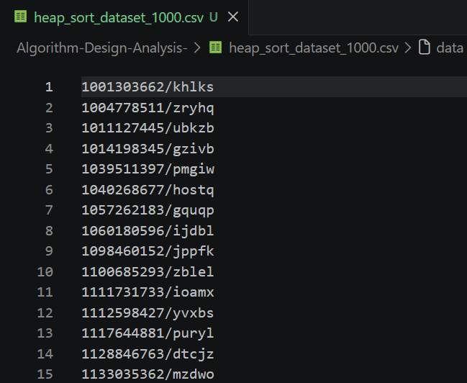
Running Time of heap_sort_dataset_1000.csv
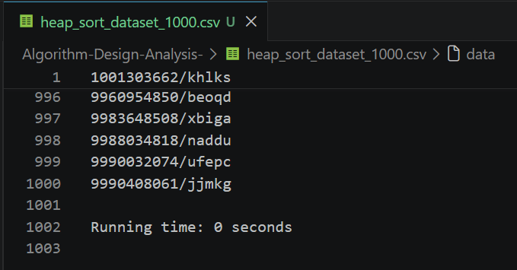
The screenshot above displays the first 15 records of the sorted 1,000-row dataset generated by the Heap Sort algorithm. It visually confirms that the algorithm successfully sorted the dataset in strict ascending order, starting with the smallest 10-digit integer. Furthermore, it proves that the associated 5-letter lowercase strings remained accurately paired with their original integers. This verifies that the swap() operation within our heapify function correctly moved the entire Record pair in memory without causing any data corruption or mismatching.
Theoretical Complexity Analysis
- Time Complexity: Time Complexity: The time complexity for Heap Sort is O(N log N) for the Average and Worst cases. While the theoretical Best case can technically be O(N) if all elements in an array are identical, our assignment strictly generates unique random integers. Therefore, the Best case for our specific dataset implementation is also strictly O(N log N). Building the initial max-heap takes O(N) time. The algorithm then extracts the maximum element (the root) N times. Every time an element is extracted, the heapify function must run to restore the max-heap property. Since the heap is a complete binary tree, heapify takes O(log N) time per extraction. Therefore, the total time for extraction is O(N log N), making the overall time complexity O(N log N).
- Space Complexity: The auxiliary space complexity is O(1) because Heap Sort is an in-place sorting algorithm. It sorts the dataset by swapping elements within the original vector and does not require the creation of any additional arrays. However, because our heapify function is implemented recursively, the maximum depth of the function call stack corresponds to the height of the tree, which adds a theoretical O(log N) space overhead during execution.

Code parts, explanations
- The heapify Function
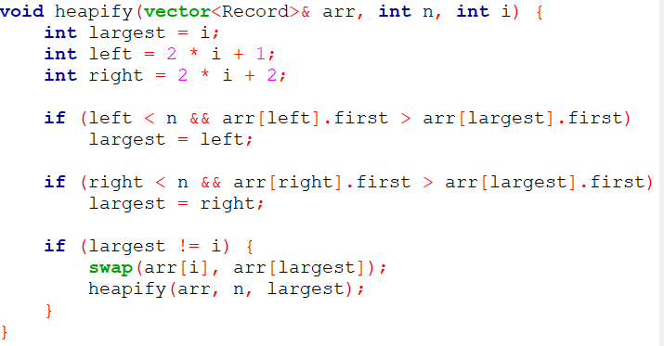
The job of heapify is to maintain the "Max-Heap" rule, which dictates that a parent node must always be larger than its children. It looks at a parent node and its two children. If either child is bigger than the parent, it swaps them and then recursively checks the next level down. The if statements specifically only compare arr[...] first. This guarantees we are strictly sorting the dataset based on the 10-digit integers, and when the swap() happens, the attached string is automatically carried along for the ride.
- The heapSort Function
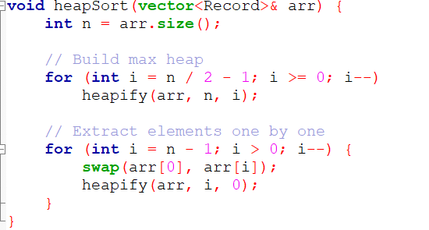
This is the main driver of the algorithm and it operates in two phases. First, it loops backwards from the middle of the array, calling heapify on every parent node to build the initial valid Max-Heap. Once the heap is built, the absolute largest number is sitting at the very top (index 0). We swap that massive number to the very end of our array where it belongs. Then, we shrink our "active" heap boundary by one (i--) and call heapify on the root again so the new top item can sink down to its proper place, repeating until the array is fully sorted.
In both functions, we pass the dataset by reference (vector<Record>& arr). If we didn't do this, C++ would attempt to create a brand-new copy of the 10-million row array every time heapify was called, which would immediately cause a memory overload. Passing by reference ensures our space complexity remains O(1). Additionally, inside our file-reading logic, we added a specific safety check (pop_back()) to strip out hidden \r and \n characters. Windows automatically attaches a carriage return to the end of CSV lines; removing it prevents the strings from being silently corrupted during our benchmark testing.
In a complete binary tree, exactly half of the nodes are leaves, which are already trivial, valid max-heaps on their own. The starting index n / 2 - 1 points to the very last non-leaf parent node. By starting here and moving backwards to index 0, the algorithm efficiently builds the heap from the bottom-up without wasting computing time running heapify on individual leaves.
In the second phase (the extraction loop), the loop stops strictly at i > 0 rather than i >= 0. This is because once the algorithm has successfully extracted and sorted n-1 elements, the single remaining element at index 0 is mathematically guaranteed to be the smallest element in the entire dataset, meaning it is already resting in its correct, final position.

Q4 [5] Hash Table Search
Question Tasks
This section performs the running time analysis for Hash Table Search. The hash table is built using the generated dataset file, where each record contains a 10-digit integer key and a 5-letter lowercase string value. The search targets are read from a separate dataset_search file.
The main dataset file is used to build the hash table, while the dataset_search file is used only as the query file. Each target key from dataset_search is searched against the hash table built from dataset_n.csv.
For each dataset size, the program produces two types of output. The first output is search_results_n.csv, which records the result of every query target from dataset_search, including whether it is FOUND or NOT_FOUND. The second output is hash_table_search_dataset_n.txt, which records the running time for best case, average case, and worst case.

Screenshots, inputs, outputs, figures, explanations, tables, charts
1. Concept Explanation
A hash table is a data structure that stores data using a hash function. The main idea is to convert a key into an index so that the record can be found quickly.
In this implementation, the 10-digit integer is used as the search key. The hash function is:
hash index = key % table size
For example, if the key is 2225882399 and the table size is 500:
hash index = 2225882399 % 500 = 399
This means the record will be stored in bucket 399 of the hash table. During searching, the same hash function is used to find the bucket where the target key should be located.
2. Collision Handling Using AVL Tree
Collision happens when two or more keys are mapped to the same hash index. Instead of using a linked list, this implementation handles collisions using an AVL tree inside each bucket.
An AVL tree is a self-balancing binary search tree. It keeps the tree height balanced after insertion by using rotations. Because the tree remains balanced, searching inside a collision bucket is more efficient than searching through a normal linked list.
If collision occurs, the search continues inside the AVL tree by comparing the target key with the current node:
If the target is smaller, the search moves to the left child.
If the target is larger, the search moves to the right child.
If the target is equal, the record is found.
If the search reaches a null pointer, the target does not exist in the hash table.
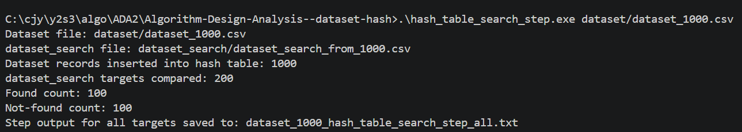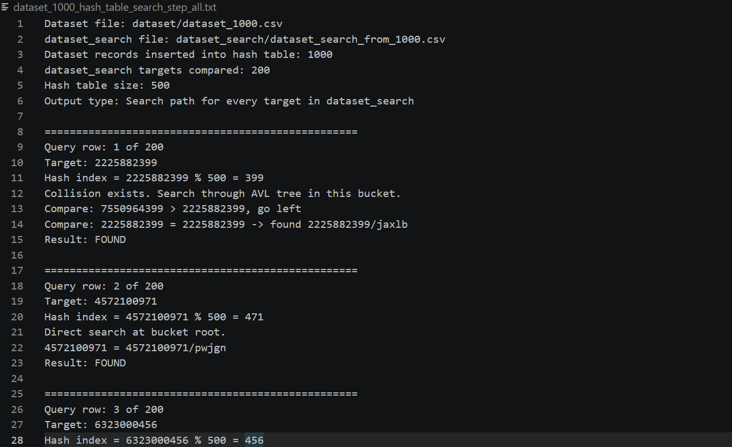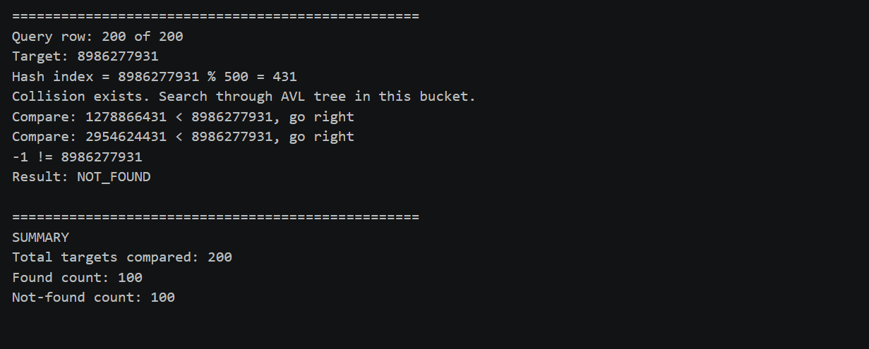
3. Best Case, Average Case, and Worst Case Setup
The best, average, and worst cases are based on the dataset_search file.
The dataset_search file is arranged so that the first half contains keys that exist in the main dataset, while the second half contains keys that do not exist in the main dataset.
Best case uses the first half of dataset_search. These targets represent found cases because they exist in the hash table. Since n size of dataset_search is 20% of n from main dataset, half of it would be 10% from main dataset.
Average case uses the odd-numbered rows from dataset_search, such as the 1st, 3rd, and 5th records. This creates a mixed search pattern because it includes both found and not-found cases.
Worst case uses the last half of dataset_search. These targets represent not-found cases because they do not exist in the hash table.
For each case, the program performs n searches, where n is the dataset size. Because the available keys in each case represent only 10% from n, running a single search pass executes too quickly to be accurately recorded by the system clock. Hence, the program cycles through the query targets until exactly n searches are completed.
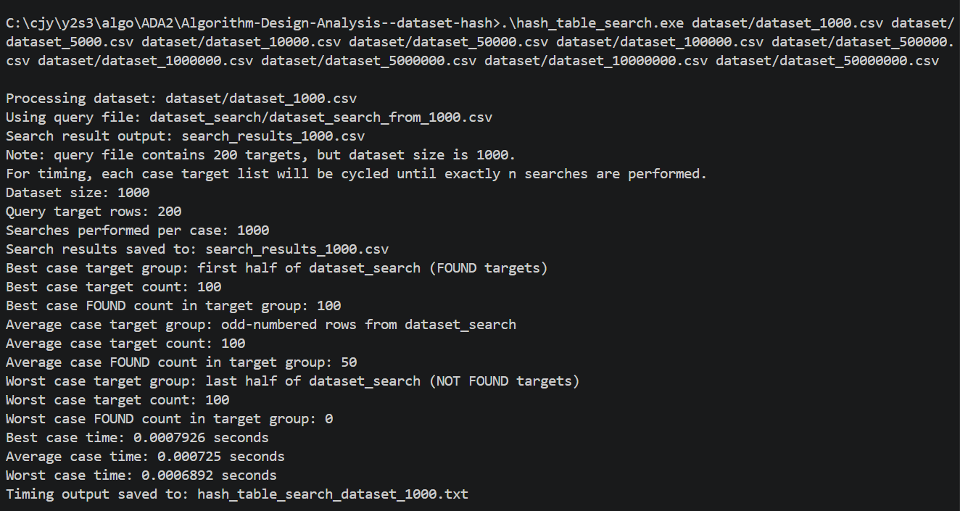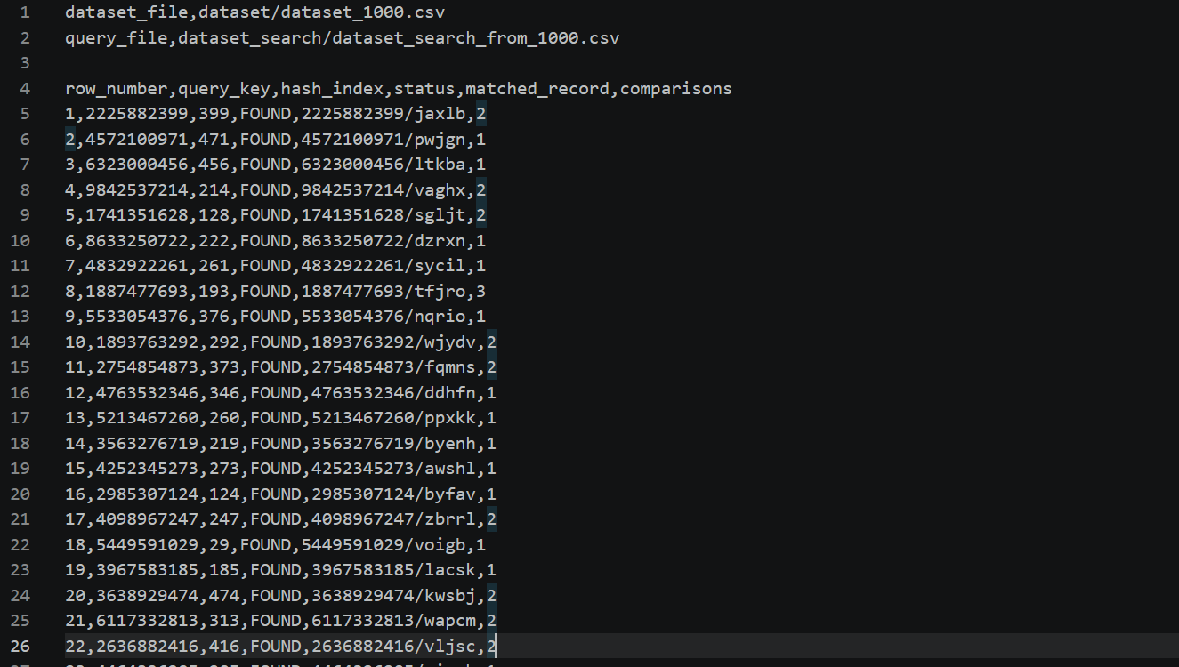
4. Time Complexity Analysis
Best Case Time Complexity: O(1)
The best case happens when the target key is found quickly after calculating the hash index. If the key is located at the root of the bucket or near the top of the AVL tree, only a small number of comparisons is required.
Average Case Time Complexity: O(1) expected
For a well-distributed hash table, most searches can be completed quickly because the hash function spreads records across different buckets. Since collisions are controlled using AVL trees, the average search time is expected to remain close to constant time.
Worst Case Time Complexity: O(log m)
In this implementation, collisions are handled using AVL trees. If many records are stored in the same bucket, the search follows the AVL tree path. Since AVL trees are balanced, the worst-case search inside one bucket is O(log m), where m is the number of records in that bucket.
Overall, the hash table gives fast expected search performance, while the AVL tree helps control the cost of collisions.
5. Space Complexity Analysis
The space complexity is O(n), where n is the number of records in the dataset.
This is because all records must be stored inside the hash table. Each bucket may contain zero, one, or multiple AVL tree nodes if collisions occur. Each AVL node stores the integer key, string value, left pointer, right pointer, and height value. Therefore, the total memory usage grows linearly with the number of records.
6. Running Time Measurement
The running time is measured using chrono::high_resolution_clock. The timer starts only after the dataset has been read and the hash table has already been built. This ensures that file input, hash table construction, and output printing are not included in the measured search time.
The program performs n searches for each case, where n is the dataset size. This is done because a single hash table search is too fast to measure accurately.
The timing output records:
- Dataset file name
- Query/search file name
- Search result CSV file name
- Dataset size
- Number of query target rows
- Number of searches performed per case
- Hash table size
- Collision handling method
- Best case target group
- Average case target group
- Worst case target group
- Best case running time
- Average case running time
- Worst case running time
7. Explanation of Running Time Difference
The running time may not always follow a perfect best < average < worst order. This is because the experiment uses groups of query targets from dataset_search, not only one selected target.
The best case searches through the first half of dataset_search, which contains found targets. The worst case searches through the last half of dataset_search, which contains not-found targets. However, a not-found target may sometimes hash to an empty bucket or a short AVL tree path, so it may finish quickly.
The average case searches odd-numbered rows from dataset_search, which creates a mixed pattern of found and not-found targets. This can access many different memory locations across the hash table. For large datasets, scattered memory access can cause more CPU cache misses, increasing the actual running time.
Therefore, the measured running time is affected by both algorithm behaviour and hardware factors such as CPU cache and memory access patterns. The timing result still correctly represents the performance of the required search cases.

Code Parts and Explanations
1. Record Structure
The Record structure stores one dataset row. It contains the 10-digit integer key and the 5-letter string value. The key is used for hashing and searching, while the string value is stored together with the key so the output can show the full record.
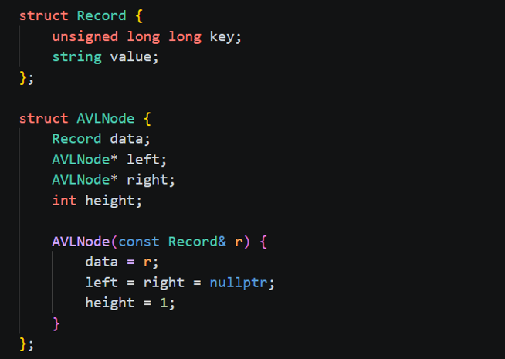

2. Hash Function
The hash function converts the integer key into a valid bucket index using key % tableSize. This ensures that every key is mapped to an index from 0 to tableSize - 1.
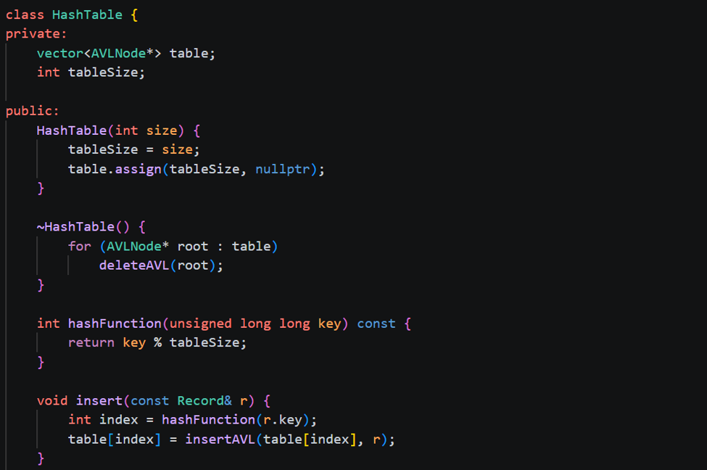
3. Insert Function
The insert function stores each record into the hash table. First, the hash index is calculated. Then, the record is inserted into the AVL tree at that bucket. If the bucket is empty, a new AVL node is created. If a collision happens, the record is inserted into the existing AVL tree.


4. Search Function
The search function looks for a target key in the hash table. It first calculates the hash index, then searches inside the AVL tree at that bucket. If the target is found, it returns true. If the search reaches a null pointer, it returns false.
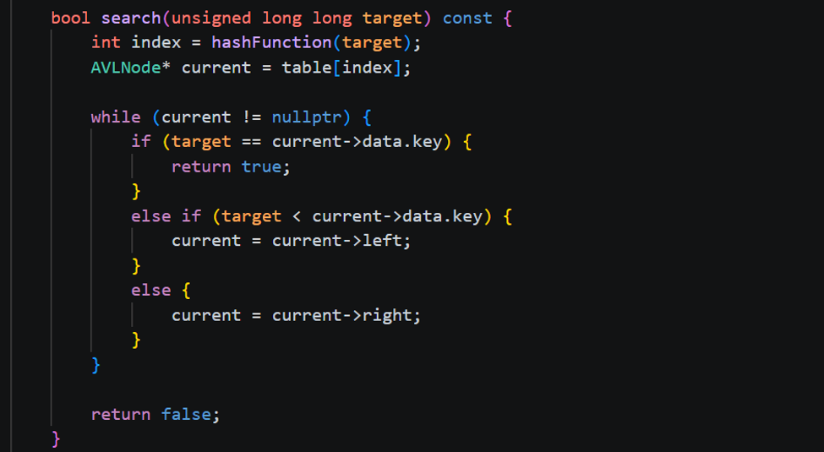
5. Reading the Query File
The readQueryCSV function reads target keys from dataset_search_from_n.csv. These targets are not inserted into the hash table. They are used only as search queries to test whether each key exists in the dataset hash table.
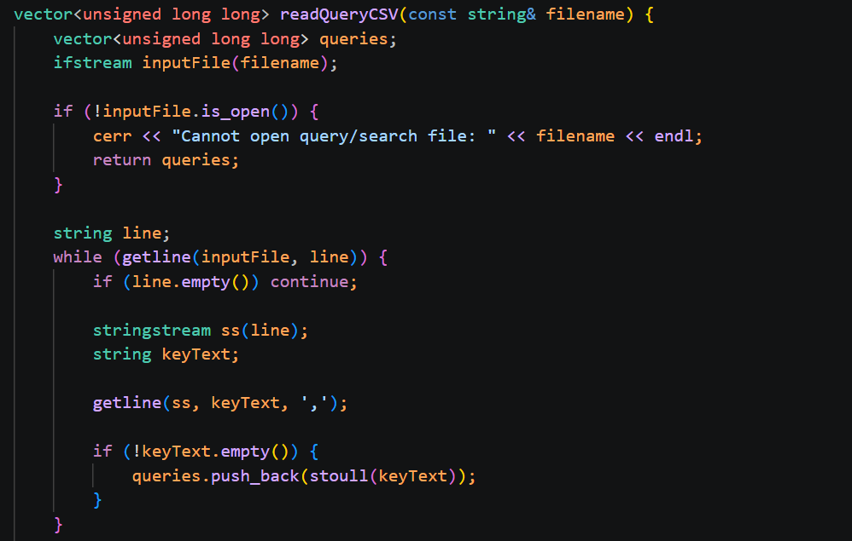
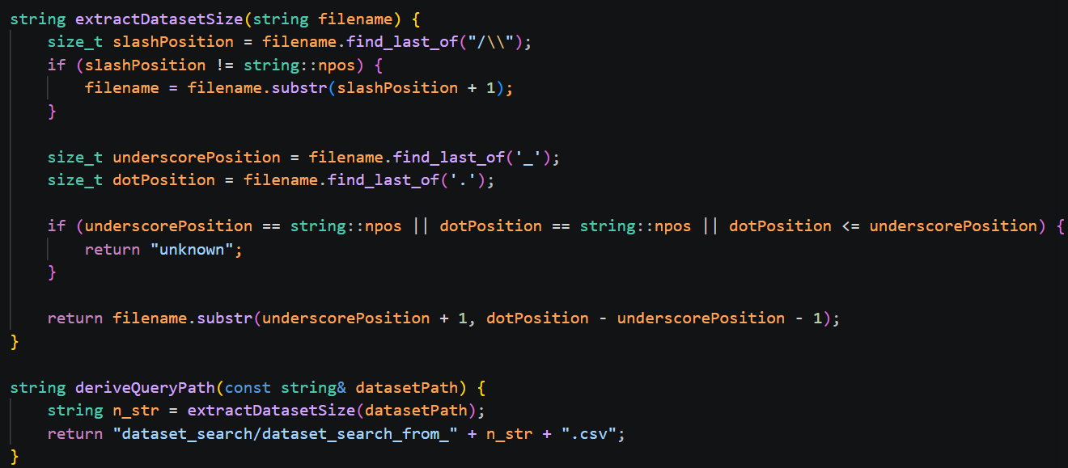
6. Search Result Output
The writeSearchResultsCSV function searches every target key from the dataset_search file and writes the result to search_results_n.csv. Each row records the query key, hash index, status, matched record, and comparison count.
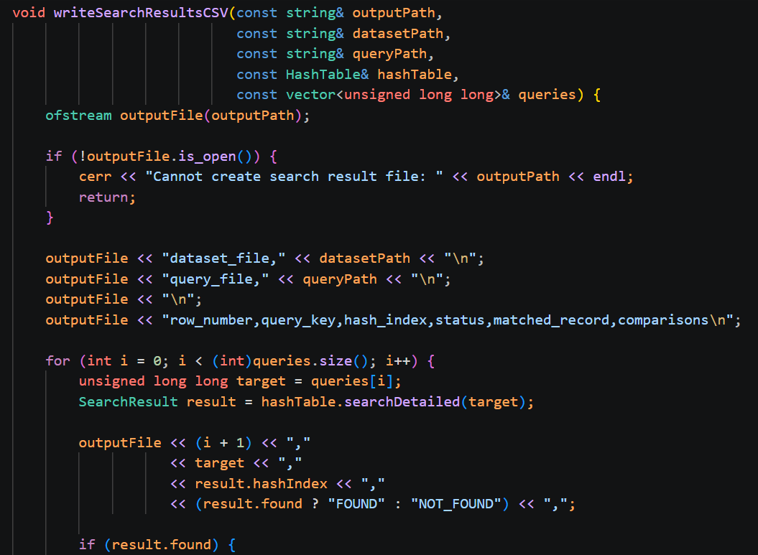
7. Best, Average, and Worst Case Selection
The program splits the query targets from dataset_search into three search cases.
The best case uses the first half of dataset_search, representing found searches.
The average case uses odd-numbered rows from dataset_search, representing a mixture of found and not-found searches.
The worst case uses the last half of dataset_search, representing not-found searches.
Each case is repeated until n searches are completed.
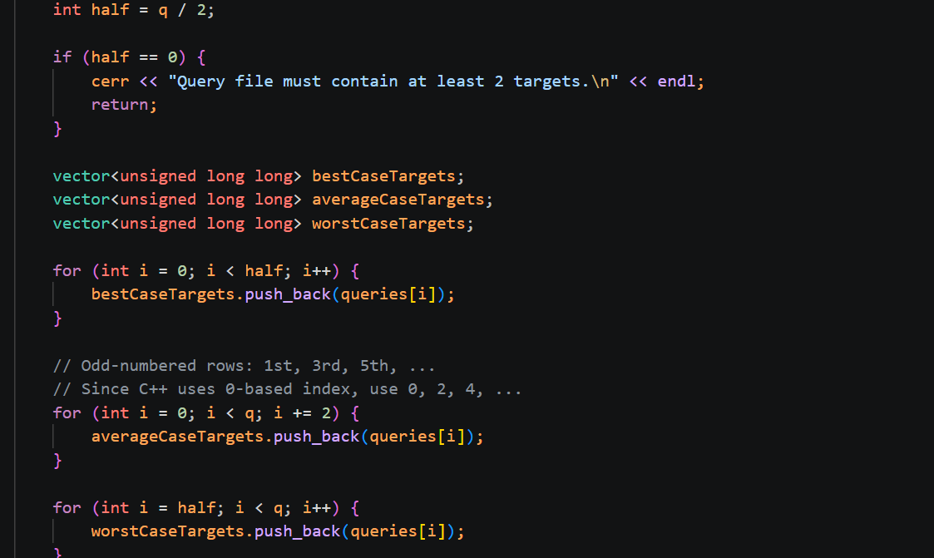

8. Timer Placement
The timer starts only before the search loop and stops immediately after the search loop. This ensures that only the search operation is measured. Reading the dataset, building the hash table, and writing output files are not included in the measured running time.
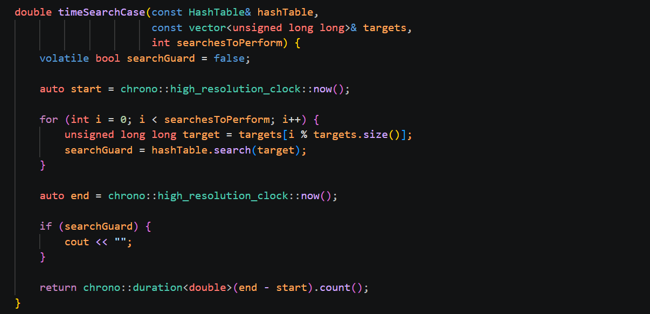
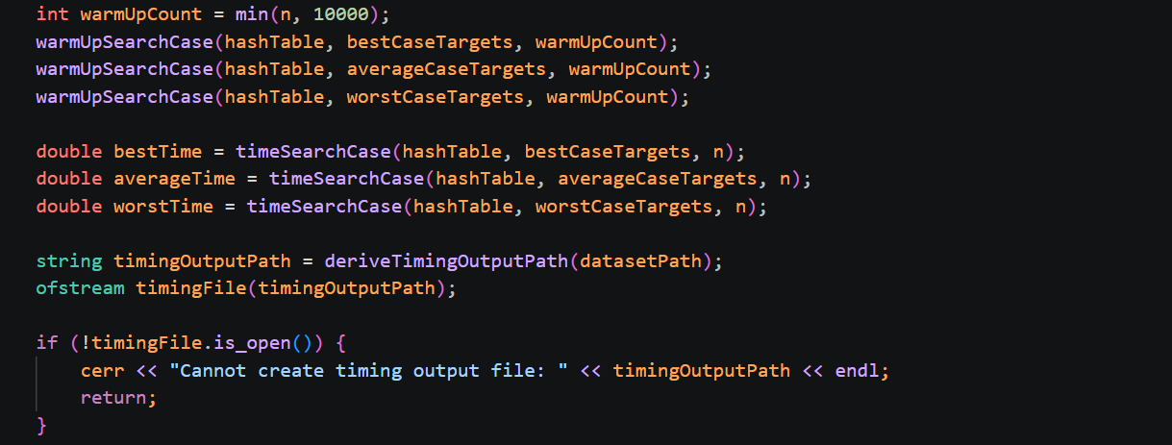
9. Step Output Function
The hash_table_search_step.cpp file is used to show the detailed search path for all targets in the dataset_search file. It prints the target, hash index, and each comparison made inside the AVL tree.
For a found target, the output shows the comparison path until the record is found.
For a not-found target, the output shows the comparison path until the search reaches the end of the tree.
At the end of the file, a summary shows the total number of targets compared, the number of found targets, and the number of not-found targets.
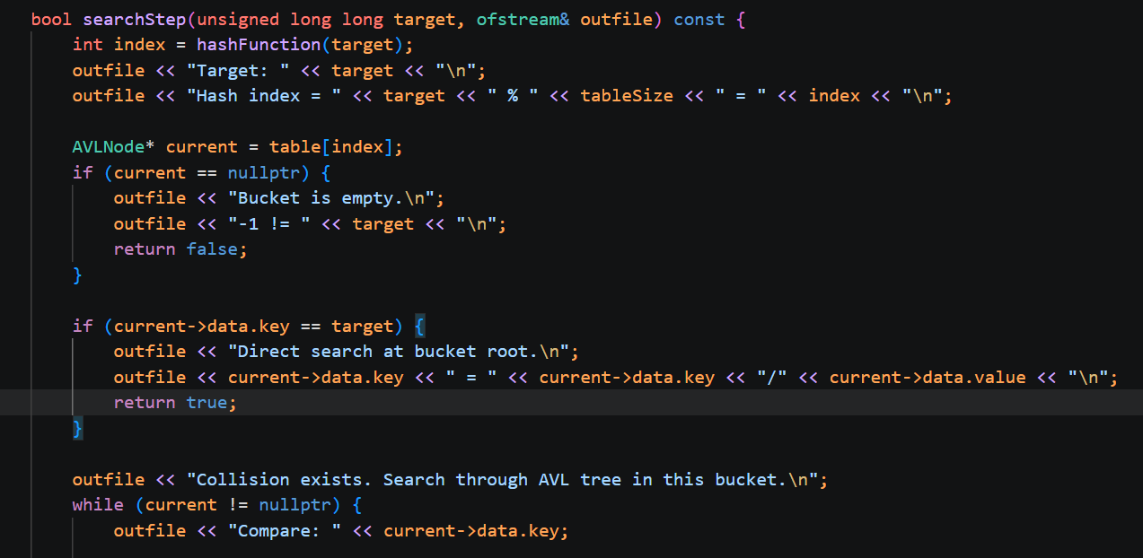
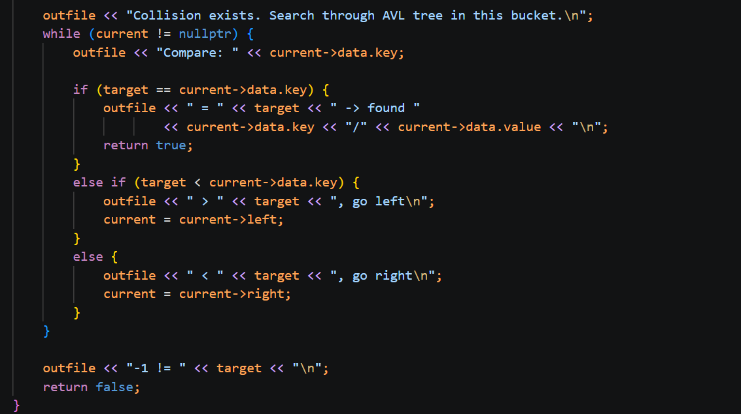

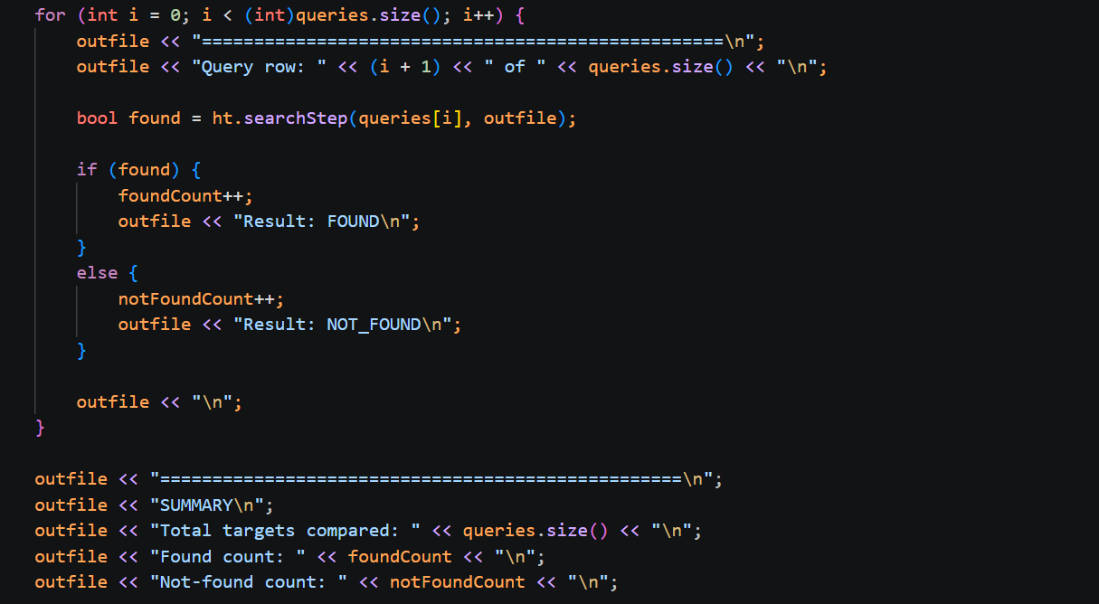

Q5 [5] Conclusion
Question tasks
Conclude the following:
a) Findings on algorithms on the same hardware.
b) The best sorting algorithm for the array-based implementation.
Compare theoretically the hash table search algorithm between the array based AVL balanced binary search tree implementation and linked list based AVL balanced binary search tree implementation.

a) Findings on Algorithms on the Same Hardware
Running Radix Sort, Heap Sort, and Hash Table Search on the same machine revealed patterns that strongly align with their theoretical time complexities, while also highlighting real-world hardware limits.

- Sorting Performance: Radix Sort showed a clear and growing advantage at large input sizes, though Heap Sort was marginally faster at a couple of low-range sizes (n<5000), likely due to memory allocation overhead from Radix Sort's repeated output buffer reallocation across its 10 passes.

- Search Performance & Cache Locality: Best-case hash table searches (root of the bucket) were always fastest. However, wall-clock time did not strictly match logical comparison counts. Average-case searches required fewer comparisons (~1.7) than worst-case (4–5) yet took noticeably longer at large input sizes.

- Hardware Impact: This discrepancy is caused by CPU cache locality. The worst-case benchmark repeatedly accesses the same localized keys, keeping them cached. The average-case scatters searches across the table, triggering cache misses at scale. This proves that real-world performance is shaped by memory access patterns, not just Big-O analysis.

b) The Best Sorting Algorithm for the Array-Based Implementation
Based on theoretical analysis and our experimental results, Radix Sort is the superior choice for this implementation.

- Speed Advantage: Because the dataset consists of fixed-width 10-digit integers, Radix Sort achieves genuine O(n) linear-time performance across best, average, and worst cases by processing a fixed d = 10 passes. Heap Sort remains bound to O(n log n).

- Space Trade-off: Heap Sort sorts in-place (O(1) auxiliary space), whereas Radix Sort requires O(n) extra space for its output buffer.

- Conclusion: Since demonstrating speed efficiency at massive scale was the primary goal, Radix Sort's significant time advantage easily justifies its higher memory footprint for this specific dataset.

c) Array-Based vs. Linked-List-Based AVL Hash Table Implementation
Our collision handling used a linked-list-based (pointer-based) AVL tree. An array-based AVL tree is a strong alternative, with distinct trade-offs:

- Time Complexity: Both achieve O(log m) for search, insertion, and deletion. The balancing logic (rotations) remains identical regardless of how child nodes are referenced.

- Space Complexity: Linked-list nodes use exactly the memory needed but carry a heavier per-node overhead (16 bytes for two pointers). Array nodes use smaller 4-byte indices, but the array itself may waste capacity through over-allocation or "holes" left by deleted nodes.

- Real-World Speed (Cache Locality): Linked-list nodes are allocated dynamically, scattering them across memory. This causes the severe CPU cache misses observed in our average-case experiments. Array elements are stored contiguously, offering superior cache locality and faster physical traversals.

- Implementation Complexity: Linked lists are simpler to code since rotations only require reassigning pointers. Array-based trees require complex index arithmetic and free-list management to handle gaps left by deleted nodes.

- Summary: While theoretically equal in time complexity, the linked-list approach is simpler and memory-strict but suffers from cache penalties at scale. An array-based approach is harder to implement but delivers significantly better real-world hardware efficiency.

Q7 [5] Experiments
Question tasks
For the experiment study:
a) The running time captured should NOT include the time for reading input or printing output (I/O).
b) At least 10 different input sizes should be captured for each algorithm.
c) Each member should run all algorithms and include the results in the document. Screenshots, inputs, outputs, figures, explanations, tables, charts
d) For hash table search, the comparison count followed the expected pattern, but the running time did not always increase strictly with input size. This is because repeated searches of selected worst-case targets can benefit from CPU cache, while average-case searches access many different memory locations. Therefore, real running time is affected by both algorithm complexity and hardware behavior.

Input command: All members compiled and run the code through the following command:
>g++ radix_sort.cpp -o radix_sort
> radix_sort.exe dataset\dataset_1000.csv dataset\dataset_5000.csv dataset\dataset_10000.csv dataset\dataset_50000.csv dataset\dataset_100000.csv dataset\dataset_500000.csv dataset\dataset_1000000.csv dataset\dataset_5000000.csv dataset\dataset_10000000.csv dataset\dataset_50000000.csv
> g++ heap_sort.cpp -o heap_sort
> heap_sort.exe dataset\dataset_1000.csv dataset\dataset_5000.csv dataset\dataset_10000.csv dataset\dataset_50000.csv dataset\dataset_100000.csv dataset\dataset_500000.csv dataset\dataset_1000000.csv dataset\dataset_5000000.csv dataset\dataset_10000000.csv dataset\dataset_50000000.csv
> g++ hash_table_search.cpp -o hash_table_search
>hash_table_search.exe dataset\dataset_1000.csv dataset\dataset_5000.csv dataset\dataset_10000.csv dataset\dataset_50000.csv dataset\dataset_100000.csv dataset\dataset_500000.csv dataset\dataset_1000000.csv dataset\dataset_5000000.csv dataset\dataset_10000000.csv dataset\dataset_50000000.csv

The same dataset is used by all group members, the link to download the dataset is as follows: https://mmuedumy-my.sharepoint.com/:f:/g/personal/koay_yee_shuen_student_mmu_edu_my/IgC5vM4FSql7QYt0sAFJeNcrAbvm1xwcV8TYC2Aux_QcMTc?e=WDcVV0
Chan Jia Yi
Radix sort:
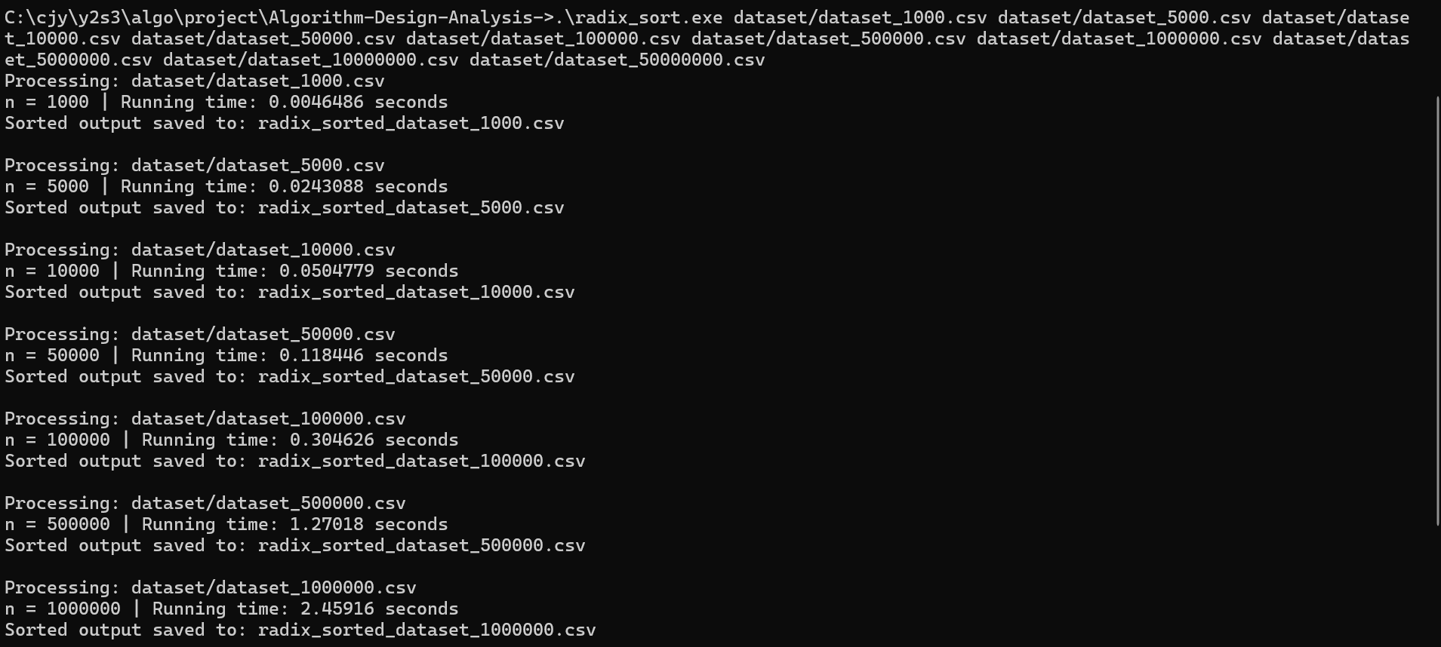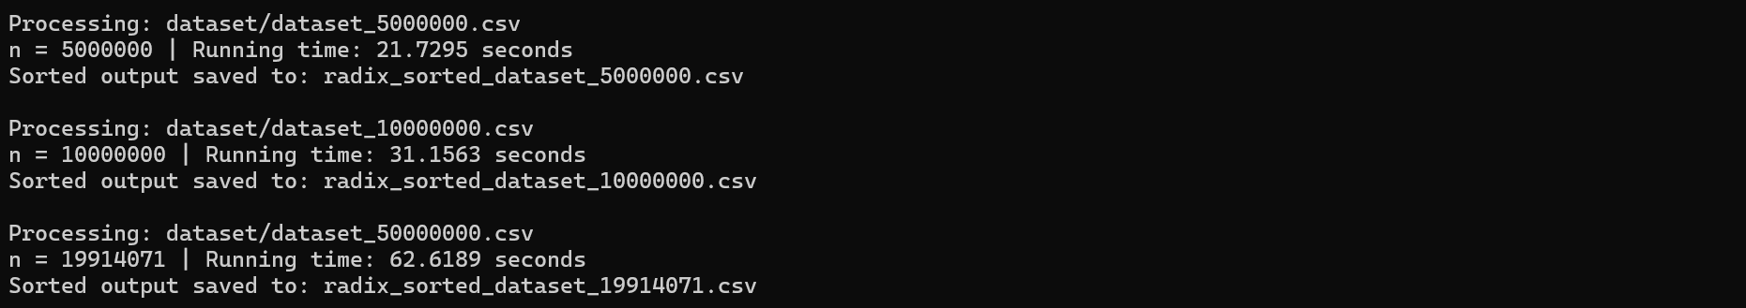
Heap sort:
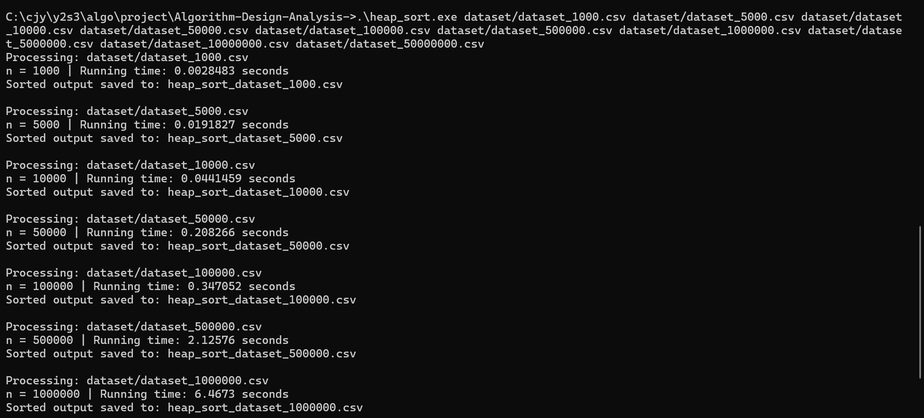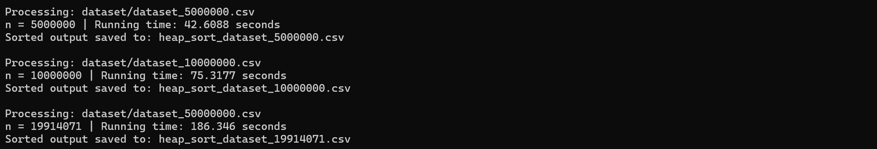
Hash Table Search:
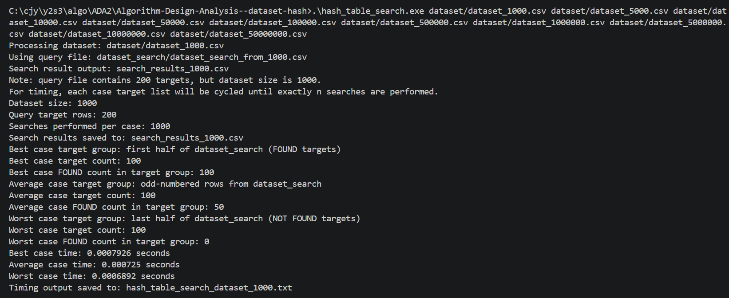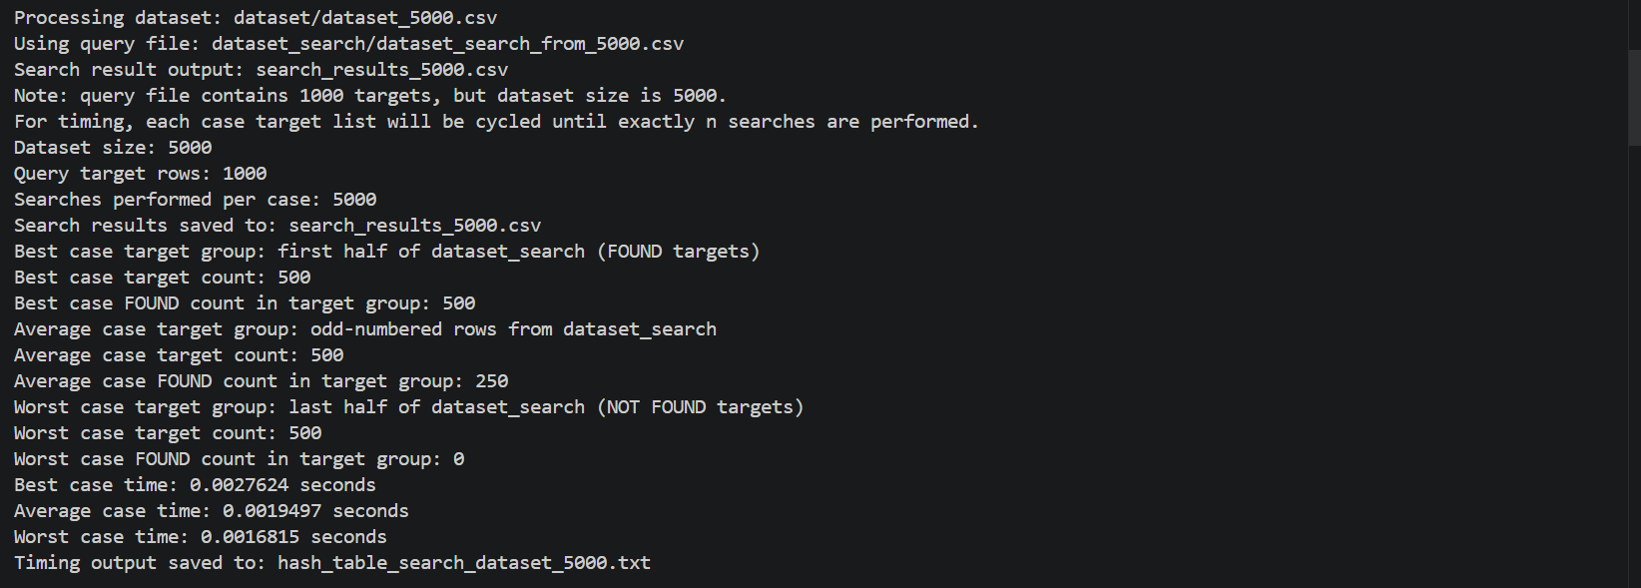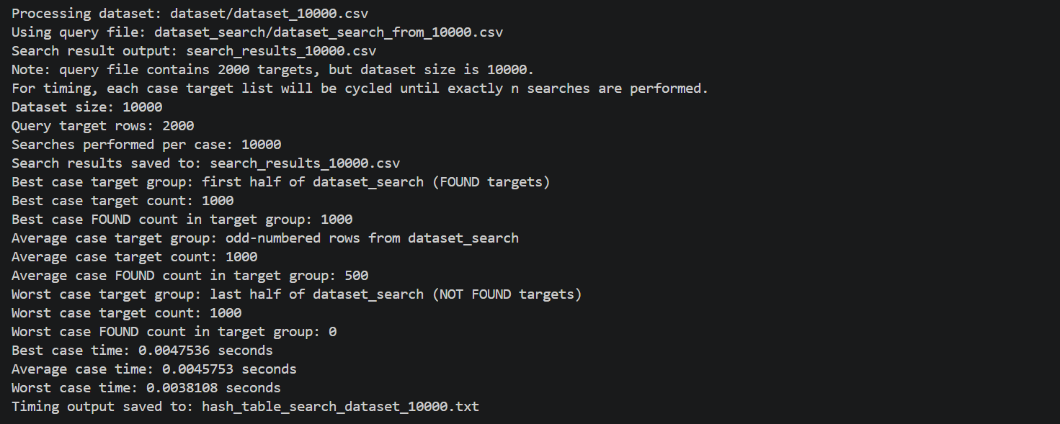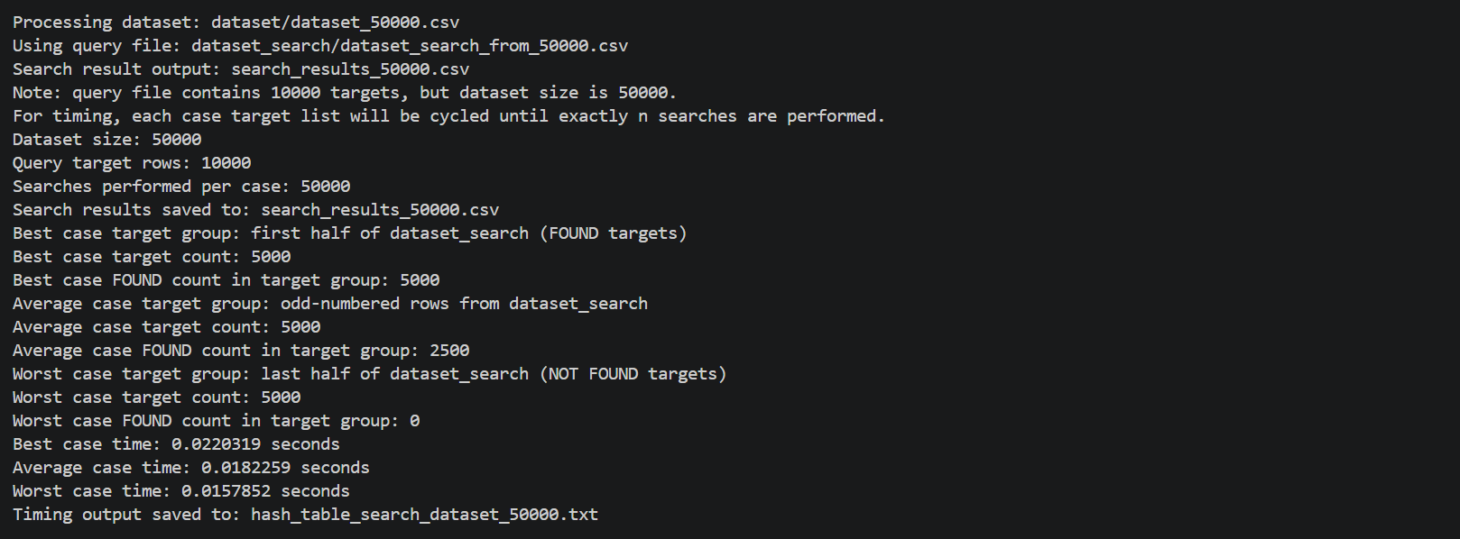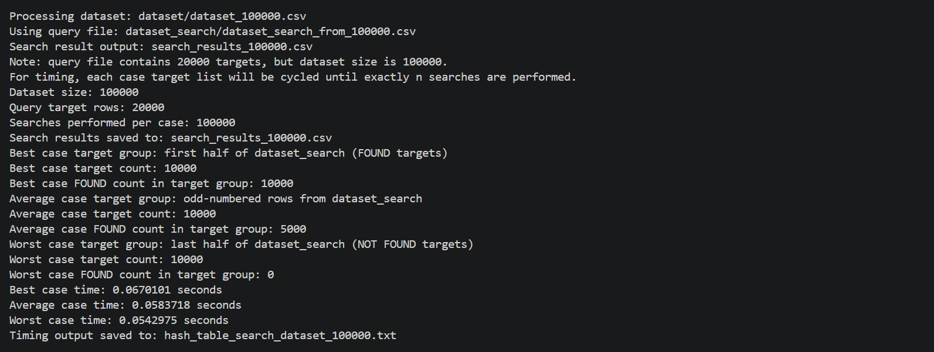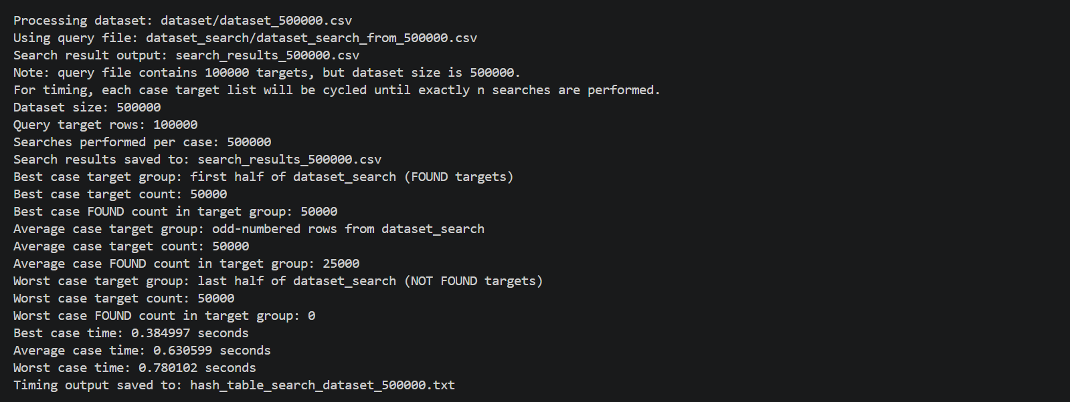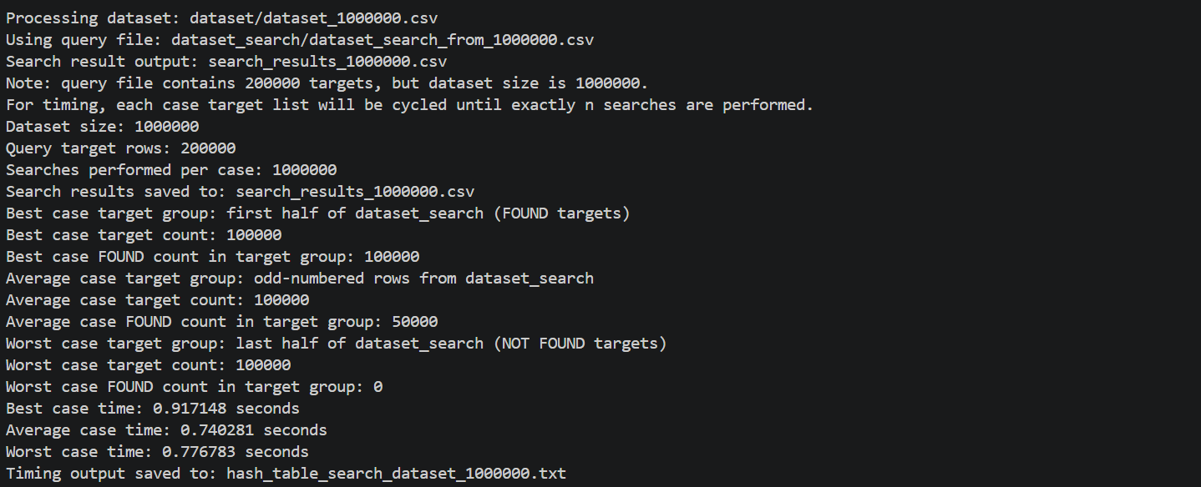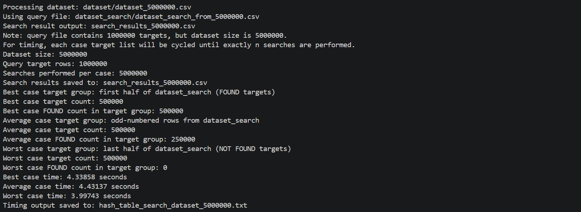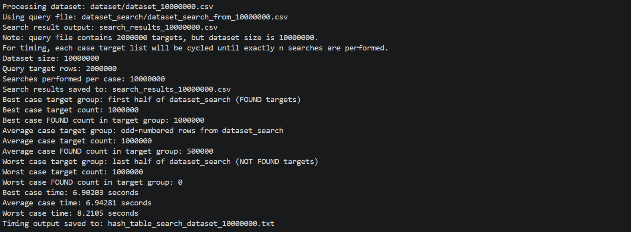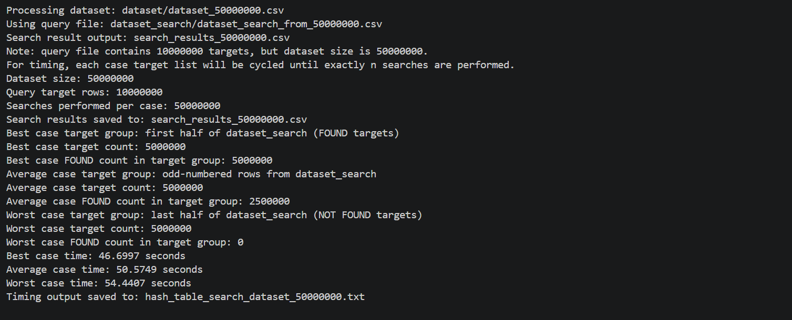

Summary :
Radix sort vs Heap sort
 | Radix Sort Time (s) | Heap Sort Time (s) | Differences (s)
1,000 | 0.0046486 | 0.0028483 | -0.0018003
5,000 | 0.0243088 | 0.0191827 | -0.0051261
10,000 | 0.0504779 | 0.0441459 | -0.006332
50,000 | 0.118446 | 0.208266 | 0.08982
100,000 | 0.304626 | 0.347052 | 0.042426
500,000 | 1.27018 | 2.12576 | 0.85558
1,000,000 | 4.00814 | 6.4673 | 4.00814
5,000,000 | 21.7295 | 42.6088 | 20.8793
10,000,000 | 31.1563 | 75.3177 | 44.1614
50,000,000 | 110.853 | 357.241 | 246.388

Hash Table Search
Input Size (n) | Best Case (s) | Average Case (s) | Worst Case (s)
1,000 | 0.0007926 | 0.000725 | 0.0006892
5,000 | 0.0027624 | 0.0019497 | 0.0016815
10,000 | 0.0047536 | 0.0045753 | 0.0038108
50,000 | 0.0220319 | 0.0583718 | 0.0157852
100,000 | 0.0670101 | 0.0583718 | 0.0542975
500,000 | 0.384997 | 0.630599 | 0.780102
1,000,000 | 0.917148 | 0.740281 | 0.776783
5,000,000 | 4.33858 | 4.43137 | 3.99743
10,000,000 | 6.90203 | 6.94281 | 8.2105
50,000,000 | 46.6997 | 50.5749 | 54.4407

Chew Jia Yi
Radix sort:

Heap sort:
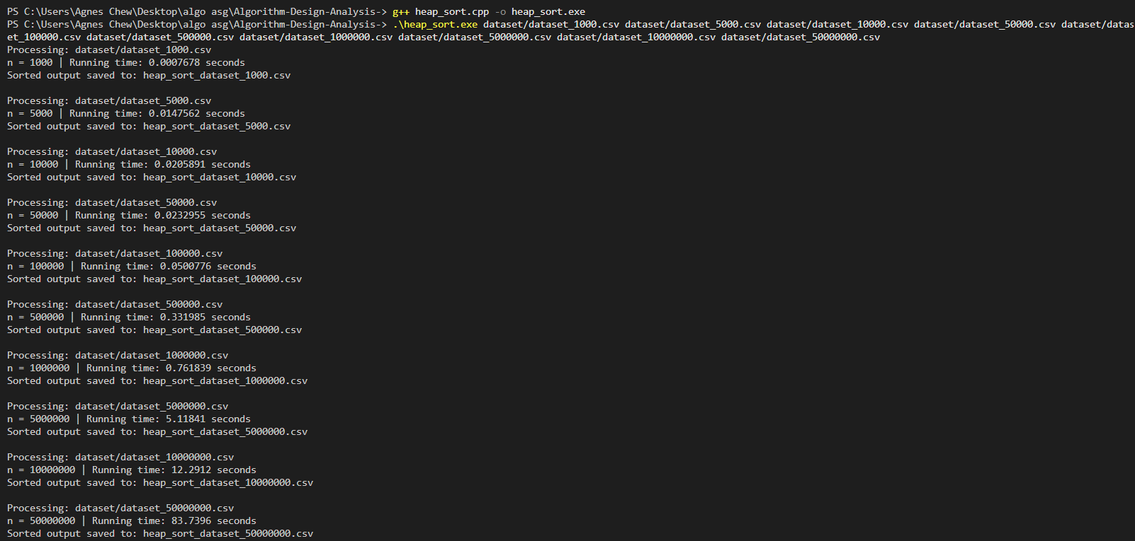

Hash table search:

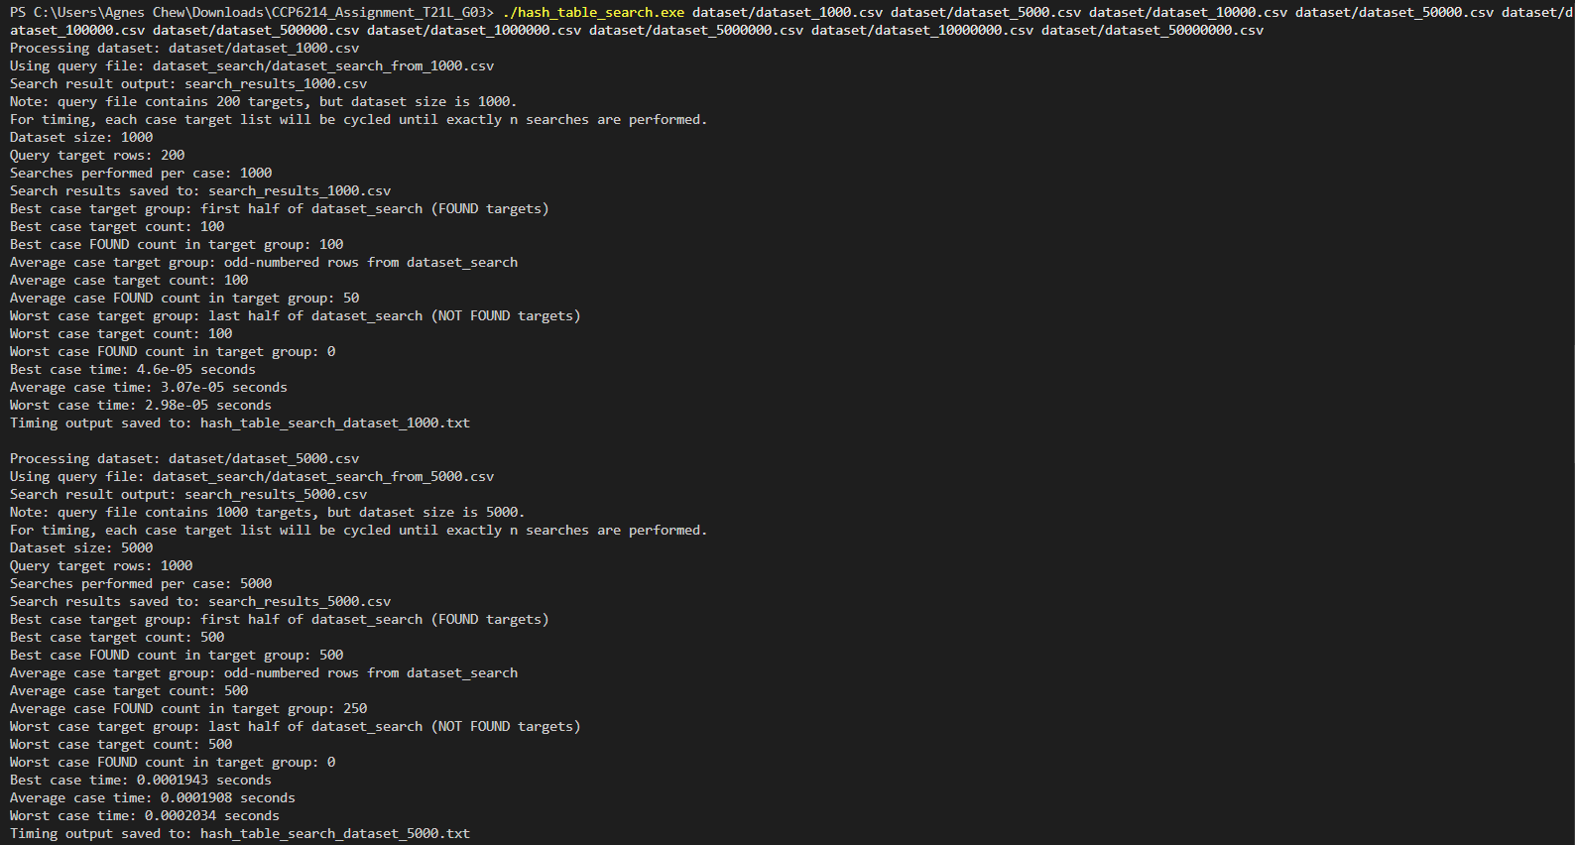
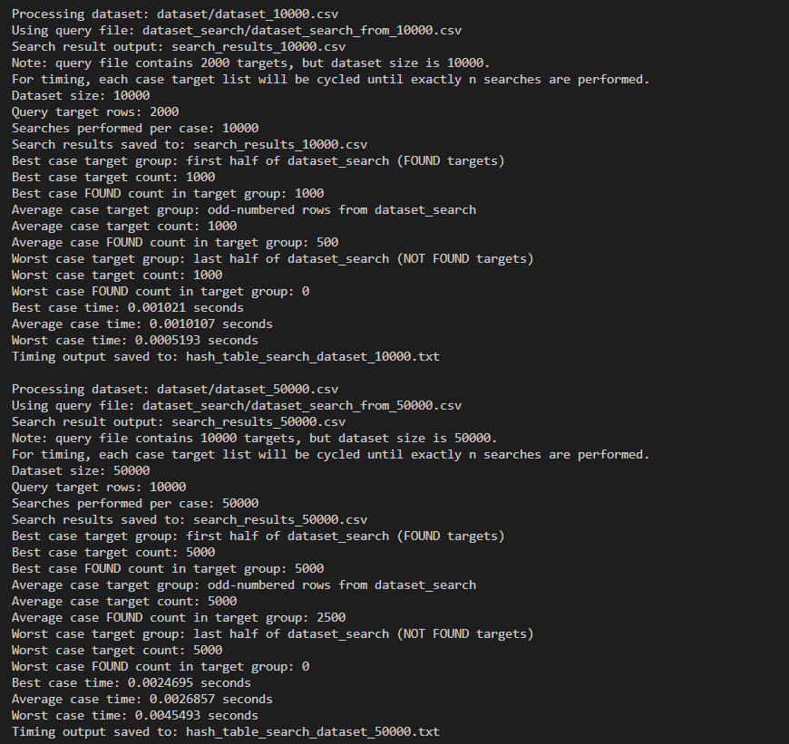
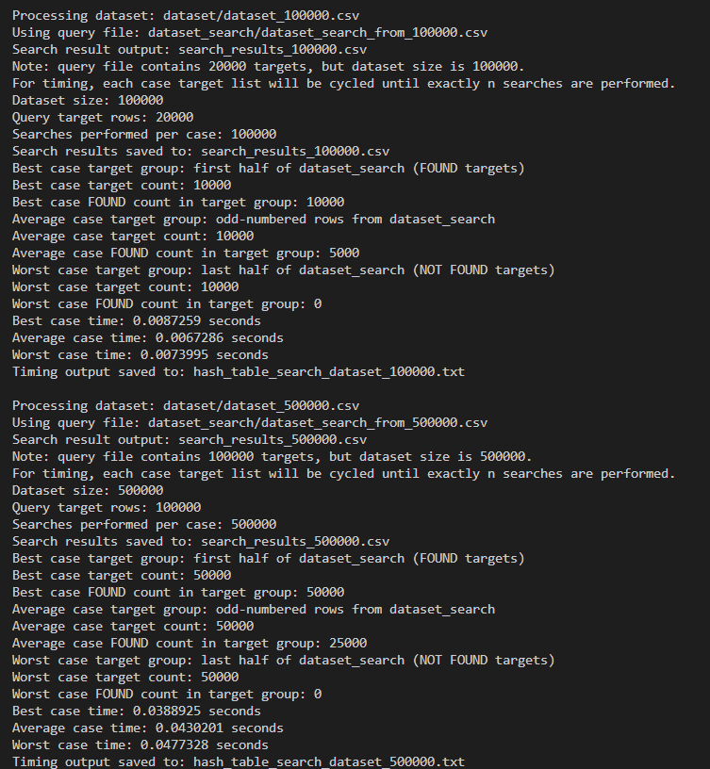
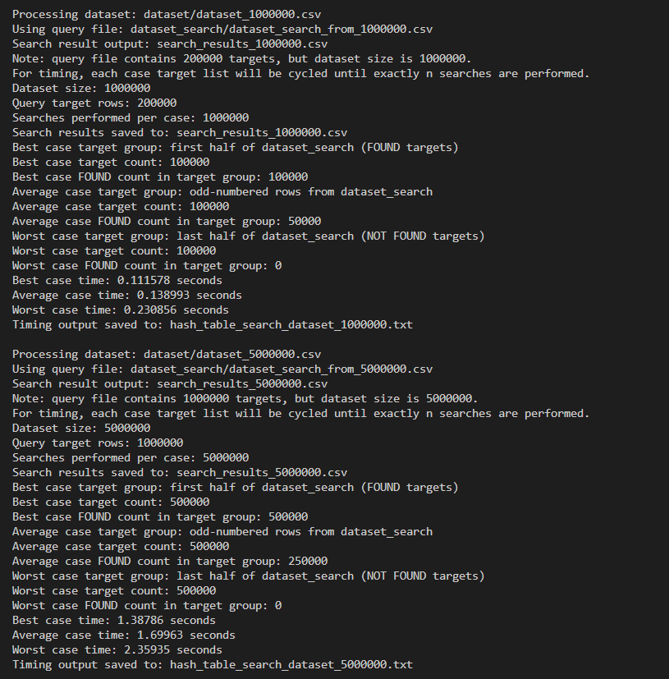
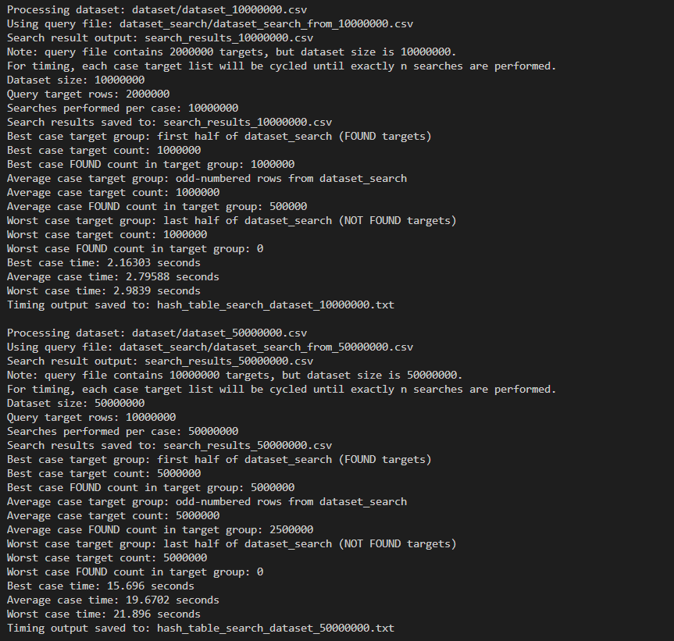

Radix Sort vs Heap Sort Table:

Input Size (n) | Radix Sort (s) | Heap Sort (s) | Difference (s)
1,000 | 0.0003368 | 0.0007678 | 0.0004310
5,000 | 0.0054395 | 0.0147562 | 0.0093167
10,000 | 0.0108760 | 0.0205891 | 0.0097131
50,000 | 0.0184743 | 0.0232955 | 0.0048212
100,000 | 0.0392546 | 0.0500776 | 0.0108230
500,000 | 0.2031030 | 0.3319850 | 0.1288820
1,000,000 | 0.4734860 | 0.7618390 | 0.2883530
5,000,000 | 2.5971300 | 5.1184100 | 2.5212800
10,000,000 | 4.3912600 | 12.2912000 | 7.8999400
50,000,000 | 23.7367000 | 83.7396000 | 60.0029000
Note: Difference calculated as (Heap Sort - Radix Sort). Positive means Radix was faster.

Hash Table Search:

Input Size (n) | Best Case (s) | Average Case (s) | Worst Case (s)
1,000 | 0.0000460 | 0.0000307 | 0.0000298
5,000 | 0.0001943 | 0.0001908 | 0.0002034
10,000 | 0.0010210 | 0.0010107 | 0.0005193
50,000 | 0.0024695 | 0.0026857 | 0.0045493
100,000 | 0.0087259 | 0.0067286 | 0.0073995
500,000 | 0.0388925 | 0.0430201 | 0.0477328
1,000,000 | 0.1115780 | 0.1389930 | 0.2308560
5,000,000 | 1.3878600 | 1.6996300 | 2.3593500
10,000,000 | 2.1630300 | 2.7958800 | 2.9839000
50,000,000 | 15.6960000 | 19.6702000 | 21.8960000

Koay Yee Shuen
Radix sort:
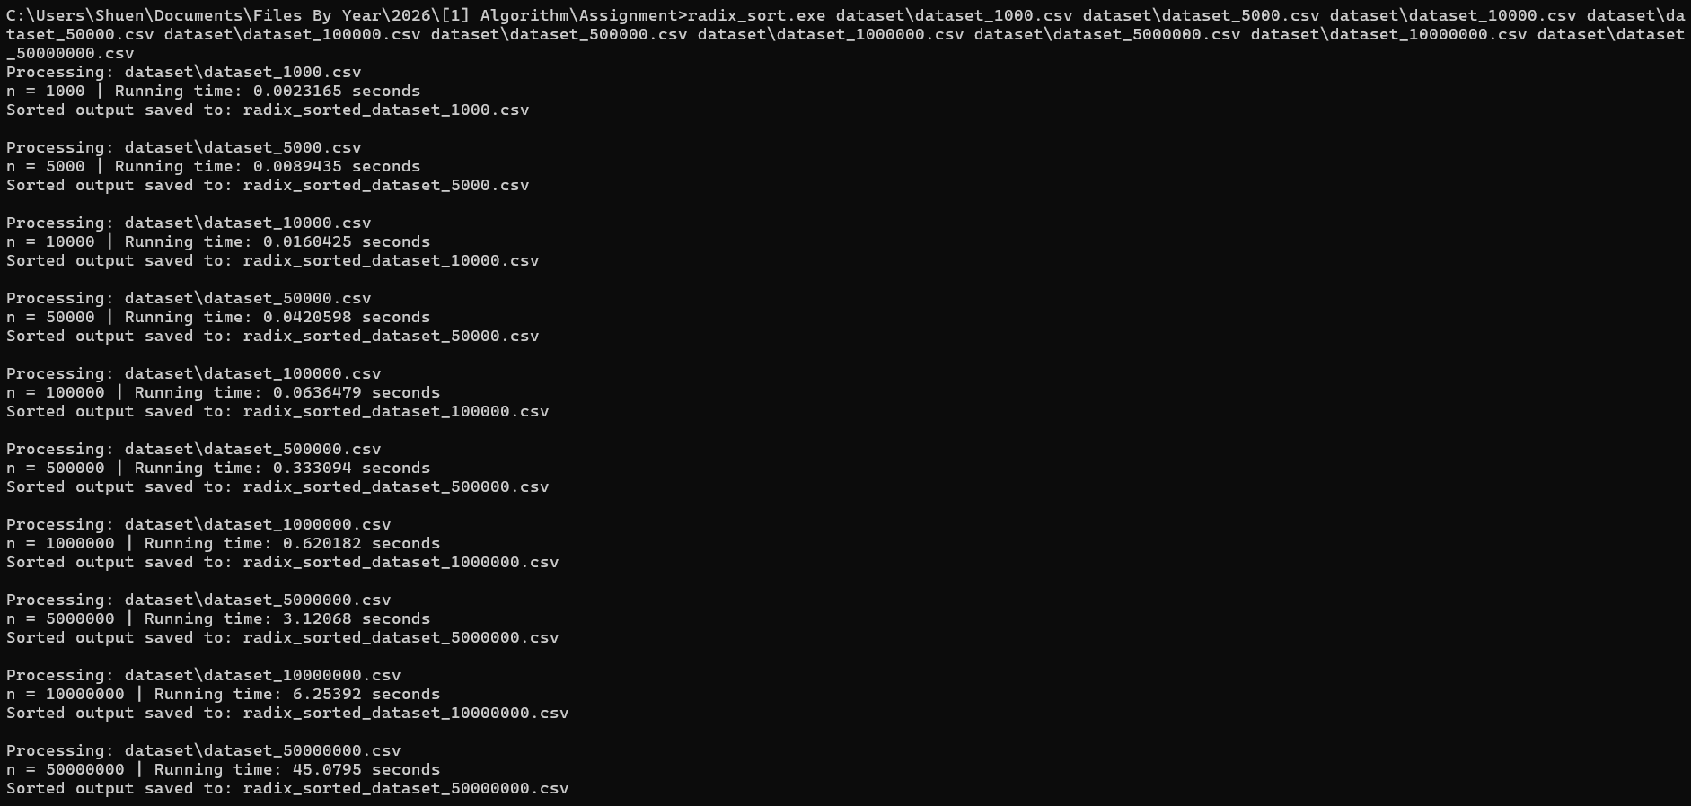
Heap sort
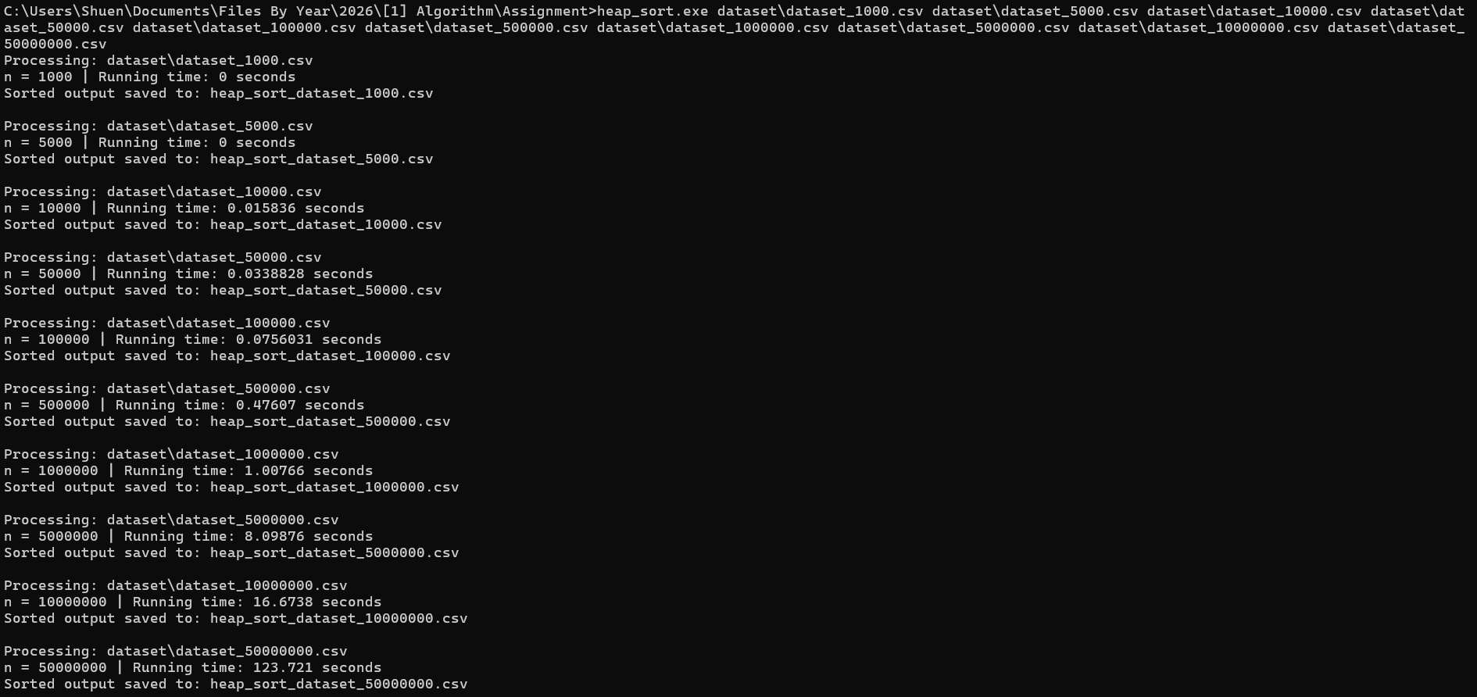
Hash Table Search
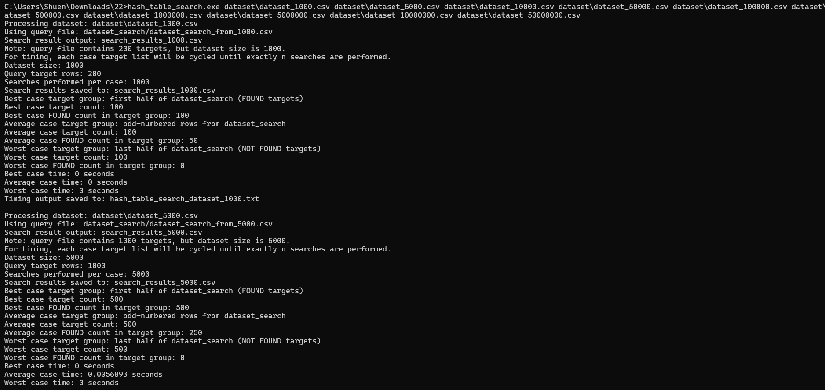
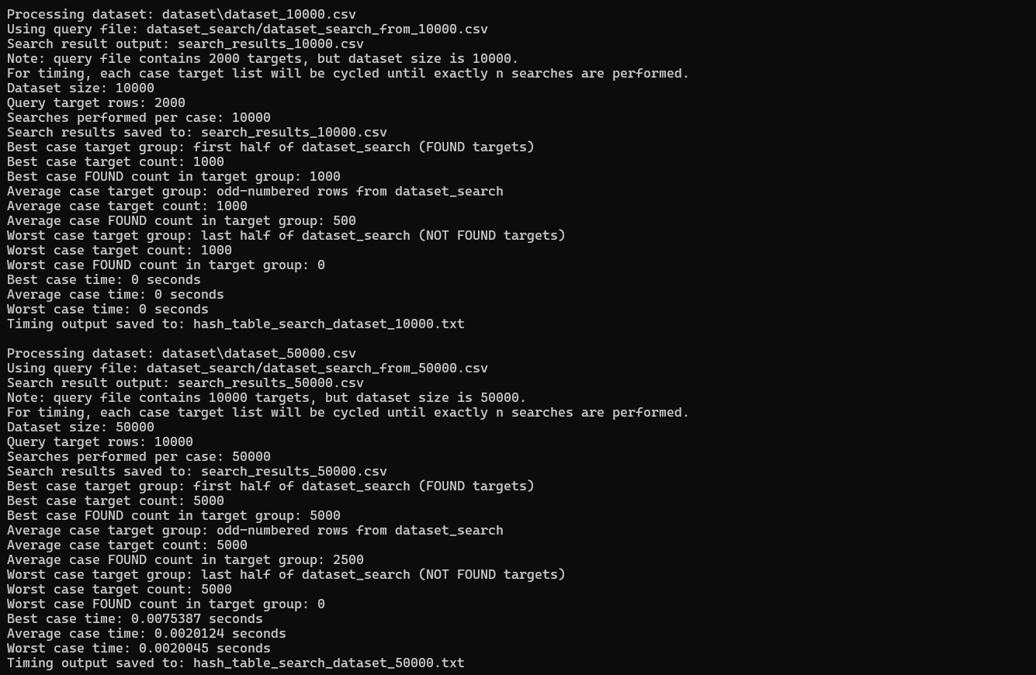

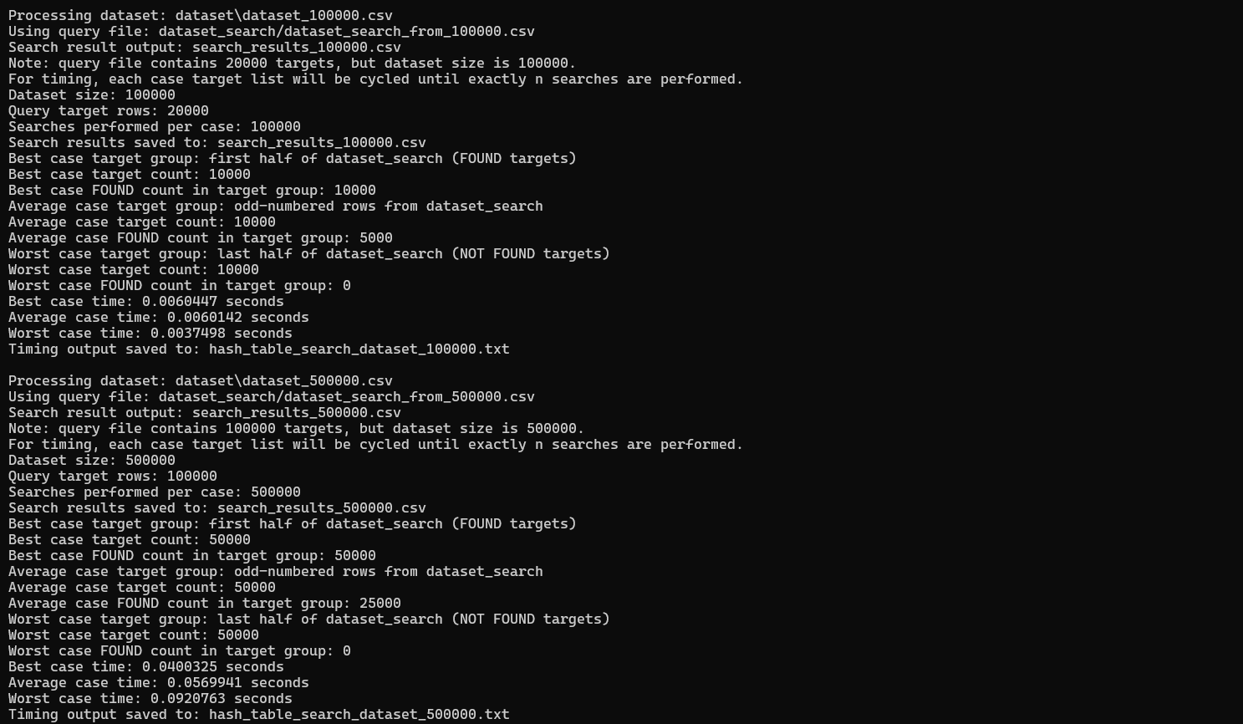
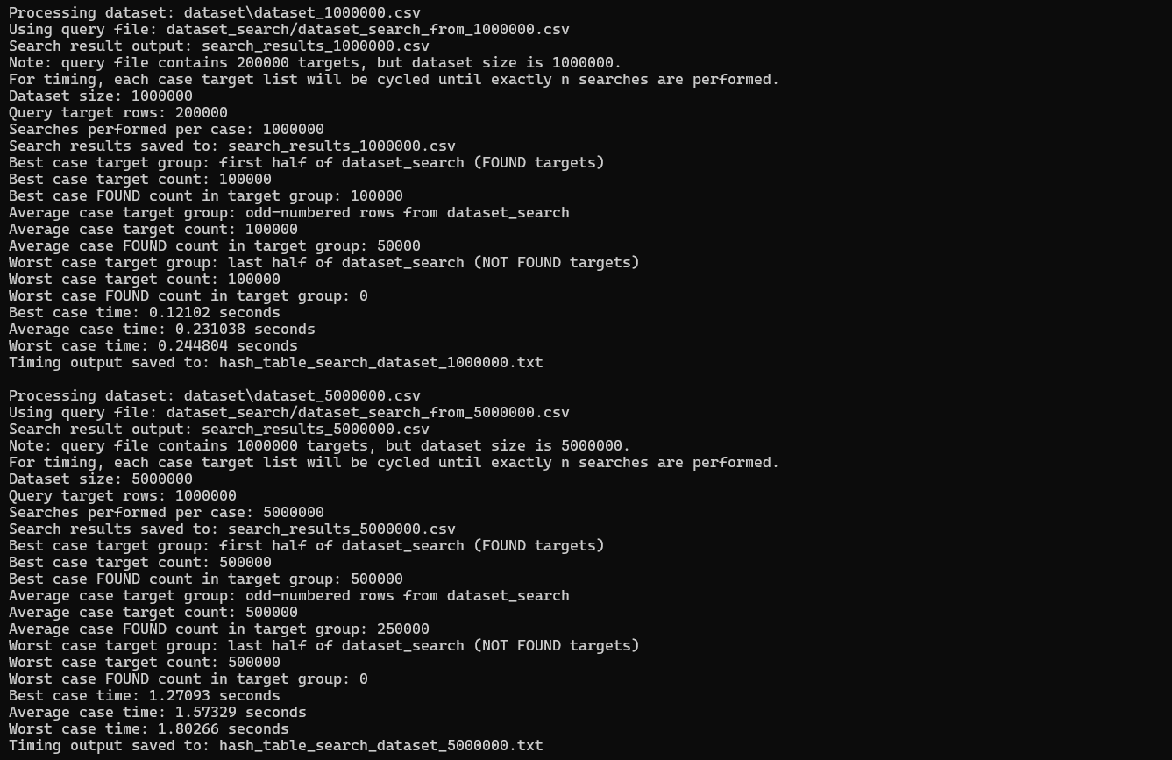
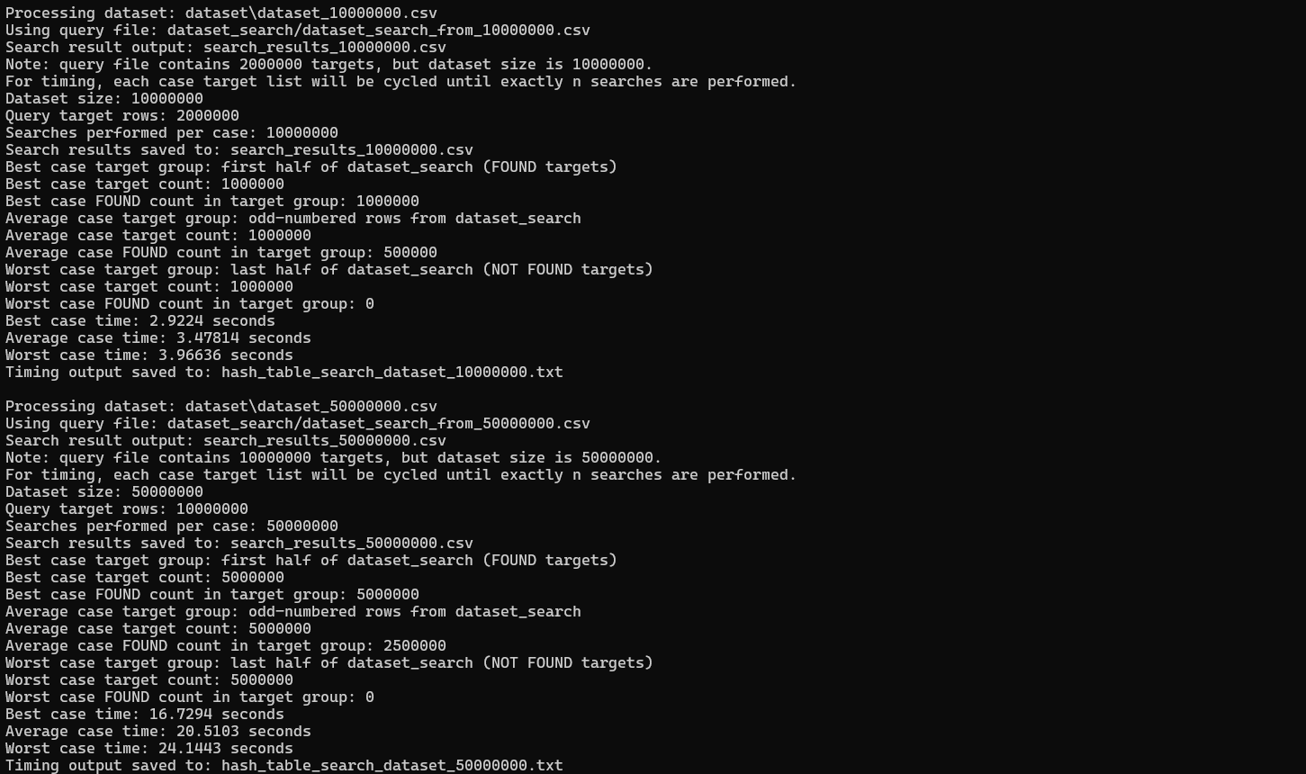

Summary:
Radix vs Heap Sort
 | Radix Sort Time (s) | Heap Sort Time (s) | Difference (s)
1,000 | 0.0023165 | 0 | -0.0023165
5,000 | 0.0089435 | 0 | -0.0089435
10,000 | 0.0160425 | 0.015836 | -0.0002065
50,000 | 0.0420598 | 0.0338828 | -0.008177
100,000 | 0.0636479 | 0.0756031 | 0.0119552
500,000 | 0.333094 | 0.47607 | 0.142976
1,000,000 | 0.620182 | 1.00766 | 0.387478
5,000,000 | 3.12068 | 8.09876 | 4.97808
10,000,000 | 6.25392 | 16.6738 | 10.41988
50,000,000 | 45.0795 | 123.721 | 78.6415

Hash Table Search Running Time
Input Size (N) | Best Time (s) | Average Time (s) | Worst Time (s)
1,000 | 0 | 0 | 0
5,000 | 0 | 0.0056893 | 0
10,000 | 0 | 0 | 0
50,000 | 0.0075387 | 0.0020124 | 0.0020045
100,000 | 0.0060447 | 0.0060142 | 0.0037498
500,000 | 0.0400325 | 0.0569941 | 0.0920763
1,000,000 | 0.12102 | 0.231038 | 0.244804
5,000,000 | 1.27093 | 1.57329 | 1.80266
10,000,000 | 2.9224 | 3.47814 | 3.96636
50,000,000 | 16.7294 | 20.5103 | 24.1443

Ong Wan Ning
Radix Sort
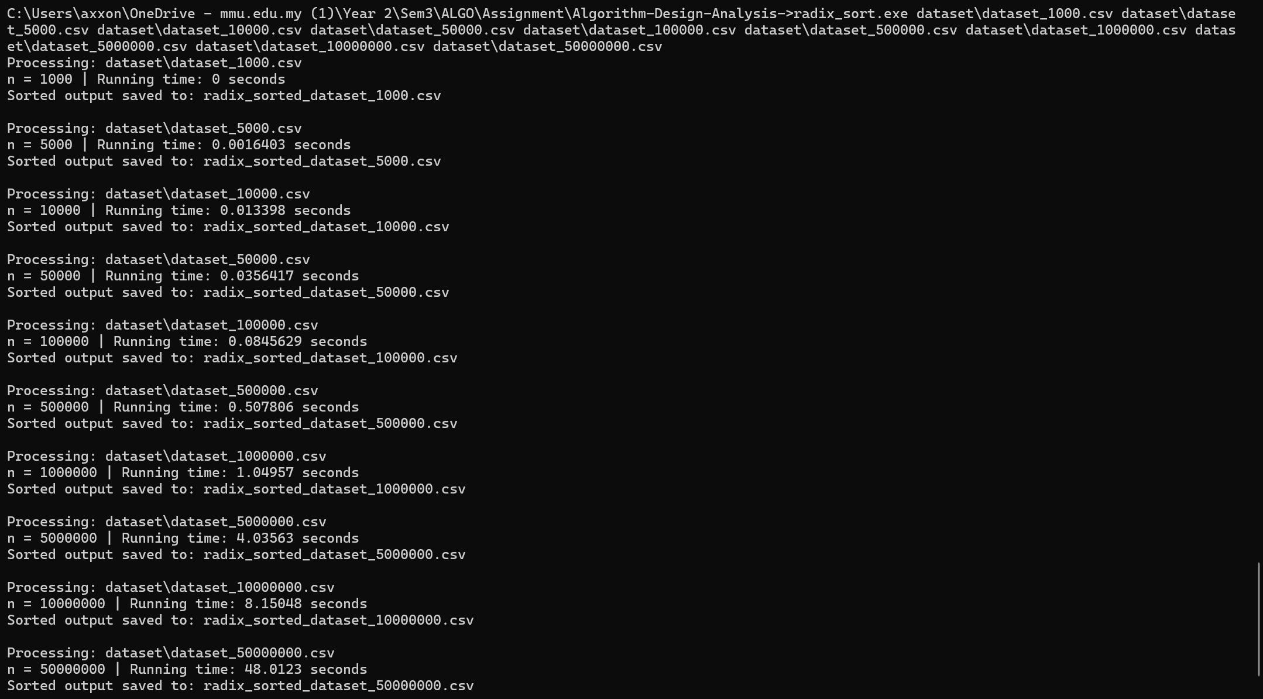

Heap Sort
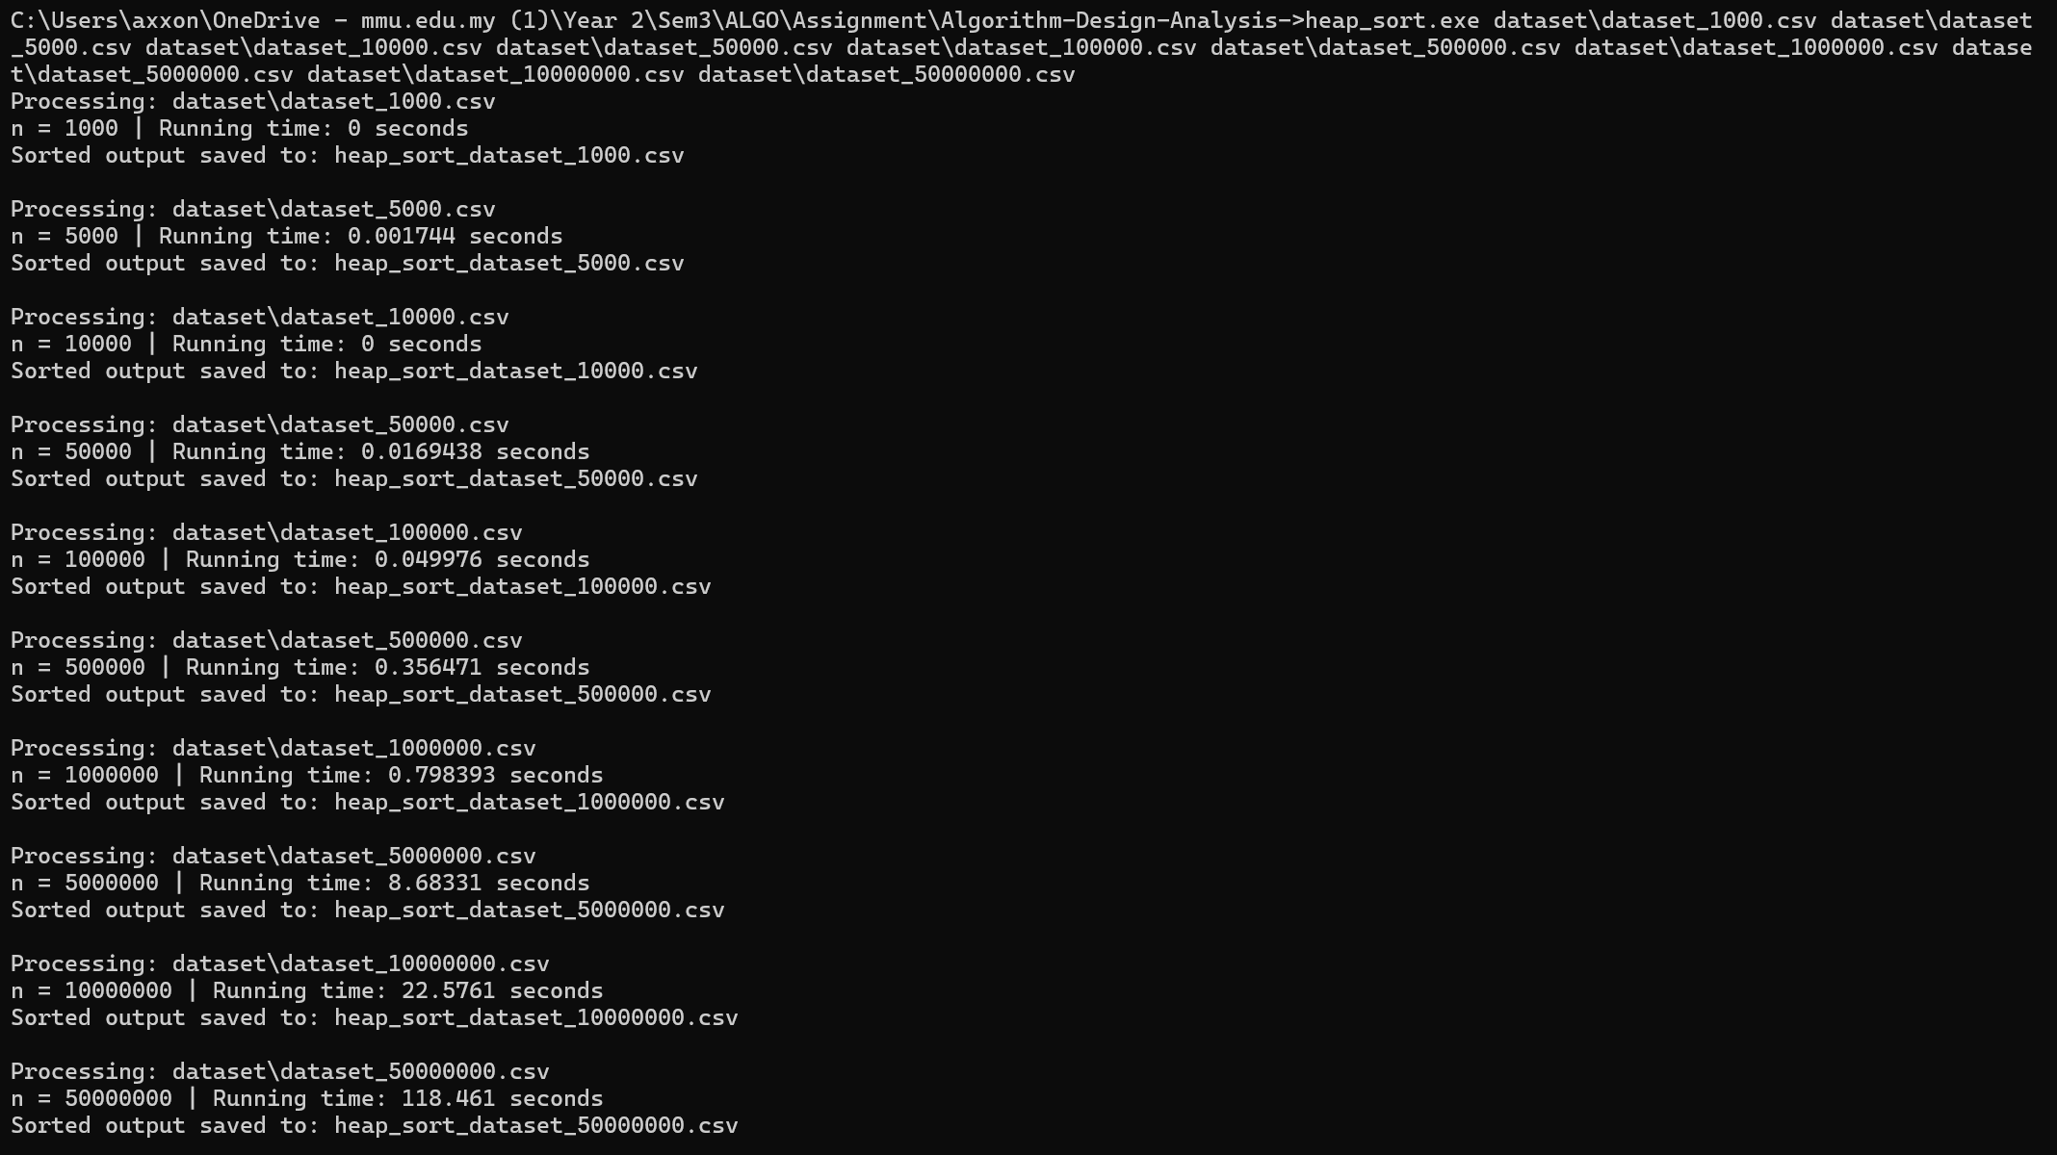

Input Size (n) | Radix Sort (s) | Heap Sort (s) | Difference (s)
1,000 | 0.000000 | 0.000000 | 0.000000
5,000 | 0.001640 | 0.001744 | 0.000104
10,000 | 0.013398 | 0.008000 | -0.005398
50,000 | 0.035641 | 0.016943 | -0.018698
100,000 | 0.084562 | 0.049976 | -0.034586
500,000 | 0.507806 | 0.356471 | -0.151335
1,000,000 | 1.049570 | 0.798393 | -0.251177
5,000,000 | 4.635630 | 8.683310 | 4.047680
10,000,000 | 8.150480 | 22.576100 | 14.425620
50,000,000 | 48.912300 | 118.461000 | 69.548700

Hash Table Search
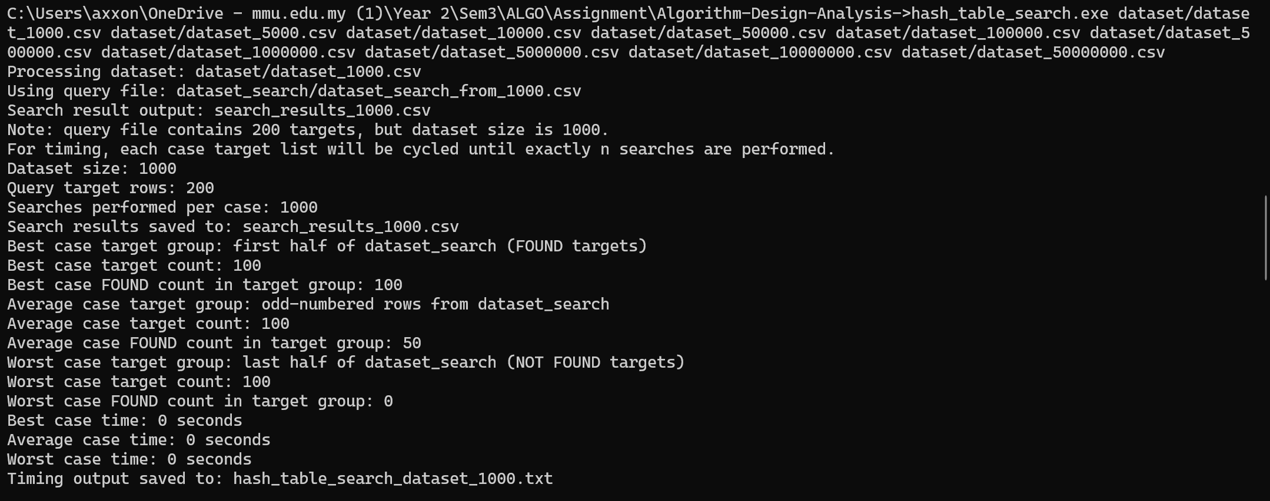
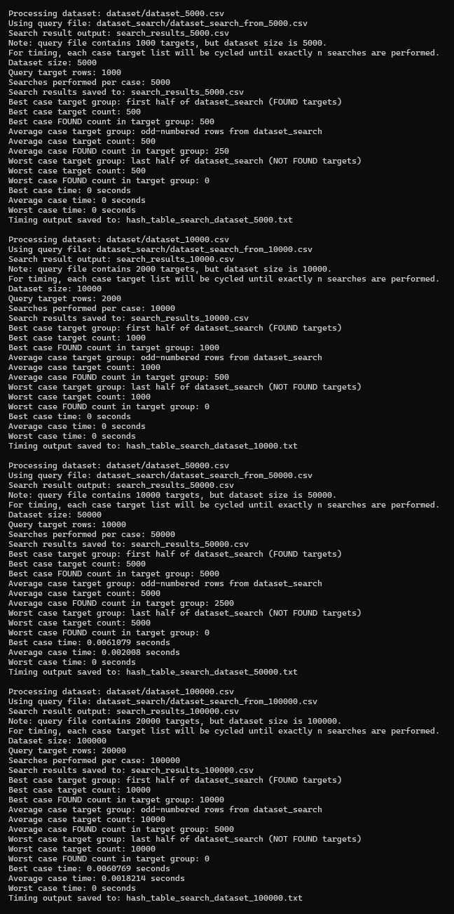
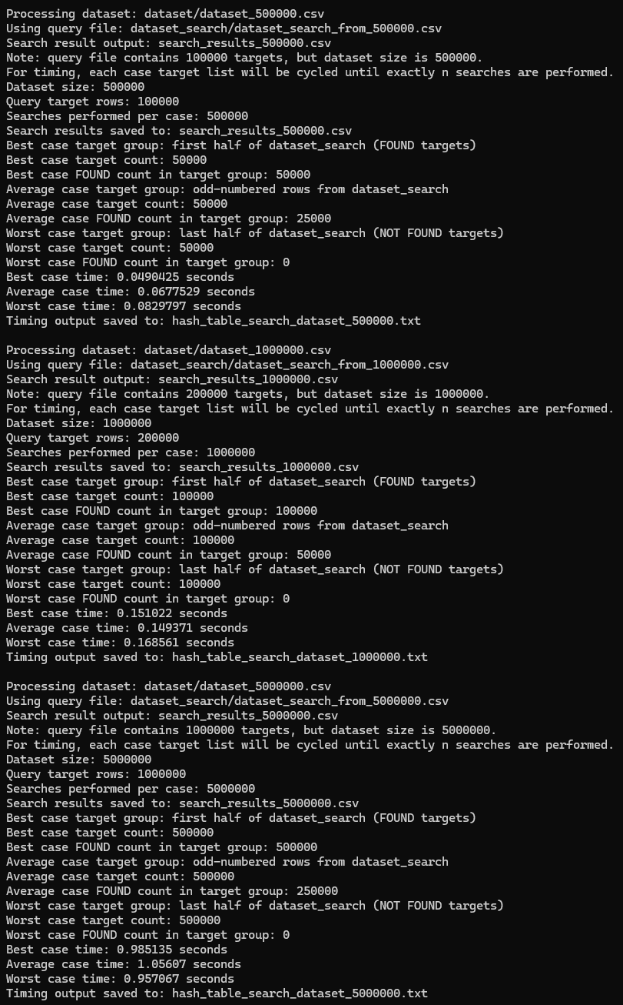
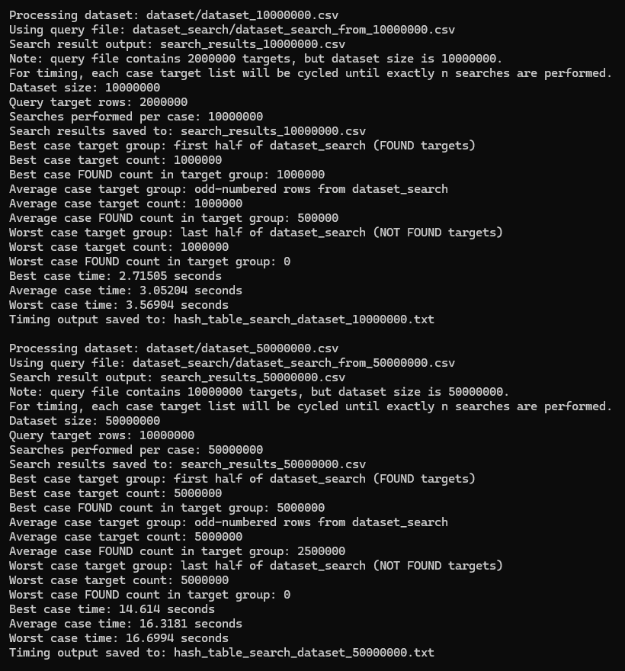
Input Size (n) | Best Case (s) | Average Case (s) | Worst Case (s)
1,000 | 0.0000000 | 0.0000000 | 0.0000000
5,000 | 0.0000000 | 0.0000000 | 0.0000000
10,000 | 0.0000000 | 0.0000000 | 0.0000000
50,000 | 0.0061079 | 0.0020080 | 0.0000000
100,000 | 0.0060769 | 0.0018214 | 0.0000000
500,000 | 0.0490425 | 0.0677529 | 0.0829797
1,000,000 | 0.1510220 | 0.1493710 | 0.1685610
5,000,000 | 0.9851350 | 1.0560700 | 0.9570670
10,000,000 | 2.7150500 | 3.0520400 | 3.5690400
50,000,000 | 14.6140000 | 16.3181000 | 16.6994000

Q8 [5] Hardware Specifications
Question tasks
Provide a screenshot of computer hardware specifications (Windows / Mac / Linux) for each member.
Chan Jia Yi’s PC Specification
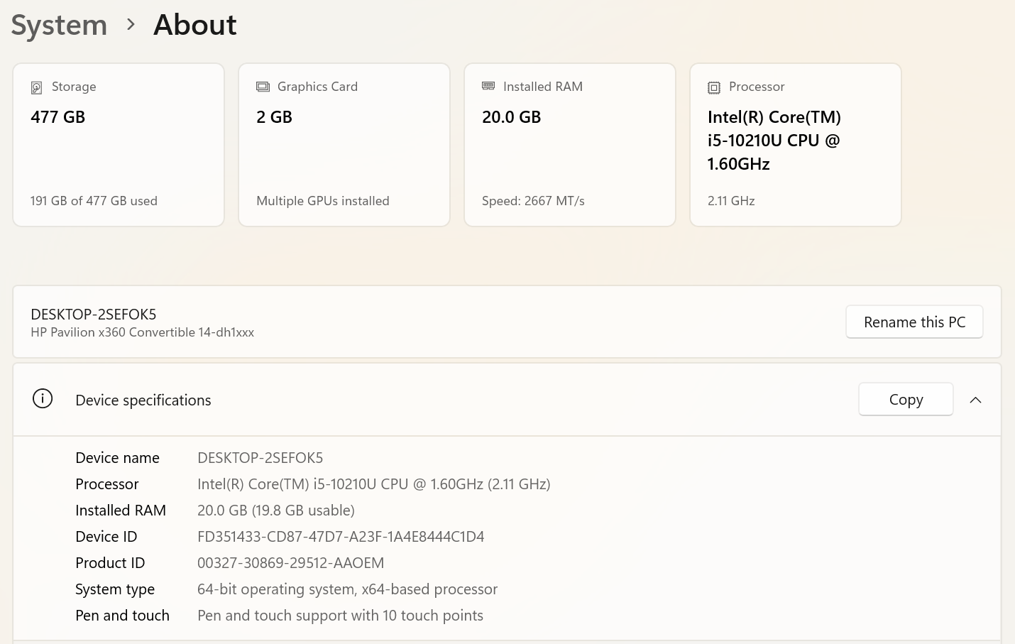
Chew Jia Yi’s PC Specification
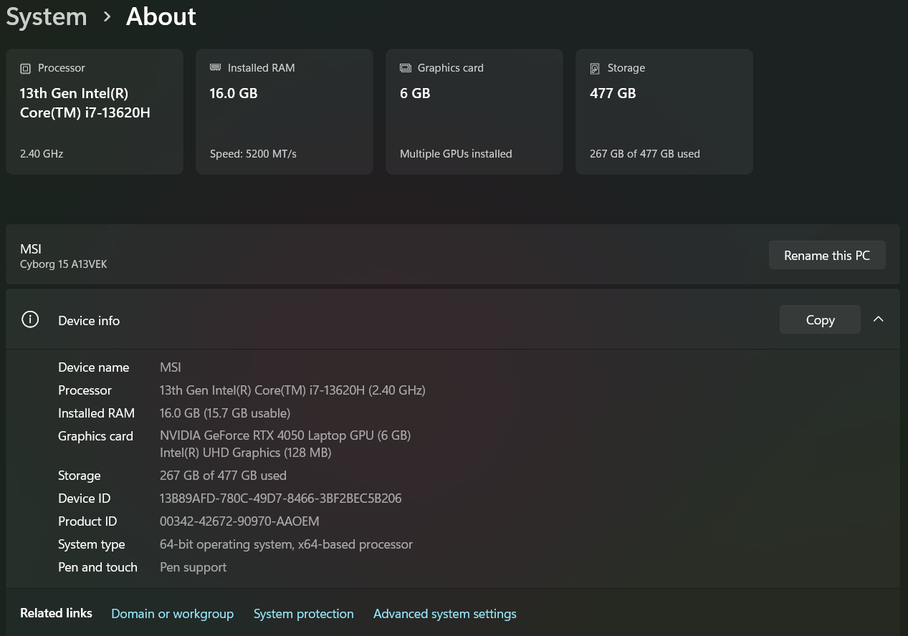
Koay Yee Shuen’s PC Specification
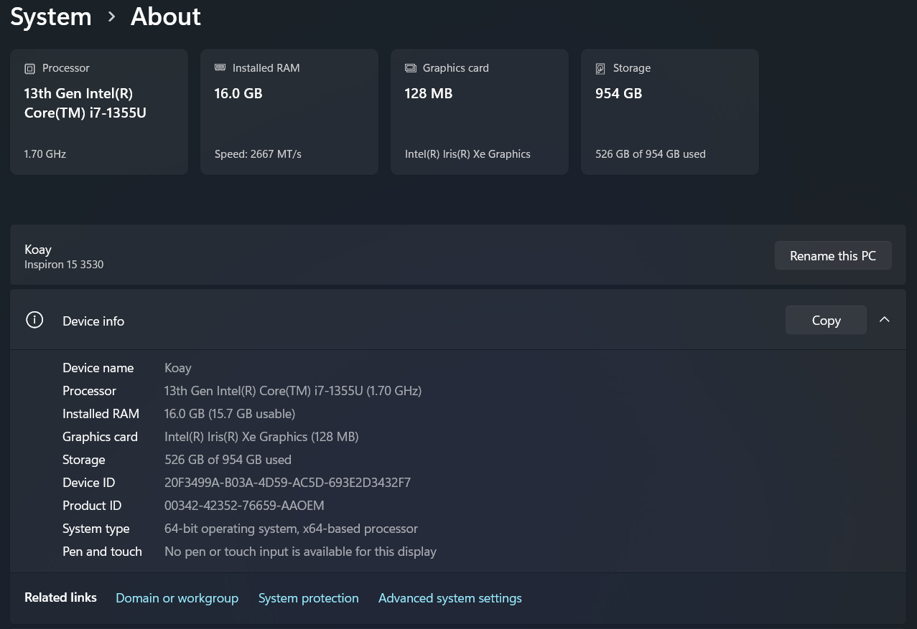
Ong Wan Ning’s PC Specification
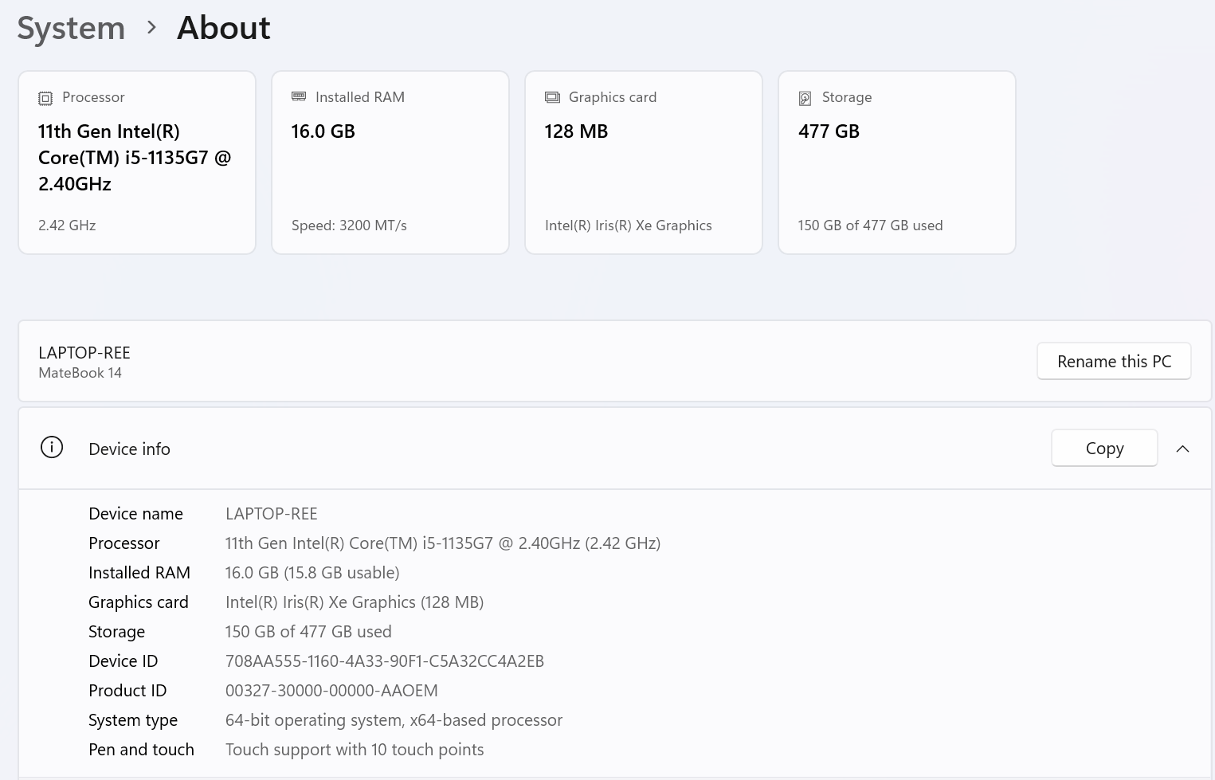

Citations and references section // on new page

References

Ala’anzy, M. A., Tolendi, N., Baubek, B., & Algarni, A. (2026). Performance evaluation of GPU-based parallel sorting algorithms. PLOS ONE. https://doi.org/10.1371/journal.pone.0342167

