**Setup Database**

Prerequisite : Microsoft SQL server Management Studio, Visual Studio 2019, chrome browser

* Create a new database or use existing database

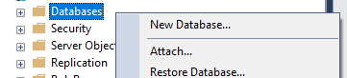

* Create ProductsDetail table and ProductSupplier table
* ProductDetail

|  |
| --- |
| USE [DatabaseName]  GO  /****** Object: Table [dbo].[ProductsDetail] Script Date: 11/27/2022 9:10:58 AM ******/  SET ANSI_NULLS ON  GO  SET QUOTED_IDENTIFIER ON  GO  CREATE TABLE [dbo].[ProductsDetail](  [ProductId] [int] IDENTITY(1,1) NOT NULL,  [ProductName] [varchar](50) NOT NULL,  [ProductSKU] [int] NOT NULL,  [ProductAvaibility] [int] NOT NULL,  [ProductSupplierId] [int] NOT NULL,  PRIMARY KEY CLUSTERED  (  [ProductId] ASC  )WITH (PAD_INDEX = OFF, STATISTICS_NORECOMPUTE = OFF, IGNORE_DUP_KEY = OFF, ALLOW_ROW_LOCKS = ON, ALLOW_PAGE_LOCKS = ON, OPTIMIZE_FOR_SEQUENTIAL_KEY = OFF) ON [PRIMARY]  ) ON [PRIMARY]  GO |

* ProductSupplier

|  |
| --- |
| USE [DatabaseName]  GO  /****** Object: Table [dbo].[ProductSupplier] Script Date: 11/27/2022 9:13:41 AM ******/  SET ANSI_NULLS ON  GO  SET QUOTED_IDENTIFIER ON  GO  CREATE TABLE [dbo].[ProductSupplier](  [SupplierId] [int] IDENTITY(1,1) NOT NULL,  [SupplierName] [varchar](50) NOT NULL,  [Email] [varchar](255) NOT NULL,  [PhoneNumber] [varchar](255) NOT NULL,  PRIMARY KEY CLUSTERED  (  [SupplierId] ASC  )WITH (PAD_INDEX = OFF, STATISTICS_NORECOMPUTE = OFF, IGNORE_DUP_KEY = OFF, ALLOW_ROW_LOCKS = ON, ALLOW_PAGE_LOCKS = ON, OPTIMIZE_FOR_SEQUENTIAL_KEY = OFF) ON [PRIMARY]  ) ON [PRIMARY]  GO |

* Open up the Web.config file under WebApiDemo folder and replace {dbServerIpAddress}, {dbTable} , {dbServerUsername} and {dbServerPassword} with your db server ip address, db table, username and password

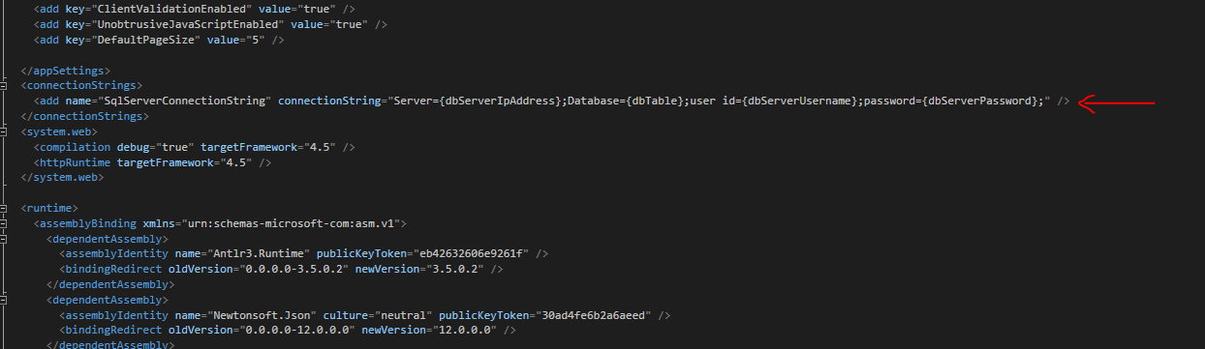

* Ensure the apiUrl is pointed to Restful API while running the Restful API program with visual studio 2019(Reminder: If apiUrl is different from your Restful API url , please change it in script.js under UI folder)



**How to run the program**

* Open up the UI/index.html in the chrome browser
* Open up the Restful API with visual studio 2019 by double click the WebApiDemo.sln
* Ensure all that the database table is setup properly as following the instruction above

Result

Create supplier in UI

* Able to create a supplier and get the supplier code

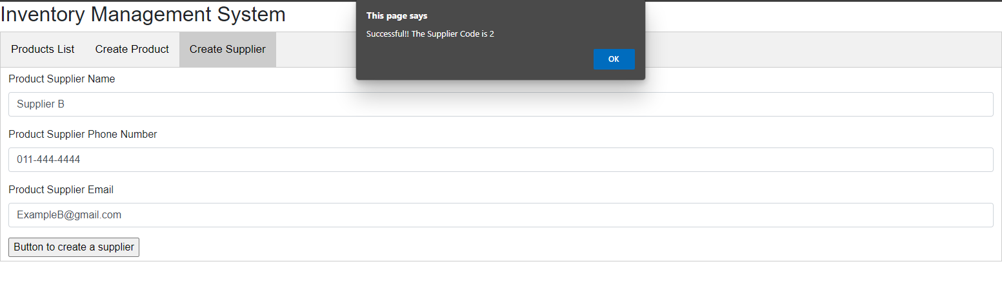

* Able to store the record in ProductSupplier Table

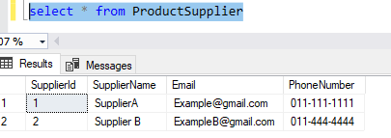

Create a product with the supplier code

* Able to create a new product with supplier code

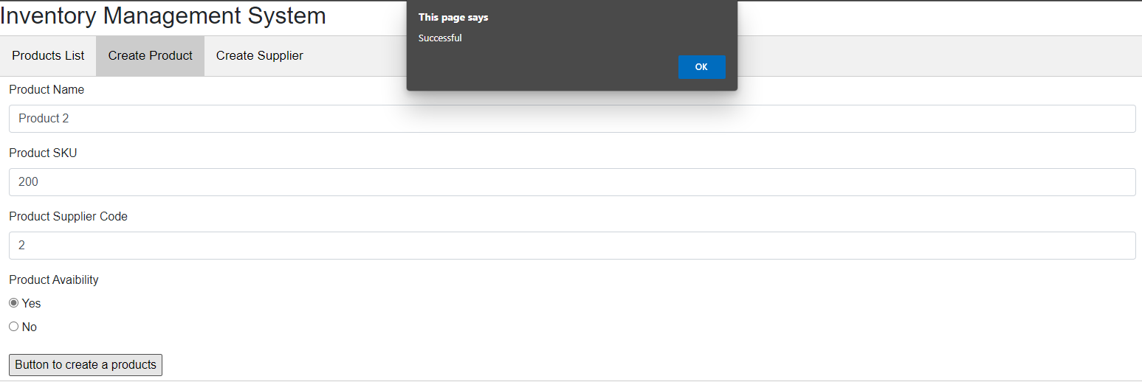

* Able to store record in ProductsDetail table

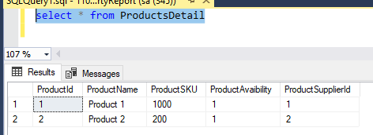

Display products in UI to user

* Able to display all products

