Web Dev Notes – JS Fundamentals

# Section 29 – OOP, Classes, Inheritance

## Prototypes

* The **template** by which JavaScript objects inherit features from one another.
  + Contains a bunch of methods that an object can access (**ex**. Array objects have .push())
    - **Example**:
      * 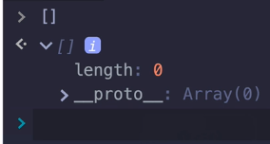
  + You can also add custom methods and properties to a prototype
    - **ex**. String.prototype.grumpus()
      * 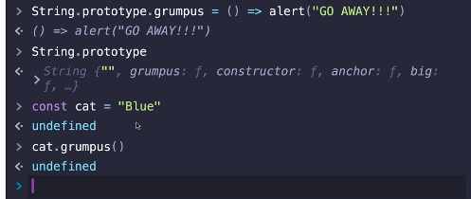
  + You can also overwrite existing proto methods.. not recommended tho!

## Constructor Functions

* A function that helps you create new objects
  + Not used, since CLASS keyword was produced

## Classes

* Basic class:
  + 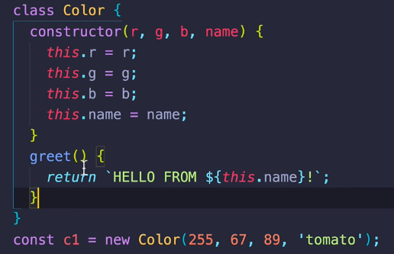

## Inheritance

* Extends (inheritance) & Super (references constructor of parent)
  + 