Back-end-Notes

NodeJS - a JS runtime

The Node REPL
- The node command line
  - 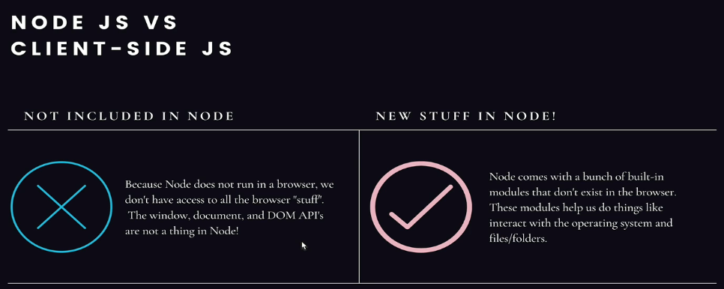

Process & ArgV
- The Process Object provides info/control on the current NodeJS process
  - Process obj in use:
    - 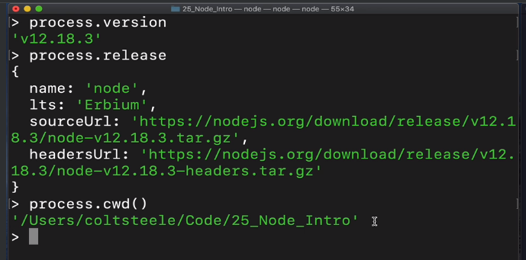
- process.argv
  - This returns the command line arguments passed when the NodeJS process started

fs.writeFileSync
- 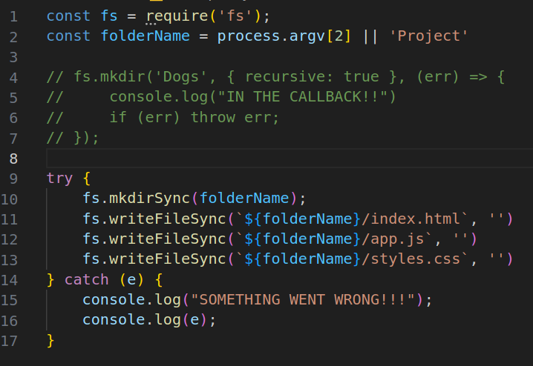 const fs = require(‘fs’) // is needed

Node Modules and NPM

Intro
- module.exports -> it’s an object that allows you to define which variables you wish to export to other files
  - You can also use exports.varName as the shorthand
    - 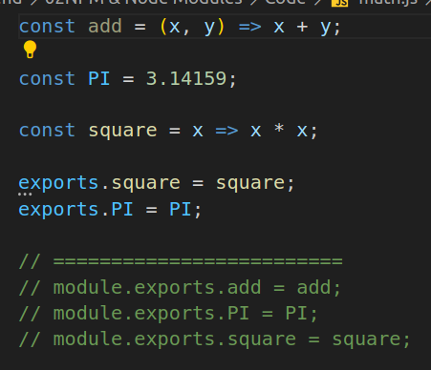
  - This allows the chosen variables/functions to be used in other files which ‘require’ them
  - 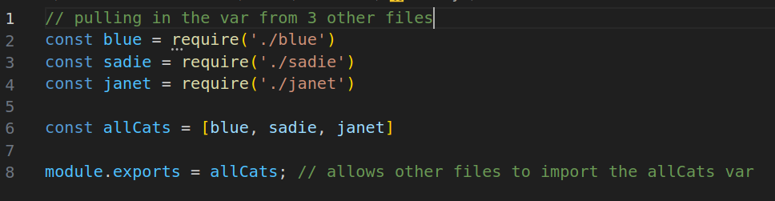

NPM – library of Node packages that can be installed/managed by us!

Installing new packs
- Jokes and Rainbows
  - npm install --save give-me-a-joke
  - npm install colors
- The new packages are ALL stored in ‘node_modules’
- You can GLOBALLY install packages by using ‘npm i -g package_name’
  - The node_modules directory will be under:
    - usr/local/lib

package.json
- It contains the metadata on a project, package, app, etc.
- Use ‘node init’ to initialize a package.json file!
  - Example:
    - 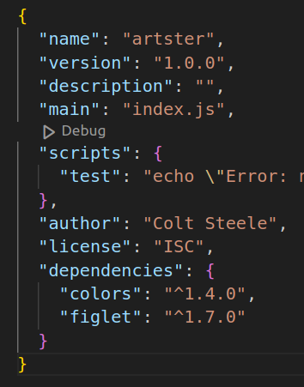
- *** if you are using ‘import’, then use npm init es6
  - Example: type: “module”
    - 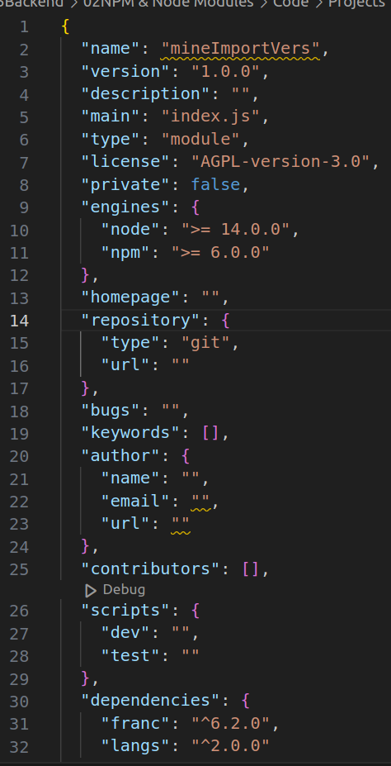

Section 33 – Express (Web Framework for Servers)
- Purpose of ExpressJS
  - 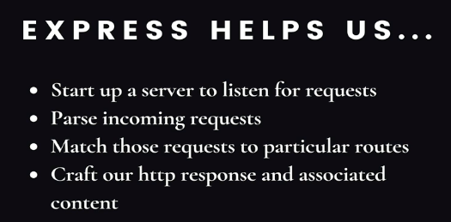
- Framework vs Library
  - 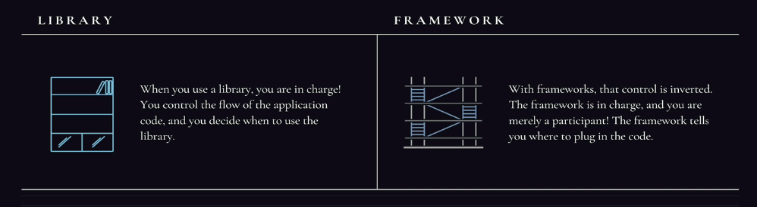
    - ExpressJS (server-side) framework --> build back-end of web applications
      - Axios (manage HTTP requests to talk to server) vs. Express which builds the server
    - React (client-side) framework --> for developing dynamic user interfaces.

Routing (‘/<path>’)
- Take incoming request and path it is requesting for
  - app.listen() -> listens for user’s requests based on a port (ex. Localhost:3000)
  - app.get() -> used to send back/GET a response to a path!
    - 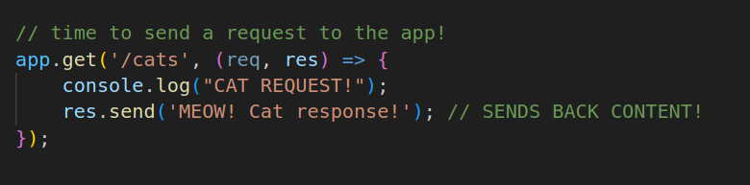
  - app.post() -> used to send data as a request to a path!
- Catch ALL Path:
  - 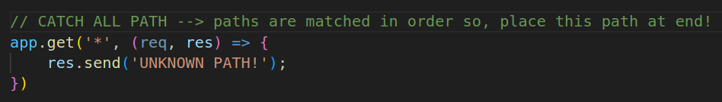

Express Path Parameters
- 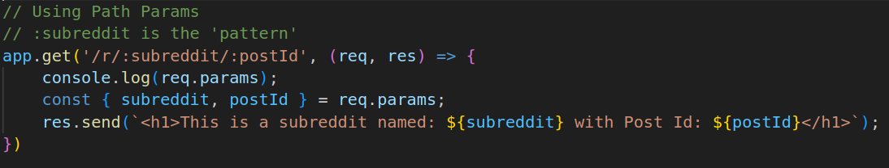
  - /:<pattern>
    - This is used to capture the value of a path with a specific parameter
      - ex. :subreddit --> captures the subreddit name set in the request!
        - Path = localhost:3000/r/<subreddit>/<postId>

Express & Query Strings
- Query String comes after the ‘?’ in URL
  - You pass in key-value pairs for info
    - ex. <url.com>/search?q=colors
- 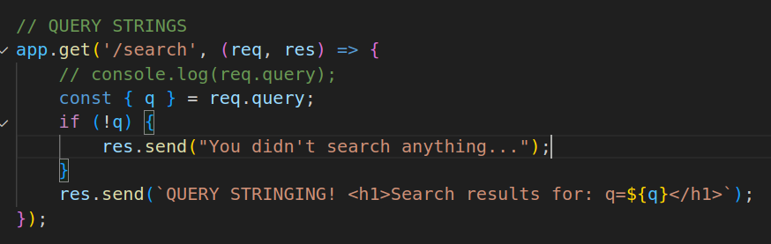

Nodemon -> auto-restart of Server to see changes!
- npm install -g nodemon
  - basically just ‘dotnet run’

Section 35 – REST: Representational State Transfer

GET vs. POST
- Diagram:
  - 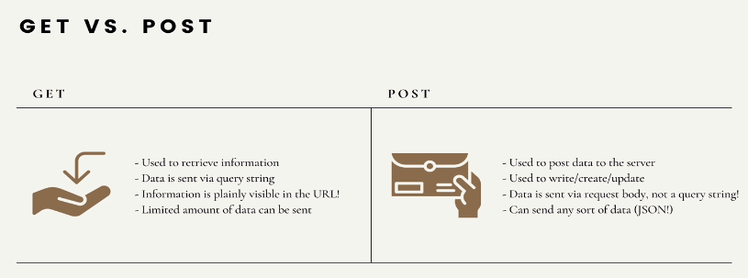
- Example:
  - 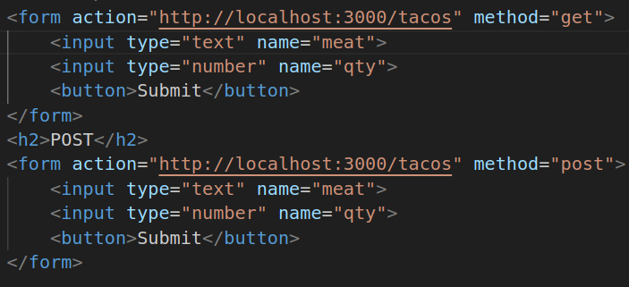
    - 'action' will send requests to the defined route (ex. express server at port 3000)

POST requests
- 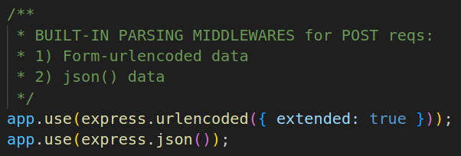
  - Needs these 2 lines to parse the incoming req.body data in POST req.body
    - req.body = x-www-form-urlencoded or json

REST INTRO
- 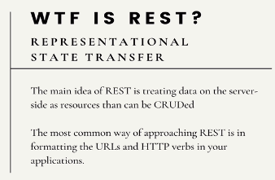

CRUD = Create/POST, Read/GET, Update/PATCH, Delete
- Chart:
  - 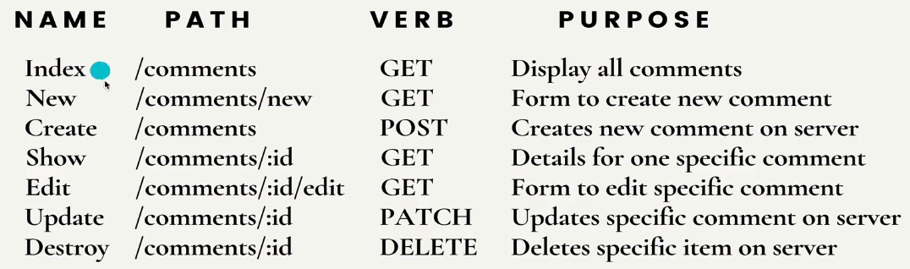

1) Index (type of GET – display all items)
- 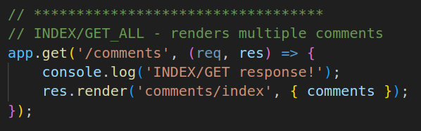
  - Send the ‘comments’ variable into the ejs file (named index.ejs)

2) & 3) New & Create – Used together!!
- a) NEW renders a form
  - 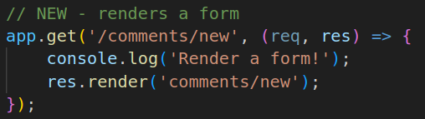
- b) CREATE makes new items
  - Creates new ‘comment’, then redirects back to the INDEX/Get route
  - 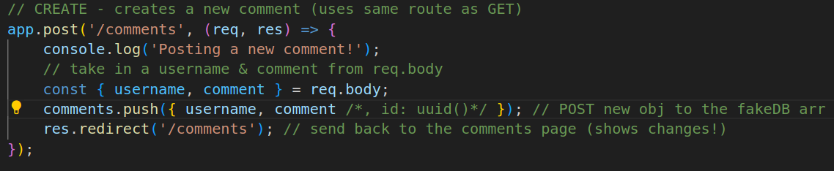

3) Show (this is GET for 1 specific item based on UUID)
- 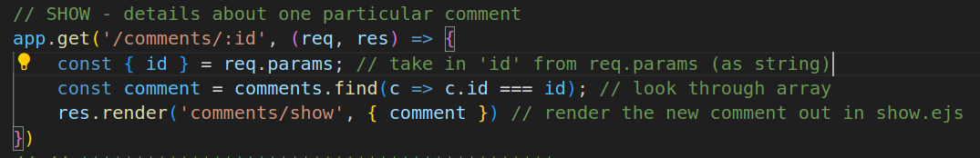
- Takes you to the ‘show.ejs’ page after finding the ‘id’ passed into the request

4) Edit & 5) Update
- Edit – GET/render a form to edit specific item
  - Sends you to a form filled with the item’s information (‘edit.ejs’)
    - 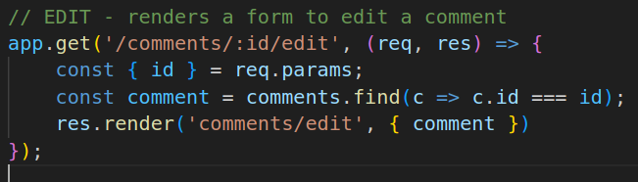
- Update – PATCH to change specific item on server
  - Within the Edit Form, a request will send in the id, and new value for item
    - 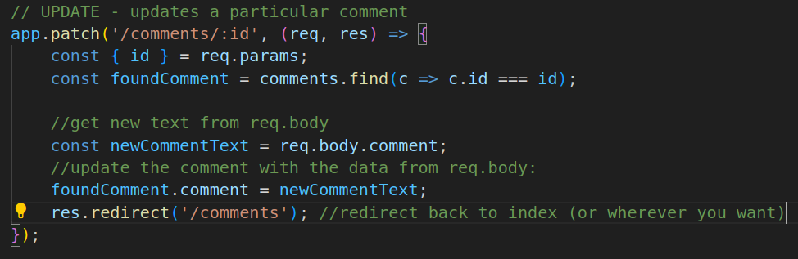
    - You take the id of the item, then change its content. Then redirect to back to the index.ejs

6) DELETE
- 

