React Notes

Section 60 – React Intro
- React Front-end Library is made up of Components:
  - 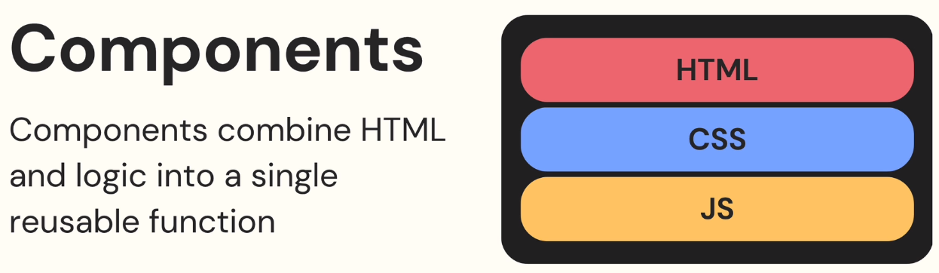
- React uses .JSX files to store its components
  - Mixes JS with HTML
    - 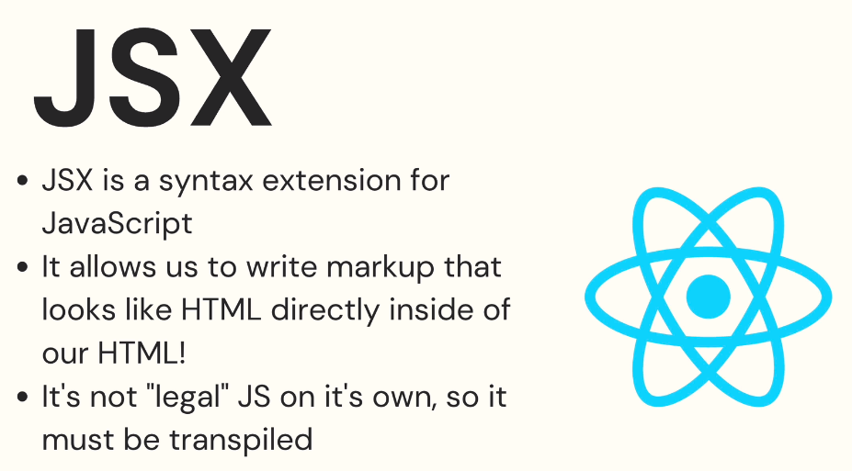

Basic React Structure
- ‘App.js’ is usually the top file in the React Web App.
- ‘Index.js’ will import this App.js file to compile

First Component Example:
- How to create a Component.jsx file
  - 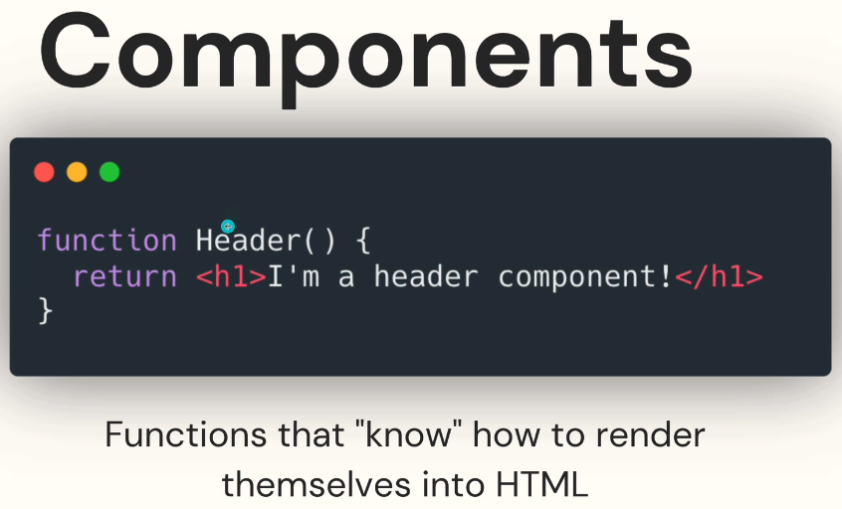
- How to import a component into App.js
  - 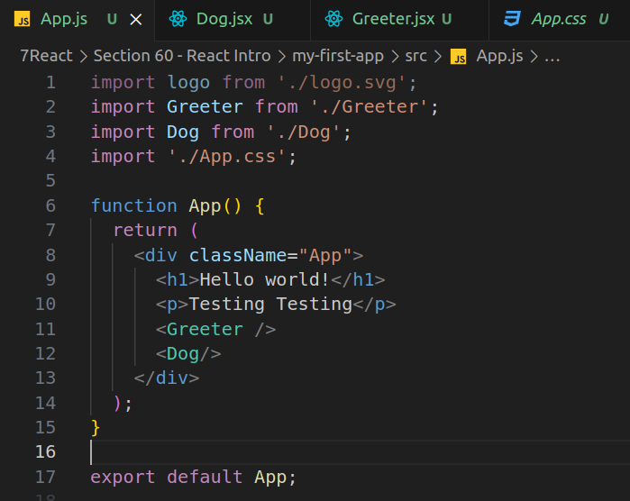
  - Component File:
    - 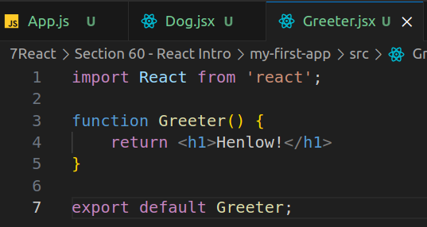

Section 61 – JSX Intro
- Refer to the code in Section 60 (my-first-app)

Rules:
- You must close your self-closing elements (ex. <br/>)
- Components can only return 1 TOP-LEVEL element!
  - But if you wrap elements in 1 <div>, it considers the <div> as 1 element!

React Fragments
- <></> → a React Fragment (acts like a div tag, but without actually being an element on the page)
  - 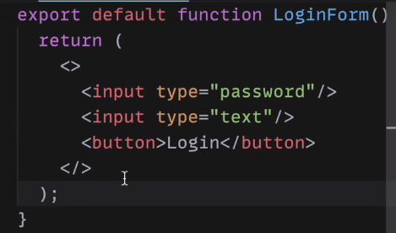

JS Expressions in JSX
- Embedded JS: (technically, it’s embedded HTML in a JS file)
  - 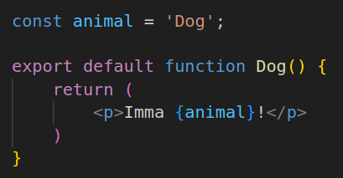

Styling Components
- When setting the ‘class’ for a HTML tag, use ‘classname’ instead for JSX files
  - 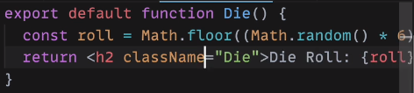
  - When setting the classname for a component, be sure to reuse the name of the component
    - ex. Die.jsx would have classname = ‘Die’
    - Then import the css file into the component .jsx file

Section 62 – Vite and React
- 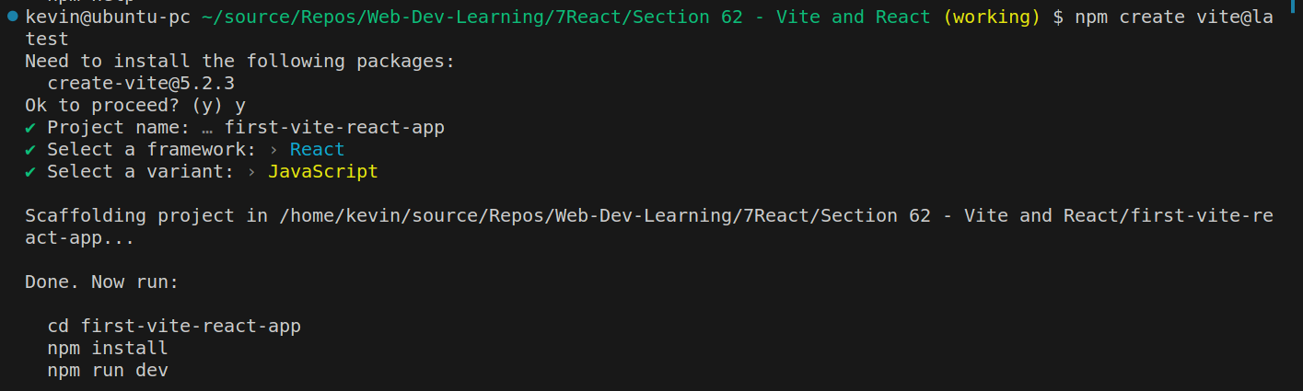
- RUN: npm create vite@latest

Section 63 – React Props

Intro
- Props are arguments you provide to your components to be used!
- You provide the props by placing them into the component
  - Example:
    - 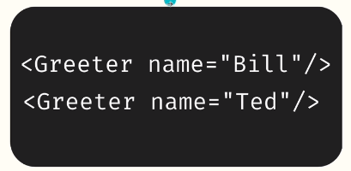
      - ‘name’ is a prop (it is an object!)
        - 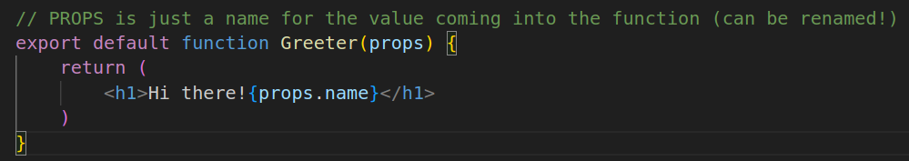
          - Call the value using props.name or you can de-structure right away:

Non-String Props
- Use {} to pass in non-strings
  - 

