Lab-04
2016136108 이찬규

컴퓨터공학부
cksrb4225@koreatech.ac.kr
- Introduction

  - Assignment Introduction
About my database : My database is about convenience stores. A total of 5 tables were create through the design process (Branch, Buying, Contain, Customer, Stuff), and there are 2 scalar values functions, 17 table-valued functions, 15 stored procedures, and 6 triggers. I will explain in detail through the tasks below.

This task is to develop my own database designed so far as an application.
First, I do that establish a connection between your data base and Java Application using JDBC driver
Second, I create an appropriate GUI using Java language. my GUI should facilitate user to perform basic operations on database. So, I implemented the following four steps.
- Display information about my database(tables, functions, stored procedures etc)
- Navigate (see) records (data) from each table in my database.
- Run functions to insert, update and delete records for each table in my database.
- Print reports (data from different tables)

- Task
  - Display information about my database(tables, functions, stored procedures etc)

Information related to my database, such as Database name, Information of table, function, stored procedures and triggers, is printed.

Resolution
The fillgrid and nodestoTree functions were implemented by referring to the professor’s lecture and lecture materials, and correct values were displayed.
Depending on the situation, the getParameter() function and the getColumnList() function were used appropriately.

Results screen
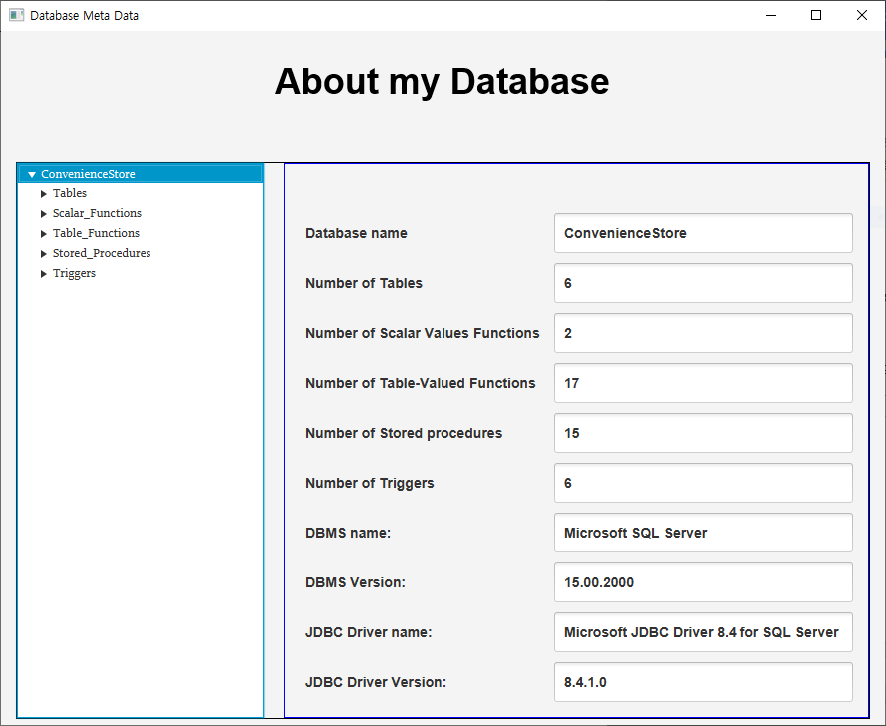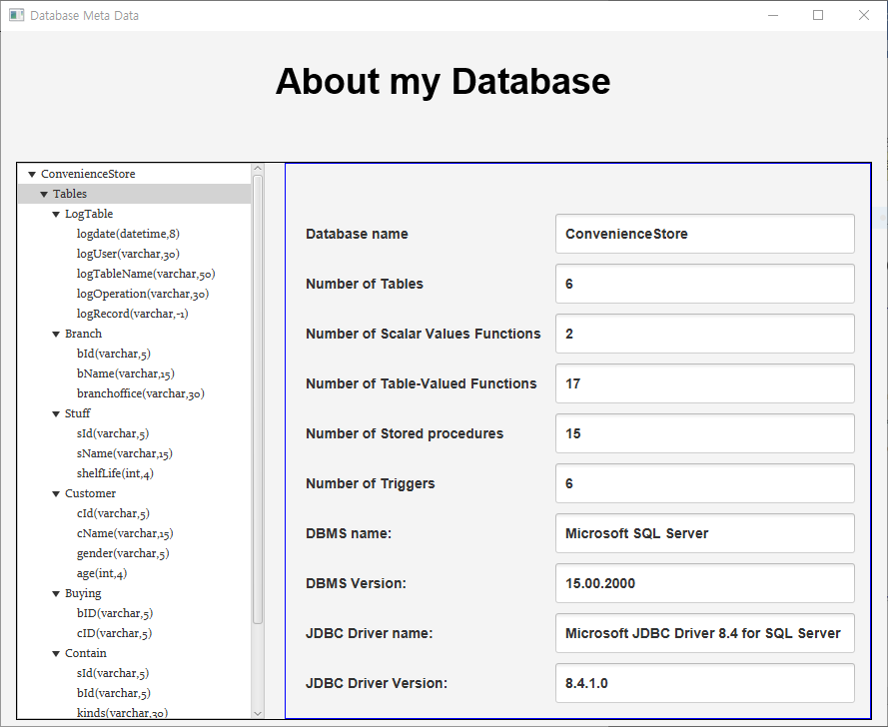

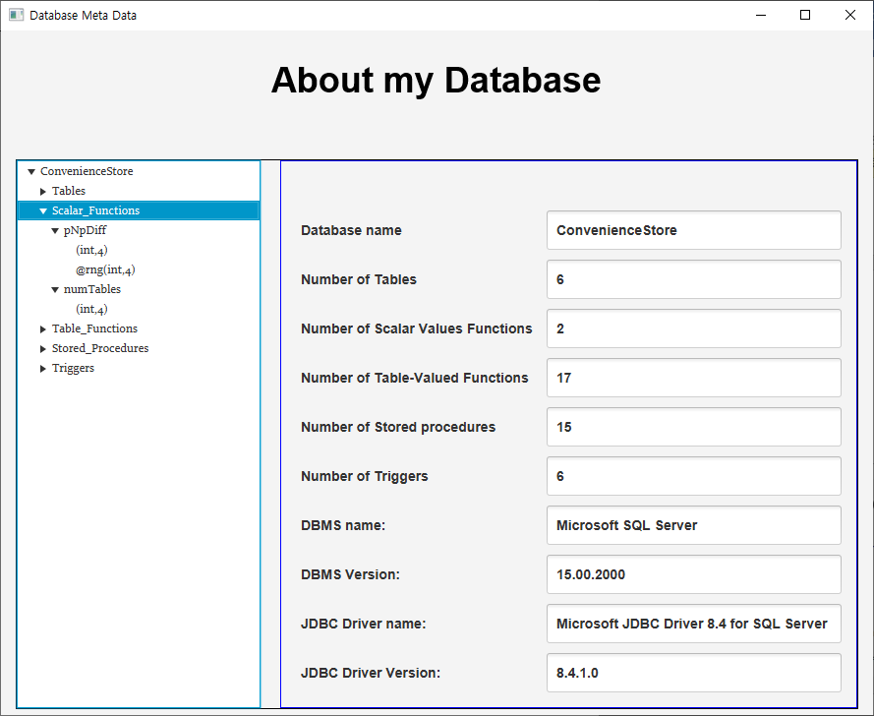
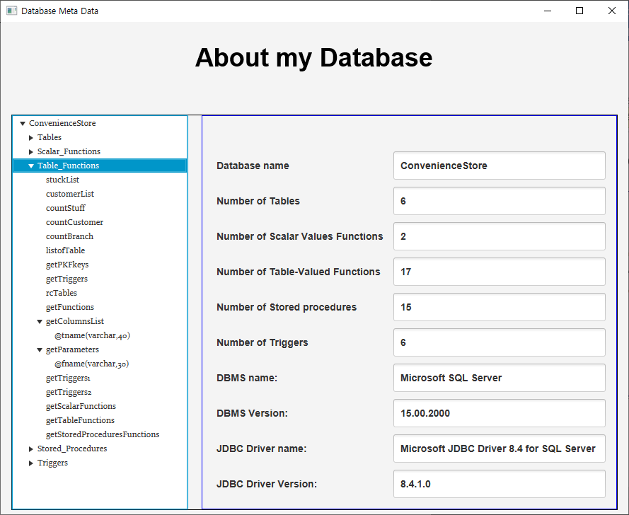
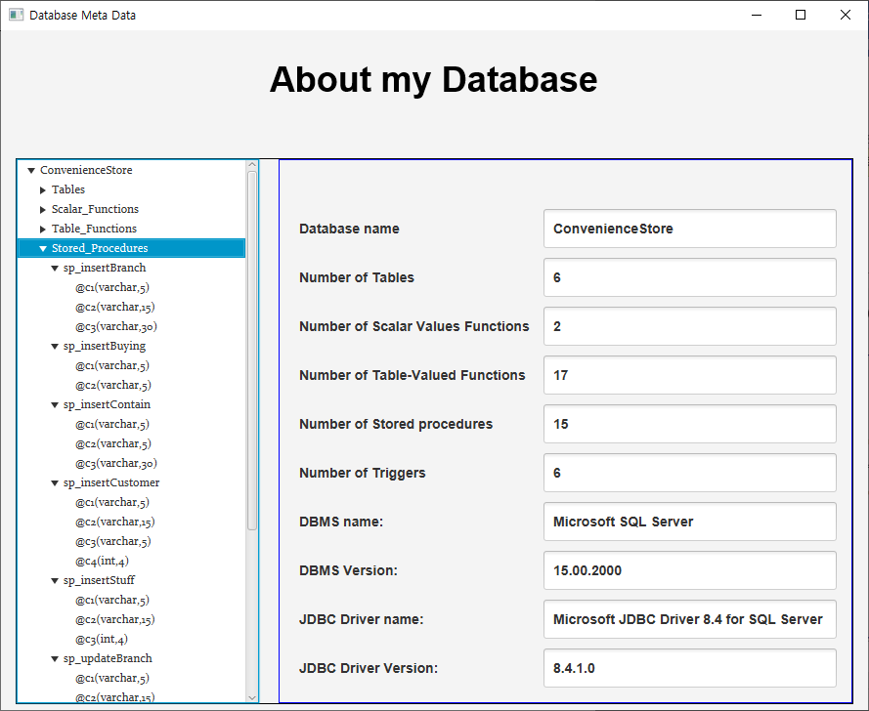
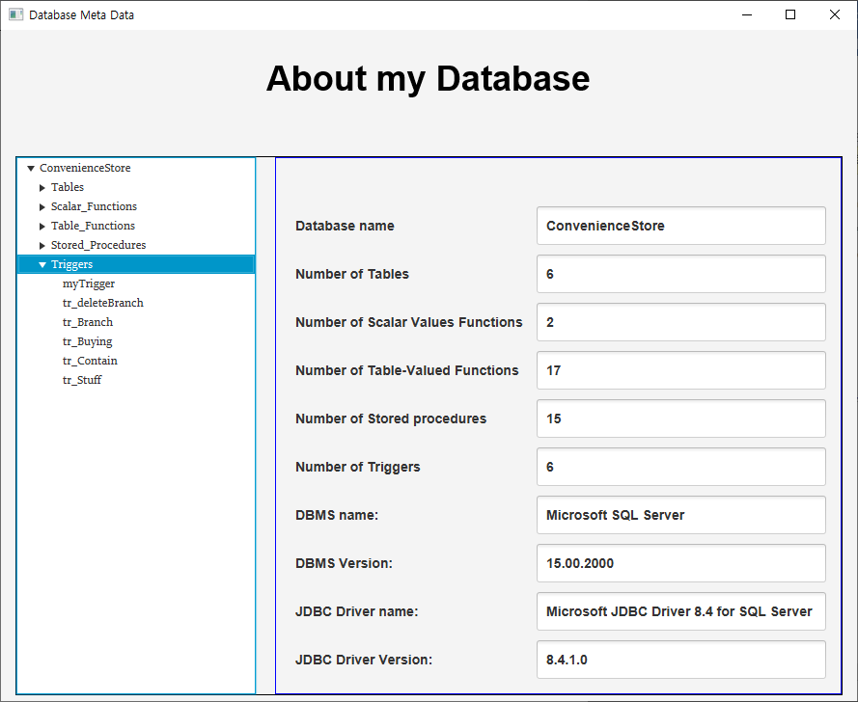
Fig. 1. Result of Task-2.1

Results and analysis
The corresponding value was derived using the query statement, and the information of the table, function, stored procedure, and trigger was output so that the user could easily know the database .

I felt that
When a user wants to use my database, I think it will be easier to understand the database by looking at this first.

  - Navigate (see) records (data) from each table in my database.

This is a task that displays the records on the UI when selecting a table.

Resolution
I applied what the professor told me in the lecture, and modified it to fit the table of my own database to perform the assignment.

Results screen
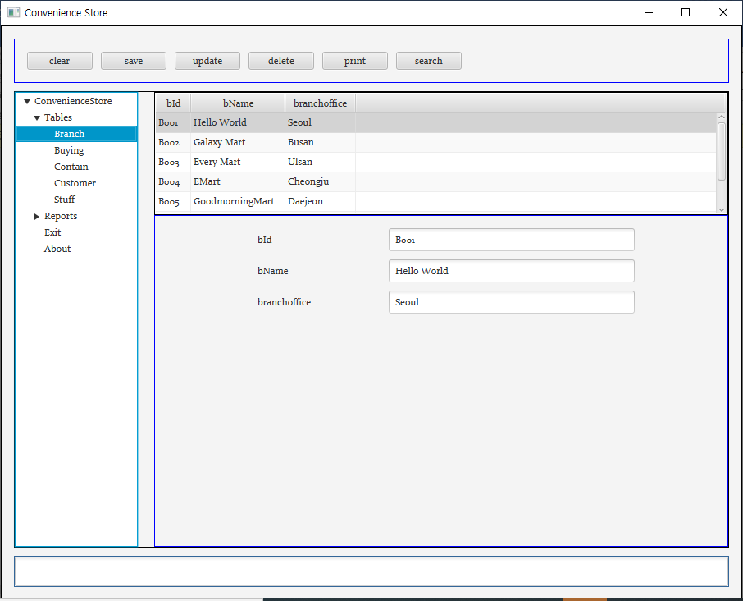
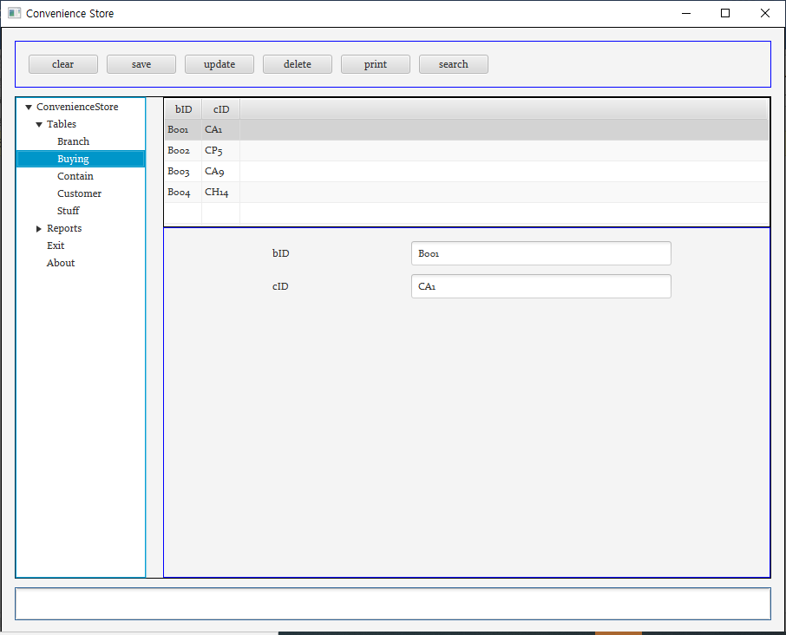
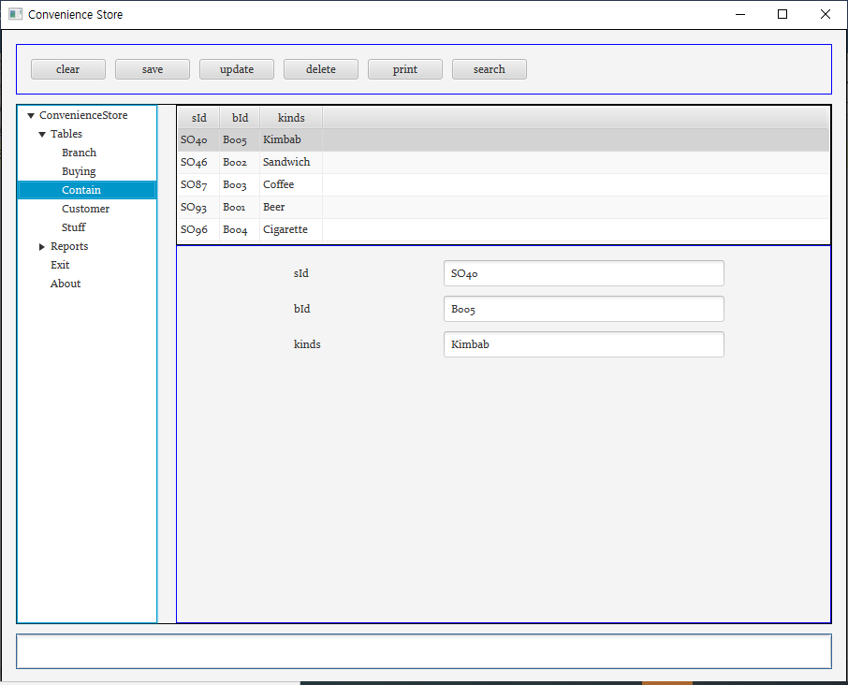
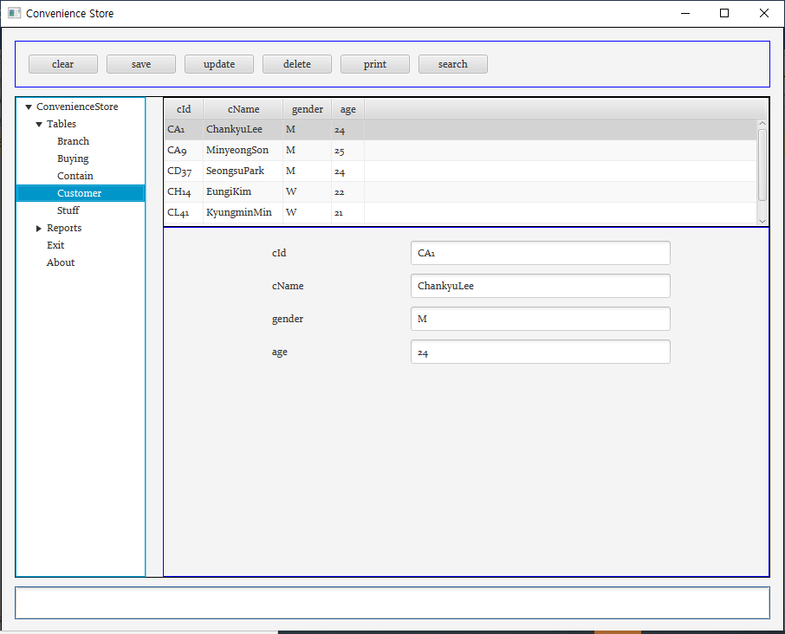
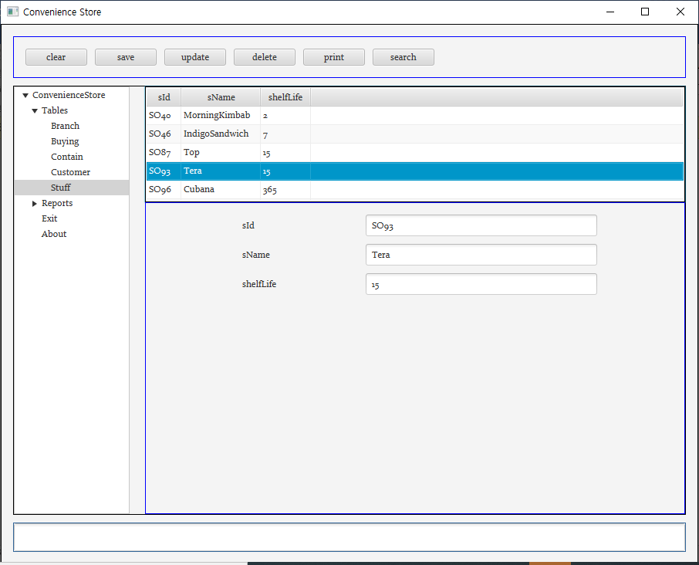
Fig. 2. Result of Task-2.2

Results and analysis
When the table is selected, the corresponding records are displayed normally, and when Insert, delete or update are performed, they are immediately applied and output normally.

I felt that
It was convenient and easy to see at a glance because I could easily check the records of the table I created through the GUI.

  - Run functions to insert, update and delete records for each table in my database.
This is a task of easily inserting, updating and deleting the database using GUI.

Resolution
I learned the basic method through the professor’s lecture and applied it to my database and applied it with different properties for each table.

Results screen

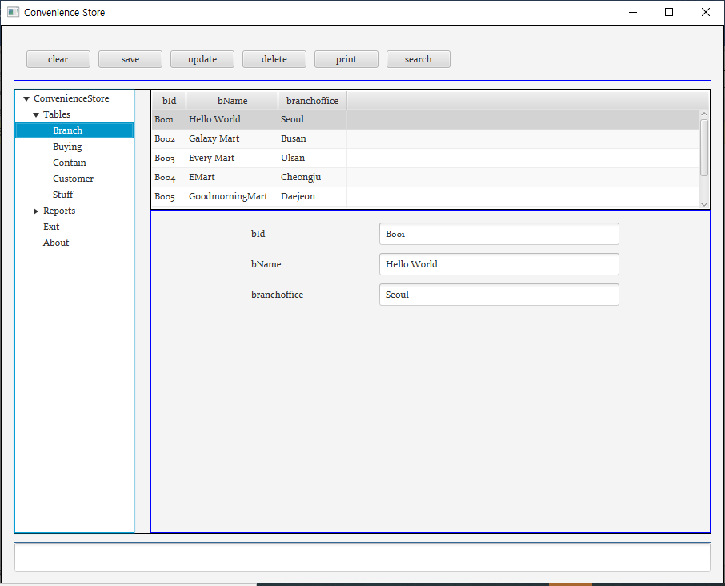
Fig. 3. (BranchTable)Before Inserting (bId=B555, bName=YMart, branchoffice=Seoul)
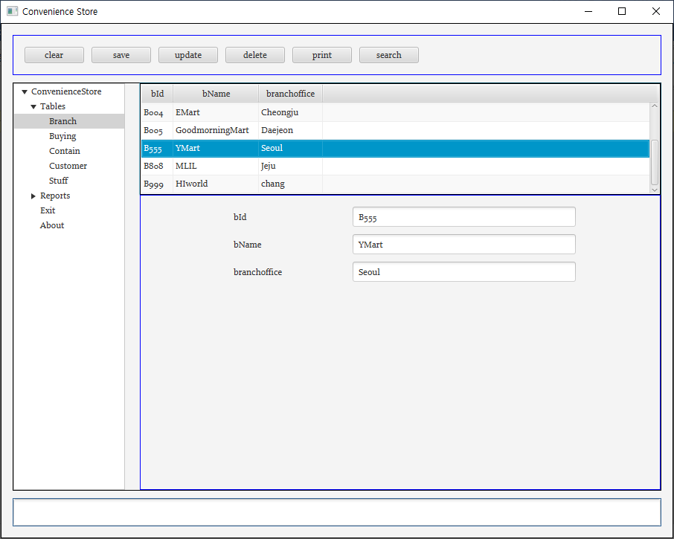
Fig. 4. (BranchTable)After Inserting (bId=B555, bName=YMart, branchoffice=Seoul)
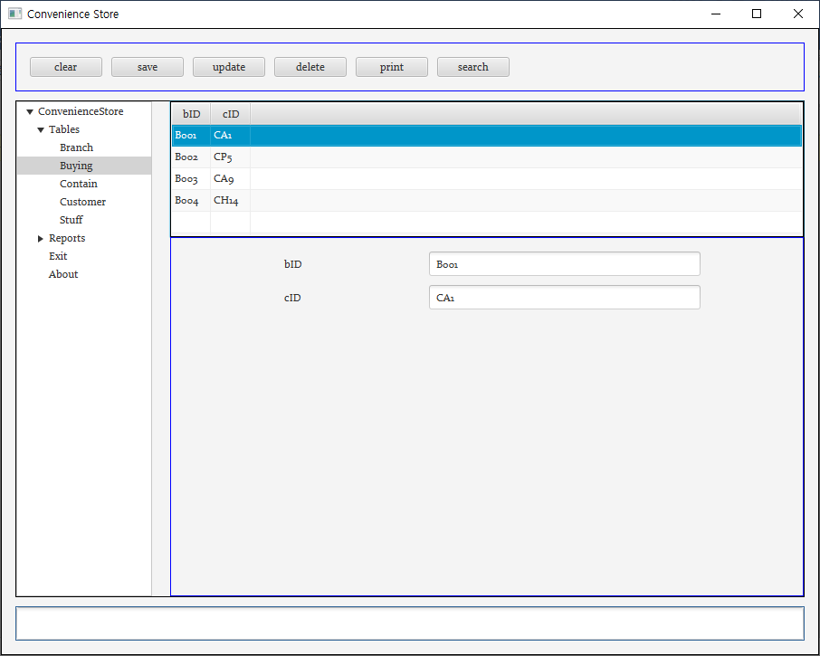
Fig. 5. (BuyingTable)Before Inserting (bId=B555, Cid=CP5)
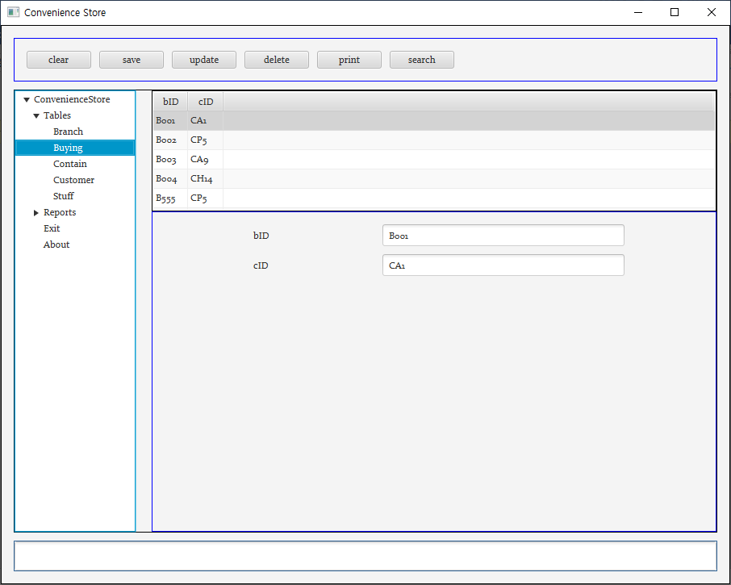
Fig. 6. (BuyingTable)After Inserting (bId=B555, Cid=CP5)
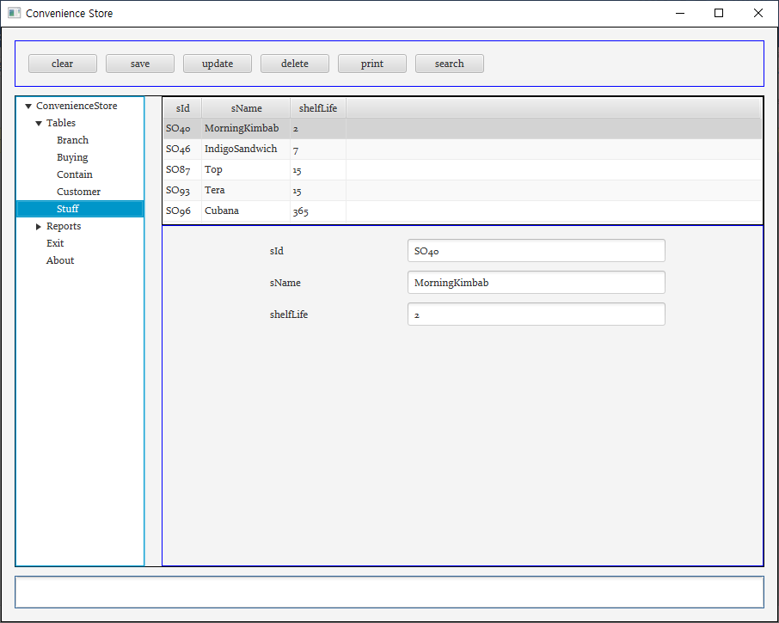
Fig. 7. (StuffTable)Before Inserting (sId=SO555, sName=MorningCoffee, shelfLife=30)
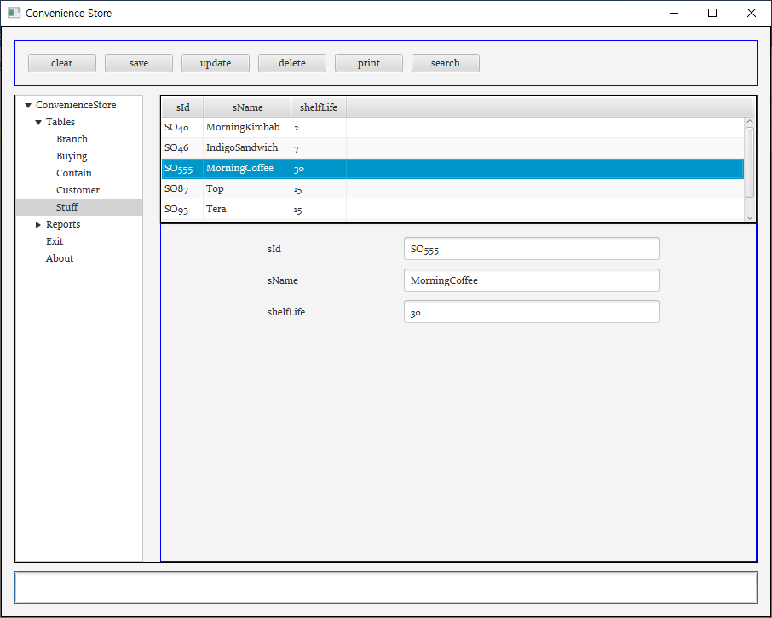
Fig. 8. (Stuff Table) After Inserting (sId=SO555, sName=MorningCoffee, shelfLife=30)
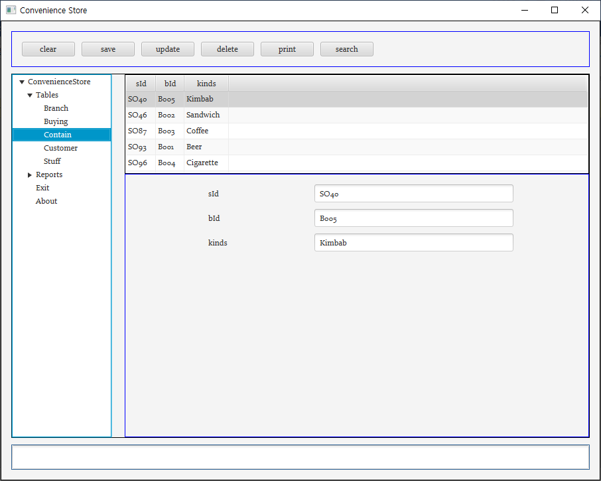
Fig. 9. (ContainTable) Before Inserting (sId=SO555, bId=B555, kinds=Coffee)
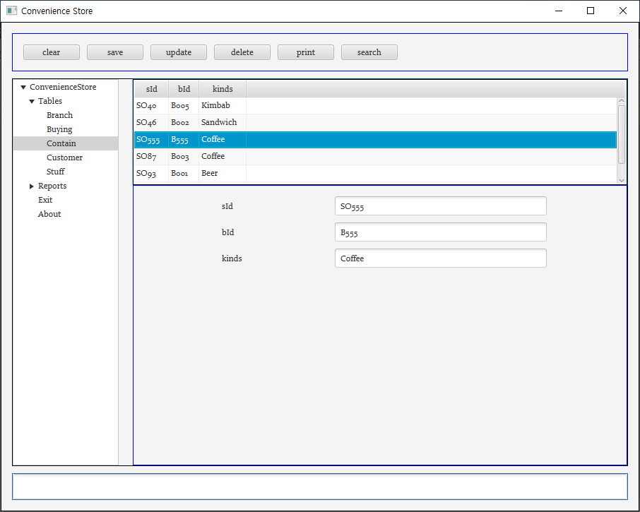
Fig. 10. (ContainTable) After Inserting (sId=SO555, bId=B555, kinds=Coffee)
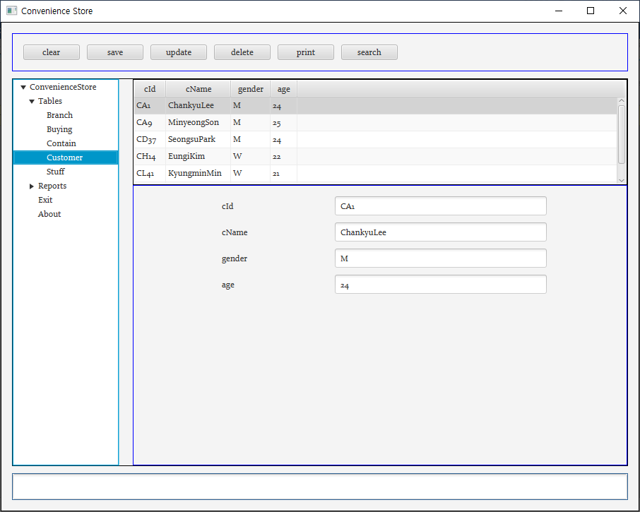
Fig. 11. (CustomerTable) Before Inserting (cId=CD33, cName=james, gender=m, age=30)
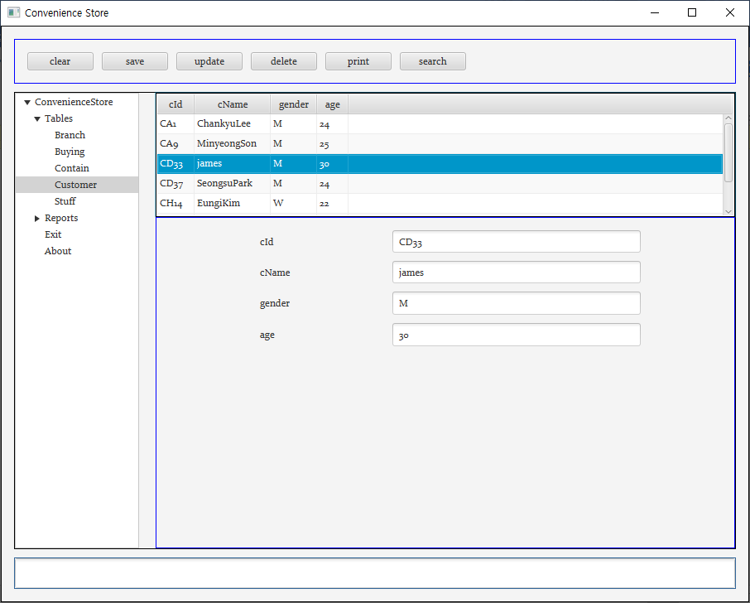
Fig. 12. (CustomerTable) After Inserting (cId=CD33, cName=james, gender=m, age=30)

Results and analysis
I checked whether it words normally by performing the functions of insert, update, and delete. The result screen displays it. It has been confirmed that the functions performed through the GUI are applied normally to the database.

I felt that
Creating such an application was very convenient because even people who do not know much about the database could easily use it and it was more visualized.

  - Print reports (data from different tables)
It is a problem of printing the records of the corresponding table using JasperSoftStudio.

Resolution
Reports in jrxml format were created and designed using JasperSoftStudio. After that, when the “print” button is clicked in connection with the database, the record of the corresponding table is displayed..

Results screen
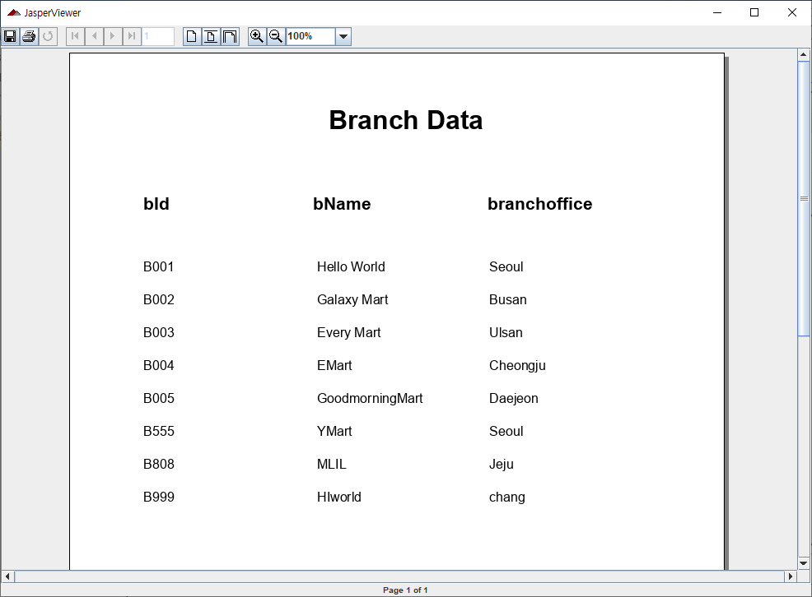
Fig. 13. (BranchTable) print reports
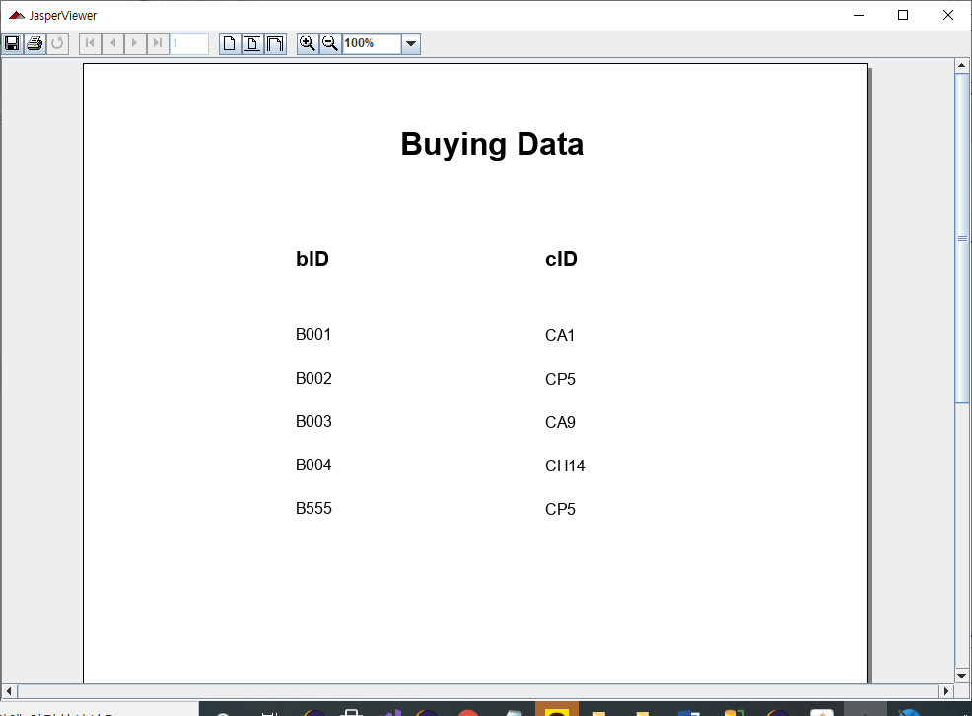
Fig. 14. (BuyingTable) print reports
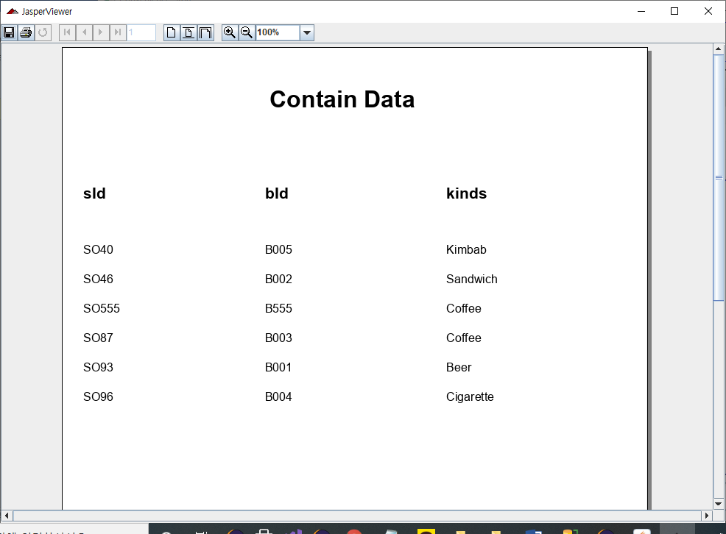
Fig. 15. (ContainTable) print reports
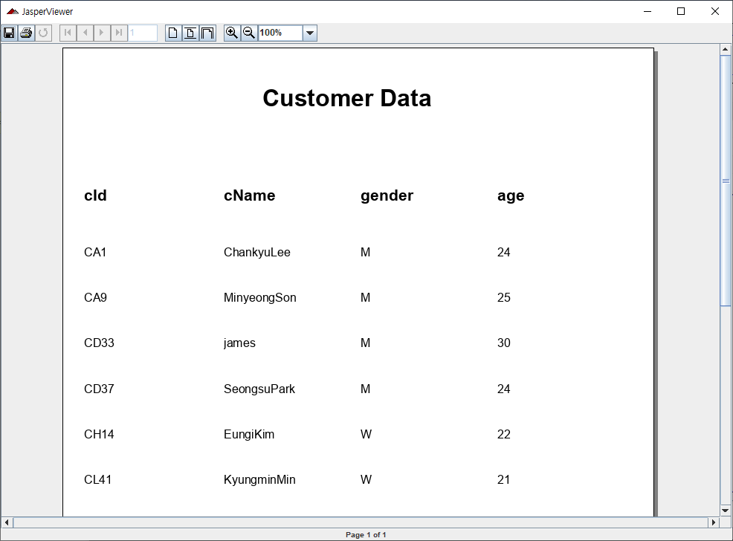
Fig. 16. (CustomerTable) print reports
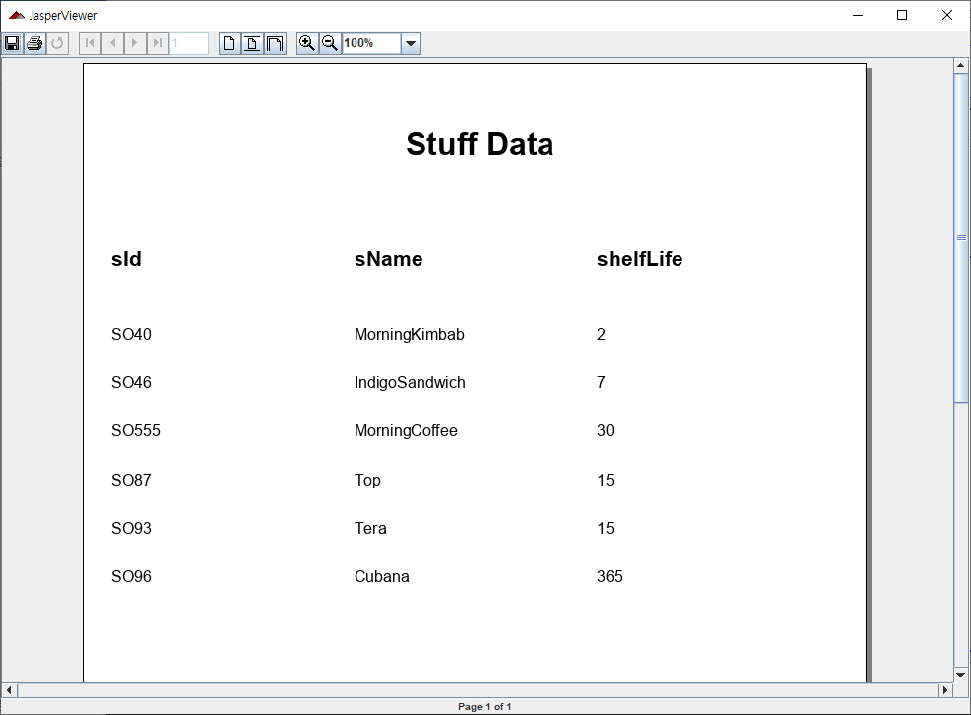
Fig. 17. (StuffTable) print reports

Results and analysis
The records of the table corresponding to the reports I designed in JasperSotfStudio were displayed normally.

I felt that
This is the first time I knew a platform like JasperSoftStudio. I was curious about how the UI that represents the output on the web is usually made, but this was solved by carrying out this task. It seems to be very convenient when I want to physically use a database that contains a lot of information.
- Conclusion

I felt that
In fact, being a database is full of vast amounts and difficult to understand information. However, I thought it was really convenient to be able to check this neatly through the GUI, add, modify, and update data, and know various information. I also thought this would be a lot to be used on other projects in the future.

Difficult point
There was a difficulty in implementing the fillgrid function and the addNodestoTree function in the MetaData.java file. It took a lot of time to think to properly express the contents of parameters and columns for each table, function, trigger, and stored procedure and in the end I followed the professor’s lecture to understand the overall flow and wrote the code to fit the logic.

Suggestions
None.

References

