Assignment 2: Smartphone Addiction

By Marcus Chan

Introduction:

In this day and age there are more and more applications that demand your attention and to compete with each other becomes as addicting as possible. This has led to a growing population of people who are addicted to screentime. There are more pronounced effects when looking at people addicted to their smartphone. This effect is aided by the ubiquitous use of smartphones in our society and how it is becoming more convenient to have a smartphone on your person at all times. I wanted to take a look at the population that are most affected by the screen addiction whether we are able to predict those that have an addiction. That way we can make connections on who are the most vulnerable populations as well as the effects of screen time on their life based on the dataset used.

Data Preparation

The dataset that we are using for this report have be found here: https://www.kaggle.com/datasets/jayjoshi37/smartphone-usage-and-addiction-prediction/data

The very first thing we do when looking at the data is check if there are any missing data that we might have to address. There is only one column where this may be the case the addiction levels column that holders unique values “None”, “Mild” , “Moderate”, and “Severe”

How we address this is complicated due to the categorical nature of this feature. During the initial process we converted Mild, Moderate and Severe as 2, 3, and 4 respectively, however None wasn’t stored as text for some reason so we set up conditional masking to match the addiction condition with the lowest level of addiction as I believe the dataset intended.

The way that this data was structured means that it has some parts of the data stored via categorical formats. Things like gender or the level of addiction severity. For true categorical data the answer is simple, use pandas get_dummies function and convert all of the features into separate columns because the categorical values aren’t related to each other. However with the addiction levels categories, these are related to each other.

Next is to remove the multicolinearity from the dataset since columns with overlapping influence on the desired predicted column will skew the results. By taking the VIF scores we see that the features weekend screen time and daily screen time where overlapping as well as all the features created from the get dummies function. By removing 1 feature from the groups of features we reduce the multicollinearity. We also removed weekend screen time to ensure the model will perform better. Below is a screenshot of the resulting VIF scores.

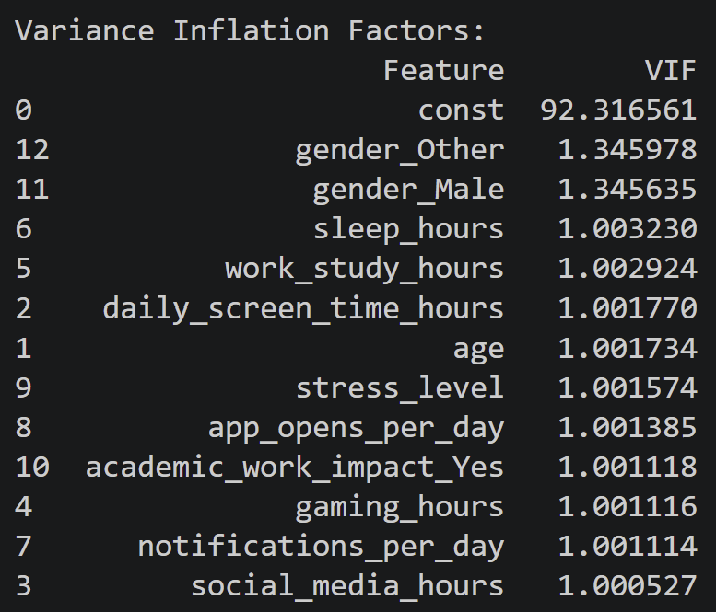

Now to prepare the dataset for actual modeling we need to determine the relevant features used for the models. The first step taken was to remove the transaction ID and the user ID from the set since that information shouldn’t give the model an advantage in the prediction. Next since we are working with a minimum of 8 features I decided to expand the features list to 10. This will ensure that all features that are relevant will be included using a simple features selection algorithm.

Using the chi2 algorithm in this instance then that produces the features:
- 'Age'
- 'daily_screen_time_hours'
- 'social_media_hours',
- 'gaming_hours'
- 'sleep_hours',
- 'notifications_per_day'
- 'app_opens_per_day'
- 'stress_level'
- 'gender_Male'
- 'gender_Other'

Data Exploration
Using PowerBI we can graph these features against the features of our prediction, the addiction label and the addiction level.

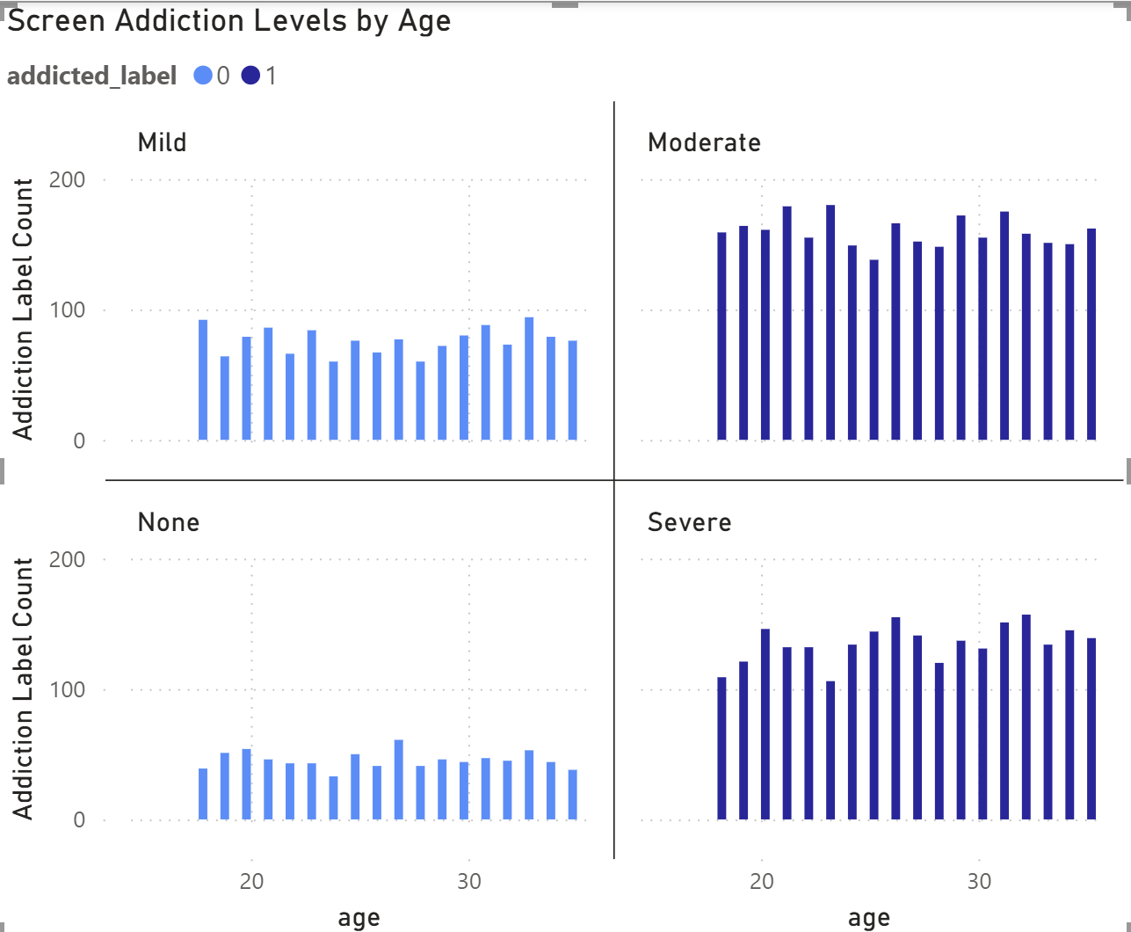
Figure 1: Screen Addiction by Age
Based on the age graph we can see that there is a larger population of people that are addicted to their smartphone than not. But we can also see that this addiction is spread pretty evenly throughout the recorded age range. There are some troughs but that could be attributed to variation in the data collection.

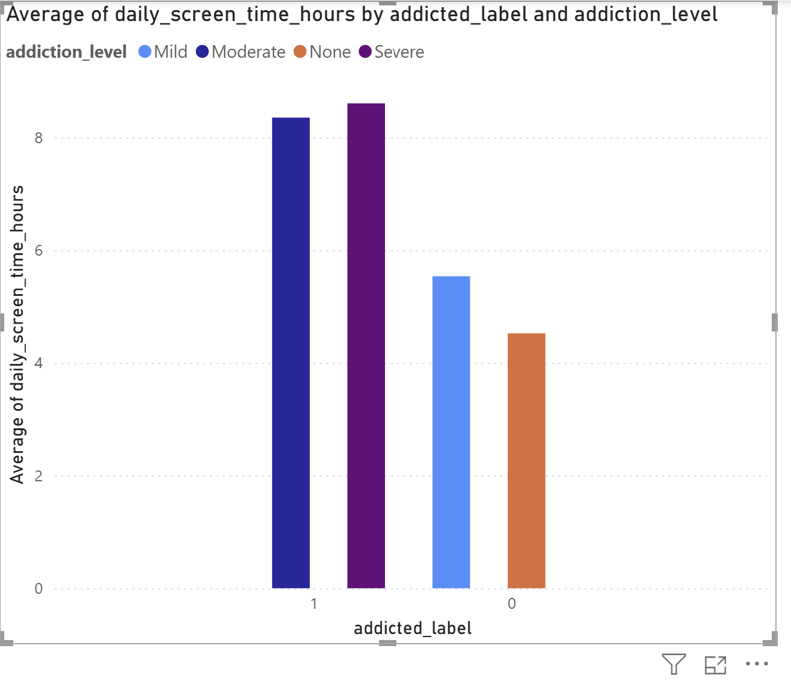
Figure 2: Average Daily Screen Time

This is one of the best indications of correlation in the dataset. There is a significant difference in the average screen time addicted people have over the non-addicted. This also follows the addiction label format None < Mild < Moderate < Severe. Though those that have severe and moderate screen time are very close in value around 8 hours each on average.

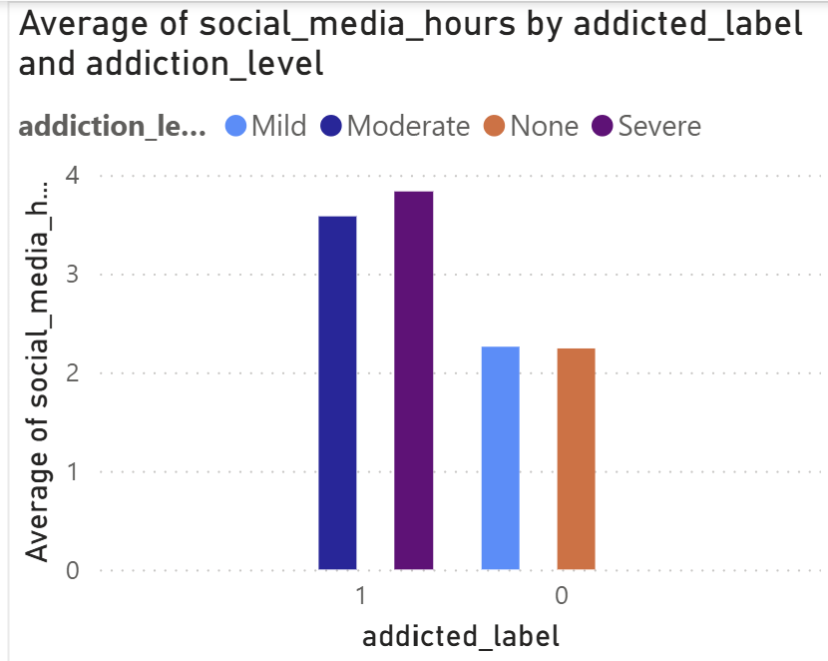
Figure 3: Average Hours Spent on Social Media

This graph displaying the average hours spent on social media is revealing in showing that some of the people who have a smartphone addiction spend that time on social media.

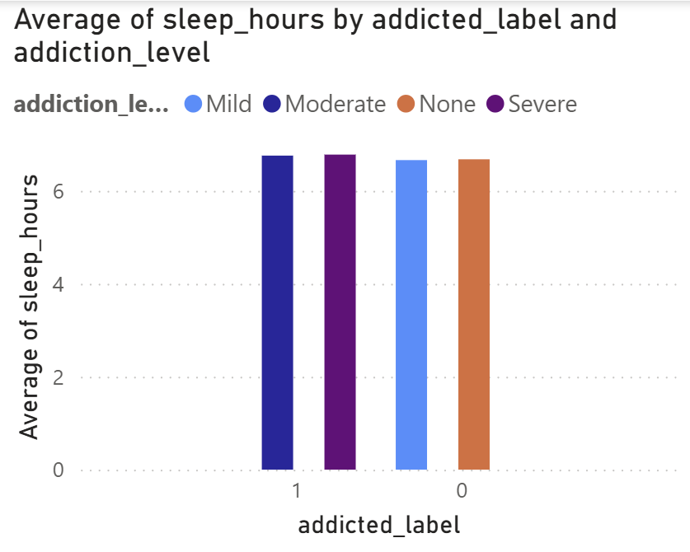
Figure 4: Average Hours used to Sleep
Surprisingly, the average amount of sleep among all users remains steady at around 7 hours.
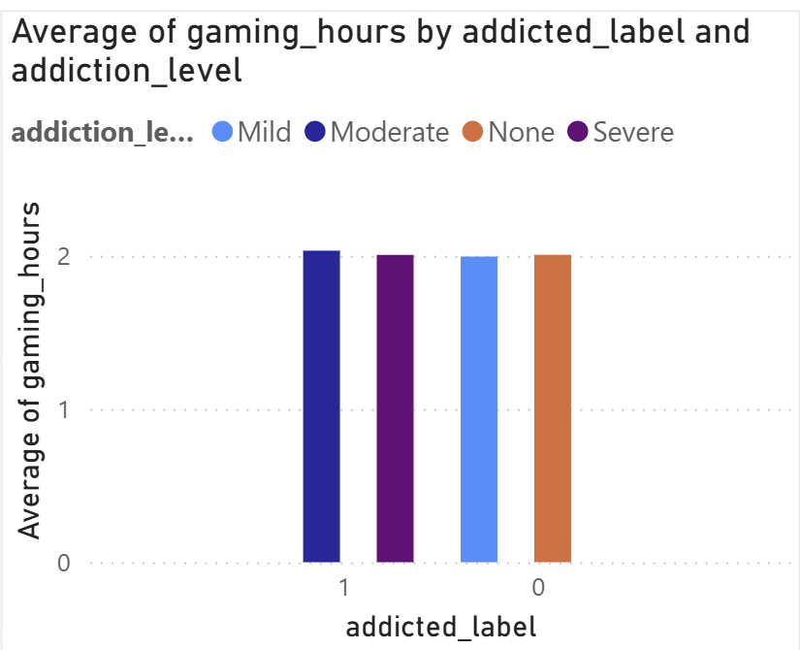
Figure 5: Average Number of Hours spent Gaming

Gaming hours from sampled users appear to be consistent throughout the population. Gaming is not a high priority for determining smartphone addiction.

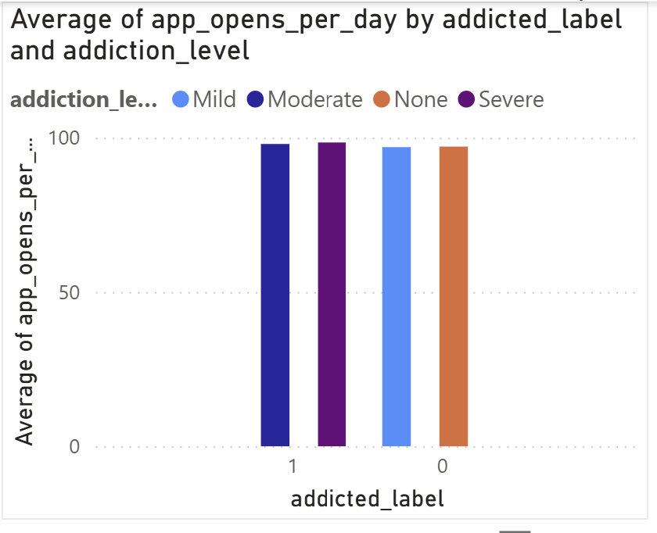
Figure 6: Average number of App opened per day

We see that users across the addiction categories roughly open the same number of apps per day. Based on the difference in how they have spent that time from previous graphs, it is presumed that social media apps will stay open longer than any other kind of app on the smartphone.

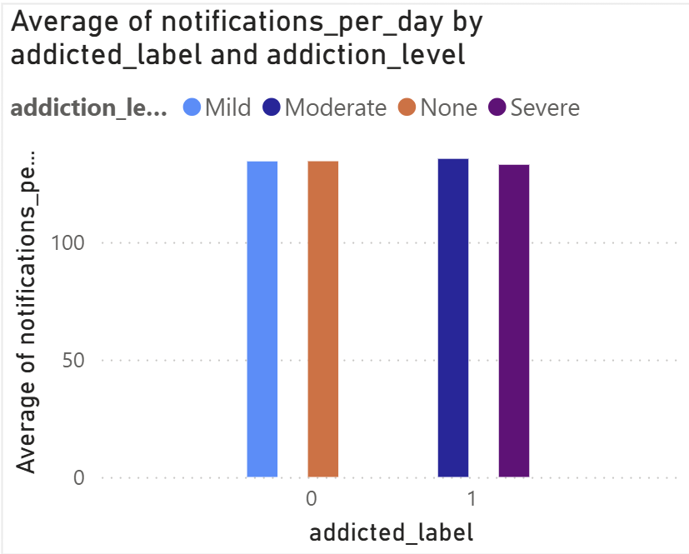
Figure 7: Average Number of Notifications per Day
The average number of notifications per day also seems consistent among all addiction levels. Combined with the data extracted from social media and gaming hours, we could extrapolate that the people who aren’t addicted get the same number of notifications but they care less about the notifications than people who are addicted.

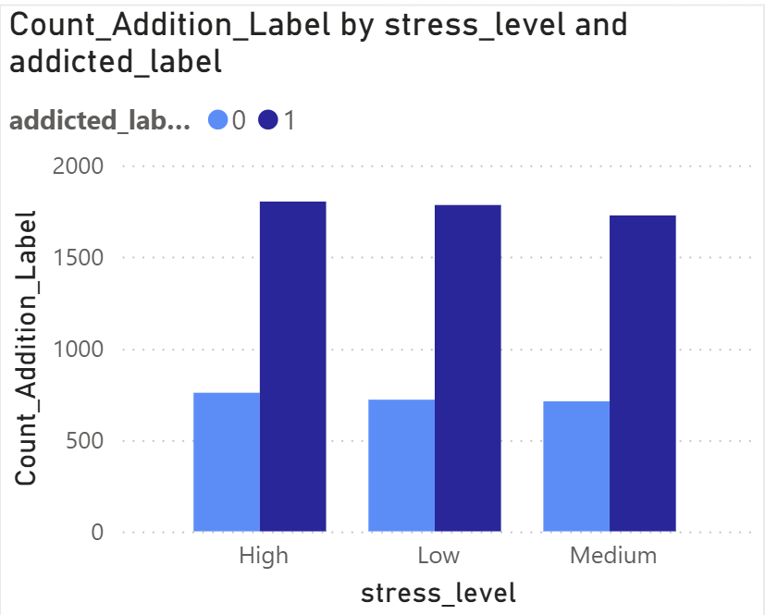
Figure 8: Count of Stress Levels by Addiction

What we look for in Figure 8 is the comparisons against stress levels, however they barely change. This indicates that people who are addicted to their smartphone are stressed the same way people who aren’t addicted. This means that the addiction doesn’t contribute to their stress in a way that is directly noticeable.
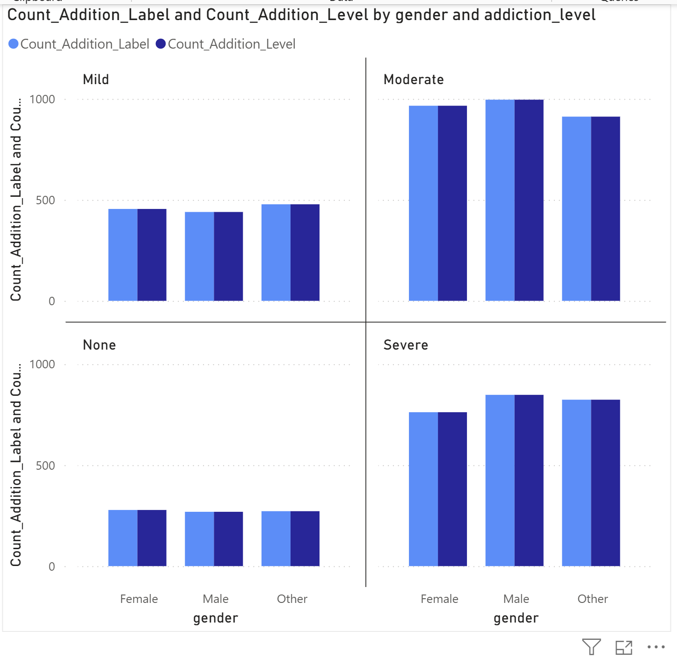
Figure 9: Screen Addiction by Gender

There aside that males are slightly more addicting to their smartphones than other genders. The comparison across genders show that every gender is vulnerable to this kind of addiction.

Based on these feature graphs we don’t have a very strong correlation. We can see more details based on the heatmap correlation to just the addiction label prediction feature.

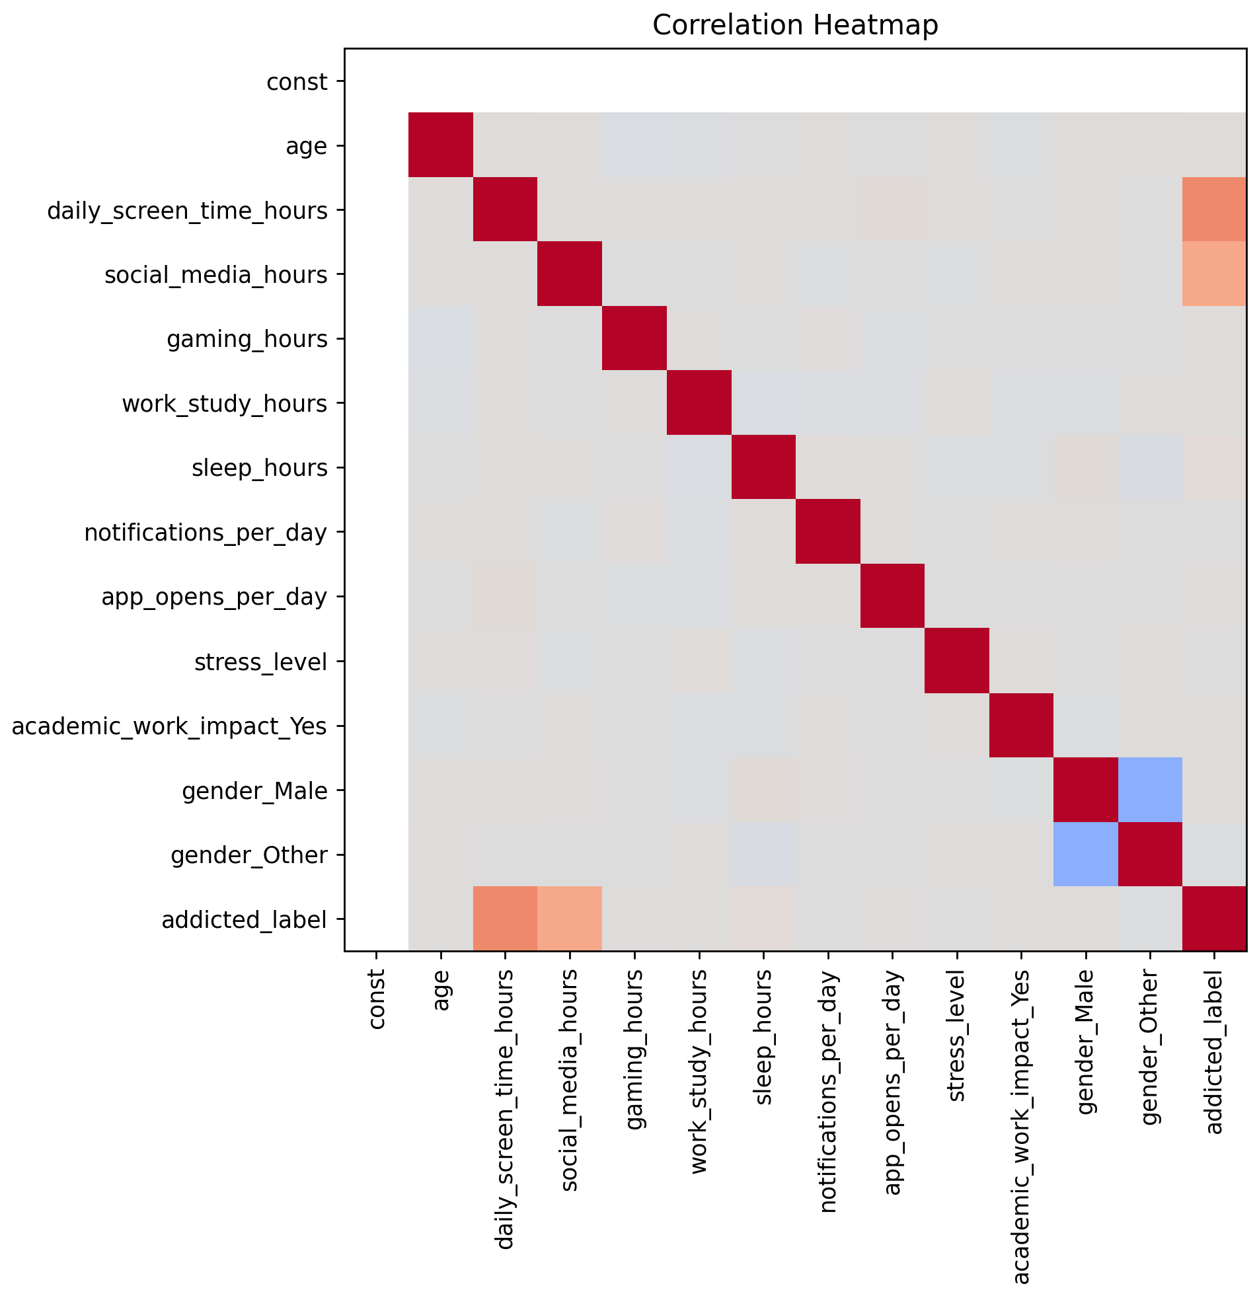
Figure 10: Heatmap Correlation

Data Modelling
Now that we have the data features dataframe preprocessed and prepared we can move to modeling the data. We will be attempting to model the data using a variety of the base models used for classification. Once we have narrowed down the model I will fine tune the model further to attempt to improve the results.

The models that we are trying are shown below, all the model names have been shortened for viewing convienience.

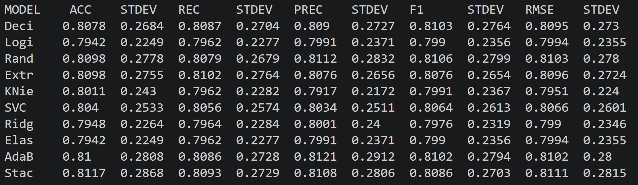
Figure 11: Data Model Summary Addiction Label
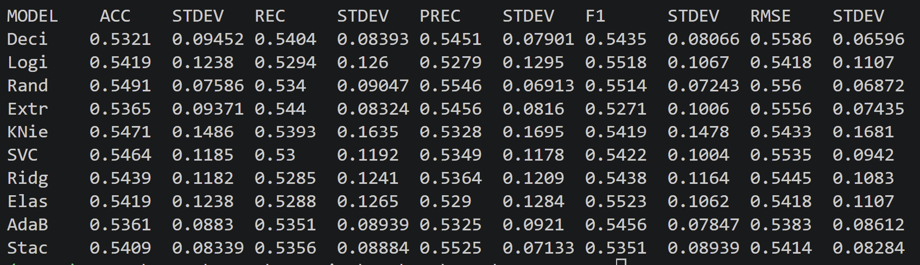
Figure 12: Data Model Summary Addiction Level

We can see that the best kind of classifiers that we are working with show roughly the same score; this is probably due to the very few correlating features that are found. In the heatmap we see that there are only strong distinctions correlating with the daily screen time in hours per day and the number of social media hours. There are very low relations with every other feature. There was a strong correlation with screen time on the weekends, but the feature caused multicolinearity within the dataset.

Model Evaluation

Based on the results gathered from the initial tests across multiple models I think the KNeighbors Classifier is the best model strictly based on the RMSE. Based on the readings in Figure 11 & 12 the the KNeighbors classifier has the lowest RMSE. Although it does have a higher standard deviation the variance between the standard deviations in the models are very similar. Again I suspect this is due to the limited number of correlated features in the dataset. There are similar effects in the Recall, Accuracy, Precision and F1 score for other models as they all share close values.

The Kneighbors model shows one of the lowest RMSE values for both the addiction label and the addiction level. However the accuracy, recall, and precision numbers are also lower in comparison to other models, but still within a reasonable degree with all other models.

Conclusion
This data set is not really suited for data analysis through the models found in the sklearn library. Most predictability comes from the features that are tied to the direct use of the smartphone or the hours they spend on social media. On that note it is remarkable that these are the only factors that seem to impact the averages of these values. Averages across work, and sleep remain steady, which means that of the small fraction for which their smartphone addiction is due to these factors aren’t a large percentage. The main cause of smartphone addiction is primarily due to social media based on the data collected in this report.

I mention that the models from sklearn were not suited for this issue given the constraints of this assignment. This is because since this data was from kaggle there are sample codes listed for this dataset. Among the more successful predictions at 95% I found that models based on a neural network appear to function with much more accuracy.

Appendix:

import pandas as pd
import numpy as np
from sklearn.preprocessing import MinMaxScaler, StandardScaler, RobustScaler
from sklearn.metrics import precision_score, accuracy_score, recall_score, f1_score, root_mean_squared_error, confusion_matrix
from sklearn.model_selection import KFold
from sklearn.feature_selection import chi2, SelectKBest
from sklearn.tree import DecisionTreeClassifier
from sklearn.ensemble import RandomForestClassifier, StackingClassifier, AdaBoostClassifier
from sklearn.linear_model import LogisticRegression
from sklearn.ensemble import BaggingClassifier, ExtraTreesClassifier
from sklearn.neighbors import KNeighborsClassifier
from sklearn.linear_model import RidgeClassifier,
from sklearn.svm import SVC

import matplotlib.pyplot as plt
from statsmodels.stats.outliers_influence import variance_inflation_factor
from statsmodels.tools.tools import add_constant

df = pd.read_csv('C:/Users/marcu/OneDrive/Desktop/BCIT/COMP 4254/Assignment2/' \
'archive/Smartphone_Usage_And_Addiction_Analysis_7500_Rows.csv')

pd.set_option('display.max_columns', None)
pd.set_option('display.width', 1000)

#Function used to compile results and complete test evaluation
def find_results(model, X_data, y_data, output_type='binary', x_scaler=None):
#TODO: integrate code to handle scalers
# applying scaler (optional)

# this function will take the model, x and y data then test them though Kfold validation
kf = KFold(n_splits=6, shuffle=True, random_state=123)

store_scores = []
for train_index, test_index in kf.split(X_data):
X_train, X_test = X_data.iloc[train_index], X_data.iloc[test_index]
y_train, y_test = y_data.iloc[train_index], y_data.iloc[test_index]

if x_scaler != None:
sc_x = x_scaler
X_test = sc_x.fit_transform(X_test)
X_train = sc_x.transform(X_train)

testing_model = model
testing_model.fit(X_train, y_train.values.ravel())

predictions = testing_model.predict(X_test)
# based on the type of data that we are predciting alot of it will be a binary decision however they might be a case we
# are looking at the types of addiction, we have to be flexible about the scoring

# accuracy score can only handle classifier outputs, not possible for regression.
accuracy = accuracy_score(predictions, y_test)
recall = recall_score(predictions, y_test, average=output_type)
precision = precision_score(predictions, y_test, average=output_type)
f1 = f1_score(predictions, y_test, average=output_type)
rsme = root_mean_squared_error(predictions, y_test)
# storing the calculated results
store_scores.append((accuracy, recall, precision, f1, rsme))

#calculating the averages given the test results
average_accuracy = np.mean(store_scores[0][:])
average_recall = np.mean(store_scores[1][:])
average_precision = np.mean(store_scores[2][:])
average_f1 = np.mean(store_scores[3][:])
average_rmse = np.mean(store_scores[4][:])

# calculating the standard deviation based on the results of KFold
stdev_accuracy = np.std(store_scores[0][:])
stdev_recall = np.std(store_scores[1][:])
stdev_precision = np.std(store_scores[2][:])
stdev_f1 = np.std(store_scores[3][:])
stdev_rmse = np.std(store_scores[4][:])

# print_confusion(y_test, predictions)

# print(f"Accuracy: {average_accuracy} +/- {stdev_accuracy}")
# print(f"Recall: {average_recall} +/- {stdev_recall}")
# print(f"Precision: {average_precision} +/- {stdev_precision}")
# print(f"F1 Score: {average_f1} +/- {stdev_f1}")
# print(f"RMSE: {average_rmse} +/- {stdev_rmse}")

return [average_accuracy, stdev_accuracy, average_recall, stdev_recall, average_precision, stdev_precision,
average_f1, stdev_f1, average_rmse, stdev_rmse]

def print_confusion(y_test, y_pred):
cm = confusion_matrix(y_test, y_pred)
print(cm)

def showVIF(X): # need to rewrite this in my own code # this is a placeholder
# this doesn't work becuase VIF score doesn't handle boolean well, convert true/false column to float
# acedemic work impact no/ yes
# genders as well
vif_df = pd.DataFrame()
vif_df["Feature"] = X.columns
vif_df["VIF"] = [variance_inflation_factor(X.values, i) for i in range(len(X.columns))]
print("\nVariance Inflation Factors:")
vif_df = vif_df.sort_values(["VIF"], ascending=False)
print(vif_df)

def display_complied_reports(report_list):
#columns = ['Acc', 'Acc Stdev', 'Recall', 'Recall Stdev', 'Prec', 'Prec Stdev', 'F1', 'F1 Stdev', 'RMSE', 'RMSE Stdev']
print("MODEL \t ACC\tSTDEV\tREC\tSTDEV\tPREC\tSTDEV\tF1\tSTDEV\tRMSE\tSTDEV")
for report in report_list:
print(f"{report[0]:.4}\t{report[1]:.4}\t{report[2]:.4}\t{report[3]:.4}\t{report[4]:.4}\t{report[5]:.4}\t{report[6]:.4}\t{report[7]:.4}\t{report[8]:.4}\t{report[9]:.4}\t{report[10]:.4}")

def feature_selection(X, y, n=10):
selector = SelectKBest(chi2, k=n)
select_X = selector.fit_transform(X, y)
selected_features = X.columns[selector.get_support()]
print(f"Selected features: {list(selected_features)}")

X = X[selected_features]
return X

def createStackingClassifier():
# Define base models
# base_models = [
# ('dt', DecisionTreeClassifier()),
# ('rf', RandomForestClassifier()),
# ('lr', LogisticRegression(solver='newton-cg')),
# ('et', ExtraTreesClassifier()),
# ('knn', KNeighborsClassifier()),
# ('svc', SVC(probability=True)),
# ('rg', RidgeClassifier()),
# ('en', LogisticRegression(penalty='elasticnet', solver='saga')),
# ('ada', AdaBoostClassifier())
# ]
base_models = [
('knn', KNeighborsClassifier(n_neighbors=4)),
('rf', RandomForestClassifier(max_depth=10, n_estimators=15)),
('lr', LogisticRegression(solver='newton-cg')),
('et', ExtraTreesClassifier()),
('rf2', RandomForestClassifier(max_depth=20, n_estimators=20)),
('lr2', LogisticRegression(solver='newton-cg')),
('rg', RidgeClassifier()),
('en', LogisticRegression(penalty='elasticnet', solver='saga') ),
('ada', AdaBoostClassifier())
]

# Define meta model
#meta_model = LogisticRegression(solver='newton-cg')
meta_model = RidgeClassifier()

# Create Stacking Classifier
stack_classifier = StackingClassifier(estimators=base_models, final_estimator=meta_model)

return stack_classifier

print(df['addiction_level'].unique())
print(df['stress_level'].unique())

addiction_level_map = {'None': 0, 'Mild': 1, 'Moderate': 2,'Severe': 3}
df['addiction_level'] = df['addiction_level'].map(addiction_level_map)

stress_level_map = {'Low': 1, 'Medium': 2, 'High': 3}
df['stress_level'] = df['stress_level'].map(stress_level_map)

df['addiction_level'].mask(((df['addiction_level'].isnull()) & (df['addicted_label']== 0)) , 0, inplace=True)
# we notice that there are no elements that violate the conditions that there is null values outside of the addicted_label == 0
# this implies that the Nan values were just the intended None values and that the dataset was complete
print(df['addiction_level'].unique())

df_final = pd.get_dummies(df, columns=['academic_work_impact', 'gender'])
print(df_final.head())

# print(df.describe())
y = df_final[['addicted_label']]
y2 = df_final[['addiction_level']]

X = df_final.copy()
del X['addicted_label']
del X['addiction_level']

# we are removing the transaction_id and user_id since that information is useless for this project
del X['transaction_id']
del X['user_id']

# converting bool features to type float
X['academic_work_impact_No'] = X['academic_work_impact_No'].astype(float)
X['academic_work_impact_Yes'] = X['academic_work_impact_Yes'].astype(float)
X['gender_Female'] = X['gender_Female'].astype(float)
X['gender_Male'] = X['gender_Male'].astype(float)
X['gender_Other'] = X['gender_Other'].astype(float)

# based on VIF scores we have to remove a few columns
del X['gender_Female']
del X['academic_work_impact_No']
del X['weekend_screen_time']

#looking at the VIF scores to identify multicolinearity
X = add_constant(X)
showVIF(X)

# # looking at the heatmap with removing the obvious multicolinearity
combine = pd.concat([X, y], axis=1)
correlation_matrix = combine.corr()
plt.figure(figsize=(10,8))
plt.imshow(correlation_matrix, cmap='coolwarm', vmin=-1, vmax=1)
plt.xticks(range(len(correlation_matrix.columns)), correlation_matrix.columns, rotation=90)
plt.yticks(range(len(correlation_matrix.columns)), correlation_matrix.columns)
plt.title('Correlation Heatmap')
plt.tight_layout()
plt.show()

X = feature_selection(X, y)

# output_type for find_result: binary, micro, macro, weighted
# only binary and micro should be necessary for this project
min_max = MinMaxScaler()
robust = RobustScaler()
standard = StandardScaler()

report_list1 = []
report_list2 = []
dt = DecisionTreeClassifier()
lr = LogisticRegression(solver='newton-cg')
rf = RandomForestClassifier()
et = ExtraTreesClassifier()
knn = KNeighborsClassifier()
svc = SVC()
rg = RidgeClassifier()
en = LogisticRegression(penalty='elasticnet', solver='saga')
ada = AdaBoostClassifier()
stack = createStackingClassifier()

model_dict = {"Decision Tree": dt,
"Logistic Regression": lr,
"Random Forest": rf,
"Extra Trees": et,
"KNieghbors": knn,
"SVC": svc,
"Ridge": rg,
"Elastic Net": en,
"AdaBoost": ada,
"Stacking": stack}

for key, value in model_dict.items():
model_name = key
print(f"++++++++++++++++{model_name}====================")

temp_array = find_results(value, X, y, output_type='binary', x_scaler=min_max)
temp_array.insert(0, f"{model_name}")
report_list1.append(temp_array)

temp_array = find_results(value, X, y2, output_type='micro', x_scaler=min_max)
temp_array.insert(0, f"{model_name}")
report_list2.append(temp_array)

display_complied_reports(report_list1)
print("")
display_complied_reports(report_list2)

# stack_classifier = StackingClassifier()

