

**USER guide**

*HIV Supply Chain*

Prepared by: iLab & xxx

December, 2015

**Revision Sheet**

|  |  |  |
| --- | --- | --- |
| **Release No.** | **Date** | **Revision Description** |
| Rev. 0 | Nov/16/2015 | User’s Manual Created |
| Rev. 1 | Nov/24/2015 | Added conversion program information |
|  |  |  |
|  |  |  |
|  |  |  |

**USER'S MANUAL**

**TABLE OF CONTENTS**

Page #

1.0 GENERAL INFORMATION 1-1

1.1 System Overview 1-1

1.2 Acronyms and Abbreviations 1-1

2.0 SYSTEM SUMMARY 2-1

2.1 System Configuration 2-1

2.2 User Access Levels 2-1

3.0 GETTING STARTED 3-1

3.1 Login to the system with default Admin role 3-1

3.2 Setting up Province 3-2

3.3 Setting up Unit 3-3

3.4 Setting up Commodity Categories 3-4

3.5 Setting up Category for Lab Testing 3-5

3.6 Setting up Regimen Categories 3-6

3.7 Setting up Lab Test 3-7

3.8 Setting up Regimen 3-8

3.9 Setting up SMS Message Templates 3-9

3.4 Adding/Removing MySQL Users 3-10

4.0 USING the CLIENT APPLICATION 4-1

4.1 Settings 4-1

4.1.1 Server 4-1

4.1.2 Username 4-1

4.1.3 Password 4-1

4.1.4 Database Name 4-1

4.1.5 Database Table 4-1

4.1.6 Equipment Table 4-1

4.1.7 Save most recent queries 4-1

4.2 Connect/Disconnection to database 4-1

4.3 Student Information 4-1

4.3.1 Add Record 4-2

4.3.2 Update Record 4-2

4.3.3 Clear Fields 4-2

4.4 Equipment Rental 4-2

4.5 Query 4-2

4.5.1 Save Query 4-2

4.5.2 Load Query 4-2

4.5.3 Query Results 4-2

4.5.4 Save Query Results 4-3

4.5.5 Change Query Results Display 4-3

5.0 USING the CONVERSION APPLICATION 5-1

5.1 Connect 5-1

5.2 Convert 5-1

This function converts the Access records to the new MySQL database format. Depending on the amount of records and speed of the computer, this can take several minutes. To assure that the program has not locked up, a progress bar has been implemented to show function progress. 5-1

5.3 Report 5-1

This function should be run after the completion of the convert function. It creates a Notepad text file in the grandparent directory of the conversion application that lists the DawgTag numbers of all student records and equipment records that contain data formats which the conversion application could not convert easily. 5-1

5.4 Disconnect 5-1

Disconnects the conversion application from both the Microsoft Access input database and the MySQL output database. 5-1

**1.0 GENERAL INFORMATION**

# GENERAL INFORMATION

## 1.1 System Overview

The PNG HIV SUPPLY CHAIN (HSC) is a web application that utilizes an intuitive user interface that allow PNG HIV health worker play role (Site, Data Entry, Data Entry and Reviewer, Reviewer, AMS and Admin) user to collaborate in a predefined workflow. This application provides a graphical user interface that allows a user to input all information and store it electronically to exterminate the need for using paper records, automatic remind to site user to send requisition order and update the status of shipment.

This app uses a client, server model. The client is any browser the user. The client program will communicate with the server that saves all the information. The information saved in the database is about HIV commodities like Drug and Test Kit.

## 1.2 Acronyms and Abbreviations

HSC – HIV SUPPLY CHAIN collaboration tool for tracking HIV supply across PNG.

MySQL – This is a free SQL database used to store all information for each student.

**2.0 SYSTEM SUMMARY**

# SYSTEM SUMMARY

## 2.1 System Configuration

Each users uses their own computer with any modern browser namely Firefox, Google Chrome. On those the browser will connect to PNG Server hosted <http://www.png.com> that is centralize server running on Linux Ubuntu Server operating System. To be able to connect to server the computer requires to be on a LAN connection to the internet.

The information stores on the database server MYSQL. It can be exported.

## 2.2 User Access Levels

There are 5 different roles of users described below

**Admin users** are those who are responsible for setting up the initial data like create other user, setting commodities, sites, provinces, SMS template and so on.

**Site users** are those who are located in a specific HIV site. They are responsible for submitting requisition order. They receive the shipment from AMS users; they also can send SMS to PNG HSC phone number updating the shipment status.

**Data Entry users** are those who responsible for creating SURV form for completing requisition orders of site. Edit and save order requisition submitted from sites to be able to send to be reviewed to reviewer users.

**Reviewer users** are those who responsible for reviewing order requisition from **Data Entry** user. Reviewer can reject and accept each order item. If order requisition is accepted, then the system will make it available for AMS, otherwise it will available for Data Entry user to correct it.

**AMS users** are those who responsible for order shipment. After Reviewer users approved the order, the order will appear to AMS. AMS can choose items from the list and ship.

**3.0 GETTING STARTED**

# GETTING STARTED

## 3.1 Login to the system with default Admin role

In your browser visit: <http://www.png.com>. You will be redirected to page log in if you have not logged in yet as below:

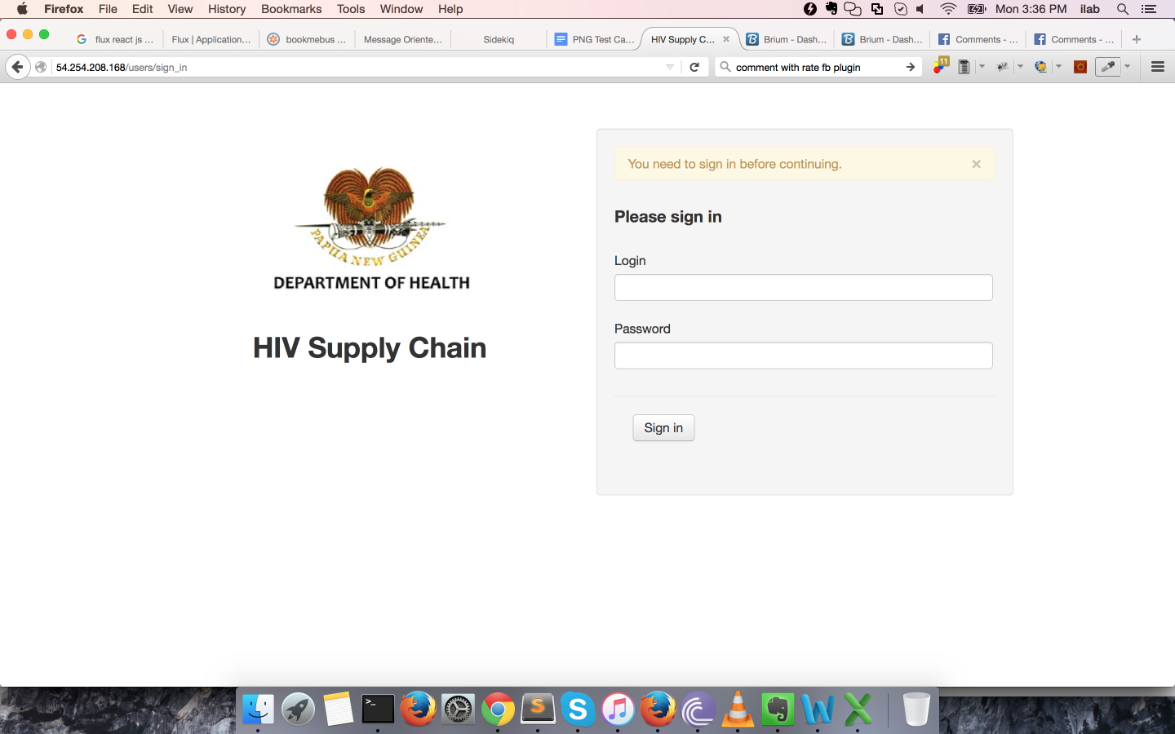

Enter the Login and Password for admin user then click ‘Sign In‘ button. If you provide correct Login and Password then I will bring you to the admin page as bellows:

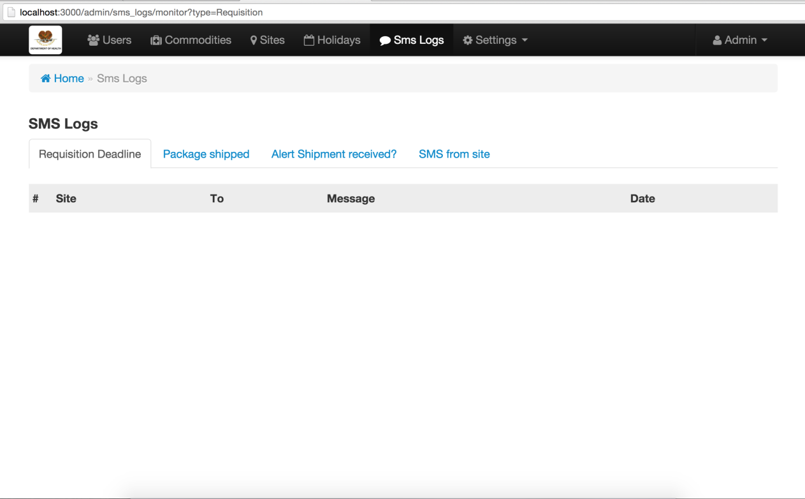

## 3.2 Setting up Province

Go **Settings -> Provinces** HSC will show the provinces listing

## Macintosh HD:Users:ilab:Project:png user guide:provinces.png

You can create a new province, edit or delete an existing one. When you edit the province data then all other tables that have province will get the new updated.

If you try to **delete*1\**** a province that is being **associated** with other tables for instance Sites listing then the system will complain and you are rejected from being able to delete the province successfully. If you really want to remove the province on purpose then you must disconnect the association by removing or editing to break the association. **This concept applies to all tables in the HSC**.

## 3.3 Setting up Unit

Go to Settings -> Units then HSC will show the units listing

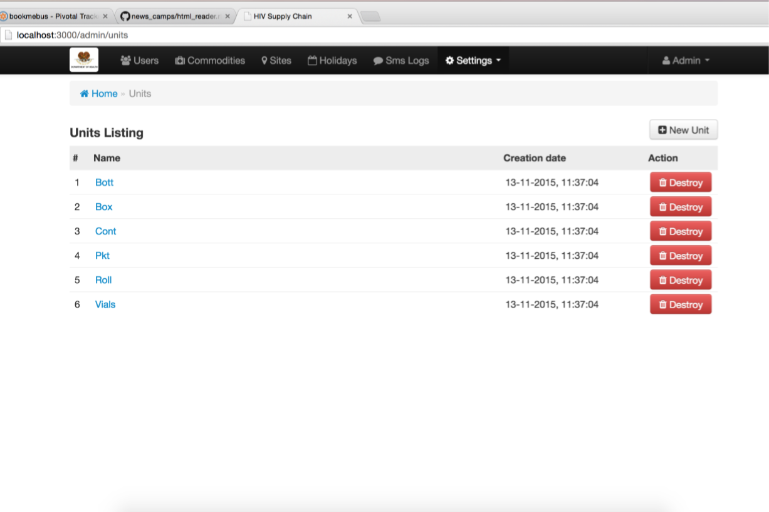

## 3.4 Setting up Commodity Categories

Go to Settings -> Commodity Categories then HSC will show

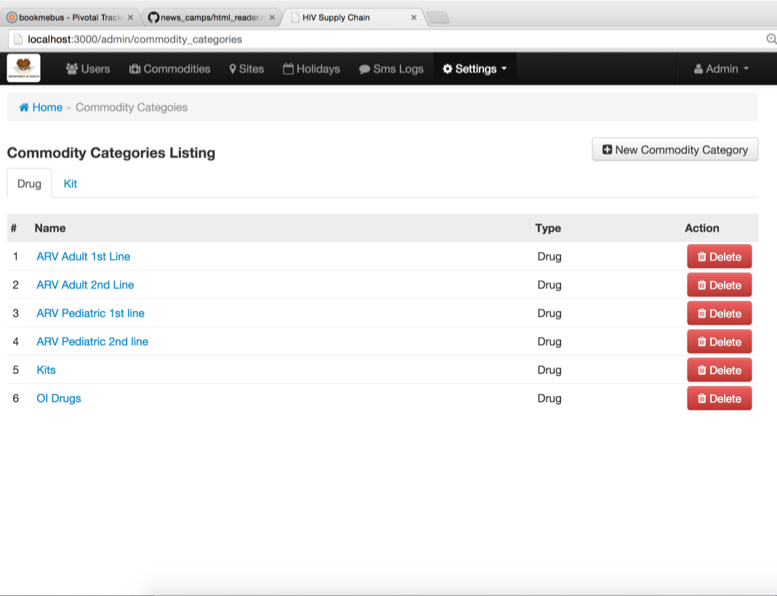

There are 2 types of commodity categories – Drug and Kit. They are represented as a tab so to switch between Drug and Kit you simply click on the tab.

## 3.5 Setting up Category for Lab Testing

Go to Settings -> Lab Test Categories then HSC will show the list of lab testing categories

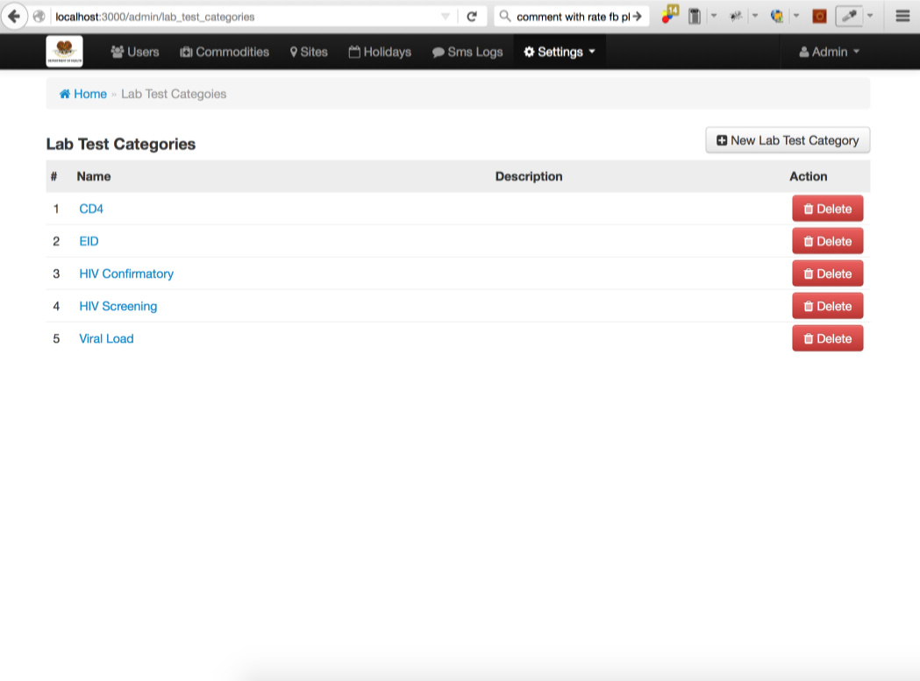

## 3.6 Setting up Regimen Categories

Go to Settings -> Regimen Categories then HSC will show listing of Regimen Categories

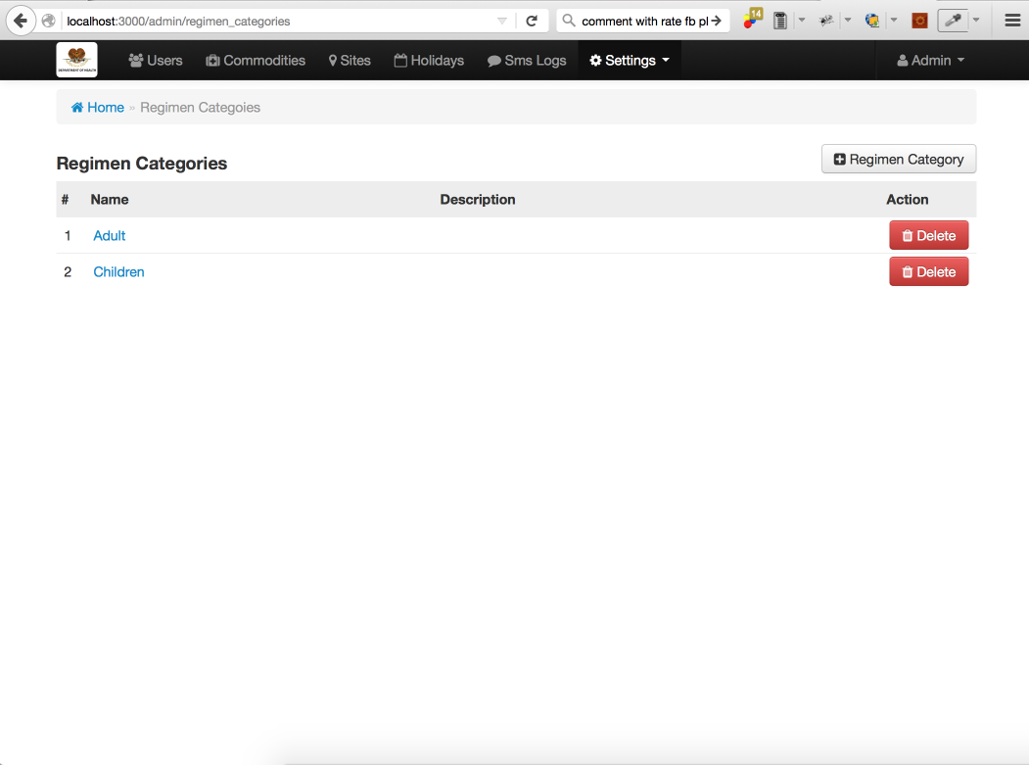

## 3.7 Setting up Lab Test

Go Settings -> Lab Test then HSC will show the listing of Lab Testing

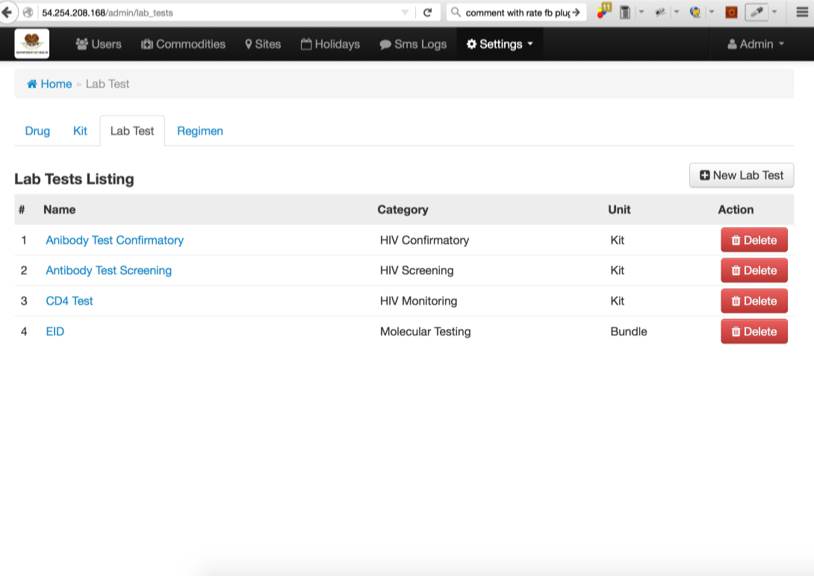

## 3.8 Setting up Regimen

Go to Settings -> Regimen then HSC will show the listing of Regimen

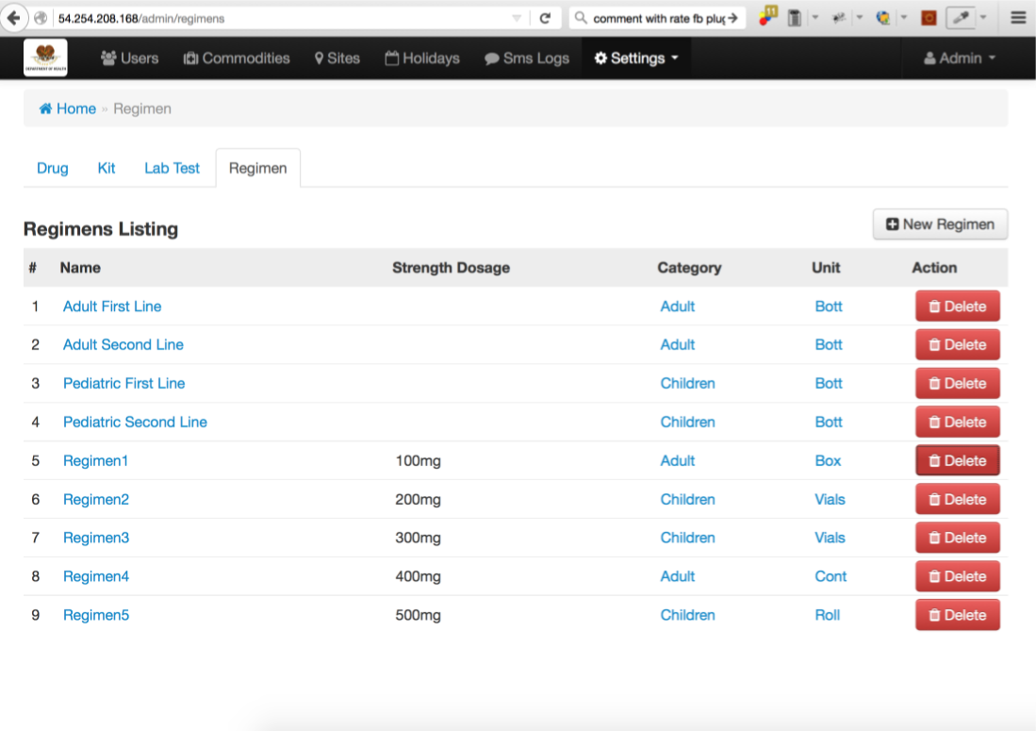

## 3.9 Setting up SMS Message Templates

Go to Settings -> SMS Message Template then HSC show all the templates configuration to all aspect of SMS message in HSC system.

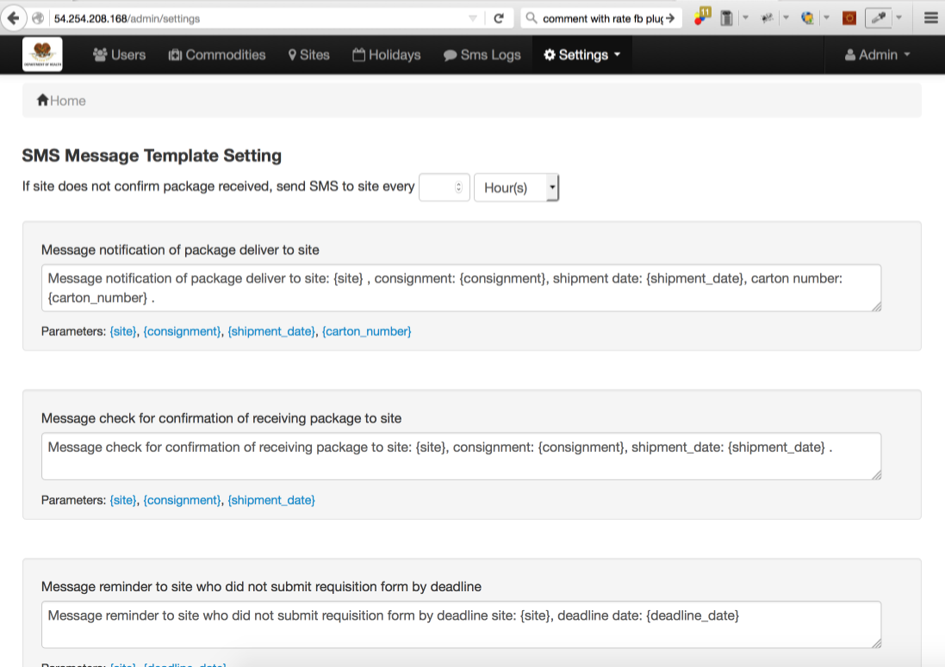

## 3.10 Setting up Commodities

Go to Commodities on the top menu bar then HSC will show the listing of commodities

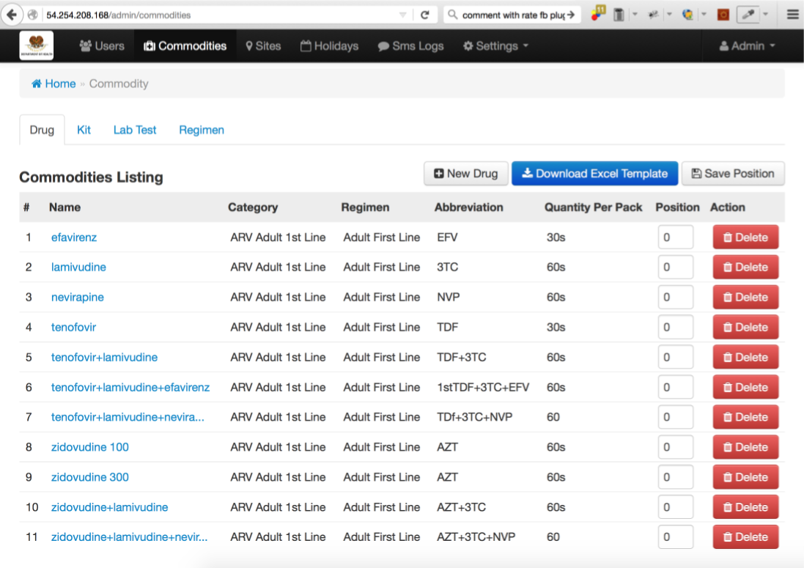

Actually there are only 2 types of commodities – Drug and Kit. They are corresponding to Drug and Kit commodity categories. These 2 types of commodities are represented as a tab. You can switch between commodities by click on the tab. Lab Test and Regimen are represented as tab here as quick access because commodities are mostly related to regimen and lab testing.

Beside create/edit/delete commodities admin user can rearrange position of the commodities to manage the order of appearance by changing the text box position and then click on the ‘**Save Position**’ button.

**3.11** **Setting up Sites**

Go to Sites on the top menu bar then HSC will show the listing of sites

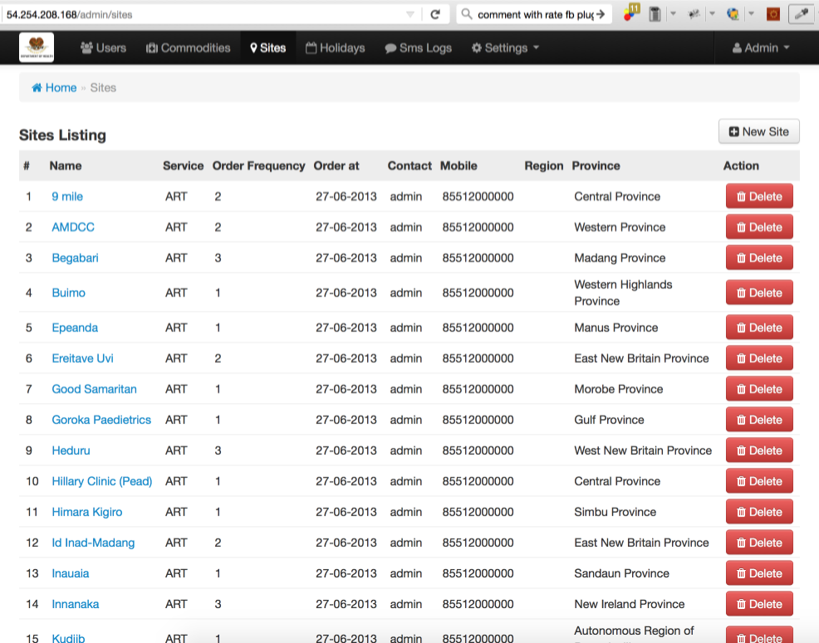

**3.12** **Setting up Users**

Go to Users then HSC will show the listing of users

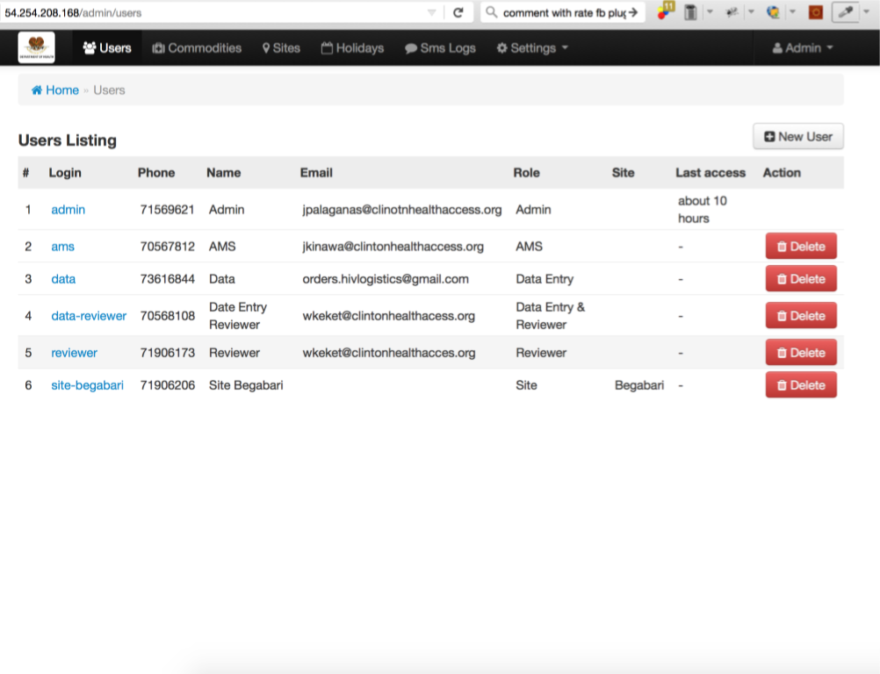

**4.0 APPLICATION FEATURES**

# APPLICATION FEATURES

## 4.1 Settings

Changing the settings to fit the current user is the first step that should be taken by a new user to the computer before using the application. The settings can be access from the “Settings” menu in the main application window. There are seven (7) settings that can be changed to fit the current user’s needs. When the settings are changed, the changes will be saved even when the program is restarted. Users may need to contact the network administrator to find out all of the details for these settings.

### 4.1.1 Server

The IP address of the computer on the LAN that is running the MySQL server. You may either type the IP address of the database server or the network name of the computer

### 4.1.2 Username

The name of the current user that was setup in the MySQL server by the Administrator specifically for the current user

### 4.1.3 Password

The password that corresponds to the current user that was setup in the MySQL server by the Administrator specifically for the current user

### 4.1.4 Database Name

The name of the database specified in section 3.2 when MySQL was being setup

### 4.1.5 Database Table

The name of the student information table that was added to the database in section 3.3 when MySQL was being setup

### 4.1.6 Equipment Table

The name of the equipment table that was added to the database in section 3.3 when MySQL was being setup

### 4.1.7 Save most recent queries

If this box is checked queries that are made will be saved so that the next time the user returns to the query form, the previous credentials will still be displayed. If it is not checked a new query form will be blank.

## 4.2 Connect/Disconnection to database

To be able to access the database the user must connect to it through the “Connect” menu found under the “Database” menu. When the user is finished with their task they can disconnect from the database using the “Disconnect” menu under the “Database” menu.

## 4.3 Student Information

Student information is stored in three (3) parts. The first is the basic personal information, contact information and services provided which all three wrapped up into one is also called student information. The second is Equipment Rental. This tab is where information is stored regarding any equipment the student might have rented from the university. The final is Case Notes. Case Notes are any kind of notes that will help the user better understand the student’s case. Once the appropriate information has been filled out the student records can be added to the database or edited via the function described in this section.

### 4.3.1 Add Record

Once all of the data fields are filled in on the main application window (i.e. Student Information, Equipment Rental, and Case Notes) the record can be added to the database from the “Add” menu under the “Student” menu on the main form.

### 4.3.2 Update Record

After a record has been loaded and information has been changed the user can update the record by clicking on “Update” under the “Student” menu.

### 4.3.3 Clear Fields

This is a convenience feature that will clear all fields in the main form. When the user selects “Clear Fields” under the “Student” menu, they will be prompted to confirm the clear. If they user selects “yes” the information will be cleared, otherwise nothing will happen.

## 4.4 Equipment Rental

Once a record has been loaded into the main form the user can add, edit, or remove equipment entries from the database for that particular student. This can be done one of two ways: the menu items under the “Equipment” menu, or by right clicking in the Equipment Rental list box. To edit and remove records the user must have a record selected, however to add a record the user does not.

## 4.5 Query

To be able to search the database for a particular student, or a group of students that meet a certain criteria, the user must select “Query” from the “Student” menu. This will bring up a new dialog box with all of the same fields that are on the main form. To search the database type in the desired criteria in the fields on the query form then click the “OK” button on the bottom left of the form. Once this is done a new dialog box will come up showing the results.

### 4.5.1 Save Query

What this does is save the criteria that are currently entered in the query form into a file on the hard disc specified by the user. This allows common queries to be saved so the user does not have to type in the same information every time. To save a query the user must click the “Save” button on the query form after the desired query criteria has been filled in.

### 4.5.2 Load Query

To retrieve the search criteria from a saved query the user will select “Load” from the query form, then choose the file name and location of the query to load.

### 4.5.3 Query Results

Once the search criteria have been entered and the user clicks “OK” on the query form all of the results that match the search will be shown in the query results form. From here the user can either double click, or single click then click the “OK” button to load the record data into the main form.

### 4.5.4 Save Query Results

Once a query has been performed and the user can choose to save the query results. To do so they will click the “Save” button on the query results form. Saving the query results will save all of the information for each student that was successfully found based on that query (i.e. all of the students in the query results). This data is save in a Microsoft Excel compatible XML format and can be further edited to remove unwanted columns via Excel.

### 4.5.5 Change Query Results Display

In the query results form the user can select which columns they want displayed by right clicking in the list view and selecting the menu item corresponding to the field they want to see.

**5.0 USING THE CONVERSION APPLICATION**

# USING the CONVERSION APPLICATION

## 5.1 Connect

Connects the conversion application to the existing Microsoft Access input database and MySQL output database. A settings form loads when connect is clicked to allow user input of database information. There are (7) settings that can be changed to fit the user’s needs. Settings must be input every time the application is run, but the application is only intended to be run once. This software must be run by an administrative user, so as to allow the application to create all the necessary records in the MySQL database. To facilitate Access database conversion, a copy of the Access database must be inserted into the parent directory of the conversion application, and the input file should be listed as ‘xxxxxx.mdb’.

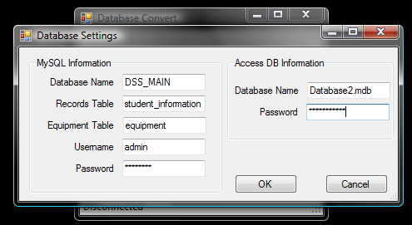

## 5.2 Convert

### This function converts the Access records to the new MySQL database format. Depending on the amount of records and speed of the computer, this can take several minutes. To assure that the program has not locked up, a progress bar has been implemented to show function progress.

## 5.3 Report

### This function should be run after the completion of the convert function. It creates a Notepad text file in the grandparent directory of the conversion application that lists the DawgTag numbers of all student records and equipment records that contain data formats which the conversion application could not convert easily.

## 5.4 Disconnect

### Disconnects the conversion application from both the Microsoft Access input database and the MySQL output database.