Luo Chen (001564677)

**Program Structures & Algorithms**

**Fall 2021**

**Assignment No. 2**

* **Task (List down the tasks performed in the Assignment)**
  + **Part 1, Implement Class Timer**
  + **Part 2, Implement Class InsertionSort**
  + **Part 3, Implement main method in InsertionSort and compare the time growth of the 4 kind of order**
* **Relationship Conclusion:**

growth(ordered) < growth(random) ≈ growth(partially ordered) < growth(reverse ordered)

* **Evidence to support the conclusion:**

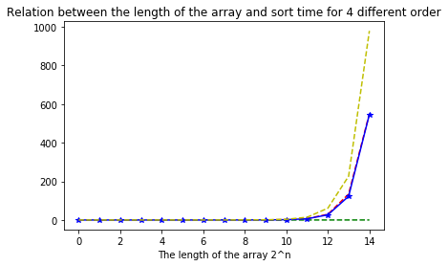

**Output (Snapshot of Code output in the terminal)**

**TimerTest**

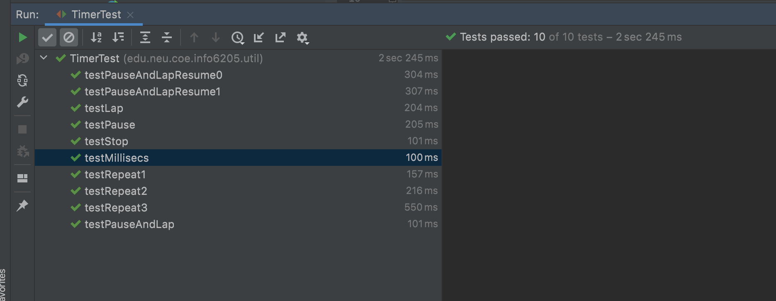

**InsertionSortTest**

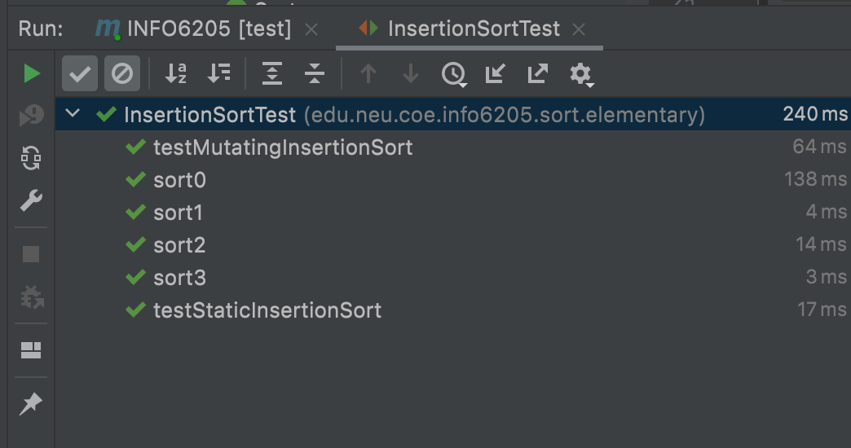

**Main() in InsertionSort.java**

