Agent-based system applied in TAC AdX

Chao Duan (Channer)
University of Southampton
Wessex Lane Halls
Southampton
+44 07823924833
cd3a14@soton.ac.uk

ABSTRACT
Brand advertising is the cornerstone of Internet economic ecosystem [3]. And there are substantial new technologies arise to promote the efficiency of online advertising. Thus the Trading Agent Competition Ad Exchange (TAC AdX) is introduced to simulate the online ad market and provides the opportunity to do some research in that ecosystem. In that competition, the competitor agent called Ad network should win advertising campaigns with proper budgets from advertisers and finish them by competing proper users from Ad Exchange with a proper level of User Classification Service. Furthermore, the main challenge that agent faces is how to make a good balance between profit and its quality. This paper will introduce our agent Lucy and give explicit analysis about its performance in tournament.

General Terms
Algorithms, Performance, Design

Keywords
Agent, TAC

INTRODUCTION
I am responsible for the designing of market model, impression bidding strategy and the main programming of the whole project.

This paper will give the design details of my part and then discuss the overall strategy monopoly. Finally, analyzing the performance in class tournament and giving some understandings about it.

MARKET MODEL
The world of TAC AdX is complex because of the uncertainty that no one knows what kind of opponents they will face. Therefore, maximizing the utilization of any information that is already known is important. A market model is built to help the agent know the situation of the game world.
The table 2 and the table 3 in the specification [3] show the division of users and the audience orientation from different segments of users to different publishers. Base on the data within those 2 tables, the design of market model partly refer to the idea of reachable checking and overlapping segments detection in Elad et al.’s report [2]. However, our design is more complex but more intuitive.

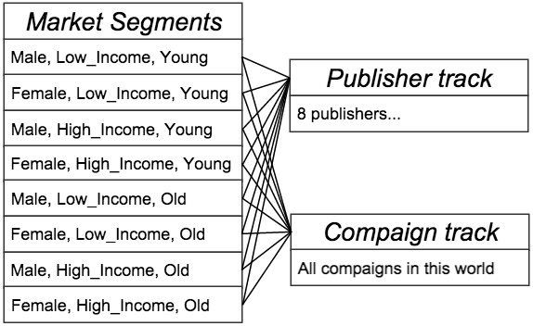 Figure 1. Architecture of Market Model

The structure of market model showed in figure 1. The whole market is divided into 8 basic market segments. Each segment has 2 main connections. First, each segment knows the size its own population, the distribution of its population to 8 publishers and the mobile ratios and video ratios of these publishers. A segment can calculate its average mobile ratio and video ratio depends on that information, then quantitatively measure the expected cost of population of a campaign in that segment. Second, a segment tracks all valid and matched campaigns and adds all the pressure from them to measure the situation of this market segment. The formula to calculate the pressure (P) of one segment is below:

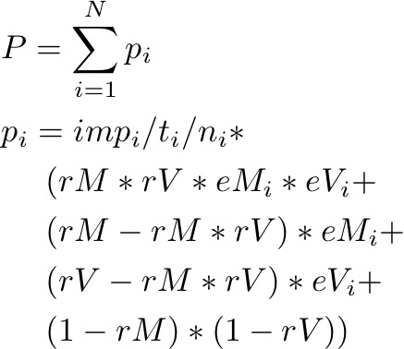

The p means a pressure come from a valid and matched campaign. And the n means how many basic market segments the campaign covers such as 1, 2 or 4, which means the pressure of a campaign is averaged to different segments that it matches. The other parameters above are requirement (imp), mobile effect (eM) and video effect (eV) of the campaign and average mobile ratio (rM) and video ratio (vM) of that segment.

In general, each segment knows its resource and the current pressure. Therefore, for any campaign, the market model can analyze its potential size of market and the degree of competition in that market and finally decide the bid price of that campaign. Besides, in order to reduce the overlapping problem, every campaign owned by our agent provides an extra ratio of pressure as penalty, which makes our agent tend to abandon the overlapping campaigns.

IMPRESSION BIDDING
Another important source of data is ‘AdxPublisherReport’ (result of impression compete), base on the substantial feedbacks through it, a complex query model established to quickly adapt to the market and use proper price to bid impressions.

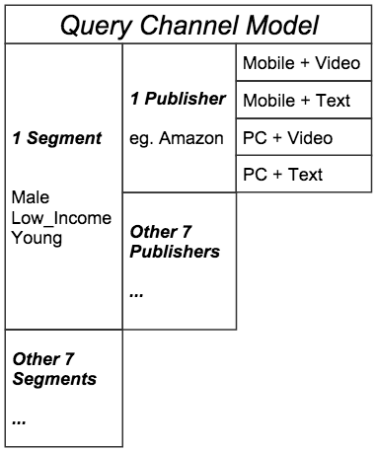
Figure 2. Structure of Query Channel Model
Like the figure 2 above, there are 192 (8*8*4) basic queries in this game. The key of query channel model is every channel manages a reference price. Thus the cost of impressions can be predicted and it is a quantitative way to choose cheaper channels to save money. The details of creating bid bundle are below:

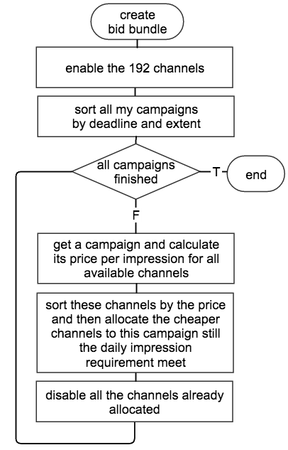
Figure 3. Process of build bid bundle

As the process in figure 3, the campaigns that have closer deadline and simpler market segment have higher priority to be allocated first to ensure they can be finished. Besides, every campaign will be allocated resource more than they need because the economic way to compete is win some of bids with proper price.
Furthermore, another fundamental task for this model is training its 192 reference prices.
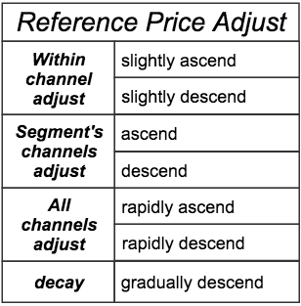
Figure 4. Strategy of reference price adjust

At the start, each channel has an initial reference price. Then, there are 7 ways belong to 4 levels in the figure 4 to adjust prices. Briefly, the first 3 levels are monitors in different levels, base on the feedbacks about impression bidding, wining ratio is calculated in 3 levels: within every channel, within every overall market segment and the overall market. And the low level just slightly optimize one channel’s price while high levels dramatically change all the price within one segment or all segments to rapidly adapt to the environment.
In addition to all adjust about feedback, all channels which have not been updated over 3 days will automated and gradually reduce their prices to obtain opportunity to update. It is extremely important because all channels should be trained at the start. Besides, the market is changing all the time, so any outdated knowledge should be recheck. It is necessary to keep training, which is also the reason that every campaign are allocated extra channel more than they need.
Furthermore, like the section of impression bidder in Bingyang et al.’s paper [1], the ANL raises price if the incomplete campaign is close to its deadline. Our agent uses similar approach to solve that stress and keep quality. The time pressure of campaign is introduced by the progress of campaign divided by the remain time ratio of campaign. Then the bid prices for the campaign and the number of allocated channels for the campaign both raise once the time pressure of a campaign rise.
In general, our impression bidding strategy is established base on the query channel model. The most economic bid bundle is created by the evaluation of the reference prices and all the feedback information is used to update reference prices to make them more accurate.

PROJECT DESIGN

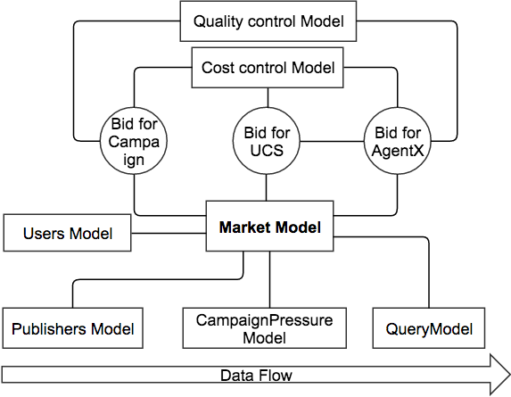
Figure 5. The Architecture of Agent
The figure 5 shows the overall design of our agent. The core ‘Market Model’ in this project is composed by mathematic models proposed in section 2 and 3. Besides, the mathematic models keep updated base on the bottom components, which track all publishers, all campaigns and all feedback about queries. However, the cost control is canceled because of the monopoly principle explained in the next section.

MONOPOLY PRINCIPLE
Monopoly is our general principle to win the game. There are 2 reasons.

Firstly, monopoly is a tempting way to win! The quality of agent is quite important in the game because it can directly influence the competitiveness to get campaign and budget of it. However, the specification defines quality learning rate as LRating= 0.6 [3] which makes it volatile. For example, if some agent totally failed the assigned campaign at the beginning, the quality of it will become 0.4 and that agent may keep silent all the time in the rest of the game. Therefore, if an agent does not concern about the cost at the start and just destroy the qualities of other opponents, it can dominate the whole market and get substantial profit. Actually, in our local tournaments to fight against other agents on the website such as Agent00 and GIZA, our agent can successfully monopolize the whole market sometimes and get over hundred profit.

Second, our mathematic models especially the query channel model requires substantial data to train. Thus the more campaign, the more interaction and feedback, which results in a much more accurate model.

However, this monopoly principle does not work refer to the results of class tournament, which will be analyzed in the next section.

TOURNAMENT ANALYSIS
It is no doubt that our agent Lucy lost lots of money in the class tournament, and I think the overall reason is the monopoly strategy and some underlying contradiction. This paper uses several figures drawn by matlab depend on the original bank balance data to analyze the essence of our failure.

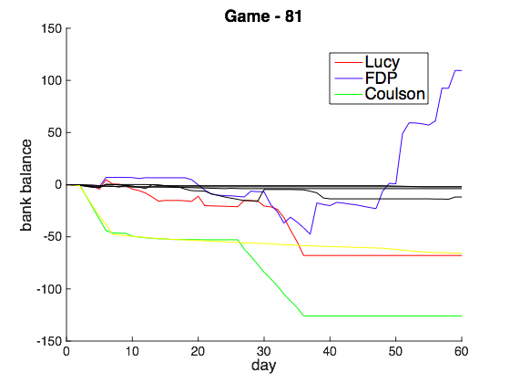
Figure 6. Typical lost for Lucy

The figure 6 shows a typical game that Lucy lost. Actually, some of other agents also use monopoly strategy such as FDP, and about half of the agents are inactive, which drew by black lines. The balance of both Lucy and FDP were fluctuating together during the first half of the game because they were competing in some market segment. However, a severe collision destroyed all active opponents for FDP. After that, FDP dominated the whole market and began to recover its loss.

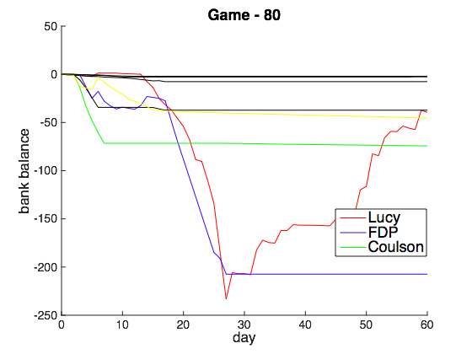
Figure 7. Monopoly by Lucy

Lucy had similar performance in figure 7. All the agents except Lucy and FDP were dead at the beginning. And an extremely hard competition happened between Lucy and FDP that made them both lost substantial money. However, Lucy quickly recovered the loss after it dominated the whole market. If the game can be longer or Lucy luckily gets some large campaigns, Lucy will get the first prize.
In general, the most performances of Lucy in these 12 games like figure 6. Lucy lost because it totally relies on the pattern of monopoly to get profit but it cannot efficiently defeat other opponents who have similar strategy. Actually, the essential reason is that Lucy is not real monopoly, which dramatically reduces the possibility that Lucy gets the monopoly position. The purpose of our market model in section 2 is avoiding the competition with others and giving up campaign bidding if the new campaign severely overlap the campaigns our agent already have. However, there is a contradiction between our market model and monopoly. In order to achieve monopoly, the agent should keep all the campaigns and don’t give others any chance to counter. On the contrary, our agent deliberately gives up hard campaigns, which gives it much lower probability to achieve monopoly in severely competitive environment. A wise example is the agent frog, which bids all campaigns but completely does not do some of them. That is a cruel way to really monopolize the market.
Besides, monopoly is not a good choice because there are too many greedy and crazy agents. Mainly relies on the analysis of our market model with serious constraint on impression bidding should be a more promising way.
By the way, one good quality Lucy showed in these games is the degree of participation. Lucy won average 60612 impressions each game, and the overall impressions occupied ratio of Lucy is 30.33% considering about the these 12 valid games. At least, Lucy indeed got involved.

CONCLUSION
Although Lucy was built with complex and graceful mathematics models, but the mistake of choosing monopoly gives it a narrow way to win. Besides, the internal contradiction that naturally avoiding hard competition and deliberately giving up overlapping campaigns become obstacles of monopoly when it faces other cruel active agents. They are the main reasons for the lost of Lucy.

ACKNOWLEDGMENTS
Thanks for our kind teacher Enrico H Gerding who introduced that amazing game to us and gave us substantial suggestions and supports. That was an enjoyable time!

REFERENCES
- Bingyang T., Fan W. and Guihai C. (2015) TAC AdX’14: Autonomous Agents for Realtime Ad Exchange
- Elad H., Moshe K. and Guy S. (2014) AdNetwork Project Report Agent00
- Mariano S. and Yishay M. (2015) The Ad Exchange Game - Specification Version 1.4

