SPY Clustering Results for Weeks 1 and 2
Đức | CSIS 3360 Fundamentals of Data Analytics | November 4, 2026
I completed the first two weeks of my clustering work: selecting features, defining standardization, preparing a common dataset, and fitting K-Means with K from 2 to 6. All comparison metrics and silhouette scores use the same dataset. Final K selection, cluster naming, and completed interpretation are scheduled for Week 3.

Scope and research questions
The group project examines whether historical price behaviour, trading volume, and volatility help explain and predict SPY's next-trading-day performance. Under Fundamental plan.docx, the four sections are Regression, Association Rules, Classification, and Clustering.
My clustering question is whether SPY trading days can be grouped by similar price movement, trend, risk, and volume characteristics. Each observation represents one trading day. The clustering analysis describes the full 2015–2025 period retrospectively.

Completed work
Week | My assigned tasks | Outputs
1 | Select clustering features, scaling, and candidate K values. | Four inputs, variable dictionary, StandardScaler specification, and K = 2–6.
2 | Fit K-Means for K = 2–6 and calculate silhouette scores. | Five models, comparison metrics, cluster sizes, dated assignments, centroids, and two figures.

Data and team handoff
The original CSV is preserved byte for byte and identified by its SHA-256 hash. The prepared dataset is included so that all four algorithms can use consistent dates and variable definitions. The team should reconcile it with Nguyên's preparation work before freezing the shared version.
Python and package versions are recorded. The code uses portable relative paths and a fixed random seed. The package includes English run instructions and eight automated verification checks.

Data preparation and feature definitions
Stage | Rows | Date range or reason
Original CSV | 4,023 | 2010-01-04 to 2025-12-31
Study-period filter | 2,766 | 2015-01-02 to 2025-12-31
Four complete clustering inputs | 2,746 | Remove the first 20 rows to obtain 20 daily returns.
Common modeling table | 2,745 | Also remove the last row with an unknown next-day outcome.

The common modeling table covers 2015-02-02 to 2025-12-30. The year filter is applied before rolling calculations; pre-2015 data does not initialize the windows. Each window uses the current and earlier observed trading days, with no backfill or interpolation.
Input feature | Definition and purpose
Daily_Return | Today's Close / previous day's Close - 1. Measures the direction and magnitude of the current price change.
Price_to_MA20_Ratio | Today's Close / mean of the 20 most recent Close values, including today. Measures price position relative to a trailing trend.
Volatility_20D | Sample standard deviation of the 20 most recent daily returns, ddof = 1. Measures volatility and is not annualized.
Volume_Change | Today's Volume / previous day's Volume - 1. Measures the change in trading activity.

Returns, volatility, and volume change are stored as decimal fractions; 0.01 means 1%. Price-to-MA20 is a ratio; 1 means that price equals MA20. Other candidate features remain available for team review but do not enter this K-Means distance calculation, limiting repeated weighting of similar information.

Standardization and future information
StandardScaler subtracts the mean and divides by the population standard deviation, ddof = 0. The scaler and K-Means are fitted on all 2,745 rows for retrospective description. Both next-day targets, target dates, train/validation/test labels, trading dates, and raw price levels are excluded from the clustering matrix.
The common table contains Regression and Classification targets. The final unknown target remains missing before its row is removed; it is not assigned to class 0. Predictive split boundaries use target dates. This full-period scaler and these cluster labels must not be transferred directly into predictive-model training or selection.

Week 2 comparison results
All five runs use the same four inputs, scaler, and 2,745 observations. Settings are k-means++, n_init = 20, random_state = 42, max_iter = 300, tol = 0.0001, and the Lloyd algorithm. Silhouette scores use all observations and Euclidean distance after standardization.
K | Silhouette | SSE | Smallest cluster | Largest cluster
2 | 0.3973 | 8,535.75 | 477 | 2268
3 | 0.2733 | 7,306.18 | 284 | 1830
4 | 0.2601 | 6,259.48 | 49 | 1666
5 | 0.2603 | 5,591.75 | 47 | 1503
6 | 0.2605 | 5,093.15 | 26 | 1281

K = 2 has the highest silhouette among the tested configurations, approximately 0.3973. SSE decreases as K increases. At K = 6, one cluster contains only 26 days, so its meaning and stability require examination. These results inform Week 3; they do not establish the final K.
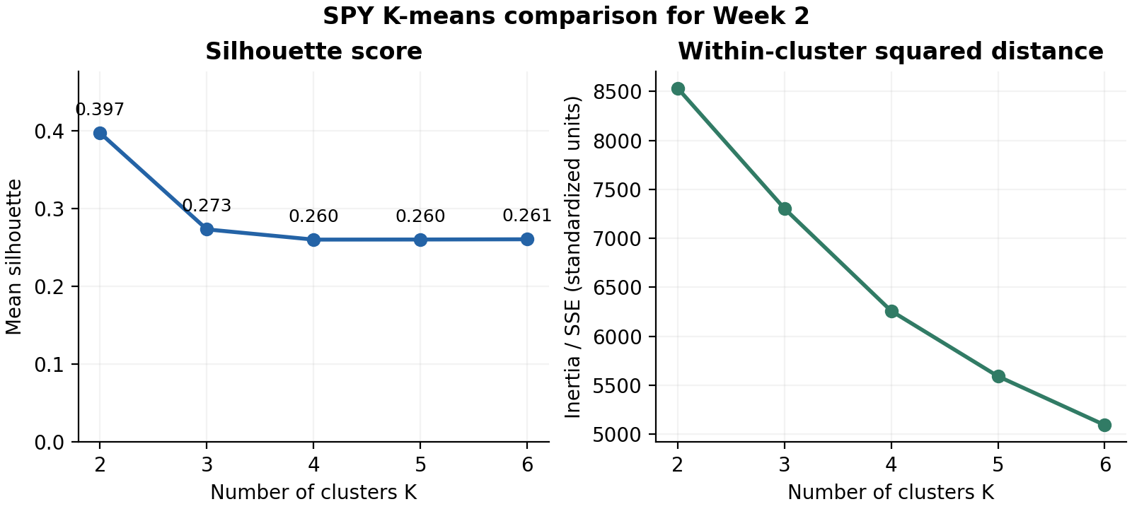
Figure 1 Silhouette and within-cluster squared distances on standardized inputs. Both panels use the same observations.

Interpretation limits
K-Means depends on feature choice, scaling, and extreme observations. Twenty initializations within a run do not establish stability across seeds. Cluster IDs are arbitrary labels without an inherent order. The models describe observed days; they do not establish future-price predictability or persistent market regimes.

Code and data handoff
README.md provides run instructions for the team. From the extracted project folder, create a Python 3.12 environment, install requirements.txt, and run the commands below. The code requires no personal absolute-path edits.
python -m venv .venv
macOS/Linux: source .venv/bin/activate
Windows PowerShell: .venv\Scripts\Activate.ps1
python -m pip install -r requirements.txt
python src/clustering_week1_week2.py
python -m unittest discover -s tests -p "test_*.py" -v
File or folder | Contents
src/clustering_week1_week2.py | Prepare data, standardize inputs, fit five configurations, and export results.
results/data/common_modeling_dataset.csv | Shared table with historical features, two targets, and target dates.
results/data/variable_dictionary.csv | Definitions, units, and flags identifying clustering inputs.
results/data/kmeans_comparison.csv | Silhouette, SSE, iteration counts, and cluster size ranges for K = 2–6.
results/figures | Two figures comparing K values and cluster membership counts.
docs/Week1_Method_and_Handoff_EN.md | Scope, method choices, and points to reconcile with the team.

Quality checks and reproducibility
The CSV has no missing values, duplicate dates, nonfinite values, nonpositive prices or volume, weekend dates, or invalid OHLC relationships under the implemented checks. No source values were corrected; 15 days with absolute daily returns above 5% were retained. Independent checks verified row-level formulas, causal feature construction, target-date split boundaries, scaling, SSE, silhouettes, and nearest-centroid assignments. The eight automated checks are included for rerunning.

Team decisions and Week 3 work
The plan proposes Stooq, https://stooq.com/db/h/, as the source. The CSV was supplied for this project; its exact original download and adjustment methodology remain unverified. The field is used as Close, without an Adjusted Close claim. Trading-calendar completeness has not been checked against an exchange calendar.
The team should reconcile formulas and dates with Nguyên before freezing the shared data. In Week 3, I will select final K after checking stability and interpretability, complete evidence-based cluster profiles and names, and review Hưng's Association Rules section. Slides and the overall project conclusion are scheduled for Week 4.

