**GPIO setting**

Device Tree

Because need to use the gpio2_23, you need to remove the original settings

// USER1 {

// label = "Up";

// linux,code = <KEY_UP>;

// gpios = <&gpio2 23 GPIO_ACTIVE_LOW>;

// };

power fail detect io

#define POWER_SUB_INT GPIO_TO_PIN(2,23)

#define POWER_MAIN_INT GPIO_TO_PIN(3,21)

**Install kernel module**

insmod power_fail.ko

[ 194.569832] pxm_io_int_init_module

[ 194.573551] pxm_io_int_config

[ 194.576539] gpio_to_irq(55)

[ 194.579418] Mapped int 94

[ 194.582189] gpio pin is high

[ 194.585080] IEI GPIO INFO [ver: 0.0.1] enable successfully!

**Run Dhrystone to Simulate full load(Because it is dual core, we run twice)**

|  |
| --- |
| root@am57xx-evm:/run/media/mmcblk0p1# dhrystone 700000000 &  [1] 1345  Dhrystone Benchmark, Version 2.1 (Language: C)  Program compiled without 'register' attribute  number of runs = 700000000  Execution starts, 700000000 runs through Dhrystone  root@am57xx-evm:/run/media/mmcblk0p1# dhrystone 700000000 &  [2] 1352  Dhrystone Benchmark, Version 2.1 (Language: C)  Program compiled without 'register' attribute  number of runs = 700000000  Execution starts, 700000000 runs through Dhrystone |

**Test power fail function**

root@am57xx-evm:/run/media/mmcblk0p1# ./power_fail_ap

[ 89.511459] GPIO_SET_PID 0x555

[ 89.514527] pid = 1365

1. TEST SIG

99. Exit Program

Please enter the choice>>

Unplug the power supply and get power_fail signal

get 0x20001 <--- power_fail detect

Power hold time is 38.375ms on full load

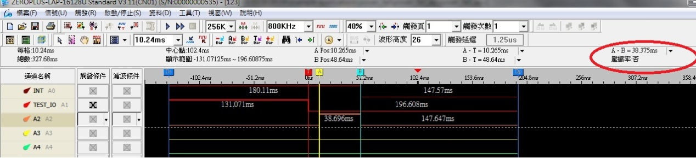

Power hold time is 133ms on idle

