Contents

Their History 1

Their Innovation 1

Ford Motor Company 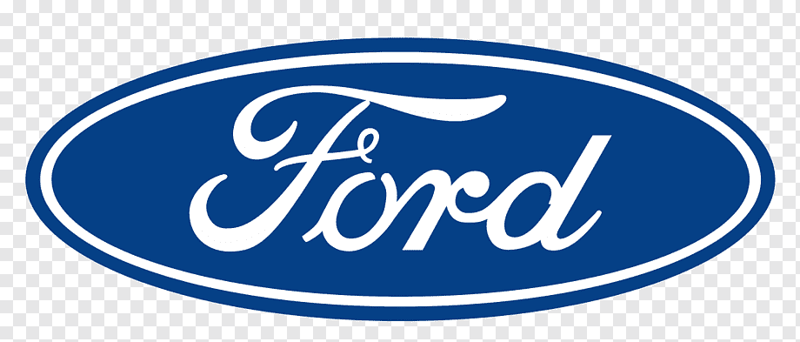

# Their History

* The Ford Company founded in1903,June16 by Henery Ford.
* The Company has produced multipurpose Vehicles.
* The most Popular Line ups are

1.Ranger Series

2.Mustang Series

3.Fiesta Series

* It is American Based Company and very popular in Europe .

## Their Innovation

* In February 2017, Ford Motor Co. acquired majority ownership of [Argo AI](https://en.wikipedia.org/wiki/Argo_AI), a self-driving car startup.
* On April 2018, Ford announced it would discontinue passenger cars in the North American market in the next four year.
* In March 2022,the Company has separate into the three departments. E for Electric Vehicle,B for internal combustion engine and Pro for Service and destribuction.

(Gyi, 2006) **#Citation**

**This is the Nissan’s most powerful Super Car in the World.**

(WikipiDia, 2004)

# References

Gyi, C., 2006. *Wiki.* [Online]   
Available at: www.wikipidia.com  
[Accessed 27 September 2023].

WikipiDia, 2004. *Ford Motor Company.* [Online]   
Available at: www.Fordmotor.com  
[Accessed 21 march 2023].

|  |  |  |
| --- | --- | --- |
| **Name** | **Age** | **Height** |
| Chan | **12** | **5’9’’** |
| Nyein | **12** | **6’** |
| Thant | **12** | **5’8’’** |