**Services Dashboard - Design version 1 (18 June 2025)**

Service Overview:  
Number of clients, by category (F2F waiting list, Online waiting list, CYP waiting list, In Counselling, Closed)

Risk Monitoring:   
Highlight clients with very high scores (risk flags) for a rapid appointment

New Client - Submit Client Intake Form:   
Shows the number of new customers who fill out the form daily

Waiting time:   
Waiting time to get a matching appointment

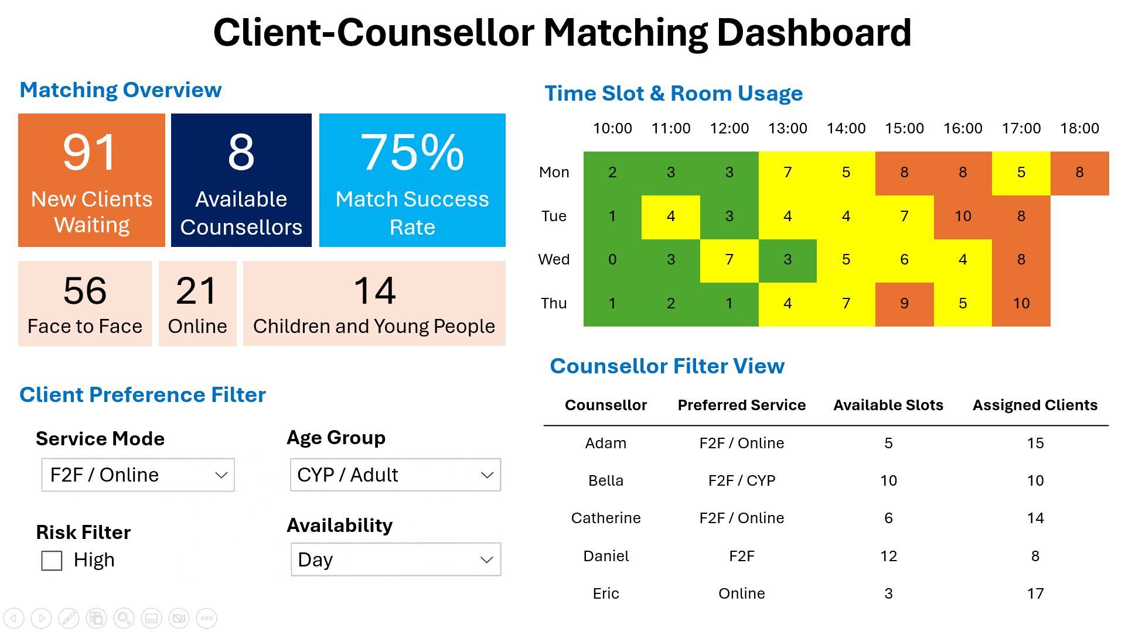

**Client-Counsellor Matching Dashboard - Design version 1 (23 June 2025)**

Matching Overview:  
Help admin instantly views current demand and availability

Time Slot & Room Usage:  
Show heatmap for optimizing the use of the 10 rooms (Mon-Thu)

Client Preference Filter:   
Enable the admin to filter clients by mode, age group, risk filter, and availability for counselling sessions

Counsellor Filter View:   
Let the admin check counsellor preferences, available slots, and assigned clients