***Generic Analytic Tool***

**Objective:** Generic Analytic Tool is built from the Kratrim-Pragnya team for Hackathon-2019. The main objective of the tool to ease the analysis performed by Data Analyst and Data Scientist**.** It will cut-down the project timing up to 60% by automating the iterative steps carried in the Data Science domain.

Generic Analytics Tool provide 2 powerful features of Analytics in a single click way. Here we take care that the each function is independent each other. From the tool you can perform the following steps:

1. **Preliminary Analysis:** Preliminary Analysis is basic feature of this tool which provide basic information about the data which you have uploaded.

A: Choose the file - Click on the “Choose File” Button.

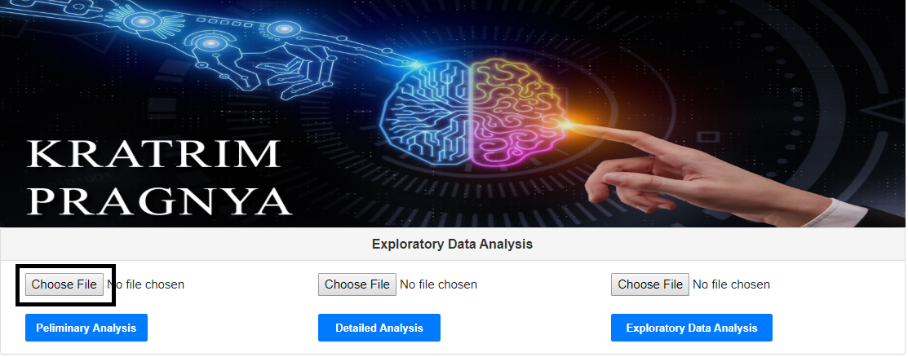

B: Preliminary Analysis: Click on the “Preliminary Analysis” Button.

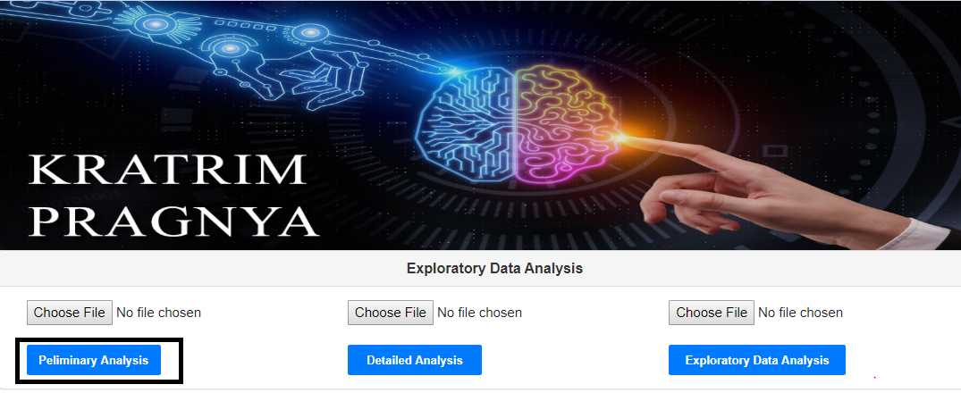

C. A webpage will be rendered and results will be displayed in the web-Page.

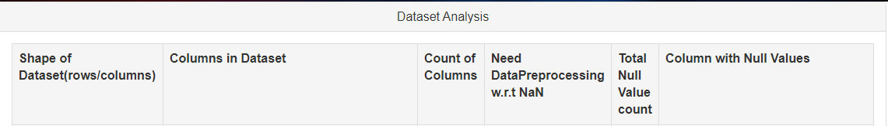

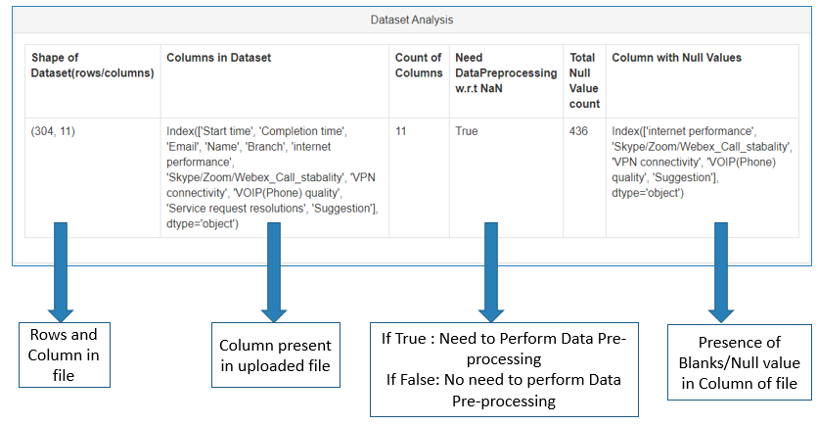

1. **Detailed Analysis: Detailed Analysis is one of the main feature of the tool which provide the information like categorical Data Present in the dataset, Null Values in Column, possible primary keys and column analysis.**

A: Choose the file - Click on the “Choose File” Button.

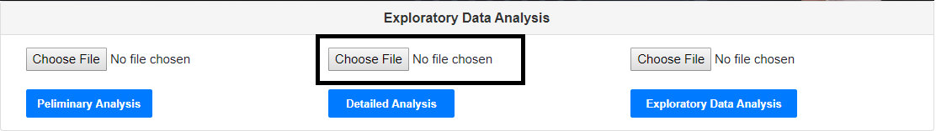

B: **D**etailedAnalysis: Click on the “Detailed Analysis” Button.

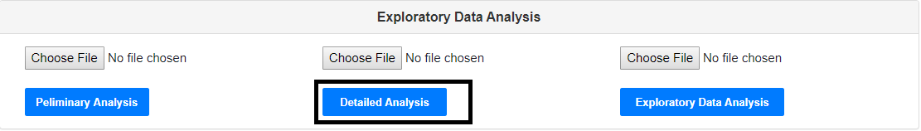

**C:** A webpage will be rendered and results will be displayed in the web-Page

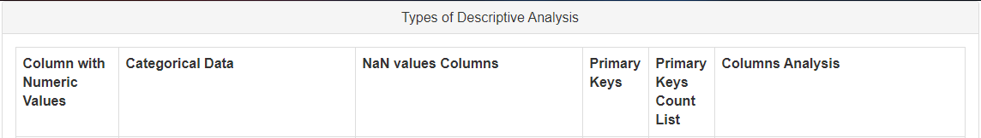

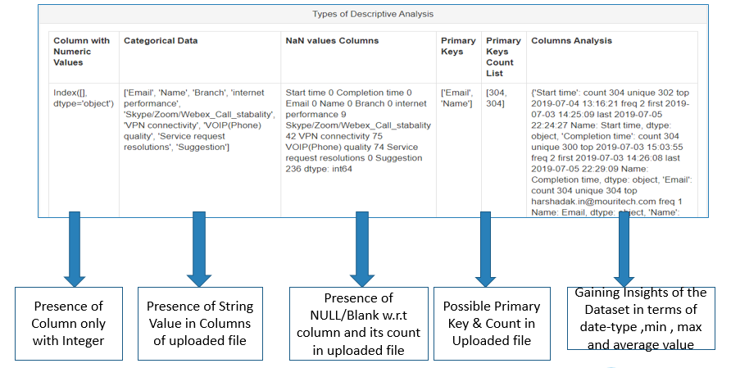

1. **Exploratory Data Analysis: Exploratory Data Analysis is a graphical visualisation of the data we upload. In E.D.A we present the data insight in term of graphs/chart/trends.**

A: Choose the file - Click on the “Choose File” Button.

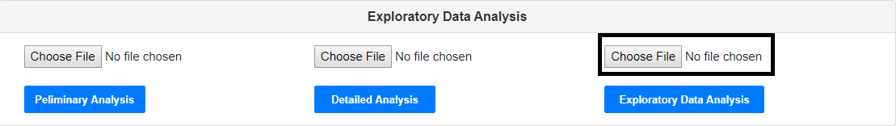

B: Exploratory DataAnalysis: Click on the “Exploratory Data Analysis” Button.

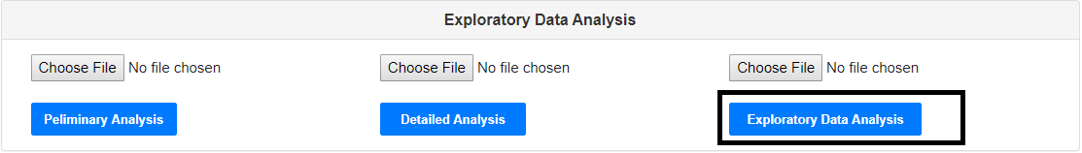

**C:** A webpage will be rendered and results will be displayed in the web-Page

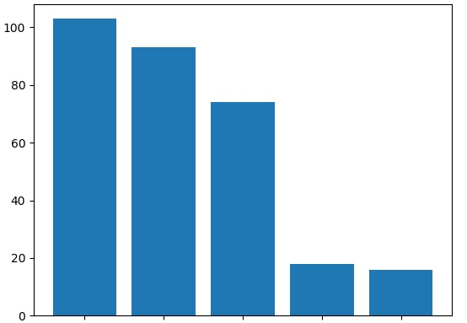

1. **Data Profiling: Data Profiling is most crucial part of the tool which perform most of the E.D.A along with the data science related task also.**

A: Choose the file - Click on the “Choose File” Button.

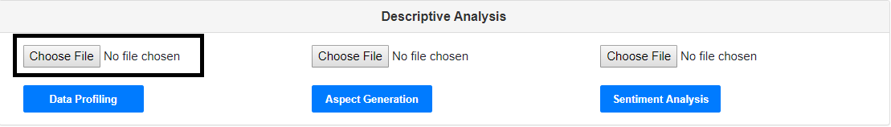

B:Data Profiling: Click on the “Data Profiling” Button.

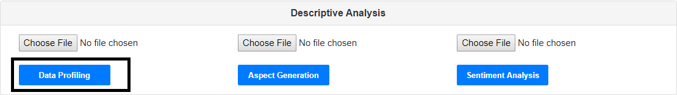

**C:** A webpage will be rendered and results will be displayed in the web-Page

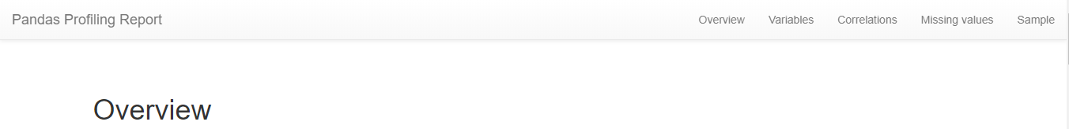

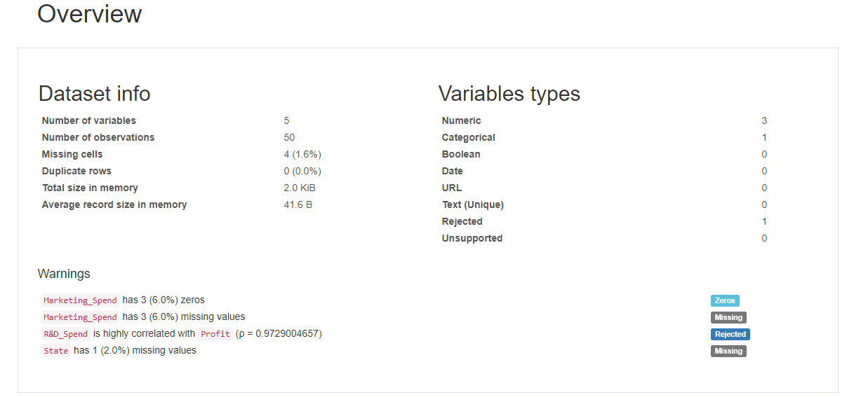

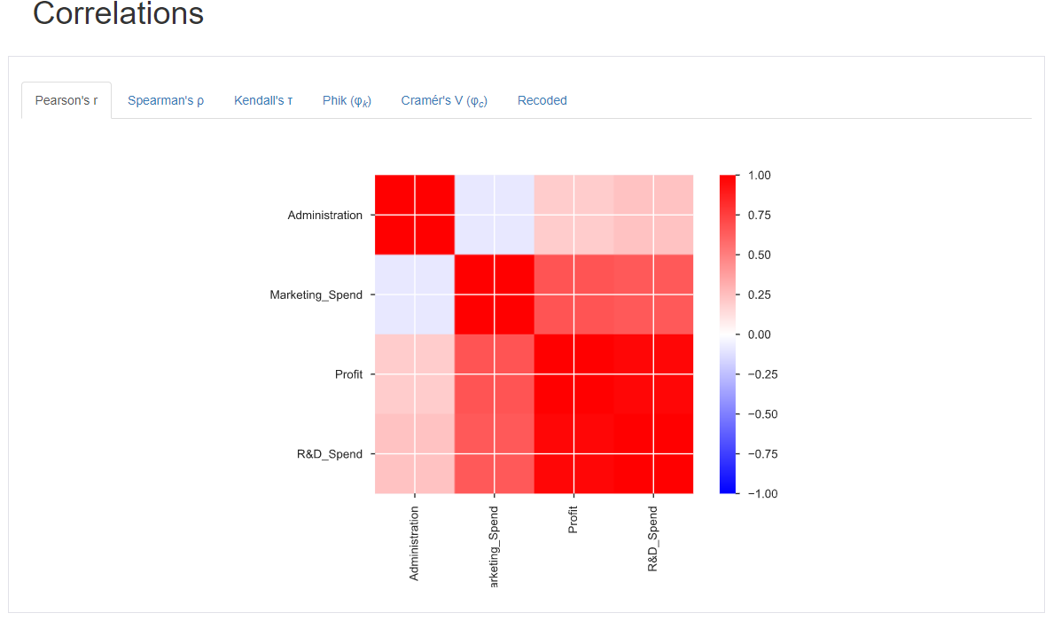

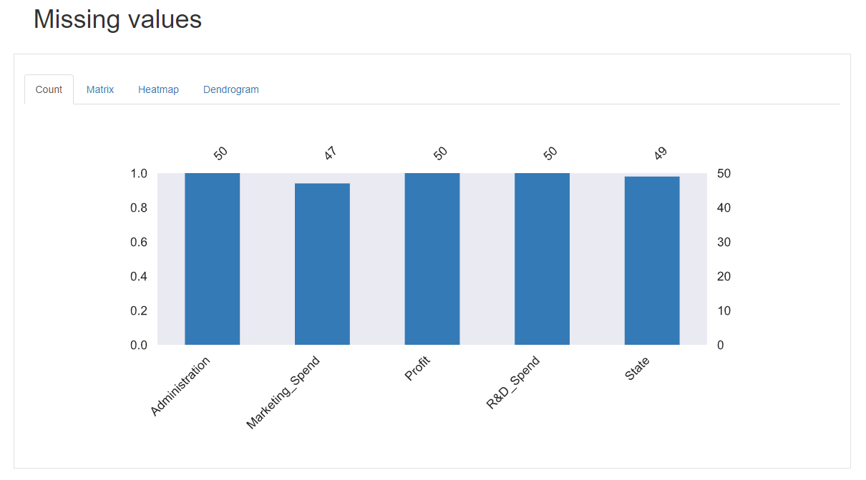

1. **Aspect Generation:** Aspect Generation is one of the functionality where we dynamically extract top 10 popular aspects in the data.

A: Choose the file - Click on the “Choose File” Button.

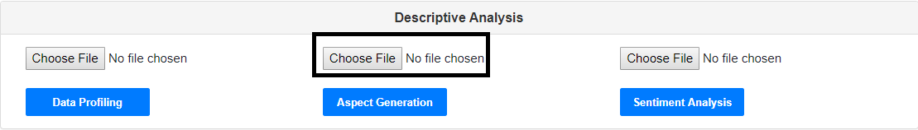

B: **Aspect Generation**: Click on the “Aspect Generation” Button.



**C:** A webpage will be rendered and results will be displayed in the web-Page

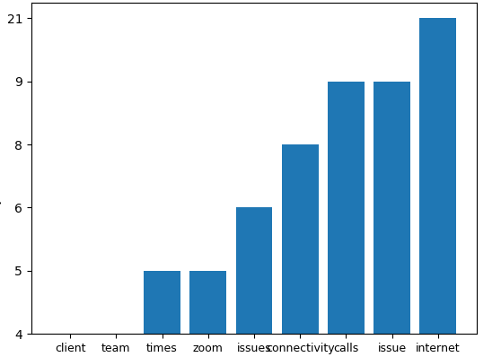

1. **Sentiment Analysis: This is the section where we applied our idea and dynamically gathered the insight of data and represented in the graphical format.**

A: Choose the file - Click on the “Choose File” Button.

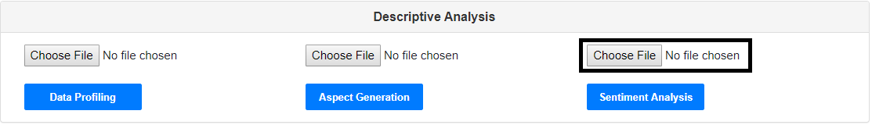

B:Sentiment Analysis: Click on the “Sentiment Analysis” Button.

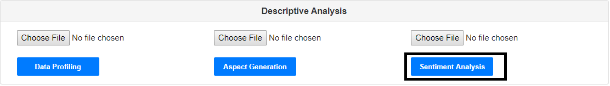

**C:** A webpage will be rendered and results will be displayed in the web-Page

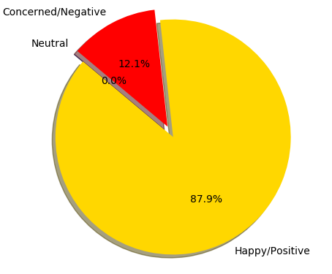

**Data Science Project**

**Data Science POC:** This is the section where we applied our idea and dynamically gathered the insight of Dataset. Tool performed the regression (simple/multiple) and forecasted the values.

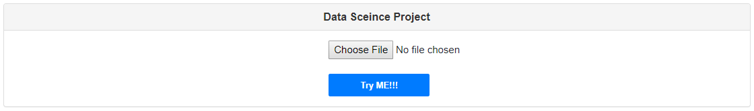

a. Select the file for forecasting:

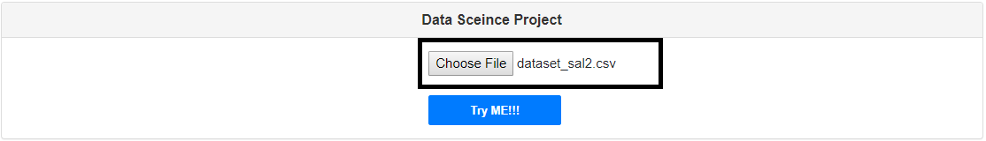

b. click on the file “Try ME!!!” to begin the forcasting

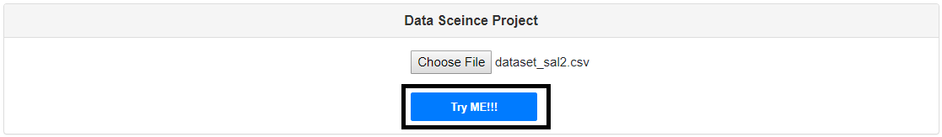

c. Steps we follow in Data Science :

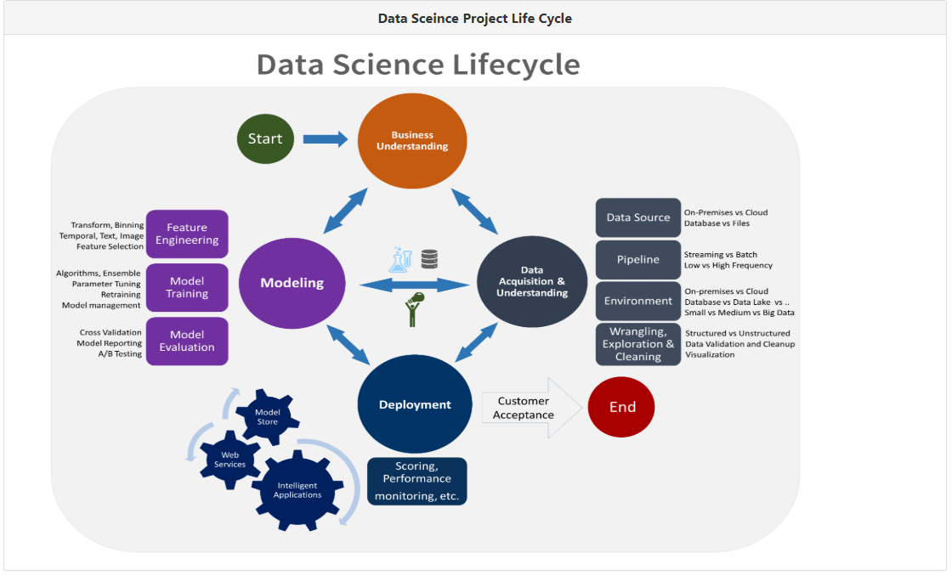

d. A look on the Dataset we have uploaded for the forecasting

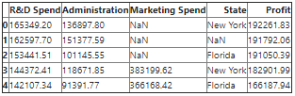

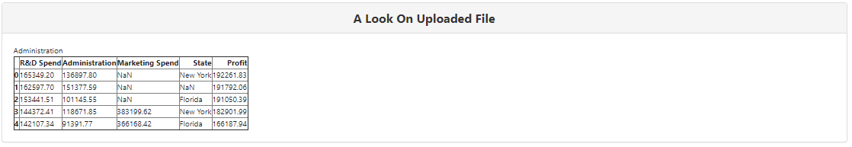

e. As we saw from a picture , second prominent in Data Science Life Cycle is Data Preprocessing. Click on the “Perform Data Preprocessing” button.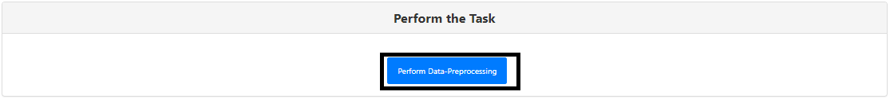

f. Once we click on the “Perform Data Preprocessing” , tool will populate the empty cell with mean/average of column type integer and delete the row if empty cell is in the column type string (categorical data).

After the pre-processing , uploaded dataset looks like following:

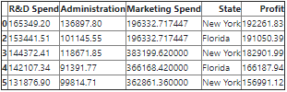

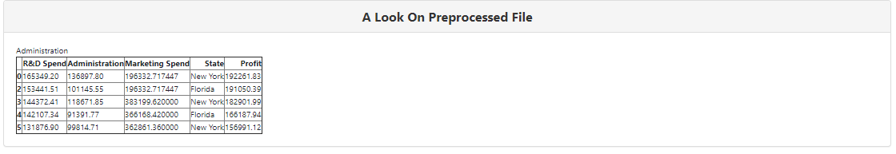

g. once we are done cleaning of the data , tool will give the choice of performing Exploratory Data Analysis and Training the Model .

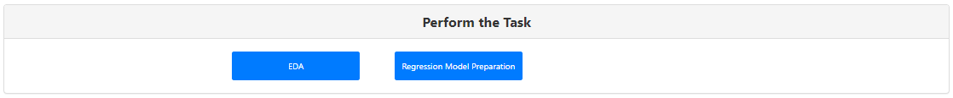

h. Click on the EDA button to gain the insight about the dataset in the form of html report with a lot of visualisation.

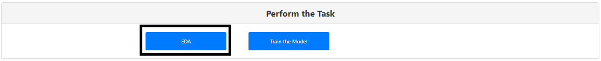

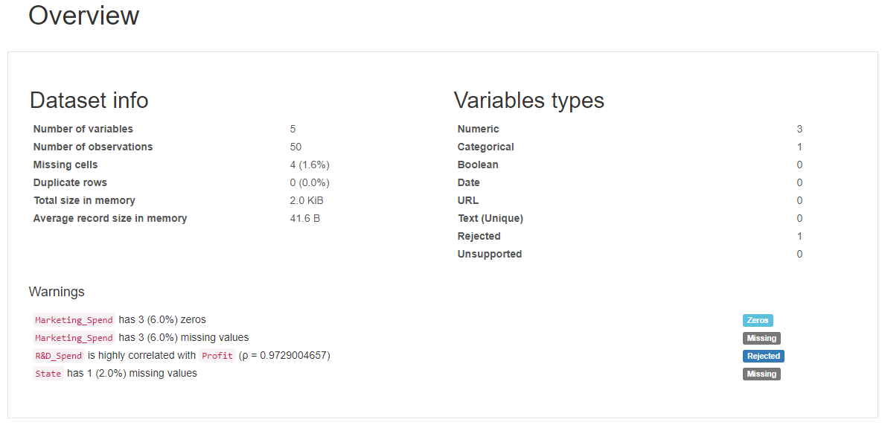

i. Now click on “Train the model” with training set of Dataset.



Following is the trasformed data before feeding it to the model

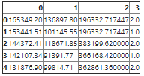

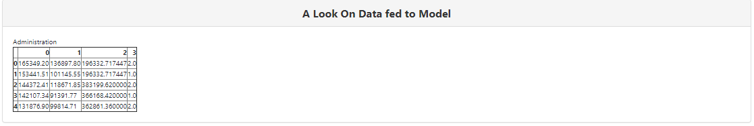

j. Now click on the “Forecasting/Prediction” to predict the the values according to dataset.

Select the “x_test” file and click on the Forecasting/Prediction.

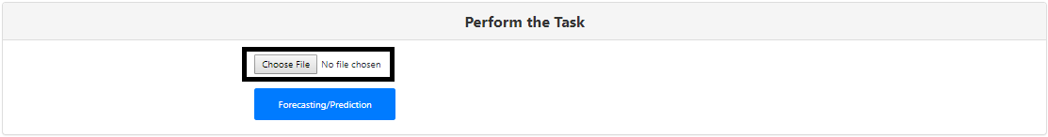

Click on the “Forecasting/Prediction” for predicted values.

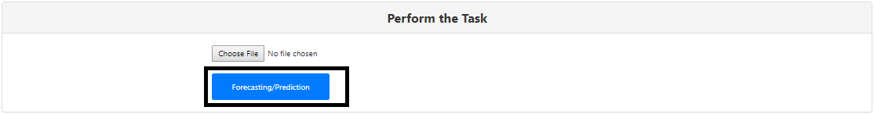

k. Predicted value will be shown in the UI.

