**CHAPTER 9 | Conclusion**

* Thus, by carrying out above activities, we came to know about the limitations in existing systems and hence tried to solve them in best possible way to satisfy all the unmet needs of the user. This was possible because of the prior art search activity due to which we got in-depth knowledge about the components and technologies to be used in our system.
* It is essential for project to understand the requirements of the project in terms of functional requirements, non-functional requirements, technicality, resources, timelines, information availability, delivery expectations and costs. At the same lime, it is equally or more important to communicate this understanding to the client upfront and advise the client of the assumptions.
* We have also made several representation or diagrams of our project for analysis and ease.
* We studied and implemented the project canvas and prepared a project report.

So, we studied about how we can implement this website for the betterment of client and its customers.

**CHAPTER 10 | 8th Semester Planning**

* This below timeline chart shows the expected work to be performed in 8th semester.

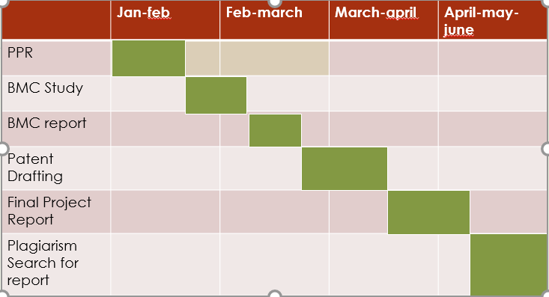

**CHAPTER 11 | References**

* <http://www.tradexl.com/pro-search.php?keywords=Pharma+Distributor>
* <http://paraspharmadistributors.com/index.php?firm=pars>
* For learning the tools, we referred
* <http://www.tutorialspoint.com/asp.net_mvc/>
* <https://www.udacity.com/courses/android>
* <https://www.w3schools.com/jquery/> <https://www.tutorialspoint.com/asp.net_mvc/index.htm>