Programming 7 自博16 陈斯杰 2016310721

本程序使用了R语言中e1071包中的svm函数来训练支持向量机，该函数为libsvm在R中的一个接口。

本程序使用rgl库对六维数据三维切片进行了可视化，从三维可视化结果看数据集的三维切片是线性可分的。

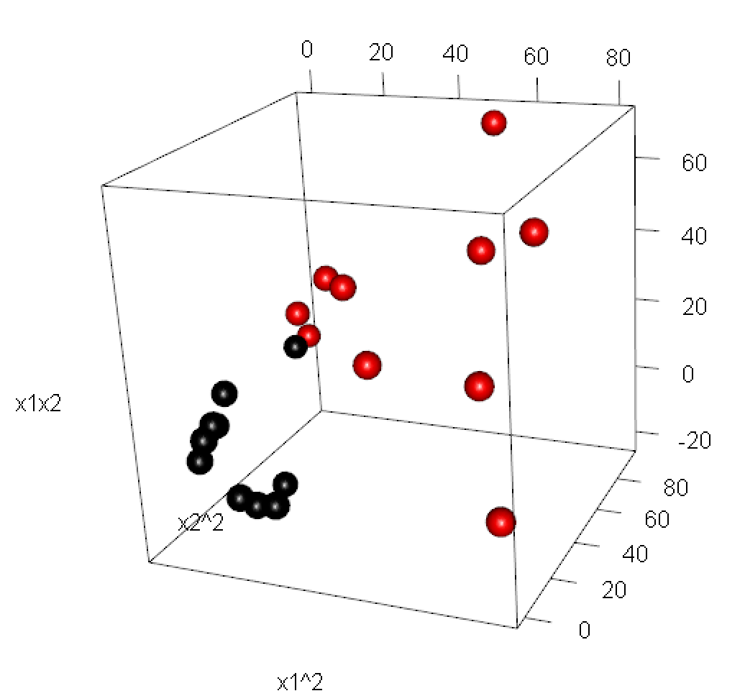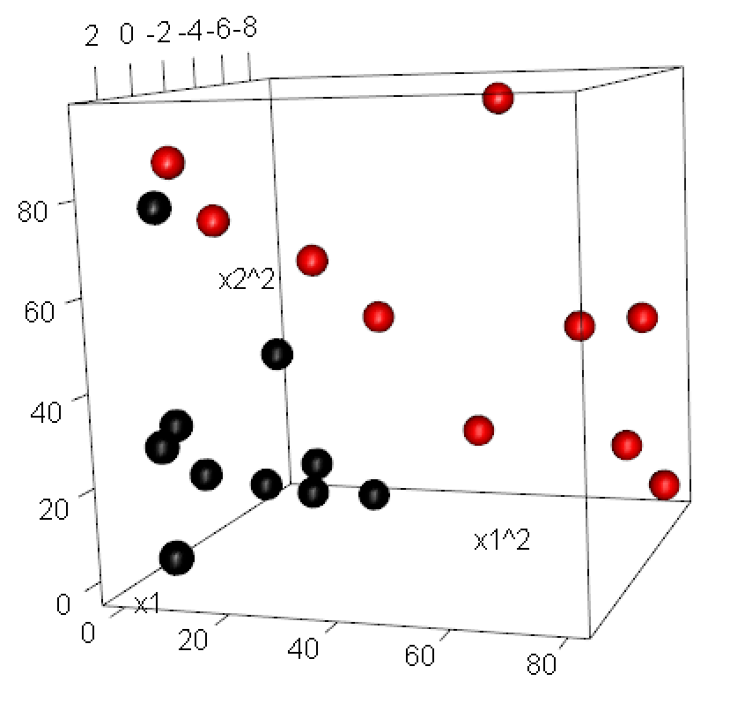

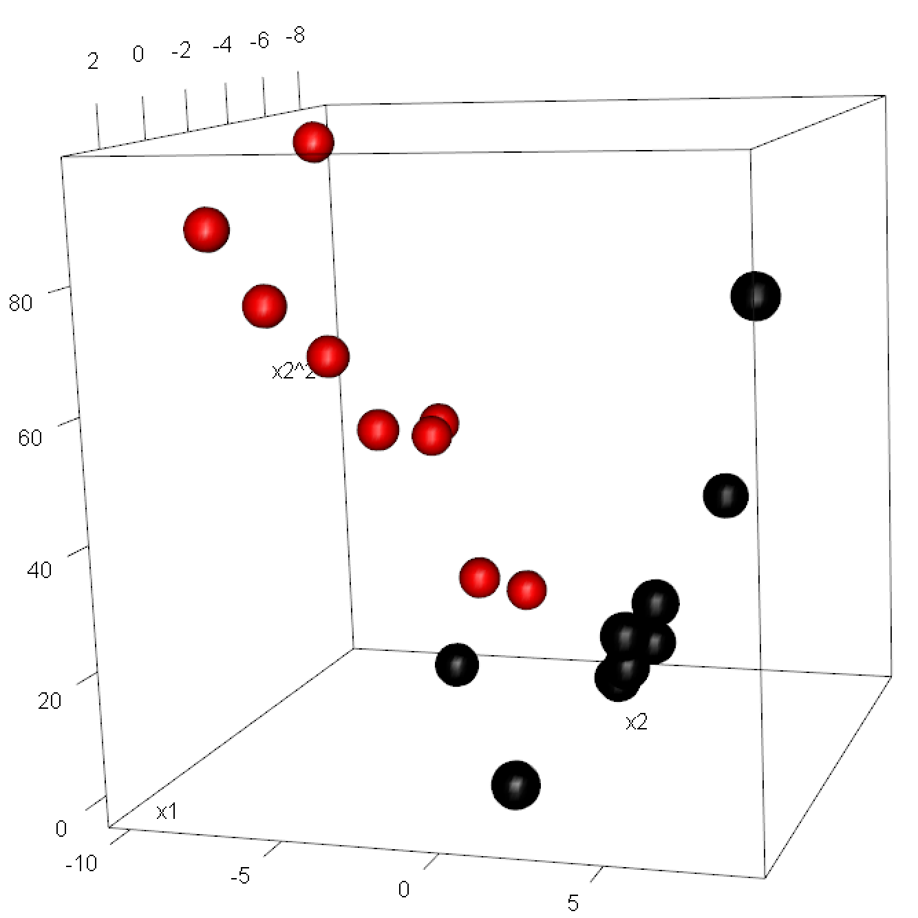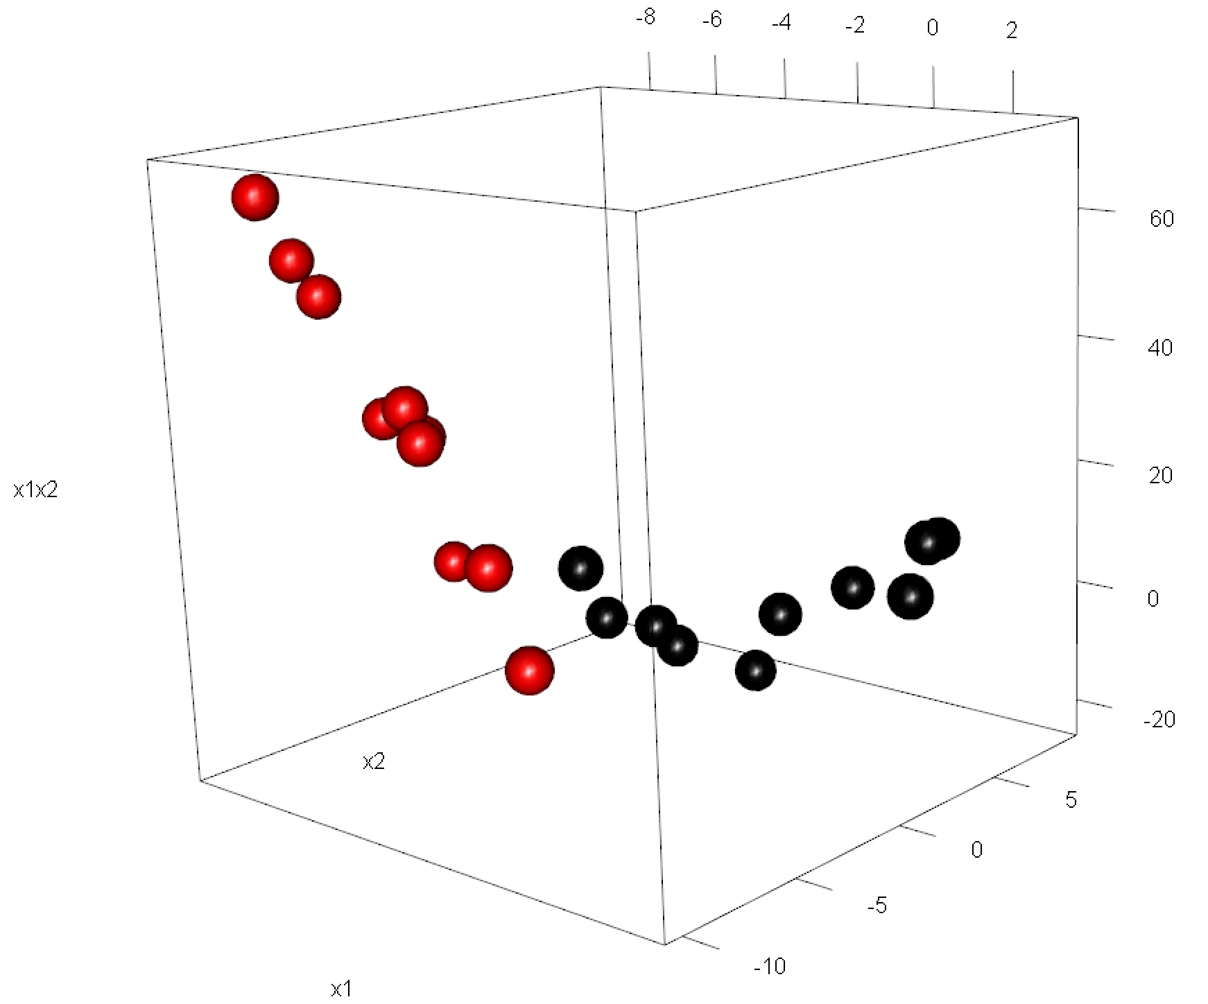

1. 使用ω1和ω2的第一个样本点训练

超平面六个维度“1”、“x­­1”、“x2”、“x1x2”、“x12”、“x22” 上面的权值为

0, -0.0005019472, 0.00276071, -0.004065773, 0.002509736, -0.03119602

截距为：

1.281643

Margin为：

63.122757

1. 逐个增加两类样本点，直到所有样本都加入训练，运行结果如下：

[1] "------------------------------------------------------------------------"

[1] "training sample size= 2"

[1] "weight vector ="

X.1. x1 x2 x1x2 X.x1.2. X.x2.2.

[1,] 0 -0.0005019472 0.00276071 -0.004065773 0.002509736 -0.03119602

[1] "negative intercept = -1.281643"

[1] "margin = 63.122757"

[1] "misclassified = 4/20, ratio = 0.200000"

[1] "------------------------------------------------------------------------"

[1] "training sample size= 4"

[1] "weight vector ="

X.1. x1 x2 x1x2 X.x1.2. X.x2.2.

[1,] -1.734723e-18 0.01211095 0.07388063 -0.05342728 -0.0413511 -0.02219439

[1] "negative intercept = -2.274025"

[1] "margin = 19.369154"

[1] "misclassified = 0/20, ratio = 0.000000"

[1] "------------------------------------------------------------------------"

[1] "training sample size= 6"

[1] "weight vector ="

X.1. x1 x2 x1x2 X.x1.2. X.x2.2.

[1,] 7.589415e-19 0.01211039 0.07388009 -0.05342764 -0.04134682 -0.02220017

[1] "negative intercept = -2.274150"

[1] "margin = 19.369291"

[1] "misclassified = 0/20, ratio = 0.000000"

[1] "------------------------------------------------------------------------"

[1] "training sample size= 8"

[1] "weight vector ="

X.1. x1 x2 x1x2 X.x1.2. X.x2.2.

[1,] -3.252607e-19 0.01211066 0.07388491 -0.05343135 -0.04133998 -0.02218631

[1] "negative intercept = -2.273486"

[1] "margin = 19.369351"

[1] "misclassified = 0/20, ratio = 0.000000"

[1] "------------------------------------------------------------------------"

[1] "training sample size= 10"

[1] "weight vector ="

X.1. x1 x2 x1x2 X.x1.2. X.x2.2.

[1,] 4.87891e-19 0.01211056 0.07388327 -0.05343034 -0.04134406 -0.02219931

[1] "negative intercept = -2.274074"

[1] "margin = 19.368842"

[1] "misclassified = 0/20, ratio = 0.000000"

[1] "------------------------------------------------------------------------"

[1] "training sample size= 12"

[1] "weight vector ="

X.1. x1 x2 x1x2 X.x1.2. X.x2.2.

[1,] -2.602085e-18 0.01111275 0.09887252 -0.02104346 -0.03790442 -0.02391609

[1] "negative intercept = -2.045415"

[1] "margin = 17.996253"

[1] "misclassified = 0/20, ratio = 0.000000"

[1] "------------------------------------------------------------------------"

[1] "training sample size= 14"

[1] "weight vector ="

X.1. x1 x2 x1x2 X.x1.2. X.x2.2.

[1,] 0 0.01111196 0.09886336 -0.02104316 -0.03790068 -0.02390782

[1] "negative intercept = -2.044924"

[1] "margin = 17.998090"

[1] "misclassified = 0/20, ratio = 0.000000"

[1] "------------------------------------------------------------------------"

[1] "training sample size= 16"

[1] "weight vector ="

X.1. x1 x2 x1x2 X.x1.2. X.x2.2.

[1,] 3.035766e-18 0.01111157 0.09886391 -0.02103957 -0.03789863 -0.02390687

[1] "negative intercept = -2.044817"

[1] "margin = 17.998274"

[1] "misclassified = 0/20, ratio = 0.000000"

[1] "------------------------------------------------------------------------"

[1] "training sample size= 18"

[1] "weight vector ="

X.1. x1 x2 x1x2 X.x1.2. X.x2.2.

[1,] 0 0.01111317 0.09887065 -0.0210538 -0.03789904 -0.02390273

[1] "negative intercept = -2.044740"

[1] "margin = 17.996962"

[1] "misclassified = 0/20, ratio = 0.000000"

[1] "------------------------------------------------------------------------"

[1] "training sample size= 20"

[1] "weight vector ="

X.1. x1 x2 x1x2 X.x1.2. X.x2.2.

[1,] -1.301043e-18 0.01111204 0.09886354 -0.021045 -0.03789993 -0.02390741

[1] "negative intercept = -2.044903"

[1] "margin = 17.998063"

[1] "misclassified = 0/20, ratio = 0.000000"