Software Requirements Specification
for
Face Recognition System [Database Subsystem]
Version 1.0
Prepared by Empire team
Jilin University
10 Apr 2016
Revision History
Name | Date | Reason For Changes | Version
Limeng Qiao | 2016/04/10 | Create | 0.1
Limeng Qiao | 2016/04/13 | Improve | 0.2
Table of Contents
Table of Contents ii
Revision History ii
1. Introduction 1
1.1 Purpose 1
1.2 Intended Audience and Reading Suggestions 1
1.3 Product Scope 1
1.4 References 1
2. Overall Description 2
2.1 Product Perspective 2
2.2 Product Functions 2
2.3 User Case Diagram 2
2.4 Data Flow Diagram 2
2.5 Data Dictionary Description 2
2.6 Operating Environment 2
3. External Interface Requirements 3
3.1 Test Module 3
3.2 Sign up Module 3
3.3 Sign in Module 3
3.4 Error Code Statement 3

Introduction

Purpose
This SRS describes the module function and nonfunctional requirements for version 1.0 of the Database Module. This document is intended to be used by team members whom will implement and verify the system. In addition, this SRS is aimed at facilitating the communication with other teams of Face Recognition Project.

Intended Audience and Reading Suggestions
The readers that the documents is intended for include architect, developers, project managers, users, and documentation writers. The rest of this SRS is organized in the following way. In the next section.

Product Scope
Database Module is a module in Face recognition project, to create software for storing user’s information (i.e. username, MD5 value of password, recognition websites info and so on). Database module can receive requests from Authentication server module and return validation information or error code by JSON code to Authentication server module.

References
1. SRS template from (http://www.csc.villanova.edu/~tway/courses/csc4181/s2010/srs_template-1.doc)

Overall Description

Module Perspective
Database module is a sub system of Face Recognition System, which will be to develop and extend an application framework using facial recognition to support remote authentication. This module is mainly composed of three parts including TEST, SIGN IN, and SIGN UP and uses protocols with JSON format to interact with authentication server. A simple diagram that shows the major components of the sub system by Figure 1.
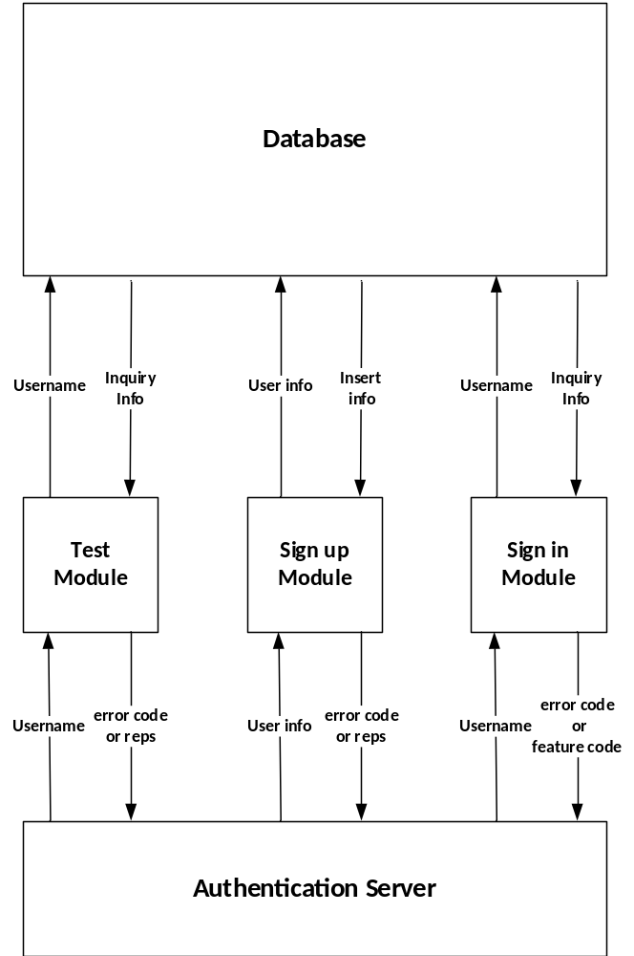
Fig. 1. The diagram of interaction between Database and Authentication Server

Module Functions
The TEST module is used to test whether current username exists in the database or not. If the username is the first time appeared in the database, TEST will return code 200 (i.e. current username is valid) or code 201 (i.e. which tells server that the current username is existent).
The SIGN UP module receives the user information from server and creates a record in the database for each user. This module is executed after module TEST, which guarantees that current info is legal. What’s more, the module will performs an insert operation on the database to store user information. The SIGN UP module return code 200 (i.e. the insert operation is successful) or code 202 (i.e. which means that an unknown error occurred from database).
The SIGN IN module receives the username from server and return code to tell server whether the user is successful. What’s more, the module will performs a search operation on the database to check the user’s information. If OK, the database module will return feature code as current user’s identification code, user’s password (i.e. using MD5 encryption), and code 200 to server. Otherwise, the database module return code 203(i.e. user not registered error) or code 404 (i.e. other unknown errors).

User Case Diagram
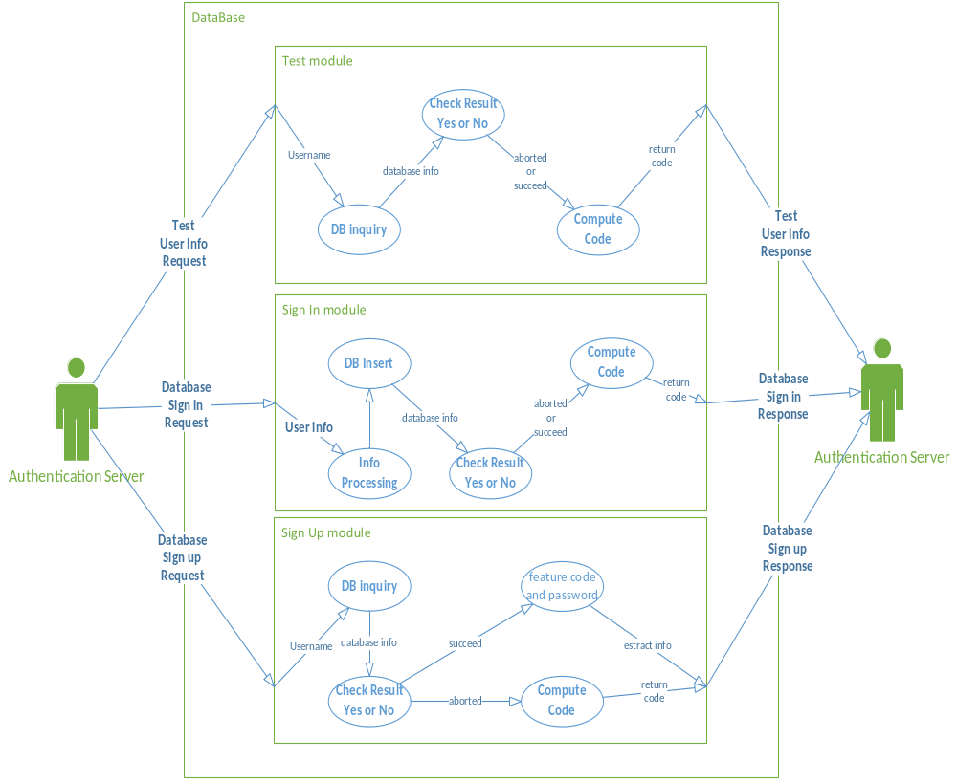
Fig.2. User case Diagram for Database

Data Flow Diagram
According to the User Case Diagram, the database module need to maintain the following data flow diagram (see figure 3, figure 4 and figure 5).

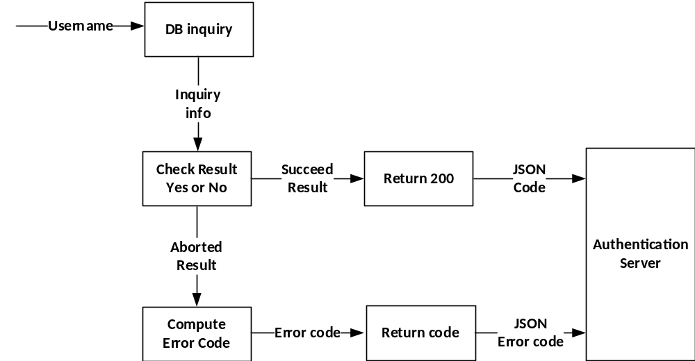
Fig.3. DFD for TEST Module

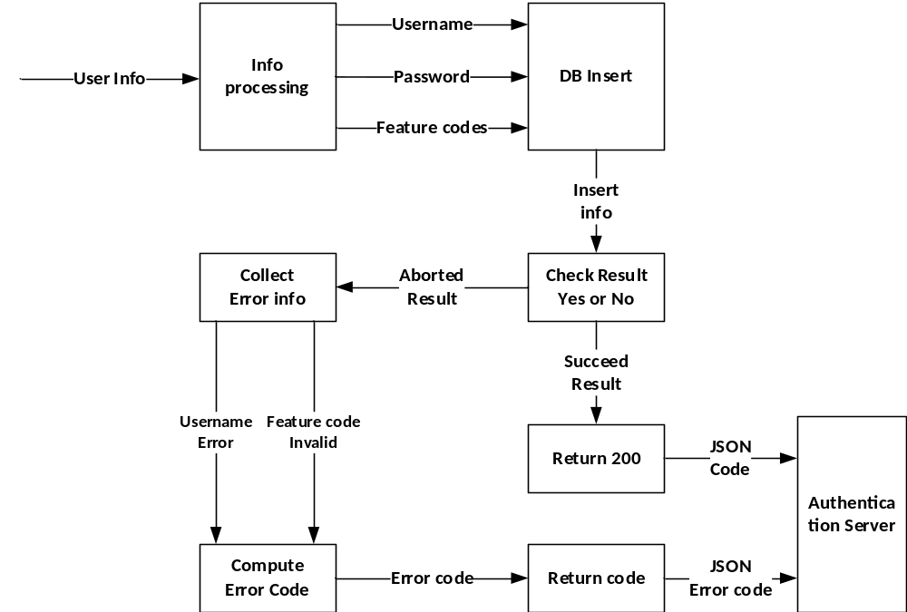
Fig.4. DFD for SIGN UP Module
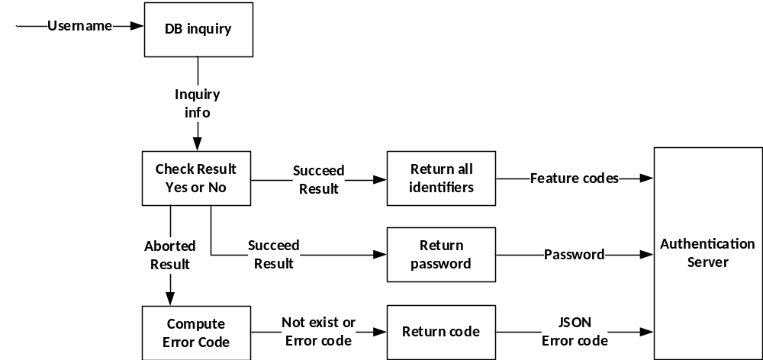
Fig.5. DFD for SIGN IN Module

Data Dictionary Description
Data Flow Number | 1.1
Data Flow Name | Receive Test Request from Server
Description | Receiv Server request which is used to test username validity
Data Flow Composition | Receive Test Request from Server = JSON( userName )  userName=[a-zA-Z0-9]{2,20}
Data Flow From | Authentication Server
Data Flow To | Database
Cases:
{
"userName":”helloworld”,
}

Data Flow Number | 1.2
Data Flow Name | Send Test Response to Server
Description | Tell server that the username is valid or not, and send test result to serve.
Data Flow Composition | Send Test Response to Server = JSON( retCode)  retCode:  200: No errors and user information legal  201: Error, User name already exists  404: Unknown error occurred
Special note | 1. If successful, retCode[0] = 200. Otherwise, retCode[0]=-1;  2. Error codes appear only in other locations of the array;  3. All content in retCode is number, not a string
Data Flow From | Database
Data Flow To | Authentication Server
Cases:
{
"retCode":[001,404],
}
Data Flow Number | 1.3
Data Flow Name | Receive Sign Up Request from Server
Description | Receive user registration request from server and create a record for the user in the database.
Data Flow Composition | Receive Sign Up Request from Server = JSON ( userName + passwdMd5 + Identifier )  userName=[a-zA-Z0-9]{2,20}  passwdMd5=[a-zA-Z0-9]{32}  Identifier=( webName + id ) {1, }  webName=[a-zA-Z0-9]{1,}  id= [a-zA-Z0-9]{1,32}
Special note | 1. Identifier’s JSON variable name is identifiers, which is a JSON object consisting of a pair (webName + id). (i.e. a group webName and id)
Data Flow From | Authentication Server
Data Flow To | Database
Cases:
{
"userName":”helloworld”,
"passwdMd5": “E10ADC3949BA59ABBE56E057F20F883E”,
"identifiers":
[
{
webName=”face++”,
id=”aaaaaaaaa”
},

{
webName=”gface++”,
id=”bbbbbbbb”
}
]
}

Data Flow Number | 1.4
Data Flow Name | Send Sign Up Response to Server
Description | Return user registration results to server.
Data Flow Composition | Send Sign Up Response to Server = JSON( retCode)  retCode:  200: No errors  202: Database insert exception  404: Unknown error occurred
Special note | 1. If successful, retCode[0] = 200. Otherwise, retCode[0]=-1;  2. Error codes appear only in other locations of the array;  3. All content in retCode is number, not a string
Data Flow From | Database
Data Flow To | Authentication Server
Cases:
{
"retCode":[001,404]
}

Data Flow Number | 1.5
Data Flow Name | Receive Sign In Request from Server
Description | Receive login request from server
Data Flow Composition | Receive Sign In Request from Server = JSON ( userName )  username = [a-zA-Z0-9]{2,20}
Special note | None
Data Flow From | Authentication Server
Data Flow To | Database
Cases:
{
“userName”:”helloworld”
}

Data Flow Number | 1.6
Data Flow Name | Send Sign In Response to Server
Description | Return user’s login information to server
Data Flow Composition | Send Sign In Response to Server = JSON (passwdMd5 + Identifiers{1, } + retCode)  passwdMd5=[a-zA-Z0-9]{32}  Identifier=( webName + id ) {1, }  webName=[a-zA-Z0-9]{1,}  id= [a-zA-Z0-9]{1,32}  retCode:  200：No errors  203：Error, user name not exists  404：Unknown error occurred
Special note | 1. If successful, retCode[0] = 200. Otherwise, retCode[0]=-1;  2. Error codes appear only in other locations of the array;  3. All content in retCode is number, not a string
Data Flow From | Database
Data Flow To | Authentication Server
Cases:
{
“passwdMd5”:” E10ADC3949BA59ABBE56E057F20F883E”,
"identifiers":
[
{
“webName”=”face++”,
“id”:=”aaaaaaaaa”
},

{
“webName”=”gface++”,
“id”=”bbbbbbbb”
}
]
“retCode”:[200,201,202]
}

Operating Environment
1. Linux : Ubuntu 14.04.4 LTS (GNU/Linux 3.13.0-65-generic x86_64)
2. Apache: Apache 2.4.7 (Ubuntu)
3. MySql : mysql Ver 14.14 Distrib 5.5.47
4. PHP : PHP Version 5.5.9-1
5. LAMP : apt-get install lamp-server

External Interface Requirements

Test Module

User interface: Receive username from Authentication server

User interface: Return test result or error code to Authentication server

Sign up Module

User interface: Receive user info from Authentication server.

User interface: Return Registration result or error code to Authentication server.

Sign in Module

User interface: Receive username from Authentication server

User interface: Return login info (passwdMd5+identifier) or error code to Server

Error Code Statement
Error Code | Error Statement
200 | No errors
201 | Error, User name already exists
202 | Database insert exception
203 | Error, user name not exists
404 | Unknown error occurred

