**Deliverables #1 (by 10/15):**

1. literature review (the CREDO report)
2. learning about the data sets
3. merge all dataset using through school id
4. take NYU Library Data Service GIS courses (if don’t have the knowledge of Arc GIS and basic ideas about map data)

**Chansoo Song:**

**1. Literature Review:**

(a) The CREDO report (Center for Research on Education Outcomes at Stanford University):

**Background:** CREDO was established to improve evidence-based support for education organizations and policymakers. The purpose of this report is to provide an in-depth examination of results for charter schools in New York City over five years of schooling, from the 2011-2012 school year and ending in 2015-2016.

**Results:** There is overall improvement in the **academic performance** of New York City charter schools. Compared to the educational gains that charter student might have had in a traditional public school, the analysis shows that in a year’s time, on average, charter school students in New York City show stronger growth in both reading and math. An average NYC charter student demonstrates growth equivalent to competing **23 additional days of learning in reading and 63 additional days in math each year.**

**Data:** The study uses historical sets of student-level administrative records from the New York State Education Department.

**Method:** The study relies on the Virtual Control Record (VCR) methodology. This is a quasi-experimental study design with matched student records that are followed over time. The analysis includes the following as controls for student characteristics:

* prior test score on NY state achievement tests
* gender
* race/ethnicity
* special education status
* lunch program participation
* English proficiency
* Grade level

A VCR is a matched student from the comparison group to a charter school student. Thus, a VCR should have identical academic experiences of the charter school students that they are matched to, except for the fact that the VCR students attend a traditional public school (TPS) that each charter school’s students would have attended if not enrolled in their charter school. We can think of VCR as a “virtual twin”.

A “feeder school” are traditional public schools whose students transfer to a given charter school. A VCR for a given charter school is comprised of matched samples from its “feeder schools”. In other words, VCR does not match a charter school student with any public school student, but within the subset of public school students that attend a “feeder school”.

(b) *Cordes (2017). “In Pursuit of the Common Good: The Spillover Effects of Charter Schools on Public School Students in New York City”. Education Finance and Policy*

Cordes finds that charter schools significantly increase TPS student performance in both English Language Arts and math and decrease the probability of grade retention. ***Moreover, effects increase with charter school proximity and are largest in TPSs co-located with charter schools.***

Cordes uses a difference-in-difference strategy that identifies charter school effects from two separate sources of variation: the timing of charter entry across neighborhoods and the distance to the nearest charter school within a one mile radius. Cordes addresses the concern of endogenous student movement after charter school entry (which would conflate changes in TPS student *composition* with changes in TPS student *performance*) by conducting an ITT analysis: Cordes fixes students in the first school they are observed attending.

Cordes also examines school-level factors that might explain charter school effects on TPS student performance, namely: the relationship between charter school entry and TPS demographics, per pupil expenditures (PPE), and parent and teacher responses to school climate surveys.

Cordes suggests that increased PPE, academic expectations, student engagement, and a more respectful and safe school environment may be explanations for these spillover effects.

(c) Other highlights of literature on the effect of charter schools on public school students

Almost all previous literature on this topic is conducted at the district level or examines the effects of charter schools within a wide radius of public schools (2.5-10 miles). In large urban districts, however, the urban charter school spillovers may be concentrated in nearby schools. Thus, the previous district-level analyses would average outcomes of students further away (who are less affected) with outcomes of students very close (who are more affected), resulting in an underestimate of charter school impacts.

Imberman (2011) examines spillovers of charter schools in a large urban school district in the Southwest. Imberman uses an IV strategy that relies on the plausibly exogenous variation in local building supply to address the endogenous location of charter schools. Results show that charters induce drops in math and ELA test scores of nearby public schools.

Following Bifulco and Reback (2014), which found that adverse fiscal externalities of charter school entry depends in part on the nature of state and local funding policies, Ladd and Singleton (2018) evaluate fiscal externalities of charter schools in North Carolina. Ladd finds a large and negative fiscal impact on public schools as a result of charter school entry.

**2. Our Datasets and (3) Merge Datasets:**

Our code can be accessed through github (<https://github.com/chansooligans/charter_school_project>). There are two key scripts so far: (1) “compile_schools_data.R” and (2) “data_inventory.R”.

(1) aggregates charter school and public school math and ELA school-level data from NYC Department of Education for the years 2013-2018.

(2) checks the output from (1) against the location data obtained from NYC Open Data. For each school, it indicates the years for which location is available (presumably whether the school existed in that year or not) as well as the grade, year, and math/ela combinations for which data is available. As an example:

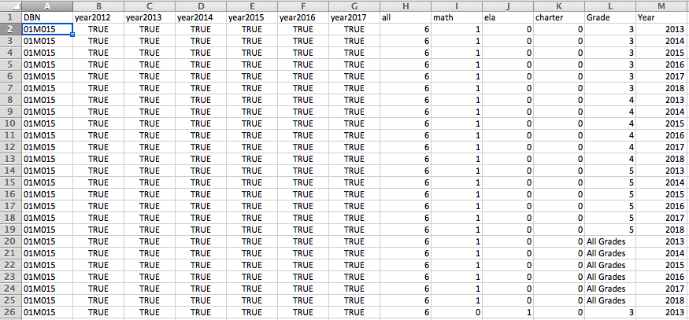

**4. ArcGIS Tutorial:**

We were all present for the GIS workshop.

**Frankie Wunschel:**

After reviewing the current literature there are both a lot of unanswered questions as well as a plethora of conflicting information and findings, which is typical in the statistics world. What is not typical is the state of the conflicting findings they tend to be polar opposite. In general, the largest discrepancy occurs in the argument of the effect of charter schools on children in the area. Though many of the resources argue their findings show a positive correlation between charter schools and test scores some of our other published works show the very opposite. Furthermore, and very importantly in many of the reports, it is agreed that new charter schools in an area would change the allocation of resources, which is simply common sense. Furthermore, common sense says less resources, less opportunity and less opportunity mean a worse outcome in test scores for students. Interestingly enough a finding in the credo report suggest a lack of significant correlation between achievement and resources, which would make this allocation issue non-existent if it had no sway on performance. This is extremely important in understanding the effect of charter schools on public and education, and though much of the findings differ time wise, earlier reports showing a negative effect due to public schools and newer reports revealing a more positive outlook, but many of the newer articles and published pieces even in time with the credo report suggest a problem with resource allocation and the report’s findings defy common sense. This is something that needs to be explored much more heavily. Continuing on with the findings of the Credo report much of the study itself quantifies more readily known ideas, the fact that poorer students and minority students perform at a lower student then white students and that between 30 and 40 percent of the matched pairs, charter to public had no significant difference in testing. Along with this the credo report shows the effects of longevity on test scores the idea that the longer a student is in a charter school the higher the growth, but there is a lack of research on the other side. It could be due to the charter school itself or simply the comfort of the student as they settle into a new environment.

The database that has been constructed contains a good set of information about the schools at hand they contain the median score for the tests both in English and math as well as the number of students who have taken the test within the school along with this it gives count per level of student and the percent of students tested in that rang for that row. This has been merged with indicator variables illustrating if the school is a charter school or not, as well as if there is math data or English data or both present giving us a checklist to decipher which schools we have completely information for. This has been merged with a location dataset which gives the longitude and latitude of each place, we do this in separate datasets for different years as obviously scores change, but so does location and presence of certain schools. Using the GIS program, we can link these to demographic and other multi-feature census data to learn things about the district, zone, and borough statistics and see if there is a relation, which inevitably there will be between outside variables in internal scores within the school, a step passed what is expected in this exploration. For those that contain one or both of these elements these are supplied in the specified column and for those who do not have such information are given an NA, we are primarily focused with complete cases and appear to have a large amount of them thus our sample is adequately large. From there we can look at the scores at individual years, compared to census tract data and eventually look at the change in scores overtime.