CSE2101 - Software Engineering Project Plan



|  |  |
| --- | --- |
| **Name:** | **Usi:** |
| **Chris Wilson** | **1039866** |
| **Jamal Famey** | **1036181** |
| **Jamie King** | **1039773** |
| **Shakeel Haneef** | **1041460** |
| **Leon Duke** | **1041351** |

**University of Guyana CSE2101- Software Engineering**

**Table of Content**

**Topic Page**

**Introduction 3-4**

**Project Organization 5**

**Hardware and Software Resource Requirements 6**

**Risk Analysis 7-8**

**Work Breakdown 9-10**

# Introduction

## Purpose

The purpose of this document is to present a detailed description of an integrated database system that will enhance GPHC’s current recorder-keeping/documentation of patients’ medical records. Such as (pregnant mothers) demographics and tracking their visitation records or patients' Blood type etc. This document will explain the purpose and features of the system, what the system will do, the system or user interface, hardware and software requirements for the system completion, and explore possible constraints of the system. This document is intended for the Minister of Health, Dr. Frank Anthony Ministry of Health, the Project manager, testers, documentation writers, and system developers.

## Scope of the Project

Primarily, the scope pertains to the Integration of the database system that may be used to improve GPHC’s Record management system. This system will strive to meet the standards of GPHC and W.H.O while remaining easy to understand and use.

The system will be designed to minimize the use of resources and maximize the reliability of sharing and accessing information across all branches and the Department of GPHC. More Specifically, this system would be designed to allow medical staff access to accurate medical data of patients during pregnancy or in the event of an incident where the patient is Unconscious/Non-responsive, etc. The system will also solve the problem of limited storage (by using cloud storage and severe), lack of security, data loss, and inconsistency in data.

Our development team is composed of certified:

1. Business Analyst who would verify the project and ensure that we meet the specific requirements.
2. Project manager who would do the planning, scheduling, budgeting, and supervising of the development team.
3. Team Leader acts as a mentor to help keep the team on task, deliver work on time, and prevent and solve any issues that may arise.
4. Software Architect who would design the overall architecture of the system, dictates coding standards together with tools and any other system design.
5. Developers are reasonable in coding and developing the product.
6. UI Designers who analyze functional requirements and navigate architecture models.
7. Product owner who represents the end-user. They will act as the main point of contact for all decisions of the project.
8. Testers who are reasonable in ensuring that the software meets the functional requirement.

Project Organization

Our management system in this project starts with the registering of patients, storing their medical details, then booking an appointment with their doctor, this is initially done by the receptionist. Each patient and staff have a unique id to identify them thanks to our software architect. With this id system, the patient can check the availability of their doctor and the doctor can check the medical history of their patient and any other necessary details before the appointment. The management system can only be accessed by admin users or the receptionist via username and password and only they can edit information in the database. Our UI designers coded the interface in a very user-friendly manner, which makes data easily accessible and readable.

Hardware and software resource requirements

Throughout this project we will implement different software (system, programming, and application) and hardware:

Software:

* + Debuggers (Fusion Reactor, GDB)
  + Compilers (GCC, C++ and Java etc.)
  + Disk management
  + Hardware management
  + Microsoft offices (word, Visio)
  + Sketch interface software (Mock flow, Axure)
  + Security & Encryption software (Atakama) etc.
  + SAM Accelerate etc.

Hardware:

* + Computer (Desktop, Tablets and their other interface)
  + Hard drives & server etc.

Risk Analysis

The following are five (5) identified risks that can affect the successful development of the proposed database system for GPHC to manage their maternity patients’ records. The probability or the likelihood of each risk occurring is given along with their associated impact on the project if they do occur. Strategies to minimize or avoid each risk is also given.

**Risk 1**  
Management at the Guyana Public Hospital Complex can request for the database system to support the integration with one of their pre-existing GPHC systems that was not catered for in the initial requirements.

Likelihood   
Medium probability of occurring.

Impact   
This will have a serious impact on the project if it occurs because to incorporate this new change, the database system will have to be redesigned and/or existing code will have to be adjusted depending on how far the project has gone.

Strategy   
To prevent this situation, an agile approach to development should be used because it will allow the team to accommodate this new requirement or any other change in requirements GPHC may desire.

**Risk 2**Reduce funding for the project due to a change inmanagement at GPHC and who may not necessarily see the project as a priority.

Likelihood  
Medium probability of occurring.

Impact   
Adequate funding is important to offset the costs incurred to develop the database management system. Therefore any loss in this area can have a catastrophic effect on the project since there would not be enough money to pay the developers and purchase software tools etc. which can ultimately lead to stalling or eventual scrapping of the project.

Strategy  
Prepare and present a convincing document to the management of GPHC to prove why having an integrated database management system to manage the records of their pregnant patients is better than their current system and therefore should prioritize its development by ensuring the availability of  funds to see its completion.

**Risk 3**The unavailabilityof the right version of library or plugin(s) that would allow the database to integrate with the appropriate GPHC system(s) to share maternity patient records across all its branches and departments.

Likelihood  
Medium probability of occurring.

Impact  
This will have a serious impact on the project as it would delay implementation subsequent deployment of the database system.

Strategy  
The required version of library or plugin(s) should be investigated to ensure alternatives are available before starting development.

**Risk 4**The leader of the development team quits his/her job while the project is on-going

Likelihood  
The probability of occurring is medium

Impact  
If this particular situation occurs it can have a catastrophic effect on the project, especially if there is no other member on the team who is as skilled as leader or who understands this role well enough to function in that capacity.

Strategy  
Organize team members so that the team consists of an adequate supply of skilled developers who understand each other’s roles well enough to switch roles if the need arises.

**Risk 5**   
Medical staff at GPHC intentionally or unintentionally withhold key information during the requirements gathering process

Likelihood  
High probability of occurring

Impact  
This event can have a serious impact on the project if it occurs as it would lead to an inadequate design of the system and the ultimate development of a database system that fails to properly manage GPHC pregnant patients’ records.

Strategy  
Obtain all access clearance (relevant to the scope of the project) from the management of GPHC before interviewing staff and pregnant patients of GPHC. Also conduct a thorough investigation of the procedures/processes involved in records keeping for the patients (pregnant).

Work Breakdown

|  |  |  |  |
| --- | --- | --- | --- |
| **LEVEL 1** | **LEVEL 2** | **MILESTONES** | **DELIVERABLES** |
| 1. Requirements Definition | 1.1 Conduct Feasibility Study |  | * Requirements Specification Document |
| 1.2 Perform Requirements Elicitation and Analysis | M1 |
| 1.3 Perform Requirements Specification | M2 |
| 1.4 Perform Requirements Validation |
| 2. System and Software Design | 2.1 Architecture Design | M3 | * System Design Specification Document |
| 2.2 Interface Design | M4 |
| 2.3 Component Design | M5 |
| 2.4 Database Design | M6 |
| 3. System Build/Implemental | 3. 1 Develope/code UI | M7 | * Working Software (codebase) |
|  | 3.2 Develope/code Database | M8 |
|  | 3.3 Develope/code Business Logic | M9 |
| 4. System Testing | 4.1 Unit Testing | M10 | * Test Plan (Quality Assurance) * Test Closure Report |
| 4.2 Component Testing |
| 4.3 System Integration Testing | M11 |
| 4.4 Performance Testing | M12 |
| 4.5 Acceptance Testing |
| 5. System Deployment and Maintenance | 5.1 System Release/Installation | M13 | * Completed System * Installation / Configuratio n Guide * Release Notes * User Manual |
| 5.2 Fault Repair |  |
| 5.3 Environment Adaptation |  |
| 5.4 Functionality Addition |  |

***T****able 1. Showing the work breakdown of the project*

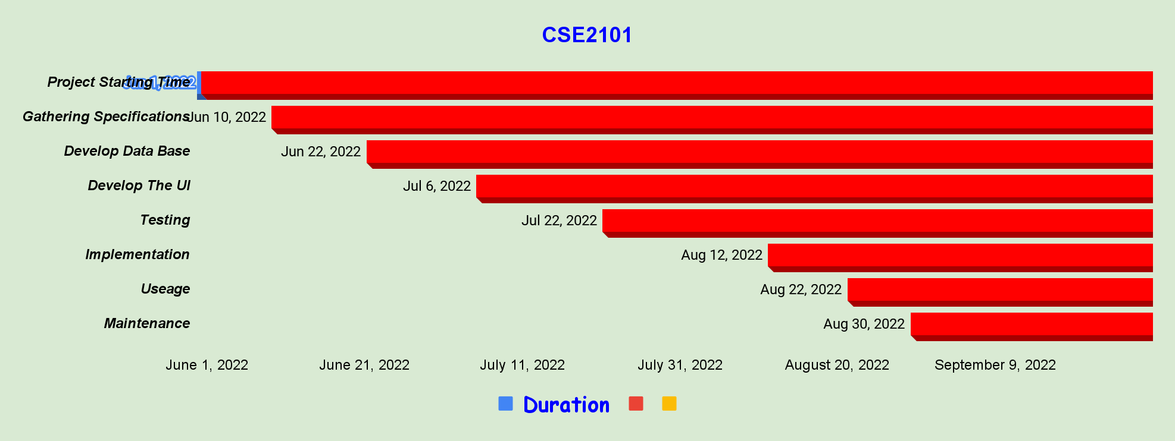

|  |  |  |  |  |
| --- | --- | --- | --- | --- |
| **Task** | **Start Date** | **End Date** | **Duration** |  |
| Project Starting Time | 6/1/2022 | 6/10/2022 | 9 |  |
| Gathering Specifications | 6/10/2022 | 6/22/2022 | 12 |  |
| Develop Database | 6/22/2022 | 7/6/2022 | 14 |  |
| Develop The UI | 7/6/2022 | 7/22/2022 | 16 |  |
| Testing | 7/22/2022 | 8/12/2022 | 21 |  |
| Implementation | 8/12/2022 | 8/22/2022 | 10 |  |
| Useage | 8/22/2022 | 8/30/2022 | 8 |  |
| Maintenance | 8/30/2022 | 9/29/2022 | 30 |  |

**Gantt Chart**