Status of Petrale sole (*Eopsetta jordani* )

along the US west coast in 2019

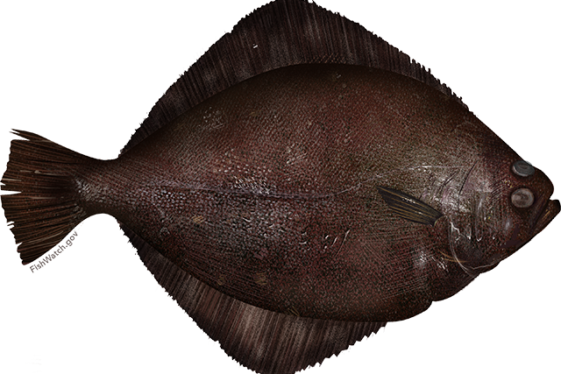

Chantel R. Wetzel1

1Northwest Fisheries Science Center, U.S. Department of Commerce, National Oceanic and Atmospheric Administration, National Marine Fisheries Service, 2725 Montlake Boulevard East, Seattle, Washington 98112

June 2019

Please cite as:

Wetzel, C.R. 2019. TITLE. Pacific Fishery Management Council, 7700 Ambassador Place NE, Suite 200, Portland, OR 97220.

Status of Petrale sole (*Eopsetta jordani* ) along the US west coast in 2019

**Contents**

**Executive Summary** **i**

Stock . . . . . . . . . . . . . . . . . . . . . . . . . . . . . . . . . . . . . . . . . . . i

Landings . . . . . . . . . . . . . . . . . . . . . . . . . . . . . . . . . . . . . . . . . i

Data and Assessment iii

Stock Biomass iii

Recruitment vi

Exploitation Status viii

Ecosystem Considerations xi

Reference Points xi

Management Performance xi

Unresolved Problems and Major Uncertainties xii

Decision Table xii

Research and Data Needs xv

1 Introduction 1

1.1 Distribution and Stock Structure . . . . . . . . . . . . . . . . . . . . . . . . 1

1.2 Historical and Current Fishery . . . . . . . . . . . . . . . . . . . . . . . . . . 1

* 1. Summary of Management History and Performance . . . . . . . . . . . . . . 1
  2. Fisheries off Canada and Alaska . . . . . . . . . . . . . . . . . . . . . . . . . 1

1. Data 1

2.1 Fishery-Independent Data . . . . . . . . . . . . . . . . . . . . . . . . . . . . 1

* + 1. Northwest Fisheries Science Center (NWFSC) Shelf-Slope Survey . . 1
    2. Northwest Fisheries Science Center (NWFSC) Slope Survey . . . . . 1

2.1.3 Triennial Shelf Survey . . . . . . . . . . . . . . . . . . . . . . . . . . 1

2.2 Fishery-Dependent Data . . . . . . . . . . . . . . . . . . . . . . . . . . . . . 2

2.2.1 Commercial Fishery Landings . . . . . . . . . . . . . . . . . . . . . . 2

2.2.2 Discards . . . . . . . . . . . . . . . . . . . . . . . . . . . . . . . . . . 2

* + 1. Fishery Length and Age Data . . . . . . . . . . . . . . . . . . . . . . 3 2.2.3.1 Commercial Fishery . . . . . . . . . . . . . . . . . . . . . . 3
    2. Historical Commercial Catch-Per-Unit Effort . . . . . . . . . . . . . . 4 2.3 Biological Data . . . . . . . . . . . . . . . . . . . . . . . . . . . . . . . . . . 4 2.3.1 Natural Mortality . . . . . . . . . . . . . . . . . . . . . . . . . . . . . 4

2.3.2 Sex Ratio, Maturation, and Fecundity . . . . . . . . . . . . . . . . . 4

2.3.3 Length-Weight Relationship . . . . . . . . . . . . . . . . . . . . . . . 4 2.3.4 Growth (Length-at-Age) . . . . . . . . . . . . . . . . . . . . . . . . . 4

2.3.5 Ageing Precision and Bias . . . . . . . . . . . . . . . . . . . . . . . . 4

2.4 History of Modeling Approaches Used for This Stock . . . . . . . . . . . . . 4 2.4.1 Previous Assessments . . . . . . . . . . . . . . . . . . . . . . . . . . . 4

1. **Assessment** **4**

3.1 General Model Specifications and Assumptions . . . . . . . . . . . . . . . . . 4

3.1.1 Changes Between the 2015 Update Assessment Model and Current Model 4

3.1.2 Summary of Fleets and Areas . . . . . . . . . . . . . . . . . . . . . . 4

3.1.3 Other Specifications . . . . . . . . . . . . . . . . . . . . . . . . . . . 4

3.1.4 Modeling Software . . . . . . . . . . . . . . . . . . . . . . . . . . . . 4

3.1.5 Priors . . . . . . . . . . . . . . . . . . . . . . . . . . . . . . . . . . . 7

3.1.6 Data Weighting . . . . . . . . . . . . . . . . . . . . . . . . . . . . . . 7

* + 1. Estimated and Fixed Parameters . . . . . . . . . . . . . . . . . . . . 7
    2. Key Assumptions and Structural Choices . . . . . . . . . . . . . . . . 7

3.1.9 Bridging Analysis . . . . . . . . . . . . . . . . . . . . . . . . . . . . . 7

3.1.10 Convergence . . . . . . . . . . . . . . . . . . . . . . . . . . . . . . . . 7

3.2 Base Model Results . . . . . . . . . . . . . . . . . . . . . . . . . . . . . . . . 7

3.2.1 Parameter Estimates . . . . . . . . . . . . . . . . . . . . . . . . . . . 7

3.2.2 Fits to the Data . . . . . . . . . . . . . . . . . . . . . . . . . . . . . . 7

3.2.3 Population Trajectory . . . . . . . . . . . . . . . . . . . . . . . . . . 7

3.2.4 Uncertainty and Sensitivity Analyses . . . . . . . . . . . . . . . . . . 7

3.2.5 Retrospective Analysis . . . . . . . . . . . . . . . . . . . . . . . . . . 7

3.2.6 Historical Analysis . . . . . . . . . . . . . . . . . . . . . . . . . . . . 7

3.2.7 Likelihood Profiles . . . . . . . . . . . . . . . . . . . . . . . . . . . . 7

3.2.8 Reference Points . . . . . . . . . . . . . . . . . . . . . . . . . . . . . 7

### Harvest Projections and Decision Tables 7

### Regional Management Considerations 7

### Research Needs 7

### Acknowledgments 8

### Figures 9

1. **References**

**Executive Summary**

**Stock**

This assessment reports the status of the Petrale sole (*Eopsetta jordani* ) off US coast of California, Oregon, and Washington using data through 2018.

**Landings**

Harvest of Petrale sole first began off the US west coast in 1876.

Petrale sole are a desirable market species and discarding has historically been low.

Table a: Landings (mt) for the past 10 years for Petrale sole by source.

|  |  |  |  |  |  |
| --- | --- | --- | --- | --- | --- |
| Year | Winter | Summer | Winter | Summer | Total |
|  | (N) | (N) | (S) | (S) | Landings |
| 2009 | 846.71 | 641.75 | 469.66 | 250.38 | 2208.49 |
| 2010 | 258.09 | 292.34 | 77.60 | 120.95 | 748.98 |
| 2011 | 221.60 | 423.11 | 39.59 | 77.70 | 762.00 |
| 2012 | 406.05 | 477.71 | 124.46 | 107.63 | 1115.85 |
| 2013 | 509.04 | 1007.26 | 130.10 | 278.35 | 1924.74 |
| 2014 | 852.90 | 860.31 | 273.40 | 354.19 | 2340.80 |

4000

3000

Landings (mt)

2000

Fishery

Winter (N) Summer (N) Winter (S) Summer (S)

1000

0

1876 1896 1916 1936 1956 1976 1996 2016

Year

Figure a: Landings of Petrale sole by the Northern and Southern winter and summer fleets of the US west coast.

## Data and Assessment

This an update assessment for Petrale sole, which was last assessed in 2013 and updated in 2015. The update assessment was conducted using the length- and age-structured modeling software Stock Synthesis (version 3.30.03.XX). The coastwide population was modeled allowing separate growth and mortality parameters for each sex (a two-sex model) from 1876 to 2019 and forecasted beyond 2019.

## Stock Biomass

The predicted spawning output from the base model . . .

Table b: Recent trend in estimated spawning output (mt) and estimated relative spawning output (depletion).

|  |  |  |  |  |
| --- | --- | --- | --- | --- |
| Year | Spawning Output  (mt) | ˜ 95%  Confidence Interval | Estimated  Depletion | ˜ 95%  Confidence Interval |
| 2010 | 3448 | 2895 - 4001 | 0.102 | 0.073 - 0.131 |
| 2011 | 4396 | 3691 - 5101 | 0.130 | 0.094 - 0.167 |
| 2012 | 5957 | 5020 - 6895 | 0.177 | 0.128 - 0.225 |
| 2013 | 7887 | 6641 - 9133 | 0.234 | 0.171 - 0.297 |
| 2014 | 9514 | 7942 - 11086 | 0.282 | 0.207 - 0.358 |
| 2015 | 10531 | 8672 - 12390 | 0.313 | 0.229 - 0.396 |
| 2016 | 12329 | 10225 - 14433 | 0.366 | 0.273 - 0.458 |
| 2017 | 13910 | 11567 - 16254 | 0.413 | 0.314 - 0.512 |
| 2018 | 15401 | 12797 - 18005 | 0.457 | 0.352 - 0.562 |
| 2019 | 16841 | 13924 - 19758 | 0.500 | 0.388 - 0.612 |

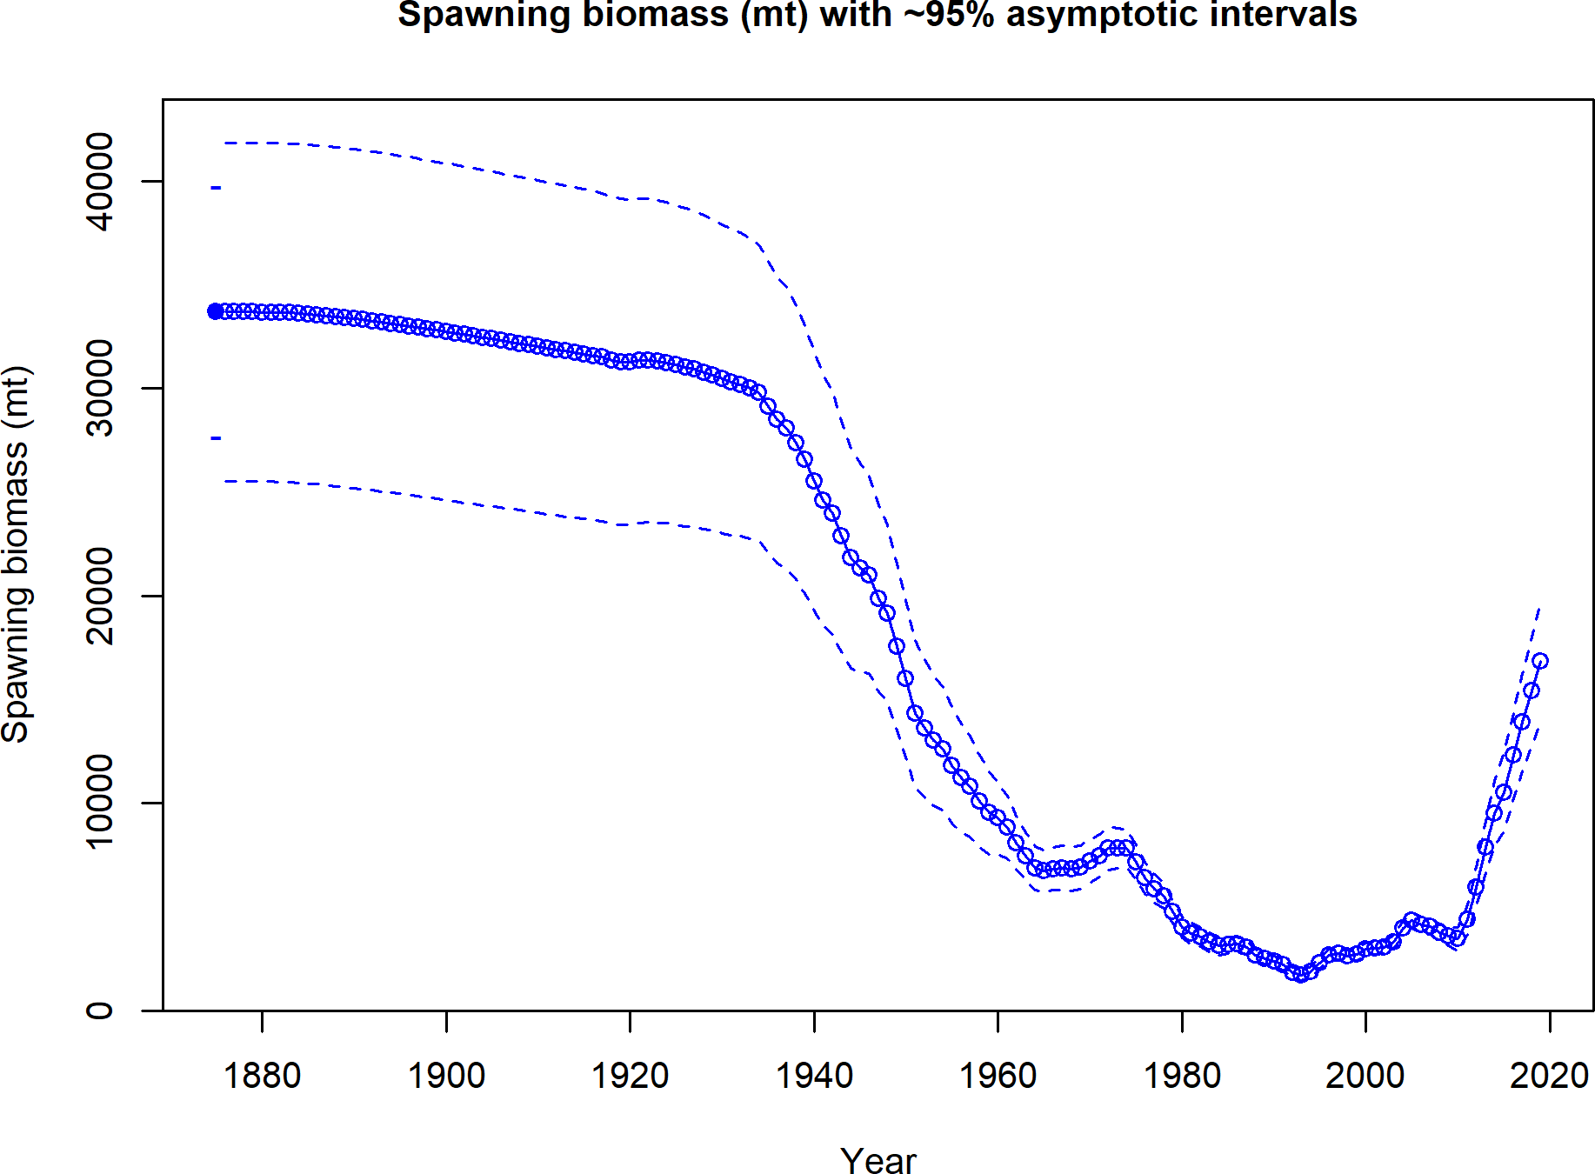

Figure b: Estimated time-series of spawning output trajectory (circles and line: median; light broken lines: 95% credibility intervals) for the base assessment model.

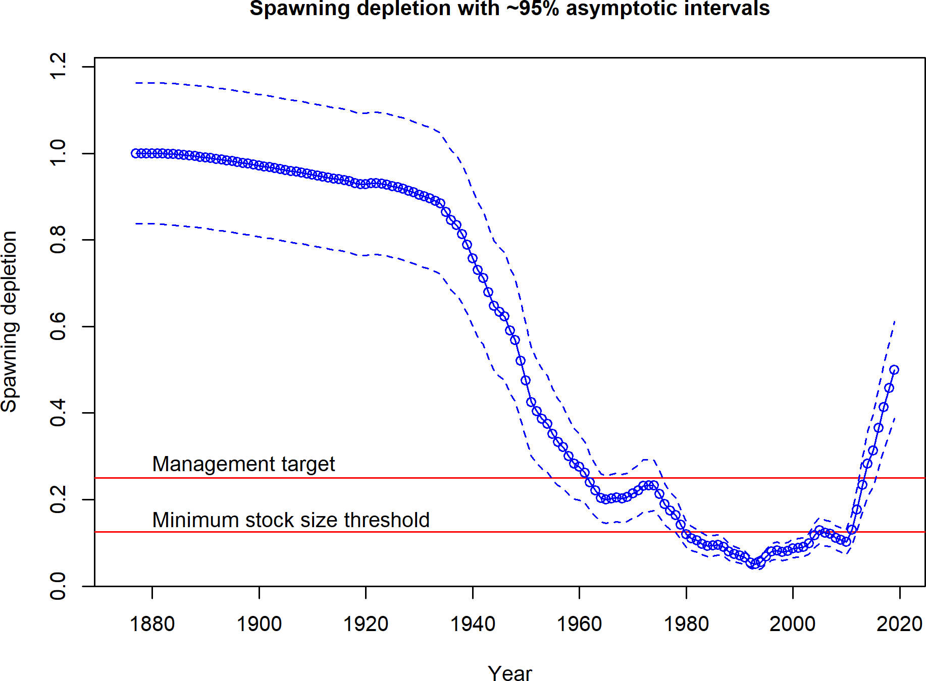

Figure c: Estimated time-series of relative spawning output (depletion) (circles and line: median; light broken lines: 95% credibility intervals) for the base assessment model.

## Recruitment

Recruitment deviations were estimated for the entire assessment period. . .

Table c: Recent estimated trend in recruitment and estimated recruitment deviations deter- mined from the base model. The recruitment deviations for 2016 and 2017 were fixed at zero within the model.

|  |  |  |  |  |
| --- | --- | --- | --- | --- |
| Year | Estimated  Recruitment | ˜ 95% Confidence  Interval | Estimated  Recruitment Devs. | ˜ 95% Confidence  Interval |
| 2010 | 9787 | 6190 - 15473 | -0.144 | -0.509 - 0.220 |
| 2011 | 9683 | 5721 - 16387 | -0.209 | -0.654 - 0.236 |
| 2012 | 13760 | 7506 - 25228 | 0.067 | -0.467 - 0.601 |
| 2013 | 12874 | 5985 - 27695 | -0.060 | -0.789 - 0.668 |
| 2014 | 14272 | 6300 - 32334 | -0.000 | -0.784 - 0.784 |
| 2015 | 14418 | 6351 - 32730 | 0.000 | -0.784 - 0.784 |
| 2016 | 14621 | 6422 - 33289 | 0.000 | -0.784 - 0.784 |
| 2017 | 14760 | 6470 - 33673 | 0.000 | -0.784 - 0.784 |
| 2018 | 14867 | 6506 - 33972 | 0.000 | -0.784 - 0.784 |
| 2019 | 14953 | 6534 - 34219 | 0.000 | -0.784 - 0.784 |

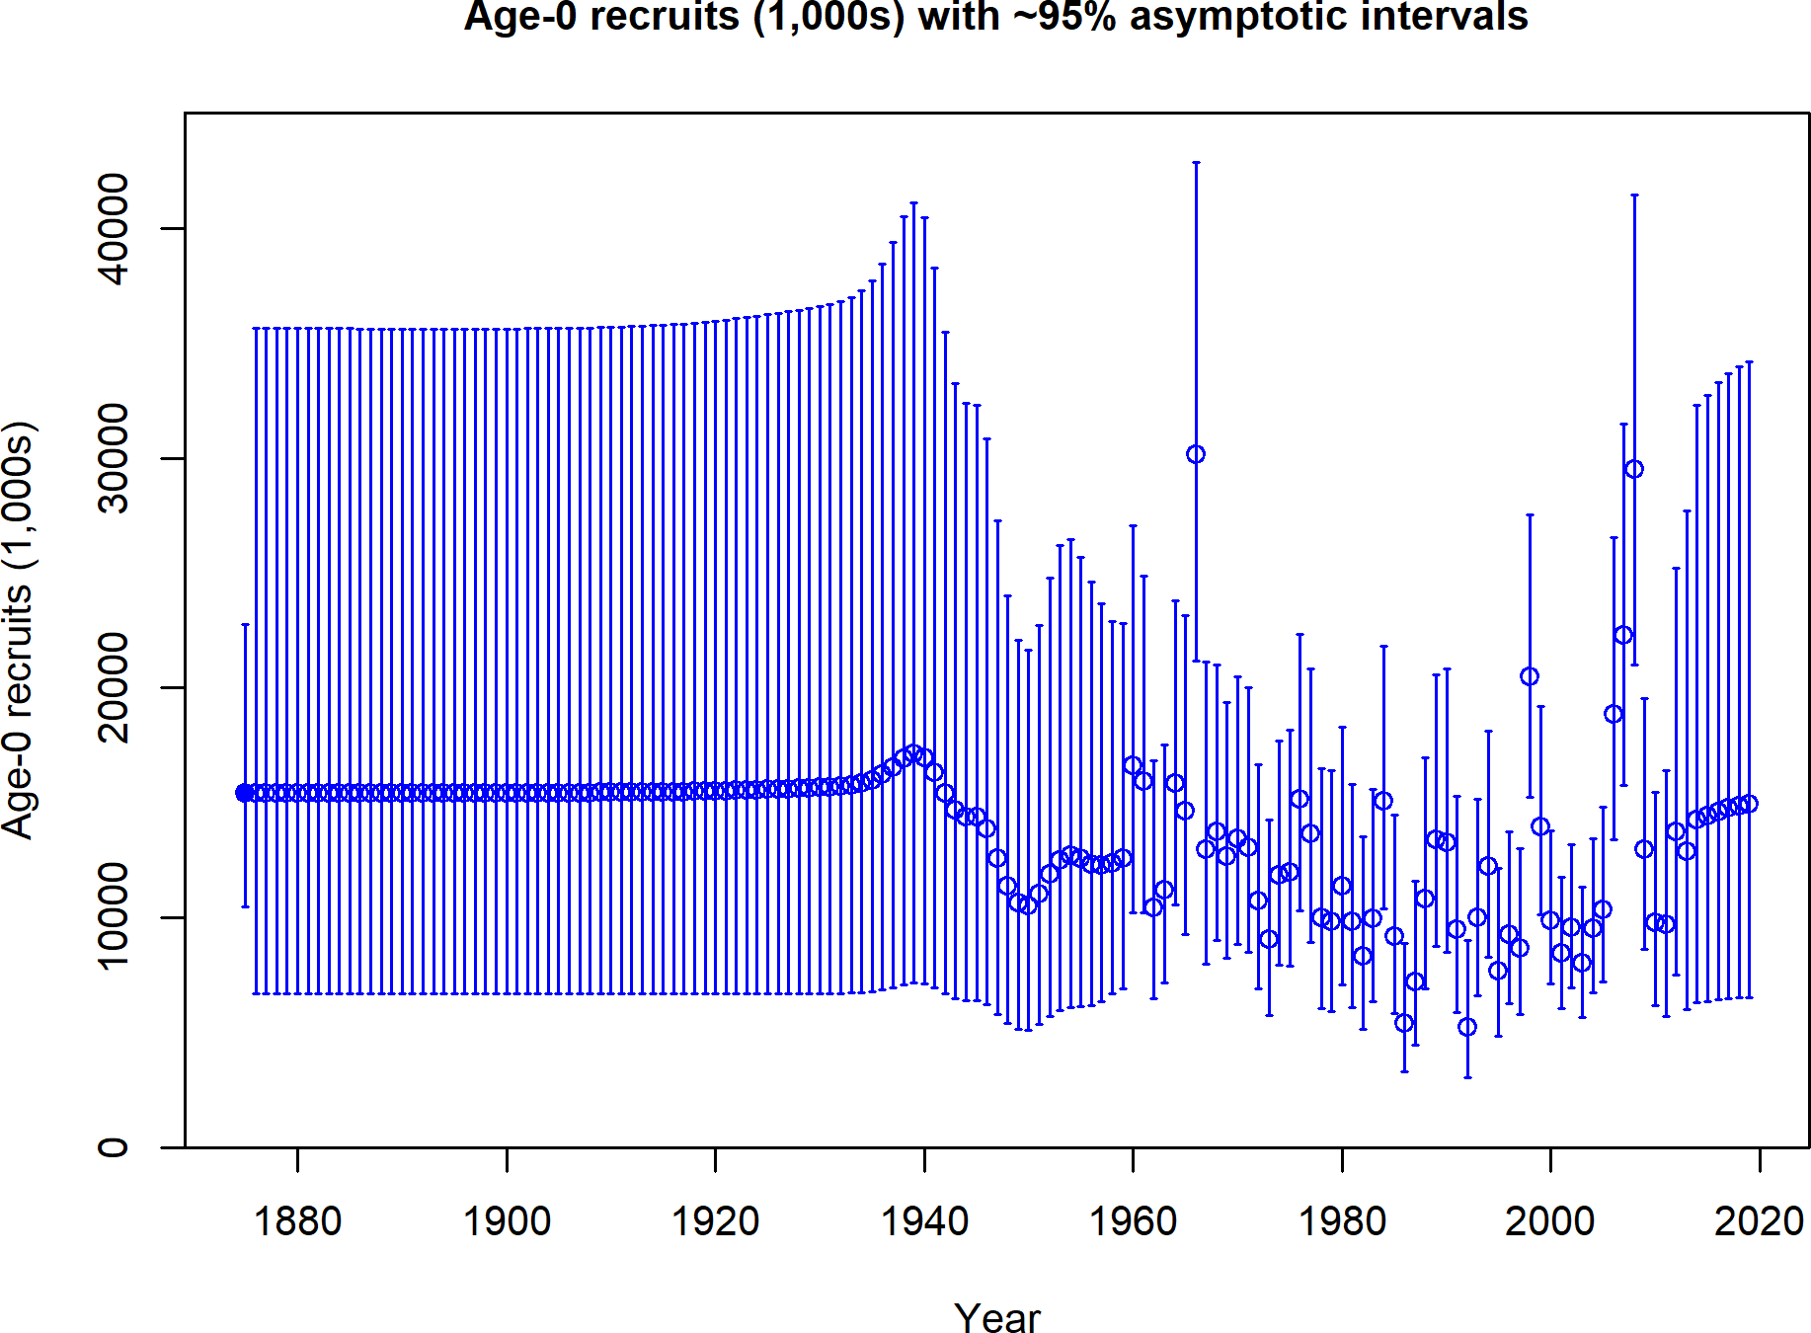

Figure d: Time-series of estimated Petrale sole recruitments for the base model with 95% confidence or credibility intervals.

## Exploitation Status

The spawning output of Petrale sole. . .

Table d: Recent trend in spawning potential ratio (1-SPR)/(1-SPR50) and summary exploita- tion rate for age 3+ biomass for Petrale sole.

|  |  |  |  |  |
| --- | --- | --- | --- | --- |
| Year | (1-SPR)/  (1-SPR50%) | ˜ 95%  Confidence Interval | Exploitation  Rate | ˜ 95%  Confidence Interval |
| 2009 | 0.847 | 0.793 - 0.900 | 0.278 | 0.236 - 0.319 |
| 2010 | 0.672 | 0.583 - 0.762 | 0.099 | 0.080 - 0.117 |
| 2011 | 0.581 | 0.487 - 0.674 | 0.063 | 0.052 - 0.074 |
| 2012 | 0.592 | 0.503 - 0.682 | 0.074 | 0.061 - 0.086 |
| 2013 | 0.656 | 0.572 - 0.739 | 0.110 | 0.092 - 0.128 |
| 2014 | 0.654 | 0.571 - 0.736 | 0.124 | 0.103 - 0.145 |
| 2015 | 0.006 | 0.004 - 0.008 | 0.001 | 0.000 - 0.001 |
| 2016 | 0.005 | 0.004 - 0.007 | 0.000 | 0.000 - 0.001 |
| 2017 | 0.005 | 0.003 - 0.006 | 0.000 | 0.000 - 0.000 |
| 2018 | 0.004 | 0.003 - 0.005 | 0.000 | 0.000 - 0.000 |

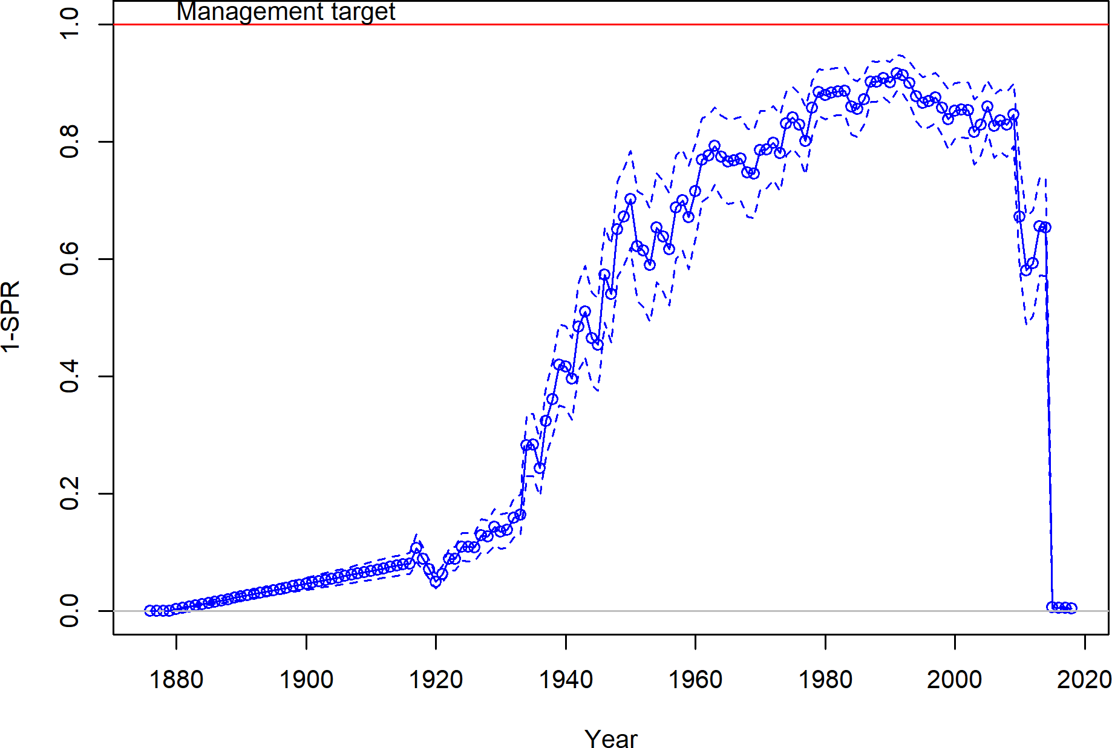

Figure e: Estimated relative spawning potential ratio (1-SPR)/(1-SPR30%) for the base model. One minus SPR is plotted so that higher exploitation rates occur on the upper portion of the y-axis. The management target is plotted as a red horizontal line and values above this reflect harvests in excess of the overfishing proxy based on the SPR30% harvest rate. The last year in the time-series is 2018.

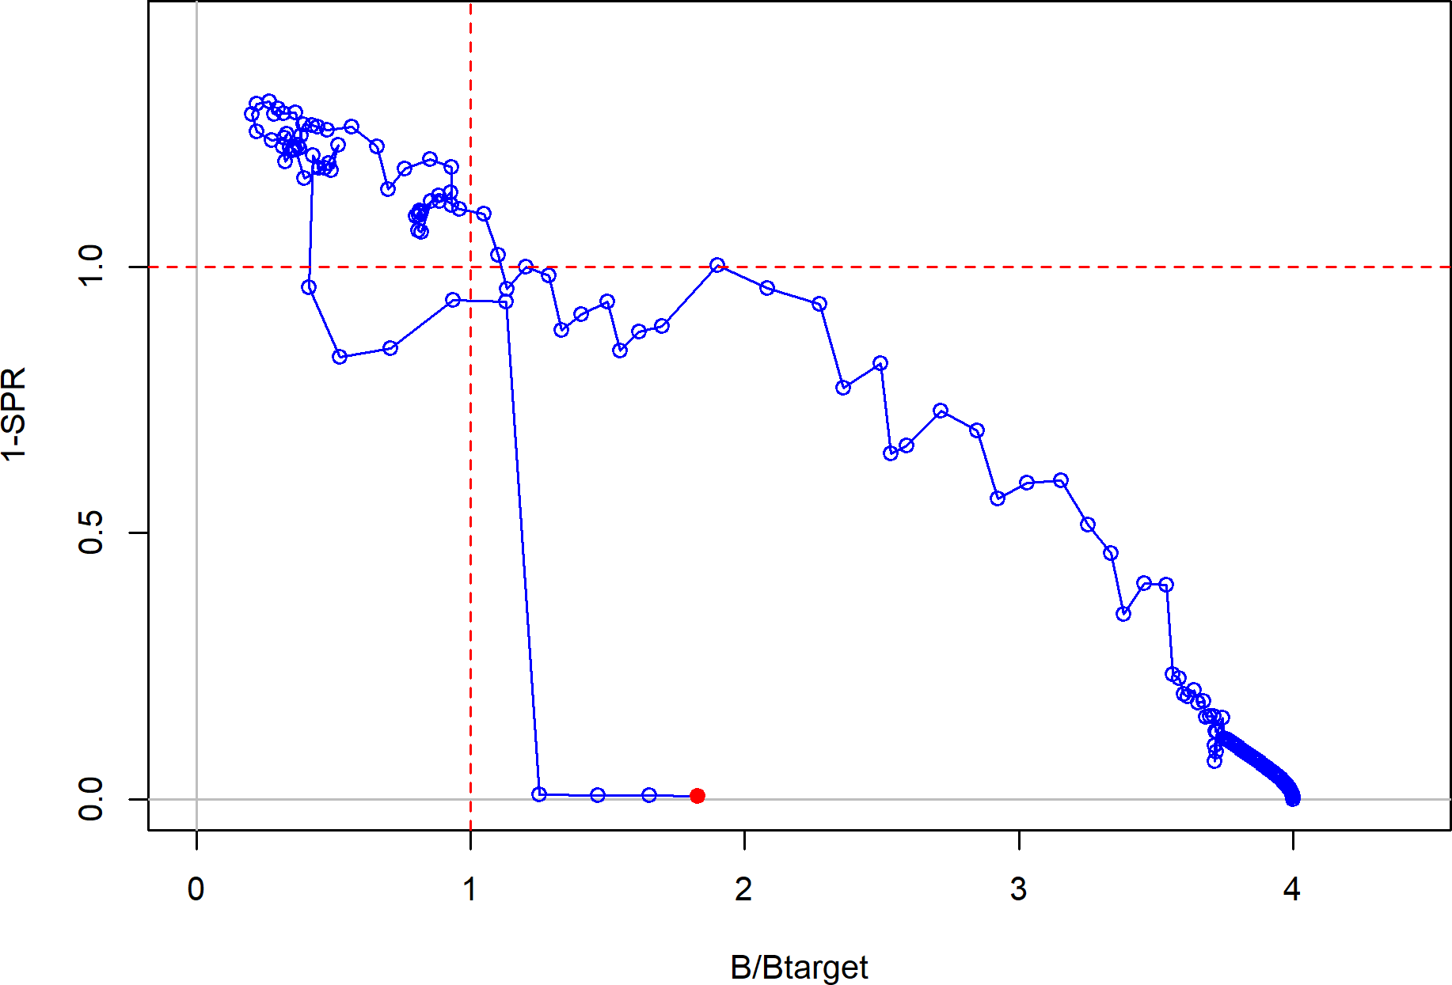

Figure f: Phase plot of estimated (1-SPR)/(1-SPR30%) vs. depletion (B/Btarget) for the base case model. The red circle indicates 2018 estimated status and exploitation for Petrale sole.

**Ecosystem Considerations** **Reference Points**

This stock assessment estimates that the spawning output of Petrale sole is above the

management target. Due to reduced landing and the large 2008 year-class, an increasing trend in spawning output was estimated in the base model. The estimated depletion in 2019 is 50.0% ( 95% asymptotic interval: 38.8%-61.2%), corresponding to an unfished spawning output of 16,841 mt ( 95% asymptotic interval: 13,924-19,758 mt). Unfished age 3+ biomass was estimated to be 53,873.7 mt in the base model. The target spawning output based on the biomass target (*𝑆𝐵*25%) is 8,423.3 mt, with an equilibrium catch of 2,729.5 mt. Equilibrium yield at the proxy *𝐹𝑀𝑆𝑌* harvest rate corresponding to *𝑆𝑃 𝑅*30% is 2,702.4 mt. Estimated MSY catch is at a 2,742.2 spawning output of 7,323.1 mt (21.7% depletion)

∼

∼ ±

Table e: Summary of reference points and management quantities for the base case.

|  |  |  |
| --- | --- | --- |
| **Quantity** | **Estimate** | ∼**95%**  **Interval** |
| Unfished spawning output (mt) | 33693.4 | 27542.4 - 39844.4 |
| Unfished age 3+ biomass (mt) | 53873.7 | 45675.1 - 62072.3 |
| Unfished recruitment (R0, thousands) | 15430.6 | 9369.1 - 21492.1 |
| Spawning output(2019 mt) | 16841.1 | 13924 - 19758.2 |
| Relative spawning output (depletion) (2019) | 0.5 | 0.388 - 0.612 |
| **Reference points based on SB25**%  Proxy spawning output (*𝐵*25%) | 8423.3 | 6885.6 - 9961.1 |
| SPR resulting in *𝐵*25% (*𝑆𝑃 𝑅𝐵*25%) | 0.274 | 0.251 - 0.297 |
| Exploitation rate resulting in *𝐵*25% | 0.166 | 0.147 - 0.186 |
| Yield with *𝑆𝑃 𝑅𝐵*25% at *𝐵*25% (mt)  ***Reference points based on SPR proxy for MSY*** | 2729.5 | 2472.1 - 2986.8 |
| Spawning output | 9329.8 | 7316.9 - 11342.7 |
| *𝑆𝑃 𝑅*30% | 0.3 |  |
| Exploitation rate corresponding to *𝑆𝑃 𝑅*30% | 0.151 | 0.125 - 0.178 |
| Yield with *𝑆𝑃 𝑅*30% at *𝑆𝐵𝑆𝑃 𝑅* (mt)  ***Reference points based on estimated MSY values*** | 2702.4 | 2414.6 - 2990.2 |
| Spawning output at *𝑀 𝑆𝑌* (*𝑆𝐵𝑀𝑆𝑌* ) | 7323.1 | 5504.8 - 9141.4 |
| *𝑆𝑃 𝑅𝑀𝑆𝑌* | 0.242 | 0.18 - 0.304 |
| Exploitation rate at *𝑀 𝑆𝑌* | 0.187 | 0.157 - 0.216 |
| *𝑀 𝑆𝑌* (mt) | 2742.2 | 2502.5 - 2982 |

**Confidence**

## Management Performance

Exploitation rates on Petrale sole. . .

Table f: Recent trend in total catch and landings (mt) relative to the management guidelines. Estimated total catch reflect the landings plus the model estimated discarded biomass based on discard rate data.

|  |  |  |  |  |
| --- | --- | --- | --- | --- |
| Year | OFL (mt; ABC  prior to 2011) | ACL (mt; OY  prior to 2011) | Total Landings  (mt) | Estimated  Total Catch |
|  |  |  |  | (mt) |
| 2009 | 2,811 | 2433 | 2208 | 2323 |
| 2010 | 2,751 | 1200 | 749 | 914 |
| 2011 | 1,021 | 976 | 762 | 781 |
| 2012 | 1,275 | 1160 | 1116 | 1135 |
| 2013 | 2,711 | 2592 | 1925 | 1954 |
| 2014 | 2,774 | 2652 | 2341 | 2361 |
| 2015 | 3,073 | 2816 | 10 | 10 |
| 2016 | 3,208 | 2910 | 10 | 10 |
| 2017 | 3,208 | 3,136 | 10 | 10 |
| 2018 | 3,152 | 3,013 | 10 | 10 |

## Unresolved Problems and Major Uncertainties

1. The current data for Petrale sole weighted according to the Francis weighting...

## Decision Table

Model uncertainty has been described by the estimated uncertainty within the base model and by the sensitivities to different model structure.

Table g: Projections of potential OFL (mt) and ABC (mt) and the estimated spawning output and relative depletion based on ABC removals. The 2019 and 2020 removals are set at the harvest limits currently set by management of XXX mt per year.

|  |  |  |  |  |
| --- | --- | --- | --- | --- |
| Year | OFL | ABC | Spawning Output (mt) | Relative  Depletion |
| 2019 | 4834 | 4640 | 16841 | 0.500 |
| 2020 | 4396 | 4219 | 15401 | 0.457 |
| 2021 | 4036 | 3873 | 14183 | 0.421 |
| 2022 | 3750 | 3599 | 13192 | 0.392 |
| 2023 | 3532 | 3389 | 12412 | 0.368 |
| 2024 | 3367 | 3231 | 11814 | 0.351 |
| 2025 | 3244 | 3113 | 11362 | 0.337 |
| 2026 | 3152 | 3025 | 11020 | 0.327 |
| 2027 | 3082 | 2958 | 10758 | 0.319 |
| 2028 | 3028 | 2906 | 10554 | 0.313 |
| 2029 | 2986 | 2865 | 10394 | 0.308 |
| 2030 | 2952 | 2832 | 10266 | 0.305 |

Table h: Decision table summary of 10-year projections beginning in 2021 for alternate states of nature based on an axis of uncertainty for the base model. The removals in 2019 and 2020 were set at the defined management specification of XXX mt for each year assuming full attainment. The range of natural mortality values corresponded to the 12.5 and 87.5th quantile from the uncertainty around final spawning biomass. Columns range over low, mid, and high states of nature, and rows range over different assumptions of catch levels. The SPR50 catch stream is based on the equilibrium yield applying the SPR50 harvest rate.

**States of nature**

M = 0.04725 M = 0.054 M = 0.0595

|  |  |  |  |  |  |  |  |  |  |
| --- | --- | --- | --- | --- | --- | --- | --- | --- | --- |
|  | Year | Catch | Spawning  Output | Depletion (%) | Spawning  Output | Depletion (%) | Spawning  Output | Depletion | (%) |
|  | 2019 | 4340 | 3944 | 62.9 | 5741 | 83.3 | 7505 | 96.8 | |
|  | 2020 | 4229 | 3909 | 62.4 | 5745 | 83.4 | 7542 | 97.3 | |
|  | 2021 | 4108 | 3858 | 61.6 | 5723 | 83.1 | 7546 | 97.3 | |
| ABC | 2022 | 3984 | 3784 | 60.4 | 5666 | 82.2 | 7503 | 96.8 | |
|  | 2023 | 3862 | 3695 | 59.0 | 5586 | 81.1 | 7427 | 95.8 | |
|  | 2024 | 3748 | 3600 | 57.4 | 5494 | 79.7 | 7332 | 94.6 | |
|  | 2025 | 3644 | 3502 | 55.9 | 5395 | 78.3 | 7226 | 93.2 | |
|  | 2026 | 3551 | 3404 | 54.3 | 5292 | 76.8 | 7113 | 91.8 | |
|  | 2027 | 3467 | 3308 | 52.8 | 5188 | 75.3 | 6996 | 90.3 | |
|  | 2028 | 3389 | 3213 | 51.3 | 5084 | 73.8 | 6879 | 88.7 | |
|  | 2019 | 1822 | 3944 | 62.9 | 5741 | 83.3 | 7505 | 96.8 | |
|  | 2020 | 1822 | 4022 | 64.2 | 5857 | 85.0 | 7654 | 98.7 | |
|  | 2021 | 1822 | 4083 | 65.1 | 5946 | 86.3 | 7768 | 100.2 | |
| SPR50 | 2022 | 1822 | 4117 | 65.7 | 5996 | 87.0 | 7830 | 101.0 | |
|  | 2023 | 1822 | 4131 | 65.9 | 6016 | 87.3 | 7852 | 101.3 | |
|  | 2024 | 1822 | 4133 | 65.9 | 6017 | 87.3 | 7848 | 101.2 | |
|  | 2025 | 1822 | 4125 | 65.8 | 6004 | 87.1 | 7824 | 100.9 | |
|  | 2026 | 1822 | 4110 | 65.6 | 5979 | 86.8 | 7786 | 100.4 | |
|  | 2027 | 1822 | 4090 | 65.3 | 5947 | 86.3 | 7736 | 99.8 | |
|  | 2028 | 1822 | 4067 | 64.9 | 5908 | 85.8 | 7679 | 99.1 | |

## Research and Data Needs

There are many areas of research that could be undertaken to benefit the understanding and assessment of Petrale sole. Below, are issues that are considered of importance.

1. **Natural mortality**:
2. **Steepness**:
3. **Basin-wide understanding of stock structure, biology, connectivity, and dis- tribution:**

xvi

Table i: Base model results summary.

|  |  |  |  |  |  |  |  |  |  |  |
| --- | --- | --- | --- | --- | --- | --- | --- | --- | --- | --- |
| Quantity | 2010 | 2011 | 2012 | 2013 | 2014 | 2015 | 2016 | 2017 | 2018 | 2019 |
| OFL (mt) | 2,751 | 1,021 | 1,275 | 2,711 | 2,774 | 3,073 | 3,208 | 3,208 | 3,152 | 1 |
| ACL (mt) | 1200 | 976 | 1160 | 2592 | 2652 | 2816 | 2910 | 3,136 | 3,013 | 1 |
| Landings (mt) | 749 | 762 | 1116 | 1925 | 2341 | 10 | 10 | 10 | 10 |  |
| Total Est. Catch (mt) | 914 | 781 | 1135 | 1954 | 2361 | 10 | 10 | 10 | 10 |  |
| (1-*𝑆𝑃 𝑅*)(1-*𝑆𝑃 𝑅*50%) | 0.672 | 0.581 | 0.592 | 0.656 | 0.654 | 0.006 | 0.005 | 0.005 | 0.004 |  |
| Exploitation rate | 0.099 | 0.063 | 0.074 | 0.110 | 0.124 | 0.001 | 0.000 | 0.000 | 0.000 |  |
| Age 3+ biomass (mt) | 9271.69 | 12406.50 | 15359.80 | 17730.40 | 18994.80 | 19707.20 | 22306.10 | 24807.50 | 27178.10 | 29422.30 |
| Spawning Output | 3448 | 4396 | 5957 | 7887 | 9514 | 10531 | 12329 | 13910 | 15401 | 16841 |
| 95% CI | 2895 - 4001 | 3691 - 5101 | 5020 - 6895 | 6641 - 9133 | 7942 - 11086 | 8672 - 12390 | 10225 - 14433 | 11567 - 16254 | 12797 - 18005 | 13924 - 19758 |
| Relative Depletion | 0.102 | 0.130 | 0.177 | 0.234 | 0.282 | 0.313 | 0.366 | 0.413 | 0.457 | 0.500 |
| 95% CI | 0.073 - 0.131 | 0.094 - 0.167 | 0.128 - 0.225 | 0.171 - 0.297 | 0.207 - 0.358 | 0.229 - 0.396 | 0.273 - 0.458 | 0.314 - 0.512 | 0.352 - 0.562 | 0.388 - 0.612 |
| Recruits | 9787 | 9683 | 13760 | 12874 | 14272 | 14418 | 14621 | 14760 | 14867 | 14953 |
| 95% CI | 6190 - 15473 | 5721 - 16387 | 7506 - 25228 | 5985 - 27695 | 6300 - 32334 | 6351 - 32730 | 6422 - 33289 | 6470 - 33673 | 6506 - 33972 | 6534 - 34219 |

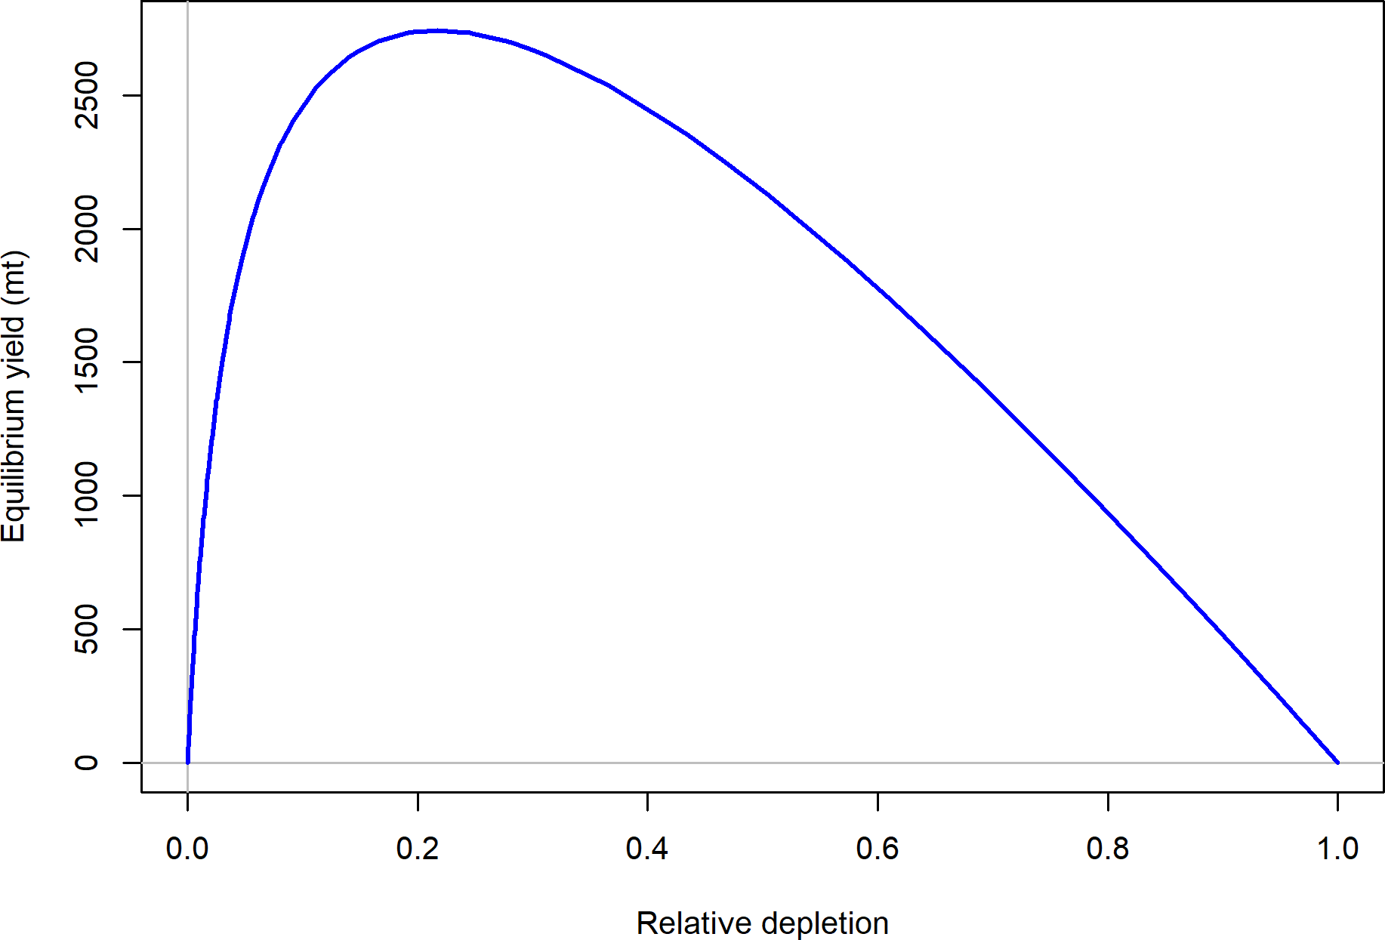

Figure g: Equilibrium yield curve for the base case model. Values are based on the 2018 fishery selectivity and with steepness fixed at 0.89.

# Introduction

## Distribution and Stock Structure

## Historical and Current Fishery

## Summary of Management History and Performance

## Fisheries off Canada and Alaska

# Data

Data used in the Petrale sole assessment are summarized in Figure 2. A description of each data source is provided below.

## Fishery-Independent Data

### Northwest Fisheries Science Center (NWFSC) Shelf-Slope Survey

### Northwest Fisheries Science Center (NWFSC) Slope Survey

### Triennial Shelf Survey

The Triennial shelf survey was first conducted by the AFSC in 1977 and spanned the time- frame from 1977-2004. The survey’s design and sampling methods are most recently described in Weinberg et al. (2002). Its basic design was a series of equally-spaced transects from which searches for tows in a specific depth range were initiated. The survey design has changed slightly over the period of time. In general, all of the surveys were conducted in the mid-summer through early fall: the 1977 survey was conducted from early July through late September; the surveys from 1980 through 1989 ran from mid-July to late September; the 1992 survey spanned from mid-July through early October; the 1995 survey was conducted from early June to late August; the 1998 survey ran from early June through early August; and the 2001 and 2004 surveys were conducted in May-July.

Haul depths ranged from 91-457 m during the 1977 survey with no hauls shallower than 91 m. The surveys in 1980, 1983, and 1986 covered the West Coast south to 36*.*8∘ N latitude and a

depth range of 55-366 m. The surveys in 1989 and 1992 covered the same depth range but extended the southern range to 34*.*5∘ N (near Point Conception). From 1995 through 2004, the surveys covered the depth range 55-500 m and surveyed south to 34*.*5∘ N. In the final year of the Triennial series, 2004, the NWFSC’s Fishery Resource and Monitoring division

(FRAM) conducted the survey and followed very similar protocols as the AFSC.

Although the Triennial shelf survey was used in the 2011 assessment, it was not used in the final base model for the current assessment for a number of reasons. First, there were concerns regarding the varying sampling and targeting of specific species by year across the time-series. Secondly, the Triennial shelf survey targeted the shelf of the West Coast and would not be expected to sample well slope species such as Petrale sole. There were limited observations of Petrale sole relative to other surveys (e.g. NWFSC shelf-slope survey) and the length and age distributions varied in such a manner that would indicate either poor sampling of Petrale sole or inconsistent sampling of the population.

## Fishery-Dependent Data

### Commercial Fishery Landings Washington

**Oregon California**

* + 1. **Discards**

Data on discards of Petrale sole are available from two different data sources. The earliest source is referred to as the Pikitch data and comes from a study organized by Ellen Pikitch

that collected trawl discards from 1985-1987 (Pikitch et al. 1988). The northern and southern boundaries of the study were 48∘42′ N latitude and 42∘60′ N latitude respectively, which is primarily within the Columbia INPFC area (Pikitch et al. 1988, Rogers and Pikitch 1992).

Participation in the study was voluntary and included vessels using bottom, midwater, and shrimp trawl gears. Observers of normal fishing operations on commercial vessels collected the data, estimated the total weight of the catch by tow, and recorded the weight of species retained and discarded in the sample. Results of the Pikitch data were obtained from John Wallace (personal communication, NWFSC, NOAA) in the form of ratios of discard weight to retained weight of Petrale sole and sex-specific length frequencies. Discard estimates are shown in Table **??**.

The second source is from the West Coast Groundfish Observer Program (WCGOP). This program is part of the NWFSC and has been recording discard observations since 2003.

Table **??** shows the discard ratios (discarded/(discarded + retained)) of Petrale sole from WCGOP. Since 2011, when the trawl rationalization program was implemented, observer coverage rates increased to nearly 100% for all the limited entry trawl vessels in the program and discard rates declined compared to pre-2011 rates. Discard rates were obtained for both the catch-share and the non-catch share sector for Petrale sole. A single discard rate was calculated by weighting discard rates based on the commercial landings by each sector. Coefficient of variations were calculated for the non-catch shares sector and pre-catch share years by bootstrapping vessels within ports because the observer program randomly chooses vessels within ports to be observed. Post-ITQ, all catch-share vessels have 100% observer coverage and discarding is assumed to be known.

* + 1. **Fishery Length and Age Data**

**2.2.3.1 Commercial Fishery**

Input effN = *𝑁*trips + 0*.*138 * *𝑁*fish if *𝑁*fish*/𝑁*trips is *<* 44 Input effN = 7*.*06 * *𝑁*trips if *𝑁*fish*/𝑁*trips is ≥ 44

**2.2.4 Historical Commercial Catch-Per-Unit Effort**

* 1. **Biological Data**
     1. **Natural Mortality**
     2. **Sex Ratio, Maturation, and Fecundity**
     3. **Length-Weight Relationship**
     4. **Growth (Length-at-Age)**
     5. **Ageing Precision and Bias**

**2.4 History of Modeling Approaches Used for This Stock**

**2.4.1 Previous Assessments**

1. **Assessment**
   1. **General Model Specifications and Assumptions**

Stock Synthesis version 3.30.03.XX was used to estimate the parameters in the model. R4SS, version 1.XX.X, along with R version 3.3.2 were used to investigate and plot model fits. A summary of the data sources used in the model (details discussed above) is shown in Figure 2.

* + 1. **Changes Between the 2015 Update Assessment Model and Current Model**
    2. **Summary of Fleets and Areas**
    3. **Other Specifications**
    4. **Modeling Software**

The STAT team used Stock Synthesis version 3.30.03.XX developed by Dr. Richard Methot at the NWFSC (Methot and Wetzel 2013). This most recent version was used because it

included improvements and corrections to older versions.

* + 1. **Priors**
    2. **Data Weighting**
    3. **Estimated and Fixed Parameters**
    4. **Key Assumptions and Structural Choices**
    5. **Bridging Analysis**
    6. **Convergence**
  1. **Base Model Results**
     1. **Parameter Estimates**
     2. **Fits to the Data**
     3. **Population Trajectory**
     4. **Uncertainty and Sensitivity Analyses**
     5. **Retrospective Analysis**
     6. **Historical Analysis**
     7. **Likelihood Profiles**
     8. **Reference Points**

1. **Harvest Projections and Decision Tables**
2. **Regional Management Considerations**
3. **Research Needs**

There are many areas of research that could be improved to benefit the understanding and assessment of Petrale sole. Below, are issues that are considered of importance.

1. **Natural mortality**:

1. **Acknowledgments**

Many people were instrumental in the successful completion of this assessment and their contribution is greatly appreciated.

1. **Figures**

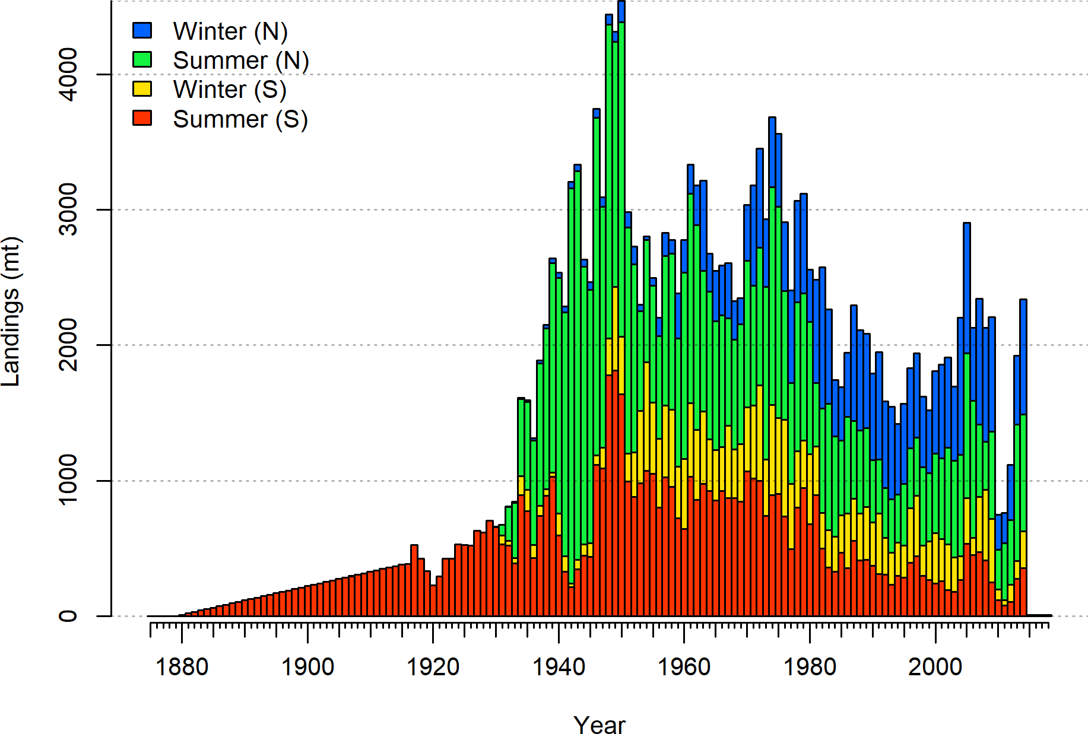

Figure 1: Total catches Petrale sole through 2016.

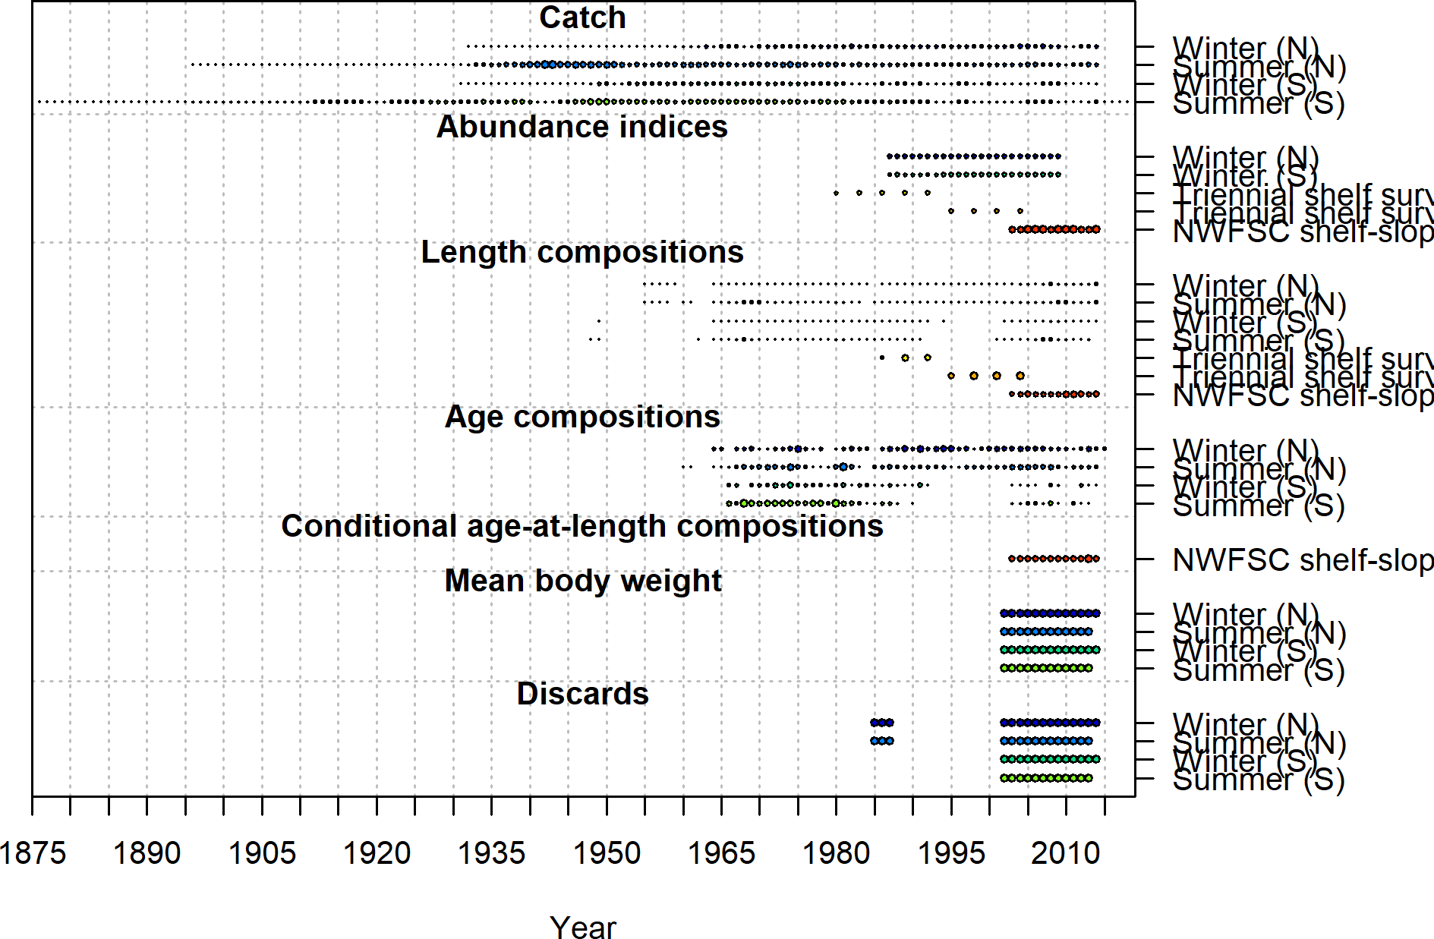

Figure 2: Summary of data sources used in the base model.

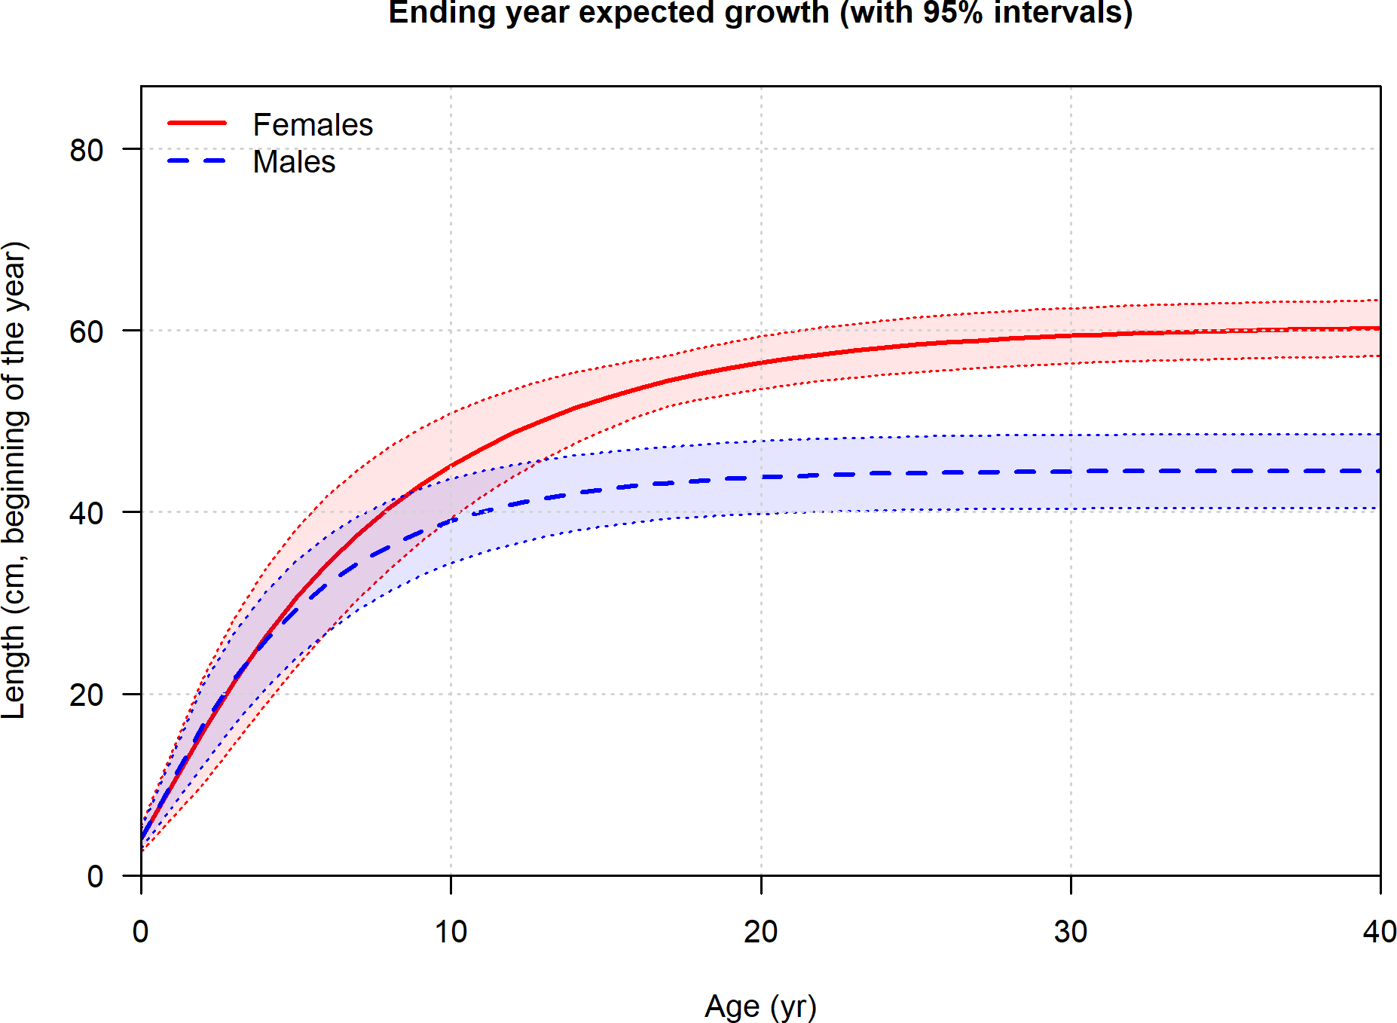

Figure 3: Estimated length-at-age for male and female for Petrale sole with estimated CV.



Figure 4: Estimated time-series of recruitment for Petrale sole.

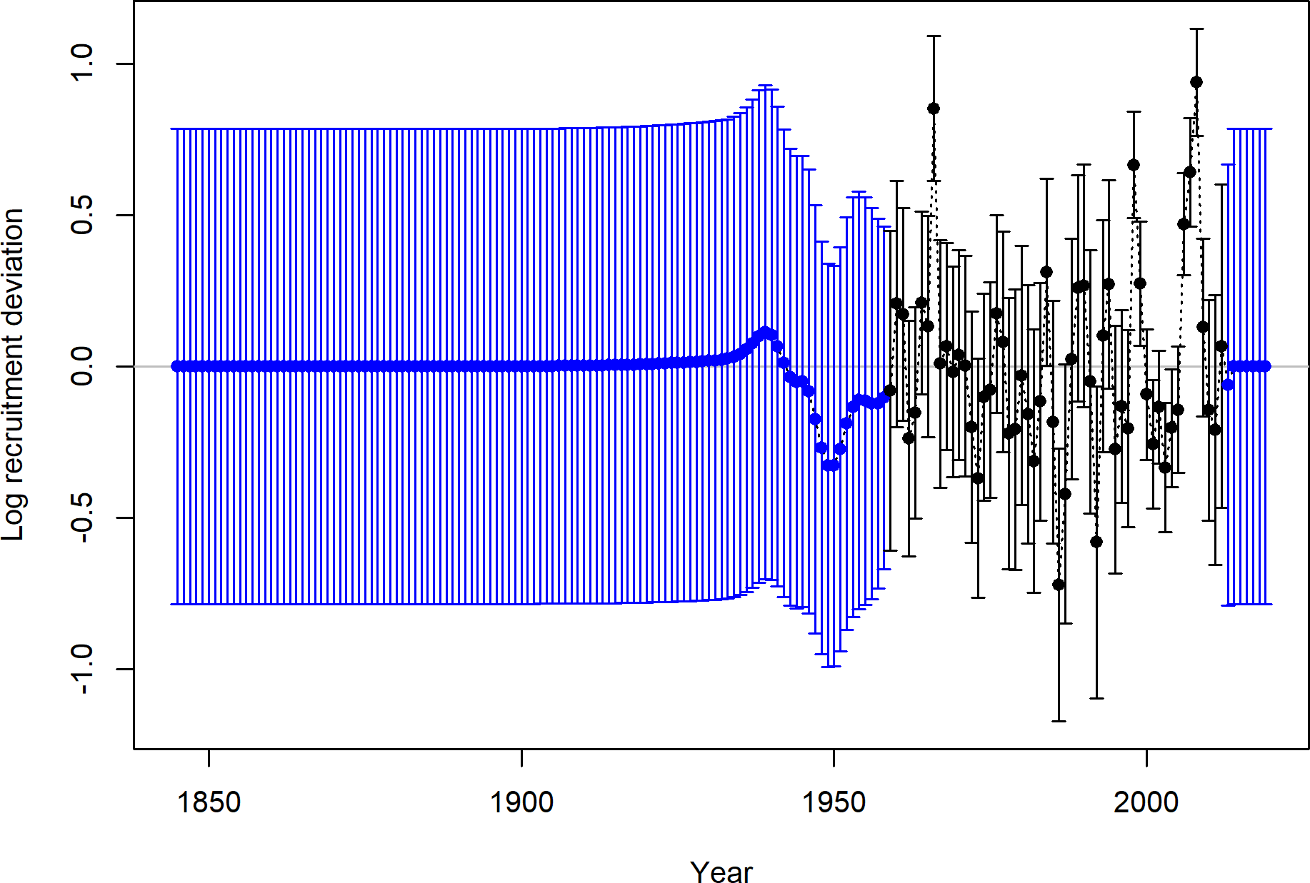

Figure 5: Estimated time-series of recruitment deviations for Petrale sole.

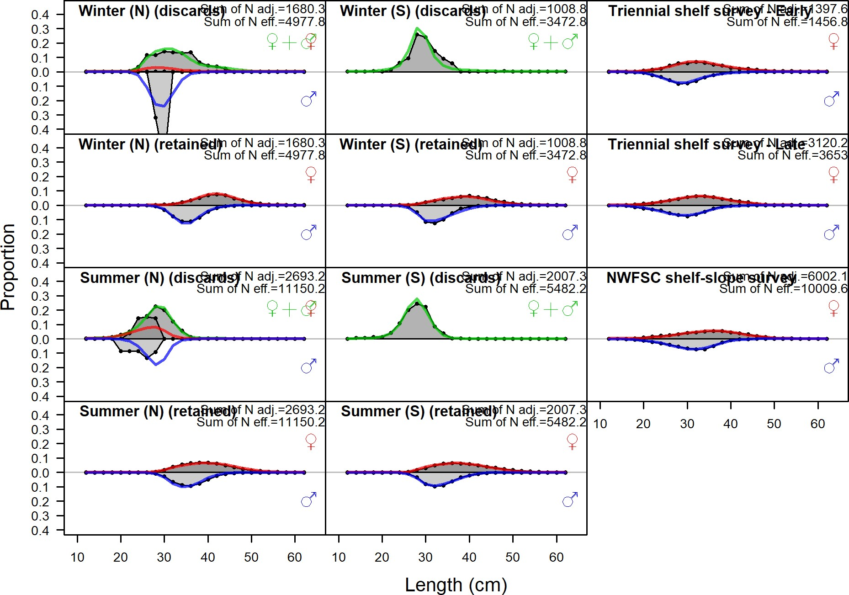

Figure 6: Length compositions aggregated across time by fleet. Labels ‘retained’ and ‘discard’ indicate retained or discarded samples for each fleet. Panels without this designation represent the whole catch. The Triennial shelf survey length data were not used in the final model, but the implied model fits are shown.

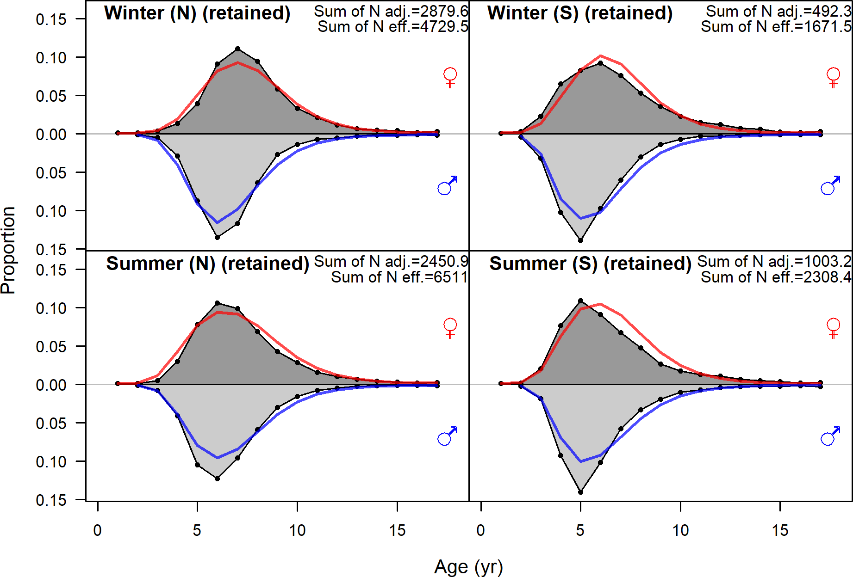

Figure 7: Age compositions aggregated across time by fleet. The Triennial shelf survey age data were not used in the final model, but the implied model fits are shown.



Figure 8: Estimated time-series of spawning output trajectory (circles and line: median; light broken lines: 95% credibility intervals) for Petrale sole.

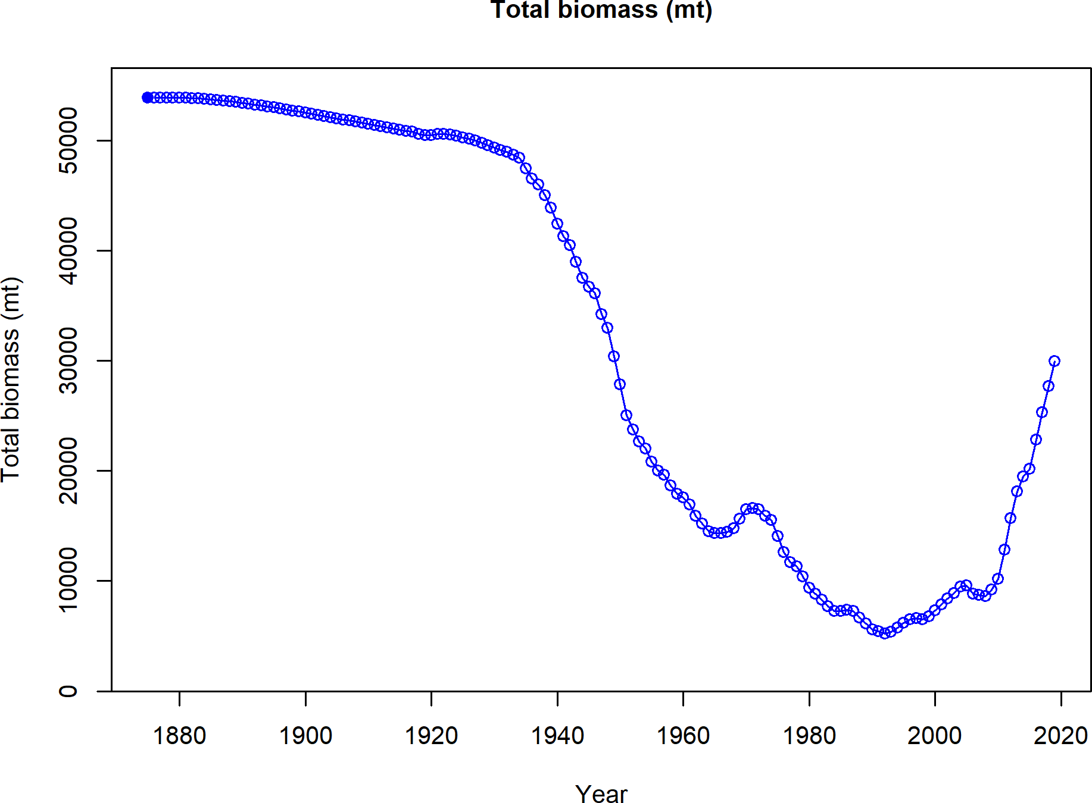

Figure 9: Estimated time-series of total biomass for Petrale sole.



Figure 10: Estimated time-series of relative spawning output (depletion) (circles and line: median; light broken lines: 95% credibility intervals) for Petrale sole.

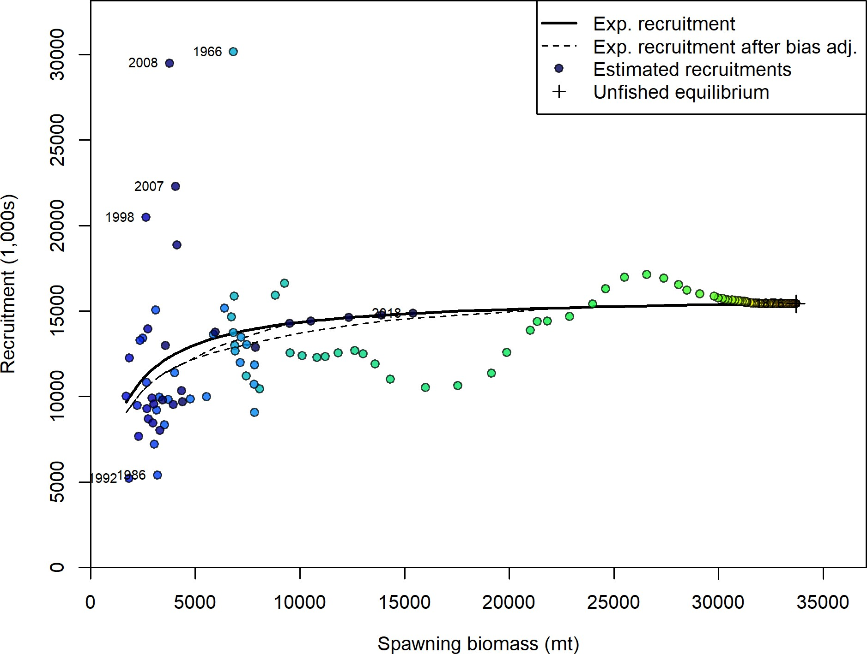

Figure 11: Estimated recruitment (red circles) and the assumed stock-recruit relationship (black line). The green line shows the effect of the bias correction for the lognormal distribution



Figure 12: Estimated spawning potential ratio (1-SPR)/(1-SPR30%) for the base-case model. One minus SPR is plotted so that higher exploitation rates occur on the upper portion of the y-axis. The management target is plotted as a red horizontal line and values above this reflect harvests in excess of the overfishing proxy based on the SPR30% harvest rate. The last year in the time series is 2018.



Figure 13: Equilibrium yield curve for the base case model. Values are based on the 2018 fishery selectivity and with steepness fixed at 0.89.

1. **References**

Methot, R.D., and Wetzel, C.R. 2013. Stock synthesis: A biological and statistical framework for fish stock assessment and fishery management. Fisheries Research **142**: 86–99. doi: [10.1016/j.fishres.2012.10.012](https://doi.org/10.1016/j.fishres.2012.10.012).

Pikitch, E.K., Erickson, D.L., and Wallace, J.R. 1988. An evaluation of the effectiveness of trip limits as a management tool. Northwest; Alaska Fisheries Center, National Marine Fisheries Service NWAFC Processed Report. Available from [https://www.afsc.noaa.gov/](https://www.afsc.noaa.gov/Publications/ProcRpt/PR1988-27.pdf) [Publications/ProcRpt/PR1988-27.pdf](https://www.afsc.noaa.gov/Publications/ProcRpt/PR1988-27.pdf) [accessed 28 February 2017].

Rogers, J.B., and Pikitch, E.K. 1992. Numerical definition of groundfish assemblages caught off the coasts of Oregon and Washington using commercial fishing strategies. Canadian Journal of Fisheries and Aquatic Sciences **49**(12): 2648–2656.

Weinberg, J.R., Rago, P.J., Wakefield, W.W., and Keith, C. 2002. Estimation of tow distance and spatial heterogeneity using data from inclinometer sensors: An example using a clam survey dredge. Fisheries Research **55**(1–3): 49–61. doi: [10.1016/S0165-7836(01)00292-2](https://doi.org/10.1016/S0165-7836(01)00292-2).