UIFactory
User Manual
Low-code internal-app platform · 2026-05-21

About this platform. UIFactory lets business users sign in with SSO, connect data sources, and build multi-page apps (AI-generated dashboards and conversational chat UIs), then deploy and share them with their organization. There are two roles: members build and use apps; administrators also manage users, templates, and platform settings. This guide walks through the platform step by step.

1. Sign in
Open the platform in your browser. When Azure AD / Entra ID is configured you sign in with Microsoft; otherwise the dev sign-in screen lists demo users. Click your account to continue. Users are provisioned automatically on first login.
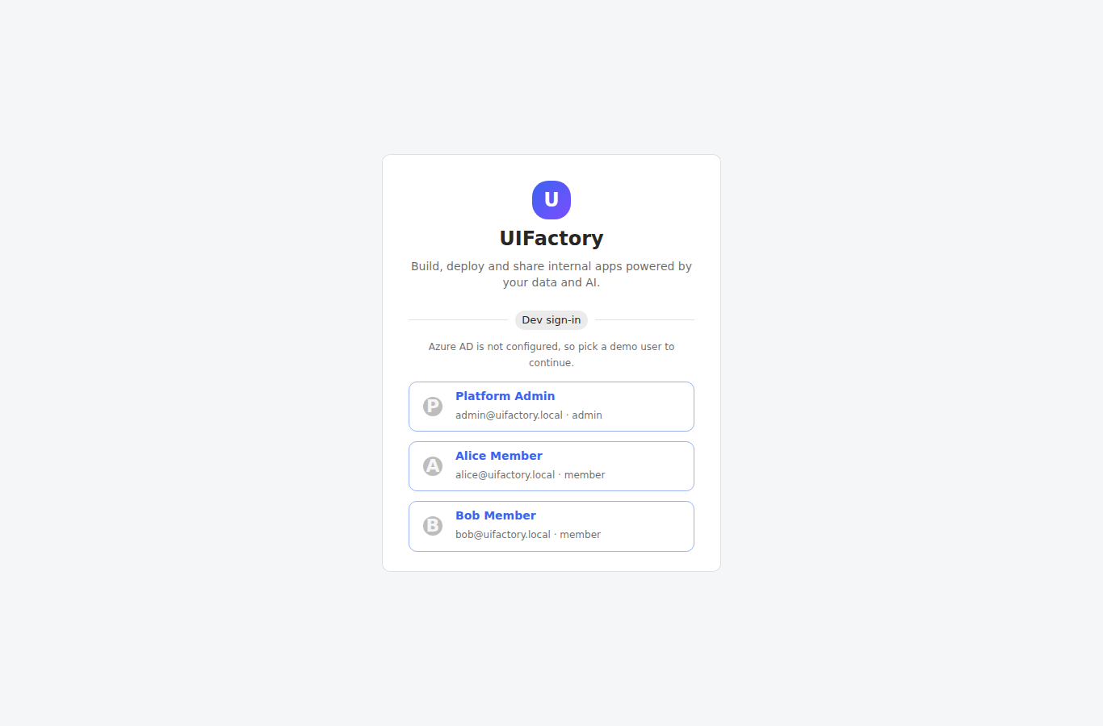

2. Browse the App Catalog
After signing in you land on the Catalog — the deployed apps shared with you or your organization. Use the search box to find an app, then click a card to open and use it.
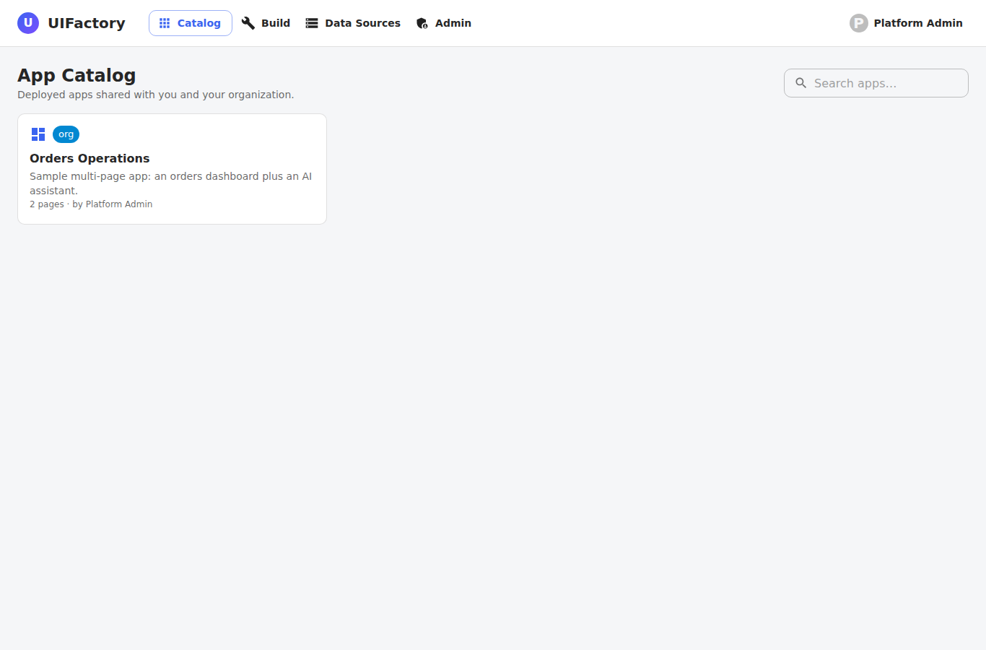

3. Use an app — dashboard page
An app can have multiple pages shown as tabs along the top. A dashboard (UI) page renders live data from its bound query. Use the filter box and click column headers to sort.
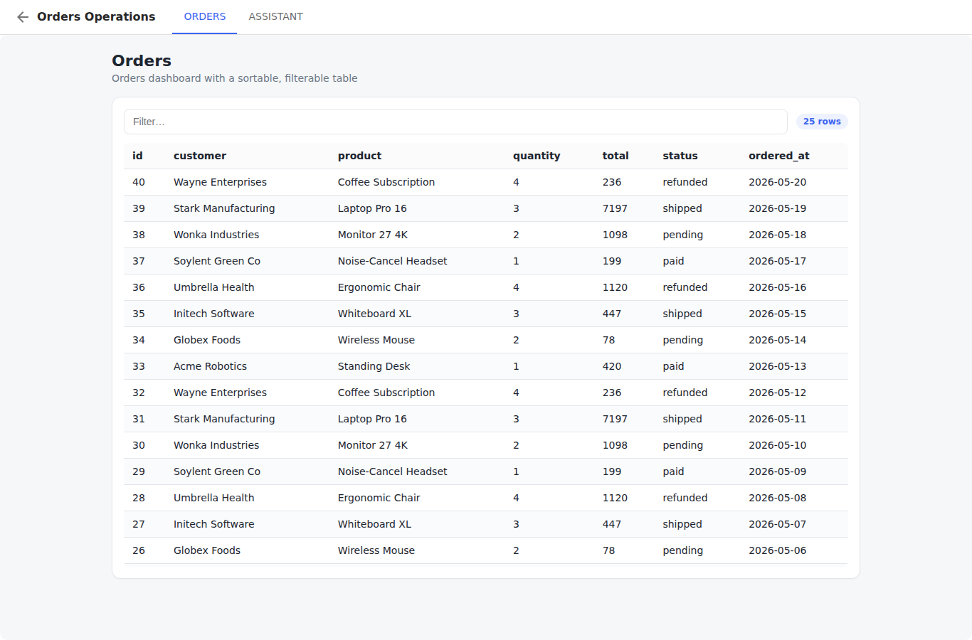

4. Use an app — chat page
A chat page is a conversational assistant, optionally grounded on the app's data. Type a question and press Enter. The assistant answers using the app's configured AI provider or your external agent API (a clearly-labelled demo reply is shown when none is configured).
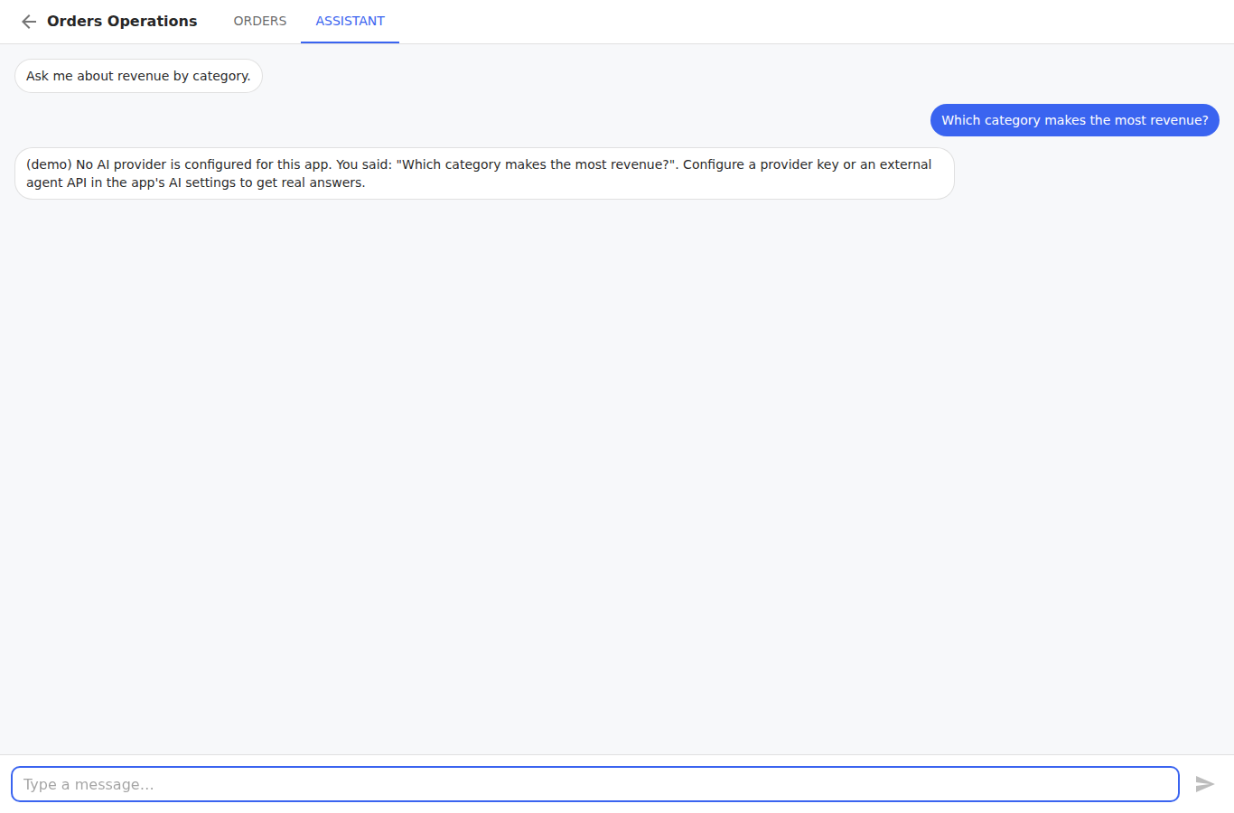

5. Open the Build workspace
Switch to Build to see the apps you own or can edit. Click 'New app' to create one, 'Edit' to open the editor, or 'Open' to run a deployed app.
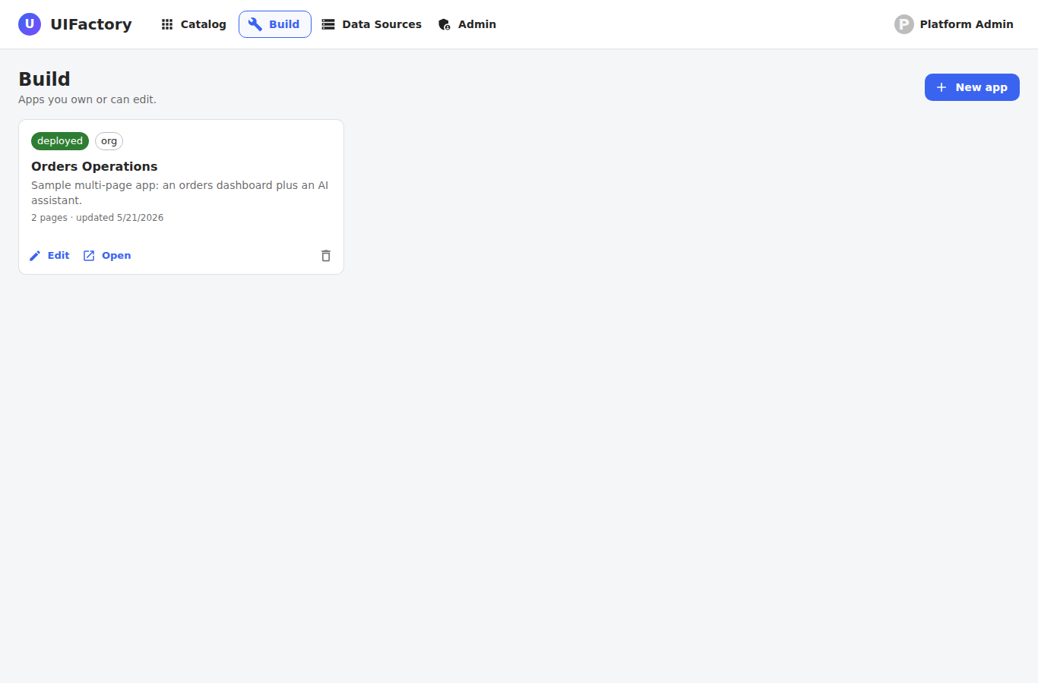

6. Create a new app
Give the app a name and optionally start from a template (for example a dashboard or a chat starter). Click Create to open it in the editor.
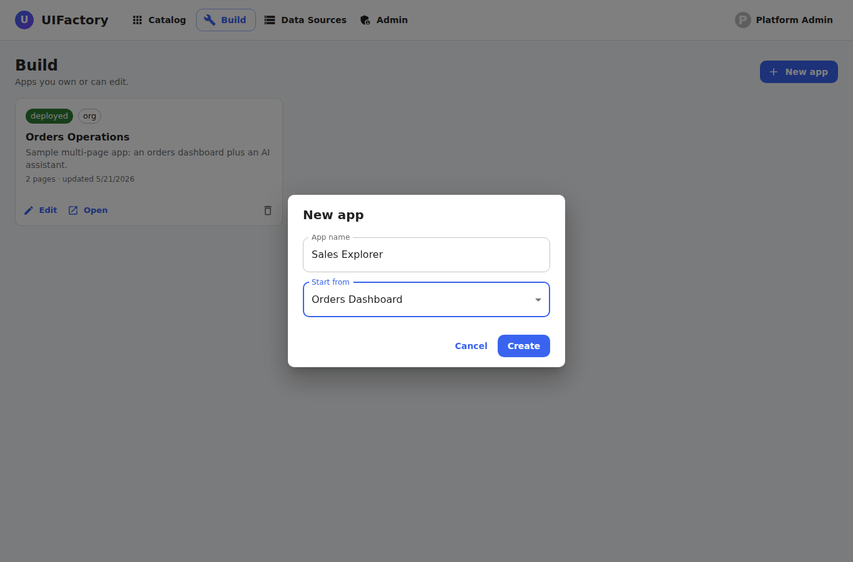

7. Build pages in the editor
Pages are listed on the left (add UI or chat pages with the + and chat icons). For a UI page: pick a Bound query and Run it, then Generate the UI with AI from the result. Use Refine to iterate on the design, and Actions to expose queries to buttons/forms (filters, lookups, and write-back). The live preview is on the right.
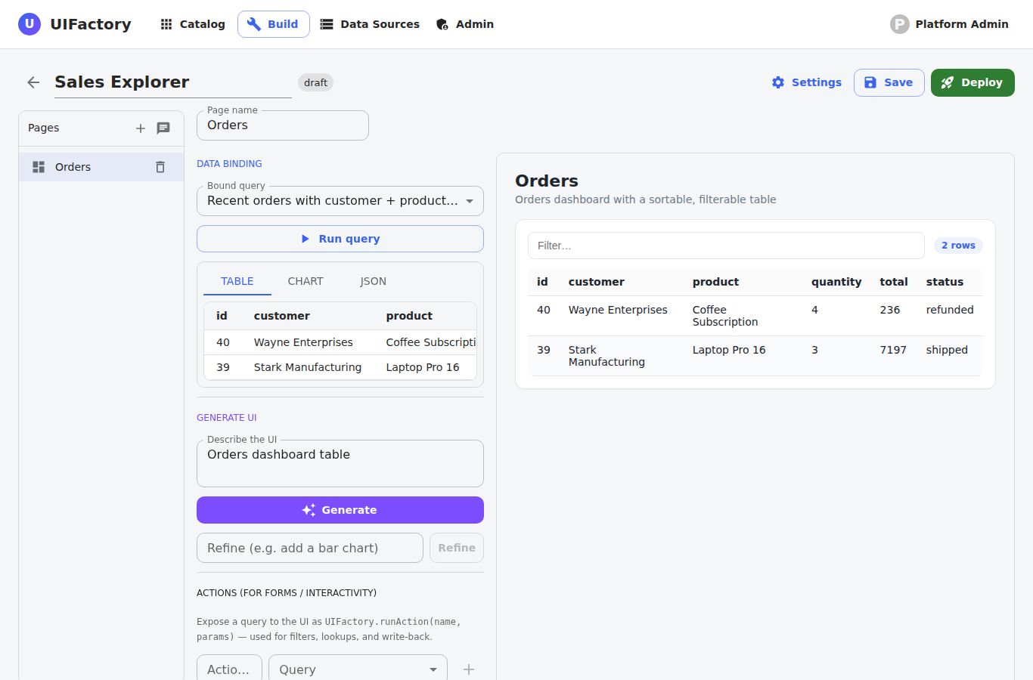

8. Configure sharing & AI connection
Open Settings to add a description, set Visibility (Private — only people you add; Organization — anyone signed in; Public — listed for everyone), share with specific organization members, and choose the AI / agent connection: the platform default, this app's own provider key (Claude / OpenAI / Azure OpenAI), or an external agent API endpoint.
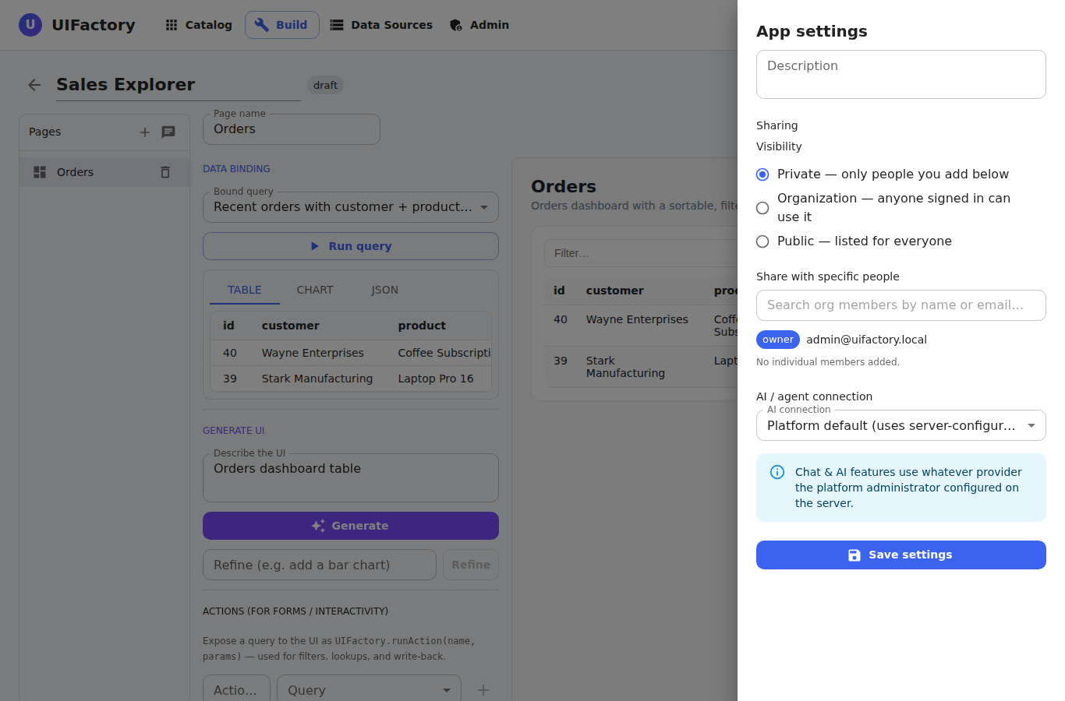

9. Deploy & publish
Click Deploy to publish a versioned snapshot of the app. People running the app always see the published version; the editor flags unpublished changes so you can 'Publish changes' when ready. Use Undeploy to take it out of the catalog.
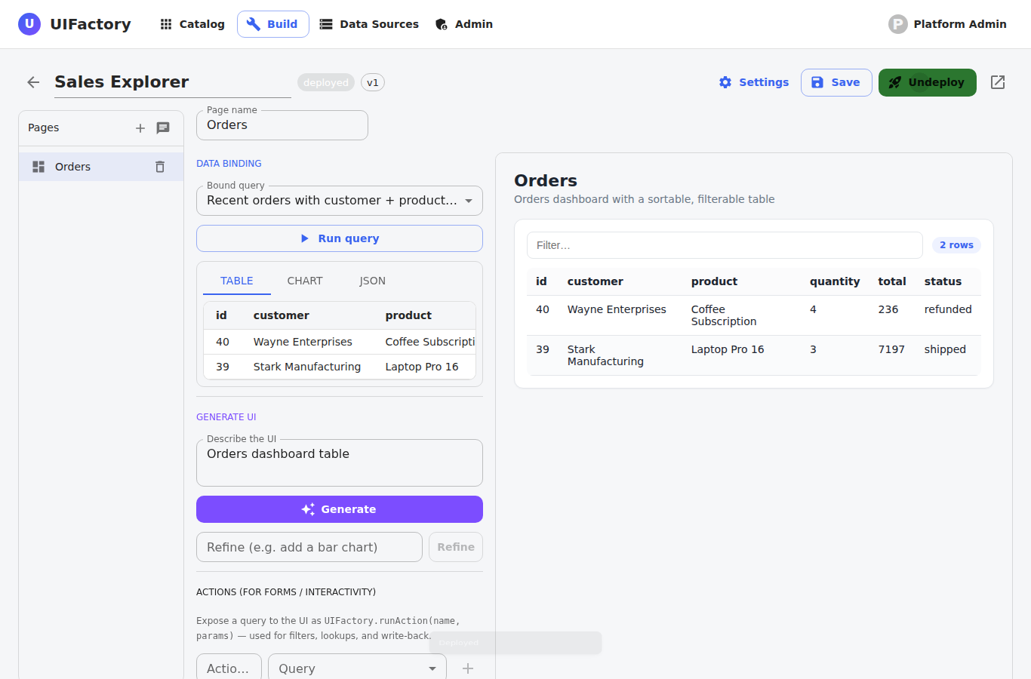

10. Manage data sources
Data Sources lists the REST APIs and databases your apps read from. Each source is owned by its creator and can be kept private or shared with the organization.
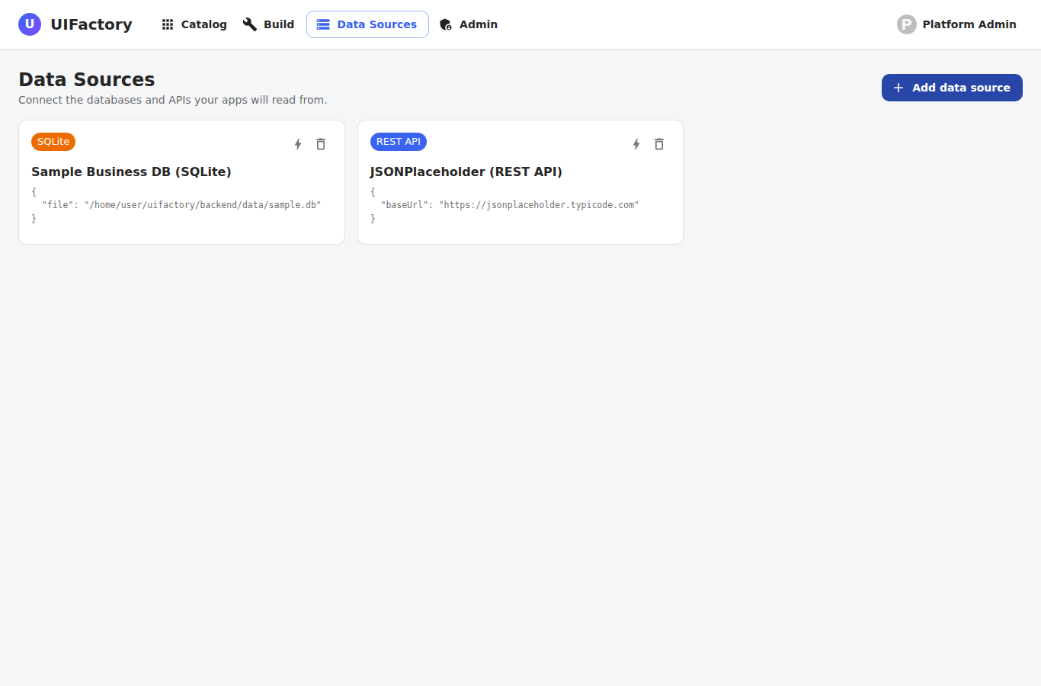

11. Add a data source
Add a REST API, PostgreSQL, or SQLite connection. Use 'Test connection' to verify it before saving. Connection secrets are encrypted at rest and never shown back in full.
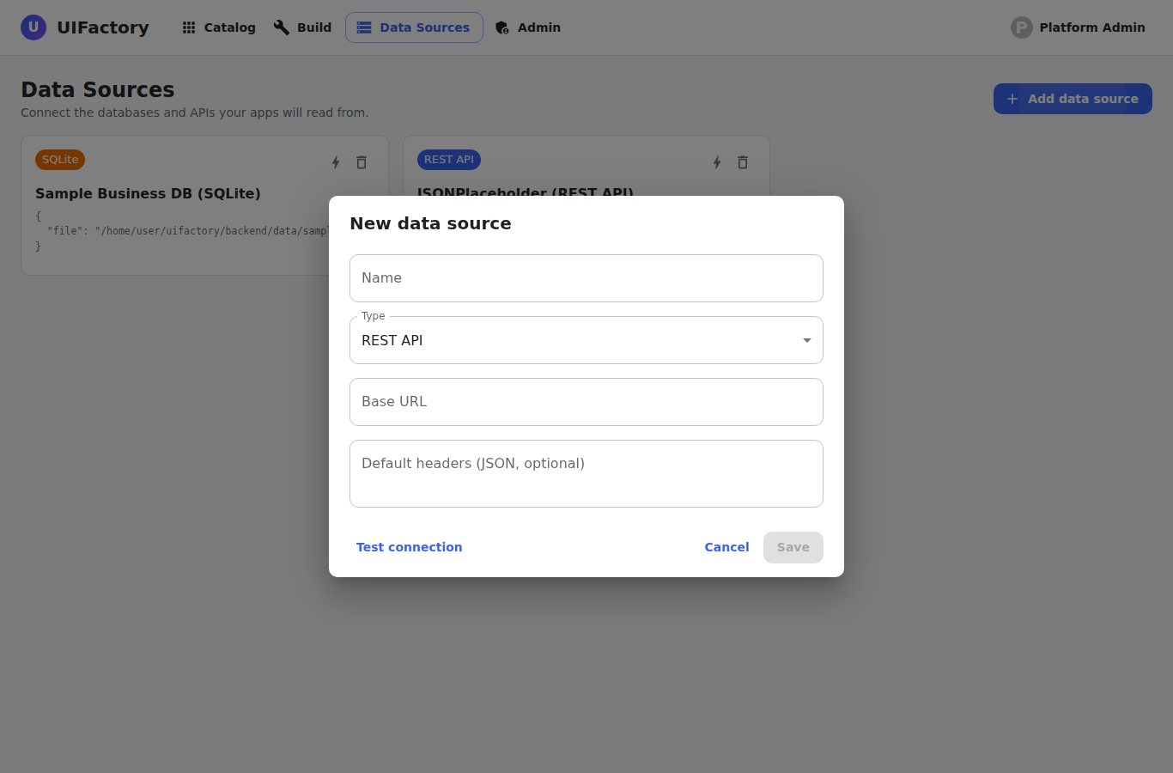

12. Admin — Users
Administrators manage platform members here: switch a user between admin and member, and activate or deactivate accounts.
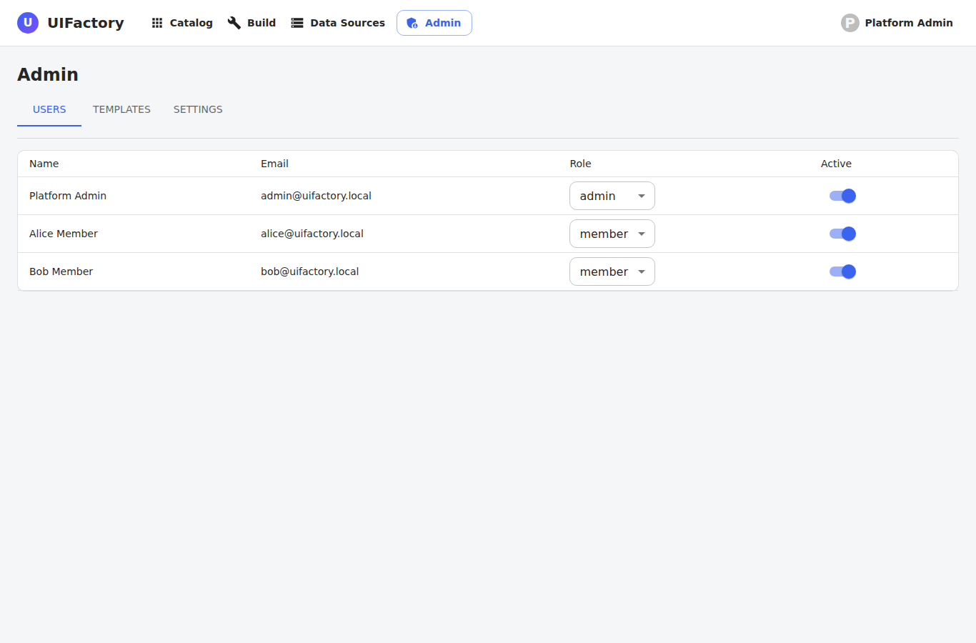

13. Admin — Templates
Create reusable starter templates (including directly from an existing app) that members can use to start new apps, and remove templates you no longer need.
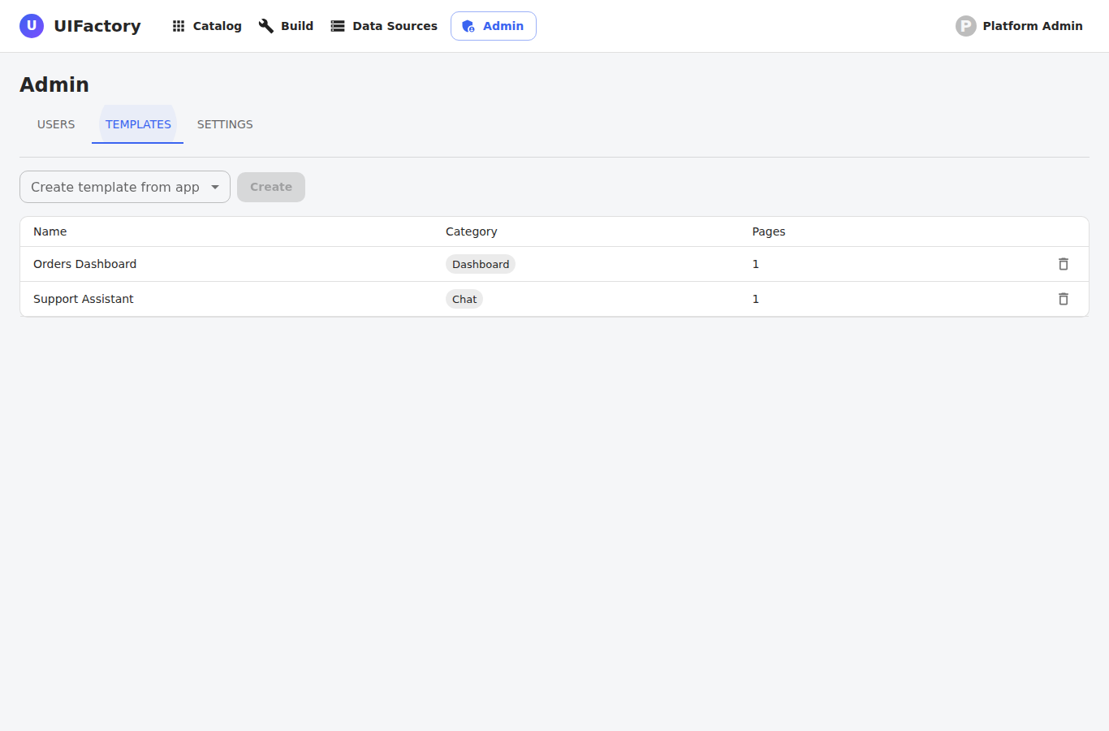

14. Admin — Settings
Configure platform-wide settings such as the platform name, the default visibility for new shares, and the default AI provider.
