**ONLINE Exam**

**DATABASE**

**Date: 04TH MAY 2020**

**Instructions - ការណែនាំ**

* You are not allowed to talk or discuss each other during exam.
* ​​​If you are found **cheating** or **attempting** to cheat, you will get a 0 score to this exam

**ហាមជជែកឬពិភាក្សាគ្នាក្នុងពេលប្រលង។​​ បើអ្នកត្រូវបានរកឃើញថាលួចចំលង​ឬ ព្យាយាមបើកមើល សំណៅឯកសារ​ នោះអ្នកនឹងត្រូវបញ្ឈប់ពីការប្រលង។**

**I. Problem Solving**

1. In a grocery store near PNC has a list of products in their database system, and the numbers of product is more than 1000 records. Moreover, each week the stock manager always check the product information in the system in order to validate the information of the product was record correctly or not, but during the time he check, he always face trouble to find each product name he looking for, So what should you do in order to help him find those product faster? Show me how you do it in query(25pt)  
   Here is the product table:  
   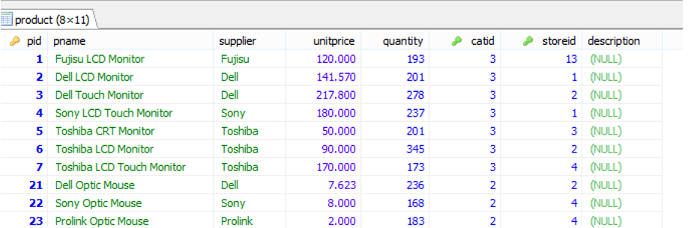

**Answer:**

**SELECT** * **FROM** product

**ORDER** **BY** pname **ASC**;

1. In RUPP University, all students has parents working in different fields such as Police, Teacher, Doctor, Farmer, etc. At the school there was a database to records all students’ and parents information. So as you are a database administrator, what should you do to display only the students who has parent working as Farmer (25pt)

Here is the table students  
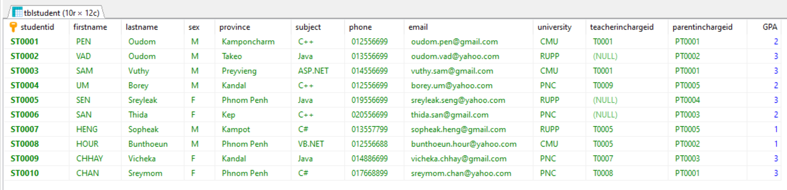

Parent table

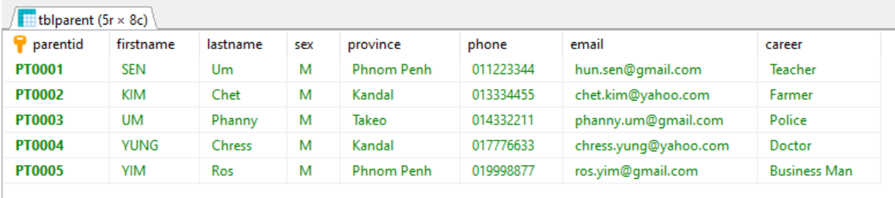

**Answer:**

**SELECT** * **FROM** tblstudent

**WHERE** parentinchargeid **IN**(

**SELECT** parentid **FROM** tblparent

**WHERE** career = "Farmer";

)

**II. Execute the Query (30pts)**

1. Find the mistake and correct it. (10pts)

**CREATE PROCEDURE** getAge(

**IN** num_employee **int**(11),

**OUT** total **int**(11))

**BEGIN**

**select** employee.age **from** employee

**where** employee.id = num_employee

**INTO** total;

**END** //

**Answer:**

DELIMITER //

**CREATE** **PROCEDURE** getAge(

**IN** num_employee **int**(11),

**OUT** total **int**(11))

**BEGIN**

**select** employee.age **from** employee

**where** employee.id = num_employee

**INTO** total;

**END** //

**CALL** getAge(2,@getAge);

**SELECT** @getAge;

1. Explain in detail the query below will do. (10pts)

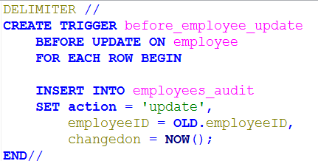

**Answer:**

**This query we create to trigger name before_employee_update to be backup data from table employee to keep on table employees_audit before user update data on table employee that have three column like action,employeeID and changedon.**

1. What kind of the query below? What will it does? Explain in details (30pts)

­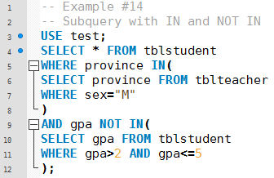

**Answer:**

1. **The kind of the query is sub-query.**
2. **Explain: We want to select all data from table tblstudent but choose only student that come from province that have sex = M and gpa not in gpa bigger than 2 and less than or equal 5.**

**III. Practices (20pts)**

1. Create a simple stored procedure to calculate your age by input only born year. (No need database and table).  
   Ex. *When you call the procedure call findAge(1996) then the result will be 24*

**Answer:**

DELIMITER //

**CREATE** **PROCEDURE** calculatAge(

**IN** YearBorn **INT**(11)

)

**BEGIN**

**SELECT** **YEAR**(**NOW**()) - YearBorn **AS** "Your age";

**END** //

**CALL** calculatAge(2000);

1. Create a trigger to record some information after a user inserts a new category. These information should include username, current time, command name and the new row id.

**Example Table Category Data**

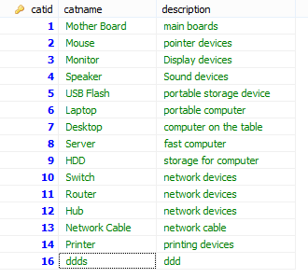

**Answer:**

DELIMITER //

**CREATE** **TRIGGER** after_user_insert **AFTER** **INSERT**

**ON** category

**FOR** **EACH** ROWpnc_trigger_practicepnc_trigger_practice

**BEGIN**

**INSERT** **INTO** user_info

**SET** user_name = **CURRENT_USER**(),

user_time = **NOW**(),

user_command ="INSERT",

user_id = **NEW**.catid;

**END** //