Comment

1. default of comment template: we cannot customize anything

<?php comments_template(); ?>

1. customize comment

* comments.php:

There are two things you must do in comment.php

* List of comment: <?php echo wp_list_comments($args,$comments);?>

Example:

<?php

$args = array(

        'walker'=>null,

        'max_depth'=>'',

        'style'=>'ol',

        'callback'=>null,

        'end-callback'=>null,

        'type'=>'all',

        'reply_text'=>'Reply',

        'page'=>'',

        'per_page'=>'',

        'avatar_size'=>'60',

        'reverse_top_level'=>null,

        'reverse_children'=>'',

        'format'=>'html5',

        'short_ping'=>false,

        'echo'=>true

wp_list_comments($args,$comments); ?>

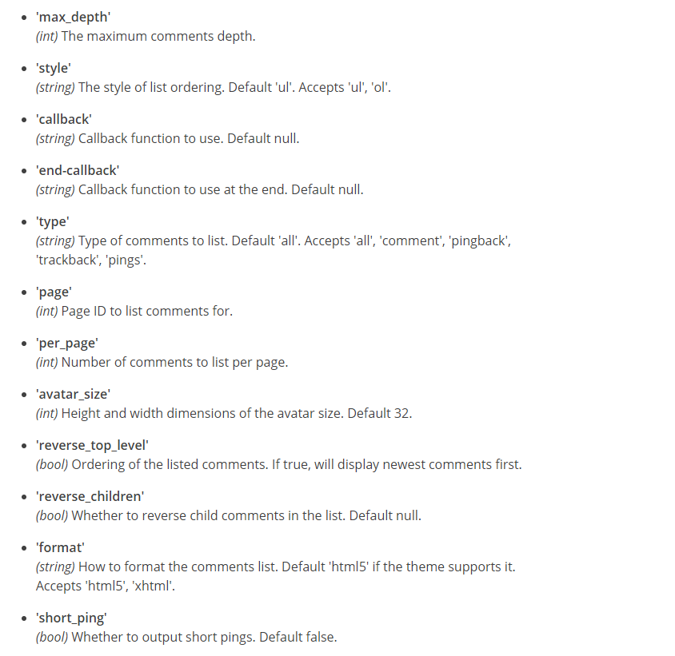

* Form of comment:<?php comment_form($form_args);?>

<?php

    $form_args = array(

        'label_submit'=>'Send Comment',

        'title_reply'=>'Write a Reply or Comment',

        'Comment_note_after'=>'', (element for a message displayed after the textarea field)

        'Comment_filed'=>'<p class = "Comment-form-comment">'

    );

    comment_form($form_args);

?>

