Agent

## Agent Login

* Open your IM App (FB Messenger, Skype…etc) and type “login” in OCS Agent Bot chat window. A Login card will be shown. Click on “Login” button

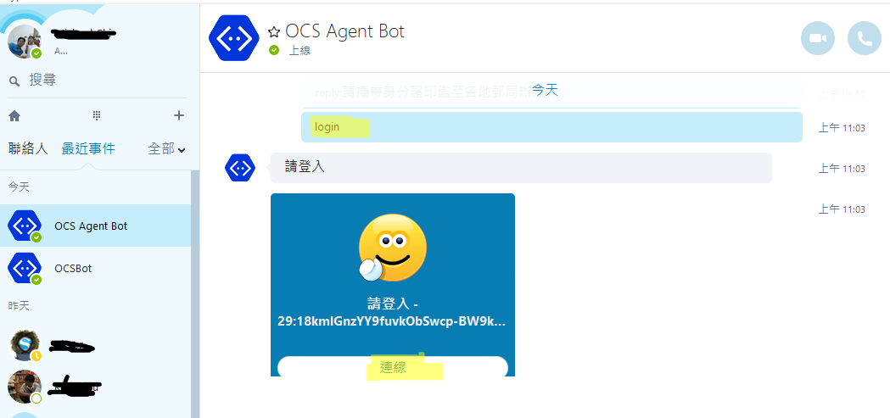

* A Web site login page will be opened in your default browser. Type any email and any password to login

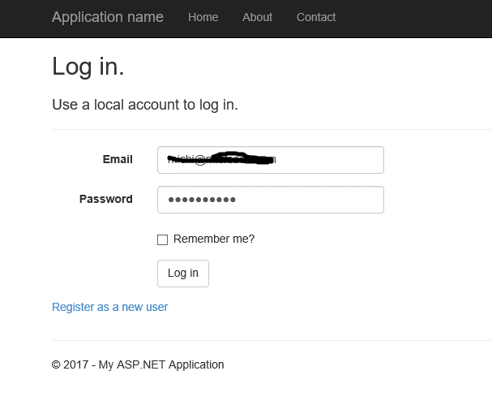

* You will be redirected to a page stating that you have been authenticated

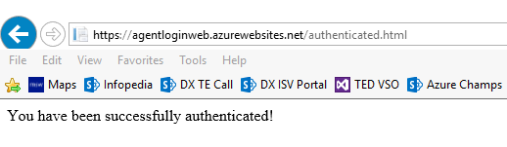

* In OCS Agent Bot Chat window. When got query from end users (messages from end-users will be prefixed with [XXX@ocsuser]), type “reply:” as prefix then followed with your answers to reply to the query

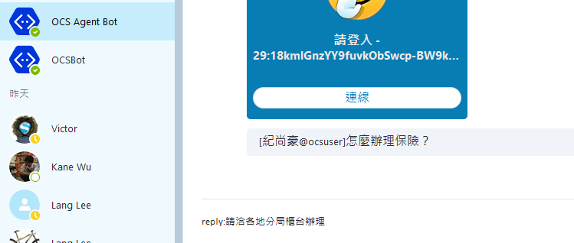

End Customers

## End User Query

* Type anything that can be identified by LUIS to demo LUIS capabilities. In built-in application, please type：我想要查包裹狀態

A prompt with validate package types will be shown, allowing you to choose one of them.

Click on the top most button to continue

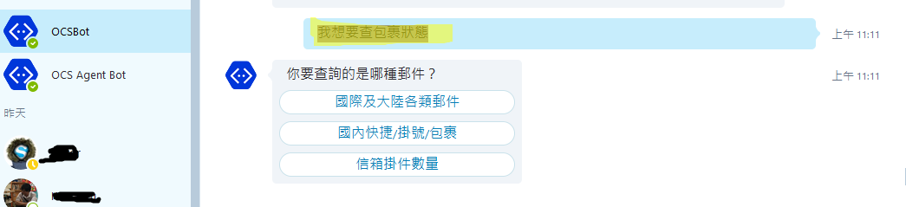

* When prompt to input Package Number, type anything to continue

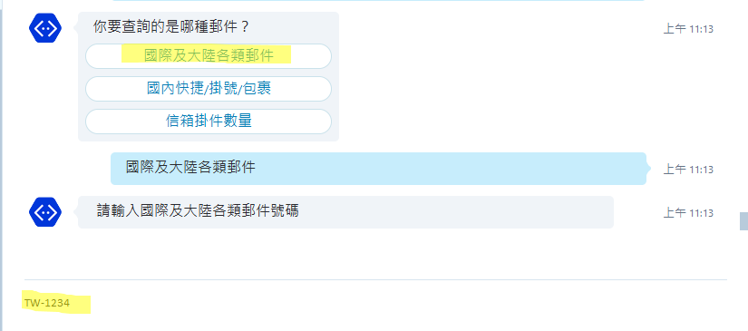

* You will get the status of your package

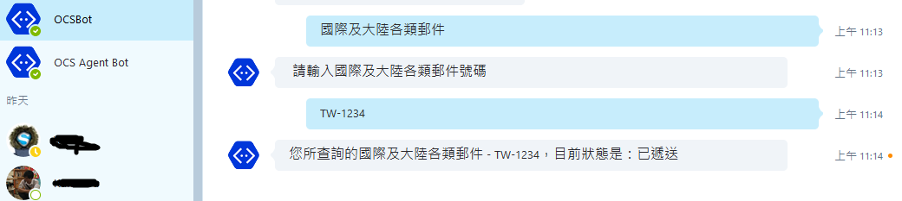

* Then type”如何申請e動郵局” as your query, you would got an answer from QnA Maker or Azure Search

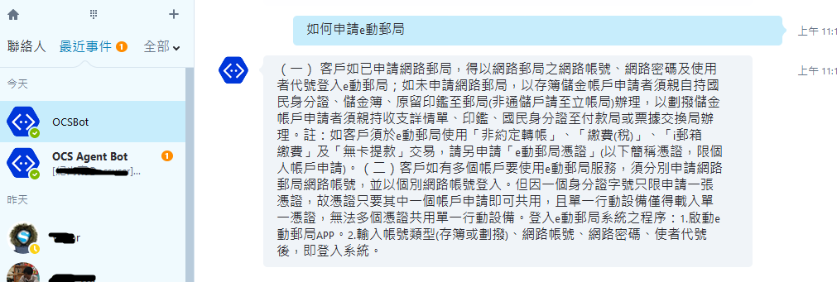

* Type “怎麼辦理郵局開戶？” as your question；This questions is not in our Azure Search nor in QnA Maker, so it will be redirected to a human agent

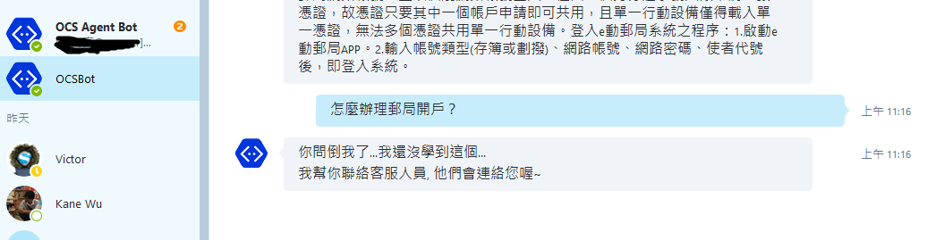

* Go to your Agent Bot Chat window, type below to respond.

reply:請洽各地分局櫃台辦理

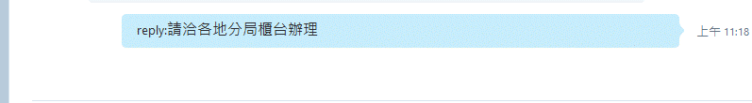

* The answer will be transferred to end-user’s chatting window

