Sri Lanka Institute of Information Technology
Programming Applications and Frameworks
IT3030
Year 03 Semester 01 - 2025
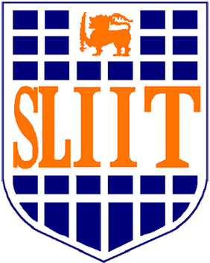

Initial Document
Inkspire - Creative Writing & Storytelling
Skill-Sharing & Learning Platform

Group ID : Y3S1-WE-02

 | Name with Initials | Registration Number
 | Daniel O.D.S | IT22060044
 | Gunathilake G.S.K | IT22280442
 | Kaveesha K.D.K | IT22075994
 | Jayasekara J.D.C.N | IT22212054

Introduction

The Skill-Sharing & Learning Platform is designed to enable users to share, learn, and improve various skills through interactive engagement. This document focuses on the Creative Writing & Storytelling skill, allowing users to enhance their writing abilities through sharing short stories, poetry, and writing exercises. This feature will provide users with tools to create structured learning plans, track their progress, and receive feedback from other users. The platform ensures engagement through likes, comments, and following other writers, fostering a collaborative learning environment.

2. Functional Requirements (FRs)

Core Features (Mapped to Assignment Functions)

✅ Skill Sharing Posts
• Users can upload and share short stories, poetry, and creative writing exercises.
• Users can add descriptions explaining their writing style, inspiration, and creative process.
• Support for image attachments (handwritten drafts, book excerpts) and audio recordings (spoken poetry or narrated stories).

✅ Learning Progress Updates
• Users can post updates on their writing journey, such as:
• "Completed 2 new chapters today!"
• "Practiced metaphor usage in poetry."
• Predefined templates for tracking writing goals (word count, editing, milestones).

✅ Learning Plan Sharing
• Users can create structured learning plans for different aspects of writing:
• Novel writing (character development, world-building, plotting).
• Poetry (rhyme schemes, free verse techniques, figurative language practice).
• Scriptwriting (dialogue structure, screenplay formatting, pacing).
• Users can update their plans as they progress.

✅ Interactivity & Engagement
• Users can like and comment on writing posts.
• Comments can be edited or deleted by the user.
• Post owners can delete inappropriate comments.

✅ User Profiles & Social Features
• Each user has a profile page displaying:
• Their shared stories and poems.
• Their learning progress (e.g., 'Completed 5 short stories').
• Their followers and engagement stats.
• Users can follow other writers to receive updates on new content.

✅ Notifications
• Users receive notifications when:
• Someone likes or comments on their writing.
• They get a new follower.
• A user replies to their comment or suggests edits.

✅ Authentication
• Users can log in via OAuth 2.0 (Google, Facebook, etc.) for secure access.

3. Non-Functional Requirements (NFRs)

• Performance: The platform should handle hundreds of concurrent users smoothly.
• Scalability: Designed to accommodate future expansion (more users, new writing-related features).
• Security: Protect user data and writing content through Spring Security & OAuth 2.0.
• Maintainability: Follow Spring Boot & React best practices to ensure long-term system stability.
• Usability: The UI/UX should be intuitive for seamless writing, sharing, and engagement.

4. System Overview Diagram

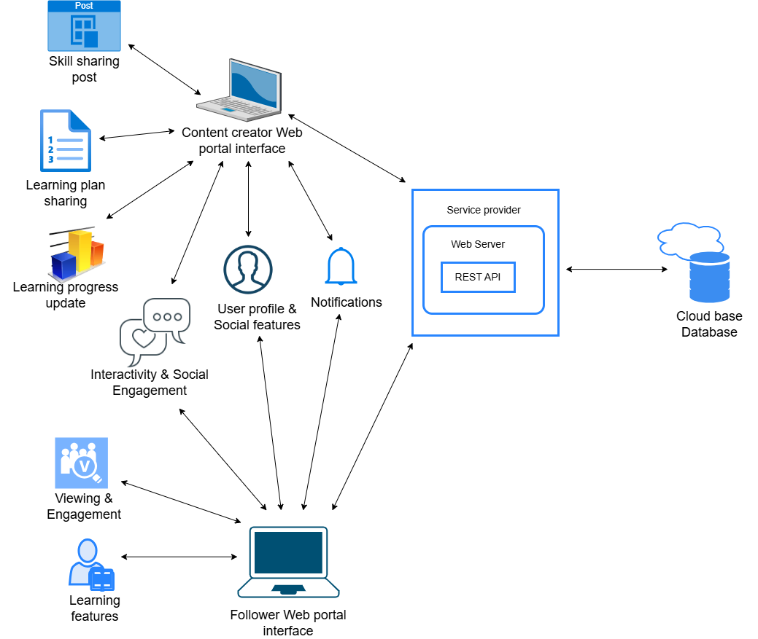

System Architecture Overview

• Backend (Spring Boot - Java): REST API for handling user authentication, writing posts, learning plans, and comments.
• Frontend (React - JavaScript): User-friendly interface for creating, browsing, and engaging with writing content.
• Database (MySQL or PostgreSQL): Store user profiles, writing posts, comments, and learning progress.

6. Work Distribution

Feature | Assigned Members
Skill Sharing Posts | Kaveesha K. D. K
Learning Plan Sharing | Jayasekera J. D. C. N
Learning Progress Updates | Daniel O. D. S
Interactivity & Engagement | Gunathilake G. S. K
User Profiles & Social Features | Daniel O. D. S, Kaveesha K. D. K, Gunathilake G. S. K
Notifications | Jayasekera J. D. C. N
Authentication | Daniel O. D. S, Kaveesha K. D. K, Gunathilake G. S. K

7. Gantt Chart

8. Conclusion
The Creative Writing & Storytelling feature will provide an engaging, structured environment where users can improve their writing skills through learning plans, progress tracking, and community feedback. This aligns well with the Skill-Sharing & Learning Platform’s goal of fostering interactive and collaborative learning experiences.

