Lab 1: Building Machine Learning models in a No-code environment

BigML Diabetes Prediction: Classification & Regression Exercise
This document contains exercises for performing both classification and regression analysis using the Diabetes dataset in BigML. You will learn how to predict whether a patient has diabetes (classification) and how to estimate glucose levels (regression).

Part 1: Binary Classification for Diabetes Prediction

Objective
This exercise guides you through using BigML to perform a binary classification task to predict whether a patient has diabetes using the Diabetes dataset.

Step 1: Upload the Diabetes Dataset
1. Download the Diabetes dataset (diabetes.csv) from Kaggle.
2. Log in to BigML (https://bigml.com/ ).
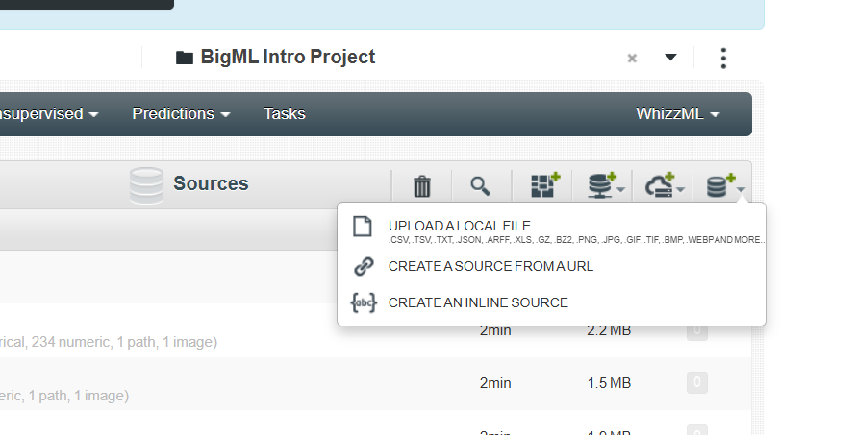
3. Go to Dashboard.
4. Click ‘upload a local file’.
5. Upload the diabetes.csv file.

Step 2: Create a Dataset
1. Go inside the diabetes dataset and click '1-Click Dataset' to generate a structured dataset.
2. BigML will process the dataset and display field information.

Step 3: Set the Target Variable
- In Datasets tab and open the dataset and navigate to the 'Fields' tab.
2. Click on the 'Outcome' field.
3. In the settings panel, set 'Objective = Yes' (mark it as the target variable 🎯).
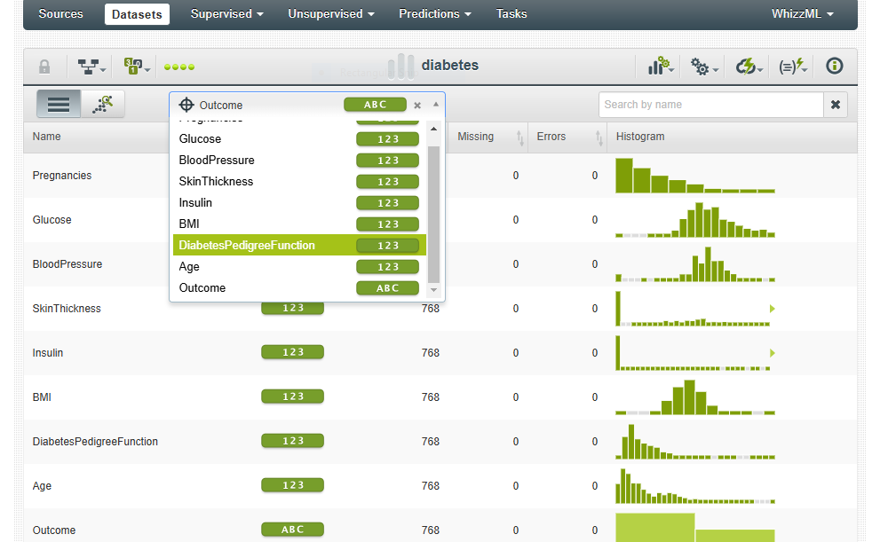

Step 4: Split the Dataset
1. Click 'Split' on the dataset page.
2. Choose 'Random Split' and set:
- 80% for training.
- 20% for testing.
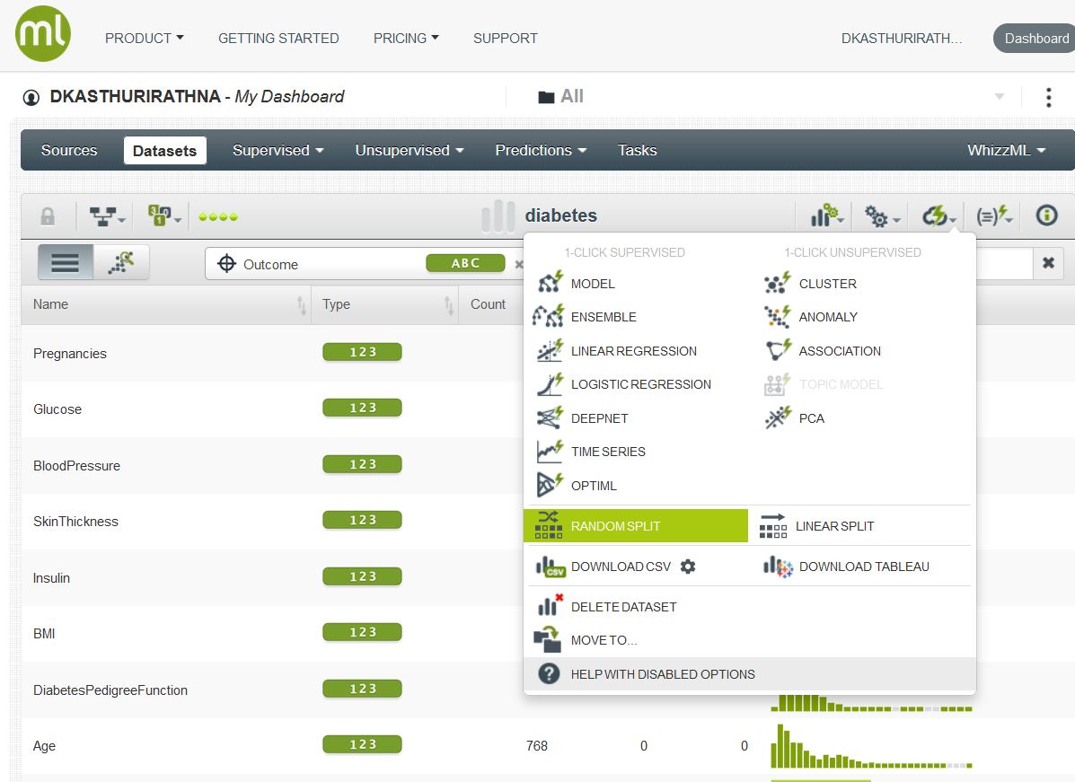

Step 5: Train a Model
1. Open the training dataset.
2. Under ‘1-Click supervised’ click 'Model' to train a Decision Tree model.

Step 6: Evaluate the Model
1. Open the model details page (Supervised->Models).
2. Click the path to visualize the model structure. (Note: After clicking a leaf node, click the root node to get the full view). Navigate a path till a leaf node to extract a rule.

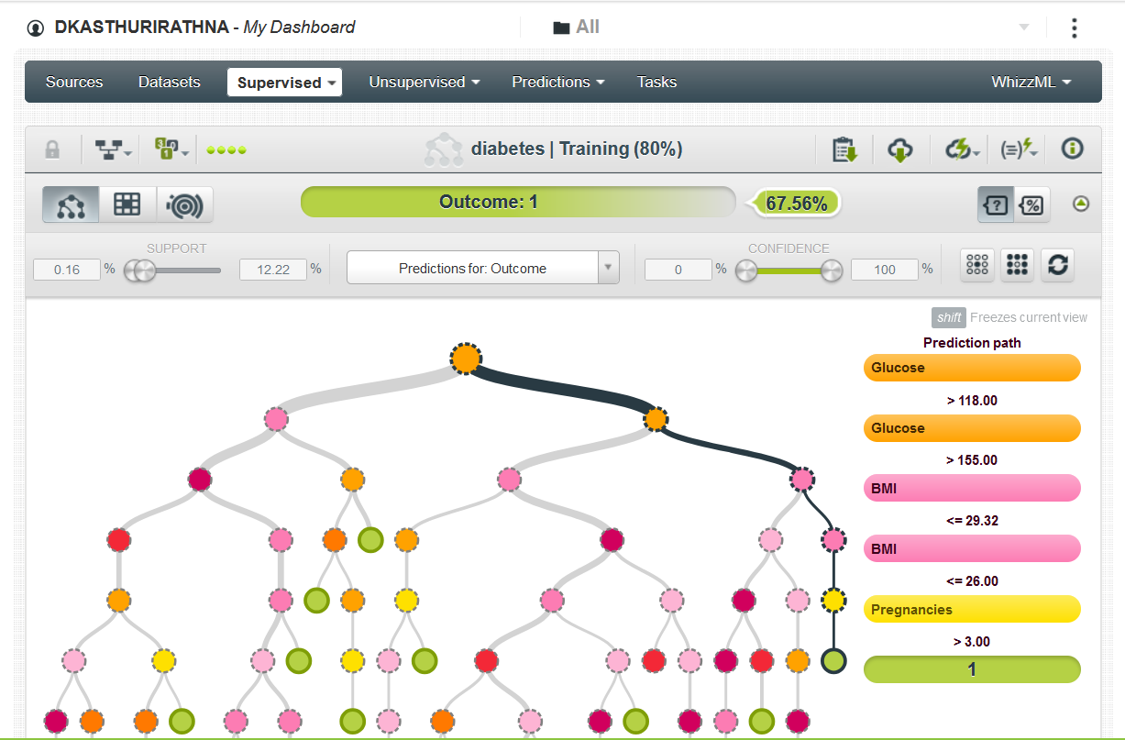
3. Click 'Evaluate'.
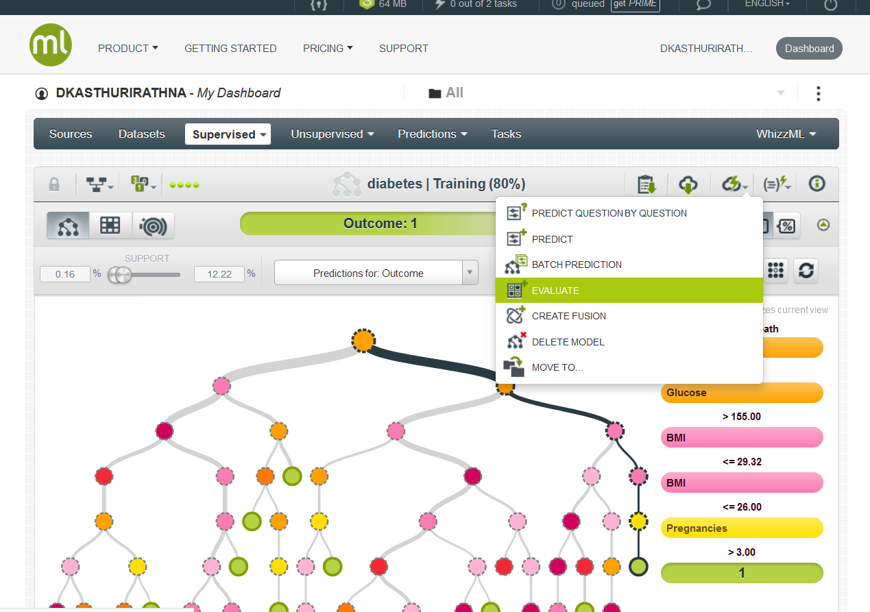

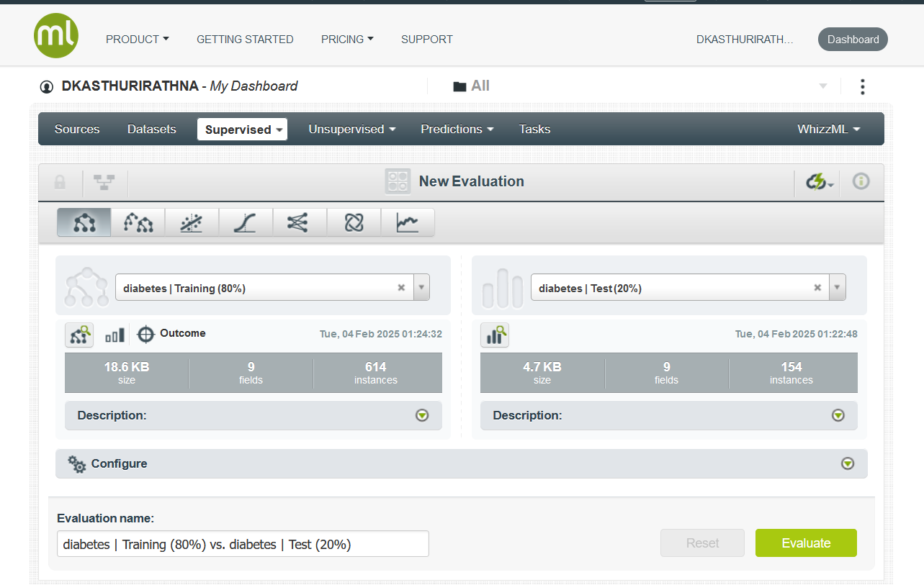
4. Select the testing dataset.
5. Review performance metrics such as:
- Accuracy
- Precision
- Recall
- F1-Score
- Confusion Matrix.

Step 7: Make Predictions
1. Click 'Predict' on the model details page.
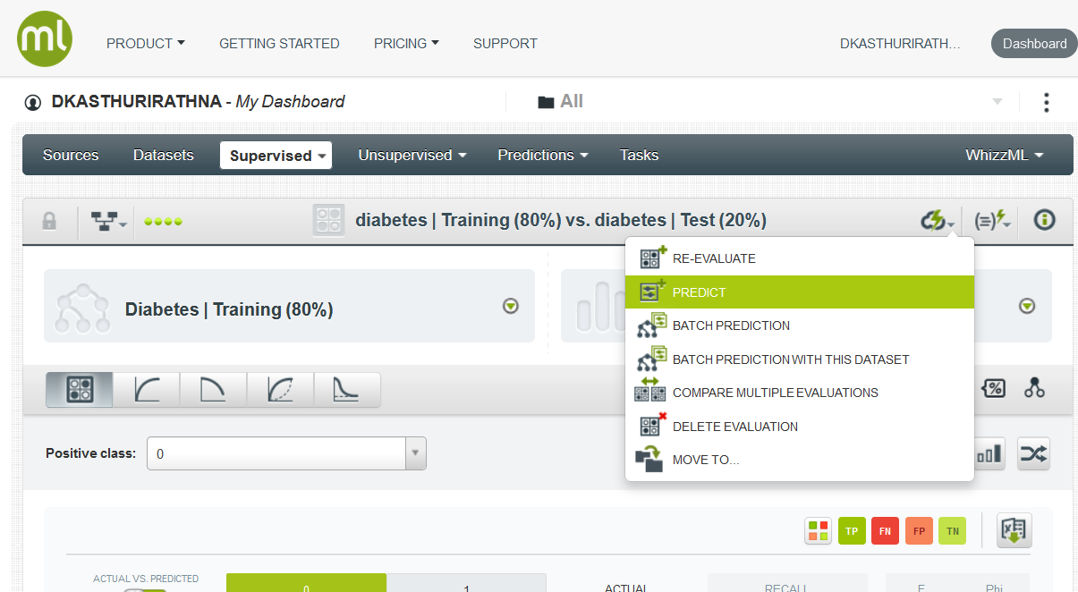
2. Enter input values (e.g., Glucose, BMI, Age, etc.).
3. Click 'Predict' → BigML will return either 1 (Diabetes) or 0 (No Diabetes).

Part 2: Regression Analysis for Glucose Level Prediction

Objective
This exercise guides you through performing regression analysis in BigML to predict Glucose levels using the Diabetes dataset.

Step 1: Set the Target Variable to Glucose
1. Open the dataset and navigate to the 'Fields' tab.
2. Click on the 'Glucose' field.
3. In the settings panel, set 'Objective = Yes' (marks it as the target variable 🎯).

Step 2: Split the Dataset
1. Click 'Split' on the dataset page.
2. Choose 'Random Split' and set:
- 80% for training.
- 20% for testing.
3. Click 'Create'.

Step 3: Train a Model
1. Open the training dataset.
2. Under ‘1-Click supervised’ click 'Model' to train a Decision Tree model.

Step 4: Evaluate the Model
1. Open the model details page.
2. Click 'Evaluate'.
3. Select the testing dataset.
4. Review performance metrics such as:
- Root Mean Squared Error (RMSE)
- R² Score
- Error distribution.
5. Click the path to visualize the regression model structure.

Step 5: Make Predictions
1. Click 'Predict' in the model details page.
2. Enter input values (e.g., Pregnancies, BMI, Age, etc.).
3. Click 'Predict' → BigML will return the predicted Glucose level.

Submission
Upload the Results pages of both exercises as screenshots in a single zip file. On the screenshots the username (on top left) should be your username. The zip file name should be your registration number.

Summary
✔ You successfully performed both classification (Diabetes Prediction) and regression (Glucose Level Prediction) in BigML.
✔ You trained, evaluated, and visualized both models.
✔ You uploaded screenshots as proof of completion.

Optional Challenges
- Try Feature Engineering: Create new features from the dataset.
- Explore other low-code/no-code environments like https://h2o.ai/ ,Google cloud API (Cloud APIs | Google Cloud) and Orange Data Mining.
- Experiment with Ensemble Models for improved accuracy.
- Explore Advanced Evaluation Metrics such as Lift Charts.
- Export these models as web services to client apps.

References
BigML tutorial videos
https://www.youtube.com/watch?v=6xbNpILmQYo&list=PL1bKyu9GtNYHAk0PUojkLYZzASoYVcsTQ

